Cytoscape 2.2



User Manual

Nov. 2005

The Cytoscape Collaboration

The Cytoscape project is an ongoing collaboration between:
 | University of California at San Diego | Institute for Systems Biology | 
 | Memorial Sloan-Kettering Cancer Center | Institut Pasteur | 

Funding for Cytoscape is provided by a federal grant from the U.S. National Institute of General Medical Sciences (NIGMS) of the National Institutes of Health (NIH) under award number GM070743-01. Corporate funding is provided through a contract from Unilever PLC.
Table of Contents

1. Introduction 3
2. Launching Cytoscape 4
3. Quick Tour of Cytoscape 7
4. Command Line Arguments and Properties 14
5. Building and Storing Interaction Networks 17
6. Loading Gene Expression Data 21
7. Node and Edge Attributes 23
8. Navigation and Layout 27
9. Visual Styles 30
Introduction to Visual Styles 30
Visual Attributes, Graph Attributes and Visual Mappers 33
Tutorial: Creating a New Visual Style 36
Tutorial: Creating a New Visual Style with a Discrete Mapper 38
Tutorial: Visualizing Expression Data on a Network 39
10. Editing Networks 40
11. CytoPanels 42
12. Annotation 45
New Ontology and Annotation Files 45
Gene Ontology Server Wizard 46
13. Filters 49
14. Acknowledgements 54
Appendix A: Old Annotation Server Format 55
Gene Ontology Server Wizard 55
Building your own annotation files 56
Load Data into Cytoscape 58
Getting and Reformatting GO Data 58
Appendix B: GNU Lesser General Public License 64

1. Introduction

Cytoscape is an open-source community software project for integrating biomolecular interaction networks with high-throughput expression data and other molecular state information for visualization and analysis. Although applicable to any system of molecular components and interactions, Cytoscape is most powerful when used in conjunction with large databases of protein-protein, protein-DNA, and genetic interactions that are increasingly available for humans and model organisms. A software “Core” provides basic functionality to layout and query the network; to visually integrate the network with expression profiles, phenotypes, and other molecular state information; and to link the network to databases of functional annotations. The Core is extensible through a plug-in architecture, allowing rapid development of additional computational analyses and features. The central organizing metaphor of Cytoscape is a network (graph), with genes, proteins, and molecules represented as nodes and interactions represented as links, i.e. edges, between nodes.

Development
Cytoscape is a collaborative project between the Institute for Systems Biology (Dr. Leroy Hood), the University of California San Diego (Dr. Trey Ideker), Memorial Sloan-Kettering Cancer Center (Dr. Chris Sander) and the Institut Pasteur (Dr. Benno Schwikowski).

Visit http://www.cytoscape.org for more information.

License
Cytoscape is protected under the GNU LGPL (Lesser General Public License). The License is included as an appendix to this manual, but can also be found online:
http://www.gnu.org/copyleft/lesser.txt Cytoscape also includes a number of other open source libraries, which are detailed in Section 10, Acknowledgements below.

What’s New in 2.2

Cytoscape version 2.2. contains several new features, plus improvements in the performance and usability of the software. These include:

- Enhanced support for node and edge attribute handling, including a powerful new attribute browser, for navigating, defining, and editing node and edge attributes. For plugin coders, this also includes a greatly improved API (cytoscape.data.CyAttributes).
- Support for dockable, tabbed panels (CytoPanels).
- A set of Cytoscape editors for building and modifying networks interactively by adding nodes and edges to a drawing canvas.
- Improved support for ontologies and other structured annotations.
- Simplified mechanism for saving Visual Styles in between sessions.
- A new GML visual style to manage visual properties from GML files
- Many performance improvements and bug fixes.

2. Launching Cytoscape

Cytoscape is a Java application that runs on Linux, Windows, and Mac OS X.

System requirements:
The system requirements for Cytoscape depend on the size of the networks the user wants to load, view and manipulate. We recommend a recent computer (1GHz CPU or higher) with a high-end graphics card and at least 512MB of free physical RAM. Cytoscape expects a minimum screen resolution of 1024x768.

There are a number of options for downloading and installing Cytoscape:

- For Windows and Linux platforms, one-step installation is available via InstallAnywhere. For one-step installation, go to http://www.cytoscape.org, click Download Cytoscape, and follow the on-screen instruction.

- For Mac OS X, we provide an alternative installation, available as a .dmg.zip file. When installed via this method, Cytoscape functions as a regular Mac application, and can be accessed via your Applications folder.

- Finally, you can download and install a compressed archive distribution. Instructions for this option are provided below.

(1) Download and unpack the distribution. Cytoscape is distributed as a compressed archive (tar.gz or zip) containing the following files and directories:

cytoscape.jar Main Cytoscape application (Java archive)
cytoscape.props User-configurable properties and preferences
vizmap.props User-configurable visual mapping preferences

cytoscape.sh Script to run Cytoscape from command line (Linux, Mac OS X)
cytoscape.bat Script to run Cytoscape (Windows)

LICENSE.txt Cytoscape GNU LGPL License
Cytoscape2_2Manual.pdf Cytoscape 2.2 Manual (the document you are reading now)

sampleData/
galFiltered.gml Sample molecular interaction network file *
galFiltered.sif Identical network in Simple Interaction Format *
galExpData.pvals Sample gene expression matrix file *
BINDyeast.sif Network of all yeast protein-protein interactions in the BIND database as of Nov, 2005 **
BINDhuman.sif Network of all human protein-protein interactions in the BIND database as of Nov, 2005 **
yeastHighQuality.sif Sample molecular interaction network file ***

annotation/ Directory containing Gene Ontology database entries (currently for yeast only). Info in this directory is used to associate gene names with synonyms as well as process, function, and cellular location data.

plugins/ Directory containing cytoscape PlugIns, in .jar format.

* From Ideker et al, Science 292:929 (2001)
** Obtained from data hosted at http://www.blueprint.org/bind/bind_downloads.html
** From von Mering et al, Nature, 417:399 (2002) and Lee et al, Science 298:799 (2002)

(2) If necessary, install Java. If not already installed on your computer, download and install the Java 2 Runtime Environment, version 1.4.2 or higher. It can be found at:

http://java.sun.com/j2se/1.4.2/download.html

(3) Launch the application by running "cytoscape.sh" from the command line (Linux or Mac OS X) or double-clicking "cytoscape.bat" (Windows). Alternatively, you can pass the .jar file to Java directly using the command "java -jar cytoscape.jar". In Windows, it is also possible to directly double-click the .jar file to launch it. However, this does not allow specification of command-line arguments (such as the location of the annotation data directory, see the section on command line arguments for details). On Mac OS X, users who downloaded the Mac OS X version of Cytoscape, can double-click on the Cytoscape icon to start Cytoscape. Either double-clicking or dragging onto the Cytoscape application icon any .sif or .gml file will load that file into Cytoscape.

! Important Note:
For the application to work properly, ALL FILES MUST BE LEFT IN THE DIRECTORY IN WHICH THEY ARE UNPACKED. The core Cytoscape application assumes this directory structure when looking for certain files, such as cytoscape.props, vizmap.props, and the annotation/ database.

Cytoscape Window
When you succeed in launching Cytoscape, a window will appear that looks like this:

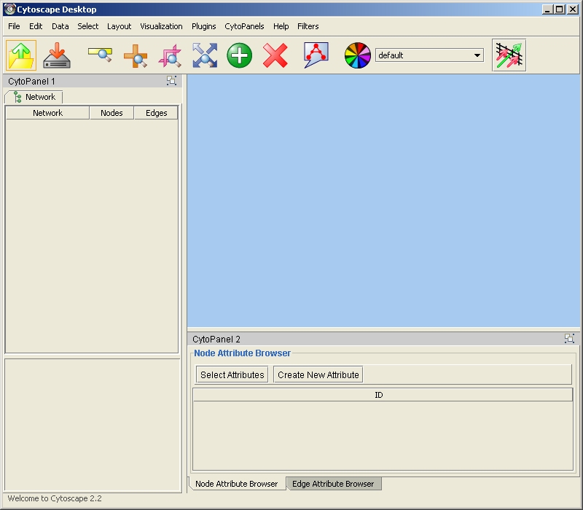

3. Quick Tour of Cytoscape

When a network is loaded, Cytoscape will look something like the image below:

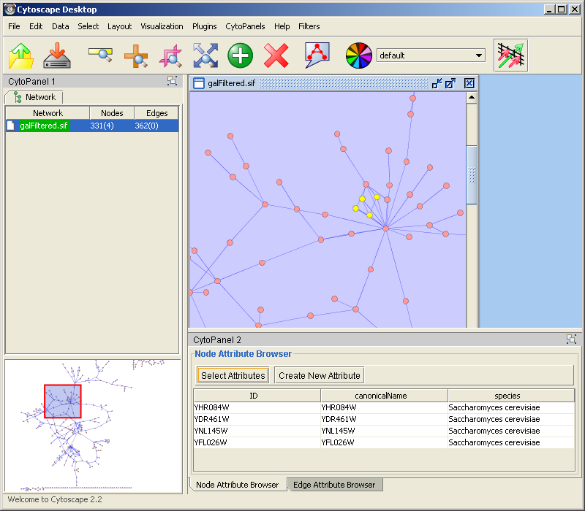

The main window here has several components:
- The menu bar at the top (See below for more information about each menu).
- The toolbar, which contains icons for commonly used functions. These functions are also available via the menus. Hover the mouse pointer over an icon and wait momentarily for a description to appear as a tooltip.
- The network management panel (top-left ). This contains an optional network overview pane (bottom-left overview of the network).
- The main network view window, which displays the network.
- The attribute browser panel (bottom panel), which displays attributes of selected nodes and edges and enables you to modify the values of attributes.

The network management and attribute browser panels are dockable tabbed panels known as CytoPanels. You can undock any of these panels by clicking on the Float Window control in the upper-right corner of the CytoPanel.

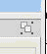

If you select this control, e.g. on the attribute browser panel, you will now have two Cytoscape windows, the main window, and a new window labeled CytoPanel 2, similar to the one shown below.

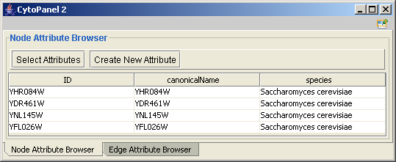

Note that CytoPanel 2 now has a Dock Window control. If you select this control, the window will dock onto the main window.

Cytoscape also has a set of editors that enable you to build and modify networks interactively by dragging and dropping nodes and edges from a palette onto the main network view window. The editors can be invoked using the Set Editor command on the File menu. An example of a simple biomolecule editor, with the palette contained in CytoPanel 1, is shown below.

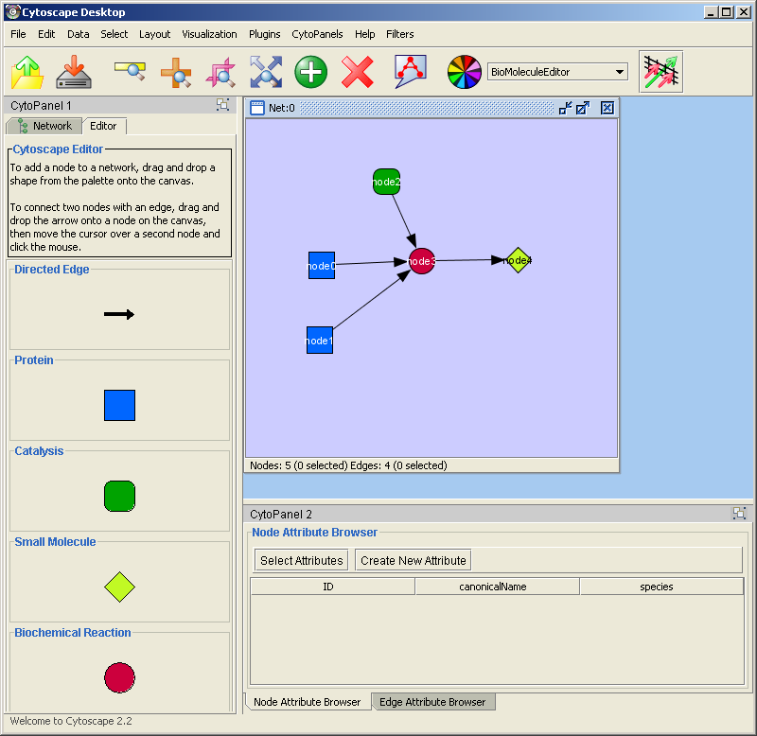

The Menus

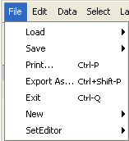
File
The File menu contains most basic file functionality: File / Load for loading a variety of file types; File / Save for saving. File/Help displays a credits screen. File / Print allows printing. File / Export As... allows you to export to a file in a number of graphics formats (such as PDF). File / Exit closes all windows of Cytoscape and exits the program. File/New opens up a New network for editing. This menu item is disabled until an editor is chosen using the File/SetEditor menu item.

Edit
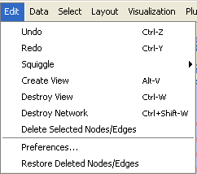
The Edit menu contains Undo and Redo menu items which undo and redo edits made in the Attribute Browser. The menu also contains a Squiggle feature that enables you to mark up your network. This can be particularly useful during live presentations. There are also options for creating and destroying views (graphical representations of a network) and networks (the network data – not yet visualized), as well as an option for deleting selected nodes and edges from the current network. All deleted nodes and edges can be restored to the network via the Edit/Restore Deleted Nodes/Edges menu item. The Edit Menu also supports Preferences editing for properties and plug-ins via a Preferences Dialog. Preferences editing operates on the cytoscape.props file associated with the user’s instance of Cytoscape. See “Command Line Arguments and Properties” for more information.

Data
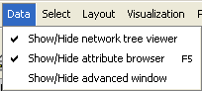
The Data menu allows you to display or hide the network management panel (CytoPanel 1). It allows you to display or hide the attribute browser (CytoPanel 2), which lets you view and edit attributes assigned to both nodes and edges. (See section 7. Node and Edge Attributes) The Data menu allows you to display an advanced window (contents of CytoPanel 3).

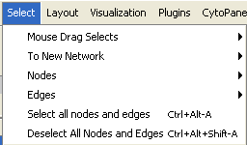
Select
The Select menu contains methods and operations for selecting nodes and edges, and using the current selection to create a new network and an associated view.

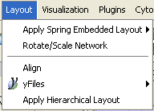
Layout
The Layout menu has an array of features for organizing the network visually according to one of several algorithms, aligning and rotating groups of nodes, and adjusting the size of the network. Most of these features are available from plugins that are packaged with Cytoscape 2.2

Visualization
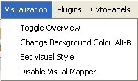
The Visualization menu provides options for changing the mapping from biological data to a visual representation: colors of nodes, thickness of edges, etc. These features are explored in-depth in section on visual styles. This menu also provides an Overview of your entire network, which is helpful for navigating very large networks.

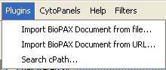
Plugins
The Plugins menu has menu items or choices added by plugins that have been loaded, such as "Import BioPAX Document from file".

Note: A list of available Cytoscape PlugIns with descriptions is available online at: http://cytoscape.org/plugins2.php

CytoPanels
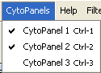
CytoPanels are floatable / dockable panels which cut down on the number of pop-up windows within Cytoscape. The CytoPanels menu allows you to show or hide CytoPanel 1, CytoPanel 2, or CytoPanel 3 based on the menu item selected.

Note:

In order for these keyboard short-cuts to work, the Cytoscape Desktop Window needs to have the focus. To give the window focus, simply click on it.

Help
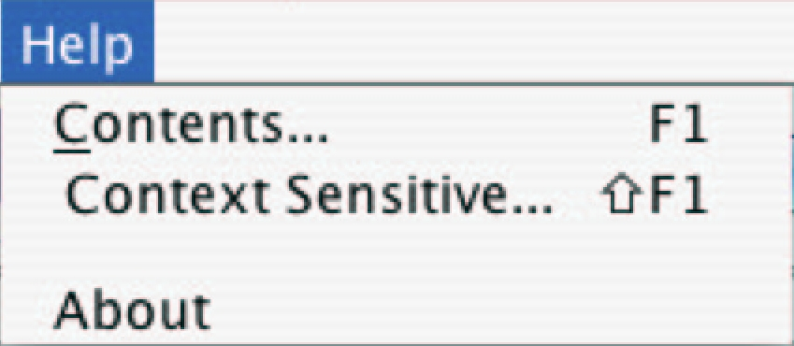
The Help menu allows you to launch the online help viewer and browse the table of contents (Contents…), or view the help text associated with a context-sensitive selection (Context Sensitive…). By selecting Context Sensitive… menu item and then selecting a GUI component, the help related to the selected item is launched. The “About…” menu item displays information about the running version of Cytoscape.

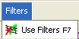
Filters
This menu allows you to bring up a user interface for defining and running filters (see 10. Filters). Filters enable you to extract subnetworks based upon the values of node and edge attributes.

Additional menus may appear, depending on the set of Plugins you have chosen to load.

Network Management

Cytoscape 2.2 allows multiple networks to be loaded at a time, either with or without a view. A network stores all the nodes and edges that are loaded by the user and a view displays them. You can have many views of the same network. Networks (and their optionally associated views) can be organized hierarchically.

An example where a number of networks have been loaded and arranged hierarchically is shown below:

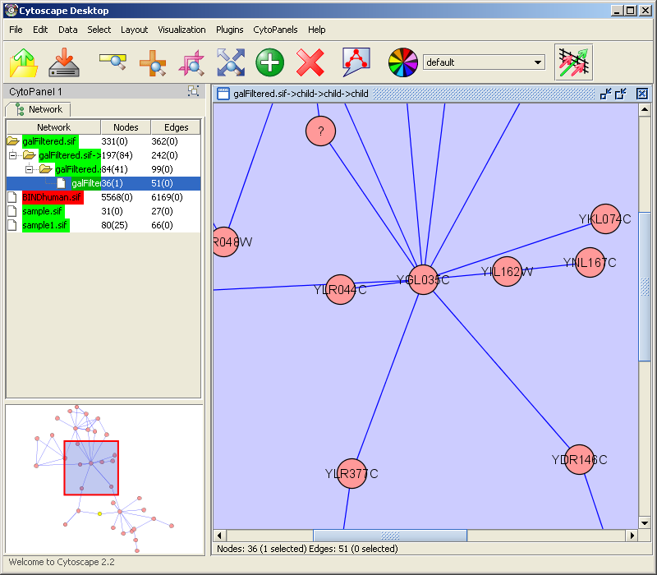

The network manager (top-right tree view in CytoPanel 1) shows the networks that are loaded. Clicking on a network here will make that view active in the main window, if the view exists (green highlighted networks only). Each network has a name and size (number of nodes and edges), which are shown in the network manager. If a network is loaded from a file, the network name is the name of the file.

Some networks are very large (thousands of nodes and edges) and can take a long time to display. For this reason, a network in Cytoscape may not contain a ‘view’. Networks that have a view are highlighted in green and networks that don’t have a view are highlighted in red. You can create or destroy a view for a network by right-clicking the network name in the network manager or by choosing the appropriate option in the edit menu. You can also destroy previously loaded networks this way. In the picture above, seven networks are loaded, six green ones with views and one red ones without a view.

Certain operations in Cytoscape will create new networks. If a new network is created from an old network, for example by selecting a set of nodes in one network and copying these nodes to a new network (via the Select->To New Network option), it will be shown as a child of the network that it was derived from. In this way, the relationships between networks that are loaded in Cytoscape can be seen at a glance. Networks in the top part of the tree in the figure above were generated in this manner.

The available network views are also arranged as multiple, overlapping windows in the network view window. You can maximize, minimize, and destroy network views by using the normal window controls for your operating system.

The Network Overview Window

The network overview window shows an overview (or ‘bird’s eye view’) of the network. It can be used to navigate around a large network view. This feature can be turned on or off via the Visualization menu. The red-outlined blue rectangle in the overview window shown below can be dragged with the mouse to navigate to a part of the network. The size of the navigation rectangle depends on the size of the active view and the zoom level of the view. The rectangle is smaller if the view is zoomed in and larger if zoomed out.
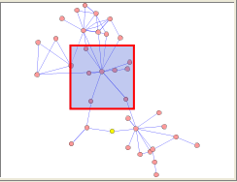

4. Command Line Arguments and Properties

Cytoscape recognizes a number of optional command line arguments, including run-time specification of network files and expression data:

-g | -graph <GML network filename> (xxx.gml)
Loads a network file in GML format (see section on Building and Storing Interaction Networks)

-i | -interaction <SIF interactions filename> (yyy.sif)
Loads a network file in SIF format (see section on Building and Storing Interaction Networks)

-b | -BDS | -bioDataServer <bioData directory> (e.g. annotation/manifest)
Specifies which directory to use for the BioDataServer annotations

-e | -expression <expression filename> (zzz.pvals)
Loads an expression data file (see section on Loading Gene Expression Data)

-n | -nodeAttributes <nodeAttributes filename> (one or more)
Loads node attributes files (see section on Node and Edge Attributes)

-j | -edgeAttributes <edgeAttributes filename> (one or more)
Loads edge attributes files
(see section on Node and Edge Attributes)

-s | -species Set the default species name

-c | -noCanonicalization Turn off default node name canonicalization

-h | -help | --help Help: display these command line arguments

-p | -plugin | --JLD | --JLW | --JLL Specify a list of plugins (jar files), directories containing plugins, URLs (http://) to jar files, or URLs to manifest files listing jar files

-props <properties file> specify and load a properties file (usually named cytoscape.props)

-vprops | -vp | -vizprops <properties file> specify and load a visual mapping properties file (usually named vizmap.props)

-noDialog | -suppressView Do not popup informational dialog when the expression file is loaded

-vt | --VT <view threshold> Specify the threshold # of nodes at which views will not automatically be created

-script | --script <script text…> -end
Specify script text

-rp | -resourcePlugin <resource plugins…>
Specify the list of resource plugins

Note that most data sets may also be loaded after Cytoscape is running.

Additional command line arguments that are not recognized by the Cytoscape core are passed to the PlugIn modules. Please refer to the documentation for each specific PlugIn for more details.
Cytoscape Properties

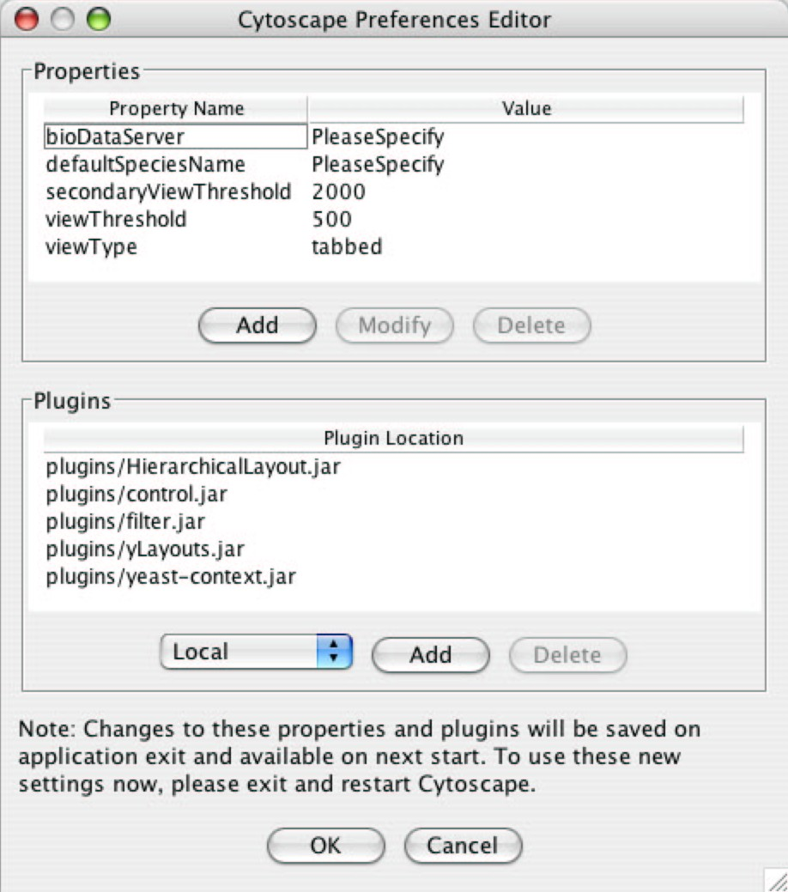
The Cytoscape Preferences Dialog, accessed via Edit->Preferences…, has sections for general properties display/editing and plugins specification via the properties mechanism. Preferences in Cytoscape are stored in the form of Java properties specified in the cytoscape.props file located in the users’ working directory, home directory (called “.cytoscape” and located in the users’ home directory) or Cytoscape distribution directory. This file is automatically loaded at startup time and written upon normal exit of the application.

Cytoscape properties are displayed in the Properties section of the dialog. These properties are configurable via Add, Modify and Delete operations.

The specification of plugins to be loaded into Cytoscape at startup time is also supported in cytoscape.props and accessible in this dialog under the Plugins section. In this special case, the plugins property specifies a comma-separated list of jar files or URLs to jar files containing plugins. This property is parsed and presented and managed in the Plugins table, as at left.

Some common properties are described below.

Property name | Default value | Valid values | Related command line argument
defaultSpeciesName | PleaseSpecify | species names  this value must match the name in the first line of the file specified in the bioDataServer’s manifest for synonyms  e.g., for yeast synonyms, specify Saccharomyces cerevisiae | -s  -species
bioDataServer | PleaseSpecify | annotation/manifest, and other manifest file locations | -b  -BDS
viewThreshold | 500 | integer > 0 | -vt  --VT
secondaryViewThreshold | 2000 | integer > 0
viewType | tabbed | tabbed
plugins |  | comma-separated list of jar files containing plugins, or URL’s to jar files containing plugins (e.g., http://server/my-plugin.jar) | -p  -plugin  --JLD  --JLW  --JLL
defaultWebBrowser |  | A path to the web browser on your system. This only needs to be specified if Cytoscape can’t find the web browser on your system.

5. Building and Storing Interaction Networks

Cytoscape reads an interaction network in two ways: from a simple interaction file (SIF or .sif format) or from a standard format known as Graph Markup Language (GML or .gml format). SIF specifies nodes and interactions only, while GML stores additional information about network layout and allows network data exchange with a variety of other network display programs. Typically, SIF is used to import interactions when building a network for the first time, since it is easy to create in a text editor or spreadsheet. Once the interactions have been loaded and layout has been performed, the network may be saved to and subsequently reloaded from GML format in future Cytoscape sessions. Both SIF and GML are ASCII text files, and you can edit and view them in a regular text editor. Additionally, GML is supported by some other network visualization tools.

SIF FORMAT:

The simple interaction format is convenient for building a graph from a list of interactions. It also makes it easy to combine different interaction sets into a larger network, or add new interactions to an existing data set. The main disadvantage is that this format does not include any layout information, forcing Cytoscape to re-compute a new layout of the network each time it is loaded.

Lines in the SIF file specify a source node, a relationship type (or edge type), and one or more target nodes:

nodeA <relationship type> nodeB
nodeC <relationship type> nodeA
nodeD <relationship type> nodeE nodeF nodeB
nodeG
...
nodeY <relationship type> nodeZ

A more specific example is:

node1 typeA node2
node2 typeB node3 node4 node5
node0

The first line identifies two nodes, called node1 and node2, and a single relationship between node1 and node2 of type typeA. The second line specifies three new nodes, node3, node4, and node5; here "node2" refers to the same node as in the first line. The second line also specifies three relationships, all of type typeB and with node2 as the source, with node3, node4, and node5 as the targets, respectively. This second form is simply shorthand for specifying multiple relationships of the same type with the same source node. The third line indicates how to specify a node that has no relationships with other nodes. This form is not needed for nodes that do have relationships, since the specification of the relationship implicitly identifies the nodes as well.
Duplicate entries are allowed and indicate multiple edges between the same nodes. For example, the following specifies three edges between the same pair of nodes, two of type pp and one of type pd:

node1 pp node2
node1 pp node2
node1 pd node2

Edges connecting a node to itself (self-edges) are also allowed:

node1 pp node1

Every node and edge in Cytoscape has an identifying name, most commonly used with the node and edge data attribute structures. Node names must be unique as identically named nodes will be treated as identical nodes. The name of each node will be the name in this file by default (unless another string is mapped to display on the node using the visual mapper. This is discussed in the section on visual styles. The name of each edge will be formed from the name of the source and target nodes plus the interaction type: for example, sourceName edgeType targetName.

The tag <interaction type> should be one of:
pp .................. protein – protein interaction
pd .................. protein -> DNA
(e.g. transcription factor binding upstream of a regulating gene.)

Any text string will work, but the above are the conventions that have been followed thus far.

Additional interaction types are also possible, but not widely used, e.g.:
pr .................. protein -> reaction
rc .................. reaction -> compound
cr .................. compound -> reaction
gl .................. genetic lethal relationship
pm .................. protein-metabolite interaction
mp .................. metabolite-protein interaction

Even whole words or concatenated words may be used to define other types of relationships e.g. geneFusion, cogInference, pullsDown, activates, degrades, inactivates, inhibits, phosphorylates, upRegulates

Delimiters. Whitespace (space or tab) is used to delimit the names in the simple interaction file format. However, in some cases spaces are desired in a node name or edge type. The standard is that, if the file contains any tab characters, then tabs are used to delimit the fields and spaces are considered part of the name. If the file contains no tabs, then any spaces are delimiters that separate names (and names cannot contain spaces).

If your network unexpectedly contains no edges and node names that look like edge names, it probably means your file contains a stray tab that's fooling the parser. On the other hand, if your network has nodes whose names are half of a full name, then you probably meant to use tabs to separate node names with spaces.

Networks in simple interactions format are often stored in files with a ".sif" extension, and Cytoscape recognizes this extension when browsing a directory for files of this type.

GML FORMAT:

In contrast to SIF, GML is a rich graph format language supported by many other network visualization packages. The GML file format specification is available at:

http://www.infosun.fmi.uni-passau.de/Graphlet/GML/

It is generally not necessary to modify the content of a GML file directly. Once a network is built in SIF format and then laid out, the layout is preserved by saving to and loading from GML. Visual attributes specified in a GML file will result in a new visual style named “Filename.style” when that GML file is loaded.

COMMANDS:
Load and save network files using the File menu of Cytoscape. Network files may also be loaded directly from the command line using the –i (SIF format) or -g (GML format) options.

FOR EXAMPLE:
To load a sample molecular interaction network in SIF format, use the menu File / Load / Network. In the resulting file dialog box, select the file “sampleData/galFiltered.sif”. After a few seconds, a small network of 331 nodes should appear in the main window. To load the same interaction network as a GML, use the menu: File / Load / Network again. In the resulting file dialog box, select the file “sampleData/galFiltered.gml”. Node and edge attribute files as well as expression data and extra annotation can be loaded as well.

NODE NAMING ISSUES IN CYTOSCAPE:

Typically, genes are represented by nodes, and interactions (or other biological relationships) are represented by edges between nodes. For compactness, a gene also represents its corresponding protein. Nodes may also be used to represent compounds and reactions (or anything else) instead of genes.

If a network of genes or proteins is to be integrated with Gene Ontology (GO) annotation or gene expression data, the gene names must exactly match the names specified in the other data files. We strongly encourage naming genes and proteins by their systematic ORF name or standard accession number; common names may be displayed on the screen for ease of interpretation, so long as these are available to the program in the annotation directory or in a node attribute file. Cytoscape ships with all yeast ORF-to-common name mappings in a synonym table within the annotation/ directory. Other organisms will be supported in the future.

Why do we recommend using standard gene names? All of the external data formats recognized by Cytoscape provide data associated with particular names of particular objects. For example, a network of protein-protein interactions would list the names of the proteins, and the attribute and expression data would likewise be indexed by the name of the object.

The problem is in connecting data from different data sources that don't necessarily use the same name for the same object. For example, genes are commonly referred to by different names, including a formal "location on the chromosome" identifier and one or more common names that are used by ordinary researchers when talking about that gene. Additionally, database identifiers from every database where the gene is stored may be used to refer to a gene (e.g. protein accession numbers from Swiss-Prot). If one data source uses the formal name while a different data source used a common name or identifier, then Cytoscape must figure out that these two different names really refer to the same biological entity.

Cytoscape has two strategies for dealing with this naming issue, one simple and one more complex. The simple strategy is to assume that every data source uses the same set of names for every object. If this is the case, then Cytoscape can easily connect all of the different data sources.

To handle data sources with different sets of names, as is usually the case when manually integrating gene information from different sources, Cytoscape needs a data server that provides synonym information (See12. Annotation.). A synonym table gives a canonical name for each object in a given organism and one or more recognized synonyms for that object. Note that the synonym table itself defines what set of names are the "canonical" names. For example, in budding yeast the ORF names are commonly used as the canonical names.

If a synonym server is available, then by default Cytoscape will convert every name that appears in a data file to the associated canonical name. Unrecognized names will not be changed. This conversion of names to a common set allows Cytoscape to connect the genes present in different data sources, even if they have different names – as long as those names are recognized by the synonym server.

For this to work, Cytoscape must also be provided with the species to which the objects belong, since the data server requires the species in order to uniquely identify the object referred to by a particular name. This is usually done in Cytoscape by specifying the species name on the command line with the –s option or by adding a line to the cytoscape.props file of the form:

defaultSpeciesName=Saccharomyces cerevisiae

The automatic canonicalization of names can be turned off with the -c command line argument (i.e. java -jar cytoscape.jar -c) or by not loading any annotation. This canonicalization of names currently does not apply to expression data. Expression data should use the same names as the other data sources or use the canonical names as defined by the synonym table.

6. Loading Gene Expression Data

Interaction networks are useful as stand-alone models. However, they are most powerful for answering scientific questions when integrated with additional biological information, such as gene or protein expression levels. Once loaded, expression ratios/levels may be visually superimposed on the network, used in a filter to select a subset of nodes, or used to identify active modules and subsystems (via plugin analysis tools). An expression data set can be loaded at any time, but are only relevant once a network has been loaded.

FORMAT:
Gene expression ratios or values are specified over one or more experiments using a text file. Ratios result from a comparison of two expression measurements (experiment vs. control). Some expression platforms, such as Affymetrix, directly measure expression values, without a comparison. The file consists of a header and a number of space- or tab-delimited fields, one line per gene, with the following format:

GeneName [CommonName] ratio1 ratio2 ... ratioN [pval1 pval2 ... pvalN]

Brackets [] indicate fields that are optional. The first two fields are the systematic gene name followed by an optional common name. Expression ratios/values are provided for each experiment, optionally followed by a p-value per experiment or other measure of the significance of each ratio/value, i.e. whether the ratio represents a true change in expression or whether the value is accurately measuring the presence of a gene (according to some statistical model). Significance values are generated by a variety of software packages for analyzing expression data generated by DNA microarrays (for instance the VERA program, from the Institute of Systems Biology, http://www.systemsbiology.org/VERAandSAM). A list of other microarray analysis packages is available at: http://www.nslij-genetics.org/microarray/soft.html

Example:
GENE DESCRIPT gal1RG.sig gal2RG.sig gal3RG.sig gal1RG.sig gal2RG.sig gal3RG.sig
YHR051W COX6 -0.034 -0.052 0.152 1.177 0.102 0.857
YHR124W NDT80 -0.090 -0.000 0.041 0.130 0.341 0.061
YKL181W PRS1 -0.167 -0.063 -0.230 -0.233 0.143 0.089

The first line is a header line giving the names of the experimental conditions. Note that each condition is duplicated; the first set of columns gives expression ratios and the second set gives significance values. The significance columns can be omitted if your data doesn't include significance measures. Every remaining row specifies the values for a gene, starting with the formal name of the gene, then a common name, then the ratios, then the significance values.

Some variations on this basic format are recognized: see the formal file format specification below for more information. Expression data files commonly have the file extensions ".mrna" or ".pvals", and these file extensions are recognized by Cytoscape when browsing for data files.

COMMANDS:
Load an expression data file using the File menu of Cytoscape, or by specifying the filename using the -e option at the command line. The –x command line option indicates that the expression data should not be loaded into node attributes. This is an advanced option, and is typically only used when the number of expression conditions is sufficiently large that it becomes unwieldy in the normal user interface.

FOR EXAMPLE:
Load a sample gene expression data set using the menu: File / Load / Expression Matrix File. In the resulting file dialog box , select the file “sampleData/galExpData.pvals”. As described in the following sections, Cytoscape is now ready to integrate these data with the underlying molecular interaction network.

Detailed file format (Advanced users)
In all expression data files, any whitespace (spaces and/or tabs) is considered a delimiter between adjacent fields. Every line of text is either the header line or contains all the measurements for a particular gene. No name conversion is applied to expression data files.

The names given in the first column of the expression data file should match exactly the names used elsewhere (i.e. in SIF or GML files).

The first line is a header line with one of the following three formats:
<text> <text> cond1 cond2 ... cond1 cond2 ... [NumSigConds]
<text> <text> cond1 cond2 ...
<tab><tab>RATIOS<tab><tab>...LAMBDAS

The first format specifies that both expression ratios and significance values are included in the file. The first two text tokens contain names for each gene. The next token set specifies the names of the experimental conditions; these columns will contain ratio values. This list of condition names must then be duplicated exactly, each spelled the same way and in the same order. Optionally, a final column with the title NumSigConds may be present. If present, this column will contain integer values indicating the number of conditions in which each gene had a statistically significant change according to some threshold.

The second format is similar to the first except that the duplicate column names are omitted, and there is no NumSigConds fields. This format specifies data with ratios but no significance values.

The third format specifies an MTX header, which is a commonly used format. Two tab characters precede the RATIOS token. This token is followed by a number of tabs equal to the number of conditions, followed by the LAMBDAS token. This format specifies both ratios and significance values.

Each line after the first is a data line with the following format:
FormalGeneName CommonGeneName ratio1 ratio2 ... [lambda1 lambda2 ...] [numSigConds]

The first two tokens are gene names. The names in the first column are the keys used for node name lookup; these names should be the same as the names used elsewhere in Cytoscape (i.e. in the SIF or GML files). Traditionally in the gene expression microarray community, who defined these file formats, the first token is expected to be the formal name of the gene (in systems where there is a formal naming scheme for genes), while the second is expected to be a synonym for the gene commonly used by biologists, although Cytoscape does not make use of the common name column. The next columns contain floating point values for the ratios, followed by columns with the significance values if specified by the header line. The final column, if specified by the header line, should contain an integer giving the number of significant conditions for that gene.
Missing values are not allowed and will confuse the parser. For example, using two consecutive tabs to indicate a missing value will not work; the parser will regard both tabs as a single delimiter and be unable to parse the line correctly.

Optionally, the last line of the file may be a special footer line with the following format:

NumSigGenes int1 int2 ...

This line specified the number of genes that were significantly differentially expressed in each condition. The first text token must be spelled exactly as shown; the rest of the line should contain one integer value for each experimental condition.

7. Node and Edge Attributes

Cytoscape allows the user to add arbitrary node and edge information to Cytoscape as node and edge attributes. Attributes could be, for example, annotation data on a gene or confidence values in a protein-protein interaction. These attributes can then be visualized in a user-defined way by setting up a mapping from data attributes to visual attributes (colors, shapes, etc.) See the section on visual styles for a discussion of this.

Node and edge attribute files are simply formatted: A node attribute file begins with the name of the attribute on the first line, and on each following line, has the name of the node, followed by an equals sign, followed by the value of that attribute. Numbers and text strings are the most common attribute types. All values for a given attribute must have the same type. For example:

FunctionalCategory
YAL001C = metabolism
YAR002W = apoptosis
YBL007C = ribosome

An edge attribute file has much the same structure, except that the name of the edge is the source node name, followed by the interaction type in parentheses, followed by the target node name. Directionality counts, so switching the source and target will refer to a different (or perhaps non-existent) edge. The following is an example edge attributes file:

InteractionStrength
YAL001C (pp) YBR043W = 0.82
YMR022W (pd) YDL112C = 0.441
YDL112C (pd) YMR022W = 0.9013

Cytoscape treats edge attributes as directional, so note that the second and third edge attribute values refer to two different edges (source and target are reversed, though the nodes involved are the same).

Each attribute is stored in a separate file. Node and edge attribute files use the same format. Node attribute file names often use the suffix ".noa", while edge attribute file names use the suffix ".eda". Cytoscape recognizes these suffixes when browsing for attribute files.

Node and edge attributes may be loaded at the command line using the –n and –j options or via the File / Load menu.

When expression data is loaded using an expression matrix, it is automatically copied into the Node Attributes data structure unless explicitly specified not to.

Detailed file format (Advanced users)
Every attribute file has one header line that gives the name of the attribute, and optionally some additional meta-information about that attribute. The format is as follows:
attributeName (class=formal.class.of.value)
The first field is always the attribute name: it cannot contain spaces. If present, the class field defines the formal (package qualified) name of the class of the attribute values. For example, java.lang.String for Strings, java.lang.Double for floating point values, java.lang.Integer for integer values, etc. If the value is actually a list of values, the class should be the type of the objects in the list.
If no class is specified in the header line, Cytoscape will attempt to guess the type from the first value. If the first value contains numbers in a floating point format, Cytoscape will assume java.lang.Double; if the first value contains only numbers with no decimal point, Cytoscape will assume java.lang.Integer; otherwise Cytoscape will assume java.lang.String. Note that the first value can lead Cytoscape astray: for example,
floatingPointAttribute
firstName = 1
secondName = 2.5
In this case, the first value will make Cytoscape think the values should be integers, when in fact they should be floating point numbers. It's safest to explicitly specify the value type to prevent confusion.
Every line past the first line identifies the name of an object and the String representation of the attribute value. The delimiter is always an equals sign; whitespace (spaces and/or tabs) before and after the equals sign is ignored. This means that your names and values can contain whitespace, but object names cannot contain an equals sign and no guarantees are made concerning leading or trailing whitespace. Usually the object names should be the same as the names in your graph file, unless name conversion is being used (see the section on name resolution in section).
Edge names are all of the form:
sourceName (edgeType) targetName
Note that this format is different from the specification of interactions in the SIF file format. To be explicit: in a SIF file, an interaction looks like
sourceName edgeType targetName
To set an attribute for the edge defined by this interaction, the matching line in an attributes file should look like
sourceName (edgeType) targetName = value
(Yes, this is confusing; we're planning on fixing this in the next file format update for Cytoscape).
To specify lists of values, use the following syntax:
listAttributeName (class=java.lang.String)
firstObjectName = (firstValue::secondValue::thirdValue)
secondObjectName = (onlyOneValue)
This defines an attribute which is a list of Strings. The first object has three strings, and thus three elements in its list, while the second object has a list with only one member. In the case of a list every attribute value should be specified as a list, and every member of the list should be of the same class. Again, the class will be inferred if it is not specified in the header line. Lists are not supported by the visual mapper, so can’t be mapped to visual attributes.

Attribute Browser
When Cytoscape is started, the Attribute Browser appears in the bottom Cytopanel. This browser can be hidden and restored using the F5 key. Like other Cytopanels, the browser can be undocked by pressing the little icon in the browser’s top right corner.
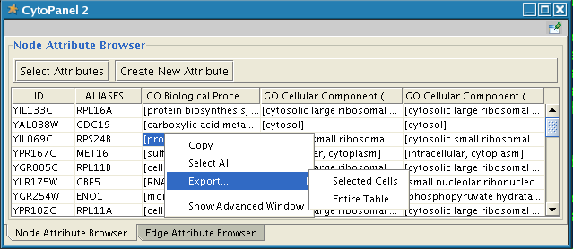
To swap between displaying node attributes and edge attributes use the bottom tabs “Node Attribute Browser” and “Edge Attribute Browser”.
The attribute browser displays attributes belonging to selected nodes and/or edges. To populate the browser with rows (as pictured above), simply select nodes and/or edges in a loaded network. By default, only the “ID” of nodes and edges is shown. To display more than just the ID, click the “Select Attributes” button and choose the attributes that are to be displayed. Each attribute chosen will result in one column in the attribute browser (in the screenshot above there are 5 columns total including the ID).
Most attribute values can be edited by double-clicking an attribute cell; list values cannot be edited, and neither can the ID.
Attribute rows in the browser can be sorted alphabetically by specific attribute by clicking on a column heading.
A new attribute can be created using the “Create New Attribute” button. Attributes created using the attribute browser must be one of four types – integer, string, floating point, or boolean.
The right-click menu on the Attribute Browser has several functions. This menu is useful for exporting attribute information to spreadsheet applications. For example, choose “Select All” and then “Copy” from the right-click and then paste into a spreadsheet application.

8. Navigation and Layout

BASIC FEATURES:
Use the zooming buttons located on the toolbar to zoom in / out of the interaction network shown in the current network display. Zoom icons are detailed below:



From Left to Right:
- Zoom Out
- Zoom In
- Zoom Selected Region
- Zoom out to Display all of Current Network

You can also zoom in/out by holding down the right mouse button and moving the mouse to the right (zoom in) or left (zoom out).

Use the left mouse button to select a node (hold down the Shift key to select more than one node). Use the right mouse button to launch a context sensitive menu with additional information about the node that was clicked on.

NETWORK LAYOUT:

The Layout menu has an array of features for organizing the network visually according to one of several algorithms, aligning and rotating groups of nodes, and adjusting the size of the network. Most of these features are available from plugins that are packaged with Cytoscape 2.2. Some of the layout algorithms provided with Cytoscape 2.2 are:

Cytoscape Spring-embedded Layout

Spring-embedded layout is based on a “force-directed” paradigm. Network nodes are treated like physical objects that repel each other, such as electrons. The connections between nodes are treated like metal springs attached to the pair of nodes. These springs repel or attract their end points according to a force function. The layout algorithm sets the positions of the nodes in a way that minimizes the sum of forces in the network.

To lay out your network in Cytoscape using a Spring Embedded Layout, select Layout → Apply Spring Embedded Layout from the main menu. A sample screen shot is provided below:

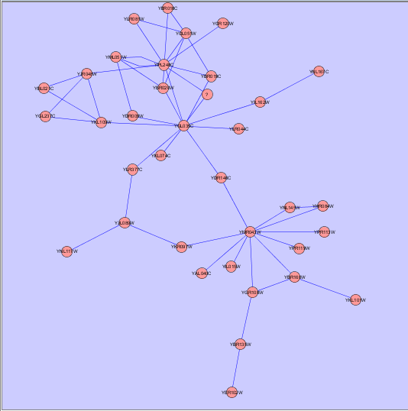

yFiles Circular Layout

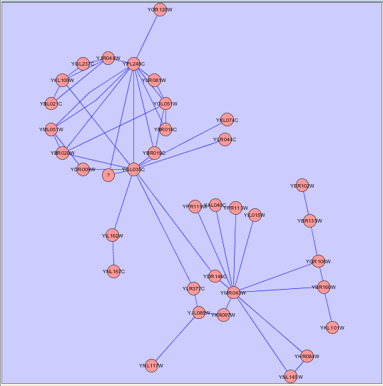
This algorithm produces layouts that emphasize group and tree structures within a network. It partitions the network by analyzing its connectivity structure, and arranges the partitions as separate circles. The circles themselves are arranged in a radial tree layout fashion.

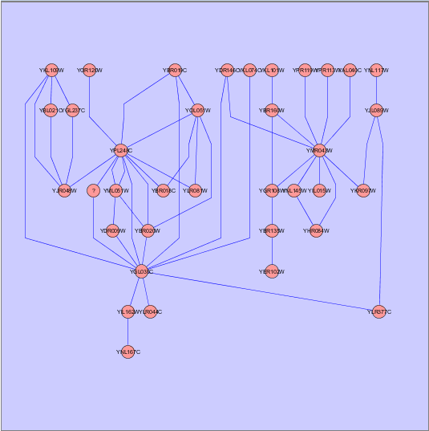
yFiles Hierarchical Layout

The hierarchical layout algorithm is good for representing main direction or flow within a network. Nodes are placed in hierarchically arranged layers and the ordering of the nodes within each layer is chosen in such a way that minimizes the number of edge crossings.

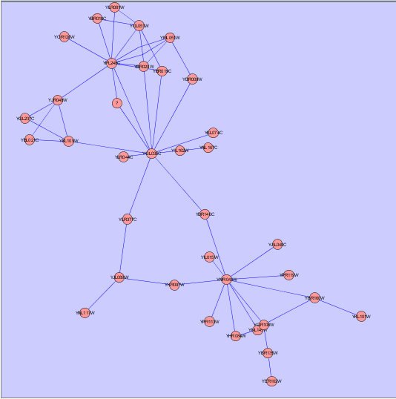
yFiles Organic Layout

The organic layout algorithm is a kind of spring-embedded algorithm that combines elements of the other algorithms to show the clustered structure of a graph.

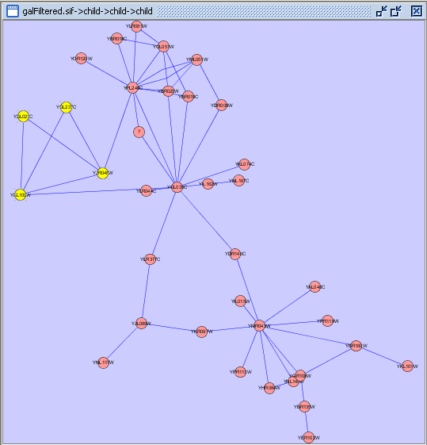
Scaling and Rotation

Cytoscape provides operations for scaling and/or rotating networks or segments of networks. The figure at right shows the network view from the organic layout, with the selected nodes scaled by a factor of 1.5 and rotated by 90 degrees.

9. Visual Styles

With the Cytoscape Visual Style feature, you can easily customize the visual appearance of your network. For example, you can specify a default color and shape for all nodes, use specific line types to indicate different types of interactions, or visualize gene expression data using a color gradient. All these features are available by selecting Visualization → Set Visual Properties from the main menu or clicking on the color wheel in the main button bar menu.

Introduction to Visual Styles

The Cytoscape distribution you have downloaded automatically loads several predefined visual styles when you start Cytoscape by using one of “cytoscape.sh” or “cytoscape.bat” start-up scripts (see step 3 in section 2. Launching Cytoscape).

The Cytoscape distribution you have downloaded automatically loads several predefined visual styles to get you started when you start Cytoscape by using one of the “cytoscape.sh” or “cytoscape.bat” scripts (see step 3 in section 2. Launching Cytoscape.) To demonstrate these styles, try out the following example:

- Load a sample network: From the main menu, select File → Load → Graph, and select sampleData/galFiltered.sif.

- Layout the network: select Layout->yFiles->Organic.

- Load a sample set of expression data: From the main menu, select File → Load → Expression Matrix File, and select sampleData/galExpData.pvals.

By default, the Visual Style labeled “default” will be automatically applied to your network. This default style has a blue background, circular pink nodes, and blue edges (see sample screenshot below).

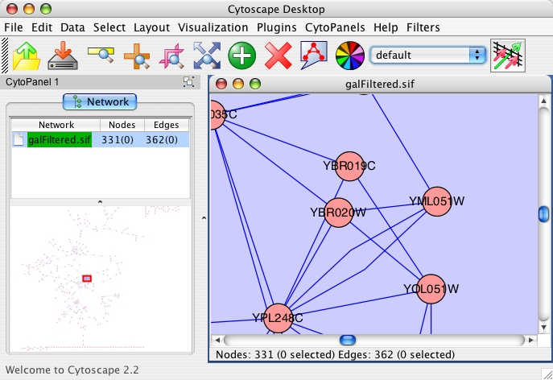
Visual Style
Pull-Down Menu

Figure: Using the default Visual Style.

The vizmap.props File: All Cytoscape Visual Style settings are automatically loaded from a file called vizmap.props. The location of this file can be specified from the command line (‘-vp). If it is not specified through the command line, then Cytoscape looks for this file in the user’s home directory (in the “.cytoscape” directory). If you start Cytoscape for the first time, and you do not start it using one of the start-up scripts (cytoscape.sh or cytoscape.bat), then, a very simple visual style will be automatically created. When you exit Cytoscape, any modifications you made to the visual styles, and any new visual styles you created, are automatically saved to the originally loaded vizmap.props file in the .cytoscape directory in the user’s home directory.

[!] If you are upgrading from Cytoscape 2.1: If you are upgrading from Cytoscape 2.1, you may want to use your vizmap.props file that is located in your home directory, since this file was used in 2.1 to store visual styles. To do this, you can either specify its location in the command line (edit cytoscape.sh or cytoscape.bat), or copy the file to the .cytoscape directory located in your home directory (on Windows XP, this is the “Documents and Settings” directory, on Linux or Mac this is your home directory, for example, /Users/iavila, or ~/).

You can flip through different visual styles by making a selection from the Visual Style pull down menu. For example, if you select “Sample1”, a new visual style will be applied to your network, and you will see a green background and round blue nodes. Additionally, if you zoom in closer, you can see that protein-DNA interactions (specified with the label: pd) are drawn with dashed edges, whereas protein-protein interactions (specified with the label: pp) are drawn with a light yellow color which is difficult to discern on the green background (see sample screenshot below). The background can be changed through the Visualization menu.

Visual Style
Pull-Down Menu
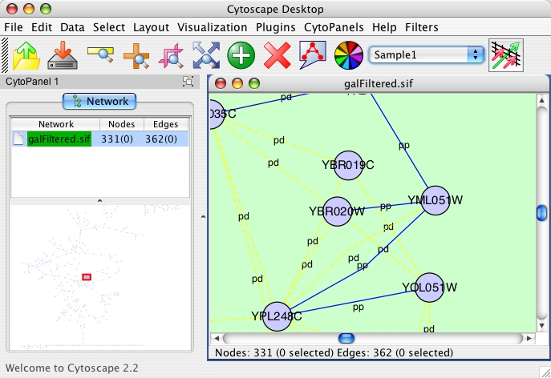
Figure: Using the Sample1 Visual Style. Protein-Protein interactions (solid lines) are now distinguishable from Protein-DNA interactions (dashed yellow lines).

Finally, if you select “Sample2”, gene expression values for each node will be colored along a color gradient between red and green (where red represents a low expression ratio, and green represents a high expression ratio - with thresholds set for the gal1RGexp experiment bundled with Cytoscape in the sampleData/galExpData.pvals file). See sample screenshot below:
Visual Style
Pull-Down Menu
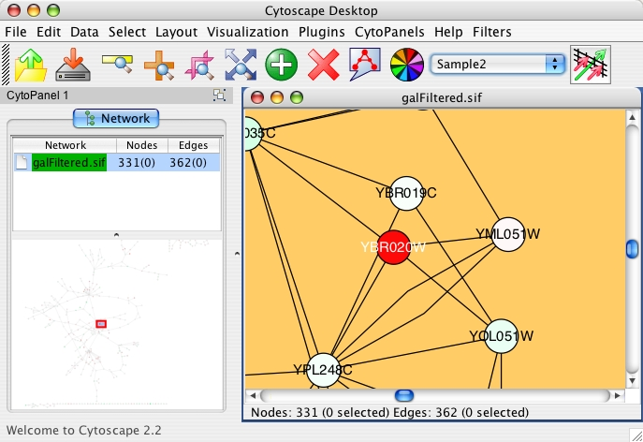

Figure: Using the Sample2 Visual Style. Gene expression values are now displayed along a red/green color gradient.

Visual Attributes, Graph Attributes and Visual Mappers

The Cytoscape Visual Mapper has three core components: visual attributes, network attributes and visual mappers:

- A visual attribute is any visual setting that can be applied to your network. For example, you can change all nodes to squares by setting the node shape visual attribute.

- A network attribute is any attribute associated with a node or an edge. For example, each edge in a network may be associated with a label, such as “pd” (protein-DNA interactions), or “pp” (protein-protein interactions).

- A visual mapper maps network attributes to visual attributes. For example, a visual mapper can map all protein-DNA interactions to the color blue, and all protein-protein interactions to the color red.

Cytoscape includes a large number of visual attributes. These are summarized in the tables below.

Visual Attributes Associated with Nodes:
- Node Color

- Node Border Color

- Node Border Type. The following options are available:

- Node Shape. The following options are available:

- Node Size: width and height of each node.

- Node Label: the text label for each node.

- Node Font: node font and size.

Visual Attributes Associated with Edges:
- Edge Color

- Edge Line Type. The following options are available:

- Edge Source Arrow. The following options are available:

- Edge Target Arrow. The following options are available:

- Edge Label: the text label for each edge.

- Edge Font: edge font and size.

Global Visual Properties:
- Background Color

For each visual attribute, you can specify a default value or define a visual mapping. Cytoscape currently supports three different types of visual mappers:

- Passthrough Mapper: network attributes are passed directly through to visual attributes. A passthrough mapper only works for node / edge labels. For example, a passthrough mapper can draw the common gene name on all nodes.

- Discrete Mapper: discrete network attributes are mapped to discrete visual attributes. For example, a discrete mapper can map all protein-protein interactions to the color blue.

- Continuous Mapper: continuous graph attributes are mapped to visual attributes. Depending on the visual attribute, there are two types of continuous mappers:

  - continuous to continuous mapper: for example, you can map a continuous value (0..1) to a continuous color gradient (red..green) or node/font size (10..100).

  - continuous to discrete mapper: for example, all values below 0 are mapped to square nodes, and all values above 0 are mapped to circular nodes. However, there is no way to smoothly morph between circular nodes and square nodes.

The matrix below shows visual mapper support for each visual property.

 | Passthrough Mapper | Discrete Mapper | Continuous Mapper

Node Properties
Node Color | - | X | X
Node Border Color | - | X | X
Node Border Type | - | X | o
Node Shape | - | X | o
Node Size | - | X | X
Node Label | X | X | o
Node Font Family | - | X | o
Node Font Size | - | X | X

Edge Properties
Edge Color | - | X | X
Edge Line Type | - | X | o
Edge Source Arrow | - | X | o
Edge Target Arrow | - | X | o
Edge Label | X | X | o
Edge Font Family | - | X | o
Edge Font Size | - | X | X

Legend
- | Mapping is not supported for specified visual property.
X | Mapping is fully supported for specified visual property.
o | Mapping is partially supported for specified visual property. Support for “continuous to continuous” mapping is not supported.

Tutorial: Creating a New Visual Style

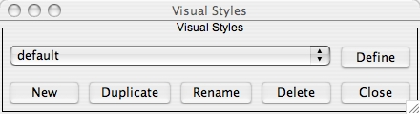
To create a new visual style, select Visualization → Set Visual Properties from the main menu, or select the color wheel icon in the main button bar. You will now see a new Visual Styles dialog box (shown at right.)

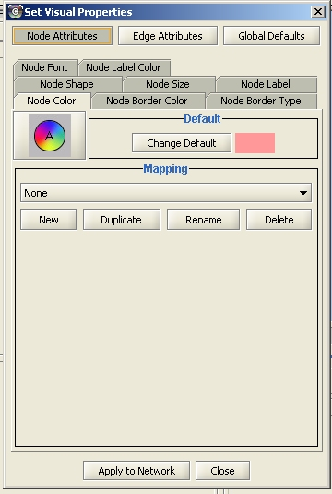
Visual Property Categories
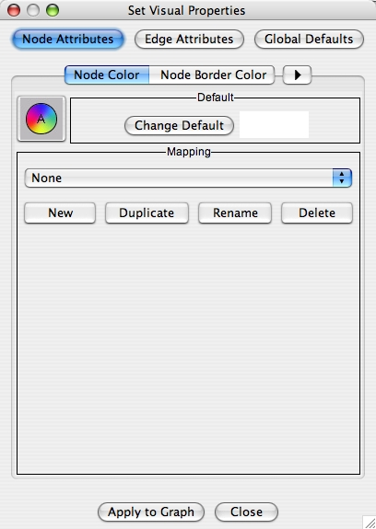
Click the New button, and enter a name for your new visual style when prompted. Then click the Define button. You will now see the main Visual Styles Properties dialog box (shown at right.)

From this dialog box, you can flip between Node Attributes, Edge Attributes, and Global Defaults. You can also specify default values for any visual property, or define a new custom mapping.
Create a new mapper.

For example, to set the default node shape to triangles, select Node Attributes → Node Shape. Then, click the “Change Default” button, and select the Triangle icon from the selection list.

Applying Changes to the Network

To apply your visual style to your network, hit the “Apply to Network”
button, available in the bottom of the dialog panel.

Saving a Visual Style

When you exit Cytoscape, new visual styles or newly modified visual styles will automatically be saved in the vizmap.props file. You can therefore create a new visual style and apply it to all future networks.

Tutorial: Creating a New Visual Style with a Discrete Mapper
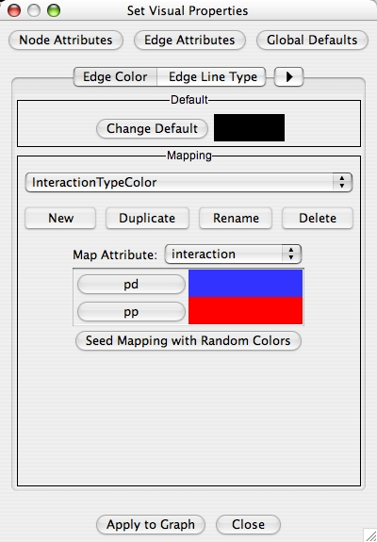
The following tutorial demonstrates how to create a new visual style with a discrete mapper. The goal is to draw Protein-DNA interactions with blue edges, and Protein-Protein interactions with red edges.

- Load a sample network: From the main menu, select File → Load → Graph, and select sampleData/galFiltered.sif.
- Select Visualization → Set Visual Properties.
- Select “New” to create a new Visual Style. Name your new style: “Sample3”.
- Click the “Define” button to define the newly created Visual Style.
- In the “Set Visual Properties” Dialog box, select Edge Attributes → Edge Color.
- Click the New button in the mapping panel.
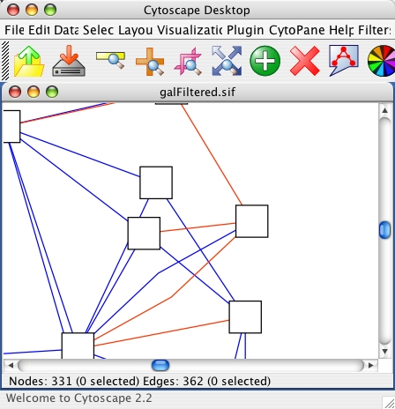
- You will be prompted to select a mapping type: passthrough mapper, discrete mapper or continuous mapper (for an overview of the differences between these mappers, please refer back to section 8.2.) Select “discrete mapper”, and enter a descriptive name. For example, enter: “InteractionTypeColor”.
- From the “Map Attribute” pull-down menu, select “interaction.” You should now see two buttons, one for pd (Protein-DNA interactions), and one for pp (Protein-Protein interactions).
- Click the “pd” button and select a blue color.
- Click the “pp” button and select a red color.
- Click the “Apply to Graph” button.

You network should now show “pd” interactions in blue, and “pp” interactions in red. Sample screenshot is provided at right

Tutorial: Visualizing Expression Data on a Network

The following tutorial demonstrates how to create a new continuous mapper. The goal is to superimpose gene expression data onto a network, and to display gene expression values along a color gradient.
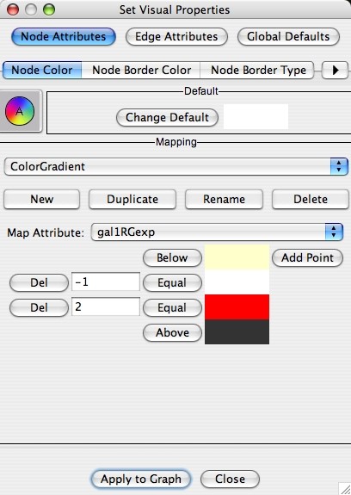
- Load a sample network: From the main menu, select File → Load → Network, and select sampleData/galFiltered.sif.
- Load a sample set of expression data: From the main menu, select File → Load → Expression Matrix File, and select sampleData/galExpData.pvals.
- Select Visualization → Set Visual Properties.
- Select “New” to create a new Visual Style. Name your new style: “Sample4”.
- Click the “Define” button to define the newly created Visual Style.
- In the “Set Visual Properties” Dialog box, select Node Attributes → Node Color.
- Click the New button in the mapping panel.
- You will be prompted to select a mapping type: passthrough mapper, discrete mapper or continuous mapper (for an overview of the differences between these mappers, please refer back to section 8.2.) Select “continuous mapper”, and enter a descriptive name. For example, enter: “ColorGradient”.
- From the “Map Attribute” pull-down menu, select “gal1RGexp.”
- Click the “Add Point” button twice to add two data points.
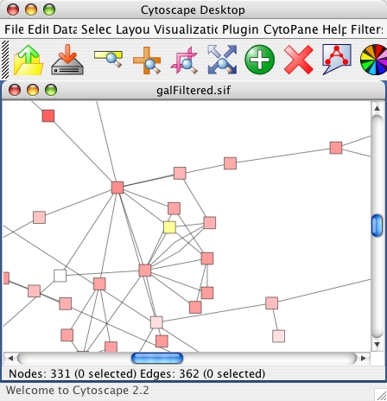
- Set the first point to “-1”, Below = Yellow, Equal = White.
- Set the second point to “2”, Equal = Red, Above = Black.
- Click the “Apply to Graph” button.

This visual mapper will set all nodes with a gal1RGexp value less than –1 to Yellow, and all nodes with a gal1RGExp value greater than 2 to Black. Additionally, all values between –1 and 2 will be painted with a white/red color gradient. Sample screenshot is shown at right.

10. Editing Networks
Cytoscape has a set of editors that enable you to build and modify networks interactively by dragging and dropping nodes and edges from a palette onto the main network view window. The palette contains a set of shapes (for nodes) and arrows (for edges). The shapes on the palette are defined by the current Visual Style, with Node Shape and Node Color mapping into the shape and color of a node, and Edge Target Arrow mapping into the target arrow of an edge. An example of an editor, with the palette contained in CytoPanel 1, is shown below.
To bring up an editor, use the File->Set Editor menu item. In Cytoscape 2.2, you are given a choice of three editors,
- a DefaultCytoscapeEditor, which contains one default node and one default edge on its palette. This editor will define the nodes and shapes on its palette using the current Visual Style.
- a SimpleBioMoleculeEditor, which defines the nodes and shapes on its palette using the SimpleBioMolecule Visual Style.
- a SimpleBioPAX_Editor, defines the nodes and shapes on its palette using a Visual Style that maps node shapes and colors according to the value of the "BIOPAX_NODE_TYPE" attribute and maps edge target arrows according to the value of the "BIOPAX_EDGE_TYPE" attribute. Note that, in this version of Cytoscape, the SimpleBioPAX_Editor is not a fully functional BioPAX editor, but rather serves as an example. Moreover, there is no facility for output to BioPAX format in the current version of Cytoscape. A fully functional BioPAX editor, with output to BioPAX format, is planned for a future version of Cytoscape.
When you bring up an editor, the visual style for the current network view is set to the visual style that is associated with the editor. If there is no current view at the time you make the File->Set Editor, then a new network and view (and network) will be created automatically for you.
To start editing a new network, use the File->New->Network menu item.
The figure below shows the display for the DefaultCytoscapeEditor.
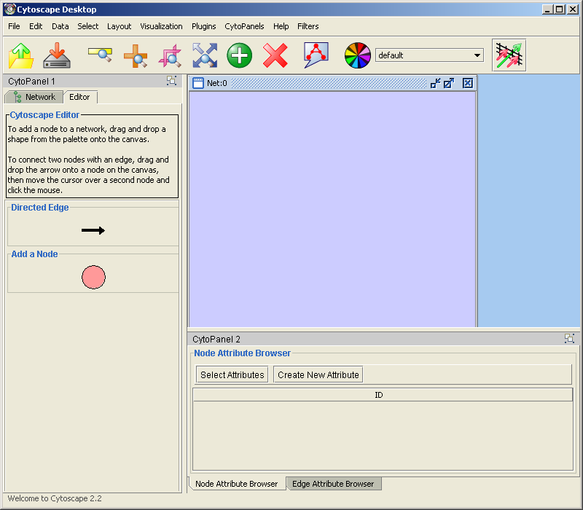
To add a node to a network, drag and drop a node shape from the palette onto the canvas.
To connect two nodes with an edge, drag and drop an arrow shape onto a node on the canvas. This node becomes the source node of the edge. Move the cursor and a rubber-banded line follows the cursor. As the cursor passes over another node, that node is highlighted and the rubber-banded line will snap to a connection point on that second node. Click the mouse while over this node and the connection is established.
You can abort the drawing of the edge by clicking on an empty spot on the palette.
Note that if you change the Visual Style, the palette used by the current network view will also change to be consistent with the mappings in the new Visual Style.
There is also an Edit => Connect Selected Nodes menu item that, when chosen, creates a clique amongst the selected nodes.
The editor provides accelerators for adding nodes and edges. Control-clicking at a position on the canvas creates a node at that position. The NODE_TYPE attribute of the node will be the same as the NODE_TYPE of the node most recently added, defaulting to "DefaultNode" type. In this manner, you can use control-clicking as a kind of "stamp" to add multiple nodes of the same type to the network. Control-clicking on a node on the canvas starts an edge with source at that node. Move the cursor and a rubber-banded line follows the cursor. As the cursor passes over another node, that node is highlighted and the rubber-banded line will snap to a connection point on that second node. Control-click the mouse again and the connection is established. The EDGE_TYPE attribute of the edge will be the same as the EDGE_TYPE of the edge most recently added, defaulting to "DefaultEdge" type. You can abort the drawing of the edge by control-clicking on an empty spot on the palette.
You can delete nodes and edges by selecting a number of nodes and edges, then selecting the Edit => Delete Selected Nodes and Edges menu item. You can recover any nodes and edges deleted from a network by selecting the Edit => Restore Deleted Nodes and Edges menu item. Note that this will restore all nodes and edges that were previously deleted from the network, not just those deleted by the most recent delete operation.

11. CytoPanels

What are CytoPanels?

CytoPanels are floatable / dockable panels designed to cut down on the number of pop-up windows within Cytoscape and to create a more unified user experience. For example, in Cytoscape 2.1, the cPath PlugIn enables users to click on a node and immediately view node details in a pop-up window. Now with CytoPanels, we can now show these node details in an embedded CytoPanel. The image below shows a screenshot of the latest BioPAX PlugIn. When you click on a node, the node details appear directly in the left CytoPanel.

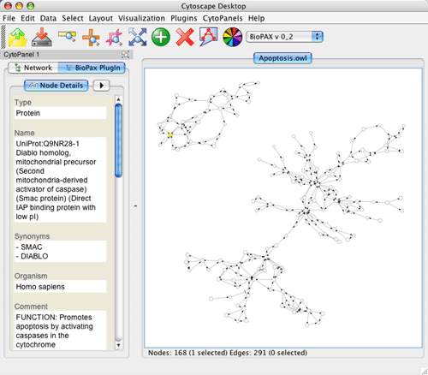
The user can then chose to resize, hide or float the left CytoPanel. For example, in the screenshot below, the user has chosen to float the CytoPanel:

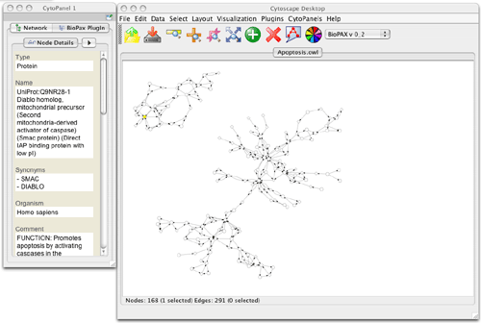

Basic Usage

Cytoscape 2.2 includes three CytoPanels: CytoPanel 1 (appears on the left), CytoPanel 2 (appears on the bottom), and CytoPanel 3 (appears on the right). By default, only CytoPanel 1 will appear, and it will automatically contain the network list and network Overview component. The other panels may appear depending on the mix of PlugIns currently installed in your Cytoscape distribution.

CytoPanels can be shown or hidden by selecting the desired menu item within the CytoPanels menu or by entering the proper keyboard accelerator short-cut (in order for the keyboard short-cuts to work, the Cytoscape Desktop must have the focus).


In addition, CytoPanels can be floated or docked by selected the icon at the top-right corner of each CytoPanel. The icon and tooltip will change based on the CytoPanel state. If the CytoPanel is docked, clicking on the icon will float the CytoPanel, as indicated by the “Float Window” tooltip. Alternatively, if the CytoPanel is floating, clicking on the icon will dock the CytoPanel, as indicated by the “Dock Window” tooltip.

12. Annotation

Annotations in Cytoscape are stored as a set of ontologies (e.g. the Gene Ontology - GO). An ontology consists of a set of controlled vocabulary terms that annotate the genes for a given organism and a synonym table for gene names. For example, using the Gene Ontology, the Saccharomyces Cerevisiae GAL4 gene’s biological process is described as “regulation of transcription”, to which GO has assigned the number 45449 (a GO ID). You can see below that “regulation of transcription” is a subcategory of “transcription”, which is a subcategory of “nucleobase, nucleoside, nucleotide and nucleic acid metabolism”, etc.

GO 8150 biological_process
GO 7582 physiological processes
GO 8152 metabolism
GO 6139 nucleobase, nucleoside, nucleotide and nucleic acid metabolism
GO 6350 transcription
GO 45449 regulation of transcription

Cytoscape can use this ‘hierarchical’ ontology to annotate recognized genes if the user chooses a level of the hierarchy to use for a given set of annotations. The ontology provided to Cytoscape does not have to be hierarchical, but if it is not, there is no real advantage to storing annotations this way compared to just storing the annotation terms in a node attribute file.

The Gene Ontology Server (originally called the biodata server) is a Cytoscape feature which allows you to load, navigate, and assign annotation terms to nodes in a network.

In version 2.2, Cytoscape has a new feature called the Gene Ontology Server Wizard, which enables users to select a local ontology and annotation files from the user interface. Although 2.2 is backwards compatible with the old file formats (the manifest file, which includes a list of anno (annotation) and onto (ontology) files), we strongly suggest using the new file formats. See Appendix B for a description of how the old file formats can be created and used.

New Ontology and Annotation Files

The standard file formats used in this release are OBO and gene association. The GO website details these file formats:

- Ontologies and Definitions: http://www.geneontology.org/GO.downloads.shtml#ont
- Current Annotations: http://www.geneontology.org/GO.current.annotations.shtml

Cytoscape provides a copy of the Gene_ontology.obo text file in the annotation directory for use with the software. An up-to-date Gene_ontology.obo file is maintained by the GO project (updated every 30 minutes). Please download the latest version of this file (from http://www.geneontology.org) if you intend to use it during analysis. In addition to the gene ontology file, we also provide gene association files for Yeast and Human (gene_association.sgd and gene_association.goa_human, both in the annotations directory). Other gene association files can be found at the gene ontology web site.

Sample Files
gene_ontology.obo:

format-version: 1.0
date: 11:08:2005 16:57
saved-by: midori
auto-generated-by: DAG-Edit 1.419 rev 3
default-namespace: gene_ontology
remark: cvs version: $Revision: 1.1 $
subsetdef: goslim_yeast "Yeast GO slim"
subsetdef: goslim_goa "GOA and proteome slim"
subsetdef: goslim_plant "Plant GO slim"
subsetdef: goslim_generic "Generic GO slim"
subsetdef: gosubset_prok "Prokaryotic GO subset"

[Term]
id: GO:0000001
name: mitochondrion inheritance
namespace: biological_process
def: "The distribution of mitochondria\, including the mitochondrial genome\, into daughter cells after mitosis or meiosis\, mediated by interactions between mitochondria and the cytoskeleton." [PMID:10873824, PMID:11389764, SGD:mcc]
is_a: GO:0048308 ! organelle inheritance
is_a: GO:0048311 ! mitochondrion distribution

[Term]
id: GO:0000002
name: mitochondrial genome maintenance
namespace: biological_process
def: "The maintenance of the structure and integrity of the mitochondrial genome." [GO:ai]
is_a: GO:0007005 ! mitochondrion organization and biogenesis

gene_association.sgd (annotation file for yeast):

SGD S000003916 AAD10 GO:0006081 SGD_REF:S000042151|PMID:10572264 ISS P aryl-alcohol dehydrogenase (putative) YJR155W gene taxon:4932 20020902 SGD
SGD S000005275 AAD14 GO:0008372 SGD_REF:S000069584 ND C aryl-alcohol dehydrogenase (putative) YNL331C gene taxon:4932 20010119 SGD

Gene Ontology Server Wizard

The Gene Ontology Server Wizard is a new graphical user interface used to select ontology and annotation files. By following the wizard, you do not have to write manifest files, which were used in older versions of Cytoscape to specify the file location of the ontology and gene annotation files.

Step 1. Select Data Format
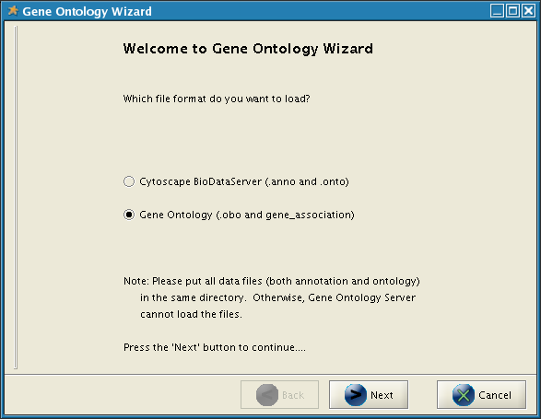
In this panel you can select two types of data formats: Cytoscape BioDataServer or Gene Ontology. Select Gene Ontology to use the new formats (obo and gene_association files). If you want to use the old file formats, select Cytoscape BioDataServer. A description of how the old formats can be created and used can be found in Appendix B.

Step 2. Select OBO and Gene Association Files

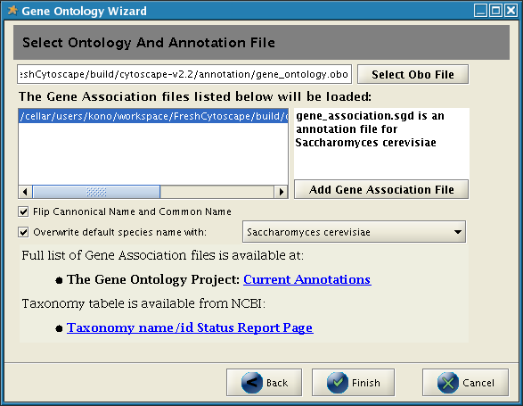

If you choose Gene Ontology in the first step, this panel appears to help you select OBO (ontology) and gene_association files. This panel has the following functions:

- Select Obo File Button
By pressing this button, you can choose an OBO file to be loaded.
- Add Gene Association File Button
You can add a gene_association file to the list by pressing this button. Once you select a file, the file name will be shown in the list in the left. If you click on the file name, the species name for the file will be shown. You can select multiple gene_association files.
- Flip Canonical Name and Common Name Check box
The following is an entry in the gene_association.sgd file (annotation file for yeast):
SGD S000004660 AAC1 GO:0006839 SGD_REF:S000050955|PMID:2167309 IGI SGD:S000000126 P ADP/ATP translocator YMR056C gene taxon:4932 20040226 SGD
The third element (AAC1, called DB_Object_Symbol in the gene_association format) will be used as a node identifier and canonical name for the gene. However, some network files (gal or sif) instead use the 11th element (YMR056C, the first entry in Synonym) as a node identifier. Since Cytoscape applies annotations based on these identifiers, the identifiers in the network file and in DB_Object_Symbols must match. This check box is used when you load network files that use the Synonym as the node identifier.
- Overwrite default species name menu
If not specified, species name for a network data will be overwritten by a property called defaultSpeciesName and the Gene Ontology Server will use it to choose which annotations to be applied. You can change defaultSpeciesName from this list.
- Links to related web sites
You can navigate to GO’s Current Annotation and NCBI’s Taxonomy pages from the links. The links open the default web browser when clicked.

Once you have finished specifying the options, click on finish. The OBO file and gene_association files specified in this panel will be automatically loaded.

Note 1: The OBO file and gene_association files MUST be in the same directory, and you must have write permission for the directory.

Note 2: Please make sure that your network file uses exact same ID’s used in the gene association file. Otherwise, the annotations will not appear in the Annotation Panel.

13. Filters
The Cytoscape Filter plugin, which is packaged with the official Cytoscape 2.2 release and is active by default, allows for a wide variety of filtering on node and edge attributes loaded onto Cytoscape networks. For example, you can easily select all the nodes whose name contains a specific pattern that you define. Several types of filters are available. Basic filters allow the selection of multiple nodes or edges according to attribute data:
- String filters allow selection of nodes or edges with attributes matching specified patterns. These patterns may include the wildcards * and ?.
- Numerical filters allow selection of nodes or edges according to numerical attributes and the mathematical operators >, =, and <.
Compound filters allow selection based on the application of pre-existing filters:
- Topology filters allow selection of nodes with neighbors that match some pre-existing filter.
- Boolean filters allow the combination of multiple filters using the AND, OR and XOR operators.
Example filters are shipped with the plugin to get started.

Using the Plugin

If the Filter plugin is loaded, then you should see a filter icon on the toolbar.
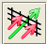

If you press the filter icon, you will see a filters dialog which looks initially like the following:

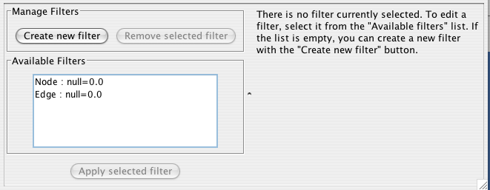

If the first filter is selected, then the dialog looks as shown (without the colors):
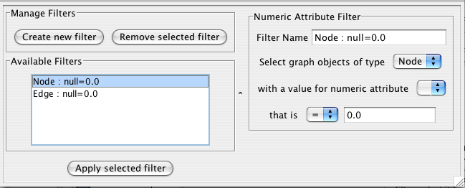
As for the colors:

The Purple Box: An existing or newly created filter can be edited in this area. Each filter type has its own user interface for editing.

The Orange Box: All available filters are shown in this list. Initially, this list will contain sample filters, but as you create more, they will be added here.

The Cyan Box: Pressing “Create new filter” adds a filter to the “Available Filters” box, and “Remove selected filter” deletes the currently selected filter.

Creating Filters

The “Create new filter” button brings up the Filter creation dialog box, shown below.
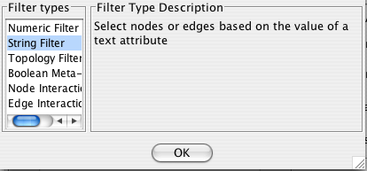
The important thing to realize when creating a filter is that the filter does not do anything by itself. Once created, the filter must be run.

String Filter:

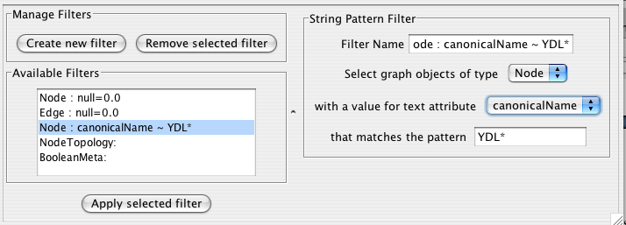
The String Filter allows you to filter nodes or edges by a given string node or edge attribute. Attributes that are loaded on the network are available for filtering against. Search terms are entered in the text box at the bottom. For example to match any Node whose canonicalName starts with “YDL” you would select “Node”, “canonicalName” and type “YDL*”. The * is important as it matches any number of characters after YDL. If you want to be more specific and only select nodes whose canonicalName starts with YDL00 followed by any other two characters, you would type “YDL00??”. The “?” denotes any single character, while the “*” represents zero or more characters. Full regular expression searching is supported, although is not covered here. Once the filter is defined, it will be assigned a default descriptive name.

Numerical Filter:

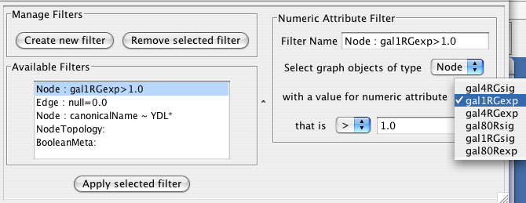
The Numerical Filter also allows you to filter nodes or edges, and presents you with a list of available attributes. This filter matches greater-than, less-than, or equal-to a number you type in the search box.

Node Topology Filter:
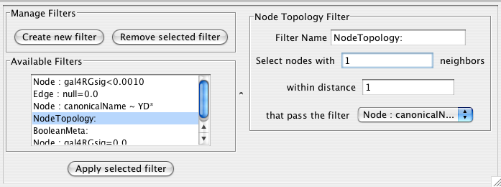
The node topology filter allows you to select nodes with at least n neighbors of distance m or less that pass some other selected filter. For instance, to select all the nodes adjacent to a node with the canonical name matching ‘YD*’, you would “select nodes with 1 neighbors”, “within distance 1”, “that pass the filter Node: canonicalName ~ YD*”.

Boolean Filter:
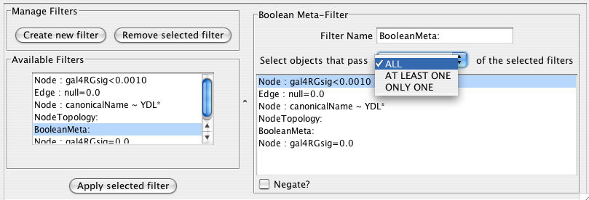
The Boolean Meta-Filter allows you to define a new filter that is a logical combination of existing filters. Available filters are displayed. By selecting one or more filters, you can then choose whether Nodes or Edges pass “ALL” (AND), “AT LEAST ONE” (OR), or “ONLY ONE” (XOR) of the selected filters. Once created Boolean filters can then themselves be combined using the Boolean filter to create arbitrarily complex logical combinations of filters. Note that unlike the String and Numerical Filters, Boolean Filters will need to be assigned a name manually.

Once created, filters are saved for future sessions, as long as you exit Cytoscape normally via the exit command in the File menu (i.e. not via ctrl-c on Linux).

Running filters
Any available filter can be run by pressing the ‘Apply selected filter’ button. When a filter is applied and multiple nodes or edges are selected, all of the normal selection-related operations may be performed, such as Delete Selected Node/Edges, Copy To New Network, and Invert Selection.

14. Acknowledgements

Cytoscape is built with a number of open source 3rd party Java libraries. The Cytoscape team gratefully acknowledges the following libraries:

- The Colt Distribution: Open Source Libraries for High Performance Scientific and Technical Computing in Java. Information is available at: http://hoschek.home.cern.ch/hoschek/colt/.

- GNU Getopt in Java. Information is available at: http://www.urbanophile.com/arenn/hacking/download.html.

- Graph INterface librarY a.k.a. GINY. Information is available at: http://csbi.sourceforge.net/.

- JDOM. Information is available at: http://www.jdom.org.

- JUnit. Information is available at: http://junit.org.

- JGoodies Looks. Information is available at: http://www.jgoodies.com/freeware/looks/index.html.

- Piccolo. Information is available at: http://www.cs.umd.edu/hcil/jazz/.

- Type-Specific Collections Library, from Sosnoski Software Solutions, Inc. Information is available at: http://www.sosnoski.com/opensrc/tclib/.

- Xerces Java XML parser. Information is available at: http://xml.apache.org/xerces-j/.

This product includes software developed by the Apache Software Foundation (http://www.apache.org/).

This product includes software developed by the JDOM Project (http://www.jdom.org/).

One-step Installation of the Cytoscape software is accomplished using the InstallAnywhere product from ZeroG Software, Inc. (http://zerog.com)

Appendix A: Old Annotation Server Format

The following section is still valid, however we strongly recommend using the new formats described in the previous section, since they are easier to download directly from the Gene Ontology project and use directly.

Gene Ontology Server Wizard

The Gene Ontology Server Wizard is a new graphical user interface used to select ontology and annotation files.

Step 1. Select Data Format
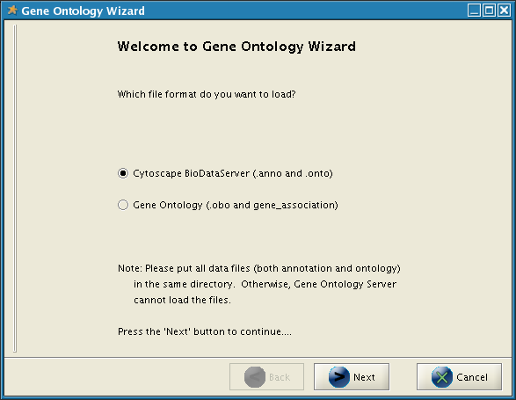
If you want to use the old manifest file to load annotations, select Cytoscape BioDataServer.
Step 2. Specify Manifest File

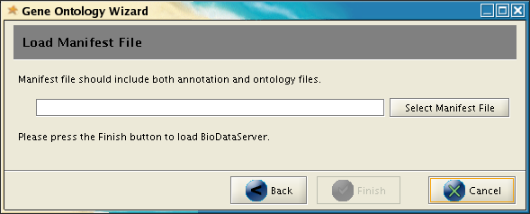

If you selected Cytoscape BioDataServer in the first step, you need to specify manifest file (which lists ontology and annotation files to load). Then click on finish. All data files will be loaded into Cytoscape. For more information about manifest file and how to create it, please read the section below.

Building your own annotation files
The annotation server requires that the gene annotations, and associated ontology on controlled vocabulary terms, follow a simple format. This simple format was chosen because it is efficient to parse and easy to use.

The flat file formats are explained below:

The Ontology Format
By example (the Gene Ontology - GO):

(curator=GO) (type=all)
0003673 = Gene_Ontology
0003674 = molecular_function [partof: 0003673 ]
0008435 = anticoagulant [isa: 0003674 ]
0016172 = antifreeze [isa: 0003674 ]
0016173 = ice nucleation inhibitor [isa: 0016172 ]
0016209 = antioxidant [isa: 0003674 ]
0045174 = glutathione dehydrogenase (ascorbate) [isa: 0009491 0015038 0016209 0016672 ]
0004362 = glutathione reductase (NADPH) [isa: 0015038 0015933 0016209 0016654 ]
0017019 = myosin phosphatase catalyst [partof: 0017018 ]
...

A second example (KEGG pathway ontology):

(curator=KEGG) (type=Metabolic Pathways)
90001 = Metabolism
80001 = Carbohydrate Metabolism [isa: 90001 ]
80003 = Lipid Metabolism [isa: 90001 ]
80002 = Energy Metabolism [isa: 90001 ]
80004 = Nucleotide Metabolism [isa: 90001 ]
80005 = Amino Acid Metabolism [isa: 90001 ]
80006 = Metabolism of Other Amino Acids [isa: 90001 ]
80007 = Metabolism of Complex Carbohydrates [isa: 90001 ]
...

The format has three required features:
- The first line contains two parenthesized assignments, for curator and type. In the GO example above, the ontology file (which is created from the XML GO provides) nests all three specific ontologies (molecular function, biological process, cellular component) below the 'root' ontology, named 'Gene_Ontology'.
(type=all)
tells you that all three ontologies are included in that file.
- Following the mandatory title line, there are one or more category lines, each with the form:
number0 = name [isa:|partof: number1 number2 ...]
'isa' and 'partof' are terms used in GO; they describe the relation between parent and child terms in the ontology hierarchy.
- The trailing blank before each left square bracket is not required; it is an artifact of the python script that creates these files.

The Annotation Format

By example (from the GO biological process annotation file):

(species=Saccharomyces cerevisiae) (type=Biological Process) (curator=GO)
YMR056C = 0006854
YBR085W = 0006854
YJR155W = 0006081
...

and from KEGG:

(species=Mycobacterium tuberculosis) (type=Metabolic Pathways) (curator=KEGG)
RV0761C = 10
RV0761C = 71
RV0761C = 120
RV0761C = 350
RV0761C = 561
RV1862 = 10
...

The format has these required features:
- The first line contains three parenthesized assignments, for species, type and curator. In the example just above, the annotation file (which we create for budding yeast from the flat text file maintained by SGD for the Gene Ontology project, and available both at their web site and at GO's) shows three yeast ORFs annotated for biological process, with respect to GO, described (further above).
- Following the mandatory title line, there are one or more annotation lines, each with the form:
canonicalName = ontologyTermID
- Once loaded, this annotation (along with the accompanying ontology) can be assigned to nodes in a Cytoscape network. For this to work, the species type of the node must exactly match the species named on the first line of the annotation file. The canonicalName of your node must exactly match the canonicalName present in the annotation file. If you don’t see the expected results when using this feature of Cytoscape, check this again, as getting either of these wrong is a common mistake.

Load Data into Cytoscape
The easiest way to make annotations available to Cytoscape is by loading annotations into the Cytoscape annotation server. This is the default behavior for the official release of Cytoscape.

The Annotation Manifest
You must first create a text file to specify the files you want Cytoscape to load. Here is an example, from a file which (for convenience) we usually call “manifest”

ontology=goOntology.txt
annotation=yeastBiologicalProcess.txt
annotation=yeastMolecularFunction.txt
annotation=yeastCellularComponent.txt

Use the Cytoscape -b command line argument to specify the annotation manifest file to read (e.g. -b manifest). Please note that the -s switch, which sets the default species for your data is required to exactly match the species named in any annotation file you wish to use.

Getting and Reformatting GO Data
The Gene Ontology (GO) project is a valuable source of annotation for the genes of many organisms. In this section we will explain how to:
- Obtain the GO ontology file
- Reformat it into the simpler flat file Cytoscape uses
- Obtain an annotation file (we illustrate with yeast and human annotation)
- Reformat the annotation files into the simple Cytoscape format
Obtain the GO ontology file
Go to the GO XML FTP (ftp://ftp.geneontology.org/pub/go/xml/) page. Download the latest go-YYYYMM-termdb.xml.gz file.

Reformat GO XML ontology file into a flat file
gunzip go-YYYYMM-termdb.xml.gz
python parseGoTermsToFlatFile.py go-YYYYMM-termdb.xml > goOntology.txt

(See below for Python script listing)

Obtain the 'association' file for your organism
GO maintains a list of association files for many organisms; these files associate genes with GO terms. The next step is to get the file for the organism/s you are interested in, and parse it into the form Cytoscape needs. A list of files may be seen at http://www.geneontology.org/GO.current.annotations.shtml. The rightmost column contains links to tab-delimited files of gene associations, by species. Choose the species you are interested in, and click 'Download'.

Let's use 'GO Annotations @ EBI Human' as an example. After you have downloaded and saved the file, look at the first few lines:

SPTR O00115 DRN2_HUMAN GO:0003677 PUBMED:9714827 TAS F Deoxyribonuclease II precursor IPI00010348 protein taxon:9606 SPTR
SPTR O00115 DRN2_HUMAN GO:0004519 GOA:spkw IEA F Deoxyribonuclease II precursor IPI00010348 protein taxon:9606 20020425 SPTR
SPTR O00115 DRN2_HUMAN GO:0004531 PUBMED:9714827 TAS F Deoxyribonuclease II precursor IPI00010348 protein taxon:9606 SPTR
...
Note that line wrapping has occurred here, so each line of the actual file is wrapped to two lines.
The goal is to create from these lines the following lines:
(species=Homo sapiens) (type=Molecular Function) (curator=GO)
IPI00010348 = 0003677
IPI00010348 = 0004519
IPI00010348 = 0004531
...
or
(species=Homo sapiens) (type=Biological Process) (curator=GO)
NP_001366 = 0006259
NP_001366 = 0006915
NP_005289 = 0007186
NP_647593 = 0006899
...
The first sample contains molecular function annotation for proteins, and each protein is identified by its IPI number. IPI is the International Protein Index, which maintains cross references to the main databases for human, mouse and rat proteomes.
The second sample contains biological process annotation, and each protein is identified by its NP (RefSeq) number.
These two naming systems, IPI and RefSeq, are two of many that you can use for canonical names when you run Cytoscape. For budding yeast, it is much easier: the yeast community always uses standard ORF names, and so Cytoscape uses these as canonical names. For human proteins and genes, there is no such single simple standard. See section for more information.
The solution (for those working with human genes or proteins) is, once you have downloaded the annotations file, to:
- Decide which naming system you want to use.
- Download ftp://ftp.ebi.ac.uk/pub/databases/GO/goa/HUMAN/xrefs.goa. This cross-reference file, when used strategically, allows you to create Cytoscape-compatible annotation files in which the canonical name is the one most meaningful to you.
- Examine xrefs.goa to figure out which column contains the names you wish to use.
- Make a very slight modification to the python script described below, and then
- Run that script, supplying both xrefs.goa and that annotation file as arguments.
Here are a few sample lines from xrefs.goa:
SP O00115 IPI00010348 ENSP00000222219; NP_001366; BAA28623;AAC77366;AAC35751;AAC39852;BAB55598;AAB51172;AAH10419; 2960,DNASE2 1777,DNASE2
SP O00116 IPI00010349 ENSP00000324567;ENSP00000264167; NP_003650; CAA70591; 327,AGPS 8540,AGPS
SP O00124 IPI00010353 ENSP00000265616;ENSP00000322580; NP_005662; BAA18958;BAA18959;AAH20694; 7993,D8S2298E
...

Note that line wrapping has occurred here – each line in this example starts with the letters SP. See the README file for more information (ftp://ftp.ebi.ac.uk/pub/databases/GO/goa/HUMAN/README)

Finally, run the script to create your three annotation files for human proteins:
- bioproc.anno (GO biological process annotation)
- molfunc.anno (GO molecular function annotation)
- cellcomp.anno (GO cellular component annotation)
using the supplied python script. It may be necessary to modify this script slightly if RefSeq identifiers are not used as canonical names or if you are using a more recent version of Python.

python parseAssignmentsToFlatFileFromGoaProject.py gene_association.goa_human xrefs.goa
(See below for Python script listing)

Python script examples:
These scripts, described above require Python version 2.2 or later.

Script 1 - parseGoTermsToFlatFile.py
# parseGoTermToFlatFile.py: translate a GO XML ontology file into a simpler
# Cytoscape flat file
#-----------------------------------------------------------------------------------
# RCS: $Revision: 1.3 $ $Date: 2003/05/18 00:38:43 $
#-----------------------------------------------------------------------------------
import re, pre, sys
#-----------------------------------------------------------------------------------
def flatFilePrint (id, name, isaIDs, partofIDs):
isa = ''
if (len (isaIDs) > 0):
isa = '[isa: '
for isaID in isaIDs:
isa += isaID
isa += ' '
isa += ']'

partof = ''
if (len (partofIDs) > 0):
partof = '[partof: '
for partofID in partofIDs:
partof += partofID
partof += ' '
partof += ']'

result = '%s = %s %s %s' % (id, name, isa, partof)
result = result.strip ()
if (result == 'isa = isa' or result == 'partof = partof'):
print >> sys.stderr, 'meaningless term: %s' % result
else:
print result
#-----------------------------------------------------------------------------------
if (len (sys.argv) != 2):
print 'usage: %s <someFile.xml>' % sys.argv [0]
sys.exit ();

inputFilename = sys.argv [1];

print >> sys.stderr, 'reading %s...' % inputFilename
text = open (inputFilename).read ()
print >> sys.stderr, 'read %d characters' % len (text)

regex = '<go:term .*?>(.*?)</go:term>';
cregex = pre.compile (regex, re.DOTALL) # . matches newlines

m = pre.findall (cregex, text)
print >> sys.stderr, 'number of go terms: %d' % len (m)

regex2 = '<go:accession>GO:(.*?)</go:accession>.*?<go:name>(.*?)</go:name>'
cregex2 = re.compile (regex2, re.DOTALL)

regex3 = '<go:isa\s*rdf:resource="http://www.geneontology.org/go#GO:(.*?)"\s*/>'
cregex3 = re.compile (regex3, re.DOTALL)

regex4 = '<go:part-of\s*rdf:resource="http://www.geneontology.org/go#GO:(.*?)"\s*/>'
cregex4 = re.compile (regex4, re.DOTALL)

goodElements = 0
badElements = 0

print '(curator=GO) (type=all)'
for term in m:
m2 = re.search (cregex2, term)
if (m2):
goodElements += 1;
id = m2.group (1)
name = m2.group (2)
isaIDs = []
m3 = re.findall (cregex3, term);
for ref in m3:
isaIDs.append (ref)
m4 = re.findall (cregex4, term);
partofIDs = []
for ref in m4:
partofIDs.append (ref)
flatFilePrint (id, name, isaIDs, partofIDs)
else:
badElements += 1;
print >> sys.stderr, 'no match to m2...'
print >> sys.stderr, "---------------\n%s\n------------------" % term

print >> sys.stderr, 'goodElements %d' % goodElements
print >> sys.stderr, 'badElements %d' % badElements

#--------------------------------------

Script 1 - parseAssignmentsToFlatFileFromGoaProject.py
#!/tools/bin/python
import sys
#-----------------------------------------------------------------------------------
def fixCanonicalName (rawName):
# for instance, trim 'YBR085W|ANC3' to 'YBR085W'
bar = rawName.find ('|')
if (bar < 0):
return rawName
return rawName [:bar]

#-----------------------------------------------------------------------------------
def fixGoID (rawID):

bar = rawID.find (':') + 1
return rawID [bar:]

#-----------------------------------------------------------------------------------
def readGoaXrefFile (filename):

lines = open (filename).read().split ('\n')
result = {}
for line in lines:
if (len (line) < 10):
continue
tokens = line.split ('\t')
ipi = tokens [2]
np = tokens [5]
semicolon = np.find (';')
if (semicolon >= 0):
np = np [:semicolon]
if (len (ipi) > 0 and len (np) > 0):
result [ipi] = np

return result

#-----------------------------------------------------------------------------------
if (len (sys.argv) != 3):
print 'error! parse <gene_associations file from GO> <goa xrefs file> '
sys.exit ()

associationFilename = sys.argv [1];
xrefsFilename = sys.argv [2]
species = 'Homo sapiens'

ipiToNPHash = readGoaXrefFile (xrefsFilename)
tester = 'IPI00099416'
print 'hash size: %d' % len (ipiToNPHash)
print 'test map: %s -> NP_054861: %s ' % (tester, ipiToNPHash [tester])

bioproc = open ('bioproc.txt', 'w')
molfunc = open ('molfunc.txt', 'w')
cellcomp = open ('cellcomp.txt', 'w')

bioproc.write ('(species=%s) (type=Biological Process) (curator=GO)\n' % species)
molfunc.write ('(species=%s) (type=Molecular Function) (curator=GO)\n' % species);
cellcomp.write ('(species=%s) (type=Cellular Component) (curator=GO)\n' % species);

lines=open(associationFilename).read().split('\n')
sys.stderr.write ('found %d lines\n' % len (lines))

for line in lines:
if (line.find ('!') == 0 or len (line) < 2):
continue
tokens = line.split ('\t')
goOntology = tokens [8]
goIDraw = tokens [4]
goID = goIDraw.split (':')[1]
ipiName = fixCanonicalName (tokens [10])
if (len (ipiName) < 1):
continue

if (not ipiToNPHash.has_key (ipiName)):
continue
refseqName = ipiToNPHash [ipiName]
printName = refseqName
#printName = ipiName
if (ipiName == tester):
print '%s (%s) has go term %s' % (tester, printName, goID)
if (goOntology == 'C'):
cellcomp.write ('%s = %s\n' % (printName, goID))
elif (goOntology == 'P'):
bioproc.write ('%s = %s\n' % (printName, goID))
elif (goOntology == 'F'):
molfunc.write ('%s = %s\n' % (printName, goID))
#-----------------------------------------------------------------------------------

Appendix B: GNU Lesser General Public License

GNU LESSER GENERAL PUBLIC LICENSE
Version 2.1, February 1999

Copyright (C) 1991, 1999 Free Software Foundation, Inc.
59 Temple Place, Suite 330, Boston, MA 02111-1307 USA
Everyone is permitted to copy and distribute verbatim copies
of this license document, but changing it is not allowed.

[This is the first released version of the Lesser GPL. It also counts
as the successor of the GNU Library Public License, version 2, hence
the version number 2.1.]

Preamble

The licenses for most software are designed to take away your
freedom to share and change it. By contrast, the GNU General Public
Licenses are intended to guarantee your freedom to share and change
free software--to make sure the software is free for all its users.

This license, the Lesser General Public License, applies to some
specially designated software packages--typically libraries--of the
Free Software Foundation and other authors who decide to use it. You
can use it too, but we suggest you first think carefully about whether
this license or the ordinary General Public License is the better
strategy to use in any particular case, based on the explanations below.

When we speak of free software, we are referring to freedom of use,
not price. Our General Public Licenses are designed to make sure that
you have the freedom to distribute copies of free software (and charge
for this service if you wish); that you receive source code or can get
it if you want it; that you can change the software and use pieces of
it in new free programs; and that you are informed that you can do
these things.

To protect your rights, we need to make restrictions that forbid
distributors to deny you these rights or to ask you to surrender these
rights. These restrictions translate to certain responsibilities for
you if you distribute copies of the library or if you modify it.

For example, if you distribute copies of the library, whether gratis
or for a fee, you must give the recipients all the rights that we gave
you. You must make sure that they, too, receive or can get the source
code. If you link other code with the library, you must provide
complete object files to the recipients, so that they can relink them
with the library after making changes to the library and recompiling
it. And you must show them these terms so they know their rights.

We protect your rights with a two-step method: (1) we copyright the
library, and (2) we offer you this license, which gives you legal
permission to copy, distribute and/or modify the library.

To protect each distributor, we want to make it very clear that
there is no warranty for the free library. Also, if the library is
modified by someone else and passed on, the recipients should know
that what they have is not the original version, so that the original
author's reputation will not be affected by problems that might be
introduced by others.

Finally, software patents pose a constant threat to the existence of
any free program. We wish to make sure that a company cannot
effectively restrict the users of a free program by obtaining a
restrictive license from a patent holder. Therefore, we insist that
any patent license obtained for a version of the library must be
consistent with the full freedom of use specified in this license.

Most GNU software, including some libraries, is covered by the
ordinary GNU General Public License. This license, the GNU Lesser
General Public License, applies to certain designated libraries, and
is quite different from the ordinary General Public License. We use
this license for certain libraries in order to permit linking those
libraries into non-free programs.

When a program is linked with a library, whether statically or using
a shared library, the combination of the two is legally speaking a
combined work, a derivative of the original library. The ordinary
General Public License therefore permits such linking only if the
entire combination fits its criteria of freedom. The Lesser General
Public License permits more lax criteria for linking other code with
the library.

We call this license the "Lesser" General Public License because it
does Less to protect the user's freedom than the ordinary General
Public License. It also provides other free software developers Less
of an advantage over competing non-free programs. These disadvantages
are the reason we use the ordinary General Public License for many
libraries. However, the Lesser license provides advantages in certain
special circumstances.

For example, on rare occasions, there may be a special need to
encourage the widest possible use of a certain library, so that it becomes
a de-facto standard. To achieve this, non-free programs must be
allowed to use the library. A more frequent case is that a free
library does the same job as widely used non-free libraries. In this
case, there is little to gain by limiting the free library to free
software only, so we use the Lesser General Public License.

In other cases, permission to use a particular library in non-free
programs enables a greater number of people to use a large body of
free software. For example, permission to use the GNU C Library in
non-free programs enables many more people to use the whole GNU
operating system, as well as its variant, the GNU/Linux operating
system.

Although the Lesser General Public License is Less protective of the
users' freedom, it does ensure that the user of a program that is
linked with the Library has the freedom and the wherewithal to run
that program using a modified version of the Library.

The precise terms and conditions for copying, distribution and
modification follow. Pay close attention to the difference between a
"work based on the library" and a "work that uses the library". The
former contains code derived from the library, whereas the latter must
be combined with the library in order to run.

GNU LESSER GENERAL PUBLIC LICENSE
TERMS AND CONDITIONS FOR COPYING, DISTRIBUTION AND MODIFICATION

0. This License Agreement applies to any software library or other
program which contains a notice placed by the copyright holder or
other authorized party saying it may be distributed under the terms of
this Lesser General Public License (also called "this License").
Each licensee is addressed as "you".

A "library" means a collection of software functions and/or data
prepared so as to be conveniently linked with application programs
(which use some of those functions and data) to form executables.

The "Library", below, refers to any such software library or work
which has been distributed under these terms. A "work based on the
Library" means either the Library or any derivative work under
copyright law: that is to say, a work containing the Library or a
portion of it, either verbatim or with modifications and/or translated
straightforwardly into another language. (Hereinafter, translation is
included without limitation in the term "modification".)

"Source code" for a work means the preferred form of the work for
making modifications to it. For a library, complete source code means
all the source code for all modules it contains, plus any associated
interface definition files, plus the scripts used to control compilation
and installation of the library.

Activities other than copying, distribution and modification are not
covered by this License; they are outside its scope. The act of
running a program using the Library is not restricted, and output from
such a program is covered only if its contents constitute a work based
on the Library (independent of the use of the Library in a tool for
writing it). Whether that is true depends on what the Library does
and what the program that uses the Library does.

1. You may copy and distribute verbatim copies of the Library's
complete source code as you receive it, in any medium, provided that
you conspicuously and appropriately publish on each copy an
appropriate copyright notice and disclaimer of warranty; keep intact
all the notices that refer to this License and to the absence of any
warranty; and distribute a copy of this License along with the
Library.

You may charge a fee for the physical act of transferring a copy,
and you may at your option offer warranty protection in exchange for a
fee.

2. You may modify your copy or copies of the Library or any portion
of it, thus forming a work based on the Library, and copy and
distribute such modifications or work under the terms of Section 1
above, provided that you also meet all of these conditions:

a) The modified work must itself be a software library.

b) You must cause the files modified to carry prominent notices
stating that you changed the files and the date of any change.

c) You must cause the whole of the work to be licensed at no
charge to all third parties under the terms of this License.

d) If a facility in the modified Library refers to a function or a
table of data to be supplied by an application program that uses
the facility, other than as an argument passed when the facility
is invoked, then you must make a good faith effort to ensure that,
in the event an application does not supply such function or
table, the facility still operates, and performs whatever part of
its purpose remains meaningful.

(For example, a function in a library to compute square roots has
a purpose that is entirely well-defined independent of the
application. Therefore, Subsection 2d requires that any
application-supplied function or table used by this function must
be optional: if the application does not supply it, the square
root function must still compute square roots.)

These requirements apply to the modified work as a whole. If
identifiable sections of that work are not derived from the Library,
and can be reasonably considered independent and separate works in
themselves, then this License, and its terms, do not apply to those
sections when you distribute them as separate works. But when you
distribute the same sections as part of a whole which is a work based
on the Library, the distribution of the whole must be on the terms of
this License, whose permissions for other licensees extend to the
entire whole, and thus to each and every part regardless of who wrote
it.

Thus, it is not the intent of this section to claim rights or contest
your rights to work written entirely by you; rather, the intent is to
exercise the right to control the distribution of derivative or
collective works based on the Library.

In addition, mere aggregation of another work not based on the Library
with the Library (or with a work based on the Library) on a volume of
a storage or distribution medium does not bring the other work under
the scope of this License.

3. You may opt to apply the terms of the ordinary GNU General Public
License instead of this License to a given copy of the Library. To do
this, you must alter all the notices that refer to this License, so
that they refer to the ordinary GNU General Public License, version 2,
instead of to this License. (If a newer version than version 2 of the
ordinary GNU General Public License has appeared, then you can specify
that version instead if you wish.) Do not make any other change in
these notices.

Once this change is made in a given copy, it is irreversible for
that copy, so the ordinary GNU General Public License applies to all
subsequent copies and derivative works made from that copy.

This option is useful when you wish to copy part of the code of
the Library into a program that is not a library.

4. You may copy and distribute the Library (or a portion or
derivative of it, under Section 2) in object code or executable form
under the terms of Sections 1 and 2 above provided that you accompany
it with the complete corresponding machine-readable source code, which
must be distributed under the terms of Sections 1 and 2 above on a
medium customarily used for software interchange.

If distribution of object code is made by offering access to copy
from a designated place, then offering equivalent access to copy the
source code from the same place satisfies the requirement to
distribute the source code, even though third parties are not
compelled to copy the source along with the object code.

5. A program that contains no derivative of any portion of the
Library, but is designed to work with the Library by being compiled or
linked with it, is called a "work that uses the Library". Such a
work, in isolation, is not a derivative work of the Library, and
therefore falls outside the scope of this License.

However, linking a "work that uses the Library" with the Library
creates an executable that is a derivative of the Library (because it
contains portions of the Library), rather than a "work that uses the
library". The executable is therefore covered by this License.
Section 6 states terms for distribution of such executables.

When a "work that uses the Library" uses material from a header file
that is part of the Library, the object code for the work may be a
derivative work of the Library even though the source code is not.
Whether this is true is especially significant if the work can be
linked without the Library, or if the work is itself a library. The
threshold for this to be true is not precisely defined by law.

If such an object file uses only numerical parameters, data
structure layouts and accessors, and small macros and small inline
functions (ten lines or less in length), then the use of the object
file is unrestricted, regardless of whether it is legally a derivative
work. (Executables containing this object code plus portions of the
Library will still fall under Section 6.)

Otherwise, if the work is a derivative of the Library, you may
distribute the object code for the work under the terms of Section 6.
Any executables containing that work also fall under Section 6,
whether or not they are linked directly with the Library itself.

6. As an exception to the Sections above, you may also combine or
link a "work that uses the Library" with the Library to produce a
work containing portions of the Library, and distribute that work
under terms of your choice, provided that the terms permit
modification of the work for the customer's own use and reverse
engineering for debugging such modifications.

You must give prominent notice with each copy of the work that the
Library is used in it and that the Library and its use are covered by
this License. You must supply a copy of this License. If the work
during execution displays copyright notices, you must include the
copyright notice for the Library among them, as well as a reference
directing the user to the copy of this License. Also, you must do one
of these things:

a) Accompany the work with the complete corresponding
machine-readable source code for the Library including whatever
changes were used in the work (which must be distributed under
Sections 1 and 2 above); and, if the work is an executable linked
with the Library, with the complete machine-readable "work that
uses the Library", as object code and/or source code, so that the
user can modify the Library and then relink to produce a modified
executable containing the modified Library. (It is understood
that the user who changes the contents of definitions files in the
Library will not necessarily be able to recompile the application
to use the modified definitions.)

b) Use a suitable shared library mechanism for linking with the
Library. A suitable mechanism is one that (1) uses at run time a
copy of the library already present on the user's computer system,
rather than copying library functions into the executable, and (2)
will operate properly with a modified version of the library, if
the user installs one, as long as the modified version is
interface-compatible with the version that the work was made with.

c) Accompany the work with a written offer, valid for at
least three years, to give the same user the materials
specified in Subsection 6a, above, for a charge no more
than the cost of performing this distribution.

d) If distribution of the work is made by offering access to copy
from a designated place, offer equivalent access to copy the above
specified materials from the same place.

e) Verify that the user has already received a copy of these
materials or that you have already sent this user a copy.

For an executable, the required form of the "work that uses the
Library" must include any data and utility programs needed for
reproducing the executable from it. However, as a special exception,
the materials to be distributed need not include anything that is
normally distributed (in either source or binary form) with the major
components (compiler, kernel, and so on) of the operating system on
which the executable runs, unless that component itself accompanies
the executable.

It may happen that this requirement contradicts the license
restrictions of other proprietary libraries that do not normally
accompany the operating system. Such a contradiction means you cannot
use both them and the Library together in an executable that you
distribute.

7. You may place library facilities that are a work based on the
Library side-by-side in a single library together with other library
facilities not covered by this License, and distribute such a combined
library, provided that the separate distribution of the work based on
the Library and of the other library facilities is otherwise
permitted, and provided that you do these two things:

a) Accompany the combined library with a copy of the same work
based on the Library, uncombined with any other library
facilities. This must be distributed under the terms of the
Sections above.

b) Give prominent notice with the combined library of the fact
that part of it is a work based on the Library, and explaining
where to find the accompanying uncombined form of the same work.

8. You may not copy, modify, sublicense, link with, or distribute
the Library except as expressly provided under this License. Any
attempt otherwise to copy, modify, sublicense, link with, or
distribute the Library is void, and will automatically terminate your
rights under this License. However, parties who have received copies,
or rights, from you under this License will not have their licenses
terminated so long as such parties remain in full compliance.

9. You are not required to accept this License, since you have not
signed it. However, nothing else grants you permission to modify or
distribute the Library or its derivative works. These actions are
prohibited by law if you do not accept this License. Therefore, by
modifying or distributing the Library (or any work based on the
Library), you indicate your acceptance of this License to do so, and
all its terms and conditions for copying, distributing or modifying
the Library or works based on it.

10. Each time you redistribute the Library (or any work based on the
Library), the recipient automatically receives a license from the
original licensor to copy, distribute, link with or modify the Library
subject to these terms and conditions. You may not impose any further
restrictions on the recipients' exercise of the rights granted herein.
You are not responsible for enforcing compliance by third parties with
this License.

11. If, as a consequence of a court judgment or allegation of patent
infringement or for any other reason (not limited to patent issues),
conditions are imposed on you (whether by court order, agreement or
otherwise) that contradict the conditions of this License, they do not
excuse you from the conditions of this License. If you cannot
distribute so as to satisfy simultaneously your obligations under this
License and any other pertinent obligations, then as a consequence you
may not distribute the Library at all. For example, if a patent
license would not permit royalty-free redistribution of the Library by
all those who receive copies directly or indirectly through you, then
the only way you could satisfy both it and this License would be to
refrain entirely from distribution of the Library.

If any portion of this section is held invalid or unenforceable under any
particular circumstance, the balance of the section is intended to apply,
and the section as a whole is intended to apply in other circumstances.

It is not the purpose of this section to induce you to infringe any
patents or other property right claims or to contest validity of any
such claims; this section has the sole purpose of protecting the
integrity of the free software distribution system which is
implemented by public license practices. Many people have made
generous contributions to the wide range of software distributed
through that system in reliance on consistent application of that
system; it is up to the author/donor to decide if he or she is willing
to distribute software through any other system and a licensee cannot
impose that choice.

This section is intended to make thoroughly clear what is believed to
be a consequence of the rest of this License.

12. If the distribution and/or use of the Library is restricted in
certain countries either by patents or by copyrighted interfaces, the
original copyright holder who places the Library under this License may add
an explicit geographical distribution limitation excluding those countries,
so that distribution is permitted only in or among countries not thus
excluded. In such case, this License incorporates the limitation as if
written in the body of this License.

13. The Free Software Foundation may publish revised and/or new
versions of the Lesser General Public License from time to time.
Such new versions will be similar in spirit to the present version,
but may differ in detail to address new problems or concerns.

Each version is given a distinguishing version number. If the Library
specifies a version number of this License which applies to it and
"any later version", you have the option of following the terms and
conditions either of that version or of any later version published by
the Free Software Foundation. If the Library does not specify a
license version number, you may choose any version ever published by
the Free Software Foundation.

14. If you wish to incorporate parts of the Library into other free
programs whose distribution conditions are incompatible with these,
write to the author to ask for permission. For software which is
copyrighted by the Free Software Foundation, write to the Free
Software Foundation; we sometimes make exceptions for this. Our
decision will be guided by the two goals of preserving the free status
of all derivatives of our free software and of promoting the sharing
and reuse of software generally.

NO WARRANTY

15. BECAUSE THE LIBRARY IS LICENSED FREE OF CHARGE, THERE IS NO
WARRANTY FOR THE LIBRARY, TO THE EXTENT PERMITTED BY APPLICABLE LAW.
EXCEPT WHEN OTHERWISE STATED IN WRITING THE COPYRIGHT HOLDERS AND/OR
OTHER PARTIES PROVIDE THE LIBRARY "AS IS" WITHOUT WARRANTY OF ANY
KIND, EITHER EXPRESSED OR IMPLIED, INCLUDING, BUT NOT LIMITED TO, THE
IMPLIED WARRANTIES OF MERCHANTABILITY AND FITNESS FOR A PARTICULAR
PURPOSE. THE ENTIRE RISK AS TO THE QUALITY AND PERFORMANCE OF THE
LIBRARY IS WITH YOU. SHOULD THE LIBRARY PROVE DEFECTIVE, YOU ASSUME
THE COST OF ALL NECESSARY SERVICING, REPAIR OR CORRECTION.

16. IN NO EVENT UNLESS REQUIRED BY APPLICABLE LAW OR AGREED TO IN
WRITING WILL ANY COPYRIGHT HOLDER, OR ANY OTHER PARTY WHO MAY MODIFY
AND/OR REDISTRIBUTE THE LIBRARY AS PERMITTED ABOVE, BE LIABLE TO YOU
FOR DAMAGES, INCLUDING ANY GENERAL, SPECIAL, INCIDENTAL OR
CONSEQUENTIAL DAMAGES ARISING OUT OF THE USE OR INABILITY TO USE THE
LIBRARY (INCLUDING BUT NOT LIMITED TO LOSS OF DATA OR DATA BEING
RENDERED INACCURATE OR LOSSES SUSTAINED BY YOU OR THIRD PARTIES OR A
FAILURE OF THE LIBRARY TO OPERATE WITH ANY OTHER SOFTWARE), EVEN IF
SUCH HOLDER OR OTHER PARTY HAS BEEN ADVISED OF THE POSSIBILITY OF SUCH
DAMAGES.

END OF TERMS AND CONDITIONS

