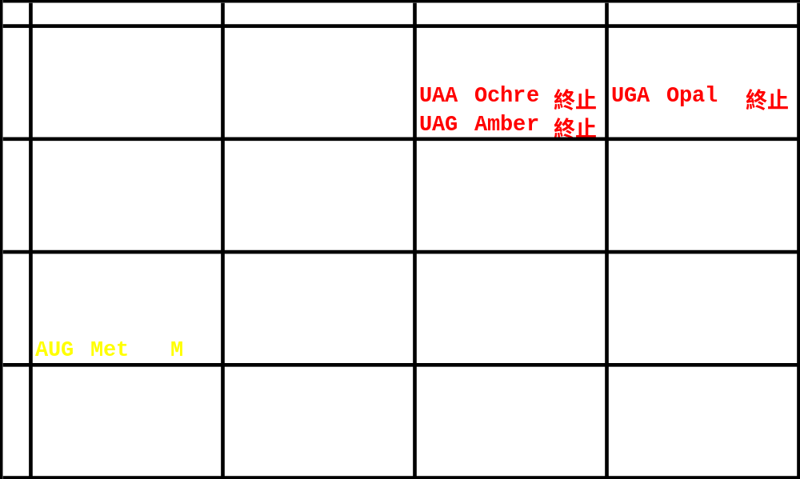

 | U |  |  | C |  |  | A |  |  | G
U | UUU | Phe | F | UCU | Ser | S | UAU | Tyr | Y | UGU | Cys | C
U | UUC | Phe | F | UCC | Ser | S | UAC | Tyr | Y | UGC | Cys | C
U | UUA | Leu | L | UCA | Ser | S | UAA | Ochre | 終止 | UGA | Opal | 終止
U | UUG | Leu | L | UCG | Ser | S | UAG | Amber | 終止 | UGG | Trp | W
C | CUU | Leu | L | CCU | Pro | P | CAU | His | H | CGU | Arg | R
C | CUC | Leu | L | CCC | Pro | P | CAC | His | H | CGC | Arg | R
C | CUA | Leu | L | CCA | Pro | P | CAA | Gln | Q | CGA | Arg | R
C | CUG | Leu | L | CCG | Pro | P | CAG | Gln | Q | CGG | Arg | R
A | AUU | Ile | I | ACU | Thr | T | AAU | Asn | N | AGU | Ser | S
A | AUC | Ile | I | ACC | Thr | T | AAC | Asn | N | AGC | Ser | S
A | AUA | Ile | I | ACA | Thr | T | AAA | Lys | K | AGA | Arg | R
A | AUG | Met | M | ACG | Thr | T | AAG | Lys | K | AGG | Arg | R
G | GUU | Val | V | GCU | Ala | A | GAU | Asp | D | GGU | Gly | G
G | GUC | Val | V | GCC | Ala | A | GAC | Asp | D | GGC | Gly | G
G | GUA | Val | V | GCA | Ala | A | GAA | Glu | E | GGA | Gly | G
G | GUG | Val | V | GCG | Ala | A | GAG | Glu | E | GGG | Gly | G

