Demo phpLiveDocx document

Demo phpLiveDocx document

Demo phpLiveDocx document

Demo phpLiveDocx document

Demo phpLiveDocx document

Demo phpLiveDocx document

Demo phpLiveDocx document

Demo phpLiveDocx document

Demo phpLiveDocx document

Demo phpLiveDocx document

turn over...
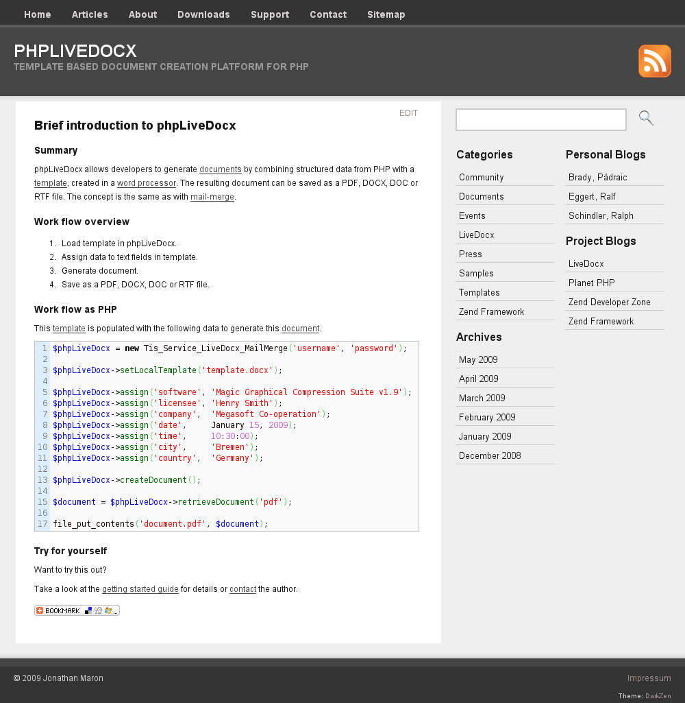
Visit phpLiveDocx.org today!

