ISO Master
Iteration1 test explanation

Introduction
A CD image is one file that contains a byte-by-byte copy of a CD. The deliverable for Iteration 1 will read and display the list of files and directories from an image. This list of files will be compared with contents of the CD as shown by a file manager.

Setup for the test
The application is developed on and designed to run on Linux. Since you do not have access to a Linux machine, you must connect to one (cs1.senecac.on.ca) using a terminal emulator. These instructions assume you will be using the terminal emulator that comes with every windows machine (telnet).

Under the start menu there is an item called 'Run', click that.

Type this into the box and click ok:
telnet cs1.senecac.on.ca

It will prompt for a username (use b5301a07) and password (use 05343521).

Running the test

The following command will run the test:
./testread2 slackd1-head.iso | less

- 'testread2' is the name of the test program
- 'slackd1-head.iso' is a file, an image of the Slackware CD provided (actually it's only the relevant part of the image, I don't have enough space on the server to store the entire image but it's not needed anyway since all the file and directory descriptors are stored in the first megabyte)
- 'less' is a pager, it will allow you access to several pages of text regardless of how many pages your terminal program can display (the windows telnet client can only show 2-3 pages at most and that's not enough). You can use the up and down arrows on your keyboard to scroll the list, don't try to use the scrollbar of the terminal application.

What to do with the CD
The CD contains Slackware, a Linux distribution. Simply put, it has files used to install Linux. If you put it into your machine, nothing will be installed and no application will run automatically.
Put the disk into your CD drive. If a window pops up asking you what to do, click cancel. Open My Computer (from the start menu). Right-click on the drive letter that represents the CD (maybe D) and choose 'Explore'.
Now you can see the contents of the disk. You can navigate this view as you normally do when you work with your files.

What you see
The list displayed in the terminal window is a hierarchical view of the directory tree on the image. The following pictures show the list next to a file manager. Note that depending on your file manager settings files within a directory may be ordered differently.

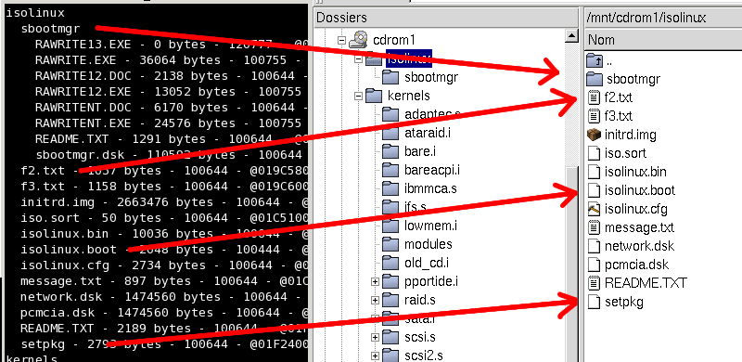
Illustration 1: Contents of the 'isolinux' directory
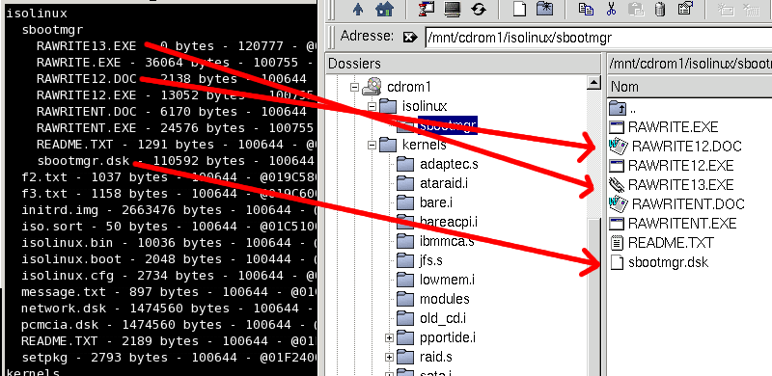
Illustration 2: Contents of the 'sbootmgr' directory (which is inside the 'isolinux' directory)
The numbers to the right of each file/directory name are:
- size in bytes
- file type (regular, link, device) and permissions in octal
- location on image in hex
This extra information is difficult to obtain without specialized tools on Windows, it is in the test because obtaining this information was part of the iteration.

Ending the test
In the terminal press the letter 'q', this will quit the application. Type 'exit' and press Enter to exit the terminal session.

