Table of Contents

1 Introduction 2
2 Scope 2
2.1 Features 2
2.1.1 View Contents 2
2.1.1.1 Optional: View Boot Files 3
2.1.2 Extract Files 3
2.1.3 Extract Boot Record 3
2.1.4 View Text Files 3
2.1.4.1 Optional: Edit Text Files 3
2.1.5 Add Files 3
2.1.6 Add or Replace Boot Record from a File 3
2.1.7 Optional: Change Format 4
2.1.8 Optional: Create New 4
2.2 Use Case Diagrams 5
2.3 Scenarios and System Sequence Diagrams 6
2.3.1 View Contents 7
2.3.1.1 View Boot Files 7
2.3.2 Extract Files 8
2.3.3 Extract Boot Record 9
2.3.4 View Text File 10
2.3.4.1 Edit Text File 11
2.3.5 Add Files 12
2.3.6 Add Boot Record from a File 13
2.3.7 Change Format 14
2.3.8 Create New 15
2.4 Stakeholders 16
3. Business Rules 16
4. Implementation Plan 16
4.1 Stage1 - Library 16
4.2 Stage2 - User Interface 16
5. Financial Analysis 17
6. Meetings and Interviews 17

1 Introduction
Sometimes it is necessary to extract files from or change the contents of an ISO9660 CD image (from here on 'image'). Such an image is one file (ex. myimage.iso) that contains all the files, directories and other information from a CD. The easiest way to accomplish this task is to use an application that will, transparently to the user, perform the necessary operations while acting like a file manager such as the Windows Explorer. Such applications exist on the Windows platform: ISOBuster and UltraISO. The goal of this project is to create an open-source ISO editor to run on the Linux platform that will offer the same functionality as the applications mentioned above.

The true clients are linux users who need to perform any of the tasks described in the 'features' section.

To fulfill the purpose of these courses John Selmys will act as the client, supplementing the research on requirements and checking the work's progress. He can be reached by email (John.Selmys@SenecaC.On.Ca) or telephone ((416) 491-5050 x3212).

By using an ISO editor, the user will save a considerable amount of time - both when viewing and changing the contents of an image.

Currently the process is very complex. For example: to change the contents of a text file on the image the user must get superuser privileges, mount the image to the filesystem with the -o loop,ro options, copy all the files to a different directory, edit the text file, use mkisofs to create a new image, unmount and delete the original. Using an ISO editor will easily change the time required from 20 to 2 minutes.

2 Scope

2.1 Features
This section contains a list of features available in the application. Some features are marked as Optional and will only be implemented if time allows.

2.1.1 View Contents
The user will be able to open a .iso file and view the contents in a Windows Explorer-like file browser.
The application will show the contents of the image in the newest format available on that image. For example:
- a Rock Ridge image is an extended ISO9660 image
- the Rock Ridge format allows a maximum of 31 characters per filename while the ISO9660 format allows a maximum of 8.3
- the application will display 31 rather then 8.3 character filenames

2.1.1.1 Optional: View Boot Files
The user will be able to view the contents of the image's boot record in a special, clearly marked directory.

2.1.2 Extract Files
The application will allow the user to select one or more files in the image browser and copy them to a chosen location on the local filesystem. This operation can be triggered using an 'Extract' button.

2.1.3 Extract Boot Record
The application will allow the user to save the boot record from the image in a file on the local filesystem. This feature will be available regardless of whether optional feature 2.1.1.1 View Boot Files is implemented or not.

2.1.4 View Text Files
The user will be able to view the contents of text files on the image in a viewer/editor of his choice.

2.1.4.1 Optional: Edit Text Files
After opening a text file the user will be able to make changes to the file and the application will rewrite the image including the updated copy of the text file.

2.1.5 Add Files
The application will provide a file browser for the local filesystem as well as the image browser. The user will be able to select one or more files in the local browser and drag them to the image browser. A button will be available as an alternative to the drag-and-drop operation.
If the attributes of the new files are too complex for the image format, the application will allow the user to cancel the operation or confirm truncation of the attribute list. For example: to add the file 'mybigpicture.png' to an ISO9660 image the filename could be truncated to 'mybigp~1.png'.
Upon request the image will be saved replacing the original.

2.1.6 Add or Replace Boot Record from a File
If the user has a boot record (such as an image of a bootable floppy disk)
the application will allow the user to add that boot record to the image making the image bootable.
If the image already has a boot record, the user will have the option of overwriting it.

2.1.7 Optional: Change Format
The application will allow the user to change the format of an image. For example: add the Joliet extension.

2.1.8 Optional: Create New
Te application will allow the user to create a new image in any supported format.

2.2 Use Case Diagrams
The use cases have been grouped in two use case diagrams:

Read:

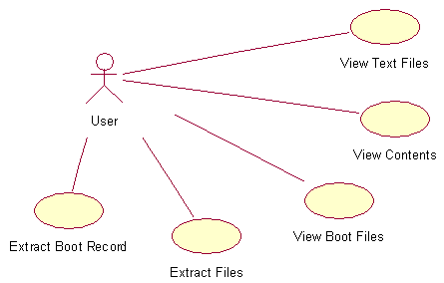

and Write:

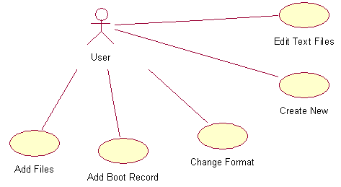

2.3 Scenarios and System Sequence Diagrams

Notes:
- Each scenario has roughly the same name as the use case it belongs too.
- 'The system asks the user to confirm' and 'the system confirms' mean different things.
- Whenever the image needs to be updated, the actual update process is not described as it is too complicated and irrelevant. Instead it is said that the system 'creates an updated copy of the image'.

2.3.1 View Contents
Precondition: application has been started

Actor | System
Requests to see the available images. | Shows all files that match the *.iso mask in the current directory and allows the user to change the current directory.
Locates the desired image and requests that it is opened. | Confirms that the file can be opened. Identifies the image type. Reads basic file and directory information. If available, reads extended file and directory information. Displays files and directories.

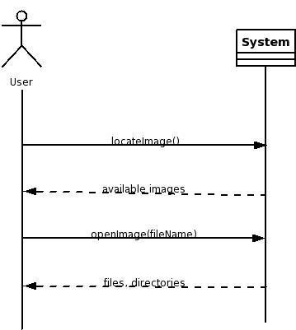

2.3.1.1 View Boot Files
This scenario is the same as 2.3.1 View Contents the only difference being that the contents of the boot record from the image rather then the files and directories from the image are displayed. Technically the two are very different but from the user's point of view they are the same.

2.3.2 Extract Files
Preconditions: application has been started; scenario 2.3.1 View Contents completed.

Actor | System
Requests that several files from the image are extracted. | Prompts the user for a path where the files should be extracted to.
Locates the desired directory. | Confirms there is enough space on the device to hold the files. Copies the files to the selected directory.

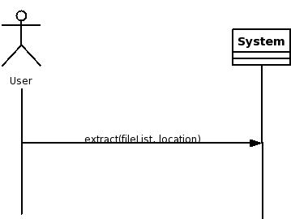

2.3.3 Extract Boot Record
Preconditions: application has been started; scenario 2.3.1 View Contents completed.

Actor | System
Requests that the boot record is extracted. | Prompts the user for a path to place the boot record and a filename for it.
Locates the desired directory, enters a name for the boot record. | Creates a file in the format of a raw floppy disk image. This is commonly used by CD writing applications.

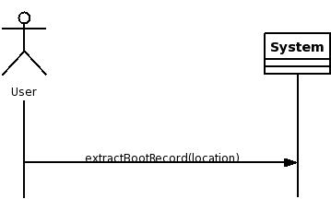

2.3.4 View Text File
Preconditions: application has been started; scenario 2.3.1 View Contents completed.

Actor | System
Locates the desired text file. Requests that the chosen file be displayed. | Confirms the selected file contains ASCII text and not binary data. Copies the selected file to a temporary location. Executes the application set as desired text editor and passes the name of the temporary file as a parameter.
Views the file. Closes the text editor. | Deletes the temporary file.

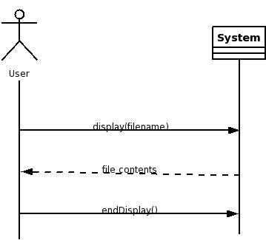

2.3.4.1 Edit Text File
Preconditions: application has been started; scenario 2.3.1 View Contents completed.

Actor | System
Locates the desired text file. Requests that the chosen file be edited. | Confirms the selected file contains ASCII text and not binary data. Copies the selected file to a temporary location. Executes the application set as desired text editor and passes the name of the temporary file as a parameter.
Changes the file. Saves the changes. Closes the text editor. Requests the image to be saved. | Confirms that the file has been changed. Confirms the image will not grow larger then will fit on a CD. Creates an updated copy of the image. Removes the original image. Renames the updated image to match the name of the original.

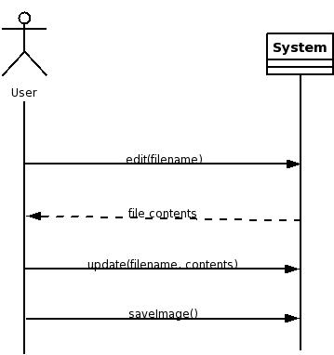

2.3.5 Add Files
Preconditions: application has been started; scenario 2.3.1 View Contents completed.

Actor | System
Requests several files to be added to the image. | Confirms the image will not grow larger then will fit on a CD. Shows a visual confirmation to the user.
Requests that the image be saved. | Creates an updated copy of the image. Removes the original image. Renames the updated image to match the name of the original.

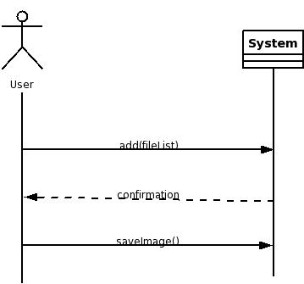

2.3.6 Add Boot Record from a File
Preconditions: application has been started; scenario 2.3.1 View Contents completed.

Actor | System
Requests to add a boot record to the image. | Prompts the user for the path and name of the file to use as a boot record.
Locates the file to be used as a boot record for the image. | Confirms that the file is in the format of a raw floppy disk image. Confirms that the size of the file does not exceed the maximum allowed for a boot record. Shows a visual confirmation to the user.
Requests that the image be saved. | Creates an updated copy of the image. Removes the original image. Renames the updated image to match the name of the original.

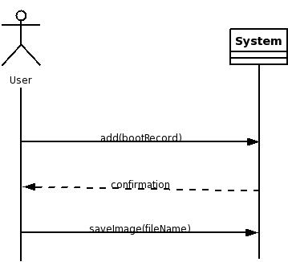

2.3.7 Change Format
Preconditions: application has been started; scenario 2.3.1 View Contents completed.

Actor | System
Requests that the image be saved without the extended file information. | Creates an updated copy of the image. Removes the original image. Renames the updated image to match the name of the original.

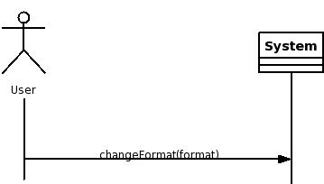

2.3.8 Create New
Precondition: application has been started.

Actor | System
Requests that a new image be created. | Asks user to select from choices about the image format.
Chooses the desired format. Requests that the blank image be saved. | Prompts the user for a path to place the image and a filename for it.
Locates the desired directory, enters a name for the image. | Creates a blank image with appropriate headers to describe the chosen format.

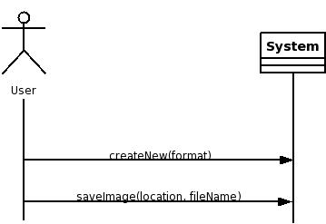

2.4 Stakeholders
- Users of the application who need to modify an image with minimal effort in the least amount of time.
- Users of the image who need to be able to record the new (modified) image and successfully read all the files as displayed by the ISO Editor.
- Maintainers of any Linux distribution who wish to provide a complete set of applications with their distribution.

3. Business Rules
- While creating or editing an image, the application may not modify or remove files without letting the user know.
- The application must not depend on Gnome or KDE libraries. Unusual dependencies must be avoided in order to ease installation.

4. Implementation Plan
The system will be imlemented in two stages. Use cases will have a significant but not decisive role in the developement process. The greatest implementation challenge is the interface between application and operating system rather then between application and users. The reason for creating this application is to hide the complexity of reading and writing images from the user, thus the interface will be as simple as possible.

4.1 Stage1 - Library
A library will be created to perform the operations described in the use case scenarios. Having this library will minimize the time required to develop a user interface.
The code written in this stage will be based on the official standards (ISO9660, Joliet, Rock Ridge, etc.) governing arrangement of data on a disk/image. Thorough understanding of the standards is required. Bugs in the library will have devastating effects on any application (user interface) using it.

4.2 Stage2 - User Interface
The user interface will be using the GTK library and the library developed in Stage1. Moderate skill with the GTK library will be necessary when the work begins.
At this stage the layout of the windows and the actions associated with events (clicks, drags, key presses) will be implemented. This will be done according to the use case specifications.

5. Financial Analysis
The application benefit the users in two ways:
- The user will not have to learn the commands to edit images. It is important to note that some users who might want to edit an image will refuse to learn the commands and will ask someone else for help unless they have an easy-to use graphical application. The value of this benefit is very hard to calculate thus it is not included in the analysis.
- Whether the user is familiar with the commands or not, he will save a significant ammount of time editing or viewing the contents of the image.

Since the application will be open-source, it is hoped to become beneficial to many people around the world. The example attached in FinancialAnalysis.xls is for creating and updating the daily images of the Debian Linux distribution. The ammount has been calculated as follows:
- Number of hours (a year) spent creating/editing 15 images daily without using the application: 15/60x15x7x4x12=1260
- Number of hours (a year) spent using the application: 5/60x15x7x4x12=420
- Number of hours (a year) saved: 1260-420=840
- At 20$/hour that's 840*20=16800$

6. Meetings and Interviews
Starting in May 2005 several hours have been spent every week communicating with people interested in this project over the internet. Opinions were solicited about the desired features in an image editor. The list of message boards and newsgroups follows:
- http://forums.linuxiso.org/
- http://www.linuxquestions.org/questions/
- http://forums.lugradio.org/
- nntp://alt.os.linux
- nntp://alt.os.linux.slackware

John Selmys has been consulted about the validity of the requirements, the various windowing libraries available, the scope of the project and the overall progress. Meetings with him were frequent (2-3 a week) but random (thus not logged).

