Contents
These are casual use case specifications for all use cases in the use case diagram.

The use case diagram can be found at http://cs1.senecac.on.ca/~b5301a07/bts530/UseCaseDiagram.odp

Each use case has only one key happy day scenario. As per instructor's request, no exception scenarios have been provided.

Casual use case specification: View Contents
Precondition: application has been started

Actor | System
Requests to see the available images. | Shows all files that match the *.iso mask in the current directory and allows the user to change the current directory.
Locates the desired image and requests that it is opened. | Confirms that the file can be opened. Identifies the image type. Reads basic file and directory information. If available, reads extended file and directory information. Displays files and directories.

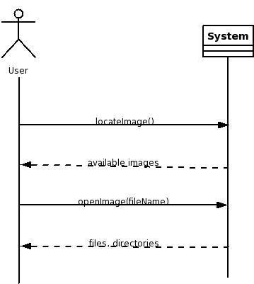

Casual use case specification: Extract Files
Preconditions: application has been started; image contents displayed.

Actor | System
Requests that several files from the image are extracted. | Prompts the user for a path where the files should be extracted to.
Locates the desired directory. | Confirms there is enough space on the device to hold the files. Copies the files to the selected directory.

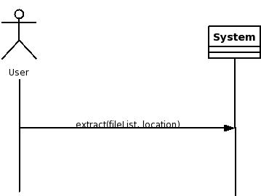

Casual use case specification: Extract Boot Record
Preconditions: application has been started; image contents displayed

Actor | System
Requests that the boot record is extracted. | Prompts the user for a path to place the boot record and a filename for it.
Locates the desired directory, enters a name for the boot record. | Creates a file in the format of a raw floppy disk image. This is commonly used by CD writing applications.

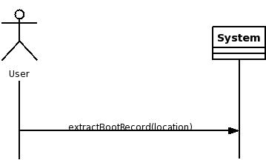

Casual use case specification: View Text File
Preconditions: application has been started; image contents displayed.
Actor | System
Locates the desired text file. Requests that the chosen file be displayed. | Confirms the selected file contains ASCII text and not binary data. Copies the selected file to a temporary location. Executes the application set as desired text editor and passes the name of the temporary file as a parameter.
Views the file. Closes the text editor. | Deletes the temporary file.

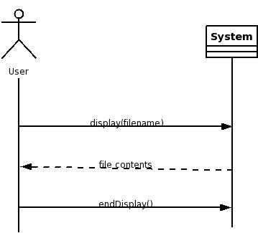

Casual use case specification: Edit Text File
Preconditions: application has been started; image contents displayed.

Actor | System
Locates the desired text file. Requests that the chosen file be edited. | Confirms the selected file contains ASCII text and not binary data. Copies the selected file to a temporary location. Executes the application set as desired text editor and passes the name of the temporary file as a parameter.
Changes the file. Saves the changes. Closes the text editor. Requests the image to be saved. | Confirms that the file has been changed. Confirms the image will not grow larger then will fit on a CD. Creates an updated copy of the image. Removes the original image. Renames the updated image to match the name of the original.

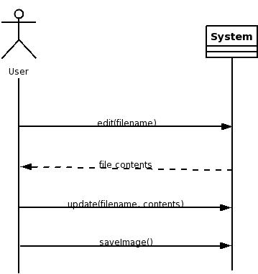

Casual use case specification: Add Files
Preconditions: application has been started; image contents displayed.

Actor | System
Requests several files to be added to the image. | Confirms the image will not grow larger then will fit on a CD. Shows a visual confirmation to the user.
Requests that the image be saved. | Creates an updated copy of the image. Removes the original image. Renames the updated image to match the name of the original.

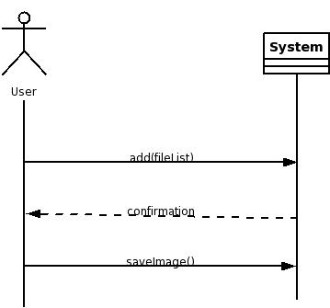

Casual use case specification: Add Boot Record from a File
Preconditions: application has been started; image contents displayed.

Actor | System
Requests to add a boot record to the image. | Prompts the user for the path and name of the file to use as a boot record.
Locates the file to be used as a boot record for the image. | Confirms that the file is in the format of a raw floppy disk image. Confirms that the size of the file does not exceed the maximum allowed for a boot record. Shows a visual confirmation to the user.
Requests that the image be saved. | Creates an updated copy of the image. Removes the original image. Renames the updated image to match the name of the original.

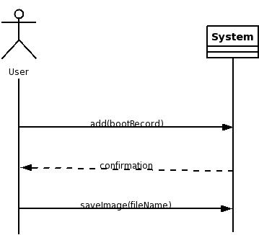

Casual use case specification: Change Format
Preconditions: application has been started; image contents displayed.

Actor | System
Requests that the image be saved without the extended file information. | Creates an updated copy of the image. Removes the original image. Renames the updated image to match the name of the original.

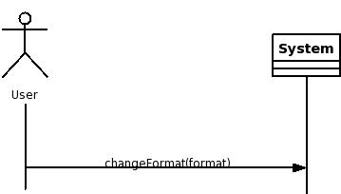

Casual use case specification: Create New
Precondition: application has been started.

Actor | System
Requests that a new image be created. | Asks user to select from choices about the image format.
Chooses the desired format. Requests that the blank image be saved. | Prompts the user for a path to place the image and a filename for it.
Locates the desired directory, enters a name for the image. | Creates a blank image with appropriate headers to describe the chosen format.

