This document has been converted from the original publication:
Barry, K. M., Cavers, D. A. and Kneale, C. W., 1975, Report on recommended standards for digital tape formats: Geophysics, 40, no. 02, 344-352.
Digital field tape format standards — SEG-D

SEG Subcommittee on Digital Tape Formats

The evolving nature of the seismic data acquisition requires a corresponding change in the recording techniques of these data. Several recording formats have been defined in the past to accommodate the previous changes in instrumentation. They were: SEG's A, B, C, and Y. The following described format includes the best features from these previous formats plus additional characteristics.
By using this new tape format, the data may be multiplexed or demultiplexed, the multiplexed records may be gapped or gapless. The data values are recorded in one of six methods; they are: eight bits or sixteen bits using a quaternary or hexadecimal exponent, twenty bits with a binary exponent, or thirty-two bits with a hexadecimal exponent. The diversity of information to be recorded required a record header that would self-define all the recorded data. Each seismic channel can be individually identified as to its start-stop time, sampling interval, filtering and type of data information recorded.
Included are examples of the defined parameters, example calculations, a glossary, and descriptors for the abbreviations used.

INTRODUCTION

During the past 12 years, a number of recommendations have been published describing proposed tape format standards for both seismic field recording and for seismic trade data (ANSI, 1973a, b, 1976). Many of today's needs, however, were not anticipated in these designs. For example, past formats do not provide for submillisecond sampling intervals, are limited in range and slope of filters, arc restricted in the number of recording channels, and make no provisions for either multiple sampling intervals or dynamic changes in parameters such as filters or sampling intervals. This proposal's objective is to overcome these restrictions while at the same time maintaining some compatibility with the presently used formats.
We propose a family of formats all with the same header structure, encompassing both multiplexed and demultiplexcd data, with 1, 2, 2½, and 4 byte data words. It is not intended to replace SEG's A, B, C, or Y standard formats. (Northwood et al, 1967; Meiners et al, 1972; Barry et al, 1975). The family is given the designation SEG-D followed by a code number defining the type of data word, and the designation "multiplexed" or "demultiplexed." The code numbers recommended are listed in Appendix A under Bytes 3 and 4 of the general header.

GENERAL FORMAT

The following requirements have been incorporated:

(1) The nine track one-half inch tape is retained, but extension to 6250 BPI is permitted as long as it is compatible with the ANSI standard (ANSI 1973a, b, 1976).
(2) Both multiplexed and demultiplexed field tape formats are represented.
(3) Various word length formats are provided to allow trade-offs to be made when recording large numbers of channels at short sampling intervals.
(4) Multiple sets of data channels can be recorded, each operating at a different sampling interval, or each having other parameter differences (e.g., filters) during the record. The parameters can be constant throughout the record, or can be dynamically switched at some predetermined time.
(5) The format is self-defining. Information in the header specifies the length of the header and the length of the data record.
(6) A one's complement number system is selected for the fractional part in all binary and quaternary exponent data recording methods. A sign and magnitude number system is selected for the fractional part of all hexadecimal exponent data recording methods.
(7) A unique four byte start of scan code is used. Status bits are provided to indicate dynamic changes starting with this scan.
(8) Submillisecond timing words are incorporated to allow shorter sampling interval systems to have a unique timing word in each scan.
(9) One start of scan code followed by a timing word is utilized in all multiplexed formats in order to facilitate software and hardware synchronization.
(10) Provisions are made for recording the instrument sample skew in the header. (This does not include cable propagation delay which must be established by the user.)

FORMAT OVERVIEW

The overall tape layout is as follows:

Leader
BOT
Seismic record file 1
EOF
Seismic record file 2
EOF

•
•
•

Seismic record file n
EOF
EOF
EOT
Trailer

As shown in Figure 1, each seismic record consists of a file of two or more blocks. The first block contains the record headers. Following the header block will be one or more blocks of multiplexed data (Figure 2) or of demultiplexed data (Figure 3). Seismic records are separated by one end. of file mark (EOF). Two EOF marks indicate that there are no more seismic records on the tape.

HEADER BLOCK — FUNCTIONAL DESCRIPTION

The record header block is a single block of information separated from the data by a standard inter-block gap. The record header block is composed of a general header, one or more scan type headers and, optionally, the extended and external headers (Figure 1). All header information is packed BCD unless otherwise specified, with bit positions 0-3 being the most significant digit. Appendix A has a detailed listing of the information contained in the general and scan type headers.

General header (required)

The general header is 32 bytes long and contains information similar to SEG A, B, and C headers (Figure 4). Abbreviations (Appendix D) are as close as possible to those used in previous formats.

Scan type header (required)
The scan type header is new. It is used to describe the information of the recorded channels [filters, sampling intervals, sample skew, etc. (Figure 6)]. The scan type header is composed of one or more channel set descriptors followed by skew information. The channel set descriptors must appear in the same order as their respective channel sets will appear within a base scan interval. A channel set, which is part of a scan type, is defined as a group of channels all recorded with identical recording parameters. One or more channel sets can be recorded concurrently within one scan type. In addition, there can be multiple scan types to permit dynamic scan type changes during the record (e.g., 12 channels at ½ msec switched at about 1 sec to 48 channels at 2 msec). Where there are dynamic changes, scan type header 1 describes the first part of the record, scan type header 2 the second part, etc. Within the scan type header, each channel set descriptor is composed of a 32 byte field (Figure 5), and up to 99 channel set descriptors may be present. In addition, up to 99 scan type headers may be utilized in a record.
Following the channel set descriptors of a scan type are a number of 32 byte fields (SK, specified in Byte 30 of the general header) that specify sample skew. Sample skew (SS) is recorded in a single byte for each sample of each subscan of each channel set, in the same order as the samples are recorded in the scan. Each byte represents a fractional part of the base scan interval (Byte 23 of the general header). The resolution is 1/256 of this interval. For instance, if the base scan interval is 2 msec, the least significant bit in the sample skew byte is 1/256 of 2 msec or 7.8125 µsec. The reference point for the skew is the timing word (T) such that the timing word represents zero skew. The actual time the sample was taken is obtained by adding the timing word (T) to the product of the sample skew (SS) and the base scan interval (I). (Actual time = T + SS x I.)
The following is a list of ground roles for the scan type header:

(1) The order in which channel sets are described in the header will be the same as the order in which the data are recorded for each channel set. (See multiplexed data example 6.)
(2) In a scan type header containing multiple channel set descriptors with different sampling intervals, each channel set descriptor will appear only once in each scan type header. Within the data block, however, shorter sampling interval data are recorded more frequently (i.e., within a base scan interval, channel sets of a shorter sampling interval will appear as multiple subscans). The number of subscans of a channel set is equal to the quotient of the base scan interval divided by the channel set sampling interval [see Byte 12 of the descriptor for this channel set (Figure 5)].
(3) In the case of multiple scan type records, such as the dynamically switched sampling interval case, each scan type will contain the same number of channel sets. Any unused channel sets needed in a scan type must be so indicated by setting Bytes 9 and 10 (channels per channel set) to zero in the channel set descriptor (Appendix A).
(4) In multiple scan type records, the number of bytes per base scan interval must remain a constant for all scan types recorded.
(5) The data recording method is not permitted to change on a reel of tape. However, multiplexed and demultiplexed data may appear on the same reel. For example, one or more multiplexed or demultiplexcd records may be recorded on tape followed by a multiplexed or demultiplexed stacked record of the same data with the same word length and data recording method.
(6) Although not essential, it is suggested that the channel set order within a scan type be: auxiliary channels, long sampling interval channels, short sampling interval channels. All
channel sets of the same sampling interval should be contiguous (see Example 4).

Extended header (optional)

The extended header provides additional areas to be used by equipment manufacturers to interface directly with their equipment. An example of this would be a vertical stacking unit used in conjunction with the data acquisition system (e.g., records per stack, records rejected in stack, type of stack, etc.). Since the nature of this data will depend heavily on the equipment and processes being applied, it will be the responsibility of the equipment manufacturer to establish a format and document this area. Byte 31 of the general header contains the number of 32 byte fields in the extended header.

External header (optional)

The external header provides a means of recording special user desired information in the header block. Some examples of this are roll box information, crew data, survey information, and a multiplicity of marine parameters. This data format will be defined and documented by the end user. The means of putting this information into the header has usually been provided by the equipment manufacturer. Byte 32 of the general header contains the number of 32 byte fields in the external header.

DATA BODY

Multiplexed

The multiplexed data may be gapped or gapless. A gapless multiplexed data block (Figure 2) is one continuous block of data separated from the header block by an interblock gap, and divided into an integral number of scans as defined in the header. If the multiplexed data body is gapped, each block must begin with a start-of-scan and must contain an integral number of scans. Bytes 24 and 25 of the general header indicate the number of scans in a block. Zero indicates gapless data.
In each scan the first eight bytes are dedicated to the start-of-scan code and timing word as shown in Figure 8. The sync code and timing word provide a means of recovering data that might otherwise be lost, and allow various checks to be made on the integrity of the data while it is being read during processing.
The 8 byte start-of-scan code and timing word overhead must be considered (counted) when computing the number of bytes per scan. The 8 byte start-of-scan and timing word format will remain the same in each of the different data recording methods. The start-of-scan code in each of the data recording methods described here must be maintained as a unique 4 byte code; therefore, there will be certain restrictions on the data in each of the different data recording methods which are covered in the individual format descriptions. (See general header Bytes 3 and 4.)
The 4 byte (start of scan) code as shown in Figure 8 and below is composed as follows: The first three bytes are all one's, and Bits 6 and 7 of Byte 4 must be a zero and a one, respectively, to guarantee uniqueness of the start of scan. The remaining bits (0-5) of Byte 4 are undefined (x) or are used as follows:

Start of scan
Bit | 0 | 1 | 2 | 3 | 4 | 5 | 6 | 7
Byte 1 | 1 | 1 | 1 | 1 | 1 | 1 | 1 | 1
Byte 2 | 1 | 1 | 1 | 1 | 1 | 1 | 1 | 1
Byte 3 | 1 | 1 | 1 | 1 | 1 | 1 | 1 | 1
Byte 4 | x | TWI | ITB | DP | x | x | 0 | 1

TWI. — This bit is included as an integrity check on time break. It changes from a zero to a one at the close of the time break window. Random variations in the time of this change indicate a problem in the fire control system. The presence of a one in the TWI bit of the first start of scan of a record indicates that time break was not detected and recording commenced at the end of the time break window.

ITB. — Intemal time break is recorded as a 1 for the entire record if an abnormal condition is detected in the synchronization of the system timing with the energy source timing. Otherwise it is recorded as a zero.

DP. — The dynamic parameter change bit is recorded as a zero for the first scan of every record and remains a zero throughout the first scan type. It is switched from a zero to a one to indicate the first scan of the second scan type which contains the first data taken after a dynamic parameter change has occurred. It will remain a one throughout the second scan type until another dynamic parameter change occurs, at which time it will be switched to a zero. It is alternately switched at each subsequent scan type. For records without dynamic parameter changes, it is recorded as a zero throughout the record.
The next three bytes (Bytes 5-7 of the scan) are dedicated to a binary timing word as shown in Figure 8 and below. Byte 8 is written as all zeros. The timing word is in milliseconds and has the following bit weight assignments:

Timing word
Bit | 0 | 1 | 2 | 3 | 4 | 5 | 6 | 7
Byte 5 | 2¹⁵ | 2¹⁴ | 2¹³ | 2¹² | 2¹¹ | 2¹⁰ | 2⁹ | 2⁸
Byte 6 | 2⁷ | 2⁶ | 2⁵ | 2⁴ | 2³ | 2² | 2¹ | 2⁰
Byte 7 | 2⁻¹ | 2⁻² | 2⁻³ | 2⁻⁴ | 2⁻⁵ | 2⁻⁶ | 2⁻⁷ | 2⁻⁸
Byte 8 | 0 | 0 | 0 | 0 | 0 | 0 | 0 | 0

The timing word LSB (2-8) is equal to 1/256 msec, and the MSB (215) is equal to 32,768 msec. The timing word for each scan is equal to the elapsed time from zero time to the start of that scan. Timing words of from 0 to 65,535.9961 msec are codable. For longer recordings the timing word may overflow to zero and then continue.
The first scan of data has typically started with timing word zero. However, this is not a requirement. In a sampling system, it is not always practical to resynchronize the system even though most seismic data acquisition systems have to date. Possible reasons for not wanting to resynchronize could be digital filtering, communication restrictions, etc.
Whether the system is resynchronized or not, the timing word will contain the time from the energy source event to the start of scan of interest. For example, assume the sampling interval is 2 msec, the system does not resynchronize, and the energy source event occurs 1 + 9/256 msec before the next normal start of scan. The timing word values would be:

First timing word | 0 + 1 + 9/256 msec
Second | 2 + 1 + 9/256 msec
Third | 4 + 1 + 9/256 msec
Fourth | 6 + 1 + 9/256 msec
•
•
•
One-thousandth timing word | 1998 + 1 + 9/256 msec

Demultiplexed

The demultiplexed data format (Figure 3) is simply an extension of the multiplexed format previously described (Figure 2). In an equivalent system, it would utilize the same header block as its multiplexed counterpart with the exception of the format code in Bytes 3 and 4 and bytes per scan in Bytes 20, 21, and 22 of the general header. The data body portion of the multiplexed format (as shown in Figure 2) is replaced with individual trace blocks (Figure 3) including a trace header (see Figure 9 and below) for all channels in each channel set of each scan type. Each trace block is separated by a standard inter block gap of erased tape and is a sequential set of points from one channel in one channel set. The data recording methods utilized within the trace blocks are described later in the section titled "Data recording method."
Trace header. — The trace header length is 20 bytes and is an identifier that precedes each channel's data. The trace header and the trace data are recorded as one block of data. A trace is restricted to one channel of data from one channel set of one scan type. All the information in the trace header is taken directly from the general header and scan type header with the exception of the channel number and the time break window end time. File number, scan type, channel set, and channel (or trace) number are recorded in packed BCD.
Bytes 7, 8, and 9 comprise the timing word that would accompany the first sample if these data were written in the multiplexed format. To obtain the exact sample time, the actual sample skew time (Byte 11 multiplied by the base scan interval) must be added to the time recorded in Bytes 7, 8, and 9.
Byte 11 contains sample skew of the first sample of this trace. This is identical to the first byte of sample skew for this channel in the scan type header.
Bytes 13, 14, and 15 are included as an integrity check on time break. They comprise the timing word of the scan in which TWI changed to a one. Thus, it represents the time from time break to the end of the time break window. Random variations in this time indicate a problem in the fire control system. The presence of a value less than the base scan interval indicates that time break was not detected and recording commenced at the end of the time break window.
Trace header
 | Bit | 0 | 1 | 2 | 3 | 4 | 5 | 6 | 7
File number | Byte 1 | F₁ | F₁ | F₁ | F₁ | F₂ | F₂ | F₂ | F₂
 | Byte 2 | F₃ | F₃ | F₃ | F₃ | F₄ | F₄ | F₄ | F₄
Scan type | Byte 3 | ST₁ | ST₁ | ST₁ | ST₁ | ST₂ | ST₂ | ST₂ | ST₂
Channel set | Byte 4 | CN₁ | CN₁ | CN₁ | CN₁ | CN₂ | CN₂ | CN₂ | CN₂
Channel or trace number | Byte 5 | TN₁ | TN₁ | TN₁ | TN₁ | TN₂ | TN₂ | TN₂ | TN₂
Channel or trace number | Byte 6 | TN₃ | TN₃ | TN₃ | TN₃ | TN₄ | TN₄ | TN₄ | TN₄
First timing word | Byte 7 | T₁₅ | T₁₄ | T₁₃ | T₁₂ | T₁₁ | T₁₀ | T₉ | T₈
First timing word | Byte 8 | T₇ | T₆ | T₅ | T₄ | T₃ | T₂ | T₁ | T₀
First timing word | Byte 9 | T₋₁ | T₋₂ | T₋₃ | T₋₄ | T₋₅ | T₋₆ | T₋₇ | T₋₈
First timing word | Byte 10 | 0 | 0 | 0 | 0 | 0 | 0 | 0 | 0
Sample skew | Byte 11 | SS₋₁ | SS₋₂ | SS₋₃ | SS₋₄ | SS₋₅ | SS₋₆ | SS₋₇ | SS₋₈
Sample skew | Byte 12 | 0 | 0 | 0 | 0 | 0 | 0 | 0 | 0
Time break window end | Byte 13 | TW₁₅ | TW₁₄ | TW₁₃ | TW₁₂ | TW₁₁ | TW₁₀ | TW₉ | TW₈
Time break window end | Byte 14 | TW₇ | TW₆ | TW₅ | TW₄ | TW₃ | TW₂ | TW₁ | TW₀
Time break window end | Byte 15 | TW₋₁ | TW₋₂ | TW₋₃ | TW₋₄ | TW₋₅ | TW₋₆ | TW₋₇ | TW₋₈
 | Byte 16 | 0 | 0 | 0 | 0 | 0 | 0 | 0 | 0
 | Byte 17 | 0 | 0 | 0 | 0 | 0 | 0 | 0 | 0
 | Byte 18 | 0 | 0 | 0 | 0 | 0 | 0 | 0 | 0
 | Byte 19 | 0 | 0 | 0 | 0 | 0 | 0 | 0 | 0
 | Byte 20 | 0 | 0 | 0 | 0 | 0 | 0 | 0 | 0

DATA RECORDING METHOD
To accommodate diverse recording needs, the data recording utilizes sample sizes of 8, 16, 20, and 32 bits.
The data word is a number representation of the sign and magnitude of the instantaneous voltage presented to the system. It is not an indication of how the hardware gain system functions. The output of stepped gain systems may be represented as a binary mantissa and a binary exponent of base 2, 4, or 16 (binary, quaternary, or hexadecimal system).
Following are descriptions of each of the data recording methods permitted. The same number system is to be used on all samples in a record, including auxiliary and all other types of channels. All recording methods are valid for multiplexed and demultiplexed records. The 2½ byte binary demultiplexed method uses the LSB whereas the comparable multiplexed method does not (in order to preserve the uniqueness of the start of scan code).

1 byte quaternary exponent data recording method

The following illustrates the 8 bit word and the corresponding bit weights:

Bit | 0 | 1 | 2 | 3 | 4 | 5 | 6 | 7
Byte 1 | S | C₂ | C₁ | C₀ | Q₋₁ | Q₋₂ | Q₋₃ | Q₋₄

S = sign bit. — (One = negative number).
C = quaternary exponent. — This is a three bit positive binary exponent of 4 written as 4^{CCC} where CCC can assume values from 0-7.
Q₁₋₄-fraction. — This is a 4 bit one's complement binary fraction. The radix point is to the left of the most significant bit (Q₋₁) with the MSB being defined as 2⁻¹. The fraction can have values from - 1 + 2-4 to 1 - 2-4. In order to guarantee the uniqueness of the start of scan, negative zero is invalid and must be convened to positive zero.
Input signal = S.QQQQ x 4^{CCC} x 2^{MP} millivolts where 2^{MP} is the value required to descale the data sample to the recording system input level. MP is defined in Byte 8 of each channel set descriptor in the scan type header.

2 byte quaternary exponent data recording method

The following illustrated the 16-bit word and the corresponding bit weights:

Bit | 0 | 1 | 2 | 3 | 4 | 5 | 6 | 7
Byte 1 | S | C₂ | C₁ | C₀ | Q₋₁ | Q₋₂ | Q₋₃ | Q₋₄
Byte 2 | Q₋₅ | Q₋₆ | Q₋₇ | Q₋₈ | Q₋₉ | Q₋₁₀ | Q₋₁₁ | Q₋₁₂

S = sign bit. — (One = negative number).
C = quaternary exponent. — This is a three bit positive binary exponent of 4 written as 4^{CCC} where CCC can assume values from 0-7.
Q₁₋₁₂ — fraction. — This is a 12 bit one's complement binary fraction. The radix point is to the left of the most significant bit (Q₋₁) with the MSB being defined as 2⁻¹. The fraction can have values from –1 + 2⁻¹² to 1 - 2⁻¹². In order to guarantee the uniqueness of the start of scan, negative zero is invalid and must be convened to positive zero.
Input signal = S.QQQQ,QQQQ,QQQQ x 4^{CCC} x 2^{MP} millivolts where 2^{MP} is the value required to de-scale the data sample to the recording system input level. MP is defined in Byte 8 of each channel set descriptor in the scan type header.

2½ byte binary exponent data recording method —multiplexed

The following illustrates the 20-bit word and the corresponding bit weights:

Bit | 0 | 1 | 2 | 3 | 4 | 5 | 6 | 7
Byte 1 | C₃ | C₂ | C₁ | C₀ | C₃ | C₂ | C₁ | C₀ | Exponent for channels 1 thru 4
Byte 2 | C₃ | C₂ | C₁ | C₀ | C₃ | C₂ | C₁ | C₀ | Exponent for channels 1 thru 4
Byte 3 | S | Q₋₁ | Q₋₂ | Q₋₃ | Q₋₄ | Q₋₅ | Q₋₆ | Q₋₇ | Channel 1
Byte 4 | Q₋₈ | Q₋₉ | Q₋₁₀ | Q₋₁₁ | Q₋₁₂ | Q₋₁₃ | Q₋₁₄ | 0 | Channel 1
Byte 5 | S | Q₋₁ | Q₋₂ | Q₋₃ | Q₋₄ | Q₋₅ | Q₋₆ | Q₋₇ | Channel 2
Byte 6 | Q₋₈ | Q₋₉ | Q₋₁₀ | Q₋₁₁ | Q₋₁₂ | Q₋₁₃ | Q₋₁₄ | 0 | Channel 2
Byte 7 | S | Q₋₁ | Q₋₂ | Q₋₃ | Q₋₄ | Q₋₅ | Q₋₆ | Q₋₇ | Channel 3
Byte 8 | Q₋₈ | Q₋₉ | Q₋₁₀ | Q₋₁₁ | Q₋₁₂ | Q₋₁₃ | Q₋₁₄ | 0 | Channel 3
Byte 9 | S | Q₋₁ | Q₋₂ | Q₋₃ | Q₋₄ | Q₋₅ | Q₋₆ | Q₋₇ | Channel 4
Byte 10 | Q₋₈ | Q₋₉ | Q₋₁₀ | Q₋₁₁ | Q₋₁₂ | Q₋₁₃ | Q₋₁₄ | 0 | Channel 4

S = sign bit. — (One = negative number).
C = binary exponents. — This is a 4 bit positive binary exponent of 2 written as 2^{CCCC} where CCCC can assume values of 0-15. The four exponents are in channel number order for the four channels starting with channel one in bits 0-3 of Byte 1.
Ql-14-fraction. — This is a 14 bit one's complement binary fraction. The radix point is to the left of the most significant bit (Q₋₁) with the MSB being defined as 2⁻¹. The sign and fraction can assume values from 1 - 2⁻¹⁴ to –1 + 2⁻¹⁴. Note that bit 7 of the second byte of each sample must be zero in order to guarantee the uniqueness of the start of scan. Negative zero is invalid and must be convened to positive zero.
Input signal = S.QQQQ,QQQQ,QQQQ,QQ x 2^{CCCC} x 2^{MP} millivolts where 2^{MP} is the value required to descale the data word to the recording system input level. MP is defined in Byte 8 of each of the corresponding channel set descriptors in the scan type header.
Note that in utilizing this data recording method, the number of data channels per channel set must be exactly divisible by 4 in order to preserve the data grouping of this method.

2½ byte binary exponent data recording method—demultiplexed

The following illustrates the 20 bit word and the corresponding bit weights:

Bit | 0 | 1 | 2 | 3 | 4 | 5 | 6 | 7
Byte 1 | C₃ | C₂ | C₁ | C₀ | C₃ | C₂ | C₁ | C₀ | Exponent for samples 1 thru 4
Byte 2 | C₃ | C₂ | C₁ | C₀ | C₃ | C₂ | C₁ | C₀ | Exponent for samples 1 thru 4
Byte 3 | S | Q₋₁ | Q₋₂ | Q₋₃ | Q₋₄ | Q₋₅ | Q₋₆ | Q₋₇ | Sample 1
Byte 4 | Q₋₈ | Q₋₉ | Q₋₁₀ | Q₋₁₁ | Q₋₁₂ | Q₋₁₃ | Q₋₁₄ | Q₋₁₅ | Sample 1
Byte 5 | S | Q₋₁ | Q₋₂ | Q₋₃ | Q₋₄ | Q₋₅ | Q₋₆ | Q₋₇ | Sample 2
Byte 6 | Q₋₈ | Q₋₉ | Q₋₁₀ | Q₋₁₁ | Q₋₁₂ | Q₋₁₃ | Q₋₁₄ | Q₋₁₅ | Sample 2
Byte 7 | S | Q₋₁ | Q₋₂ | Q₋₃ | Q₋₄ | Q₋₅ | Q₋₆ | Q₋₇ | Sample 3
Byte 8 | Q₋₈ | Q₋₉ | Q₋₁₀ | Q₋₁₁ | Q₋₁₂ | Q₋₁₃ | Q₋₁₄ | Q₋₁₅ | Sample 3
Byte 9 | S | Q₋₁ | Q₋₂ | Q₋₃ | Q₋₄ | Q₋₅ | Q₋₆ | Q₋₇ | Sample 4
Byte 10 | Q₋₈ | Q₋₉ | Q₋₁₀ | Q₋₁₁ | Q₋₁₂ | Q₋₁₃ | Q₋₁₄ | Q₋₁₅ | Sample 4

S = sign bit — (One = negative number).
C = binary exponent. — This is a 4 bit positive binary exponent of 2 written as 2^{CCCC} where CCCC can assume values of 0-15. The four exponents are in sample order for the four samples starting with the first sample in bits 0-3 of Byte 1.
Q₁₋₁₅ — fraction. — This is a 15 bit one's complement binary fraction. The radix point is to the left of the most significant bit (Q₋₁) with the MSB being defined as 2⁻¹. The sign and fraction can assume values from 1 – 2⁻¹⁵ to -1 + 2⁻¹⁵. Negative zero is invalid and must be convened to positive zero.
Input signal = S.Q, QQQ, QQQQ, QQQQ, QQQ 2cccc X 2^{MP} millivolts where 2^{MP} is the value required to descale the data word to the recording system input level. MP is defined in Byte 8 of each of the corresponding channel set descriptors in the scan type header.
Note that in utilizing this data recording method, the number of samples per channel must be exactly divisible by 4 in order to preserve the data grouping of this method.

1 byte hexadecimal exponent data recording method

The following illustrates the 8-bit word and the corresponding bit weights:

Bit | 0 | 1 | 2 | 3 | 4 | 5 | 6 | 7
Byte 1 | S | C₁ | C₀ | Q₋₁ | Q₋₂ | Q₋₃ | Q₋₄ | Q₋₅

S = sign bit. — (One - negative number).
C = hexadecimal exponent. —This is a two bit positive binary exponent of 16 written as 16^{CC} where CC can assume values from 0-3.
Q₁₋₅ — fraction. —This is a 5 bit positive binary fraction. The radix point is to the left of the most significant bit (Q₋₁) with the MSB being defined as 2⁻¹. The sign and fraction can have any value from -1 + 2⁻⁵ to 1 – 2⁻⁵. In order to guarantee the uniqueness of the start of scan, an all one's representation (sign = negative, exponent = 3, and fraction = 1 – 2⁻⁵) is invalid: Thus the full range of values allowed is -( l - 2⁻⁴ ) x 16³ to + ( l - 2⁻⁵ ) x 16³.
Input signal = S.QQQQ,Q x 16^{CC} x 2^{MP} millivolts where 2^{MP} is the value required to descale the data sample to the recording system input level. MP is defined in Byte 8 of each channel set descriptor in the scan type header.

2 byte hexadecimal exponent data recording method
The following illustrates the 16-bit word and the corresponding bit weights:

Bit | 0 | 1 | 2 | 3 | 4 | 5 | 6 | 7
Byte l | S | C₁ | C₀ | Q₋₁ | Q₋₂ | Q₋₃ | Q₋₄ | Q₋₅
Byte 2 | Q₋₆ | Q₋₇ | Q₋₈ | Q₋₉ | Q₋₁₀ | Q₋₁₁ | Q₋₁₂ | Q₋₁₃

S = sign bit. — (One = negative number).
C = hexadecimal exponent. — This is a two bit positive binary exponent of 16 written as 16^{CC} where CC can assume values from 0-3.
Q₁₋₁₃ — fraction. — This is a 13 bit positive binary fraction. The radix point is to the left of the most significant bit (Q₋₁ with the MSB being defined as 2⁻¹ the sign and fraction can have any value from -1 + 2⁻¹³ to 1- 2⁻¹³. In order to guarantee the uniqueness of the start of scan, an all one's representation (sign = negative, exponent = 3, and fraction = 1 – 2⁻¹³) is invalid. Thus the full range of values allowed is -(1 – 2⁻¹²) x 16³ to + (1 – 2⁻¹³) x 16³
Input signal = S.QQQQ,QQQQ,QQQQ,Q x 16^{CC} X 2^{MP} millivolts where 2^{MP} is the value required to descale the data sample to the recording system input level. MP is defined in Byte 8 of each channel set descriptor in the scan type header.

4 byte hexadecimal exponent data recording method

The following illustrates the 32-bit word and the corresponding bit weights:

Bit | 0 | 1 | 2 | 3 | 4 | 5 | 6 | 7
Byte 1 | S | C₆ | C₅ | C₄ | C₃ | C₂ | C₁ | C₀
Byte 2 | Q₋₁ | Q₋₂ | Q₋₃ | Q₋₄ | Q₋₅ | Q₋₆ | Q₋₇ | Q₋₈
Byte 3 | Q₋₉ | Q₋₁₀ | Q₋₁₁ | Q₋₁₂ | Q₋₁₃ | Q₋₁₄ | Q₋₁₅ | Q₋₁₆
Byte 4 | Q₋₁₇ | Q₋₁₈ | Q₋₁₉ | Q₋₂₀ | Q₋₂₁ | Q₋₂₂ | Q₋₂₃ | 0

S = sign bit. — (One = negative number).
C = excess 64 hexadecimal exponent. — This is a binary exponent of 16. It has been biased by 64 such that it represents 16^{(CCCCCCC-64)} where CCCCCCC can assume values from 0 to 127.
Q₁₋₂₃ — magnitude fraction.—This is a 23 bit positive binary fraction (i.e., the number system is sign and magnitude). The radix point is to the left of the most significant bit (Q₋₁) with the MSB being defined as 2⁻¹. The sign and fraction can assume values from 1 – 2⁻²³ to -( 1 + 2⁻²³). It must always be written as a hexadecimal left justified number. If this fraction is zero, the sign and exponent must also be zero (i.e., the entire word is zero). Note that bit 7 of Byte 4 must be zero in order to guarantee the uniqueness of the start of scan.
Input signal = S. QQQQ, QQQQ, QQQQ, QQQQ, QQQQ, QQQ x 16^{(CCCCCCC-64)} x 2^{MP} millivolts where 2^{MP} is the value required to descale the data sample to the recording system input level. MP is defined in Byte 8 of each channel set descriptor in the scan type header. This data recording method has more than sufficient range to handle the dynamic range of a typical seismic system. Thus, MP may not be needed to account for any scaling and may be recorded as zero.

EXAMPLES

Three sets of examples are given. The header block set illustrates the header lengths for various combinations of scan types and channel sets. The multiplexed data set of examples illustrates the organization of data within scans for an example which includes multiple scan types and multiple channel sets. The demultiplexed data set of examples illustrates the order of trace blocks for most of the examples.

Header block
The following examples describe the general and scan type headers required for each case. The optional extended and external headers are not included.

Example 1 — Typical 24 channel system (Figure 6A)
4 auxiliary channels at 2-msec sampling intervals
24 seismic channels at 2-msec sampling intervals
This system would contain one scan type header because there are no parameter changes during the record. This one scan type header would contain two channel set descriptors, one for the 4 auxiliary channels and one for the 24 seismic channels. The header block in this case would be as follows, assuming no extensions for the extended and external headers:

32 bytes | General header
 | Scan type header 1
32 bytes | auxiliary channel set
32 bytes | seismic channel set
32 bytes | sample skew (28 used)
128 bytes | Total header block

Example 2---24 channel system with parameter differences (Figure 6B)
4 auxiliary channels
12 seismic channels with 18-Hz low-cut filters
12 seismic channels with 36-Hz low-cut filters (2-msec sampling on all channels)
This example is similar to the previous one with the exception of needing one additional channel set descriptor, which is required because some of the seismic channels are operating at a different filter setting. The header block in this case would contain one additional 32 byte field.

32 bytes | General header
 | Scan type header 1
32 bytes | auxiliary channel set
32 bytes | seismic channel set (18-Hz low cut)
32 bytes | seismic channel set (36-Hz low cut)
32 bytes | sample skew (28 used)
160 bytes | Total header block

Example 3--Large system (Figure 6C)
4 auxiliary channels
240 seismic channels(4 msec sampling on all channels)
The header block in this case will be longer than in Example 1 because it will have additional bytes of sample skew.

32 bytes | General header
 | Scan type header 1
32 bytes | auxiliary channel set
32 bytes | seismic channel set
256 bytes | sample skew (244 used)
352 bytes | Total header block

Example 4---Dual sampling intervals
(Figure 7A)
4 auxiliary channels at 2-msec sampling interval
48 seismic channels at 2-msec sampling interval
12 seismic channels at ½ msec sampling interval (sampled four times in each scan)
In this case there would be three channel set descriptors required to make up the scan type header. The additional channel set descriptor is required to identify the channel set operating at ½ msec.

32 bytes | General header
 | Scan type header 1
32 bytes | auxiliary channel set
32 bytes | seismic channel set at 2 msec
32 bytes | seismic channel set at ½ msec
128 bytes | sample skew (100 used)
256 bytes | Total header block

Example 5---Dynamically switched sampling interval (Figure 7B)
Scan type header 1
4 auxiliary channels at 2-msec sampling interval
12 seismic channels at ½ msec sampling interval
Scan type header 2
4 auxiliary channels at 2 msec
48 seismic channels at 2 msec
This is a switched sampling interval system in which 12 of the channels will be sampled for a portion of the record at a V2-msec interval, then it will switch to 48 seismic channels at a 2-msec interval for the remainder of the record.
This system has a parameter change in mid-record and therefore requires a second scan type header to define it. Its header block would be constructed as follows:

32 bytes | General header
 | Scan type header 1
32 bytes | 4 auxiliary channels at 2 msec
32 bytes | 12 seismic channels at V2 msec
64 bytes | Sample Skew (52 used)
 | Scan type header 2
32 bytes | 4 auxiliary channels at 2 msec
32 bytes | 48 seismic channels at 2 msec
64 bytes | Sample skew (52 used)
288 bytes | Total header block

Example 6 — Dynamically switched sampling interval (Figure 7C)
This, as in Example 5, is a 2-msec base scan interval system that is dynamically switching sampling interval in mid-record. It starts as a 12 channel, ½ msec sampling interval system and ends as a 48 channel 2 msec sampling interval system with a common filter. The 12 channels in this example, though, are divided into 2 channel sets, with 6 channels utilizing low-cut filters and the remaining 6 without low-cut filters. The header block would be constructed in the following manner:

32 bytes | General header
 | Scan type header 1
32 bytes | 4 auxiliary channels at 2 msec
32 bytes | 6 seismic channels with low-cut  filters at ½ msec
32 bytes | 6 seismic channels without  low-cut filters at ½ msec
64 bytes | Sample skew (52 used)
 | Scan type header 2
32 bytes | 4 auxiliary channels at 2 msec
32 bytes | 48 seismic channels at 2 msec
32 bytes | 0 channels (dummy)
64 bytes | Sample skew (52 used)
352 bytes | Total header block

The dummy channel set descriptor is required in scan type header 2 in order to maintain its length equal to that of scan type header I. This preserves easy expandability of the format and its self-defining header length capability (see Appendix E4).

Multiplexed data
Example 6. — The multiplexed data block section of the seismic record is organized in the same order as the scan type headers and channel set descriptors they contain. Within each base scan in scan type 1, all of the data for channel set I are recorded before channel set 2. Likewise, all of the data for channel set 2 are recorded before channel set 3. Because the sampling interval for channel sets 2 and 3 is one-fourth of the base scan interval, each base scan will contain four subscans (a subscan contains one sample from each channel) of channel sets 2 and 3. Furthermore, all four subscans of channel set 2 are recorded before the four subscans of channel set 3. Thus the base scan interval is 2 msec and the data would be recorded in the following order: (I) start of scan and timing word; (2) four auxiliary channels in channel number sequence; (3a) six seismic channels with low-cut filters in channel number sequence; (3b) the second, third, and fourth set of samples of the channels in 3a; (4a) six seismic channels without low-cut filters in channel number sequence; and (4b) the second, third, and fourth sets of samples of the channels in (4a).
The pictorial representation of the multiplexed format of Example 6 as recorded on tape is shown below. Scan type 1 is:

Start of scan and timing word 2 msec base scan | 4 Auxiliary channels sampled once each | 4 Subscans of 6 seismic channels with low- cut filters sampled at ½ msec | 4 Subscans of 6 seismic channels without low- cut filters sampled at ½ msec

Note that this scan is repeated for the required number of scans until the channel set length is satisfied and the sampling interval is changed.
Scan type 2 is:
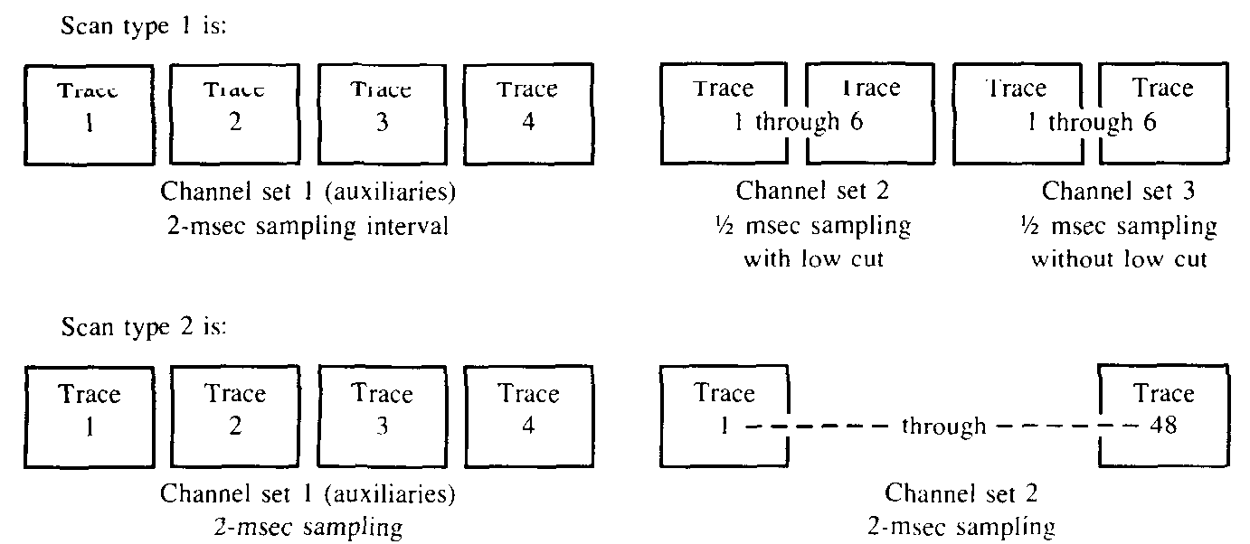
Note that there are no traces recorded for channel set 3 of scan type 2. There are 68 trace blocks total. Each new channel set starts with trace number 1.

Start of scan and timing word | 4 Auxiliary channels sampled once each at 2 msec | 48 Seismic channels sampled once each at 2 msec

Note that this scan type follows the recording of all of scan type 1 and repeats for the required number of scans. Scan types 1 and 2 have the same number of bytes per scan.

Demultiplexed data

The following examples are the demultiplexed versions of the previous examples given.

Example l. — Typical 24 channel system
The trace blocks in this case would be in the following order.
4 traces of auxiliary channels
24 traces of seismic data
28 trace blocks total

The channel order above is the same order in which the channel descriptions appear in the scan type header. All other examples of one scan type system follow this pattern.

Example 2. — 24 channel system with parameter differences
The trace blocks in this case would be in the following order.
4 traces of auxiliary channels
12 traces of seismic data with 18-Hz low-cut filters
12 traces of seismic data with 36-Hz low-cut filters
28 trace blocks total

Example 3.— Is similar to Example 1, but it has 240 traces of seismic data, resulting in 244 trace blocks total.

Example 4. — Dual sampling intervals
The trace blocks in this case would be in the following order.
4 traces of auxiliary channels
48 traces of seismic data recorded at a 2 msec sampling interval
12 traces of seismic data recorded at a ½ msec sampling interval
64 trace blocks total

Example 5. — Dynamically switched sampling interval
The trace blocks appear in the following order.
4 traces of auxiliary channels, recorded for the length of scan type 1
12 traces of seismic channels, recorded for the length of scan type 1
4 traces of auxiliary channels, recorded for the length of scan type 2
48 traces of seismic channels, recorded for the length of scan type 2
68 trace blocks total

Example 6. — The following is Example 6 again illustrating in graphical form the order of the trace blocks on tape. Note that even though auxiliary traces 1 to 4 are the same channels in both scan types, the data collected during the time of scan type 1 is recorded separately from those in scan type 2.

REFERENCES
American National Standards Institute,
1973a, Recorded magnetic tape for information exchange, 800 BPI: ANSI X3.22-1973.
1973b, Recorded magnetic tape for information exchange, 1600 BPI: ANSI X3.39-1973.
1976, Recorded magnetic tape for information exchange, 6250 BPI: ANSI X3.54-1976.
Barry, K.M., Cavers, D.A., and Kneale, C.W., 1975, Recommended standards for digital tape formats: Geophysics, v. 40, p. 344-352.
Dampney, C.N.G., Funkhouser, D., and Alexander, M., 1978, Structure of the SEG point data exchange and field formats: Geophysics, v. 43, p. 216-227.
Meiners, E.P., Lenz, L.L., Dalby, A.E., and Hornsby, J.M., 1972, Recommended standards for digital tape formats: Geophysics, v. 37, p. 36-44.
Northwood, E.J., Weisinger, R.C., and Bradley, J.J., 1967, Recommended standards for digital tape formats: Geophysics, v. 32, p. 1073-1084.

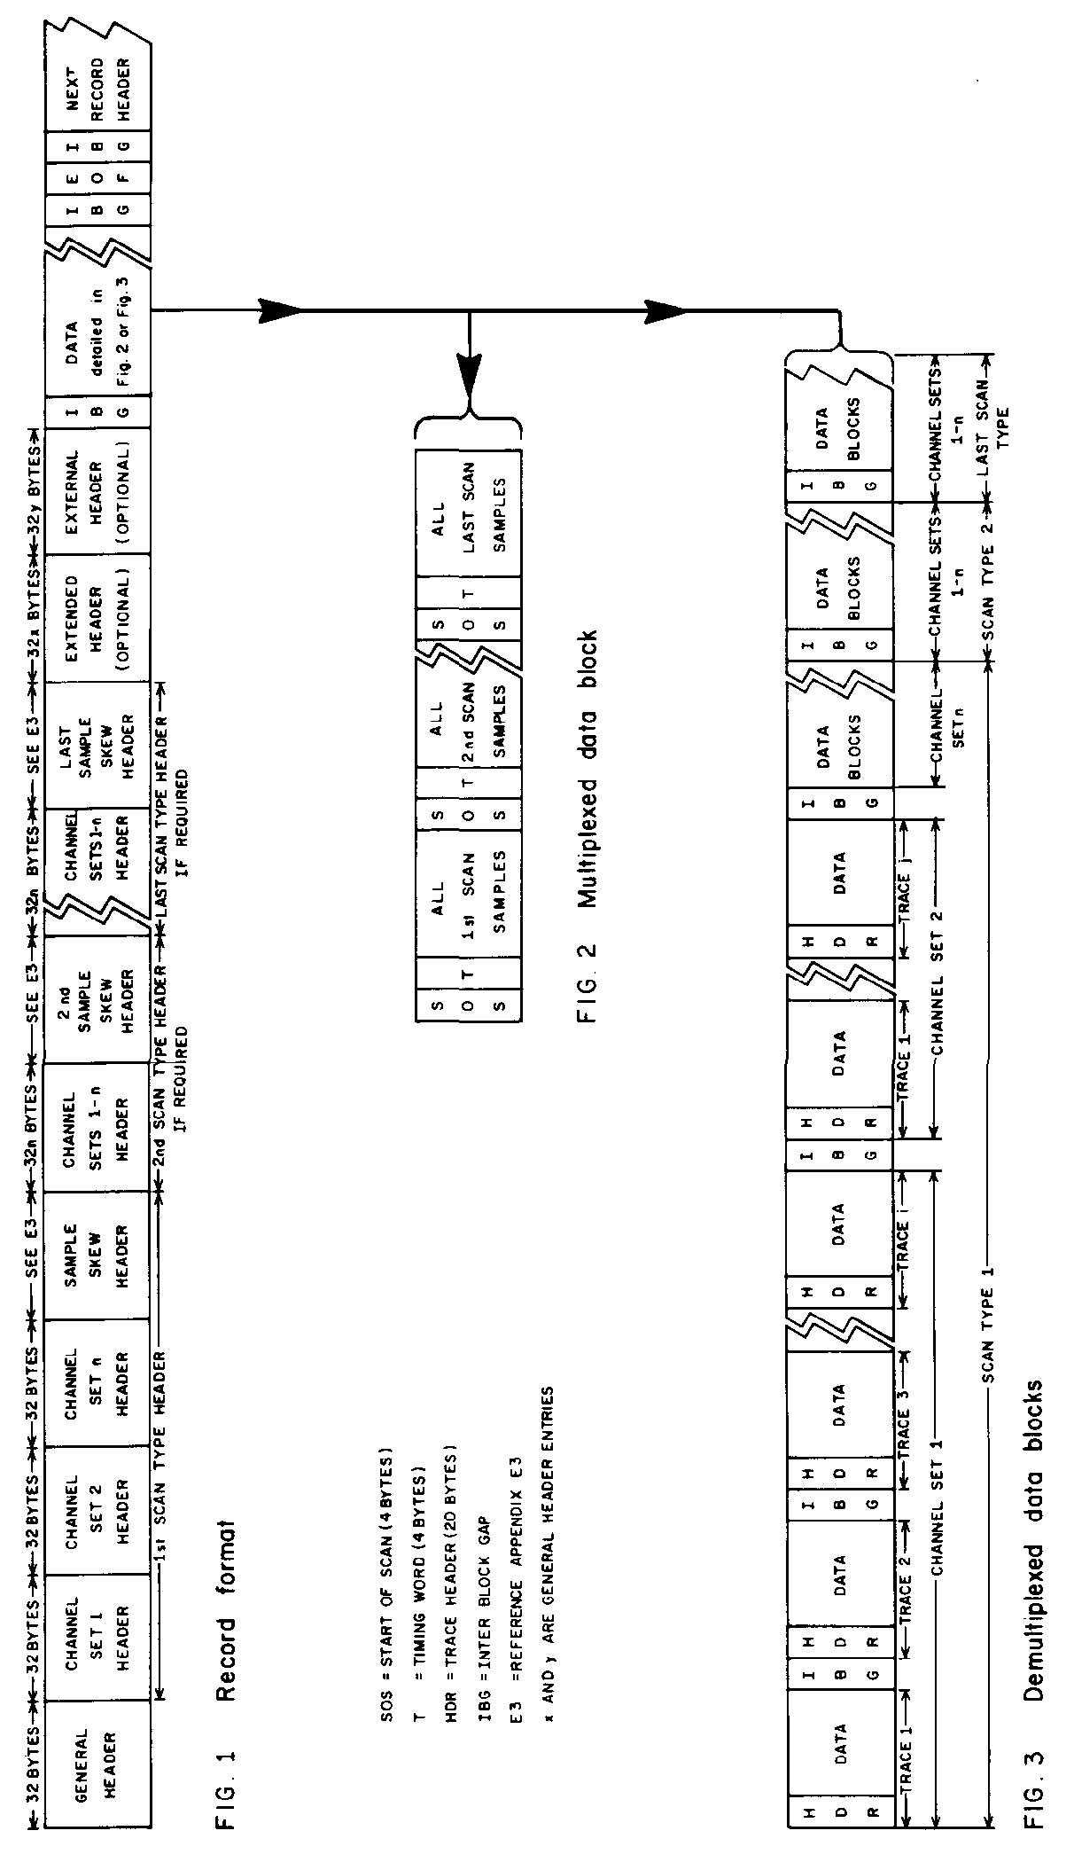
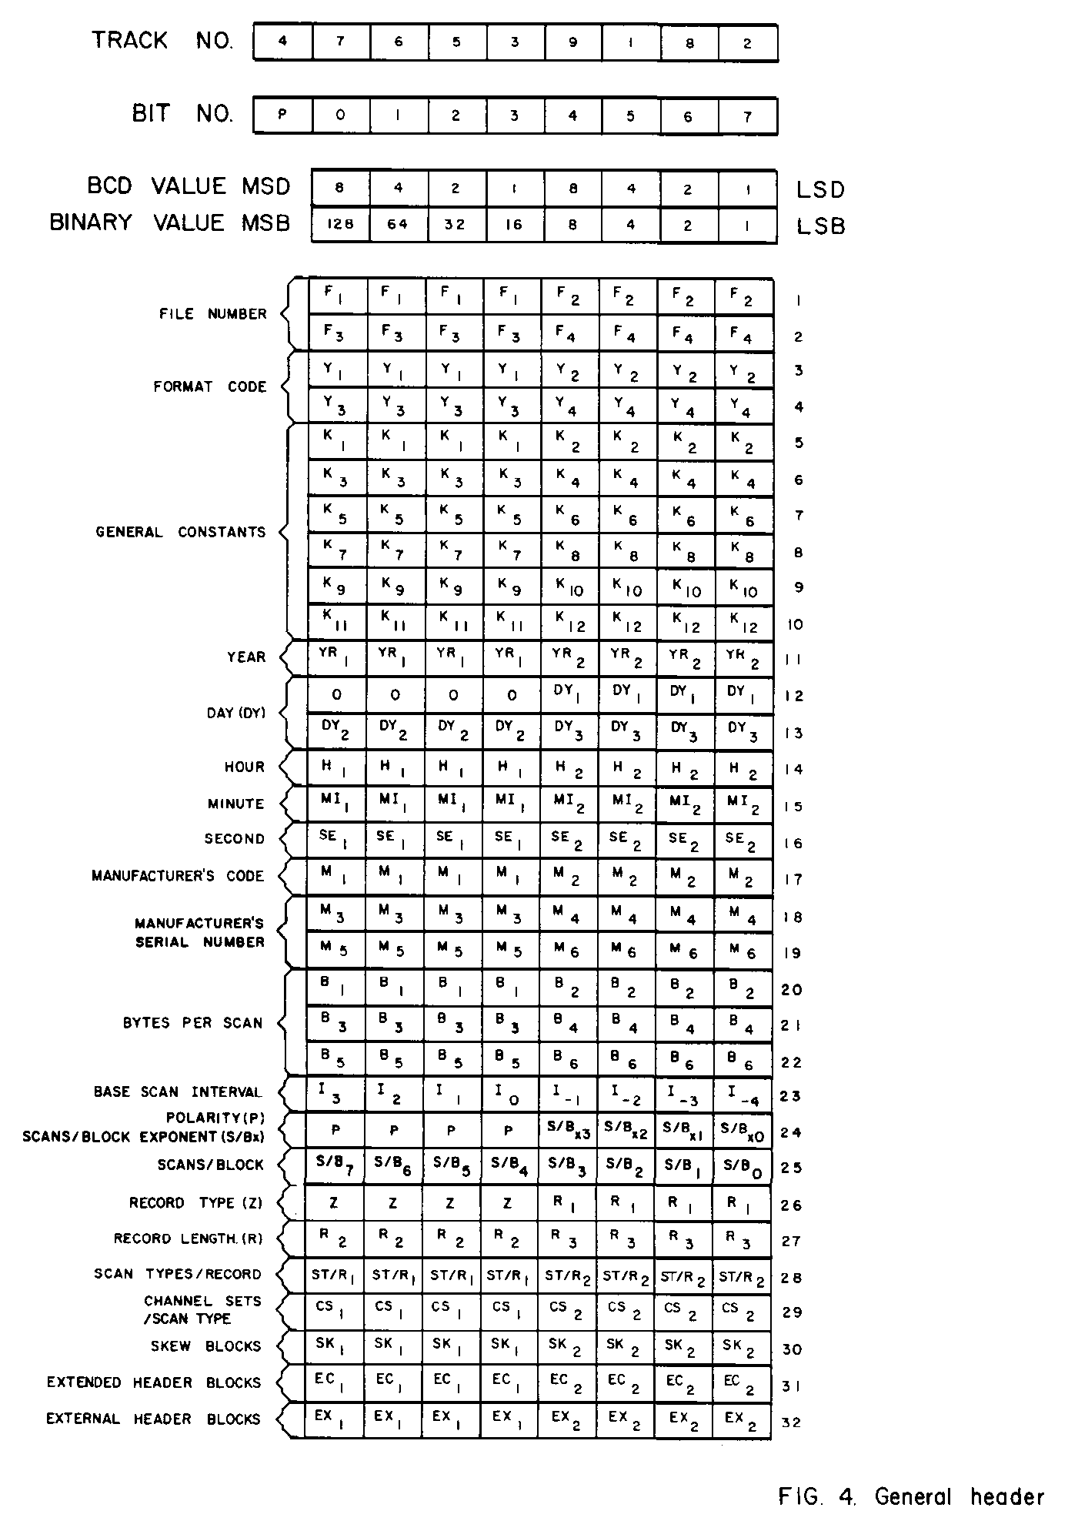
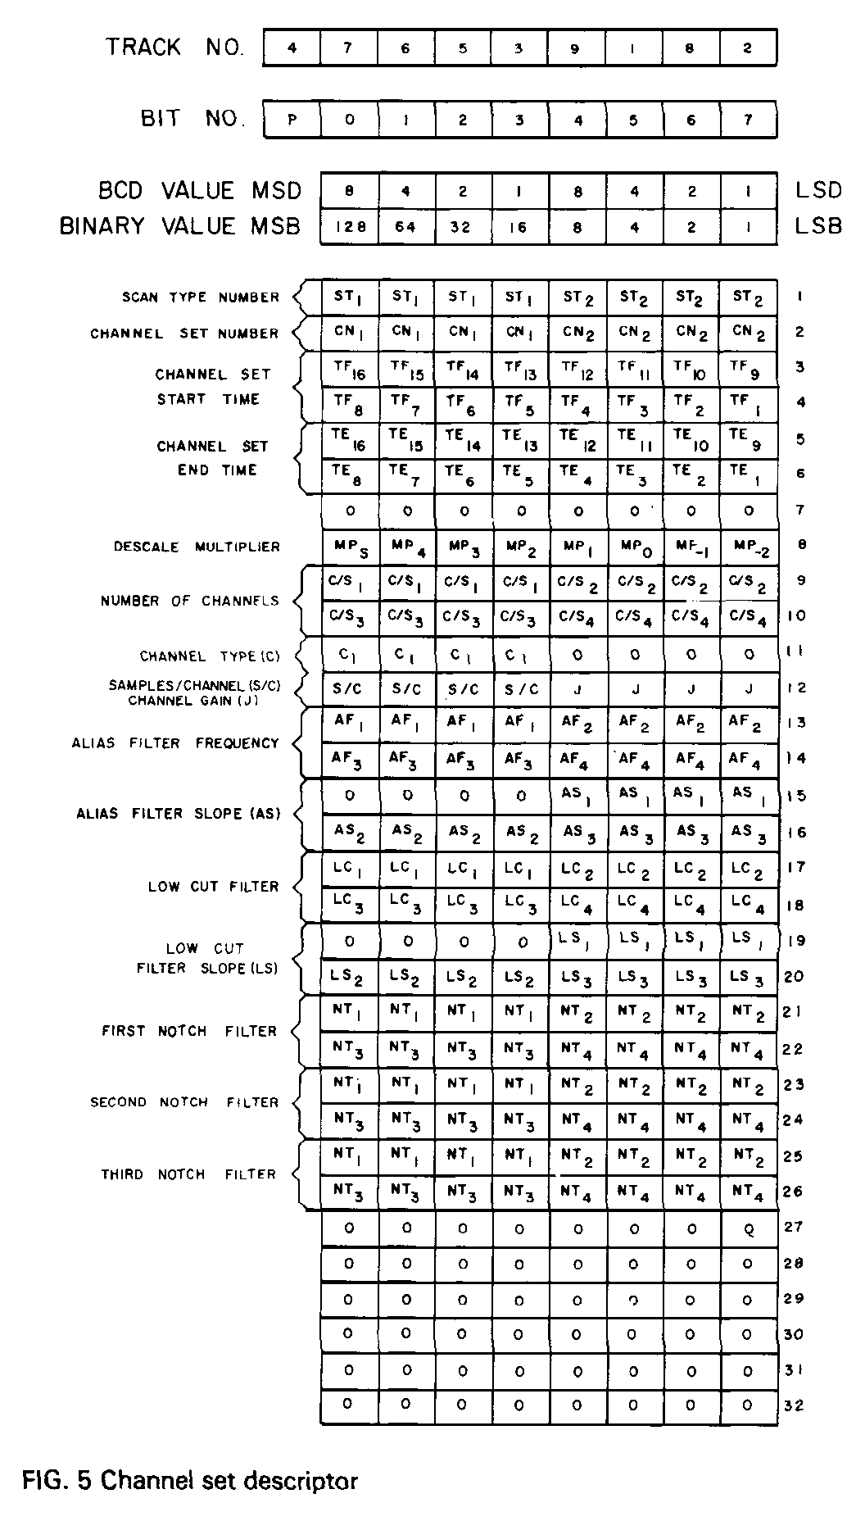
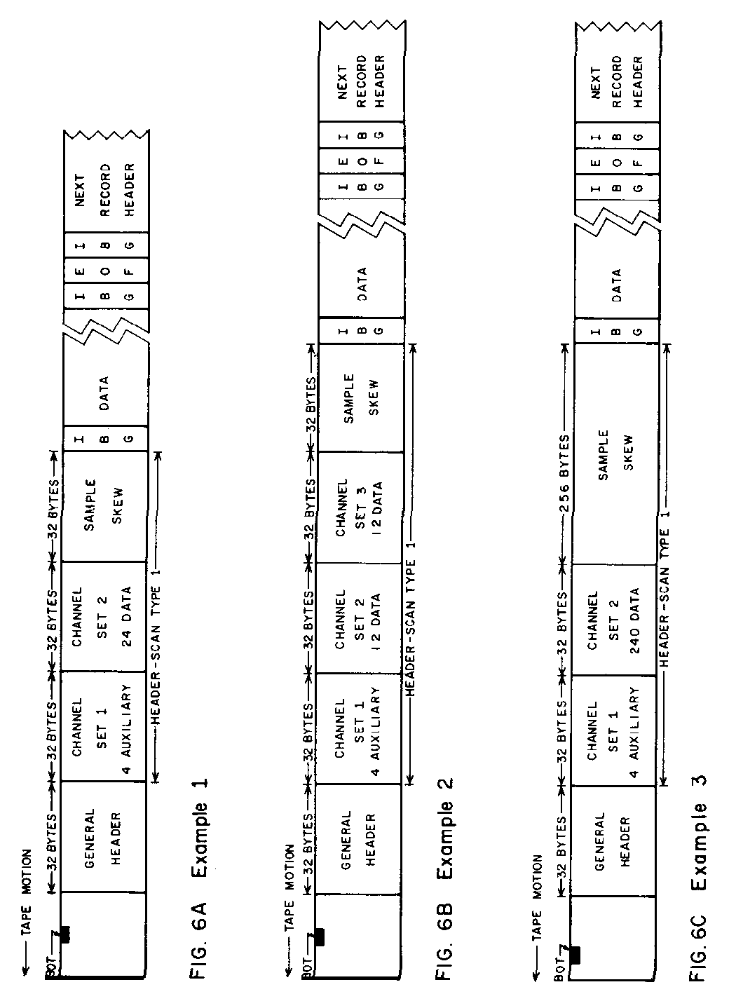
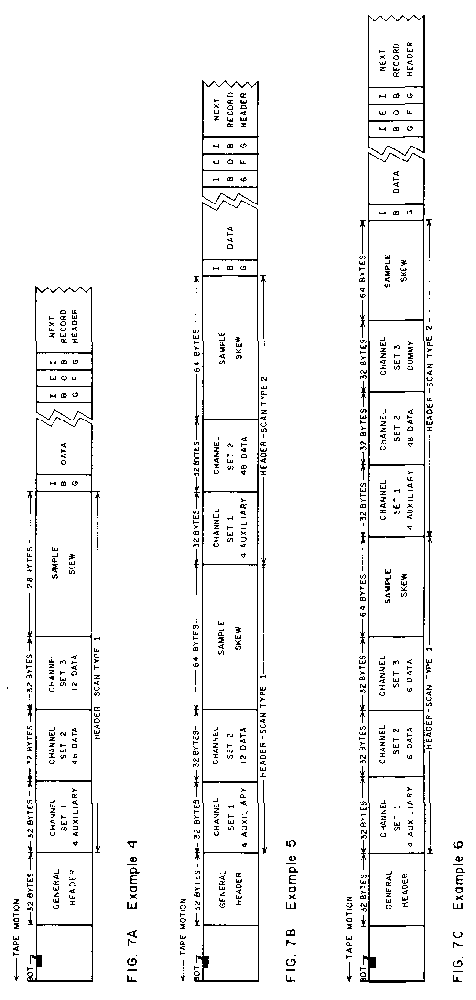

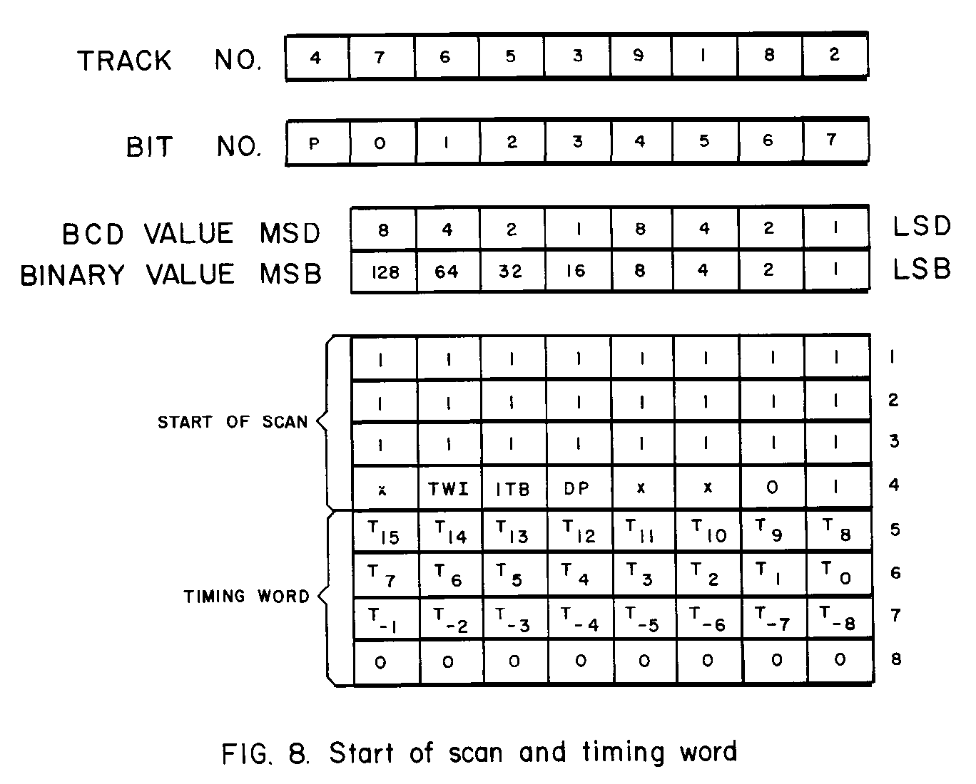
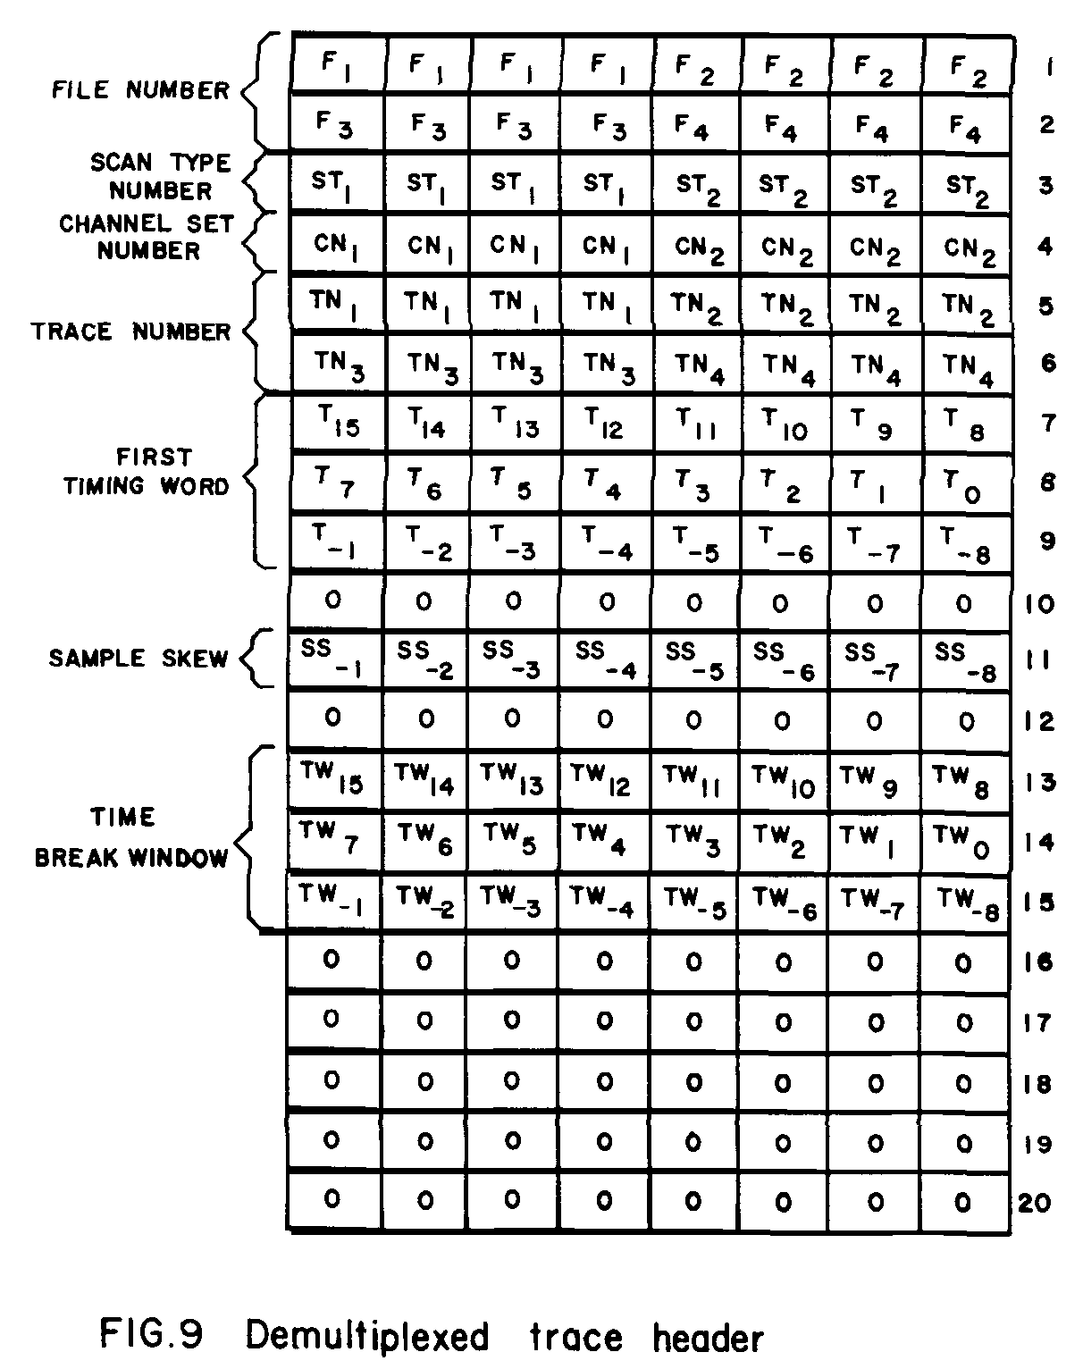

APPENDIX A

HEADER BLOCK PARAMETERS

General header
All values are in packed BCD unless otherwise specified.

INDEX ABBREVIATION DESCRIPTION
BYTE

1 F₁, F₂ File number of four
2 F₃, F₄ digits (0-9999)
3 Y₁, Y₂ Format code:
4 Y₃, Y₄ 0015 20 bit binary multiplexed
0022 8 bit quaternary multiplexed
0024 16 bit quaternary multiplexed
0042 8 bit hexadecimal multiplexed
0044 16 bit hexadecimal multiplexed
0048 32 bit hexadecimal multiplexed
8015 20 bit binary demultiplexed
8022 8 bit quaternary demultiplexed
8024 16 bit quaternary demultiplexed
8042 8 bit hexadecimal demultiplexed
8044 16 bit hexadecimal &multiplexed
8048 32 bit hexadecimal demultiplexed
0200 Illegal, do not use
0000 Illegal, do not use
5 K₁, K₂ General constants, 12 digits
6 K₃, K₄
7 K₅, K₆
8 K₇, K₈
9 K₉ K₁₀
10 K₁₁, K₁₂
11 YR₁, YR₂ Last two digits of year (0-99)
12 0, DY₁ Julian day 3 digits (1-366)
13 DY₂, DY₃
14 H₁, H₂ Hour of day 2 digits (0-23) (Greenwich Mean
Time)
1:5 MI₁, MI₂ Minute of hour 2 digits (0-59)
16 SE₁, SE₂ Second of minute 2 digits (0-59)
17 M₁, M₂ Manufacturer's code 2 digits
Note: See Appendix B for the current assignments
18 M₃, M₄ Manufacturer's serial number, 4 digits
19 M₅, M₆
20 B₁, B₂ Bytes per scan 6 digits (1-999,999) are utilized in
21 B₃, B₄ the multiplexed formats to identify the number of
22 B₅, B₆ bytes (including data, auxiliary, sync, and timing
bytes, etc.) required to make up a complete scan.
In a demultiplexed record, this field is not used and
is recorded as zeros. (See Appendix E2)
23 I₃ thru I₋₄ Base scan interval — This is coded as a binary
number with the LSB equal to 1/16 msec. This will
allow sampling intervals from 1/16 through 8 msec
INDEX ABBREVIATION DESCRIPTION
BYTE

in binary steps. Thus, the allowable base scan inter-
vals are 1/16, 1/8, 1/4, 1/2, 1, 2, 4, and 8 msec. The
base scan interval is always the difference between
successive timing words. Each channel used will
be sampled one or more times per base scan inter-
val.
24 P, Polarity. — These 4 binary bits are measured on
the sensors, cables, instrument, and source com-
bination and are set into the system manually.
The codes are:
0000 Untested
0001 Zero
0010 45 degrees
0011 90 degrees
0100 135 degrees
0101 180 degrees
0110 225 degrees
011l 270 degrees
1000 315 degrees
1001
1010
1011
1100 unassigned
1101
1110
1111
, S/BX₇ thru S/BX₀ This binary number (range 0 to 15) is an exponent
of 2 and is used in conjunction with S/B (Byte 25).
25 S/B₇ thru S/B₀ This binary number (range 0 to 255) is used in con-
junction with S/BX (see Byte 24) to indicate the
number of scans in a block. If it is 0, the data body
is one continuous block. Otherwise, the data body
is composed of multiple blocks, each block con-
taining S/B x 2S/BX scans. It is valid only for
multiplexed data.
26 Z, Record type
Bits 0 1 2 3
0 0 1 0 Test record
0 1 0 0 Parallel channel test
0 1 1 0 Direct channel test
1 0 0 0 Normal record
0 0 0 1 Other
, R₁ Record length from time zero (in increments of 0.5
27 R₂, R₃ times 1.024 sec). This value can be set from 00.5
to 99.5 representing times from 0.512 sec. to
101.888 sec. A setting of 00.0 indicates the record
length is indeterminate.

APPENDIX A

GENERAL HEADER

INDEX ABBREVIATION DESCRIPTION
BYTE

28 ST/R₁, ST/R₂ Scan types per record. This 2 digit code is the num-
ber of scan types per record (1-99). (Zero is invalid.)
29 CS₁, CS₂ Number of channel sets per scan type (1-99).
(Zero is invalid.) This 2 digit code is the number of
channel sets per scan. If multiple scan types are
used (such as in a switching sampling interval
environment), this number is equal to the number
of channel sets contained in the scan type with the
largest number of channel sets. If scan types also
exist with less than this maximum number of chan-
nel sets per scan type, dummy channel set descrip-
tors will have to be recorded in the scan type
header. This can be done by setting the number of
channels in the dummy channel set descriptor to
zero (reference Bytes 9 and 10 of the scan type
header description). Example 6 illustrates this
requirement.
30 SK₁, SK₂ Number of 32 byte fields added to the end of each
scan type header in order to record the sample
skew of all channels (0-99). (See Appendix E3).
Zero indicates that skew is not recorded.
31 EC₁, EC₂ Extended header length. The extended header is
used to record additional equipment parameters.
An example of this would be parameters generated
by the addition of a field stacker to the system.
The two digits (0-99) in this field specify the
number of 32 byte extensions.
32 EX₁, EX₂ External header length. The external header is
used to record additional user supplied information
in the header. The two digits (0-99) in this field
specify the number of 32 byte extensions.

Scan type header (channel set descriptor)

The scan type header is determined by the system configuration and consists of one or more channel set descriptors each of 32 bytes followed by a series of 32 byte sample skew fields. A channel set is defined as a group of channels operating with the same set of parameters and being sampled as part of a scan of data. A scan type header can be composed of from I to 99 channel set descriptors. If dynamic parameter changes are required during the recording, additional scan type headers must be added, each containing the channel set descriptors necessary to define the new parameters. Each scan type header must have the same number of channel set descriptors (see Appendix E4 for header length calculation).
APPENDIX A

CHANNEL SET DESCRIPTOR

INDEX ABBREVIATION DESCRIPTION
BYTE
1 ST₁, ST₂ These two digits (1-99) identify the number of the
scan type header to be described by the subsequent
bytes. The first scan type header is I and the last
scan type header number is the same value as Byte
28 (ST/R) of the general header. If a scan type
header contains more than one channel set descrip-
tor, the scan type header number will be repeated
in each of its channel set descriptors. If the sys-
tem does not have dynamic parameter changes
during the record, such as switched sampling inter-
vals, there will only be one scan type header
required.
2 CN₁, CN₂ These two digits (1-99) identify the channel set to
be described in the next 30 bytes within this scan
type header. The first channel set is "1" and the
last channel set number is the same number as
Byte 29 (CS) of the general header. If the scan
actually contains fewer channel sets than CS, then
dummy channel set descriptors are included as
specified in Byte 29 of general header.
3 TF₁₆ thru TF₉ Channel set starting time. This is a binary number
4 TF₈ thru TF₁ where TF₁ = 2¹ msec (2-msec increments). This
number identifies the timing word of the first scan
of data in this channel set. In a single scan type
record, this would typically be recorded as a zero
(an exception might be deep water recording). In
multiple scan type records, this number represents
the starting time, in milliseconds, of the channel
set. Start times from 0 to 131,070 msec (in 2-msec
increments) can be recorded.
5 TE_{l6} thru TE₉ Channel set end time. This is a binary number
6 TE₈ thru TE₁ where TE₁ = 2¹ milliseconds (2 millisecond incre-
ments). These two bytes represent the record end
time of the channel set in milliseconds. In a multi-
plexed record, all channels of a channel set must
be of the same length. TE may be used in a de-
multiplexed record to allow the termination of a
particular channel set shorter than other channel
sets within its scan type. In a single scan type
record, Bytes 5 and 6 would be the length of the
record. End times up to 131,070 msec (in 2-msec
increments) can be recorded.
7 0,0
8 MP_{S}, MP₄ thru This sign magnitude binary number is the ex-
MP₋₂ ponent of the base 2 multiplier to be used to descale
the data on tape to obtain input voltage in milli-
volts. The radix point is between MP₀ and MP₋₁.
This multiplier has a range of 2^{31.75} to 2^{-31.75}. (See
Appendix E7.)
9 C/S₁, C/S₂ This is the number of channels in this channel set.
10 C/S₃, C/S₄ It can assume a number from 0-9999.
INDEX ABBREVIATION DESCRIPTION
BYTE
11 C₁, 0 Channel type identification:
Bit 0 1 2 3
0 1 1 1 Other
0 1 1 0 Extemaldata
0 1 0 1 Timecounter
0 1 0 0 Water break
0 0 1 1 Up hole
0 0 1 0 Time break
0 0 0 1 Seis
0 0 0 0 Unused
1 0 0 0 Signature, unfiltered
1 0 0 1 Signature, filtered
12 S/C, This packed BCD number is an exponent of 2. The
number (2s/c) represents the number of subscans of
this channel set in the base scan. Possible values for
this parameter (2s/c) are 1 to 512 (2⁰ to 2⁹). Refer-
ence Byte 23 of the general header.)
12 , J Channel gain control method
Bits 4 5 6 7 Gain mode
0 0 0 1 - (1) Individual AGC
0 0 1 0 - (2) Ganged AGC
0 0 1 1 - (3) Fixed gain
0 1 0 0 - (4) Programmed gain
1 0 0 0 - (8) Binary gain control
1 0 0 1 - (9) IFP gain control
13 AF₁, AF₂ Alias filter frequency. It can be coded for any
14 AF₃, AF₄ frequency from 0 to 9999 Hz.
15 0, AS₁ Alias filter slope in dB per octave. It can be coded
16 AS₂, AS₃ from 0 to 999 dB in 1-dB steps. A zero indicates
the filter is out (see Appendix E5 for definition).
17 LC₁, LC₂ Low-cut filter setting. It can be coded for any
18 LC₃, LC₄ frequency from 0 to 9999 Hz.
19 0, LS₁ Low-cut filter slope. It can be coded for any slope
20 LS₂, LS₃ from 0 to 999 dB per octave. A zero slope indicates
the filter is out. (See Appendix E5 for definition.)
21 NT₁, NT₂ Notch frequency setting. It can be coded for any
22 NT₃, NT₄ frequency from 0 to 999.9 Hz. The out filter is
written as 000.0 Hz.

The following notch filters are coded in a similar manner:
23 NT₁, NT₂ Second notch frequency
24 NT₃, NT₄
25 NT₁, NT₂ Third notch frequency
26 NT₃, NT₄
27
28
29 Unused. Written as zeros.
30
31
32

APPENDIX B

MANUFACTURERS OF SEISMIC DIGITAL FIELD RECORDERS

Code No.
01 Alpine Geophysical Associates, Inc.
(Obsolete) ∗
65 Oak Street
Norwood, New Jersey

02 Applied Magnetics Corporation (See 09)
75 Robin Hill Rd.
Goleta, California 93017

05 Dyna-Tronics Mfg. Corporation (Obsolete) *
5820 Star Lane
Box 22202
Houston, Texas 77027

06 Electronic Instrumentation, Inc. (Obsolete) *
601 Dooley Road
Box 34046
Dallas, Texas 75234

07 Electro-Technical Labs
Div. of Geosource, Inc.
6909 Southwest Freeway
Box 36827
Houston, Texas 77036

08 Fortune Electronics, Inc. (Obsolete) *
5606 Parkersburg Drive
Houston, Texas 77036

09 Geo Space Corporation
(Subsidiary of Applied Magnetics Company)
5803 Glenmont Drive
Box 36374
Houston, Texas 77036

17 GUS Manufacturing, Inc.
P.O. Box 10013
El Paso, Texas 79991

- Input/Output, Inc.
8009 Harwin Dr.
Houston, Texas 77036

10 Leach Corporation (Obsolete) *
405 Huntington Drive
San Marino, California

03 Litton Resources Systems, Inc.
3930 Westholme Dr.
Houston, Texas 77063

11 Metrix Instrument Co. (Obsolete) *
8200 Westglen
Box 36501
Houston, Texas 77063

12 Redcor Corporation (Obsolete) *
7800 Deering Avenue
Box 1031
Canoga Park, California 91304

14 Scientific Data Systems (SDS) (Obsolete) *
1649 Seventeenth Street
Santa Monica, California 90404

13 Sercel (Societe d'Etudes, Recherches Et
Constructions Electroniques)
25 X, 44040 Nantes Cedex,
France

04 SIE, Inc.
5110 Ashbrook
Box 36293
Houston, Texas 77036

15 Texas Instruments, Inc.
P.O. Box 1444
Houston, Texas 77001

APPENDIX C

GLOSSARY

Base scan interval The time between timing words. A base scan interval usually contains one scan but under some conditions may contain multiple subscans.
Block The data between gaps on tape.
Channel set One or more channels sampled at the same sampling interval and containing the same filter, fixed gain, and other fixed parameter information.
Channel set descriptor A unit of the scan type header describing the parameters of a channel set.
Data recording method The arrangement of bits to represent samples on tape.
File All data recorded from a single energy impulse or sweep. It may also be the sum of a number of energy impulses or sweeps. Literally, it is all of the blocks between file marks.
Format Data recording method combined with a multiplexed/demultiplexed indicator (see general header Bytes 3 and 4).
General header The first header in the header block. It contains information common to the entire record. Index byte The byte number of some particular parameter within the general or scan type header.
Packed BCD Binary coded decimal digits represented by four data bits.
Sample skew The fraction of the base scan interval between the timing word and the actual time the sample was taken in a base scan interval (not related to position on tape).
Sampling interval The interval between readings such as the time between successive samples of a digital seismic trace.
Scan One complete sequence of events, such as sampling all channels. Data recorded during a base scan interval.
Scan interval The interval between readings of all samples contained in a scan type. Scan type One complete set of channel sets which make up a scan. A seismic record contains multiple scans, and may or may not contain more than one scan type.
Scan type header A header containing one or more channel set descriptors and the skew information.
Subscan A set of samples containing one sample for each channel in a channel set.
Time break window Time interval in which time break is expected. If time break does not occur by the end of the window, internal time break is generated.
Trace A record of one seismic channel within a scan type. A collection of a sequential set of points from one seismic channel.
Trace block A block containing the data of one trace or a part of a trace with constant parameters.

APPENDIX D

HEADER DESCRIPTORS

G = general header S = scan type header (channel set descriptor)

ABBREVIATION HEADER BYTE NO. DESCRIPTION

AF S 13, 14 ALIAS FILTER FREQUENCY
AS S 15, 16 ALIAS FILTER SLOPE
B G 20, 21,22 BYTES PER SCAN (MULTIPLEXED ONLY)
BCD — BINARY CODED DECIMAL
BOY BEGINNING OF TAPE MARK
C S 11 CHANNEL TYPE IDENTIFICATION
CN S 2 CHANNEL SET NUMBER
CS G 29 CHANNEL SETS PER SCAN TYPE
C/S S 9, l0 CHANNELS IN THIS CHANNEL SET
DP — DYNAMIC PARAMETER CHANGE BIT (SEE
THE MULTIPLEXED DATA BLOCK, SOS
BYTE 4)
DY G 12, 13 DAY OF YEAR
EC G 31 EXTENDED HEADER LENGTH
EOF — END OF FILE MARK
EOT END OF TAPE MARK
EX G 32 EXTERNAL HEADER LENGTH
F G 1, 2 FILE NUMBER
H G 14 HOUR OF DAY
HDR — HEADER FOR DEMULTIPLEXED TRACE
HL — HEADER LENGTH (SEE APPENDIX E4)
I G 23 BASE SCAN INTERVAL
IBG — INTERBLOCK GAP (ALSO GAP)
ITB INTERNAL TIME BREAK (SEE THE MULTI-
PLEXED DATA BLOCK, SOS BYTE 4)
J S 12 GAIN CONTROL METHOD
K G 5 THRU 10 GENERAL CONSTANTS
LC S 17, 18 LOW CUT FILTER FREQUENCY
LS S 19, 20 LOW CUT FILTER SLOPE
LSB — LEAST SIGNIFICANT BIT
LSD — LEAST SIGNIFICANT DIGIT
M G 17 THRU 19 MANUFACTURER'S CODE AND SERIAL
NUMBER
MI G 15 MINUTE OF HOUR
MP S 8 DESCALING EXPONENT
MSB — MOST SIGNIFICANT BIT
MSD MOST SIGNIFICANT DIGIT
NT S 21 THRU 26 NOTCH FILTER FREQUENCY
P G 24 POLARITY
R G 26, 27 RECORD LENGTH
S — SIGN BIT
S/B, S/BX G 24, 25 NUMBER OF SCANS PER BLOCK
S/C S 12 EXPONENT OF SAMPLES PER CHANNEL IN
THE BASE SCAN
SE G 16 SECOND OF MINUTE
SK G 30 NUMBER OF 32 BYTE SKEW FIELDS
SOS — START OF SCAN (MULTIPLEXED DATA
BLOCK)
SS — SAMPLE SKEW
S/S — SAMPLES/SCAN
ST S 1 SCAN TYPE NUMBER
ST/R G 28 SCAN TYPES PER RECORD
T — TIMING WORD (MULTIPLEXED DATA
BLOCK)
TF S 3, 4 FIRST TIMING WORD IN THIS CHANNEL
SET
TE S 5, 6 END TIME OF THIS CHANNEL SET
TN — DEMULTIPLEXED TRACE NO. (SEE TRACE
HEADER)
TW — TIME BREAK WINDOW (SEE DEMULTI-
PLEXED DATA BLOCK, TRACE HEADER
BYTES 13, 14 AND 15)
TWI — TIME BREAK WINDOW INDICATOR (SEE
MULTIPLEXED DATA BLOCK, SOS BYTE 4)
Y G 3, 4 FORMAT CODE (DATA RECORDING
METHOD)
YR G 11 YEAR (LAST TWO DIGITS)
Z G 26 RECORD TYPE

APPENDIX E

SAMPLE CALCULATIONS

E1 Samples per scan type

CS
S/S = ∑ C/S x 2s/c
1
where
S/S = samples per scan type
C/S = channels in this channel set (channel set descriptor Bytes 9 and 10)
2s/c = samples per channel (in this channel set) (channel set descriptor Byte 12)
CS = number of channel sets in this scan type (general header Byte 29)
For example, for a 2-msec base scan interval with 4 auxiliary channels at 2 msec, 96 channels at 2 msec and 12 channels at V2 msec. There are three channel sets, so CS = 3.
 | S/S = C/S x 2s/c | + C/S x 2s/c | + … | .
 |  | CS = 1 | CS = 2
S/S = 4 x 1 + 96 x 1 + 12 x 4
S/S = 4 + 96 + 48 = 148
Note that all scan types must have the same number of data samples.

E2 Bytes per scan

CS
B = 8 + ∑ C/S x 2s/c x bytes/sample
1
where
B = bytes per scan
8 = start of scan plus timing word
C/S = channels in this channel set (channel set descriptor Bytes 9 and 10)
2s/c = samples per channel (in this channel set) (channel set descriptor header Byte 12)
CS = number of channel sets in this scan type (general header Byte 29)
Bytes/sample format code (general header Bytes 3 and 4)
1.0 0042, 0022
2.0 0024, 0044
2.5 0015
4.0 0048
For example, for a 2-msec base scan with a 2.5 byte format that contains 4 auxiliary channels, 96 channels at 2 msec and 12 channels at ½ msec.

B = 8+(4 x 1 x 2.5) + (96 x 1 x 2.5) + ( 12 x 4 x 2.5)
B = 8 + (4 + 96 + 48) x 2.5
B = 8+ 148 x 2.5 = 378 bytes

E3 Skew fields per scan type
S/S (If the quotient is not a whole number, round up to the next largest whole number.)
SK = ——
32
where
SK = skew fields (of 32 bytes each) per scan type (general header Byte 30)
S/S = samples per scan (Appendix E1) Substituting for S/S from Appendix El:
CS
∑ C/S x 2s/c (If the quotient is not a whole number,
1 round up to the next largest whole number.)
SK = —————————
32

where
CS = the number of channel sets in each scan type (general header Byte 29)
C/S = channels in this channel set (channel set descriptor Bytes 9 and 10)
2s/c = samples per channel in this channel set (channel set descriptor Byte 12).
For example, for a 2-msec base scan with 4 auxiliary channels at 2 msec, 96 channels at 2 msec and 12 channels at ~,6 msec
4 × 1+ 96 × 1 + 12 × 4
SK = —————————
32

148 20
SK = —— = 4 —— roundup = 5 fields of 32 bytes each
32 32

E4 Total header length

HL = 32 x [ ST/R (CS + SK)+ 1 + EC + EX],
where
HL = header length (bytes)
ST/R = number of scan types per record (general header Byte 28)
CS = number of channel sets per scan type (general header Byte 29)
SK = skew fields per scan type (general header Byte 30)
EC = extended header length (general header Byte 31)
EX = external header length (general header Byte 32)

Example 1: For a system with a 2-msec base scan, 4 auxiliary channels at 2 msec, 96 channels at 2 msec, and 12 channels at Y2 msec

HL = 32 x (l x (3+5) + 1 + EC + EX)
ST/R = 1 since there is only one scan type in this example,
= 32 x (9) = 288 bytes + extended header + external header

E5 Filter slope calculation

Modern filters may not have a constant slope, so it is necessary to define this parameter. The slope is defined as the asymptote of effective performance as it would be in a constant slope filter. This slope is zero dB attenuation at the cut-off frequency and a specific attenuation at the beginning of the stop band. The chosen values are 40 dB for a low-cut filter and 60 dB for an anti-alias filter.

Low-cut filter slope calculation. —
40 40 12.04
LS = ————— = ———————— = ——————
log₂ f_{LCO}/f₄₀ 3.322 log₁₀ f_{LCO}/f₄₀ log₁₀ f_{LCO}/f₄₀

LS = low-cut filter slope (channel set descriptor Bytes 19 and 20),
F₄₀ = the frequency of 40 dB low-cut filter attenuation,
f_{LCO} = low-cut filter cut-off frequency usually 6 or 12 dB attenuation.

Alias-filter slope calculation. —

60 60 18.06
AS = ————— = ———————— = —————
log₂ f6o/f_{ACO} 3.322 log₁₀ f60/f_{ACO} log₁₀ f₆₀/f_{ACO}

AS = alias filter slope (channel set descriptor Bytes 15 and 16)
F₆₀ = the frequency of 60 dB alias-filter attenuation
f_{ACO} = alias-filter cut-off frequency usually 3 or 6 dB attenuation

The resultant slope in the above calculations is rounded to the nearest whole number and is written in the channel set descriptor.

E6 Calculation of byte offset from the beginning of the header block to a specific byte index in channel set descriptor i of scan type header j

Byte no. = 32 + index byte + 32 (CN_{i} - l) + 32 (ST_{j} - l) (CS + SK)
where
CN_{i} = channel set number of interest
index byte = byte number of interest in the channel set descriptor
CS = number of channel sets per scan type (general header Byte 29).
ST_{j} = scan type of interest
SK -skew fields per scan type (Appendix E3)
1 ≤ CN_{i} ≤ CS
1 ≤ ST_{j} ≤ ST/R; i = 1, 2,...,ST/R

Example: For a 2 msec base scan system having 2 scan types: (1) 4 auxiliary channels at 2 msec plus 12 channels at ½ msec, and in the second scan type (2) 4 auxiliary channels at 2 msec plus 48 channels at 2 msec.

First calculate the samples per scan (S/S) per Appendix El and skew field (SK) per Appendix E3.
CS
S/S = ∑C/S x 2sic
1

S/S = C/S x 2s/c + C/S x 2s/c
CS = 1 CS = 2
= 4 x 1 + 12 x 4
S/S = 4 + 48 = 52.

Note: It is not necessary to evaluate the samples per scan in the second scan type because all scan types must have the same number of samples.
Second, evaluate the skew fields per scan per Example 3.
CS
∑ S/S (round up to the next
1 largest whole number),
SK = ————
32

52 20
SK = —— = 1 ——
32 32

Now, compute the header byte number of index Byte 11 of the second channel set in the second scan type.
Byte no. = 32 + 11 + 32 ( 2- 1) +32 ( 2 - 1) ( 2 + 2 )
Byte no. = 43 + 32 (1) + 32 (4)
Byte no. = 203.

E7 Calculation and use of MP
The MP parameter is provided to allow the dimensionless numbers recorded on tape to be "descaled" back to the instantaneous sample values in millivolts at the system inputs. MP is encoded in Byte 8 of each channel set descriptor in the scan type header. It is a sign and magnitude binary exponent. It can have any value between -31.75 and +31.75 in increments of 0.25.
In general, recording systems scale the input signal level in order to match the useful range of input levels to the gain-ranging amplifier. MP must account for all scaling (unless, as in the 4 byte hexadecimal case, the data recording method has sufficient range).

MP CALCULATION

The calculation of MP for a data recording method is given by one of the following equations:
(1) MP = FS - PA - Cmax; for binary exponents,
(2) MP = FS- PA – 2 x Cmax; for quaternary exponents,
(3) MP = FS - PA – 4 x Cmax; for hexadecimal exponents (except the 4 byte excess 64 method),
(4) MP = FS – PA - 4 (Cmax - 64); for excess 64 hexadecimal exponents,
where
2FS = Converter full scale (millivolts),
2PA= Minimum system gain,
and
Cmax = maximum value of the data exponent.
Cmax = 15 for binary exponents,
= 7 for quaternary exponents,
= 3 for hexadecimal exponents except excess 64; and
= 127 for excess 64 exponents.

The term "minimum system gain" includes preamplifier gain and the minimum floating point amplifier gain. For example, one system may use a preamplifier gain of 256 and a minimum floating point amplifier gain of one. The minimum system gain is 256 x 1 = 2⁸, so PA=8. Another system may use a preamplifier gain of 320 and a minimum floating point amplifier gain of 0.8. In this case, the minimum system gain is 320 x 0.8 = 256 or 2⁸ Again PA = 8.
PA may also account for any amplification needed to accommodate an analog to digital converter with a full scale value that is not a power of 2 in millivolts. For example, a 10 V (10,000 mV) converter may be preceded by an amplifier with a gain of 1.221 (10,000/8,192). This gain may be accounted for in PA. Alternatively, it could be considered part of the converter, making it appear to have a binary full scale. In either case, FS - PA must be a multiple of 0.25.

JUSTIFICATIONS FOR THE EQUATIONS

The output of the analog-to-digital converter is written as the fractional portion of the data value. This is equivalent to dividing the value by the full scale of the converter. In order to compensate for this, the data value recorded on tape must be multiplied by the full scale value of the converter (2^{FS}). Thus FS appears in equations (1)-(4) with a positive sign.
The input signal was multiplied by the minimum system gain (2^{PA}) which, as mentioned, includes any preamplification gain, minimum floating point amplifier gain, or analog-to-digital converter adjustment gain. The data recorded on tape must be divided by this minimum system gain; thus, PA appears in the equations with a negative sign.
Large input signals converted at minimum floating point amplifier gain are written on tape with the maximum exponent for the data recording method used. Likewise, small signals converted at full gain are written with the minimum exponent. The data as written have been multiplied by the exponent base raised to Cmax (or Cmax -64 in the excess 64 case). Thus Cmax appears in the equations with a negative sign. MP is a power of 2 so the quaternary and hexadecimal Cmax values are multiplied by 2 and 4, respectively (4^{C} = 2^{2C} and 16c = 2^{4C}).

EXAMPLES

Note: In the following examples, all logarithms are base 10.
Example 1
Assume: quaternary data recording method, converter full scale = 8192 m V, preamplifier gain = 320, and minimum floating point amplifier gain = 0.8. Then
Cmax = 7,
FS = log 8192 / log ₂ = 13,
PA = log (320 x 0.8) / log ₂ = 8.
and
MP = 13 - 8 - 2 x 7 = -9.

Example 2
Assume: binary data recording method, convener full scale = 10 volts, preamplifier gain = 128, and minimum floating point amplifier gain = 1.0. Then
Cmax = 15,
FS = log 10000 / log ₂ = 13.287 ....
PA = log 128 / log ₂ = 7,
and
MP = 13.287... - 7 – 15 = -8.712 ....

But MP must be a multiple of 0.25. This can be achieved by changing the preamplifier gain to 131.39. Then
PA = log 131.39 / 1og ₂ = 7.037 and
MP = 13.287 . . . -7.037 . . . -15 = -8.75.
MP could be made a whole number by changing the preamplifier gain to 156.25. Then
PA = log 156.25/log ₂ = 7.287 and
MP= 13.287 . . .-7.287 . . . -15 = -9.
Note that this is equivalent to preceding the conventer with an amplifier of gain 1.220... thus making the converter appear to have a full scale value of 8192 mV. Then
FS = log 8192 / 1og ₂ = 13,
PA = log 128 / log₂ = 7,
and
MP = 13 – 7 – 15 = -9.

Example 3
Assume: hexadecimal (1 or 2 byte) data recording method, convener full scale - 8192 mV, preamplifier gain = 256, and minimum floating point amplifier gain = 1.0. Then
Cmax = 3,
FS = log 8192 / 1og ₂ = 13,
PA = log 256 / log₂ = 8,
and
MP = 13 - 8 - 4 x 3 = -7.
Note: In the 4 byte hexadecimal case, it is expected that MP will generally be recorded as zero because of the large range of the number system of this data recording method. Nonetheless, equation 4 must still be valid:
MP = FS - PA – 4 x ( Cmax – 64 ).
If MP = 0, then
FS- PA = 4 ( Cmax- 64 ).
Since Cmax is always an integer, FS - PA must be a multiple of 4.

Note: The data recording method (binary, quaternary, or hexadecimal) does not indicate the type of floating point amplifier used. Any gain ranging amplifier and converter outputs can be convened to any of the data recording methods.

USE OF MP

As indicated in the descriptions of the data recording formats, MP is applied by multiplying the recorded data by 2MP.

E8 Calculation of the byte offset from the beginning of the header block to the skew information byte for channel k of channel set i of scan typej

For clarity, the equation is given on several lines. The terms on each line are explained.
SS OFFSET = 32 (general header)
+ 32(STj- 1) (CS + SK) (all previous scan type
headers)
+ 32 (CS) (channel set descriptors in
scan type header j)
CNi- 1
+ ∑ C/S x 2s/c (samples in the base scan for
1 all previous channel sets in
this scan type)
+ k (position of channel in this
channel set)
Where
STj = scan type of interest,
CS = number of channel sets per scan type (general header Byte 29),
SK = number of skew fields per scan type (Appendix E3),
CN_{i} = channel set number of interest,
C/S = channels in this channel set (channel set descriptor Bytes 9 and 10), and
2s/c = samples per channel of this channel set in a base scan (channel set descriptor Byte 12).
Note that if there are multiple subscans of a channel set within a base scan (i.e., 2s/c greater than one), a skew information byte is written for each sample in each subscan.
The above equation accounts for multiple subscans of previous channel sets, but it determines the location of the skew information byte of channel k in the first subscan only of channel set i. Skew information for subsequent subscans can be obtained in two ways:

(1) Add multiples of C/S to the computed offset to obtain the offset to the byte of interest; or
(2) Add multiples of 2-s/c to the value of the skew information byte obtained for the first sub-scan.

For example, assume there are two .scan types with three channel sets, as follows:
Scan type 1:
channel set 1 — 4 channels at 4 msec (1 subscan per base scan)
channel set 2 — 24 channels at 2 msec (2 subscans per base scan)
channel set 3 — 12 channels at l msec (4 subscans per base scan)
Scan type 2:
Channel set 1 — 4 channels at 4 msec (1 subscan per base scan)
Channel set 2 — 48 channels at 2 msec (2 subscans per base scan)
Channel set 3 — 0 channels (dummy).

The offset to the skew information byte for channel 11 of channel set 2 in scan type 2 is computed below. The number of skew fields (Appendix E3) is:
CS
∑C/S x 2s/c = 4 + 24 x 2 + 12 x 4 = 100
1
—————— = ——
32 32

or 4 (rounded up).

CNi- 1
SS offset = 32 + 32(STj- 1)(CS + SK) + 32(CS) + ∑ C/S x 2^{S/C} + k
1
= 32 + 32(2 - 1)(3 + 4) + 32(3) + 4 + 11
= 367.
The position of the skew information byte for the second subscan of channel 11 in this scan is: 367 + 48 = 415.

E9 Calculation of the number of bytes per block for a gapped multiplexed record
Bytes per block = (S/B x 2^{S/BX}) × B
where
S/B x 2^{S/BX} = scans per block (general header Bytes 24 and 25)
B = bytes per scan (general header Bytes 20, 21, and 22).

Note: S/B and S/BX are written in the header as binary numbers; whereas B is represented as 6 packed BCD digits.
Assume, as in example E2, that there are 378 bytes per scan. Further assume that S/BX is 2 and S/B is 173. Then
( S/B x 2^{S/BX} ) x B = 173 x 2² x 378, and bytes per block = 261,576.

E10 Determination of scans per block subject to block size limits
S/B and S/BX will normally be chosen to result in the largest block (fewest gaps) possible without exceeding a predetermined limit. This is accomplished by selecting S/BX to be just large enough that 2^{S/BX} is within a factor of 256 of the maximum number of scans allowed. Maximum number of scans = integer
portion of block limit per bytes per scan.

Max number
S/BX = log₂ ——————— rounded up,
256

Max number of scans
S/B = —————————— rounded down.
2^{S/BX}
For example, assume that there are 378 bytes per scan and the block size may not exceed 250,000 bytes.

Int of 250,000 661
Max scans = ————— S/B = ——— rounded down
378 2²

= 661 = 165;

661 Block length = 165 x 22 x 378,
S/BX = Log₂ —— rounded up, = 249,480 bytes.
256
=2;

© 1975 Society of Exploration Geophysicist, All rights reserved.
D.A. Cavers (Chairman), Gulf Research and Development, Box 36506, Houston, TX 77036; P.E. Carroll, Texas Instruments, P.O. Box 1444, M.S. 6i7, Houston, TX 77001; E.P. Meiners, Chevron Geophysical, Box 36487, Houston, TX 77036; C.W. Racer, Chevron Geophysical, 8114 Pella, Houston, TX 77036; L.E. Siems, Litton Resources, 3930 Westholme Drive, Houston, TX 77063; M.G. Sojourner, Input/Output, 8009 Harwin Drive, Houston, TX 77036; J.L. Twombly, GUS Manufacturing, 10486 Dauwood, E1 Paso, TX 79925; J.A. Weigand, Texaco Inc., 4800 Foumace Place E302, Bellaire, TX 77401.
In the multiplexed format, Bytes 1 and 2 contain the exponents for the following four channels of the scan. The channel numbers are relative and are only to denote position in the four channel subset.
In the demultiplexed format, Bytes I and 2 contain the exponents for the following four samples of the channel. The sample numbers are relative and are only to denote position in the four sample subset.
Details of polarity codes and test methods are listed in the following reference: Thigpen, B. B., Dalby, A. E., Landrum, R., 1975, Special report of the subcommittee on polarity standards' Geophysics, v. 40, p. 694.
Illegal code for this format because the timing counter is part of the start of scan and cannot be identified as part of a channel.
 This was originally extracted from Geophysics, v. 32. The ones marked obsolete do not appear in the latest edition of the Geophysical Directory (1979). Should additional manufacturer code numbers be required, contact the SEG Standards Committee for the assignment of these numbers.

