RKWard – A comprehensive Graphical User Interface and Integrated Development Environment for statistical analysis with R

Authors: Stefan Rödiger, Meik Michalke, Detlef Steuer, Prasenjit Kapat, Matthieu Stigler, Thomas Friedrichsmeier
Institution:

Keywords: GUI, IDE, R, plug-in, cross-platform
Table of Contents
1 Abbreviations (alphabetical): 1
2 Abstract 2
3 Background and motivation 2
4 Using RKWard 3
4.1 Structure of RKWard - Technical Design Overview 3
4.2 Development process of RKWard and RKWard plug-ins 5
4.3 Installing RKWard 7
4.4 Starting RKWard 7
4.5 Default Graphical User Interface Elements 7
4.6 Internationalization 8
4.6.1 Workspace browser 9
4.6.2 Code editor - Integrated development environment 10
4.6.3 Spreadsheet-like data editor 10
4.6.4 Controlling RKWard and R 10
4.6.5 Results output 11
4.7 Help system 12
4.8 Data import and management of data 12
4.9 Cross-platform Usage 12
4.10 Package Management 12
4.11 Automatic code generation 13
4.11.1 Bioconductor 14
4.12 On the fly plot updates 15
5 Comparison with Cantor and other software packages 15
6 Conclusion and Summary 15
7 Bibliography 15

Abbreviations (alphabetical):
CRAN The Comprehensive R Archive Network
CSV Comma separated values
GUI Graphical User Interface
HTML Hypertext Markup Language
IDE Integrated Development Environment
JS JavaScript
KDE SC KDE Software Compilation
ODF OASIS Open Document Format
PHP PHP: Hypertext Preprocessor
PNG Portable Network Graphic
Qt
TDI Tab document interface
XML Extended Markup Language
Rcmdr R Commander
Tlc/Tk

Abstract
R is a free, open-source implementation of the S statistical computing language and programming environment. The current status of R is a command line driven interface with no Graphical User Interface but it includes tools for building such. Over the past years GUI solutions with different scopes emerged which are based on internal or external tool kits. RKWard is based on external toolkits from the KDE Software Compilation. Statistical tests and plots are implemented as an extendable plug-in architecture which is based on broadly used ECMA script (JavaScript). GUI elements are described by XML style sheet. The objective of RKWard is to provide an interface for basic and advanced statistical and graphical analysis while keeping the software portable and extensible.

Background and motivation
In mid 1993 Ihaka and Gentleman published initial efforts on the computing language and programming environment R on the s-news mailing list. Ambitions for this project mainly aimed to develop a S-like but without memory and performance issues. The source code of R was finally released in 1995 and development evolved under the umbrella of the R Development Core Team since mid.1997 (Team2001, Team2009;Ihaka_Gentlemen_1993). However, the implementation of R does not include an advanced cross-platform Graphical User Interface as known from other statistical software packages. However, R includes tools for building GUIs mainly based on Tlc/Tk (Dalgaard P (2001). “A Primer on the R-Tcl/Tk Package.” R News, 1(3), 27–31., Dalgaard P (2002). “Changes to the R-Tcl/Tk Package.” R News, 2(3), 25–71.). Since than a plethora of R GUIs emerged (see http://www.sciviews.org/_rgui/ for a comprehensive list). In 2005 John Fox released version 1.0 of R Commander which can be considered a milestone in R GUI development. However, John Fox himself stated the a basic-statistics graphical cross-platform GUI for R (Rcmdr paper). In 2004 Thomas Friedrichsmeier started RKWard to implement a R GUI which uses toolboxes relying on KDE SC and Qt technology. The aim was to develop an easy to use, transparent front-end to the R-language by providing a graphical front-end that can be used by unexperienced users as well as experts on desktops in development and routine tasks. The purpose of RKWard is to make the power of the R language easily accessible to the user, without having to learn a full programming language, first. Advanced needs to make use of the full flexibility of the R language is not restricted. RKWard offers a lot of tools to make this easier, both for novices to R, and R experts.
with the aim that others can program GUIs
- The aim is to implement a R GUI in the desktop
- Use case scenario examples (routine data analysis, standard plots)
- Statistiklabor WorkMap interface comparable to ViSta but Windows only (Young_2004; Schlittgen_2009)
- Rwui: A Web Application to Create User Friendly Web Interfaces for R Scripts (R2007)
The purpose of this paper can be divided in two parts. First will illustrate briefly the history, the development process, do a meta-analysis of the acceptance and suggest use case scenarios of RKWard. The second part will critically discuss advantages and disadvantages of technical structures and compare them briefly with plain R and competitive GUI solutions. Moreover we will show how RKWard can be extended with the plug-in system without a need to change the core source code.

Using RKWard

Structure of RKWard - Technical Design Overview
This section will describe the technical design of RKWard and discuss advantages and disadvantages for the calculation performance.
RKWard used a PHP-backend until version 0.4.9. Starting with version 0.5.3 the PHP framwork was exchanged by QtScript (ECMAscript). This move reduces the heavy dependency from PHP, increases the performance on Microsoft Windows, has no additional dependencies and is threadable. Scripting is used for the GUI logic, and the ability to script custom widgets.
- Development model (license, plug-in review process ?)
- Technical design of RKWard < 0.5.3 (PHP) (Figure 1A)

- Technical design of RKWard > 0.5.3 (PHP) (Figure 1B)
  - Transition to ECMA script (JavaScript)
RKWard interacts with R either directly through its command prompt (figure 7D) or indirectly by script files (figure “Script Window”).

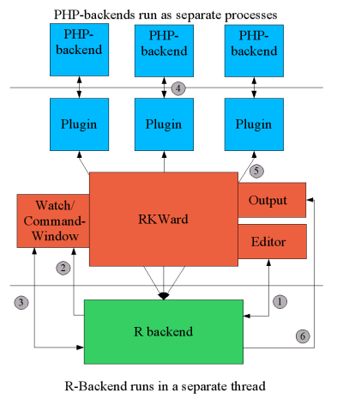  A) PHP-backends run process | B) JavaScript-backends run process
Figure 1 Structure of RKWard. Figures illustrate the communication of distinct elements of RKWard with PHP-backend (A) and JavaScript-backend (B) for plug-ins.
This structures may lead to performance bottlenecks compared to R. For example when a long loop is run in .GlobalEnv
Note when the code is changed to
i <- 1
for (i in 1:100000) { i+i }
the loop should finish much faster, and performance should be roughly back on par with plain R. The reason RKWard usage of “active bindings” to keep track of changes in R objects. In the first example, i is replaced with an active binding, and slows down each access to i, considerably. In the second example, the “i” used in the loop is just a regular R object. This issue however is planned to be improved. It is possible to work around this, though, by using local variables. For example
rm (i)
for (i in 1:100000) { i+i }
Here, a local object “i” will be used, which RKWard will not try to track (and the global object “i” will remain untouched). Or - perhaps more realistically - place all your code into functions. After all, that's generally a good idea in the first place.
i <- 1
local({
for (i in 1:100000) { i+i }
})
RKWard is considerably slower, when there is a huge amount of output. There is an unavoidable memory-overhead, of course, simply for having RKWard loaded. Thus performance of RKWard largely depends on the system resources. The performance decrease during library/package loading is discussed in chapter “Package Management”.

Development process of RKWard and RKWard plug-ins
RKWard is an open-source software project licensed under the terms of the GNU General Public License Version 2 or later. The project status can be considered to be beta (K2009). Some documentation templates are GFDL licensed. The project is hosted at SourceForge (http://sourceforge.net/).

Figure 2: Plugin Map structure of RKWard

The development process of plug-ins which enter RKWard mainline undgo a quality control process.. Plug-ins are organized according to figure 2.
- Code reuse in plug-ins by generic and extensible elements (plot options)
- Automated plug-in testing
- Plug-in status tracking. The status of a plug-in is descriptive reported (e.g. “complete”, “needs testing”) in a Wiki. Subsequent plug-ins are tested and reviewed by other developers. Then new plug-ins go from “under_development.pluginmap” to other plug-in maps.
Fox J 2007 demonstrated the extension of Rcmdr by plug-in packages (J2007).
Figure 3 Timeline of important development milestones and changes in RKWard. Years are presented as arbitrary scale.
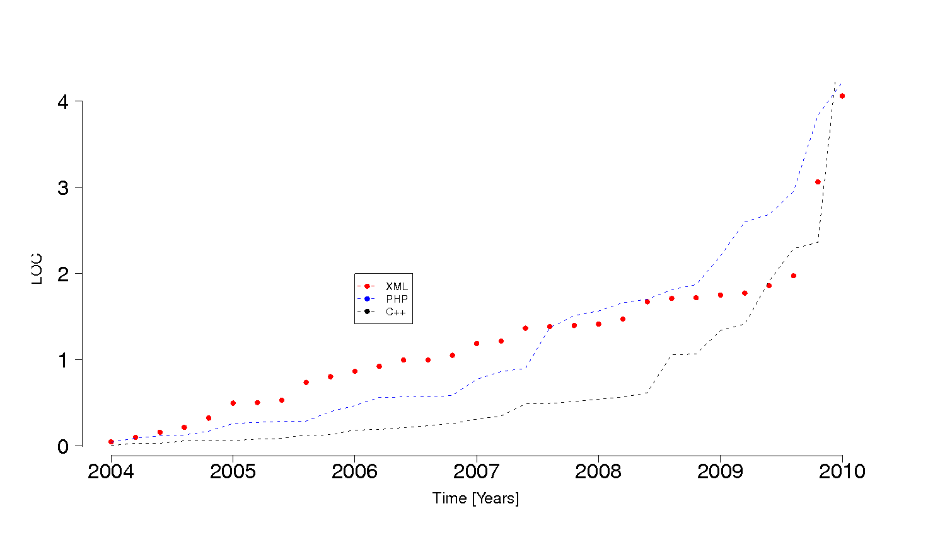Figure 4Development of RKWard described in Lines of Code (LOC). Most growth was seen in C++. In 2009 PHP-backend development ended and JS-backend started.
Basic characteristics regarding the acceptance and code development of RKWard were analyzed. We analyzed download numbers from SourceForge and Debian packages. It is known that download numbers for open source software is a controversial but broadly applied measure of usage (RossiB2010). Debian was chosen since R was early included (R 0.61, 1997) and RKWard packages were available since early versions too (D2003). Developments in source code were analyszed based on data from SourceForge and Oholo. Such approaches are widely used methods to asses the quality of open source projects (Y2005). We observed an increase … over the years (figure 6). Moreover we analyzed the Google index. Data from Google we collected from a Windows XP machine, running Firefox with the term “RKWard”. The term “Rcmdr” was used as reference. Hits were collected over a period from 01.01.2003 till 30.06.2010. Please note that these numbers are merely useful to estimate tendencies and not to present accurate numbers. We expect that real the acceptance compares to the data presented here.
Figure 6 Acceptance of RKWard analyzed by downloads from SourceForge and Debian (fictional data).
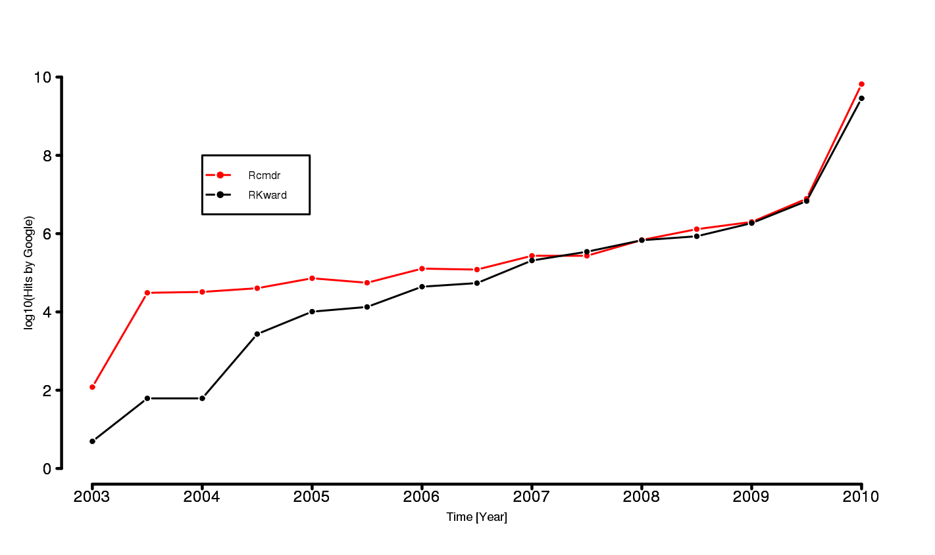Figure 5 Acceptance of RKWard measured by hits from Google (real data).

Installing RKWard
RKWard can be downloaded free of charge from “http://sourceforge.net/”. RKWard requires R to be installed. Optionally packages for specified tasks are required. Installation of additional packages is handled automatically by RKWard (see chapter “Package Management”).

Cross-platform Usage
Currently the main target of RKWard is the GNU/Linux platform. Since the availability of the KDE Software Compilation on MacOS and Microsoft Windows efforts are also undertaken to extend the scope of RKWard

Starting RKWard

Default Graphical User Interface Elements
The following chapter will describe the main GUI elements of RKWard. It is important to note that the default GUI layout is described here. User defined RKWard implements a top-level menu/dialog-box interface (figure 7A) and a tab document interface (TDI) (figure 7C). Early uses of TDIs date back to 1988 and are widely applied nowadays (; CRPITV93Kim.pdf). The TDI organizes multiple “documents” in a single window while using the tabs for switching between the documents. The top-level menus include Files, Edit, View, Execute … . The tab document interface is used to organize data, output and help pages.
- Form factor of used device (small form factor devices usable due to TDI and MDI interface, navigation simple by shortcuts, GUI elements toggle-able)
MDI elements
As R RKWard assumes that all files (for example custom script files) are located in the current working directory in case no path was specified. The location is indicated besides the status notification element of RKWard (see section “Controlling RKWard and R” figure 11A). The working directory can be changed via GUI elements (Workspace) or via command line (see R documentation getwd() or setwd(), respectively).
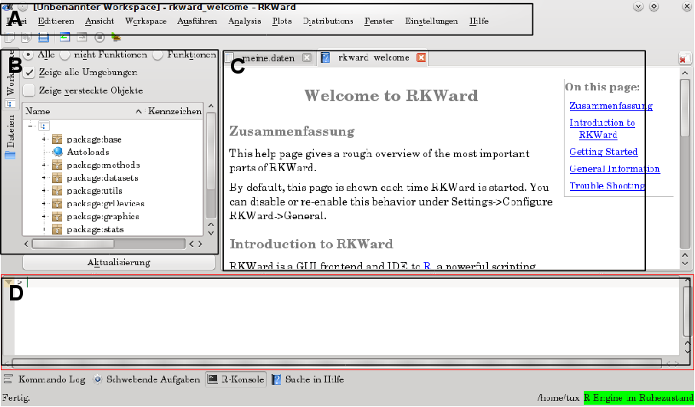Figure 7 Default RKWard main window after start up. A) Menu bar, B) navigator elements, C) output and data management. D) command prompt.
All plug-ins present the R syntax in an additional box affiliated to the GUI. This box can be toggled on and off. The intention is to provide for both average and advanced R-users the underlying code for learning and review. GUIs can represent only to a limited extend the whole power of the R-language. This applies in especial to plots. However, users can reuse RKWard generated code to tweak some functions to their particular needs and esp. to automate some tasks.

Shortcut navigation of RKWard
Navigation of RKWard is possible for main components without using a mouse device by using the keyboard exclusively. Shortcuts are configurable from the GUI via “Settings/Configure Shortcuts”. However, for technical reasons, only the shortcuts of those components currently active will be listed. Hence, adoption data editor shortcuts requires first to open a data editor and then to select “Settings/Configure Shortcuts”. Since RKWard relies on KDE SC editor component as editor component shortcuts for the script editor (section “Code editor - Integrated development environment”) are managed separately using “Settings/Configure Editor/Shortcuts”.
On most systems, you can also configure shortcuts by right-clicking on the respective menu item.

Workspace browser
The workspace browser allows to view and manipulate R objects. This includes both user objects (data, functions), and so-called “package environments”. As a rough analogy, this is similar to a regular file-system browser.
Literally hundreds or even thousands of objects are present in a typical R session. This can be overwhelming at first, therefore the workspace browser offers to show only a certain subset of objects. The options here are “Show Hidden Objects”, “All vs. Non-Functions vs. Functions”, and “Show All Environments” (available at the top of the browser window, or chosing “Show Objects” from the context menu). The first should be obvious. It controls whether objects whose name start with a dot ('.') are shown or not. Those are often used for internal objects, which are not meant for direct use, so it's generally safe to hide them from view. The second allows to select by the type of object. “All” does not filter, while “Functions” shows only functions, and “Non-Functions” shows all other objects (typically data). The “Show All Environments” option controls, whether package environments and their objects are shown. Roughly speaking, if you turn off this option, only your “own” objects are shown, while with the option turned on, all pre-defined objects are also shown. More technically speaking, when the option is turned off, only the .GlobalEnv (see R reference for 'globalenv') is shown, which is the environment, in which you create and edit your data. Note that objects are organized in a hierarchy, i.e. some types of objects contain further “child” objects. This is indicated by a “+” symbol to the left of the object name. Clicking on this will expand the view to show all the children of the object. Hovering the mouse pointer over an object will show a short summary of the objects' basic properties.
Available actions
Several actions are available from the context menu (by right-clicking on one of the objects), however some of these actions are only available for some types of objects. The most important actions for objects in package environments: Search Help: This will try to locate and show a relevant R help page on the object. View: Open a window with detailed information about the object. This will, among others, use the R commands print and summary to show more information. Copy to new symbol / Copy to .GlobalEnv: In order to manipulate objects, you need to copy them to the .GlobalEnv. For instance, you could copy an object from the environment “package:datasets” into the .GlobalEnv, and in a second step, edit it. Further actions available for objects in the .GlobalEnv: Edit: Open the object in a data editor. Currently editing is only supported for data.frames. Rename / Delete: These should be obvious. Configurable Settings Some default settings for the Workspace Browser can be configured using Settings → Configure RKWard → Workspace, or by selecting “Configure Defaults” from the context menu: Show hidden objects / show all environments: See above. In contrast to the settings made directly in the workspace browser, these configure the default settings in the workspace browser (i.e. those that are effectively after restarting RKWard). Show objects with children: Controls whether objects with children (such as environments, lists) are shown, even if they do not correspond to the current filter. Show variables / functions: Equivalent to the “All vs. Non-Function vs. Functions” control described above. Label field / Type field / Class field: Which columns are shown for each object? Never fetch the structure of these packages: Some (few) R packages contain very many small objects (tens of thousands). In the worst case, trying to fetch structure information on those (i.e. fetching the information to be shown in the workspace browser) can consume a lot of resources and make RKWard unresponsive. Package “GO” is one such package, and is “blacklisted” by default. If you note that loading a package takes exceedingly long, you may consider adding it to this list.

Code editor - Integrated development environment
The Integrated development environment (IDE) of RKWard consists of a source code editor (script editor) with syntax highlighting, an interpretor (connection to R) and an object browser (figure 7C). The code editor is based on KDE SC editor component from the KDE SC. It covers, R syntax highlighting, code folding, auto-completion, automatic brackets, line numbering. “Search and Replace” cover standard features and regular expressions.
Code execution can be performed as single line, block part or complete block which allows usage of code parts or the complete code.

Spreadsheet-like data editor
- Uses a spreadsheet-like data editor
- allows basic operations (change names, inserting or deleting of rows and columns, change type (string, integer, …))
- renameable
- column summary statistics for fast data overview

Results output
The output of results in RKWard is separated into content and layout. There is no layout of its own tables and plots which have to be converted to the style used in the rest of a publication by hand. Using appropriate style definitions reformatting this output to match the rest of the publication is thus open to the user. Technically this is realized as HTML with basic formating (header tag, …) (Figure 7) Currently RKWard uses HTML for its output which is based on the R2HTML package (E2003). Font size of the text but not embedded images can be adjusted to user needs. In future releases RKWard will even seek stronger integration with existing office suites. Herein odfWeave is a currently discussed approach. odfWeave is a package for Sweave processing of Open Document Format (ODF) ﬁles developed by Max Kuhn and Steve Weaston available from CRAN (F2002; Kuhn 2006).
- “Run again” elements for re-usage of code
- Notification about removed (no longer existent objects)
Direct usage of the RKWard output in an office suite is one goals. Future plans of RKWard include the usage of the “OASIS Open Document Format for Office Applications (ODF)”. Currently there is only support for standard HTML. Raster images are embedded as PNGs. HTML can be read and worked on with any modern office suite. The easiest way to get output into your office suite, is to first select the relevant portions, copy them (“/Edit/Copy”), then paste them. Same applies to drag and drop of images finto an office document. Access to the raw HTML and PNG image files is also possible. These data are stored in a hidden directory, by default in the sub-folder “.rkward” of the home directory (“/Settings/Configure RKWard/General”). The corresponding files are called “rk_out.html” for the HTML part or “graph*.png” for the PNG raster images. The output can be stored in another location and opened with another application (e.g. web browser, office suit, editor).
The advantage of this approach is that GUI elements for specific tasks can be customized by the user for example for automatic report generation. Raffelsberger et al. (2008) developed RreportGenerator (RaffelsbergerW2008) which generates automatic reports from routine statistical analysis in bioinformatical applications. It is a simple Tlc/Tk based GUI which allows to execute R code from a user-selected pre-defined Analysis Scenarios. The report is an intermediary .tex file which is passed to a LaTeX imprisonment which in turn is process to a PDF file. This compares to RKWards approach as followed. Plug-in GUIs can define one or more tasks (see chapter “Automatic code generation”). These can be developed without changing the core of RKWard. The definition of the GUI elements is done in XML language and the JavaScript/R-code is described in chapter “Defining a RKWard plug-in GUI” and “JavaScript/R code generation”.

On the fly plot updates
Figure 8 Elements of a test output. Important information like date of test, name of test and user defined parameters keep stored of analysis. “Run again” elements open the corresponding test again.
- Plot get updated (if activated) immediately after changes were done
- RGB/HSV color selection widgets

Data import and management of data
This chapter will describe how external data import and data are managed in RKWard. Reading data into R for analysis and export of processed data can be elaborative. In especial in case data come from a wide range of sources (e.g. other software packages, office-suites, “decimal system”) automated scripts will fail to work. Technically RKWard relies on R packages for certain set of data which were already described elsewhere (Murdoch D R-news 2002-1 p 2-ff). Currently import from defined data structures SPSS, Stata files and undefined Text (CSV) files is implemented in RKWard. All import modules cover handling of header lines, field separators, decimal separators, quoting, missing values, unfilled lines, blank lines, skipped lines, white space in character ﬁelds, variable classes, and comments. However, the implemented feature set varies within the import plug-ins.
Depending on the data set size, different applications might better be suited for pre-data manipulation with a different application (Team2004).
In contrast Rcmdr can RKWard make use of any data object currently loaded (interesting to note). Any created data.frame, matrix, … can be used.

Package Management
RKWard has basically all the functionality which comes with the standard packages of R or user installed packages. The following chapter will describe how RKWard handles (I) non-installed packages and (II) installed packages which offer updates. RKWard has no build-in tools for the interactive exploration of R packages. However, it is possible to invoke external helpers (Zhang J and Gentleman R, R-news 2004-1, p. 20-ff).The underlying package management technology was already described elsewhere (U2003; BD2005). RKWard offers notification from GUI elements and tracks notification in the output (see chapter “Default Graphical User Interface Elements”). Proper package handling is an important issue since the number of R packages available from CRAN, Omegahat and Bioconductor has grown exponentially since R v. 1.3 (2001) to R v. 2.7 (2008) (J2008, U2003).
(I) RKWard notifies users about libraries (packages) which are not present in the standard installation (figure 9A). Basic functionality of RKWard is affected for data import (foreign package) or moments analysis for example. Other RGUIs like Rcmdr face the same issue (citation needed). An example for the management of package installation will be illustrated for Kurtosis and Skewness analysis which is accessible in RKWard from “Menu/Analysis/Moments”. The installation is guided by RKWard during the complete process (figure 9B). Generally the installation process requires root/administration privileges. For the convenience of the user the corresponding CRAN mirror to operate from is user defined (figure 9B) from a dialog-box interface. Package installation destination can be manually chosen. The packages installation takes place with no further need of user interaction. The process is can be followed from the interface for error tracking. However, it is also possible to install missing libraries via command line (see R documentation “install.packages()”). Dependencies can by solved by R (RKWard) automatically, depending on the user configuration. First time use of such functions thus requires the guided installation. A restarted RKWard in contrast requires just automatic loading of a prior installed package. It is important to note that loading libraries/packages is typically slightly slower in RKWard. But since packages/libraries are mostly loaded only one-time thing per session this issue is negligible from a user point of view. The uninstallation process is not yet covered in RKWard (as of v. 0.5.3). (II) Updates of installed packages is also covered by RKWard. In plain R updates are performed via “update.packages”. RKWard operates in a two-panel interface. Informations cover the current installed version of a package, the installation location and the newest version from CRAN. As stated before the update process is guided. The user is not restricted to an “all or nothing” update process. A mode for single, user selected of complete update is possible. This is an important feature if problems from single updated CRAN package versions are known or different installation paths were used.
A) Notification about missing library (package). | B) Option for choosing a CRAN mirro and installation process control.
Figure 9 Automated user notification about missing packages and guided installation process of missing packages.

Help system
- RKWard build-in help system
- RKWard help invoked by “F1”
- Reference to help system of package in separate tab

Internationalization
The internationalization of R was already discussed by Ripley 2005 (BD2005a). This section will focus on internationalization of RKWard. Currently strings are translated to different degrees in cs, ca, Spanish (es), German (de), Chinese (zh_CN), Turkish (tr), Polish (pl), Italian (it), French (fr), el and Danish (da) (figure 10). Translatable strings are to be found under po/**.po in the sources. These files can be conveniently by edited with front-ends like KBabel (URL) or Kaider (URL). Plug-ins of RKWard however, do not have a message catalog in order to translate the strings. This is due to the fact that they use languages other than Qt/C++. Thus currently there is no standard way to internationalize this GUI parts conveniently other than by hand.
Figure 10 Percentage of translated strings (localization) compared between 2004 and 2010 for English, German and Polish.

Controlling RKWard and R
RKWard starts first and subsequent R is started in the background. Depending on the speed of a computer starting times of R might differ. The current state of R within RKWard is monitored constantly. An indicator box on the right bottom corner of RKWard indicates the status in green (free for operation), yellow () and red (operating) (figure 11A). Moreover performance of RKWard is directly affected by R which in turn is dependent on the number of objects in the memory and number and sizes of loaded packages (BD2004).
Commands can be submitted while the R backend has not yet started, or while another lengthy calculation is still performing. In this case commands are placed into a queue, first, and executed as soon as the R backend becomes available. R code execution can be controlled from RKWard completely. Running code can be interrupted or reseted (figure 11B).
Figure 11 Controling R and RKWard.

Programmer’s Niche – Extending RKWard
This chapter will give a brief introduction how to extend RKWard either by extending existent plug-ins or how to develop new.

Defining a RKWard plug-in GUI
- Use condensed and updated version of writing_plugins_introduction.docbook
- I consider this one of the most interesting chapters
- Code example with screenshot

JavaScript/R code generation
- Use condensed and updated version of writing_plugins_introduction.docbook
- I consider this one of the most interesting chapters
- Code example

Automatic code generation
One main aim of RKWard is the education of novice R users in code generation. Therefore every plug-in offers an option to present the R code generated from objects and data provided to the GUI plug-in fields. Plug-ins are in many cases able to perform more than one task. A task is defined as the processing of any user defined object (e.g. data or formula) by R functions under certain arguments invoked by the RKWard GUI. The result of a task is either stored as new object or presented in a human readable form (see section “Results output”). For example the “Descriptive statistics” plug-ins computes among the mean also the median, the standard deviation and so forth or a combination. Currently the code generated for that is:
This approach however, has the advantage, that users can copy the entire code snippet, and simply change the “domedian” option to 1 to run the same calculation including the median. Another approach is generate code for the chosen options only. In especial if mean is selected, but not median, only the following would be generated:
rk.temp.options <- list (domean=1, domedian=0)
for (...) {
if (rk.temp.options$domean) rk.temp.results$mean[i] <- ...
if (rk.temp.options$domedian) rk.temp.results$median[i] <- ...
}
...

for (...) {
rk.temp.results$mean[i] <- ...
}
...
While if both are selected,
would be generated. The second approach has the advantage of keeping the generated code shorter, and more readable. While documenting the used code (for example in quality control or documentation in research) it is rather desirable to reduce not needed information. However this approach comes to cost of a slightly more complex logic for code generation. This would not be visible by the user.
for (...) {
rk.temp.results$mean[i] <- ...
rk.temp.results$median[i] <- ...
}
...

Comparison with Cantor and other software packages
- Cantor is in an early stage of development
- Also integrated in KDE SC technology
- Worksheet Interface

Example Bioconductor
Consider to include bioconductor sources. Bioconductor was first published by Gentleman et al. 2004.
> source("http://bioconductor.org/biocLite.R")
> biocLite() # install standard packages...
> biocLite("rtracklayer") # or rtracklayer

Conclusion and Summary

Bibliography
Please see abbreviations in text

# ^ "Design Specifications and Guidelines - Window Management". Microsoft Developer Network. Microsoft. http://msdn2.microsoft.com/en-us/library/ms997505.aspx. Retrieved 2010-03-01. # ^ Hopkins, Don (September 29, 2005). "HyperTIES Hypermedia Browser and Emacs Authoring Tool for NeWS". Don Hopkins' Web Site. http://www.donhopkins.com/drupal/node/101. Retrieved 2010-03-01.
M. Kuhn. Sweave and the open document format – the odfWeave package. R News, 6(4):2–8, 2006. URL http://CRAN.R-project.org/doc/Rnews/Rnews_2006-4.pdf.
Gentleman,R.C., Carey,V.J., Bates,D.M., Bolstad,B., Dettling,M., Dudoit,S., Ellis,B., Gautier,L., Ge,Y., Gentry,J., Hornik,K., Hothorn,T., Huber,W., Iacus, S., Irizarry,R., Leisch,F., Li,C., Maechler,M., Rossini,A.J., Sawitzki,G., Smith,C., Smyth,G., Tierney, L., Yang,J.Y.H., Zhang,J. (2004) Bioconductor: Open software development for computational biology and bioinformatics, Genome Biology, 5, R80.

