RKWard – A comprehensive Graphical User Interface and Integrated Development Environment for statistical analysis with R

Authors: Stefan Rödiger, Meik Michalke, Detlef Steuer, Prasenjit Kapat, Matthieu Stigler, Thomas Friedrichsmeier
Institution:

Keywords: GUI, IDE, R, plugin, cross-platform
Table of Contents
1 Abbreviations (alphabetical): 2
2 Abstract 2
3 Background and motivation 3
4 Technical Design 4
4.1 Asynchronous command execution 4
4.2 Choice of toolkit and implementation languages 6
4.3 Plugin infrastructure 6
4.3.1 Defining a plugin 6
4.3.2 Embedding and reuse of plugins 7
4.3.3 Enforcing a consistent interface 7
4.3.4 Handling of R package dependencies 8
4.4 Development processes / Quality assurance 8
4.4.1 Plugin review 8
4.4.2 Automated testing 9
4.5 Other aspects? 9
4.5.1 Graphics Windows 9
5 A heading 10
6 Using RKWard 11
6.1 Installing RKWard 11
6.2 Cross-platform Usage 11
6.3 Starting RKWard 11
6.4 Default Graphical User Interface Elements 11
6.4.1 Shortcut navigation of RKWard 12
6.4.2 Workspace browser 13
6.4.3 Code editor - Integrated development environment 14
6.4.4 Spreadsheet-like data editor 14
6.4.5 Results output 15
6.4.6 On the fly plot updates 16
6.5 Data import and management of data 16
6.6 Package Management 17
6.7 Help system 18
6.8 Internationalization 18
6.9 Controlling RKWard and R 19
7 Programmer’s Niche – Extending RKWard 20
7.1 Defining a RKWard plug-in GUI 20
7.2 JavaScript/R code generation 20
7.3 Automatic code generation 20
8 Comparison withother software packages for R 21
9 Example Bioconductor 22
10 Conclusion and Summary 22
11 Bibliography 22

Abbreviations (alphabetical):
CRAN The Comprehensive R Archive Network
CSS Cascade Style Sheet
CSV Comma separated values
GUI Graphical User Interface
HTML Hypertext Markup Language
IDE Integrated Development Environment
JS JavaScript
KDE SC KDE Software Compilation
ODF OASIS Open Document Format
PHP PHP: Hypertext Preprocessor
PNG Portable Network Graphic
Rcmdr R Commander
TDI Tab document interface
XML Extended Markup Language

Abstract
R is a free, open-source implementation of the S statistical computing language and programming environment. The current status of R is a command line driven interface with no advanced standard Graphical User Interface (GUI) but it includes tools for building such. Over the past years proprietary and non-proprietary GUI solutions, based on internal or external tool kits, with different scopes and technological concepts emerged. In this paper we discuss RKWard which is both a comprehensive cross-platform GUI and Integrated Development Environment (IDE) for R. RKWard is based on the KDE software libraries. Statistical tests and plots are implemented as extendable plugin architecture. A plugin is defined by the broadly used ECMA script (JavaScript) R and XML style sheets. XML style sheets herein are used to describe the GUI. This approach allows an easy and rapid developments of customized or new plugins. The objective of RKWard is to provide an R interface for basic and advanced statistical and graphical analysis while keeping the software portable and extensible.

Background and motivation
In mid 1993 Ihaka and Gentleman published initial efforts on the computing language and programming environment R on the s-news mailing list. Ambitions for this project aimed to develop a S-like language but without inheriting memory and performance issues. The source code of R was finally released in 1995 and development evolved since under the umbrella of the R Development Core Team since mid 1997 (Team2001, Team2009;Ihaka_Gentlemen_1993). R does not include an advanced cross-platform Graphical User Interface as known from other statistical software packages. However, R includes tools for building GUIs mainly based on Tlc/Tk (Dalgaard P (2001). “A Primer on the R-Tcl/Tk Package.” R News, 1(3), 27–31., Dalgaard P (2002). “Changes to the R-Tcl/Tk Package.” R News, 2(3), 25–71.). Till now a plethora of R GUIs emerged (see http://www.sciviews.org/_rgui/ for a comprehensive list). In 2005 John Fox released version 1.0 of R Commander which can be considered a milestone in R GUI development since this was the first GUI implementation which was able to deliver the experience of statistical tests, plots and data manipulation easily accessible for R novices to advanced users. However, John Fox stated that R Commander's target is to provide functionality for basic-statistical courses though functionality increased over time beyond this (Rcmdr paper). In November 2002 Thomas Friedrichsmeier started the RKWard open-source software project. The goal was the implementation of a R GUI which is based KDE and Qt technologies. RKWard is licensed under the terms of the GNU General Public License Version 2 or later. This means the RKWard code itself is GPL v 2 or 3 but effectively distributable only under GPL v 2 due to R code. Some documentation templates are GFDL licensed. The current project status of the core application is tagged as beta (K2009). However, from experience RKWard is reliably usable in productive scenarios. The source code, selected binaries and documentation is hosted at SourceForge (http://sourceforge.net/). Milestones of the RKWards development are demonstrated in figure 1. The aim was to develop an easy to use, transparent front-end to the R language in routine and development tasks in desktop environments. The purpose of RKWard is to make the power of the R language easily accessible to the user, without having to learn a full programming language, first. The scope of RKWard is deliberately broad, targeting both R novices, and R experts. The idea is that novices may soon advance to exploit the full flexibility of R as a scripting language. R experts will benefit from task-oriented GUI dialogs when exploring an unfamiliar type of analysis or by implementing a routinely performed tasks as GUI element. RKWard offers a lot of tools to support users in their everyday work (see “Default Graphical User Interface Elements”). RKWard is specifically meant as a productive tool, not as teaching tool for the R language. Teaching of the R language is already implemented by other authors (see Rcmdr or TeachingDemos). However, it supports users in advancing their knowledge of R, gradually. This means that dialogs for statistical procedures in RKWard do not necessarily show a 1:1 correspondence to the underlying steps in R, but are rather oriented at statistical tasks. At the same time, RKWard tries to provide a high level of transparency about the steps that are needed to perform any supported task in R. RKWard tries to show all code for all actions to the user. In particular, RKWard does not try to provide convenience functions for analysis or data manipulation on its own. One guideline is that tasks are best solved in dedicated R packages. RKWard does not impose artificial limitations on how users can work with the application. For example allowing to use only one data.frame at a time is or to use data from several frames is intentionally supported. Rather, RKWard limits itself to generate R code from GUI settings. Compared to other GUIs, this may lead to comparatively verbose code in some cases. RKWard can easily be enhanced by custom GUIs.
Figure 1 Timeline of important development milestones and changes in RKWard. Years are presented as arbitrary scale.
This paper is divided in two parts. First we will illustrate briefly the history, the development process, do a meta-analysis of the acceptance and suggest use case scenarios of RKWard. The second part will critically discuss advantages and disadvantages of technical structures and compare them briefly with plain R and competitive GUI solutions. Moreover we will show how RKWard can be extended with the plugin system without a need to change the core source code.

Technical Design
In this section we will give a compact overview over key aspects of RKWards technical design. We will give slightly more attention to the details of the plugin framework used in RKWard, since this is central to the extensibility of RKWard. The plugin framework is basically a tool set used to define GUIs for the automatic generation of R code.

Asynchronous command execution
One central design decision in the implementation of RKWard is that the interface to the R engine operates asynchronous. The intention is to remain the application usable to a high degree, even during the computation of time-consuming analyses. It is also a prerequisite for a implementation of the plot-preview feature (see chapter 6.4). Commands generated from plugins or user actions are placed in queue and are evaluated in a separate thread in the order they were submitted, but it is possible and in some cases necessary (EXAMPLE) to specify a different order of command execution. The asynchronous design implies that RKWard avoids to rely on the R engine during interactive use. This is one of several reasons for the use of ECMAScript in plugins, instead of scripting using R (see sections 4.2 and 4.3). A further implication is that RKWard avoids queering information about the existence and properties of objects in R, interactively. Rather RKWard keeps a representation of R objects and their basic properties (e.g. class and dimensions), which is used for the workspace browser (section 6.4.2), object name completion, and function argument hinting and other occasions. The object representation includes objects in all environments on the search path, and any objects contained within these environments in a hierarchical tree. The representation of R objects is gathered pro-actively. This has a notable impact on performance when loading packages (specifically, objects which would usually be “lazy loaded” only when needed are accessed in order to fetch information on their properties; this means the data has to be loaded from disk, however, the memory is freed directly after fetching information on the object).
A further side-effect of the asynchronous threaded design is that there is inherently a rather clear separation between GUI code and code making direct use of the R API. This design aspect could allow to separate GUI and R code into separate processes, possibly running on different computers, in the future.
Object modification detection
RKWard allows the user to run arbitrary commands in R at any time. One implication of this is that any user command could potentially add, modify, or remove objects in R. RKWard tries to detect such changes in order to always display accurate information in the workspace browser and other lists of objects, and object views. Beyond that, detecting any changes is particularly important with respect to objects which are currently opened for editing in the data editor (which provides an illusion of in-place editing, see section 6.4.4). Here, it is necessary to synchronize the data between R and the GUI in both directions.
For simplicity and performance, object modification detection is only implemented for objects inside the global environment (including in environments inside the global environment), since this is where changes are typically done. Currently object modification detection is based on active bindings. Essentially, any object which is created in the global environment is first moved to a hidden storage environment, and then replaced with an active binding. The active binding acts as a transparent proxy to the object in the storage environment, which registers any write-access to the object.
The use of active bindings has significant performance implications, when objects are accessed very frequently. This is particularly notable where an object inside the global environment (i.e. an object wrapped into an active binding) is used as the index variable in a loop, as illustrated by the following example:
i <- 1 # create object
# “i” will become subject to object modification detection
# as soon as the user command returns
for (i in 1:100000) { # this loop will run slow
i + i
}

f <- function () {
for (i in 1:100000) { # this loop will run approximately as
# fast as in plain R
# “i” is a local object in this function,
# and not subject to object modification
# detection
i + i
}
}
f ()
It may be possible to overcome this performance problem in future versions of RKWard. One approach that is currently under consideration is to simply perform a pointer comparison of the SEXP records of objects in global environment with their copies in the hidden storage environment. Due to the implicit sharing of SEXP records, this should provide for a reliable way to detect changes for most types of R objects, with comparatively low memory and performance overhead. Special handling will be needed for environments and active bindings.

Choice of toolkit and implementation languages
In addition to R, RKWard is based on the KDE libraries, which are in turn based on Qt, and implemented mostly in C++. Compared with many competing libraries, this constitutes a rather heavy dependency. Moreover, the KDE libraries are still known to have portability issues especially on Mac OS, but to some degree also on the Windows platform. In fact, to date, RKWard has not been proven on Mac OS.
The most reason for the choice of the KDE and Qt libraries is that they provide many high level features which have allowed RKWard development to make quick progress despite limited resources. Most important the KDE libraries provide a full featured text editor (KatePart) as a component which can be seamlessly integrated into a hosting application using KParts technology (Reference for KParts). A further KPart provides HTML browsing capabilities in a similarly integrated way. The availability of kword (Reference) as an embeddable KPart might prove useful in future versions of RKWard, when better integration with office-suites will be sought.
Another technology from the KDE libraries that is important to the development of RKWard is the XMLGUI-technology (Reference: there's a KDE 2.0 development book, which has something on this, AFAIR). This is especially helpful in providing an integrated GUI for the various components of RKWard.
Plugins in RKWard rely on XML and ECMAScript (see section 4.3). XML is well suited to describe the layout of the GUI of plugins, but simple functional logic can also be represented. ECMAScript was chosen for the generation of R commands within plugins in particular due to its availability as an embedded scripting engine inside the Qt libraries. While at first glance, R itself would appear as a natural choice of scripting language as well, this would make it impossible to use plugins in an asynchronous way. Further, the main functional requirement at this place is the manipulation and concatenation of text strings, and while R provides support for this, concatenating strings with the “+”-operator, as available in ECMAScript, allows for a much more readable way to perform such text concatenation.

Plugin infrastructure
One of the earliest features of RKWard was the extensibility by plugins. Basically, plugins in RKWard provide complete GUI-dialogs, or re-useable GUI-components, which accept user settings, and translate those user settings into R code. Much of the functionality in RKWard is currently implemented as plugins. For example import of different file formats relying on the foreign package is achieved by this approach.

Defining a plugin
Plugins consist of four parts (see section 7 for examples; for a complete manual, see Reference):
- An XML file called a “plugin map” is used to declare one or more plugins, each with a unique identifier. For most plugins, the plugin map also defines the placement in the menu hierarchy. Plugin maps are meant to represent groups of plugins. Users can disable/enable such groups of plugins in order to reduce the complexity of the menu hierarchy.
- A second XML file describes the plugin itself. Most importantly this includes the definition of the GUI-layout and GUI-behavior. High level GUI-elements can be defined with simple XML-tags. Layout is based on “rows” and “columns”, instead of pixel-counts. In most cases this allows for a sensible resizing behavior. RKWard supports single-page dialogs, and multi-page wizards, however, most plugins define only a single-page UI. GUI behavior is can be programmed by connecting “properties” of the GUI elements to each other. For example the state of a checkbox could be connected to the “enabled” property of a dependent control. More complex logic is also supported. The current development version also supports procedural scripting of GUI behavior using ECMAScript.
- A separate ECMAScript-file is used to translate GUI settings into R code. This ECMAScript file is evaluated asynchronously in a separate thread. RKWard currently enforced structuring the code into three separate sections for preprocessing, calculating, and printing results. The generated code is always run in a local environment, in order to allow the use of temporary variables without the danger of overwriting user data.
- A third XML file defines a help page. This help page usually links to the R help pages of the central functions/concepts used by the plugin. Compared to R help pages, the plugin help pages try to give more hands-on advice on using the plugin. Plugins can be invoked from their help page by clicking on a link near the top, which can be useful after following a link from a related help page.
Basically the source code of these elements can be changed without a requirement to recompile.

Embedding and reuse of plugins
RKWard supports several mechanisms for modularization and re-use of functionality in plugins. File inclusion is one very simple but effective mechanism, which can be used in both the ECMAScript files but is also supported in the XML-files. In script files this is most useful by defining common functions in an included file. For the XML-files, the equivalent is to define “snippets” in the included file, which can then be inserted.
A third mechanism allows to completely embed one plugin into another. For instance the plot_options plugin is used by many plugins in RKWard to provide common plot options such as plot labels, axis options, and grids. Other plugins can embed this using the “embed”-tag in their XML file (the plugin supports hiding irrelevant options). The generated code portions can be fetched from the ECMAScript file just like any other GUI settings, and inserted into the complete code. Other examples of embedded plugins are options for histograms, barplots, and ECDF plots (which in turn embed the generic plot options plugin).

Moreover there is a RGB/HSV color selection widget though not many plugins make use of this.

Enforcing a consistent interface
RKWard tries to make it easy to create a consistent interface in all plugins. GUI-wise this is supported by providing high-level GUI elements, and embeddable clients. Also, the standard-elements of each dialog (“Submit”, and “Cancel” buttons, on-the-fly code view, etc.) are hard coded. Up to version 0.5.3 of RKWard it was not possible to use any GUI elements in plugins which were not explicitly defined for this purpose. In the current development version, theoretically all GUI elements available from Qt can be inserted, where necessary.
For the output, the function rk.header() can be used to print a standardized caption for each piece of output. Printing results in vector or tabular form is facilitated by rk.results(). A wide range of objects can be printed using rk.print(), which is just a thin wrapper around the HTML()-function of the R2HTML-package (Reference?) in the current implementation. The use of custom formatting with HTML is possible, but discouraged. Standard elements such as a horizontal separator, and the run-again link (see section 6.4.5) are inserted automatically, without the need to define them for each plugin.
Regarding the style of the generated R code, enforcing consistency is harder, but plugins which are to become part of the official RKWard distribution are reviewed for adherence to some guidelines. Perhaps the most important guidelines are
- Write readable code, which is properly indented, and commented where necessary.
- Do not hide any relevant computations from the user by performing them in the ECMAScript. Rather, generate R code which will perform those computations, transparently.

Handling of R package dependencies
A wide range of plugins for diverse functionality is present in RKWard (see appendix for details). This encompasses plots (e.g. boxplot) or standard tests (e.g. Student's t-Test). Some of the plugins depend on R packages other than the recommended R base packages. Examples herein are the calculation of kurtosis, skewness or the exact Wilcoxon test. Installation of additional packages is handled automatically by RKWard (see chapter “Package Management”).
RKWard avoids loading all these packages pro-actively, as Rcmdr does. Rather, plugins which depend on certain package simply include an appropriate call to require() in the pre-processing section of the generated R code. The require() function is overloaded in RKWard, in order to bring up the package-installation dialog, in case the required package is not currently installed. Packages invoked by require() remain loaded unless RKWard is terminated or a certain package is manually unloaded (detach()).
Dependencies between (embedded) plugins are currently handled using the <require>-tag in the plugin map.

Development process

Core and external Plugins
Newly developed plugins are placed in a dedicated plugin map called under_development.pluginmap. Plugins in this map are not visible to the user by default, but need to be enabled manually. Once the author(s) of a plugin announces that they consider it stable, the plugin is subjected to a review for correctness, style, and usability. The review status is tracked in the project wiki. Currently at least one positive review is needed before the plugin is allowed to be made visible by default, by moving it to an appropriate plugin map.
Fox J 2007 demonstrated the extension of Rcmdr by plug-in packages (J2007).
Figure 2: Plugin Map structure of RKWard

Automated testing
A second requirement for new plugins is that each plugin must be accompanied by at least one automated test. The automated testing framework in RKWard consists of a set of R scripts which allow to run a plugin with specific GUI settings, automatically. The resulting R code, R messages, and output are then compared to a defined standard. Automated tests are run routinely after changes in the plugin infrastructure, and before any new release.
The automated testing framework is also useful in testing some aspects of the application which are not implemented as plugins, but this is currently limited to very few basic tests.

Other aspects?

Graphics Windows – Working with plots
Contrary to the approach used in JGR (reference), RKWard does not technically provide a custom on-screen graphics device. RKWard detects when new graphics windows are created via calls to X11() or windows(). These windows are then “captured” in a platform dependent way (based on the XEmbed protocol for X11, on reparenting for the Windows platform). An RKWard menu bar (and in development versions also a toolbar) is then added to these windows to provide added functionality. While this approach requires some platform dependent code, any corrections or improvements made to the underlying R native devices will automatically be available in RKWard.
Figure 3 Elements of a test output. Important information like date of test, name of test and user defined parameters keep stored of analysis. “Run again” elements open the corresponding test again.
This approach leads to numerous benefits and sophisticated features which ease work with plots. As know from other R GUIs export to various pixel (JPG, PNG) and vector (SVG, PS/EPS compatible, PDF) based formats which are adjustable (size, font family). A unique feature is the possibility to add customizable grids to plots.
Any plot invoked from RKWard plugins offers plot previews and changes are repainted immediately. The preview feature can be turned off for complex plots and those with large sample numbers where repainting will be decelerated.
RKWard provides a plot history as known from RGUI (Win32) for regular and trellis plots. The plot history allows the user to navigate through plot created during a RKWard session. Number and size of stored plots can be defined by the user.
1a. first / prev / next / last
1b. Remove plot
1c. Forcefully append plot, irrespective of its status and type
1d. Clear history
1e. Drop down menu
More notes which should not really go here
(But I did not want to mix last week's comments with new comments, to make merging easier).

Further:
I don't know how to handle the figures best in "record changes" mode. So I'll leave it to you to re-insert the Figures. I think Figure 1 can be discarded. If it should stay, it would need to be reworked, significantly.

A heading
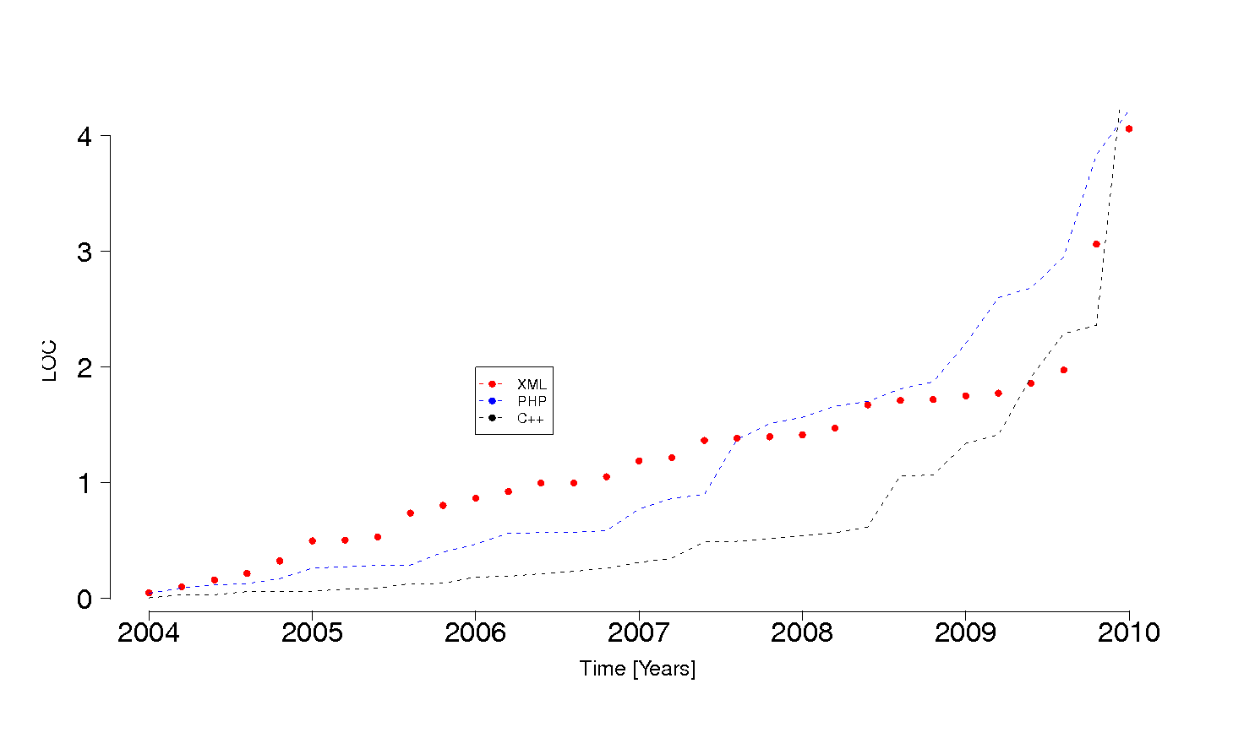Figure 4Development of RKWard described in Lines of Code (LOC). Most growth was seen in C++. In 2009 PHP-backend development ended and JS-backend started.
Basic characteristics regarding the acceptance and code development of RKWard were analyzed. Development of RKWard initially progressed slowly but accelerated in 2004. We analyzed download numbers from SourceForge and Debian packages. It is known that download numbers for open source software is a controversial but broadly applied measure of usage (RossiB2010). Debian was chosen since R was early included (R 0.61, 1997) and RKWard packages were available since early versions too (D2003). Developments in source code were analyzed based on data from SourceForge and Oholo. Such approaches are widely used methods to asses the quality of open source projects (Y2005). We observed an increase … over the years (figure 6). Moreover we analyzed the Google index. Data from Google we collected from a Windows XP machine, running Firefox with the term “RKWard”. The term “Rcmdr” was used as reference. Hits were collected over a period from 01.01.2003 till 30.06.2010. Please note that these numbers are merely useful to estimate tendencies and not to present accurate numbers. We expect that real the acceptance compares to the data presented here.
Figure 6 Acceptance of RKWard analyzed by downloads from SourceForge and Debian (fictional data).
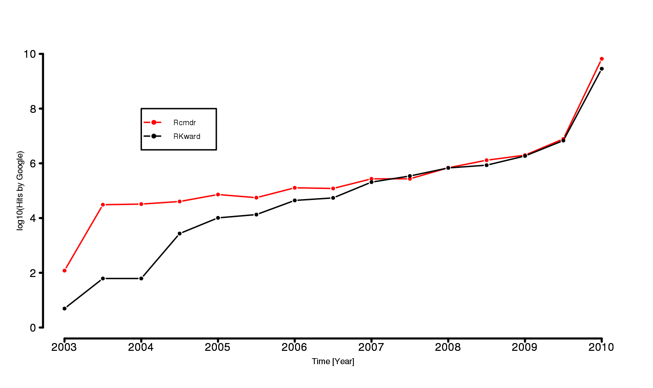Figure 5 Acceptance of RKWard measured by hits from Google (real data).

Using RKWard

Installing RKWard
RKWard can be downloaded free of charge in source and binary from “http://sourceforge.net/”. On the GNU/Linux platform, binary packages are available for many major distributions, including Debian, Ubuntu, OpenSuse, Gentoo, and Fedora. On windows, RKWard is available as a single binary installer (requires existing installations of R and KDE), and as an installation bundle.

Cross-platform Usage
The main development platform of RKWard is GNU/Linux, however the Microsoft Windows port can be considered stable enough for productive use. Efforts are underway to provide RKWard on MacOS X.

Starting RKWard

Default Graphical User Interface Elements
The following chapter describes the main GUI elements of RKWard in the default layout. User defined layouts are definable as desired. The interface is divided into three panel subwindows (figure 7). Each panel may be undocked, resized or moved to another screen location depending on the capabilities of the system window manager. All panels may be opened and closed by point and click via mouse or shortcuts (see section). Top left is the file browser and workspace browser (see chapter “Workspace browser”), respectively. The file browser is used to access files (e.g. R scripts, text files) which are handled by RKWard internally. RKWard is able to invoke external applications for files which are not internally handled. Both bowser work with hierarchical structures and are able to sort, remove and show properties of elements. Right hand is a single row TDI for different documents. Documents can be results output, spreadsheet-like editors, help pages and scripts. The console, command log, status messages and help search are located in the bottom of the interface. All windows, including tool views, are detachable from the main window as independent windows managed by the window manager. An usecase for this is described in section “spreadsheet-like editor”. The console panel provides standard output from R processes and highlighted error messages. Several GUI concepts controll RKWard in all aspects ranging from file management, package management, GUI driven statistical analysis and R script orientated tasks. The versatility is achieved by common GUI concept implementations. These are
- a top-level menu (figure 7A),
- context sensitive toolbars,
- dialog-box interfaces (mainly plugins),
- single row tab document interface (TDI) (figure 7C),
- pop-up dialogs (e.g. CRAN mirror selection, error messages)
- and floating windows (detached documents of the TDI).
Early uses of TDIs date back to 1988 and are widely applied nowadays (; CRPITV93Kim.pdf). The top-level menus include Files, Edit, View, Execute … . The single row TDI organizes multiple documents of different kinds (spread-sheet like editors, help pages, scripts, etc.) in a single window. A document herein is defined as any . Tabs are used for switching between the documents.
- Form factor of used device (small form factor devices usable due to TDI and MDI interface, navigation simple by shortcuts, GUI elements toggle-able)
As R RKWard assumes that all files (for example custom script files) are located in the current working directory in case no path was specified. The location is indicated besides the status notification element of RKWard (see section “Controlling RKWard and R” figure 13A). The working directory can be changed via GUI elements (/Workspace/Set Working Directory) or command line (see R documentation getwd() or setwd(), respectively).
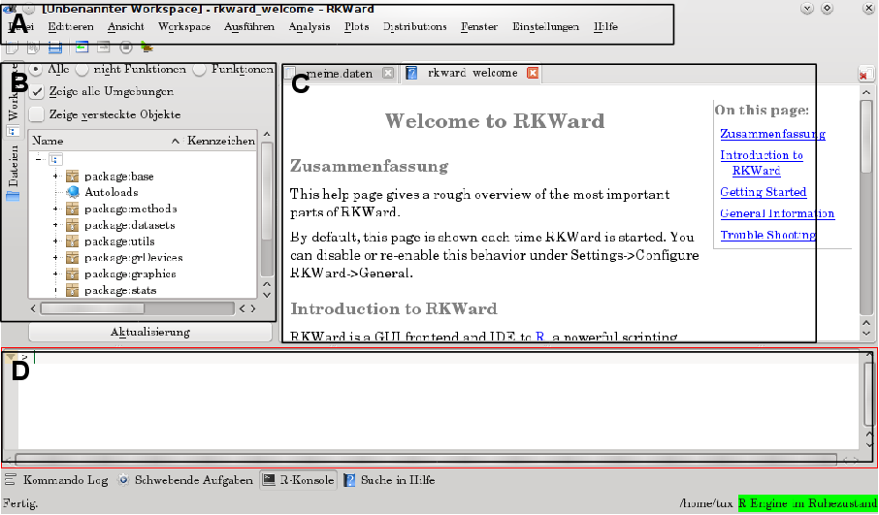Figure 7 Default RKWard main window after start up. A) Menu bar, B) navigator elements, C) output and data management. D) command prompt.
All plugins present the R syntax in an additional box affiliated to the GUI. This box can be toggled on and off. The intention is to provide for both average and advanced R-users the underlying code for learning and review. GUIs can represent only to a limited extend the whole power of the R language. This applies in especial to plots. However, users can reuse RKWard generated code to tweak some functions to their particular needs and especially to automate some tasks.

Shortcut navigation of RKWard
Navigation of RKWard is possible for main components without using a mouse device by using the keyboard exclusively. Shortcuts are configurable from the GUI via “Settings/Configure Shortcuts”. However, for technical reasons, only the shortcuts of those components currently active will be listed. Hence, adoption data editor shortcuts requires first to open a data editor and then to select “Settings/Configure Shortcuts”. Since RKWard relies on KDE SC editor component as editor component shortcuts for the script editor (section “Code editor - Integrated development environment”) are managed separately using “Settings/Configure Editor/Shortcuts”.
On most systems, you can also configure shortcuts by right-clicking on the respective menu item.

Workspace browser
The workspace browser allows to view and manipulate R objects. This includes both user objects (data, functions), and R package environments. As a rough analogy, this is similar to a regular file-system browser. Objects are organized in a flat hierarchical structure. Elements can be loaded to .GlobalEnv are removable and sortable. Moreover detailed properties of any objects can be presented.
Literally hundreds or even thousands of objects are present in a typical R session. This can be overwhelming at first, therefore the workspace browser offers to show only a certain subset of objects. The options here are “Show Hidden Objects”, “All vs. Non-Functions vs. Functions”, and “Show All Environments” (available at the top of the browser window, or choosing “Show Objects” from the context menu). The first should be obvious. It controls whether objects whose name start with a dot ('.') are shown or not. Those are often used for internal objects, which are not meant for direct use, so it's generally safe to hide them from view. The second allows to select by the type of object. “All” does not filter, while “Functions” shows only functions, and “Non-Functions” shows all other objects (typically data). The “Show All Environments” option controls, whether package environments and their objects are shown. Roughly speaking, if you turn off this option, only your “own” objects are shown, while with the option turned on, all pre-defined objects are also shown. More technically speaking, when the option is turned off, only the .GlobalEnv (see R reference for 'globalenv') is shown, which is the environment, in which you create and edit your data. Note that objects are organized in a hierarchy, i.e. some types of objects contain further “child” objects. This is indicated by a “+” symbol to the left of the object name. Clicking on this will expand the view to show all the children of the object. Hovering the mouse pointer over an object will show a short summary of the objects' basic properties.
Available actions
Several actions are available from the context menu (by right-clicking on one of the objects), however some of these actions are only available for some types of objects. The most important actions for objects in package environments: Search Help: This will try to locate and show a relevant R help page on the object. View: Open a window with detailed information about the object. This will, among others, use the R commands print and summary to show more information. Copy to new symbol / Copy to .GlobalEnv: In order to manipulate objects, you need to copy them to the .GlobalEnv. For instance, you could copy an object from the environment “package:datasets” into the .GlobalEnv, and in a second step, edit it. Further actions available for objects in the .GlobalEnv: Edit: Open the object in a data editor. Currently editing is only supported for data.frames. Rename / Delete: These should be obvious. Configurable Settings Some default settings for the Workspace Browser can be configured using Settings → Configure RKWard → Workspace, or by selecting “Configure Defaults” from the context menu: Show hidden objects / show all environments: See above. In contrast to the settings made directly in the workspace browser, these configure the default settings in the workspace browser (i.e. those that are effectively after restarting RKWard). Show objects with children: Controls whether objects with children (such as environments, lists) are shown, even if they do not correspond to the current filter. Show variables / functions: Equivalent to the “All vs. Non-Function vs. Functions” control described above. Label field / Type field / Class field: Which columns are shown for each object? Never fetch the structure of these packages: Some (few) R packages contain very many small objects (tens of thousands). In the worst case, trying to fetch structure information on those (i.e. fetching the information to be shown in the workspace browser) can consume a lot of resources and make RKWard unresponsive. Package “GO” is one such package, and is “blacklisted” by default. If you note that loading a package takes exceedingly long, you may consider adding it to this list.
A similar list (by default showing the globalenv(), only) is also used at several places for the selection of objects to work with, e.g. in an analysis.

Code editor - Integrated development environment (IDE)
The Integrated development environment (IDE) of RKWard consists of a source code editor (script editor) with syntax highlighting, an interpretor (connection to R) and an object browser (figure 7C). The code editor is based on KDE editor component (http://kate-editor.org/). It covers, code folding, auto-completion, automatic brackets, line numbering. R syntax highlighting is present but other common languages are supported too. Following advanced text editing features EXAMPLE1-N are also available from the RKWard code editor. “Search and Replace” cover standard features and regular expressions. RKWard keeps a backup of scripts prior editing.
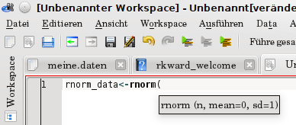Figure 8
Code execution can be performed as single line, block part or complete block which allows usage of code parts or the complete code.
Another helper tool is the “special paste” dialog-box (figure 9). With help of special paste it is possible to create strings, vectors and matrices.
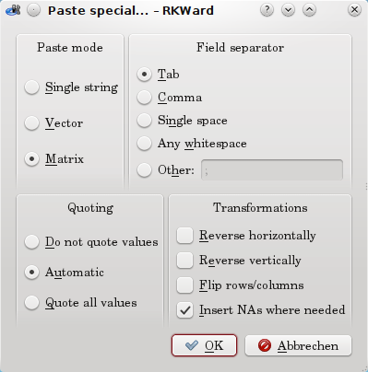Figure 9 RKWard special paste.

Spreadsheet-like data editor
RKWard has a built-in spreadsheet-like data editor. Currently editing of R objects from type “data.frames()” is possible. The editor gives the illusion of “in-place” editing of data (in contrast to R's edit()). These spreadsheets can be created new via GUI or existing objects can be used. RKWard suggests names for new “spreadsheets” and prevents overwriting of existing. In case uses applied the names multiple times a warning is given. Spreadsheets get organized by a TDI (section “Default Graphical User Interface Elements”). All tabs are freely arrangeable by drag and drop or detachable and thus allowing the parallel viewing and working of multiple spreadsheets simultaneously. To our knowledge RKWard is the only R GUI which offers such workflows. The basic operations cover those expected from a spreadsheet like changing of spreadsheet names and column/row names, inserting or deleting of rows and columns, change type (Number, Factor, String, Logical) or editing of single entries. It is also possible to enable editing protection. An interesting feature is the availability of two paste modes for clipboard data which allow to paste inside a selected field or the complete table. For quick data inspection summaries (see summary() for details) and properties can be viewed any time from the object viewer.

Results output
The output of results in RKWard is separated into content and layout. There is no layout of its own tables and plots which have to be converted to the style used in the rest of a publication by hand. Using appropriate style definitions reformatting this output to match the rest of the publication is thus open to the user. Technically this is realized as HTML with basic formating (header tag, …) (Figure 7) Currently RKWard uses HTML for its output which is based on the R2HTML package (E2003). Font size of the text but not embedded images can be adjusted to user needs. In future releases RKWard will even seek stronger integration with existing office suites. Herein odfWeave is a currently discussed approach. odfWeave is a package for Sweave processing of Open Document Format (ODF) ﬁles developed by Max Kuhn and Steve Weaston available from CRAN (F2002; Kuhn 2006).
- “Run again” elements for re-usage of code
- Notification about removed (no longer existent objects)
Direct usage of the RKWard output in an office suite is one goals. Future plans of RKWard include the usage of the “OASIS Open Document Format for Office Applications (ODF)”. Currently there is only support for standard HTML. Raster images are embedded as PNGs by default. JPG and SVG are also supported. Herein resolution and size, respectively, can be defined by the user. Regarding the SVG output it might be worth to mention that the rendering is performed by the KDE khtml_part which does not support all elements of SVG currently. However, from experience using dedicated tools like inkscape renders SVGs created with RKWard satisfyingly. HTML can be read and worked on with any modern office suite. The easiest way to get output into your office suite, is to first select the relevant portions, copy them (“/Edit/Copy”), then paste them. Same applies to drag and drop of images into an office document. Access to the raw HTML and image files is also possible. These data are stored in a hidden directory, by default in the sub-folder “.rkward” of the home directory (“/Settings/Configure RKWard/General”). The corresponding files are called “rk_out.html” for the HTML part or “graph*.png” for the PNG raster images. The output can be stored in another location and opened with another application (e.g. web browser, office suit, text editor).
The advantage of this approach is that GUI elements for specific tasks can be customized by the user for example for automatic report generation. Raffelsberger et al. (2008) developed RreportGenerator (RaffelsbergerW2008) which generates automatic reports from routine statistical analysis in bioinformatical applications. It is a simple Tlc/Tk based GUI which allows to execute R code from a user-selected pre-defined Analysis Scenarios. The report is an intermediary .tex file which is passed to a LaTeX imprisonment which in turn is process to a PDF file. This compares to RKWards approach as followed. Plugin GUIs can define one or more tasks (see chapter “Automatic code generation”). These can be developed without changing the core of RKWard. The definition of the GUI elements is done in XML language and the JavaScript/R-code is described in section “Defining a RKWard plugin GUI” and “JavaScript/R code generation”.
Figure 10 Elements of a test output. Important information like date of test, name of test and user defined parameters keep stored of analysis. “Run again” elements open the corresponding test again.

Data import and management of data
This section will describe how external data import and data are managed in RKWard. Reading data into R for analysis and export of processed data can be elaborative. In especial in case data come from a wide range of sources (e.g. other software packages, office-suites, “decimal system”) automated scripts will fail to work. Technically RKWard relies on R packages for certain set of data which were already described elsewhere (Murdoch D R-news 2002-1 p 2-ff). Currently import from defined data structures SPSS, Stata files and undefined Text (CSV) files is implemented in RKWard. All import modules cover handling of header lines, field separators, decimal separators, quoting, missing values, unfilled lines, blank lines, skipped lines, white space in character fields, variable classes, and comments. However, the implemented feature set varies within the import plugins.
Depending on the data set size, different applications might better be suited for pre-data manipulation with a different application (Team2004).
In contrast Rcmdr can RKWard make use of any data object currently loaded (interesting to note). Any created data.frame, matrix, … can be used.

Package Management
RKWard has basically all the functionality which comes with the standard packages of R or user installed packages. The following chapter will describe how RKWard handles (I) non-installed packages and (II) installed packages which offer updates. RKWard has no build-in tools for the interactive exploration of R packages. However, it is possible to invoke external helpers (Zhang J and Gentleman R, R-news 2004-1, p. 20-ff).The underlying package management technology was already described elsewhere (U2003; BD2005). RKWard offers notification from GUI elements and tracks notification in the output (see chapter “Default Graphical User Interface Elements”). Proper package handling is an important issue since the number of R packages available from CRAN, Omegahat and Bioconductor has grown exponentially since R v. 1.3 (2001) to R v. 2.7 (2008) (J2008, U2003).
(I) RKWard notifies users about libraries (packages) which are not present in the standard installation (figure 11A). Basic functionality of RKWard is affected for data import (foreign package) or moments analysis for example. Other RGUIs like Rcmdr face the same issue (citation needed). An example for the management of package installation will be illustrated for Kurtosis and Skewness analysis which is accessible in RKWard from “Menu/Analysis/Moments”. The installation is guided by RKWard during the complete process (figure 11B). RKWard supports installation to any user-writable library location. On Unix-systems, acquiring administrator rights for installation to the system-wide library is also supported. For the convenience of the user the corresponding CRAN mirror to operate from is user defined (figure 11B) from a dialog-box interface. Package installation destination can be manually chosen. The packages installation takes place with no further need of user interaction. The process is can be followed from the interface for error tracking. However, it is also possible to install missing libraries via command line (see R documentation “install.packages()”). Dependencies can by solved by R (RKWard) automatically, depending on the user configuration. First time use of such functions thus requires the guided installation. A restarted RKWard in contrast requires just automatic loading of a prior installed package. It is important to note that loading libraries/packages is typically slightly slower in RKWard. But since packages/libraries are mostly loaded only one-time thing per session this issue is negligible from a user point of view. The uninstallation process is not yet covered in RKWard (as of v. 0.5.3). (II) Updates of installed packages is also covered by RKWard. In plain R updates are performed via “update.packages”. RKWard operates in a two-panel interface. Informations cover the current installed version of a package, the installation location and the newest version from CRAN. As stated before the update process is guided. The user is not restricted to an “all or nothing” update process. A mode for single, user selected of complete update is possible. This is an important feature if problems from single updated CRAN package versions are known or different installation paths were used.
A) Notification about missing library (package). | B) Option for choosing a CRAN mirror and installation process control.
Figure 11 Automated user notification about missing packages and guided installation process of missing packages.

Help system
This section gives an introduction to the comprehensive help system available from RKWard. It is possible to invoke the R help system within RKWard. The build-in help system coves issues specific to RKWard but also R. Build-in help on RKWard is invoked by “F1” or from the menu (/Help/Help on RKWard). Content of the help pages is stored in rkh-files which have a unified structure and a layout defined by CSS. When working with the script editor pressing F2 (or selecting “Function reference” from the context menu) will try to look up the R help page for whichever keyword the cursor is currently on. The reference to help system of package will be presented in a separate tab. It is important to note that the examples in R help documentations can be run directly. However, depending on the completeness of the example documentation a call to require() certain packages might be necessary.
Each plugin has a help page which explains the usage (example boxplot/mean). But it also points to the underlying R functions.

Internationalization
The internationalization of R was already discussed by Ripley 2005 (BD2005a). This section will focus on internationalization of RKWard. Currently strings are translated to different degrees in cs, ca, Spanish (es), German (de), Chinese (zh_CN), Turkish (tr), Polish (pl), Italian (it), French (fr), el and Danish (da) (figure 12). Translatable strings are to be found under po/**.po in the sources. These files can be conveniently by edited with front-ends like Lokalize (http://i18n.kde.org/tools/). Plugins of RKWard however, do not have a message catalog in order to translate the strings. This is due to the fact that they use languages other than Qt/C++. Thus currently there is no standard way to internationalize this GUI parts conveniently other than by hand.
Figure 12 Percentage of translated strings (localization) compared between 2004 and 2010 for English, German and Polish.

Controlling RKWard and R
The current state of R within RKWard is monitored constantly. An indicator box on the right bottom corner of RKWard indicates the status in green (free for operation), yellow () and red (operating) (figure 13A).
Commands can be submitted while the R backend has not yet started, or while another lengthy calculation is still performing. In this case commands are placed into a queue, first, and executed as soon as the R backend becomes available. R code execution can be controlled from RKWard completely. Running code can be interrupted or reseted (figure 13B).
Figure 13 Controlling R and RKWard.

Programmer’s Niche – Extending RKWard
This chapter will give a brief introduction how to extend RKWard either by extending existent plug-ins or how to develop new. RKWard is a completely open software which means that core and peripheral parts (plug-ins, help system etc.) are open for anybody for modification.

Defining a RKWard plug-in GUI
- Use condensed and updated version of writing_plugins_introduction.docbook
- I consider this one of the most interesting chapters
- Code example with screenshot

JavaScript/R code generation
- Use condensed and updated version of writing_plugins_introduction.docbook
- I consider this one of the most interesting chapters
- Code example

Automatic code generation
One minor aim of RKWard is the education of novice R users in code generation. Therefore every plugin offers an option to present the R code generated from objects and data provided to the GUI plugin fields. Plugins are in many cases able to perform more than one task. A task is defined as the processing of any user defined object (e.g. data or formula) by R functions under certain arguments invoked by the RKWard GUI. The result of a task is either stored as new object or presented in a human readable form (see section “Results output”). Results can also accessed from the workspace browser. For example the “Descriptive statistics” plugins computes among the mean also the median, the standard deviation and so forth or a combination. Currently the code generated for that is:
This approach however, has the advantage, that users can copy the entire code snippet, and simply change the “domedian” option to 1 to run the same calculation including the median. Another approach is generate code for the chosen options only. In especial if mean is selected, but not median, only the following would be generated:
rk.temp.options <- list (domean=1, domedian=0)
for (...) {
if (rk.temp.options$domean) rk.temp.results$mean[i] <- ...
if (rk.temp.options$domedian) rk.temp.results$median[i] <- ...
}
...

for (...) {
rk.temp.results$mean[i] <- ...
}
...
While if both are selected,
would be generated. The second approach has the advantage of keeping the generated code shorter, and more readable. While documenting the used code (for example in quality control or documentation in research) it is rather desirable to reduce not needed information. However this approach comes to cost of a slightly more complex logic for code generation. This would not be visible by the user.
for (...) {
rk.temp.results$mean[i] <- ...
rk.temp.results$median[i] <- ...
}
...

Comparison with other software packages for R
“R (programming language).pdf” page 4 for more details

Within this section we compare RKWard
Software package | Stage of development | GUI | IDE | Opens Source | Cross-platform | Technological basis
RKWard | advanced/beta | ++  MDI, TDI | ++ | Yes  (GPL) | Yes  GNU/Linux, BSD, Windows, MacOS X | KDE libraries  XML and JS for plugins
R-commander (Rcmdr) | advanced (productive) | ++  MDI | - | Yes  (GPL) | Yes  GNU/Linux, BSD, Windows, MacOS X | Tlc/Tk
Cantor | early | +  WI | - | Yes  (GPL) | So for only GNU/Linux documented | KDE libraries
JGR (Jaguar) | Advanced | + | ++ |  | Yes  GNU/Linux, BSD, Windows, MacOS X | JS
Notepad++ to R | Advanced | - | ++ | Yes  (GPL) | Yes  GNU/Linux, BSD, Windows
Tinn-R | Advanced | - | +++ | Yes  (GPL)
RGui | Advanced | + | - | Yes  (GPL) | No  Windows only
Statistiklabor |  | ++ |  |  | No  Windows only
Table 1 - no, + basic, ++ advanced, Overview of different R GUIs, as of version 0.1. npp2R is an interface to R from the advanced editor notepad++, WI: Worksheet interface

Example Bioconductor
Consider to include bioconductor sources. Bioconductor was first published by Gentleman et al. 2004.
> source("http://bioconductor.org/biocLite.R")
> biocLite() # install standard packages...
> biocLite("rtracklayer") # or rtracklayer

Conclusion and Summary

Bibliography
Please see abbreviations in text

Current environments of functions or formulas are not taken into account.
Plugins are also used in some other contexts within RKWard, for instance the kate part supports extensions via plugins and user scripts. At this point we will focus only on plugins generating R code.
In earlier versions of RKWard, PHP was used as a scripting engine, and PHP-interpreters were run in a separate process. PHP was obanded from RKWard in v. 0.5.3.
# ^ "Design Specifications and Guidelines - Window Management". Microsoft Developer Network. Microsoft. http://msdn2.microsoft.com/en-us/library/ms997505.aspx. Retrieved 2010-03-01. # ^ Hopkins, Don (September 29, 2005). "HyperTIES Hypermedia Browser and Emacs Authoring Tool for NeWS". Don Hopkins' Web Site. http://www.donhopkins.com/drupal/node/101. Retrieved 2010-03-01.
M. Kuhn. Sweave and the open document format – the odfWeave package. R News, 6(4):2–8, 2006. URL http://CRAN.R-project.org/doc/Rnews/Rnews_2006-4.pdf.
Gentleman,R.C., Carey,V.J., Bates,D.M., Bolstad,B., Dettling,M., Dudoit,S., Ellis,B., Gautier,L., Ge,Y., Gentry,J., Hornik,K., Hothorn,T., Huber,W., Iacus, S., Irizarry,R., Leisch,F., Li,C., Maechler,M., Rossini,A.J., Sawitzki,G., Smith,C., Smyth,G., Tierney, L., Yang,J.Y.H., Zhang,J. (2004) Bioconductor: Open software development for computational biology and bioinformatics, Genome Biology, 5, R80.

