Shoulders

Wallace dataset 3, Lane 27_17r, Base 710, Mutation Missed.

- Fixed, was due to ambiguity detection. Redesigned algorithm yet again….

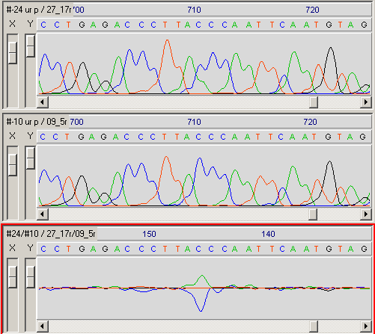

Wallace dataset 3, Lane 01_1f, Base 633, Mutation Missed.

- Shoulder not detected as a peak.
- Fixed by lowering adaptive noise threshold from 0.35 to 0.25.

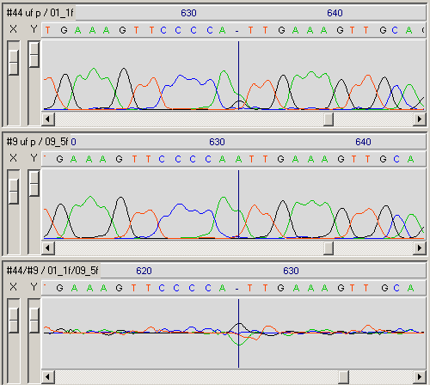

Mattocks, Dataset NF1-D02, Exon 42, Lane 22, Base 285, Incorrect Tag.

- Given MUTA tag not HETE tag, shoulder not detected as a peak.
- Fixed by measuring SNR and doing level call if low.

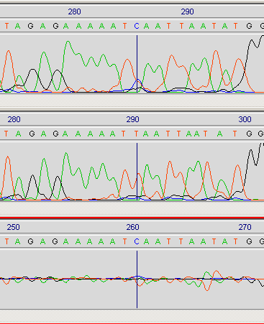

Mattocks, Dataset NF1-D02, Exon 42, Lane 66, Base 289, Incorrect Tag.

- Given MUTA tag not HETE tag, shoulder not detected as a peak.
- Fixed by measuring SNR and doing level call if low.

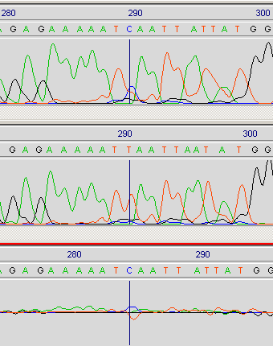

Christina, dataset LEA9, LEA913, Base 462, False +VE?

- False positive HETE tag, possibly due to shoulder?
- Looks like it could be real, not sure!
- No longer reported, could be missed now instead?

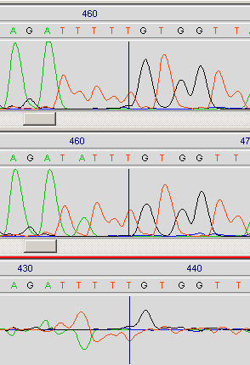

Christina, dataset LEA9, LEA934, Bases 43, 429, Mutations Missed.

- Fixed 1st case by increasing heterozygote threshold to 7.5db (was 7.4dB)
- Fixed 2nd case by lowering the difference flooring threshold from 50 to 35.

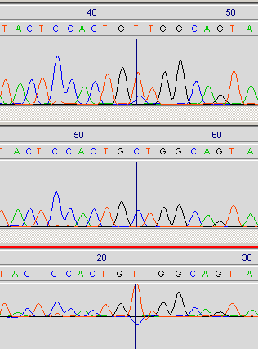 | 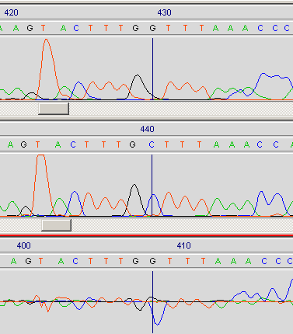

Peak Skew

Mattocks, Dataset NF1-D02, Exon 2, Mutations Missed.

- Mutations missed due to peak skew.
- Fixed by increasing search window parameter to 0.75, didn’t increase false +ve rate.

Lane | Base | Search Window Size
4 | 95 | 0.74
42 | 89 | 0.74
65 | 94 | 0.58
80 | 97 | 0.58
88 | 93 | 0.74
93 | 93 | 0.58

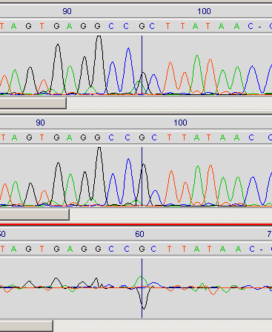

Alignment

Mattocks, Dataset NF1-D02, Exon 2, Lane 27, Base 27, False +VE.

- Alignment error at left hand edge, C->T.
- Hopefully fixed by introducing guard bands at either edge of the trace.

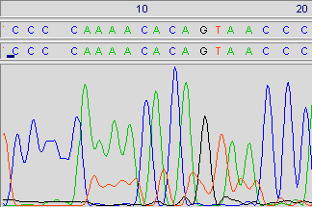
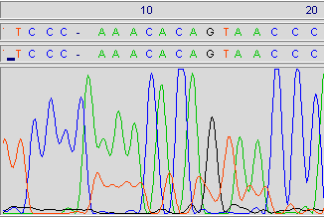

Trace Level

Mattocks, Dataset NF1-D02, Exon 2, Lane 94, Bases 203/209, False +VEs.

- Trace level extremely low (due to run of A’s?).
- Fixed by validating tags using the trace difference

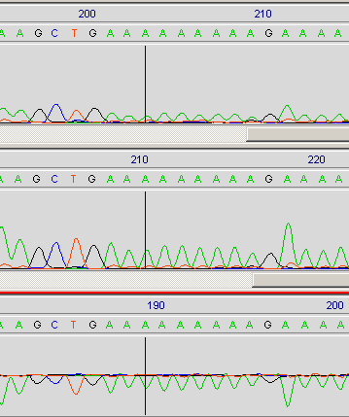

Blobs

Taylor, Dataset BRCAGRT8, 01f/09f, False +VEs.

- False positives with incorrect labels
- Fixed when search window size was increased.

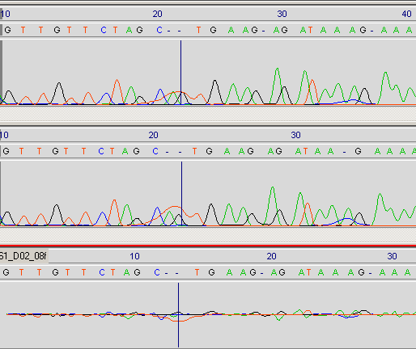

Taylor, Dataset BRCAGRT8, 07r/13r, False +VEs.

- False positives due to blobs
- Fixed now that the additional SNR measure has been added into the heterozygote detection algorithm.

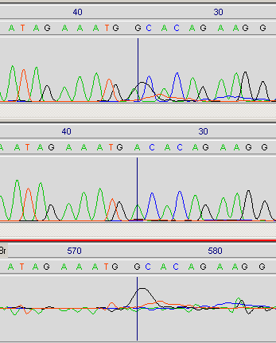 | 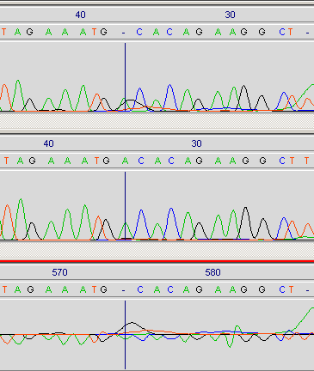

Mattocks, Dataset NF1-D02, Exon 2, Lane 84, False +Ves.

- False positives due to strange blob and significant difference in difference trace.
- Fixed now that the additional SNR measure has been added into the heterozygote detection algorithm.

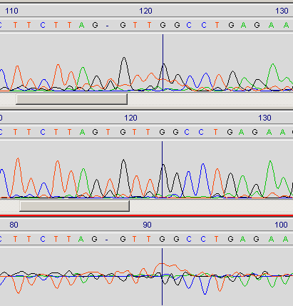

Christina, Dataset LEA9. LEA906, 3 False +VE’s.

- String of three false positives due to flat looking blob.
- Fixed now that an additional SNR measure has been incorporated into the heterozygote algorithm.

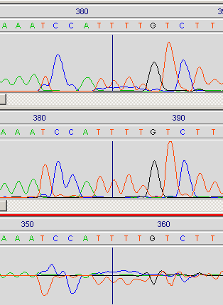

Insertions

Christina, dataset LEA9, LEA901, Base 175, Insertion Missed.

- G insertion missed because of the way the algorithm works, we only examine the reference peaks! The T was extended and interpolated in the reference.

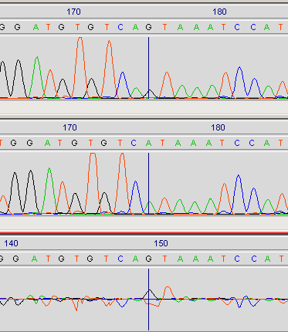

Unknown Causes

Christina, dataset LEA9, LEA904, Bases 460,501, False +VE’s.

- Two false positives generated for an uknown reasons!
- There was a tiny difference there at each location.
- Fixed, due to scale factor getting stuck at 0.54, generating huge numbers of potential mutation sites, most of which were weeded out, except these two which had slight difference trace regions. Added proper mean/sd based limits to scale factor.

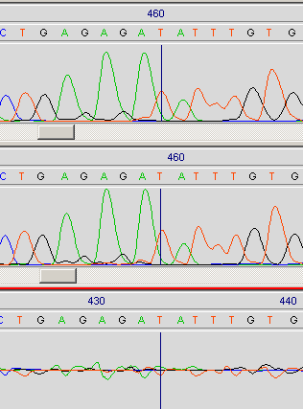 | 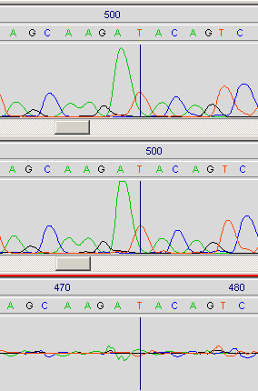

Christina, dataset LEA9, LEA920, Base 31, Missed.

- Mutation missed completely for unknown reasons!
- Fixed by decreasing left analysis margin from 4-bases to 2-bases.

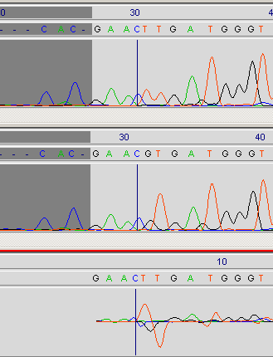

Christina, dataset LEA9, LEA927, Base 163, Missed.

- Mutation missed completely for unknown reasons!
- Fixed, was due to a pair of T’s being found at that location. The entire algorithm has been revamped to solve this and a slew of other missed mutation problems on lea934.

Scale factor | Mean | SD | No SD’s
18.6 | 1.2 | 1.42 | 8.3

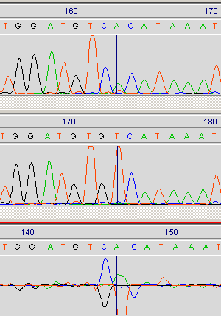

Christina, dataset LEA9, LEA934, Bases 98/152/162, Missed.

- Obvious mutations missed!
- Fixed, entire algorithm was revamped to cope with these problems.

Base | Scale factor | Mean | SD | No SD’s
98 | 6.3 | 1.14 | 0.69 | 7.47
152 | 4.73 | 1.14 | 0.69 | 5.2
162 | 4.97 | 1.14 | 0.69 | 5.55

Mattocks Data, Exon 42, Lane 12, valid mutation.

Base | Scale factor | Mean | SD | No SD’s
284 | 2.0 | 1.10 | 0.16 | 5.625

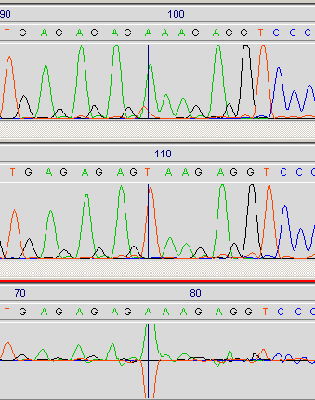 | 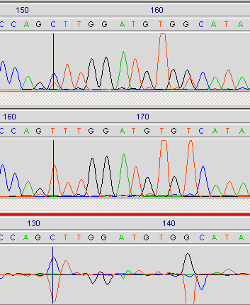

Christina, dataset LEA9, LEA935, Base 510, False +VE.

- HETE tag, can’t see why, says it’s a T->K (T/G), SNR=19dB, PKD=0.65.
- Get different results on command line & pregap invocation with the same expt file!
- Fixed clipping bug in mutscan causing the different results.
- Changed peak scale factor SD limits from 2 SD’s to 1.5 SD as it was causing the mutation scanner to overestimate the peak drop and tag it as a heterozygote.
- Also now measure the SNR of the heterozygote, and if above a threshold, we don’t generate a tag at all since it can’t be heterozygous in that case.

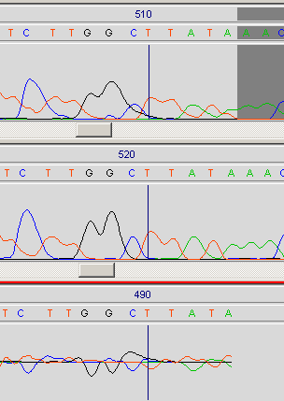

Christina, dataset LEA9, LEA901, Base 195, False +VE.

- HETE tag, can’t see why, says it’s a G->R (G/A), SNR=23dB, PKD=0.47.
- Fixed by changes above.

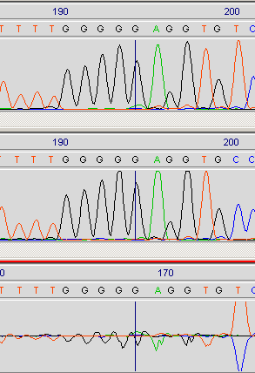

Mattocks, Dataset NF1-D02, Exon 2, Lanes 93/95, False +VEs.

- False positive, says it’s a T->A point mutation.

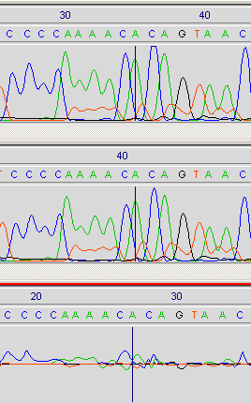

Mattocks, Dataset NF1-D02, Exon 10a, Lane 38, 58 Missed Mutation.

- Fixed. Turned out to be due to the way the difference trace was processed. In this particular case, a small 1-sample baseline glitch occurred right on the peak position, which caused the difference validator to mark it for deletion. Now we go through filling in such small gaps. Averaging the entire trace didn’t work since it altered the baseline value, messing up the validation algorithm.

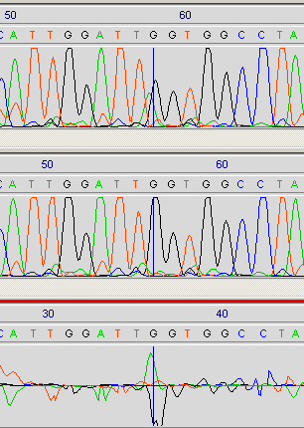

Mattocks, Dataset NF1-D02, Exon 10a, Lane 4/40/49. False +ves.

- Fixed. Turned out to be due to a high T in the reference, algorithm then expected a T in the input, but this was clipped by the adaptive noise thresholding. To cure it, I’ve set the reference adaptive noise threshold to twice that of the input.

