How to use SpagoBI Installer 1.9.3

Authors

Zerbetto Davide

Index

1 Version 3
2 Document goal 3
3 References 3
4 System requirements 3
5 Introduction to SpagoBI Platform 1.9.3 installation procedure 3
5.1 Server choice 4
5.2 Packs selection 6
5.3 Data Warehouse configuration 8
5.4 Perl interpreter path selection 9
5.5 eXo Portal path selection 10
5.6 Local repository selection 11
5.7 When the installation is completed ... 13

Version
Version/Release n° : | 1.0 | Data Version/Release : | March, 28th 2007
Update description: | How to use SpagoBI Installer 1.9.2
Version/Release n° : | 1.1 | Data Version/Release : | April, 2nd 2007
Update description: | Review by Zerbetto Davide
Version/Release n° : | 1.2 | Data Version/Release : | July, 25th 2007
Update description: | How to use SpagoBI Installer 1.9.3  Updated by Zerbetto Davide

Document goal
This document explain how to use the SpagoBI Installer 1.9.3.

References
Some of the concepts of this document refer to the following documentation:
- SpagoBI business intelligence platform framework (available at http://spagobi.eng.it/)
- Exo Portal Platform (available at http://www.exoplatform.com)

System requirements
The system requirements for the SpagoBI installation are as follows:

- JDK version 1.5.x
- OpenOffice 2.0.x (for booklets creation): an environment variable named OPENOFFICE_HOME must point to OpenOffice installation directory or the PATH environment variable must contain the OpenOffice installation program folder.
- 512 MB memory (suggested);
- a Perl interpreter (for execution of Perl based jobs with SpagoBITalendEngine, that is the SpagoBI ETL engine).

Introduction to SpagoBI Platform 1.9.3 installation procedure
In order to install SpagoBI Platform you have to download the SpagoBIInstaller-1.9.3-xxx.zip file, then unzip it and launch the file
- StartSpagoBIIntaller.bat (Windows users)
- StartSpagoBIIntaller.sh (Unix/Linux users)

Then the installer starts and it will guide you during the SpagoBI Platform installation steps.

Here below we explain the meaning of some steps that you will encounter during the installation procedure.

Server choice

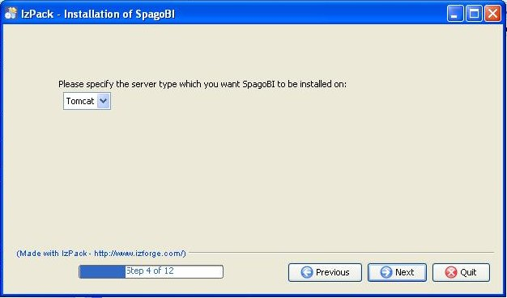

SpagoBI Platform must be installed on an existing application server installed on your pc.
This server can be Tomcat, JBoss or JOnAS (you can choose) and must have eXo-Portal Platform installed on it.

Possible server/eXo-Portal versions for SpagoBI Platform 1.9.2 are:
- Tomcat 5.0.28 with eXo-Portal 1.1.4
- JBoss 4.0.3SP1 with eXo-Portal 1.1.2
- JOnAS 4.7.4 with eXo-Portal 1.1.3

If you don't have any of the above servers on your pc you have to proceed as follows:
- Tomcat 5.0.28 with eXo-Portal 1.1.4
download eXoPortal-tomcat-1.1.4.zip from:
http://forge.objectweb.org/project/download.php?group_id=151&file_id=8171
unzip it into a local folder and the job is done.
- JBoss 4.0.3SP1 with eXo-Portal 1.1.2
download jboss-4.0.3SP1.zip from:
http://sourceforge.net/project/showfiles.php?group_id=22866&package_id=16942&release_id=365509
download eXoPortal-jboss-1.1.2.zip from:
http://forge.objectweb.org/project/download.php?group_id=151&file_id=6228
then follow the installation instructions.
- JOnAS 4.7.4 with eXo-Portal 1.1.3
download jonas4.7.4-tomcat5.5.15.tgz from:
http://forge.objectweb.org/project/download.php?group_id=5&file_id=6132
download eXoPortal-JOnAS-1.1.3.zip from:
http://forge.objectweb.org/project/download.php?group_id=151&file_id=6838
then follow the installation instructions.

SpagoBI installation requires overwriting some existing files on server, therefore it is suggested to install SpagoBI on a clean server.

When you have one of the above servers correctly installed, you can proceed with the SpagoBI installation choosing the server type.

Packs selection

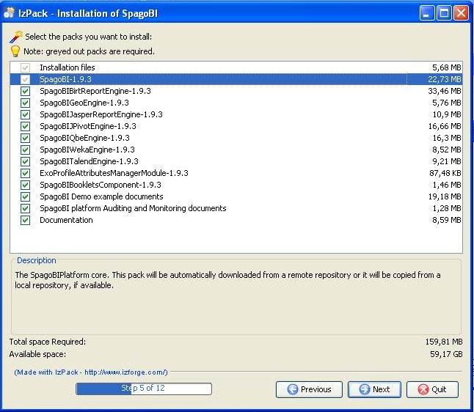

The available packs are summarized here below:

- installation files (libraries, configuration files, ...): this pack is mandatory;
- SpagoBI Core: it is mandatory;
- SpagoBI external engines: they are all optional;
- ExoProfileAttributesManagerModule: module for profile attributes managament for eXo Portal: it is optional;
- SpagoBIBookletsComponent: module for booklets creation (Open Office is required): it is optional;
- SpagoBI examples (the example documents of SpagoBI Demo and the example portal named 'sbiportal' with demonstrative groups and users configured): they are optional;
- SpagoBI platform Auditing and Monitoring documents. These are predefined administration documents analyse the actual configuration and usage of the analytical documents. They list which parameters use a certain constraint or a certain list of values, which documents use a certain parameter; they summerize documents configuration and so on... They analyse also documents execution performance (number of execution requests, average execution time and final result) and launch configuration statistical data (most used execution roles and modalities). You can keep (and obviously customize) them to monitor your environment: they are optional;
- documentation about SpagoBI: it is optional.

You can choose the SpagoBI external engines to be installed according to your requirements.
You can also choose to install or not the example documents of SpagoBI Demo and/or the Auditing and Monitoring documents.
WARNING: SpagoBI Demo examples contains documents for all SpagoBI supported engines. If you exclude some engines from the installation procedure, the relevant examples will not work!!

Data Warehouse configuration

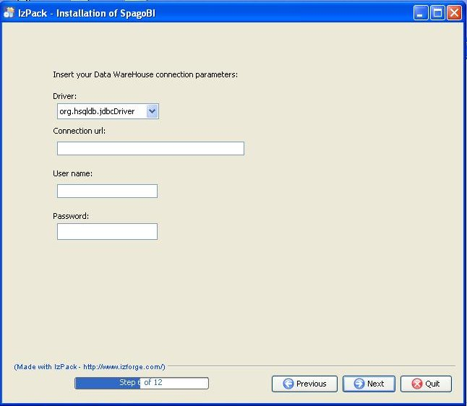

Only if you decided not to install the SpagoBI Demo examples, the installer will ask you the connection parameters to your data warehouse (driver, connection url, username and password).
The available database servers are Hsqldb, Oracle, Postgres or MySql.
If you have decided to install the SpagoBI Demo examples, the installer will not ask you any connection parameters since the data warehouse is supposed to be an Hsql demonstrative db that will be automatically installed on your pc.

Perl interpreter path selection

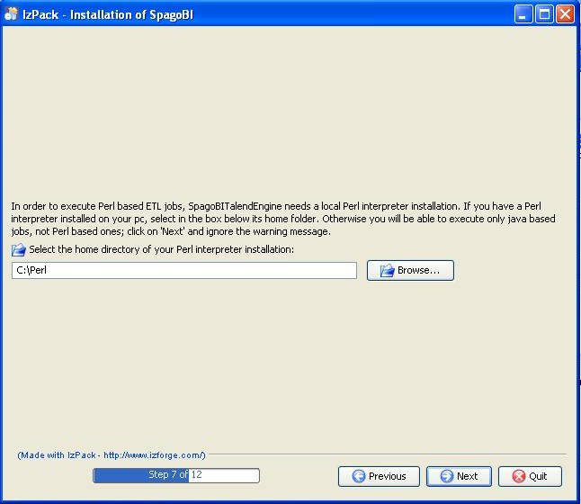

If you chose to install SpagoBITalendEngine (SpagoBI ETL engine for jobs designed with Talend Open Studio), since it requires a local Perl interpreter for Perl based jobs, the procedure will ask you the Perl interpreter home path.
If you don't have a Perl interpreter installed on your pc, you will be able to execute only java based jobs, not Perl based ones; click on 'Next' and ignore the warning message.

eXo Portal path selection

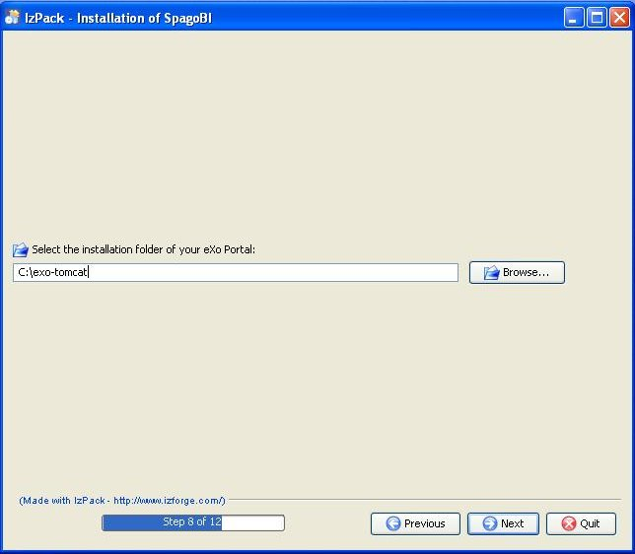

You have to select the base folder were the server (hosting eXo portal) is installed. See previous “Server Choice” chapter.

Local repository selection

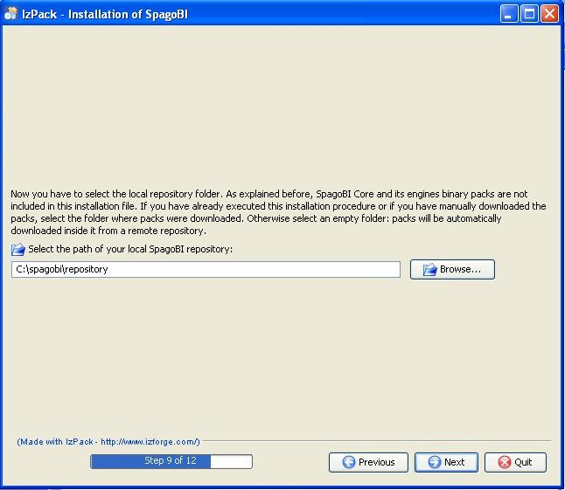

The installer does not contain all the packs needed for the installation but it is able to automatically download them from the ObjectWeb repository (that's the remote repository). More precisely, SpagoBI core and external engines binary packs are not included; they will be downloaded into a local folder of your choice (that's local repository).
In order to avoid redundant and heavy downloads, the installer asks you if you have a local repository, since maybe you donwloaded the packs manually before or you installed SpagoBI 1.9.2 using the same installer another time before: if it is the case, you have to select the folder were binary packs were downloaded. Instead, if it is the first time you use this installer, just select an empty folder: binary packs will be downloaded there and you will be able to use it as local repository during next installation procedures.

Then the installer will perform all the operation required.

When the installation is completed ...

If you want to start working with SpagoBI Platform, take a look into SpagoBI Quick Start: you will see how to configure documents, parameters and so on.

If you want to change or to customize the installation, take a look to the SpagoBI documentation (How To and Installation Manual).

