**Real Time Virtual Mouse Using Computer Vision**

**TEAM MEMBERS**

**SATRASALA VENKATA NEHA-** **20MID0033**

**GANGIREDDY MADHUMITHA-** **20MID0070**

**SHAIK CHAN ARSHAD HUSSAIN-** **20MID0069**

**CHANDRAGIRI NIKHITHA-20MID0138**

1) Introduction

* 1. Overview

Employing a hand as a virtual mouse can perform everything that a mouse does without barely involving your system. Users can use the webcam of their system to detect hands

* 1. Purpose

The purpose of a virtual mouse is to provide an alternative method for interacting with a computer or device without physically using a traditional mouse. A virtual mouse allows users to control the cursor and perform mouse actions using different input methods, such as hand tracking, gestures, or other motion-sensing technologies.

Some common use cases and benefits of a virtual mouse include:

* **Accessibility:** Virtual mice can assist individuals with physical disabilities or limitations that make it difficult to use a traditional mouse. By offering alternative input methods, virtual mice enable a more inclusive computing experience.
* **Gesture-based interactions**: Virtual mice can leverage hand tracking or gesture recognition technologies to interpret user movements and gestures as mouse actions. This opens up possibilities for intuitive and natural interactions, especially in virtual reality (VR), augmented reality (AR), and touchless environments.
* **Remote control**: Virtual mice can be used for controlling computers or devices remotely. For example, in remote desktop applications or presentations, users can control the cursor on a remote screen without requiring a physical mouse.
* **Ergonomics and convenience**: Virtual mice provide flexibility in how users interact with devices. They eliminate the need for a physical mouse, which can be beneficial when working in constrained spaces or when using touch-enabled devices like tablets or smartphones.

Overall, the purpose of a virtual mouse is to enhance accessibility, offer alternative input methods, and provide a more versatile and immersive computing experience.

2) Literature Survey

2.1 Existing problem

One existing approach to solving the problem of Real-Time Virtual Mouse Using Computer Vision involves the use of hand tracking and gesture recognition techniques. Here's a high-level overview of the approach:

* **Hand Detection**
* **Hand Landmark Localization**
* **Gesture Recognition**
* **Cursor Control**

2.2 Proposed solution

* **Hand Detection**: The first step is to detect and track the user's hand in real time. This can be achieved using computer vision techniques such as background subtraction, skin color segmentation, or machine learning-based methods like convolutional neural networks (CNNs).
* **Hand Landmark Localization**: Once the hand is detected, the next step is to locate the landmarks or key points on the hand, such as fingertips, knuckles, or palm center. Various algorithms and models can be employed for this task, including Haar cascades, deformable part models (DPMs), or deep learning-based methods like hand pose estimation networks.
* **Gesture Recognition**: After localizing the hand landmarks, the system needs to interpret the user's hand movements and gestures. This can be done by training a machine learning model, such as a decision tree, support vector machine (SVM), or a deep neural network (DNN), on a labeled dataset of hand gestures. The model should be able to classify different gestures, such as moving the hand up, down, left, right, or performing a click motion.
* **Cursor Control:** Once the hand gestures are recognized, the system can map these gestures to corresponding cursor movements. For example, moving the hand up can correspond to moving the cursor up on the screen. The mapping can be done based on predefined rules or using machine learning algorithms to learn the mapping from the labeled training data

3) Theoretical Analysis

3.1 Block diagram

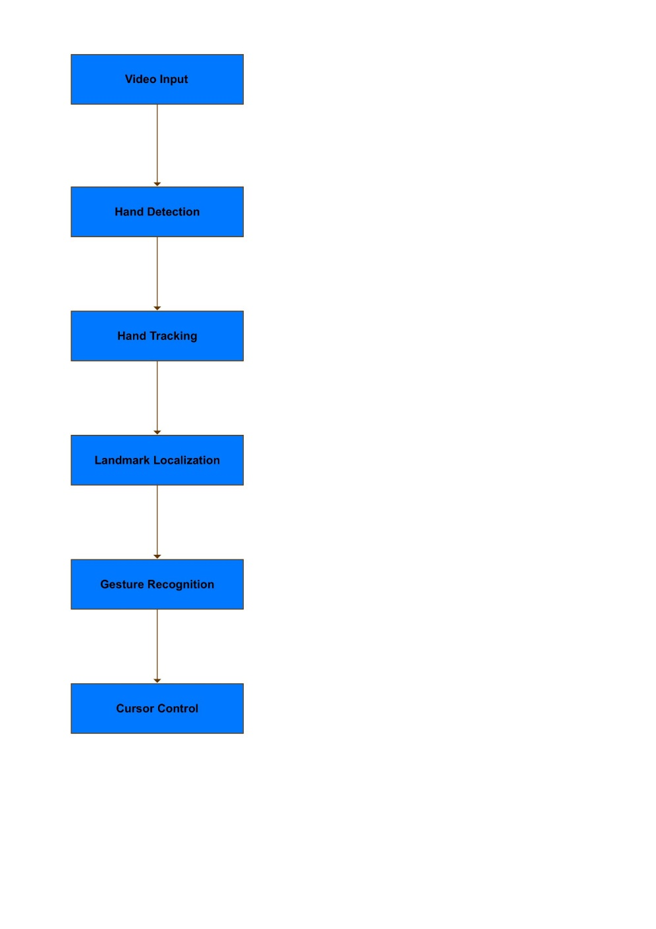

3.2 Hardware/Software Designing

Hardware and software design considerations for a Real-Time Virtual Mouse can vary depending on the specific implementation requirements and the available resources. Here are some key aspects to consider:

**Hardware Design**:

* Camera: Choose a suitable camera or sensor to capture video input. Options include webcams, depth cameras (such as Intel RealSense or Microsoft Kinect), or even smartphone cameras if applicable.
* Processing Unit: Select a hardware platform with sufficient processing power to handle the computer vision algorithms in real-time. This could range from a desktop computer or laptop to single-board computers like Raspberry Pi or specialized embedded systems.
* Connectivity: Ensure the hardware has the necessary connectivity options, such as USB or wireless (e.g., Wi-Fi or Bluetooth), to interface with the camera and communicate with the operating system.

**Software Design:**

* Operating System: Select an appropriate operating system that supports the computer vision libraries, drivers, and software tools needed for the implementation. Common choices include Windows, Linux, or specific embedded operating systems.
* Computer Vision Libraries: Utilize computer vision libraries and frameworks such as OpenCV, TensorFlow, or PyTorch to implement the necessary algorithms for hand detection, tracking, landmark localization, and gesture recognition.
* Programming Language: Choose a programming language suitable for computer vision and application development. Popular choices include Python, C++, or MATLAB, depending on the libraries and tools being used.
* Gesture Recognition Model: Design and train a gesture recognition model using machine learning algorithms. This involves selecting the appropriate model architecture, preparing a labeled dataset for training, and utilizing frameworks like scikit-learn, TensorFlow, or Keras for model training and evaluation.
* Integration with Operating System: Develop the necessary software components to interface with the operating system and control the mouse cursor. This may involve utilizing operating system-level APIs or libraries specific to the target platform.

4) Experimental Investigations

While working on the solution for Real-Time Virtual Mouse using computer vision, several analyses and investigations may have been conducted. Here are some areas that could have been explored during the development process:

* **Hand Detection Techniques:** Different hand detection techniques might have been evaluated and compared to determine the most suitable approach for the specific application. The analysis could involve assessing the accuracy, techniques such as background subtraction etc.
* **Hand Landmark Localization:** Various algorithms or models for hand landmark localization might have been investigated. This could include comparing methods like Haar cascades, deformable part models (DPMs), or deep learning-based approaches to identify the most accurate and reliable landmarks on the hand.
* **Gesture Recognition Models:** Different machine learning algorithms may have been explored and compared for gesture recognition. The analysis might involve training and evaluating multiple models with different features and parameters to identify the most effective approach.
* **Dataset Collection and Labeling:** An investigation into dataset collection and labeling would have been necessary to train and evaluate the gesture recognition model. This also include selecting appropriate labeling techniques.
* **Real-Time Performance Optimization:** Optimizing the system for real-time performance would have involved investigating techniques such as parallel processing, hardware acceleration, or algorithmic optimizations. The analysis might have focused on reducing computational overhead and latency to ensure smooth and responsive cursor control.
* **User Experience Evaluation:** Investigating the user experience aspects of the solution would have been important. This could include conducting user studies or surveys to gather feedback on the system's usability, accuracy, and overall satisfaction. The analysis of user feedback would provide insights into areas that require refinement or enhancements.

5) Flowchart

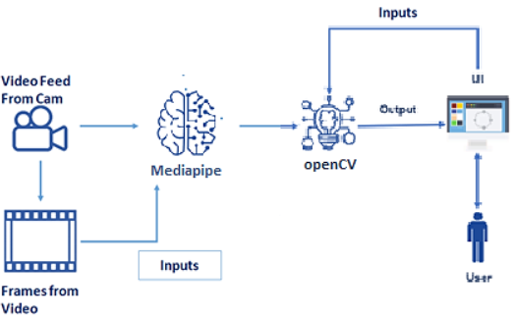

6) Result

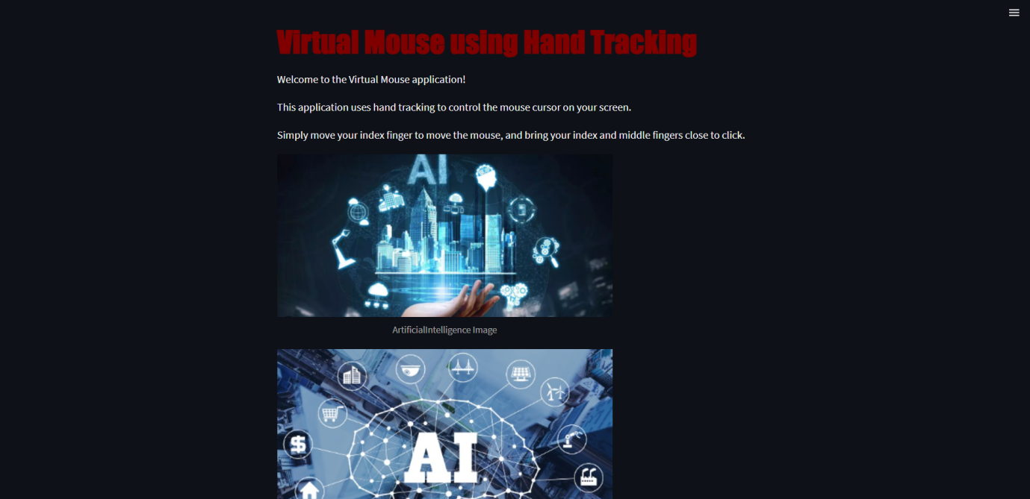

7) Advantages and Disadvantages

Advantages of Real-Time Virtual Mouse:

* **Gesture-based Interaction:** Real-Time Virtual Mouse allows users to interact with computers or devices through hand gestures, providing a more intuitive and natural user interface. This can enhance the user experience and make interactions more immersive.
* **Accessibility**: Virtual Mouse systems provides an alternative input method that is based on hand movements and gestures, allowing a wider range of users to access and interact with technology.
* **No Physical Hardware Required:** Unlike traditional mice that require physical hardware, Real-Time Virtual Mouse eliminates the need for a physical mouse.
* **Flexibility and Adaptability:** Virtual Mouse systems can be easily adapted to different environments and scenarios. They are not limited by the physical constraints of a traditional mouse, allowing users to control the cursor on various surfaces or even in mid-air.
* **Potential for Gesture Customization:** Real-Time Virtual Mouse systems offer the possibility of customizing gestures and mapping them to specific actions or commands. This flexibility enables users to define their own gestures or adapt the system to their specific needs or preferences.

Disadvantages of Real-Time Virtual Mouse:

* **Learning Curve:** Using hand gestures as an input method may require users to learn and remember specific gestures and their corresponding actions. This learning curve can be a challenge for some users, especially those who are accustomed to traditional mouse interactions.
* **Accuracy and Reliability:** Real-Time Virtual Mouse systems heavily rely on computer vision algorithms for hand tracking, gesture recognition, and cursor control. The accuracy and reliability of these algorithms can be affected by factors such as lighting conditions, occlusions, or variations in hand poses, leading to occasional inaccuracies or false positives/negatives.
* **Precision:** Fine-grained control and pixel-level accuracy can also be challenging to achieve consistently with hand gestures.
* **Limited Gestural Vocabulary:** While Real-Time Virtual Mouse allows for gesture-based interactions, the vocabulary of gestures may be limited compared to the range of actions achievable with a physical mouse and keyboard. Complex or multi-step actions may be challenging to perform with gestures alone.

It's important to note that advancements in computer vision algorithms, hardware technology, and user interface design can mitigate some of these disadvantages over time. The effectiveness of Real-Time Virtual Mouse systems will continue to improve as the field progresses and addresses these limitations.

8)Applications

* **Accessibility:** Virtual mouse technology allows individuals with physical disabilities or impairments to control the computer cursor without the need for traditional input devices such as a mouse or keyboard. It provides an alternative input method and enables people with limited mobility to interact with computers more easily.
* **Gesture Control:** Virtual mouse systems can use hand tracking and gesture recognition to control the cursor on a screen. This technology is often used in gaming, virtual reality (VR), and augmented reality (AR) applications to enable intuitive and immersive interactions.
* **Presentations and Demonstrations**: Virtual mouse applications can be utilized during presentations or demonstrations to control the cursor remotely without the need for physical contact with the computer. It allows presenters to navigate through slides or interact with applications from a distance.
* **Collaborative Environments:** Virtual mouse technology can facilitate collaborative work environments by enabling multiple users to interact with shared screens or surfaces simultaneously. It is particularly useful in interactive displays, interactive whiteboards, or large-scale touchscreens.
* **Virtual and Augmented Reality:** In VR and AR environments, virtual mouse technology can be employed to provide users with a more natural and intuitive way to interact with digital objects and interfaces. It allows users to manipulate and control virtual elements using their hands or gestures.
* **Medical and Healthcare:** Real-Time Virtual Mouse systems can find applications in the medical and healthcare domain, where precise and touchless interactions are desirable. It can be used in surgical simulations, medical training, or controlling medical imaging systems without the need for physical contact.
* **Human-Computer Interaction Research:** Virtual Mouse systems are also valuable for research purposes, enabling studies on human-computer interaction, gesture recognition, and user interface design. Researchers can explore new interaction paradigms, evaluate user experiences, and develop novel input methods using Real-Time Virtual Mouse technology.

9)Conclusion

In conclusion, virtual mouse technology offers a novel and intuitive approach to control the cursor on a screen using finger-based input. Throughout our work and exploration, we have delved into various aspects and applications of virtual mouse technology.

We began by understanding the concept of virtual mouse and its potential advantages over traditional mouse input. Virtual mouse systems utilize computer vision techniques to track finger movements and gestures, allowing users to control the cursor through natural hand movements.

We explored the implementation of a virtual mouse using hand tracking and computer vision libraries such as OpenCV and MediaPipe. By leveraging these tools, we developed a virtual mouse application that detects hand movements, tracks the position of fingers, and translates those movements into cursor control on the screen.

Furthermore, we integrated our virtual mouse application into a Streamlit-based user interface, enabling users to interact with the virtual mouse system through a browser. The user interface provided a visual representation of the captured video feed, allowing users to see their hand movements and the resulting cursor control in real-time.

10) Future Scope

* **Advanced Gesture Recognition:** Enhance the virtual mouse system to recognize a wider range of hand gestures and movements. This would allow for more precise control and enable users to perform complex actions using intuitive hand movements.
* **Integration with Smart Devices:** Explore integration of the virtual mouse with smart devices such as smartphones, tablets, and smart TVs. This would enable users to control these devices using hand gestures, eliminating the need for physical touch or remote controls.
* **Virtual Reality and Augmented Reality Interaction:** Extend the virtual mouse system to work seamlessly in virtual reality (VR) and augmented reality (AR) environments. This would enable users to interact with virtual objects and interfaces using hand gestures, enhancing immersion and user experience.
* **Accessibility Features:** Incorporate accessibility features into the virtual mouse system to cater to individuals with disabilities. This may include support for alternative input methods, voice commands, or integration with assistive technologies to make computing more accessible for everyone.
* **Natural Language Processing:** Integrate natural language processing (NLP) capabilities to enable users to control the virtual mouse through voice commands. This would provide a more intuitive and hands-free interaction experience.

11) Bibilography

[**https://pubmed.ncbi.nlm.nih.gov/34733459/**](https://pubmed.ncbi.nlm.nih.gov/34733459/)

[**https://ieeexplore.ieee.org/document/5709921**](https://ieeexplore.ieee.org/document/5709921)

[**https://ieeexplore.ieee.org/document/9985625**](https://ieeexplore.ieee.org/document/9985625)

[**https://ieeexplore.ieee.org/document/10140390**](https://ieeexplore.ieee.org/document/10140390)

[**https://ieeexplore.ieee.org/document/10128463**](https://ieeexplore.ieee.org/document/10128463)

APPENDIX

**A. Source Code**

**HandTrackingModule.py**

import cv2  
import mediapipe as mp  
import time  
import math  
import numpy as np  
  
  
class handDetector():  
 def __init__(self, mode=False, maxHands=2, detectionCon=0.5, trackCon=0.5):  
 self.mode = mode  
 self.maxHands = maxHands  
 self.detectionCon = detectionCon  
 self.trackCon = trackCon  
  
 self.mpHands = mp.solutions.hands  
 self.hands = self.mpHands.Hands(static_image_mode=self.mode,  
 max_num_hands=self.maxHands,  
 min_detection_confidence=self.detectionCon,  
 min_tracking_confidence=self.trackCon)  
 self.mpDraw = mp.solutions.drawing_utils  
 self.tipIds = [4, 8, 12, 16, 20]  
  
 # Updated line  
  
 # Rest of the code...  
  
  
 def findHands(self, img, draw=True):  
 imgRGB = cv2.cvtColor(img, cv2.COLOR_BGR2RGB)  
 self.results = self.hands.process(imgRGB)  
 # print(results.multi_hand_landmarks)  
  
 if self.results.multi_hand_landmarks:  
 for handLms in self.results.multi_hand_landmarks:  
 if draw:  
 self.mpDraw.draw_landmarks(img, handLms,  
 self.mpHands.HAND_CONNECTIONS)  
  
 return img  
  
 def findPosition(self, img, handNo=0, draw=True):  
 xList = []  
 yList = []  
 bbox = []  
 self.lmList = []  
 if self.results.multi_hand_landmarks:  
 myHand = self.results.multi_hand_landmarks[handNo]  
 for id, lm in enumerate(myHand.landmark):  
 # print(id, lm)  
 h, w, c = img.shape  
 cx, cy = int(lm.x * w), int(lm.y * h)  
 xList.append(cx)  
 yList.append(cy)  
 # print(id, cx, cy)  
 self.lmList.append([id, cx, cy])  
 if draw:  
 cv2.circle(img, (cx, cy), 5, (255, 0, 255), cv2.FILLED)  
  
 xmin, xmax = min(xList), max(xList)  
 ymin, ymax = min(yList), max(yList)  
 bbox = xmin, ymin, xmax, ymax  
  
 if draw:  
 cv2.rectangle(img, (xmin - 20, ymin - 20), (xmax + 20, ymax + 20),  
 (0, 255, 0), 2)  
  
 return self.lmList, bbox  
  
 def fingersUp(self):  
 fingers = []  
  
 if len(self.lmList) != 0: # Check if lmList is not empty  
 # Thumb  
 if self.lmList[self.tipIds[0]][1] > self.lmList[self.tipIds[0] - 1][1]:  
 fingers.append(1)  
 else:  
 fingers.append(0)  
  
 # Fingers  
 for id in range(1, 5):  
 if self.lmList[self.tipIds[id]][2] < self.lmList[self.tipIds[id] - 2][2]:  
 fingers.append(1)  
 else:  
 fingers.append(0)  
  
 return fingers  
  
 def findDistance(self, p1, p2, img, draw=True,r=15, t=3):  
 x1, y1 = self.lmList[p1][1:]  
 x2, y2 = self.lmList[p2][1:]  
 cx, cy = (x1 + x2) // 2, (y1 + y2) // 2  
  
 if draw:  
 cv2.line(img, (x1, y1), (x2, y2), (255, 0, 255), t)  
 cv2.circle(img, (x1, y1), r, (255, 0, 255), cv2.FILLED)  
 cv2.circle(img, (x2, y2), r, (255, 0, 255), cv2.FILLED)  
 cv2.circle(img, (cx, cy), r, (0, 0, 255), cv2.FILLED)  
 length = math.hypot(x2 - x1, y2 - y1)  
  
 return length, img, [x1, y1, x2, y2, cx, cy]  
  
  
def main():  
 pTime = 0  
 cTime = 0  
 cap = cv2.VideoCapture(0)  
 detector = handDetector()  
 while True:  
 success, img = cap.read()  
 img = detector.findHands(img)  
 lmList, bbox = detector.findPosition(img)  
 if len(lmList) != 0:  
 print(lmList[4])  
  
 cTime = time.time()  
 fps = 1 / (cTime - pTime)  
 pTime = cTime  
  
 cv2.putText(img, str(int(fps)), (10, 70), cv2.FONT_HERSHEY_PLAIN, 3,  
 (255, 0, 255), 3)  
  
 cv2.imshow("Image", img)  
 cv2.waitKey(1)  
  
  
if __name__ == "__main__":  
 main()

**Streamapp.py**

import streamlit as st  
import cv2  
from PIL import Image  
import numpy as np  
import HandTrackingModule as htm  
import time  
import autopy  
  
  
def main():  
 st.markdown("<h1 style='color:maroon; font-family:fantasy ;'>Virtual Mouse using Hand Tracking", unsafe_allow_html=True)  
 st.write("Welcome to the Virtual Mouse application!")  
 st.write("This application uses hand tracking to control the mouse cursor on your screen.")  
 st.write("Simply move your index finger to move the mouse, and bring your index and middle fingers close to click.")  
 image_url = "aiimage.png"  
 st.image(image_url, caption="ArtificialIntelligence Image", width=500)  
 image_url1 = "img.png"  
 st.image(image_url1, caption="ArtificialIntelligence Image", width=500)  
 wCam, hCam = 640, 480  
 frameR = 100 # Frame Reduction  
 smoothening = 7  
  
 pTime = 0  
 plocX, plocY = 0, 0  
 clocX, clocY = 0, 0  
  
 cap = cv2.VideoCapture(0)  
 cap.set(3, wCam)  
 cap.set(4, hCam)  
 detector = htm.handDetector(maxHands=1)  
 wScr, hScr = autopy.screen.size()  
  
 while True:  
 # Read frame from camera  
 success, frame = cap.read()  
  
 # Convert the frame to RGB and display it using Streamlit  
 frame_rgb = cv2.cvtColor(frame, cv2.COLOR_BGR2RGB)  
 st.image(frame_rgb, channels="RGB")  
  
 # Process the frame  
 img = detector.findHands(frame)  
 lmList, bbox = detector.findPosition(img)  
 fingers = detector.fingersUp()  
  
 if len(fingers) >= 3 and fingers[1] == 1 and fingers[2] == 0:  
 x1, y1 = lmList[8][1:]  
 x3 = np.interp(x1, (frameR, wCam - frameR), (0, wScr))  
 y3 = np.interp(y1, (frameR, hCam - frameR), (0, hScr))  
 clocX = plocX + (x3 - plocX) / smoothening  
 clocY = plocY + (y3 - plocY) / smoothening  
  
 if 0 <= clocX <= wScr and 0 <= clocY <= hScr:  
 autopy.mouse.move(wScr - clocX, clocY)  
  
 plocX, plocY = clocX, clocY  
  
 if len(fingers) >= 3 and fingers[1] == 1 and fingers[2] == 1:  
 length, img, lineInfo = detector.findDistance(8, 12, img)  
 if length < 40:  
 autopy.mouse.click()  
  
 # Calculate and display frame rate  
 cTime = time.time()  
 fps = 1 / (cTime - pTime)  
 pTime = cTime  
 st.write(f"FPS: {int(fps)}")  
  
  
  
# Run the Streamlit application  
if __name__ == "__main__":  
 main()