How to Implement Hybrid Cloud

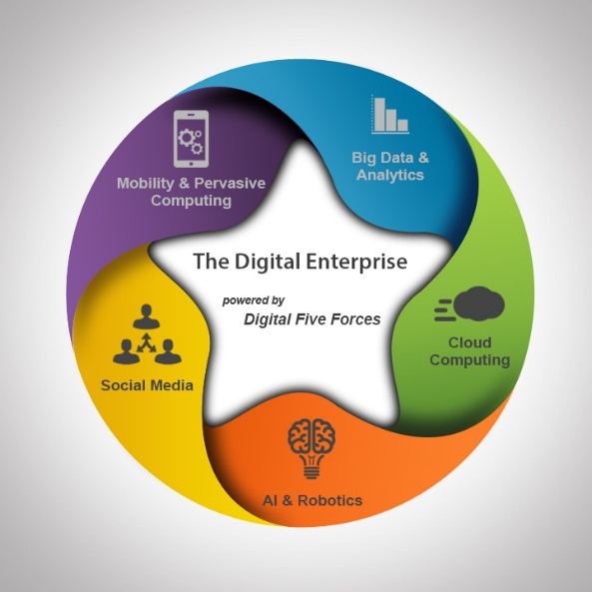

25/04/2016
Prepared by: Irusappan SL & Vinodh R
TCS Digital Enterprise - CAS

Notice
© 2026 Tata Consultancy Services Limited
This is a controlled document. Unauthorized access, copying, replication or usage for a purpose other than for which it is intended, are prohibited.
All trademarks that appear in the document have been used for identification purposes only and belong to their respective companies.

Tata Code of Conduct
We, in our dealings, are self-regulated by a Code of Conduct as enshrined in the Tata Code of Conduct. We request your support in helping us adhere to the Code in letter and spirit. We request that any violation or potential violation of the Code by any person be promptly brought to the notice of the Local Ethics Counselor or the Principal Ethics Counselor or the CEO of TCS. All communication received in this regard will be treated and kept as confidential.

Document Release Note

Document Details:
Name | Version Number | Description
Hybrid Cloud | Version 1.0 | Hybrid Cloud: Amazon AWS and Openstack

Document Revision List
Release Notice Reference (for release)
Revision Number | Revision Date | Revision Description | Page Number | Previous Page Number | Action Taken | Addenda/ New Page | Release Notice Reference

About this Document

Purpose
The purpose of this document is to describe How to Implement Hybrid cloud using Amazon AWS and Openstack using properiatary components and opensource applications to achieve the goal.

Intended Audience
The primary audience of this document is the delivery pool working on implementing Hybrid cloud using Amazon AWS and openstack.

References:
https://openfoo.org/blog/amazon_vpc_with_linux.html
http://www.heitorlessa.com/site-to-site-vpn-pfsense-and-amazon-vpc/
http://www.erikwebdesign.com/2012/05/virtualizing-pfsense-under-ubuntu-server/
https://d0.awsstatic.com/whitepapers/aws-amazon-vpc-connectivity-options.pdf

Table of Content
Purpose 2
Intended Audience 2
References: 2
1. Introduction 4
2. How To Implement 5
3. Conclusion 20

Introduction
The Hybrid cloud is a combination of a public cloud (Amazon Web Services) with a private cloud platform (Openstack) that is specifically designed for used by a enterprise. The public and private cloud infrastructure are structured, so they can operate independently but communicate via an encrypted connection (Virtual Private Network) that facilitated the portability of applications and data.
The Hybrid cloud enables enterprises to store privileged or protected data on their own private cloud whilst maintaining the ability to leverage the public cloud’s computational resources in order to run applications that depend on this data. This arrangements means that data exposure is kept to a bare minimum because data is not being stored long term on the public cloud component.
The goal of this POC is to achieve Hybrid cloud using AWS and Openstack VM. We are achieved this POC using opensource tools which are Quagga, Racoon, and Ipsec-tools. Also using components of Amazon AWS we are using VPC(Virtual Private Cloud), VPG (Virtual Private Gateway), CGW(Customer Gateway) and Hardware VPN.
Benefits of Hybrid Cloud:-
A hybrid cloud solution offers some distinct benefits for small to medium sized businesses looking to expand their computing power. These can be broken down into a few
Best of Both Worlds:
Adopting a hybrid cloud solution allows smaller businesses to take advantage of the cost effective public cloud for most non-sensitive operational procedures, while the company’s more sensitive data and critical applications remain safely stored on a private cloud configuration.
Improved Scalability:
The hybrid cloud also provides greater scalability for businesses with their own basic in-house servers. These businesses can expand their computing power via the hybrid cloud, freeing them from the need to purchase costly additional hardware, or expanding their on-site IT team.
Increased Performance and Agility:
With a hybrid cloud solution, businesses can move applications seamlessly between the public cloud and their private cloud. This is a more cost effective way of managing IT demands, as compared to building and maintaining an on-site computer network.
Increased Accessibility:
Like the public cloud, applications and programs in a hybrid cloud environment can be accessed at any time, from any internet ready device. This allows businesses to build a more mobile workforce, and to more easily expand their operations beyond their immediate geographic location.
Cost Benefit:
Businesses have been drawn to cloud computing because it offers the computing power that companies want, at a price that fits their budget. Hybrid cloud solutions are no different. While subscribing to a private cloud, as well as a public cloud, will increase operating costs to some degree, it is still significantly less expensive than building and maintaining an on-site server and computer network infrastructure.

How To Implement

Approach I: Implementation

Installation - openswan:
#: yum install openswan bind-utils
Installation – strongswan:
#: yum install http://ftp.nluug.nl/pub/os/Linux/distr/fedora-epel/7/x86_64/e/epel-release-7-5.noarch.rpm
#: yum install strongswan
Ipsec configuration file: /etc/strongswan/ipsec.conf
Secret file: /etc/strongswan/ipsec.secrets

IPSEC Configuration at both VM Instances
#sudo vi /etc/ipsec.conf
# Manual: ipsec.conf.5
# Please place your own config files in /etc/ipsec.d/ ending in .conf
version 2.0 # conforms to second version of ipsec.conf specification
# basic configuration
config setup
# Debug-logging controls: "none" for (almost) none, "all" for lots.
# klipsdebug=none
# plutodebug="control parsing"
# For Red Hat Enterprise Linux and Fedora, leave protostack=netkey
protostack=netkey
nat_traversal=yes
virtual_private=
oe=off
# Enable this if you see "failed to find any available worker"
# nhelpers=0
#You may put your configuration (.conf) file in the "/etc/ipsec.d/"
and uncomment this.
include /etc/ipsec.d/*.conf

Network Configuration at AWS-EC2 Instance
#sudo vi /etc/ipsec.d/config1.conf

conn AWS-to-Onpremises
type=tunnel
authby=secret
left=%defaultroute
leftid=54.218.x.x
leftnexthop=%defaultroute
leftsubnet=10.20.0.0/16
right=96.119.x.x
rightsubnet=10.10.10.0/24
pfs=yes
auto=start

Secret Key Configuration at AWS-EC2 Instance
#sudo vi /etc/ipsec.d/ipsec.secrets

54.218.x.x 96.119.x.x: PSK "wpQJYiMzqGKgQyaUKgGxxxxxxxx"

96.119.x.x 54.218.x.x: PSK "wpQJYjMzqGKgQyaUKgGxxxxxxxx"

Network Configuration at ComCast's VM Instance

conn Onpremises-to-AWS
type=tunnel
authby=secret
left=%defaultroute
leftid=96.119.x.x
leftnexthop=%defaultroute
leftsubnet=10.10.10.0/24
right=54.218.x.x
rightsubnet=10.20.0.0/16
pfs=yes
auto=start

Approach II: Implementation

Virtual Machine Configuration:
CPU: 2 cores, RAM: 2 GB, HDD: 10 GB, OS: Ubuntu 14.04 LTS, Eth0: Public Interface, Eth1: Private
Installing Quagga, Racoon, and Ipsec Tools
# sudo apt-get install racoon ipsec-tools
It will install racoon and ipsec-tools on Ubuntu 14.04
# sudo vi /etc/racoon/psk.txt
52.27.x.x Password 1 (It is look like “12adf234rasf234f2141sddfa”)
52.33.x.x Password 2 (It is look like “wqer2341234sdfgsa3451132”)
# sudo racoonctl show-sa ipsec
# sudo vi /etc/ipsec-tools.conf
flush;
spdflush;
spdadd 169.254.12.126/30 169.254.12.125/30 any -P out ipsec
esp/tunnel/96.119.x.x-52.27.x.x/require;
spdadd 169.254.12.125/30 169.254.12.126/30 any -P in ipsec
esp/tunnel/52.27.x.x-96.119.x.x/require;
spdadd 169.254.13.22/30 169.254.13.21/30 any -P out ipsec
esp/tunnel/96.119.x.x-52.33.x.x/require;
spdadd 169.254.13.21/30 169.254.13.22/30 any -P in ipsec
esp/tunnel/52.33.x.x-96.119.x.x/require;
spdadd 169.254.12.126/30 10.100.1.0/24 any -P out ipsec
esp/tunnel/96.119.x.x-52.27.x.x/require;
spdadd 10.100.1.0/24 169.254.12.126/30 any -P in ipsec
esp/tunnel/52.27.x.x-96.119.x.x/require;
spdadd 169.254.13.22/30 10.100.1.0/24 any -P out ipsec
esp/tunnel/96.119.245.213-52.33.28.109/require;
spdadd 10.100.1.0/24 169.254.13.22/30 any -P in ipsec
esp/tunnel/52.33.x.x-96.119.x.x/require;
spdadd 10.10.10.0/24 10.100.1.0/24 any -P out ipsec
esp/tunnel/96.119.245.213-52.33.28.109/require;
spdadd 10.100.1.0/24 10.10.10.0/24 any -P in ipsec
esp/tunnel/52.33.x.x-96.119.x.x/require;
# sudo vi /etc/racoon/racoon.conf
remote 52.27.x.x {
exchange_mode main;
lifetime time 28800 seconds;
proposal {
encryption_algorithm aes128;
hash_algorithm sha1;
authentication_method pre_shared_key;
dh_group 2;
}
generate_policy off;
}

remote 52.33.x.x {
exchange_mode main;
lifetime time 28800 seconds;
proposal {
encryption_algorithm aes128;
hash_algorithm sha1;
authentication_method pre_shared_key;
dh_group 2;
}
generate_policy off;
}

sainfo address 169.254.12.126/30 any address 169.254.12.125/30 any {
pfs_group 2;
lifetime time 3600 seconds;
encryption_algorithm aes128;
authentication_algorithm hmac_sha1;
compression_algorithm deflate;
}

sainfo address 169.254.13.22/30 any address 169.254.13.21/30 any {
pfs_group 2;
lifetime time 3600 seconds;
encryption_algorithm aes128;
authentication_algorithm hmac_sha1;
compression_algorithm deflate;
}
Setup of Inside IP Addresses and Getting Started

# ip a a 169.254.12.125/30 dev eth0
# ip a a 169.254.13.21/30 dev eth0

Followed by starting the IPSec services and establish the tunnels:
# /etc/init.d/setkey start (Always start setkey before racoon)
# /etc/init.d/racoon start

Installing Quagga and Zebra
# sudo apt-get install quagga
In /etc/quagga/daemons you have to enable the zebra and bgpd daemons. In case you are running a packet filter, please allow the Amazon VPN gateways to connect to TCP port 179 for BGP.
# sudo vi /etc/quagga/bgpd.conf ( Here bgpd.conf is not present by defaut. You have to create it for configuration)
hostname hybrid-cloud-poc1
password HYBcloudP1c
enable password HYBcloudP1c
!
log file /var/log/quagga/bgpd
!debug bgp events
!debug bgp zebra
debug bgp updates
!
router bgp 65000
bgp router-id 96.119.x.x
network 169.254.12.126/30
network 169.254.13.22/30
network 0.0.0.0/0
!
! aws tunnel #1 neighbour
neighbor 169.254.12.125 remote-as 7224
!
! aws tunnel #2 neighbour
neighbor 169.254.13.21 remote-as 7224
!
line vty
# sudo vi /etc/quagga/zebra.conf
hostname hybrid-cloud-poc1
password HYBcloudP1c
enable password HYBcloudP1c
!
! list interfaces
interface eth0
interface eth1
interface lo
!
line vty
Just activate quagga by
# /etc/init.d/quagga start
and verify the reception of the VPC subnet routing by the Amazon VPN gateways, e.g. by checking the log file /var/log/quagga/bgpd for rcvd and UPDATE entries of the appropriate VPC subnet. You can also connect to the bgpd management console using nc localhost 2605 and type show ip bgp summary for displaying BGP information.

Approach III and IV is not applicable for this POC. Approach V was requested by Internal account team.



Step 1: Login to Web administrative console of pfsense and using administrator credentials.
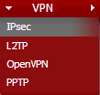
Step 2: Choose “VPN” menu and Select “IPsec”
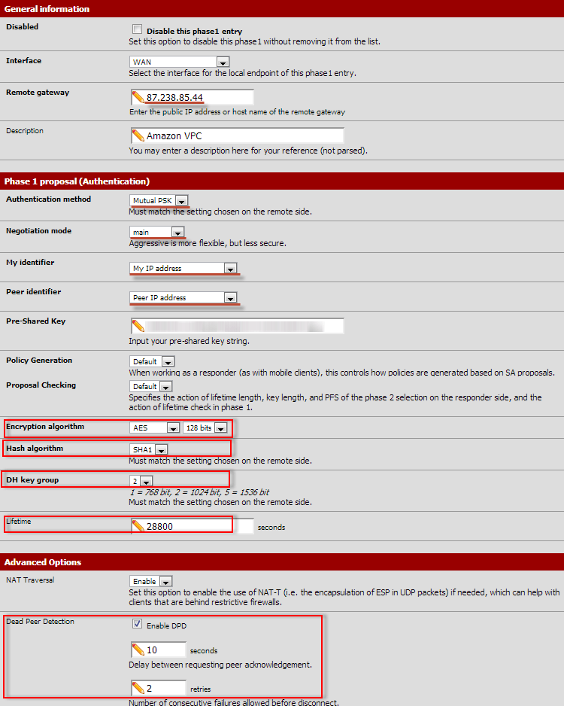
Step 3: Setup phase 1 options and settings followup by VPN Configuration downloaded from Amazon VPC – VPN Configuration.

Step 4: after done with phase 1 settings, you have to add phase 2 entries.

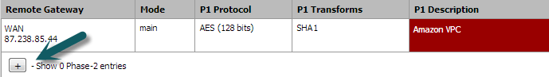
Step 5: Setting up phase 2 entries.
Step 6: Setting up phase 2 based on downloaded Amazon AWS VPN configuration.
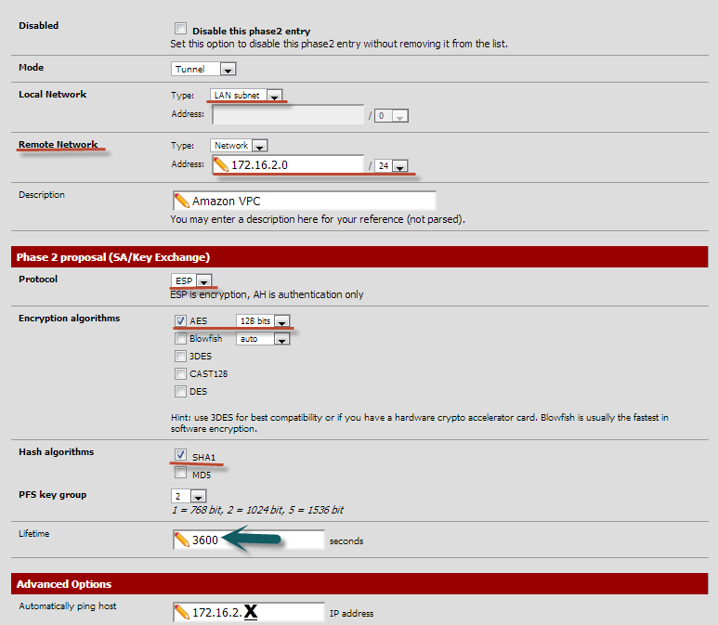

Step 7: After done with Phase 1 and Phase 2 settings, continue to add Firewall rules to allow traffic to local subnets and Amazon VPC's subnet.
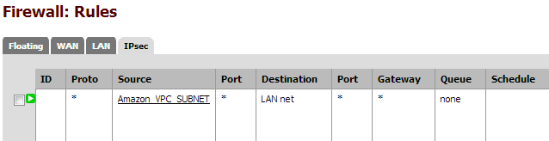
Approach I Implementation @ AWS:

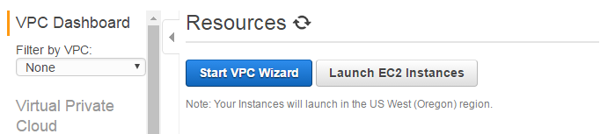
Step 1: Select the appropriate VPC setup for our use case. We used “VPC with public and private subnets” for Approach I.
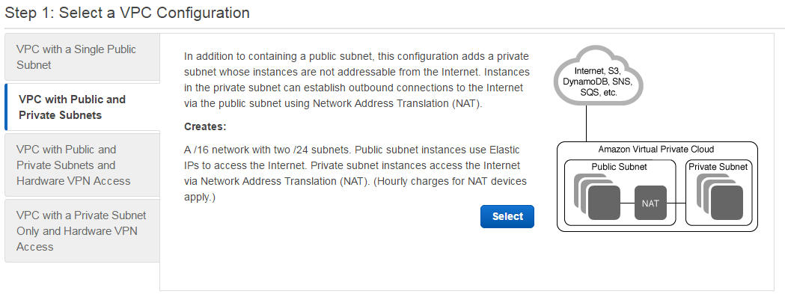
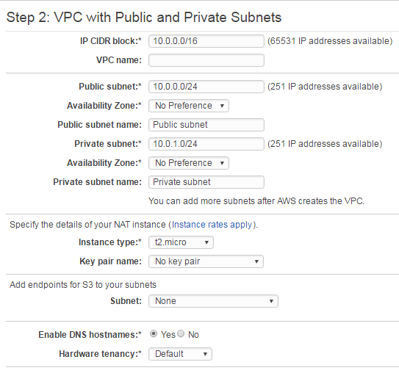
Step 2: Enter the VPC name , subnet ranges and select key pair for NAT Instance rest of the parameters leave as it is.

Approach II: Implementation @ AWS
Step 1: Choosing “VPC with a private subnet only and Hardware VPN access” for Approach II.
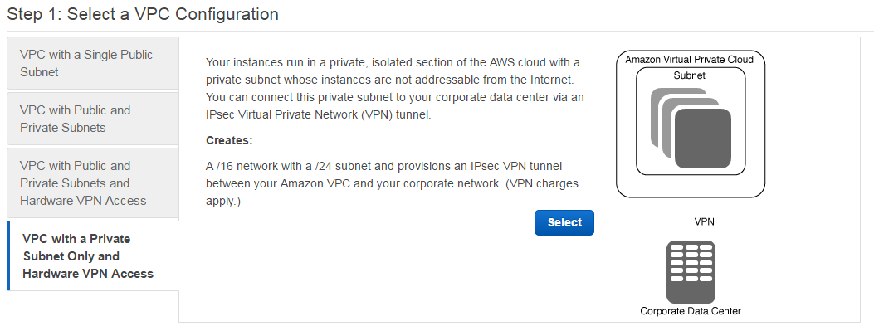

Step 2: Enter details about VPC subnet and Name, rest of the parameters leave as it is and click next.
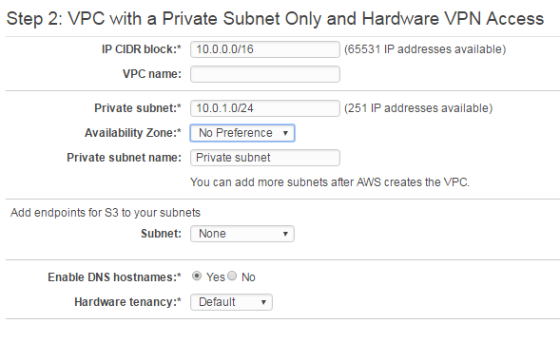
Step 3: Create a new customer gateway which is Public IP from Customer end. You can choose static (we have to give subnet range) and Dynamic (using BGP).
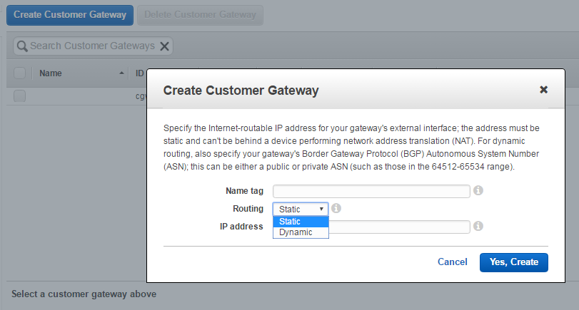

Step 4: Creating VPG (Virtual Private Gateway) which is used to conjunct VPC and Customer gateway.
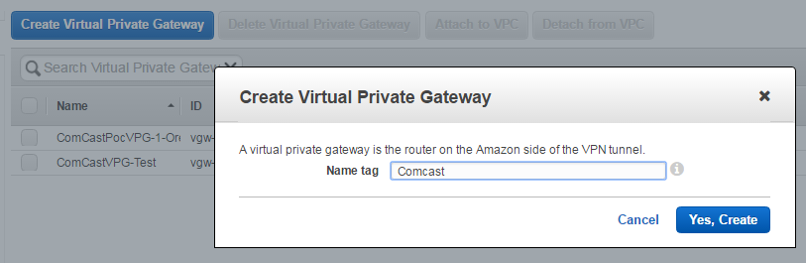
Step 5: Creating VPN connection at AWS, select VPG and Customer gateway, also select Routing options. Then create VPN connection and after created it shows in panel.
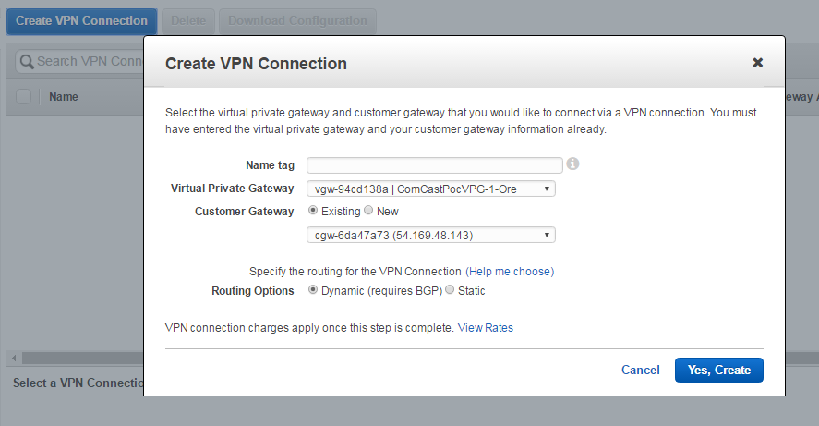
Step 6: After done withVPN creation, you can download configuration for selected VPN.
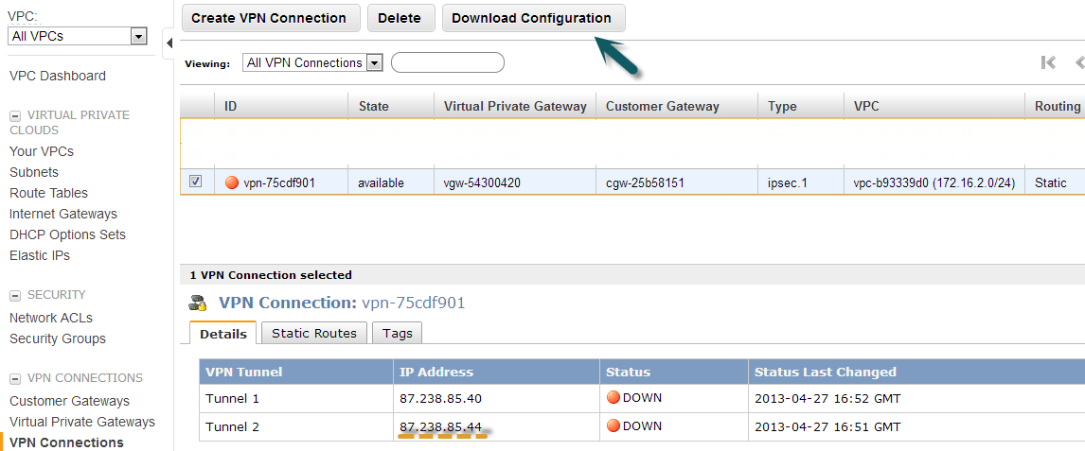
Step 7: Select “Fortinet” from Vendor, Platform as “Fortigate 40+ series” and Software as “FortiOs 4.0+(GUI)”
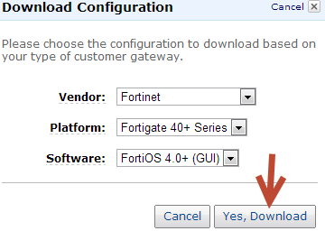
Step 8: You can get a text document with tunnel configuration and preshared key.

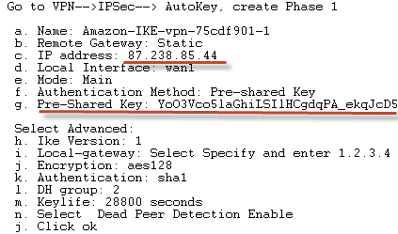

Conclusion
- Hybrid clouds benefit from both private and public cloud infrastructure.
- It makes use of on-premise infrastructure in conjunction with public clouds to reduce the need for new programming and maintenance costs.
- It provide improved and dependable data access.
- It provides scalable, flexible and reliable.
- Hybrid cloud technologies are still quickly evolving. Their biggest challenge is ensuring dependable and secure access to a company’s complete IT infrastructure.

Thank You
Contact
For more information, contact abc.xyz@tcs.com (Email Id of the unit)

About Tata Consultancy Services (TCS)
Tata Consultancy Services is an IT services, consulting and business solutions organization that delivers real results to global business, ensuring a level of certainty no other firm can match. TCS offers a consulting-led, integrated portfolio of IT and IT-enabled infrastructure, engineering and assurance services. This is delivered through its unique Global Network Delivery ModelTM, recognized as the benchmark of excellence in software development. A part of the Tata Group, India’s largest industrial conglomerate, TCS has a global footprint and is listed on the National Stock Exchange and Bombay Stock Exchange in India.
For more information, visit us at www.tcs.com.

IT Services
Business Solutions
Consulting

All content / information present here is the exclusive property of Tata Consultancy Services Limited (TCS). The content / information contained here is correct at the time of publishing. No material from here may be copied, modified, reproduced, republished, uploaded, transmitted, posted or distributed in any form without prior written permission from TCS. Unauthorized use of the content / information appearing here may violate copyright, trademark and other applicable laws, and could result in criminal or civil penalties. Copyright © 2011 Tata Consultancy Services Limited

