STARTPAGE

SEVENTH FRAMEWORK PROGRAMME

Marie Curie Actions

People

International Research Staff Exchange Scheme

Annex I - “Description of Work”

DESCRIPTION OF WORK

Part A

1 Grant Agreement Details
Full Title: Randomness and Irreversibility in Physics

Acronym: RANPHYS
Proposal Number: 269151
Scientific Panel: Physics
Grant Agreement Number: PIRSES-GA-20-269151
Duration of Project: 48 months

2 List of Partner Organizations

# | Partner | Partner Name | Partner | Country
 |  |  | Short Name
1 | Beneficiary 1 | Technische Universität Wien | TUW | AT
2 | Beneficiary 2 | École Normale Supérieure - Paris | ENS | FR
3 | Beneficiary 3 | École Polytechnique | EP | FR
4 | Partner 1 | The University of Auckland | UoA | NZ

3 Project Summary
This multidisciplinary exchange program examines the origins and formal characterization of randomness, indeterminism and irreversibility in physics, as well as their connections.
Randomness and indeterminism in physics falls into two categories: (i) classical deterministic dynamical systems may have a very strong dependency on the initial value; thus at later times the physical behaviour varies strongly with only small variations of states at the beginning; also, complex systems might perform stochastically due to the effective inability to control the large number of physical degrees of freedom; (ii) quantum randomness appears in three variants: first, it has been postulated for individual outcomes of scattering processes and other measurements; second, quantum complementarity prohibits the simultaneous measurements of certain observables with arbitrary precision; and third, Bell-, Greenberger-Horne-Zeilinger- as well as Kochen-Specker-type configurations of quantum observables imply the impossibility of (context independent) co-existence of physical observables.
Recently, indeterministic processes based on quantum indeterminism at beam splitters have been experimentally studied by a number of groups. The careful statistical and algorithmic analysis of large sequences of the data generated remains challenging.
Theoretical studies of quantum indeterministic processes and their specification and relation with respect to formal algorithmic and statistical measures of indeterminism and randomness have just started; the area requires profound knowledge of logic, mathematics and computer science, as well as of physics. The rendition of physical indeterminism; e.g., in realizations of physical random number generators, is a very delicate issue, involving, for instance, considerations about the statistical independence of the events which constitute the basis of such devices; as well as the very nature of the randomness resource.
Another long-lasting question is how physical irreversibility comes about. The existence of irreversible physical processes and an “arrow of time” in statistical physics are often derived by probabilistic arguments, but this remains a delicate issue.
In the proposed cooperation, we would like to investigate the connection between physical irreversibility as it relates to indeterminism and randomness. One of our goals is to investigate whether or not irreversibility can be proved from physical indeterminism and randomness.

Part B

4 Quality of the Exchange Programme

4.1 Objective and relevance of the joint exchange programme
The objective of this multidisciplinary exchange programme is to bring together researchers from the ERA and NZ to understand classical and quantum randomness, in particular to address the following questions:
• what are the origins of irreversibility, indeterminism and randomness in physics?
• how can we formally describe irreversibility, indeterminism and randomness in physics?
• what are the logical relations between irreversibility, indeterminism and randomness in physics?
• how do we assess the “quality” of any – classical or quantum mechanical – form of randomness?
Thereby, the objectives related to the above qestions are:
• to investigate and clarify the role played by physical measurement in both classical and quantum indeterminism;
• to investigate and clarify the relations between irreversible physical processes, the ‘arrow of time’ (as in statistical physics), and the emergent randomness;
• to investigate and clarify stability criteria for the rendition of physical indeterminism and generation of various forms of randomness.
The theoretical understanding achieved in the first three years of this project will be used to construct new, reliable methods for generating classical and quantum random bits. Applications to quantum random strings – generated with the above methods – to super-efficient Monte-Carlo simulations and to network coding, a method of making Internet file sharing faster, will be the final objective of the project.
The planned scientific activities involve four interrelated work packages which encapsulate the scope of the problems to be explored. Because of time-difference (12 hours in NZ summer), the annual first meeting will be organized always in January in Auckland; this causes minimal disruption in terms of teaching and high exposure of the ERA researchers to the most scientifically vibrant time in Auckland.
The nature of the project requires that the different work packages are, for the most part, dealt with sequentially. The project seeks to utilize the synergies and complementarities of the participant researchers to furnish a more accurate and formalized picture of the main research questions.
By unifying the complimentary skills and knowledge of researchers, Work Package #1 creates the framework for understanding the fundamental concepts researched – irreversibility, indeterminism and randomness in physics. This framework is essential for the formation of a coherent team capable of obtaining all the goals. Work Package #2 builds on the understanding obtained in the previous stage and is dedicated to formal models for the description of the fundamental concepts, the only way to be able to study various relations between classical and quantum forms of randomness. Work Package #3 – the most crucial part of the project – uses the models introduced and studies in detail the mechanisms allowing the emergence of classical and quantum randomness, and their relations. The expected results are important in themselves, as they will answer deep questions like “is irreversibility a cause of randomness? ”, and they will form the theoretical basis for controlling the process of generation of various forms of randomness. These results will be then used in the Work Package #4 for the design and implementation of procedures to generate randomness and their applications in Monte Carlo simulations and communications networking.
Each of these work packages is designed to produce specific outputs. These include workshops to discuss the results, presentations on websites, and a series of preprints published by the Centre for Discrete Mathematics and Theoretical Computer Science (CDMTCS) at the University of Auckland to put the research results quickly into public domain. At least eight papers will be published in premier peer-reviewed journals and one paper for a general audience will be published in a prestigious science magazine. Overall, the work packages aim to create a wider research agenda and develop new conceptual and methodological approaches for physical indeterminism and irreversibility. These will the basis of a joint research application and long term research collaboration, which will assist in promoting and reflecting upon knowledge transfer between the EU and New Zealand.
The benefits to Europe include the transfer of expertise in the area of random strings, with an emphasis on algorithmic information theory, and in the applicability of theoretical results to be investigated. The expertise of the researchers from Auckland is necessary to successfully advance the state of the art in the new area of Physics and Computation. The cooperation will develop a joint training and research program for young researchers in the ERA, and will lead to new technologies in simulation and network communication.
Although primarily theoretical in nature, the reseach will lead to various industrial partnerships in the ERA, possibly the establishment of a company commercializing custom-made quantum random bits and simulation software.
The project will create an international network of leading researchers from the ERA and NZ, the foundation for an enduring partnership in research, graduate training and industrial applications.
In what follows we shortly present some of the objectives of this multidisciplinary exchange program in more detail.

4.1.1 Table 1: List of Work Packages

Work package # | Work package title | Beneficiaries/Partner organization (short name) | Start month | End month
1 | A framework for understanding irreversibility, indeterminism and randomness in physics | ENS/EP/TUW/UoA | Jan 2011 | Dec2011
2 | Formal methods describing irreversibility, indeterminism and randomness in physics | ENS/EP/TUW/UoA | Oct 2011 | Sept 2012
3 | Logical relations between irreversibility, indeterminism and randomness in physics | ENS/EP/TUW/UoA | Oct 2012 | Dec 2013
4 | Design and implementation of methods to produce reliable quantum randomness with applications to Monte Carlo simulations and communications networking | ENS/EP/TUW/UoA | Jan 2014 | Dec 2014

4.1.2 Table 2: Work Packages

Work package # | 1
Start date | January 2011
Work package title | A framework for understanding
 | irreversibility, indeterminism and
 | randomness in physics
Beneficiaries/Partner organization (short name) | ENS/EP/TUW/UoA
Work package coordinator | ER 4 (Experienced Researcher 4)

Objectives
• Collect the researchers knowledge of the three main concepts of indeterminism, irreversibility and randomness in physics, and determine the relations between the concepts.
• Use this knowledge to identify various origins of randomness in both classical and quantum physics.
• Create a framework for a larger multidisciplinary team from the ERA and NZ – seeded around the researchers to this project – to cooperate for a longer period in the area of Physics and Computation.

Description of work
This work package focuses on spreading the knowledge required for the project amongst the related partner organizations and communities, and setting the stage for a stronger development of research in the future, both within the organizations and for future collaborations. By using this complementary knowledge, this work package will set the groundwork for the formal modelling and study of these properties in the successive work packages.
The tasks of this package are:

1. Share knowledge about the current understanding of randomness in physics, and identify key areas to tackle.
2. Identify and study the origins of deterministic randomness, involving the study of dependence on initial conditions and stochasticity due to the large number of physical degrees of freedom.
3. Identify and study the origins of quantum randomness, involving study of the outcomes of individual events, quantum complementarity and the impossibility of (context-independent) co-existence of physical observables.
4. Identify relationships between the origins of irreversibility and randomness studied in Tasks 1.2 and 1.3.

Deliverables
1. Participation with two papers to the annual workshop (e.g., in Turku, Finland in 2010) on “Physics and Computation.”
2. Papers on “Physics and Computation” submitted to international peer-reviewed journals.
3. Workshop in Vienna to discuss results on “Physics and Computation.”

Researchers involved

Work package # | 2
Start date | October 2011
Work package title | Formal models describing
 | irreversibility, indeterminism
 | and randomness in physics
Beneficiaries/Partner organization (short name) | ENS/EP/TUW/UoA
Work package coordinator | ER 1 (Experienced Researcher 1)

Objectives
Development of formal models to understand, model and relate the main concepts studied in the project:

• physical irreversibility and indeterminism,
• deterministic chaos,
• various forms of quantum randomness.

Description of work
As various origins for randomness and irreversibility in physics are investigated and better understood, it is vital that formal models to describe these processes are developed. It is only once such models have been developed that the consequences and applications can be thoroughly investigated. As a result, this is a fundamental part of the project. Because of the broad range of expertise needed to investigate randomness and irreversibility in physics, synergies between the researchers’ complementary knowledge must be created in order to develop effective formal models.
Various forms of algorithmic complexities will be used as the main tools for the development of formal models. Although based on a purely “linguistic” (i.e., algorithmic) notion of randomness, algorithmic randomness yields a sound and effective analysis of randomness in physics via the identification of randomness with unpredictability, in the intended physico-mathematical contexts. In order to “predict,” one has to “say in advance” (pre-dicere, in Latin), by equations or by evolution functions, about a (physical) process, and compute its behavior. Algorithmic information theory provides a consistent way to “say in advance” and to compute in mathematics. In particular, in order to prove unpredictability, algorithmic randomness describes what is provably impossible to “say in advance,” by a mathematical analysis of the “unknown” and “unknowable” part of physical measures.
UoA’s word-class experience with algorithmic complexity is vital for this part of the project, but it is only when combined with the other researchers expertise in chaotic and dynamical systems, recursion theory and quantum randomness that the formal models required can be developed.
The tasks of this package are:

1. Develop a complexity theoretical model of irreversibility and indeterminism.
2. Develop an algorithmic model of deterministic chaos.
3. Develop an algorithmic model for the various forms of physical randomness identified in the first work package.

Deliverables
1. Annual workshop in Auckland on physical random number generators.
2. Two papers concerning physical random number generators presented at the international conferences “Unconventional Computation” and “Computability in Europe”.
3. Papers submitted to international peer-reviewed journals.
4. International workshop in Paris on indeterminism and irreversibility.
5. Two lectures on physical random number generators for a general audience will be given in Paris and Auckland, respectively.

Researchers involved
Again, in this fundamental research area, all researchers, young and experienced, will be involved; they will all contribute to the objectives stated.

Work package # | 3
Start date | October 2012
Work package title | Logical relations between
 | irreversibility, indeterminism and
 | in randomness physics
Beneficiaries/Partner organization (short name) | ENS/EP/TUW/UoA
Work package coordinator | ER 2 (Experienced Researcher 2)

Objectives
This is a crucial part of the project in which we examine the relations between indeterminism, irreversibility and randomness in physics.

• Study of the possibility that irreversibility can be proved from physical indeterminism and randomness.
• Theoretical and experimental study of the Thesis stating that finite time randomness is “related” to irreversibility in time in all main physico-mathematical contexts, which include Poincaré deterministic randomness, thermodynamics and various forms of quantum randomness.
• Theoretical and experimental study of the hypothesis that quantum randomness is “more random” than classical randomness.

Description of work
Reversibility in physics corresponds to the mathematical invertibility of the function describing the trajectory. This is exemplified by looking the Euler-Lagrange formalism, where the appearance of time is raised to the power of two, and thus the direction of time does not influence the evolution of the system. When dealing with linear-field equations, motion is reversible since the equations can be inverted by changing the sign of the field. However, Poincaré has proven that non-linear (field) equations generate chaos. Arbitrarily close points may rapidly diverge or fluctuate below observability; they lead to observably different (unpredictable) evolutions. Mathematically, non-linearity implies non-invertibility of functions, and this imposes a direction on time.
Schrödinger’s equation is linear, and is “reversible,” in its own way, by the peculiar role of the imaginary ‘i’: the inversion of time, −t, yields a −i whose behavior, squared, is the same as that of i. Yet, what is computed, the evolution of the state function by Schrödinger equation, is not what is measured. And measurement in quantum mechanics, despite the possibility to reconstruct the state in certain “quantum erasure” configurations, is a highly time irreversible process. Once more, randomness emerges when one deals with a time irreversible process.
The tasks of this package are:

1. Understand the concept of entropy growth (under general conditions).
2. Study the relations between downgrading of energy by a diffusion process, randomness and irreversibility.
3. Study the role of measurement in the generation of randomness.
4. Compare the quality of deterministic and quantum forms of randomness.
5. Formulate the main results of the project in a format understandable for the general audience.

Deliverables
1. International workshop in Auckland on randomness and irreversibility.
2. Two papers presented at the premier international conferences “Computability in Europe”, “International Colloquium on Automata, Languages and Programming.”
3. Organize a special edition of the workshop “Physics and Computation” on randomness and irreversibility.
4. Papers submitted to international peer-reviewed journals.
5. Workshop in Vienna.
6. Run a graduate course at TUW on Physics and Computation, in particular, topics related to Statistical Physics and Computation.

Researchers involved

Work package # | 4
Start date | January 2014
Work package title | Design and implementation of
 | methods to produce reliable quantum
 | randomness with applications to
 | Monte Carlo simulations and
 | communications networking
Beneficiaries/Partner organization (short name) | ENS/EP/TUW/UoA
Work package coordinator | ER 3 (Experienced Researcher 3)

Objectives
The fourth year of the project is devoted to applications and their possible commercialization.
• Develop new reliable methods for generating quantum random bits.
• Apply quantum random strings – generated with the above methods – to super-efficient Monte-Carlo simulations.
• Apply quantum random strings to network coding, a method of making Internet file sharing faster.
• Explore the possibility of a spin-off company for commercializing the above practical results.

Description of work
Monte-Carlo simulations essentially use pseudo-random strings of bits; they are very fast, and their results are not always correct, but the probability of error is extremely small (for example, testing primality – an important computation used in public-key cryptography – uses probabilistic tests of randomness, like Rabin’s test, because they outperform any known polynomial-time deterministic test). We will investigate the performance of Monte-Carlo simulations powered with quantum random bits.
Will Monte-Carlo simulations powered with quantum random bits be not only a better form of simulation, but also an error-free one? Will the use of quantum random bits in communications networks, where the router doesn’t just hand off the packets, but it combines them “intelligently” into new hybrid ones, improve significantly the internet traffic?
Using the theoretical understanding of various forms of quantum randomness we will propose new reliable methods for generating quantum random bits whose correctness will be proved with the methods previously developed in the project. Since the mentioned applications of the research are important, effort will be made to ensure these results are presented to the research community in an effective manner, so that the full potential of the results can be realized.
The researchers will meet together to review the scientific results of their research and discuss arrangements for further research between the partners. To ensure a strong collaboration is maintained between the partners, plans for future research will be made to include graduate students and developing formal programs for collaboration.
A summary of the results of the project will be presented to ensure that research, as well as further open questions, are known to the community. This will encourage participation from the wider New Zealand and European research communities on the area of Physics and Computation.
The tasks of this package are:

1. Develop methods of generating quantum random bits using the knowledge gained in the previous work packages relating to quantum randomness.
2. Prove correctness and implement these methods.
3. Explore the theoretical and practical implications of being able to generate random bits from a physical source.
4. Apply these methods of generating quantum random bits to Monte Carlo Simulations and network coding.

Deliverables
1. Two papers on randomness and irreversibility will be presented at international conferences (location to be undefined).
2. Papers on randomness and irreversibility submitted to international peer-reviewed journals.
3. Workshop on randomness and irreversibility in Paris.
4. Two lectures on randomness and irreversibility for a general audience will be given in Paris and in Auckland.
5. An international workshop will be organized in Auckland in which the major results of the project with regards to randomness and irreversibility will be presented.
6. Summer School organized in Paris (to attract graduate students and young researchers to the area of Physics and Computation).
7. Start inter-hosting graduate students by partner organizations.
8. Report co-authored by all researchers reviewing the key results obtained in the four work packages, their theoretical and practical impact, the synergies that have been created and the further long term collaboration between all beneficiaries/partner organizations will be written.
9. An article or randomness for a leading science magazine, possibly Science or Nature will be written.

4.1.3 Table 3: List and Schedule of Milestones

Milestone | Milestone | WP | Beneficiary/ Partner organization | Delivery date | Content
1 | Auckland | 1 | UoA,ENS,EP,TUW | Feb 2011 | A framework for understanding irreversibility, indeterminism and randomness in physics
2 | Report | 2 | UoA,ENS,EP,TUW | Sept2012 | Formal methods describing  irreversibility, indeterminism and  randomness in physics
3 | Report | 3 | UoA,ENS,EP,TUW | Dec2013 | Logical relations between  irreversibility, indeterminism and  randomness in physics
4 | Workshop Auckland | 4 | UoA,ENS,EP,TUW | Dec2014 | Design and implementation of  methods to produce reliable  quantum randomness with  applications to Monte Carlo  simulations and communications  networking
5 | Final report | 4 | UoA,ENS,EP,TUW | Dec2014 | Final account of previous activities

4.1.4 Table 4: Gantt Chart of Secondments
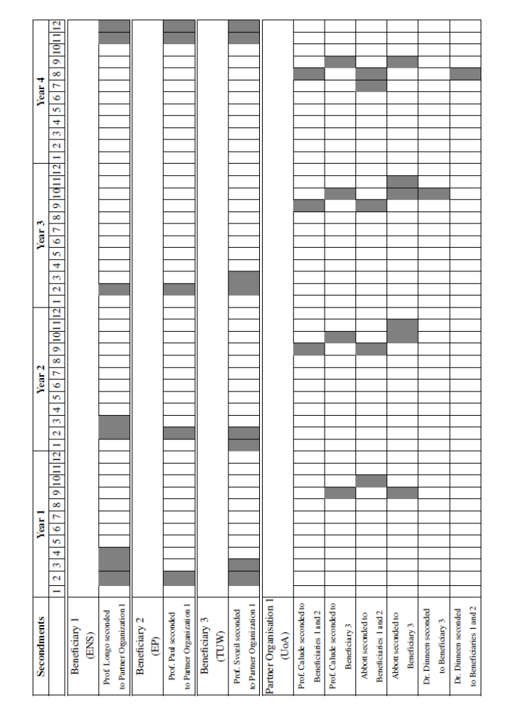

Due to the close proximity of ENS and EP, secondments to Paris are grouped together as these will involve collaborative work at both ENS and EP.

4.2 Scientific quality of the partners

4.2.1 École Normale Supérieure
The École Normale Supérieure (ENS) is a public institution, with a scientific, cultural and professional orientation, directly reporting to the Minister in charge of Higher Education. The status of August 26th, 1987, describes the ENS rule and stipulates “The École Normale Supérieure trains, through a cultural and scientific education of high level, students who intend to work in fundamental and applied research, teaching in the Universities or preparatory classes for grandes écoles, as well as high school, and more generally, who intend to work in national administrations, public institutions and enterprises.”

4.2.2 École Polytechnique
For more than two hundred years, École Polytechnique, one of the most prestigious educational establishment in France, has been dedicated to educating students in Science and Technology at the highest level and in advanced research.

4.2.3 Vienna University of Technology
The Vienna University of Technology (TUW) is Austria’s largest scientific-technical research and educational institution. It has a long-standing tradition of excellence in the physical and engineering sciences. Founded in 1815 as the “Imperial-Royal Polytechnic Institute" (k. k. Polytechnisches Institut, the first University of Technology within present-day German-speaking Europe), it currently has about 17,600 students in 8 faculties and about 4,000 staff members (1,800 academic).

4.2.4 The University of Auckland
The strategic importance of the University of Auckland (UoA) and its inclusion as a key partner in this project derive primarily from its research expertise and its strategic geographical position. With over 40,000 students and sited in the heart of New Zealand’s largest city, UoA is the leading research-intensive university in the country which consistently ranks among the top 50-60 university in the world (THES rankings 2007-2009). The UoA has the highest track record in New Zealand in obtaining research grants, both locally and also in partnership with the ERA institutions.
The UoA team is based in the Centre for Discrete Mathematics and Theoretical Computer Science (CDMTCS) of the Faculty of Science. CDMTCS, which is a joint venture involving the Computer Science and Mathematics Departments of the University of Auckland in New Zealand, was founded in 1995 to support basic research on the interface between mathematics and computing, to foster research and development in these areas within the South Pacific region, and to create links between researchers in that region and their counterparts in the rest of the world. The CDMTCS has a unique track record in research in algorithmic information theory and computational physics. The CDMTCS is the main organizer of the series of international annual conferences “Unconventional Computation”, started in Auckland in 1998, and has an unique experience in New Zealand in organizing international meetings.
The CDMTCS has a web of long-term cooperation partnerships with The Logic Group at JAIST, Japan; Turku Centre for Computer Science (TUCS), Turku, Finland; and The Valparaiso Institute of Complex Systems, Valparaiso, Chile. In such previous cooperations, the CDMTCS provides theoretical expertise that plays a key role in making the collaborations successful. The CDMTCS is the main organizer of the annual international conference “Unconventional Computing” and is a partner in the organization of the international series of conferences “Development in Language Theory” and workshops “Physics and Computation”.

4.3 Complementarities/synergies between the partners
The researchers’ previous research and areas of expertise complement each other, in that ER2 and ER3 have previously cooperated on problems on the edge of Physics and Computation; while ER1 and ER4 have engaged in research in discrete models in physics. This project encompasses partners with both the necessary expertise and academic standing in the relevant fields to deliver results which consolidate a much wider range of knowledge than the previous projects, allowing both the development of new synergies in the research and new or enhanced applications.
It is only through the synergies created between the partners and continued regular contact that this project can be successfully carried out. The specific knowledge from a wide range of areas required means that the success of the project, as well as an extended future of leading research into this area of Physics and Computation, relies on strong research cooperations being created between the partner organizations. The applicants are eminently qualified, through their combined expertise, to successfully carry on this project: their previous histories of cooperation and the success of the Paris meeting in 2009 are guarantees of success.

5 Transfer of Knowledge

5.1 Quality and mutual benefit of the transfer of knowledge
The regular meetings between researchers will serve as a basis for inter-personal knowledge exchange. All researchers will attend the regular January meetings, and this interaction between researchers will extend each of their knowledge into other researchers’ areas of expertise. This will not only be beneficial during the course of this project, but the new knowledge will increase the diversity and quality of future research by the researchers. It has the further added value of allowing them to spread their knew knowledge through their organization via graduate classes and workshops.
The secondments for this exchange are carefully arranged so that researchers are placed together at vital points where their complementary expertise must be combined. This is true not just for the research, but also for activities aimed at disseminating knowledge to other groups, such as summer schools, workshops and various publications. This ensures that the benefit of the created synergies will be utilized effectively.
The researchers will work together to present their research at seminars, workshops and conferences, in which graduate students will be invited. This is a key aspect of the transfer and dissemination of knowledge, as knew results will be spread both into the partner organizations and the wider research community, where they can foster further research. From time to time, lectures for a general audience will be given to improve public awareness of the research.
The research results obtained will be presented and published in premier peer-reviewed conferences and journals, and in one or two science magazines (e.g. New Sciences, La Recherche). The peer-reviewing and high-quality publications will help ensure the quality of the research, as well as its circulation through the research community. Publications will also result from presenting the results in workshops and conferences and will help get the research into the community quickly in order to foster further research.
We will develop a joint Masters course in Physics and Computation – which is missing from all participant universities – which will draw students from computer science, mathematics and physics, and will be followed by a Summer School in Physics and Computation addressing more advanced material. A framework will be developed to allow graduate students from participating universities to be co-supervised by researchers from participant universities, thus bringing in the wider expertise. This is part of the dissemination mechanism that will help ensure a lasting cooperation between the partner universities, and will create a continue stream of fresh researchers in the field capable to make the ERA the world centre for this field.
Some theoretical results will be used to build physical realizations of devices operating as “random oracles” which will serve in fundamental research, technology and statistical data analysis, quantum network coding, security applications (e.g., in finance).

5.2 Adequacy and role of staff exchanged with respect to the transfer of knowledge

Six researchers from four universities (three European Union and one third-country university), including one early stage researcher, will be directly involved in the project. Three researchers will be eligible to receive staff exchange funding over the total of 21 months. As described in the GANTT chart the programme plans to develop 41 months secondments including research and training stages, attendance to seminars, workshops and a final conference.

6 Implementation

6.1 Capacities (expertise/human resources/facilities/infrastructure) to achieve the objectives of the planned cooperation
All beneficiaries and partner institutions are top research universities capable to support the scientific, logistic and organizational requirements for a successful implementation of the proposal. For example, ENS and EP, as top research universities in France, can offer not only unmatched expertise, but also the chance for NZ researchers to benefit from being in the middle of one of, if not the most, vibrant city in Europe. TUW offers the chance to be just miles from two important research centers in Vienna which are relevant for our project: the group in quantum physics the University of Vienna and the Schrödinger Institute. UoA has one of the best equipped libraries in Australasia and the ideal place for the ERA researchers to meet researchers in the South-Pacific region.
All seconded researchers will be given dedicated computer and work space inside the relevant department. This will place, for example, researchers visiting UoA in the middle of the CDMTCS, immersing them inside the research environment of the centre and allowing them to gain the most from their exchange. Seconded researchers will be given all the necessary access to university resources to fully benefit from their exchanges.

6.2 Appropriateness of the plans for the overall management of the exchange program
The whole project – including the administration (financial aspects, communication with the EC, organization of secondments – will be managed by ER4, who has: i) the broad knowledge to understand all aspects – theoretical and practical – of the involved research, ii) is best suited to create the synergy between groups, iii) is capable of running all “wheels”, small or large, of the entire project.
The leaders of the four teams, ER4 (TUW), ER2 (ENS), ER3 (EP), ER1 (UoA) will work closely by email and VoIP to coordinate the project and to guarantee an updated flow of information and decisions.
The coordination of work packages is allocated to a specific researcher as indicated in B 1.1.2.
The scientific work will be coordinated by ER2 and ER3. ER1 will coordinate the dissemination of results, including publications – scientific and for the larger audience – , public lectures, etc. Dr. Dinneen and ER4 will be in charge of the coordination of the development of the curricula for, and the running of, the Master course in Physics and Computation in Vienna. Abbott and ER2 will organize the Summer School in Paris. Meetings and workshops will be organized by the local participant researchers, using their universities facilities.
All partner institutions have in place efficient accommodation arrangements for visitors. Due to the nature of the project there will be no need of local induction or other specifics: visitors will be able to seamless integrate and due their work.
The partner institutions will be able to provide the necessary intra-beneficiary exchange (within the EU). The University of Auckland, and in particular, the Centre for Discrete Mathematics and Theoretical Computer Science (CDMTCS) are able and well equipped to host meetings in New Zealand. Funding matching the IRSES-funds for Abbott, ER1 and Dr. Dinneen are provided by the New Zealand partner organization. Specific arrangements will be made such that host institutions will fully profit from the visiting researchers involved in this project; visitors will contribute in various ways to the academic life of host universities, e.g. by giving talks or invited lectures to graduate classes.
Each work package lasts 12 months and has four milestones (with the exception of the last work package which has five milestones):
• it starts with detailed planning and a meeting to organize and prioritize the annual main activities;
• at around nine months, during one of the secondments, a workshop is held to exchange results,
• towards the end of work package a review and evaluation meeting is organized during one of the secondments,
• end of year report.
There will be three levels of reporting: an annual report, a mid term report after year 2 and the final report. Dues to the small size of the team involved, the coordination and management of the project will be simple; all energies will be focussed in training and research.

7 Impact

7.1 Relevance of the proposed partnership to the area of collaboration and for the ERA
The advancement of the research in the field would not be possible in the EU only, and less so in NZ; its strength comes from the development of a formal relationship between the researchers. The research that will be carried out during this exchange will help to foster a new sub-field of research on Physics and Computation – the algorithmic study of randomness and irreversibility in physics. The development of this new field requires a close interaction between experts in a variety of areas, and specifically the expertise outlined in our project. This exchange will enable such a collaboration to be undertaken, and the researchers involved are eminently qualified with the required knowledge and ability to foster a long-lasting area of research.
This research will have a strong impact on the Physics and Computation research community, as it will provide significant advances in a new theoretical topic, and will result in publications in leading journals and conferences. Some of these results and techniques will also be relevant to other areas of Physics and Computation, and can be integrated into other topics of research. This, in turn, encourages new research pathways in relevant theoretical areas and strengthens the research community of Physics and Computation.
Direct cooperation in graduate supervision will be beneficial for students at the ERA participant universities. For example, PhD students supervised by ER2 at ENS, Giulia Frezza and Mael Montevil, will benefit directly from the expertise of UoA researchers. The summer school, the Masters course and the integration of results into graduate courses at the participating universities will also stimulate research in the area of collaboration.
The promotion of research into the study of physics as an information based science will benefit the research-base of the ERA. This exchange places emphasis on creating a lasting network for the next generation of students and scientists to be able pursue research into this developing field, in the foreseeable future. The ERA will further benefit from the world class experience of the UoA in algorithmic information theory, as emphasis early in the project is on disseminating knowledge between researchers; the exchange will make the ERA one of the most active research centers in the area of randomness in physics.
The experience/cooperation with The Centre for Software Innovation, which provides a bridge between researchers in Information and Communication Technology (ICT) at The University of Auckland and the ICT industry, will help develop strategies for commercialization of the results produced in the project. Various industrial partnerships will be explored in the ERA, possibly the establishment of a spin-off company commercializing custom-made quantum random bits and simulation software.

7.2 Potential to develop lasting collaboration with the eligible Third country partners.
The research to be conducted through this exchange is largely focused around an emerging research area; it is inevitable that many more questions will arise than those which are answered. While there are specific key areas which the participant researchers will investigate, for the long term success of this project it is vital that procedures to ensure a lasting, long-term collaboration are implemented.
As previously mentioned, the later parts of the project involve putting in place programs to ensure this is the case. Graduate programs in participant universities will be set-up (built on the opportunity of having world class external supervisors/mentors), as will programs for joint supervision of projects between participant universities. By having spent time with these groups there is an increased potential to build strong Marie Curie fellowship proposals, to train the best researchers in the field in Europe.
Further, the fast dissemination of research into the community through conferences and publications will ensure new researchers are involved in relevant research in the future, helping solidify the research as a long-term project. The commercialization of the results of the projects, as described in B.4.1, is also a long-term project. These multiple avenues for cooperation will lead to a memoranda of understanding for future collaboration between the ERA and NZ partners.
The researchers involved in this exchange have the experience in developing collaborations to ensure that these goals will be met, and that the desired lasting collaborations come to fruition. Further, it is this emphasis on creating a long lasting collaboration that could not be achieved by ad hoc collaboration between researchers, but only with a strong program for exchanges to create synergies and develop this project. The way this collaboration has been naturally developed, from a seed Hood Fellowship (from NZ), to a visiting ship at ENS (ERA) and an IRSES mobility project, is a guarantee that the area of research between the partner universities will continue at various levels and will be of mutual and long lasting benefit for both the ERA and NZ.

8 Ethical Issues
The proposed research activity is mostly fundamental research which will be published without any restriction. In the direct way, there seem to be no ethical issues involved. None of the following concerns is directly related to the proposed project:
• Informed consent
• Human embryonic stem cells
• Privacy and data protection
• Use of human biological samples and data
• Research on animals
• Research in developing countries
• Dual use
The research does not include:
• Research activity aiming at human cloning for reproductive purposes.
• Research activity intended to modify the genetic heritage of human beings which could make such changes heritable (Research related to cancer treatment of the gonads can be financed).
• Research activities intended to create human embryos solely for the purpose of research or for the purpose of stem cell procurement, including by means of somatic cell nuclear transfer.

ETHICAL ISSUES TABLE

∗ | Does the proposed research involve human Embryos?
∗ | Does the proposed research involve human Foetal Tissues/ Cells?
∗ | Does the proposed research involve human Embryos?
∗ | Does the proposed research involve human Embryonic Stem Cells (hESCs)?
∗ | Does the proposed research on human Embryonic Stem Cells involve cells in culture?
∗ | Does the proposed research on Human Embryonic Stem
 | Cells involve the derivation of cells from Embryos?
 | I CONFIRM THAT NONE OF THE ABOVE ISSUES APPLY TO MY PROPOSAL | YES | All

 | Research on Humans | YES | Page
∗ | Does the proposed research involve children?
∗ | Does the proposed research involve patients?
∗ | Does the proposed research involve persons not able to give consent?
∗ | Does the proposed research involve adult healthy volunteers?
 | Does the proposed research involve Human genetic material?
 | Does the proposed research involve Human biological samples?
 | Does the proposed research involve Human data collection?
 | I CONFIRM THAT NONE OF THE ABOVE ISSUES APPLY TO MY PROPOSAL | YES | All

 | Privacy | YES | Page
 | Does the proposed research involve processing of genetic information
 | or personal data (e.g. health, sexual lifestyle, ethnicity,
 | political opinion, religious or philosophical conviction)?
 | Does the proposed research involve tracking the location or observation of people?
 | I CONFIRM THAT NONE OF THE ABOVE ISSUES APPLY TO MY PROPOSAL | YES | All

 | Research on Animals | YES | Page
 | Does the proposed research involve research on animals?
 | Are those animals transgenic small laboratory animals?
 | Are those animals transgenic farm animals?
∗ | Are those animals non-human primates?
 | Are those animals cloned farm animals?
 | I CONFIRM THAT NONE OF THE ABOVE ISSUES APPLY TO MY PROPOSAL | YES | All

 | Research Involving Developing Countries | YES | Page
 | Does the proposed research involve the use of local
 | resources (genetic, animal, plant, etc)?
 | Is the proposed research of benefit to local communities
 | (e.g. capacity building, access to healthcare, education, etc)?
 | I CONFIRM THAT NONE OF THE ABOVE ISSUES APPLY TO MY PROPOSAL | YES | All

 | Dual Use | YES | Page
 | Research having direct military use
 | Research having the potential for terrorist abuse
 | I CONFIRM THAT NONE OF THE ABOVE ISSUES APPLY TO MY PROPOSAL | YES | All

Part C

9 Overall Maximum Community Contribution (Tables A3.1 & A3.2)
please see Tables A3.1 and A3.2 from the GPFs.

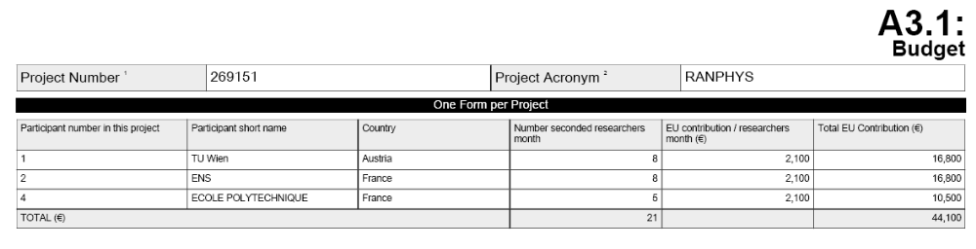

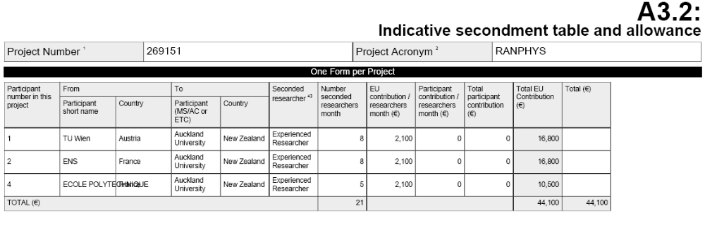

10 Reporting Periods

REPORT PERIOD | SCIENTIFIC MID-TERM REVIEW REPORT DUE AT MONTH | REPORTS* DUE AT MONTH
1 | 12 | 24
2 | 36 | 48

* They include the activity and management reports and the financial statement (Form C).

The Union support of Marie Curie Actions will be referenced in publications, conference papers, presentations and posters in connection with this project. This will include the sentence "This research was supported by a Marie Curie International Research Staff Exchange Scheme Fellowship within the 7th European Community Framework Programme", as well as, if relevant, the EU and Marie Curie logos.

ENDPAGE

PEOPLE

MARIE CURIE ACTIONS

International Research Staff Exchange Scheme

Call: FP7-PEOPLE-2010-IRSES

Annex I

RANDOMNESS AND IRREVERSIBILITY IN PHYSICS

(RANPHYS)

