Karl Svozil
Curriculum Vitæ
+43-660-5710788
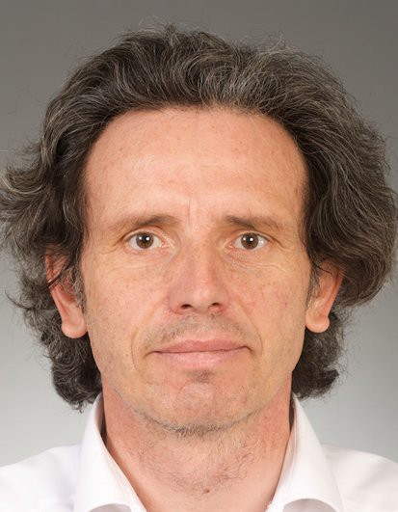
svozil@tuwien.ac.at
http://tph.tuwien.ac.at/~svozil

Personal data
18. 12. 1956 born in Vienna, Austria, Austrian (EU) nationality.
two children, (Anna, 17, Alexander, 21).
Roman Catholic.

Education
1975–1981 PhD, University of Vienna and Heidelberg, Vienna and Heidelberg, PhD. 1982–1983 Visiting Scholar, University of California at Berkeley and at the Lawrence
Berkeley Laboratory, Berkeley, through The Rotary Foundation of Rotary
International.
12. 3. 1988 Dozentur, Vienna University of Technology, Vienna, Universitätsdozent.

Experience

Vocational
1984–1990 Staff scientist, Austrian Ministry for Science & Research, Vienna. 1990–1997 Permanent researcher, Vienna University of Technology, Vienna.
1997–present A.o. Universitätsprofessor, Institute for Theoretical Physics of the Vienna University of Technology, Vienna.

Academic and organizational
1984–present Scientific visits, Various prolonged visits in academic institutions; among them research centers in the USA, Canada, New Zealand, Germany, Russia, Italy, Denmark, Malaysia and India.
1994–present Editoral duties, Associated Editor of journals in Physics and Computer Science.
2003–present (Co-)organizer, Organizer and co-organizer of various scientific conferences in Physics and Computer Science.
2010–present Panel Member, Fonds Wetenschappelijk Onderzoek - Vlaanderen, Bergium. 2011–present Honorary Appointment, Centre for Discrete Mathematics and Theoretical
Computer Science, of The University of Auckland in New Zealand.
2011–present PhD school, Coorganizer of a PhD program in Physics and Computer Science at the Vienna University of Technology.

2012–2014 President, International Quantum Structure Association (since 2014 Vice President).
2013 R. R. Hawkins Award, The American Publishers Awards for Professional and Scholarly Excellence) for co-authoring the book Alan Turing: His Work and Impact, Elsevier, 2013.

