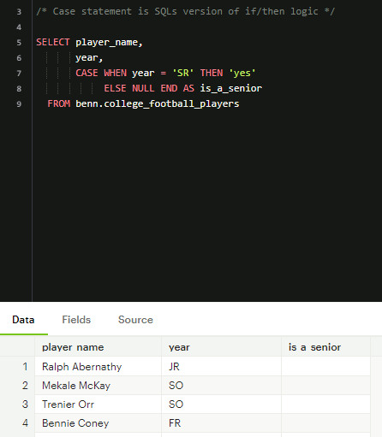

- Using the CASE statement as an excels version of if/then statement. Paired with WHEN statement. Every CASE statement must end with the END statement. Using the ELSE statement The CASE statement checks each row to see if the conditional statement year=’SR’ IS TRUE. The word “yes” gets printed for anywhere in the column that we have named is_a_senior. Where we see false, nothing happens in that row, leaving a null value in the is_a_senior column.



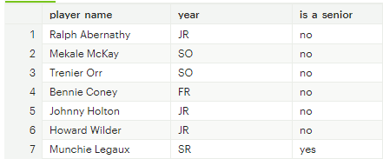

- Using NO with the ELSE statement, replaces null values

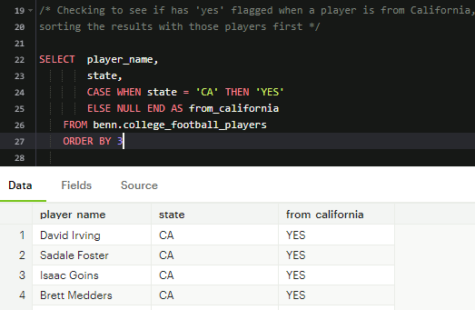

- In this query, if a player is from California, the column will be flagged ‘Yes’, and it will order the results by the from_california column

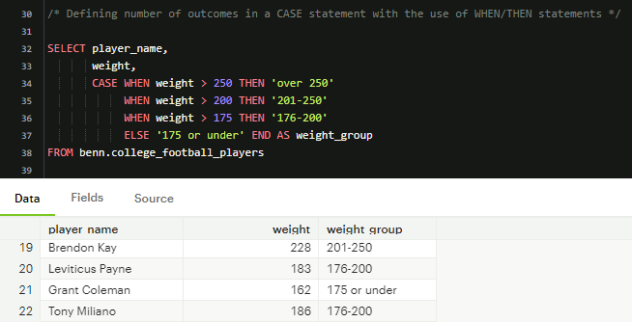

- Using the CASE statement in conjunction of the WHEN/THEN statement. This statement works in the order it is written. We did this query to identify which players weights fall under what weight group.

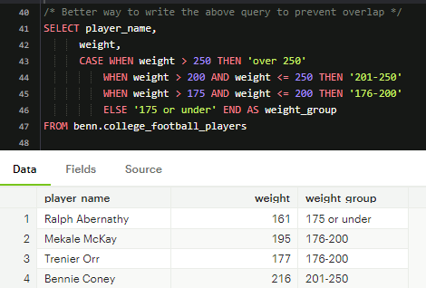

- Defining the values by using the ranges like this is the best practice .

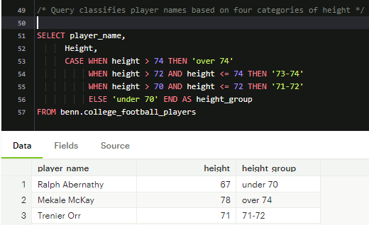

- This query includes the players names and a column named height_group to classify the height into 4 different categories. We use the CASE WHEN statement followed by multiple WHEN statements. We observe the different height groups

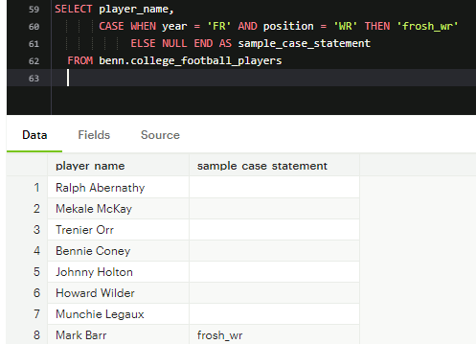

- Stringing multiple conditional statements with AND/OR

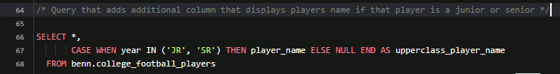

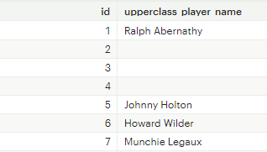

- This query was created to observe the names of players if they were juniors or seniors in a column named upperclass player name.

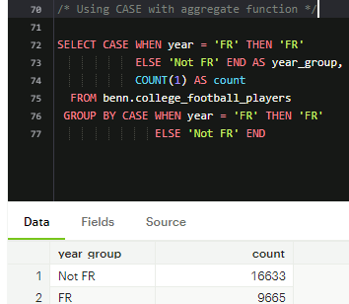

- We are looking for the count of FR and NOT FR, by pairing CASE with an aggregate function. COUNT by itself ignores nulls, the CASE statement is used to evaluate the condition and produce null or non-null values. We used NOT FR for null values.

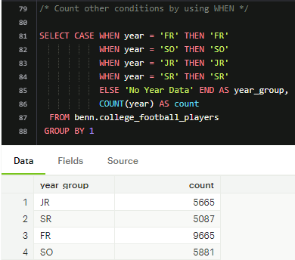

- This query we are exploring the count of year group, pairing the CASE statement with WHEN for many conditions

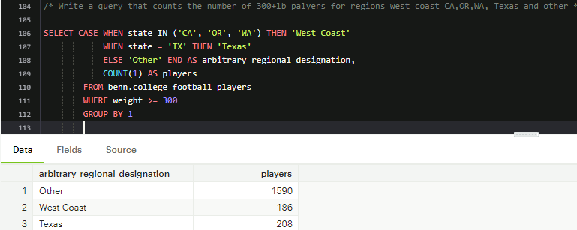

- In this query we explore the question of which states/regions have the amount of players where they weigh more than 300lbs.

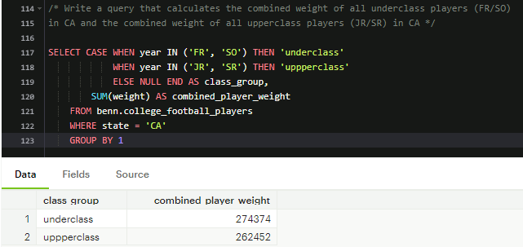

* In this query we answer the explore the calculated combined weight of underclass and upperclass. First we had to define the split of the group, then we use the SUM function to get the sum of combined weight and group by column 1.

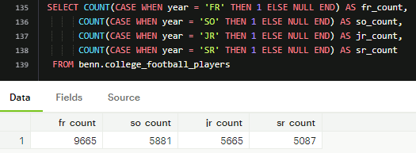

- Re-orienting the data to show horizontally as a pivot table might.

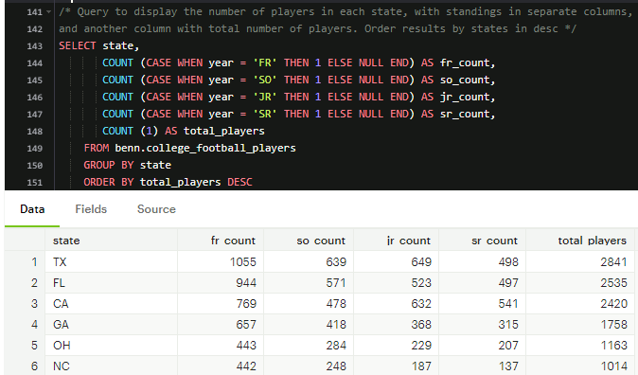

- Here we explore which states have the highest count of total players and break it down more by count of grade standing. Need the pair COUNT with CASE WHEN because we are looking for a numerical value

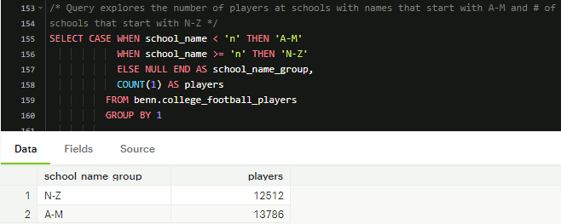

- Exploring the number of players at schools which names start with either A-M or N-Z