Knowing When to Trust a pKa Model: Conformal Prediction Intervals and an Applicability Domain for XGBoost Descriptor Models
Fahad Ali Atwi
Department of Chemical Engineering, King Fahd University of Petroleum & Minerals, Dhahran 31261, Saudi Arabia

Abstract
Machine-learning models for aqueous pKa are now accurate enough to be useful in early-stage molecular design, yet most return a single number with no measure of confidence and no statement of where the model can be trusted. Building on a previously reported XGBoost model that predicts acidic and basic pKa from RDKit and Mordred molecular descriptors (test R² ≈ 0.83), this work adds a reproducible reliability layer with two components. First, distribution-free conformal prediction intervals are attached using three methods—split conformal, locally adaptive (normalized) conformal, and conformalized quantile regression—each calibrated on a held-out portion of the training data. On a strictly held-out test set these intervals achieve their nominal coverage (for example, 90.6 % empirical coverage at the 90 % level for split conformal on the acidic task), and the locally adaptive variant reaches the same coverage with narrower intervals by widening only where an ensemble of models disagrees. Second, an explicit applicability domain (AD) is defined using two complementary measures: k-nearest-neighbour distance in descriptor space and Tanimoto similarity over Morgan fingerprints. Compounds flagged outside the AD are predicted with 1.6–2.2× higher mean absolute error and are systematically under-covered by the marginal intervals, showing that the AD isolates exactly the predictions that should be treated with caution. The whole pipeline is leakage-safe, built on open data and open-source libraries, runs in about two minutes on a laptop CPU, and is released as a small documented package that other students can reuse as an open baseline.
Keywords: pKa prediction; uncertainty quantification; conformal prediction; applicability domain; XGBoost; QSPR.

Introduction
The acid dissociation constant (pKa) governs the charge state of a molecule at a given pH and therefore influences solubility, membrane permeability, protein binding, and chemical reactivity. Reliable pKa estimates are valuable throughout medicinal chemistry and chemical process design, and a large body of work has shown that machine-learning models trained on molecular descriptors or fingerprints can predict pKa quickly and at low cost¹.
Our previous study trained gradient-boosted regression trees (XGBoost)² on the publicly available acidic and basic pKa data curated by Mansouri and co-workers from DataWarrior¹, comparing several descriptor representations and reaching a test coefficient of determination (R², the fraction of variance explained) of approximately 0.83 with a full RDKit and Mordred descriptor set^{3,4,5}. As is common for high-capacity models on chemical data, the model showed a clear train–test gap, indicating that some predictions are far more reliable than others.
That earlier model—like most quantitative structure–property relationship (QSPR) models reported at this level—has two practical gaps. First, it produces a point estimate with no uncertainty: a prediction is reported with the same apparent authority whether the query molecule closely resembles the training set or is structurally unusual. Second, it has no explicit applicability domain (AD), so nothing tells a user when a query molecule lies outside the region of chemical space the model actually learned^{6,7}. Both gaps matter most precisely when a model is used for decision-making on new chemistry.
In this work these two gaps are closed without modifying the underlying model. We add (i) calibrated, distribution-free prediction intervals via conformal prediction^{8,9,10}, and (ii) an explicit applicability domain. We then evaluate, on strictly held-out data, whether the intervals achieve their promised coverage, how sharp they are, and—most importantly—whether the applicability domain genuinely separates trustworthy from untrustworthy predictions.

Related work
Two established ideas underpin this study. Conformal prediction is a framework that turns any point predictor into one that outputs intervals with a finite-sample, distribution-free guarantee on how often the true value falls inside them^{8,9}; it has been adopted in cheminformatics and drug discovery as a transparent way to attach confidence to QSPR/QSAR predictions^{11,12}. The applicability domain—the region of chemical space where a model's predictions can be trusted—is a long-standing concept in QSAR best practice⁶, and many definitions exist, including the distance-to-training and similarity-based measures surveyed by Sahigara and co-workers⁷. What is new here is not an algorithm but their combination into a single, fully open, leakage-safe reliability layer for an already-published descriptor-based pKa model—calibrated intervals and two complementary applicability-domain measures—packaged at a level that other undergraduates can reuse and extend.

Materials and Methods

Dataset and data splitting
We use the acidic and basic aqueous pKa datasets from the Mansouri/DataWarrior curation¹, in the same train/test partitions as the original study³. Molecules are represented by the full RDKit and Mordred descriptor set used previously^{4,5}: 1,133 numeric descriptors are retained for the acidic task and 1,707 for the basic task after train-only cleaning. To calibrate prediction intervals honestly, the training set is split a second time into a proper-training set (80 %) and a calibration set (20 %); the original held-out test set is never used for any model fitting, feature selection, threshold choice, or interval calibration. Feature columns are defined entirely by the training data, and any descriptor present in training but absent from the test matrix is imputed without consulting test values. The resulting partitions are summarized in Table 1.
Table 1. Data partitions for each task.
Task | Proper-train | Calibration | Test | Descriptors
Acidic | 1,834 | 459 | 765 | 1,133
Basic | 2,021 | 506 | 843 | 1,707

Baseline XGBoost model
The baseline is XGBoost regression with the configuration from the original study (300 trees, maximum depth 6, learning rate 0.1, subsample and column-sample 0.8, L2 regularization 1.0), trained with the histogram tree method on CPU². Trained on the full training set and evaluated once on the held-out test set, it reproduces the original performance (Table 2). For uncertainty quantification we additionally train a 20-member ensemble of XGBoost models on bootstrap resamples of the proper-training set; the ensemble mean is a slightly more conservative predictor, and the per-compound standard deviation across members provides a cheap difficulty signal used below. Performance is summarized by three standard regression metrics: R² (variance explained), the root-mean-square error (RMSE), and the mean absolute error (MAE), both in pKa units.
Table 2. Baseline predictive performance on the held-out test set.
Task | Model | R² | RMSE | MAE
Acidic | XGBoost (full train) | 0.826 | 1.416 | 0.892
Basic | XGBoost (full train) | 0.842 | 1.289 | 0.825

Conformal prediction intervals
Conformal prediction converts any point predictor into interval predictions with a finite-sample, distribution-free marginal-coverage guarantee, using only a held-out calibration set^{8,9}. In plain terms, it uses the model's errors on calibration molecules to decide how wide an interval must be so that, on average, the true value lands inside the stated fraction of the time. Three variants are implemented and compared. Split conformal computes absolute residuals on the calibration set and reports the band ŷ ± q̂, where q̂ is the ⌈(n+1)(1−α)⌉-th smallest residual; this guarantees marginal coverage of at least 1−α but assigns the same width to every molecule⁹. Normalized (locally adaptive) conformal scales each residual by a per-compound difficulty estimate σ(x)—here the standard deviation across the XGBoost ensemble—so the intervals widen where the ensemble disagrees and narrow where it is confident, while retaining the coverage guarantee. Conformalized quantile regression (CQR) fits XGBoost quantile-regression models for the lower and upper quantiles and then applies a conformal correction estimated on the calibration set, yielding asymmetric, adaptive bands that remain valid even when the raw quantile estimates are imperfect¹³.

Applicability domain
Two complementary applicability-domain measures are defined, each fit on training data only, with thresholds derived from the training set's own nearest-neighbour distribution^{6,7}. The k-nearest-neighbour (kNN) distance measure standardizes the descriptor space and computes each compound's mean Euclidean distance to its five nearest training neighbours; a compound is outside the domain if this distance exceeds the 95th percentile of the training set's leave-one-out kNN distances. To avoid an artefact in which descriptors measured in training but absent from the test matrix would push every test compound out of domain, the kNN distance uses only descriptors natively measured in both sets. The Tanimoto-similarity measure computes Morgan fingerprints (radius 2, 2,048 bits)¹⁴ and takes each compound's maximum Tanimoto similarity to any training molecule; a compound is outside the domain if this maximum similarity is below the 5th percentile of training nearest-neighbour similarities. This is the chemically intuitive complement to the descriptor-space distance.

Evaluation protocol
All evaluation uses the single held-out test set. We report predictive accuracy (R², RMSE, MAE); empirical interval coverage at nominal levels of 80 %, 90 %, and 95 %, against which calibration is judged; interval sharpness (mean and median width); and accuracy and coverage inside versus outside each applicability domain. The last comparison is the central test of whether the AD is meaningful: a useful domain should contain the accurate, well-covered predictions and exclude the inaccurate, under-covered ones. The implementation uses only open-source libraries (RDKit⁵, Mordred⁴, XGBoost², scikit-learn¹⁵, NumPy, and pandas), requires no GPU, and is released with unit tests covering the conformal-coverage logic and the leakage-safe data handling.

Results and Discussion

Interval calibration and sharpness
All three conformal methods achieve close-to-nominal coverage on both tasks (Table 3, Figure 1). On the acidic task, split conformal yields 90.6 % empirical coverage at the 90 % nominal level; normalized conformal reaches 91.4 % coverage while producing the narrowest median interval (4.20 versus 5.05 pKa units for split conformal), because it concentrates width on difficult compounds rather than spreading it uniformly (Figure 2). CQR achieves comparable coverage but with the widest intervals in this setting. Coverage is slightly conservative at the 95 % level and marginally below nominal at 80–90 % on the basic task, consistent with the finite calibration-set size; all values fall within a few percentage points of target, as expected for distribution-free intervals.
Table 3. Empirical coverage at three nominal levels and median interval width (pKa units) at the 90 % level, on the held-out test set.
Task | Method | 80 % | 90 % | 95 % | Median width @90 %
Acidic | Split conformal | 0.805 | 0.906 | 0.949 | 5.05
Acidic | Normalized conformal | 0.816 | 0.914 | 0.950 | 4.20
Acidic | CQR | 0.808 | 0.897 | 0.932 | 7.55
Basic | Split conformal | 0.775 | 0.878 | 0.944 | 3.94
Basic | Normalized conformal | 0.763 | 0.896 | 0.943 | 3.44
Basic | CQR | 0.759 | 0.887 | 0.955 | 6.32
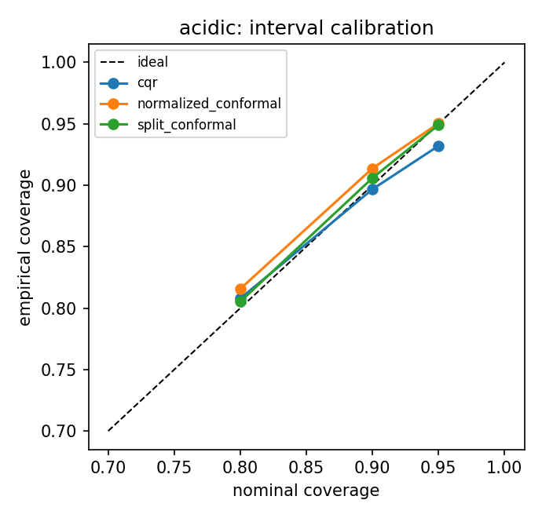
Figure 1. Interval calibration for the acidic task: empirical versus nominal coverage for the three conformal methods (the dashed line is ideal calibration).
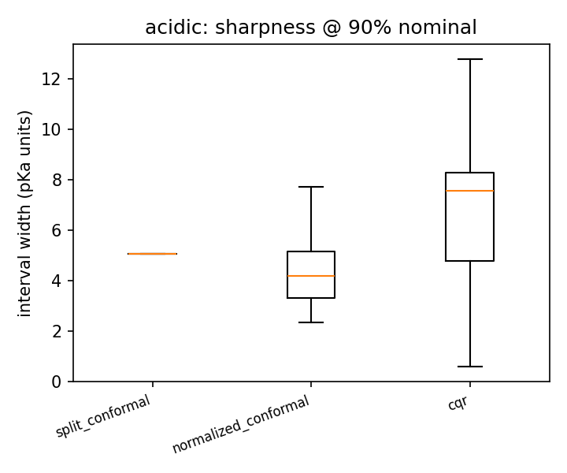
Figure 2. Interval sharpness for the acidic task: width distributions at the 90 % nominal level. Normalized conformal is sharpest at equal coverage.

The applicability domain separates reliable from unreliable predictions
Both AD measures classify roughly 94–95 % of test compounds as inside the domain, and both show that the excluded minority is predicted markedly worse (Table 4, Figure 3). Mean absolute error is 1.60× higher outside the kNN domain on the acidic task and 1.79× higher on the basic task; for the Tanimoto domain the out-of-domain penalty reaches 2.24× on the basic task. The coefficient of determination collapses correspondingly—for example, from 0.81 inside the basic kNN domain to 0.36 outside it. That two measures derived independently from descriptor distances and from structural fingerprints agree on which predictions are unreliable gives additional confidence in the flag.
Table 4. Accuracy inside versus outside each applicability domain (held-out test set).
Task | AD measure | % in-domain | MAE in | MAE out | MAE ratio | R² in | R² out
Acidic | kNN distance | 95.3 | 1.004 | 1.603 | 1.60 | 0.779 | 0.430
Acidic | Tanimoto | 94.9 | 1.003 | 1.590 | 1.59 | 0.776 | 0.595
Basic | kNN distance | 94.0 | 0.886 | 1.584 | 1.79 | 0.814 | 0.359
Basic | Tanimoto | 94.4 | 0.869 | 1.942 | 2.24 | 0.814 | 0.531
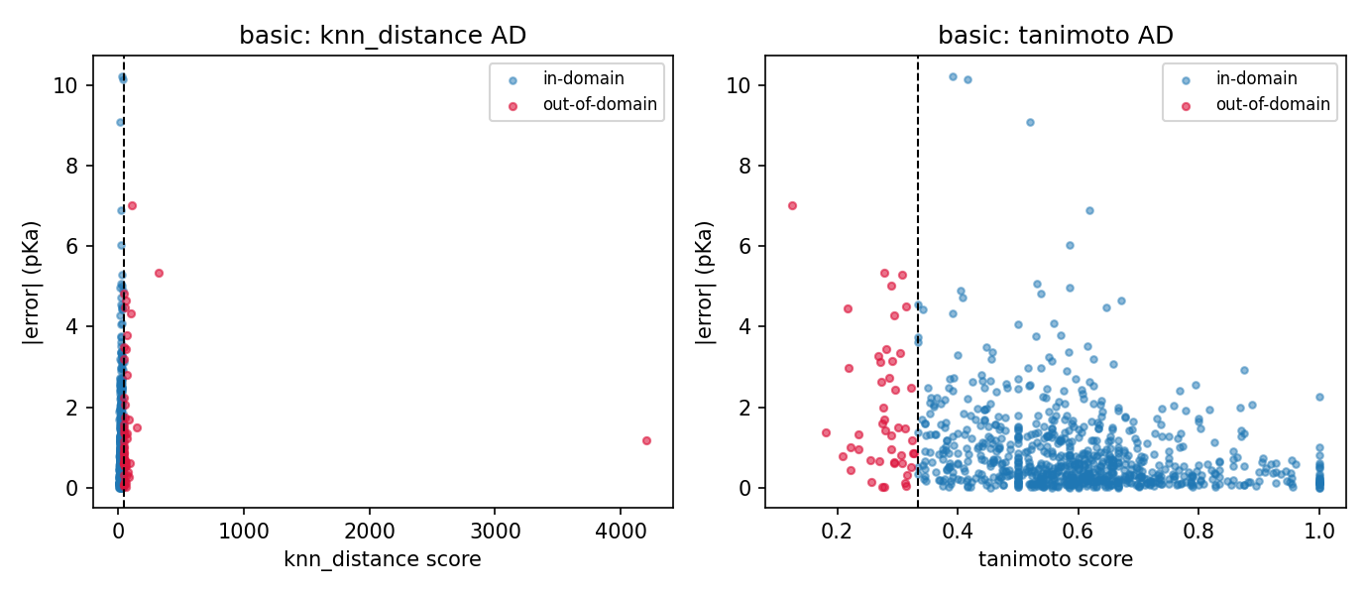
Figure 3. Applicability domain versus error (basic task): absolute prediction error against the AD score for the kNN-distance and Tanimoto measures. Out-of-domain compounds (red, beyond the dashed threshold) concentrate at high error.

Marginal intervals under-cover outside the domain
Because conformal coverage is marginal—averaged over all molecules—it can hide the fact that hard compounds are systematically under-covered. Stratifying the 90 %-nominal intervals by applicability domain makes this explicit (Table 5). On the basic task, split-conformal coverage falls from 89 % inside the Tanimoto domain to 62 % outside it; the locally adaptive intervals partly compensate by widening out-of-domain (coverage 70–77 % outside versus 91 % inside). The effect is present but milder on the acidic task, whose out-of-domain test compounds are less extreme. Together, Tables 4 and 5 show that the predictions flagged out-of-domain are exactly those where both accuracy and interval coverage degrade.
Table 5. Empirical coverage at the 90 % nominal level, inside versus outside the applicability domain.
Task | AD measure | Method | Coverage in | Coverage out
Acidic | kNN | Split | 0.911 | 0.806
Acidic | kNN | Normalized | 0.918 | 0.833
Acidic | Tanimoto | Split | 0.910 | 0.821
Acidic | Tanimoto | Normalized | 0.915 | 0.897
Basic | kNN | Split | 0.886 | 0.745
Basic | kNN | Normalized | 0.907 | 0.765
Basic | Tanimoto | Split | 0.893 | 0.617
Basic | Tanimoto | Normalized | 0.910 | 0.702

Interpretation
The results support three practical conclusions. First, attaching conformal prediction intervals to an existing XGBoost pKa model is straightforward and delivers intervals that meet their stated coverage on unseen data, turning a bare point estimate into an honest prediction-plus-reliability statement. Second, among the three interval methods, locally adaptive (normalized) conformal is the most attractive default: it matches the coverage guarantee of split conformal while producing visibly sharper intervals, because it routes interval width to the molecules the model finds difficult. Third, an explicit applicability domain is not a formality—out-of-domain compounds are substantially less accurate and are under-covered by marginal intervals, so flagging them is what keeps the reported reliability truthful. A practitioner would therefore use in-domain predictions together with the conformal interval as a realistic error bar, while treating out-of-domain predictions as low-confidence and ideally confirming them experimentally or with a more expensive method.

Limitations and future work
The most important limitation is that all evaluation is in-distribution: both the calibration and the test compounds are drawn from the same dataset and split. Conformal coverage guarantees assume exchangeability between calibration and test data, which holds here but would not for a genuinely external set drawn from different chemistry or measurement conditions^{8,9}. The strongest single addition to this work is therefore to score the same intervals and applicability domains on external pKa benchmarks and quantify how coverage degrades under distribution shift and whether the AD correctly flags external compounds as out-of-domain. Other extensions include conditional (Mondrian) conformal prediction to target coverage within subgroups rather than only marginally¹², a leverage- or Mahalanobis-based applicability domain as a third independent measure⁷, and recalibrating the descriptor model itself rather than only quantifying its uncertainty. We also note that the descriptor model's accuracy plateaus near R² ≈ 0.83; the reliability layer reports that ceiling honestly rather than removing it.

Conclusions
This study equipped an existing XGBoost pKa model with a reproducible reliability layer—calibrated, distribution-free prediction intervals and an explicit applicability domain built from two independent measures—and evaluated it on strictly held-out data. The main findings are:
All three conformal methods (split, normalized, and conformalized quantile regression) achieved their nominal coverage on the held-out test set for both acidic and basic pKa.
Locally adaptive (normalized) conformal was the sharpest method at equal coverage, producing the narrowest median intervals by widening only for difficult compounds.
Both applicability-domain measures flagged the same ~5–6 % of test compounds as out-of-domain, and these compounds had 1.6–2.2× higher mean absolute error.
Marginal intervals systematically under-covered out-of-domain compounds (coverage falling to 62–77 % at the 90 % level), confirming that the applicability-domain flag identifies genuinely unreliable predictions.
Without changing the underlying model, these additions let a practitioner know not only what the model predicts but how much to trust each prediction—a small but consequential step toward dependable machine-learning models for molecular property prediction. The complete pipeline is released as an open, documented, CPU-only package that regenerates every table and figure in this paper with a single command.

Affiliations and Author Details
Undergraduate Author (corresponding). Fahad Ali Atwi – Department of Chemical Engineering, King Fahd University of Petroleum & Minerals, Dhahran 31261, Saudi Arabia; ORCID 0009-0003-7015-9092. Email: s202283300@kfupm.edu.sa.

Acknowledgements
The author thanks Dr. Mohammed Al-Khater for mentorship and for the foundational pKa modeling work on which this study builds, and acknowledges the support provided by the King Fahd University of Petroleum and Minerals, Dhahran, Saudi Arabia. The author also acknowledges the developers of the open-source software packages used in this study, including RDKit, Mordred, XGBoost, scikit-learn, and DataWarrior.

Funding
This research received no specific grant from any funding agency in the public, commercial, or not-for-profit sectors; institutional support is acknowledged above.

Conflicts of Interest
The author declares no conflicts of interest.

Data and Code Availability
The pKa datasets analysed in this study are openly available as part of the Mansouri/DataWarrior curation¹. The complete pipeline is released as a small, documented, CPU-only Python package; a single command regenerates every table and figure in this paper from the open data: python -m sota_pka.uq.cli run --task all. The code, unit tests, and per-compound outputs (predictions, ensemble uncertainties, applicability-domain scores, and all three interval bands) are available at [GitHub URL — FILL BEFORE SUBMISSION]. The pipeline depends only on widely available open-source libraries (RDKit, Mordred, XGBoost, scikit-learn, NumPy, pandas, and Matplotlib) and completes in roughly two minutes on a laptop CPU.

References
(1) Mansouri, K. et al. Open-source QSAR models for pKa prediction using multiple machine learning approaches. J. Cheminform. 11, 60 (2019).
(2) Chen, T. & Guestrin, C. XGBoost: a scalable tree boosting system. Proc. 22nd ACM SIGKDD Int. Conf. Knowl. Discov. Data Min. 785–794 (2016).
(3) Atwi, F. A. & Al-Khater, M. XGBoost-based prediction of pKa values from molecular descriptors. J. Undergrad. Res. Int. (2026).
(4) Moriwaki, H., Tian, Y.-S., Kawashita, N. & Takagi, T. Mordred: a molecular descriptor calculator. J. Cheminform. 10, 4 (2018).
(5) Landrum, G. RDKit: open-source cheminformatics. https://www.rdkit.org (2024).
(6) Tropsha, A. Best practices for QSAR model development, validation, and exploitation. Mol. Inform. 29, 476–488 (2010).
(7) Sahigara, F. et al. Comparison of different approaches to define the applicability domain of QSAR models. Molecules 17, 4791–4810 (2012).
(8) Vovk, V., Gammerman, A. & Shafer, G. Algorithmic Learning in a Random World (Springer, 2005).
(9) Lei, J., G'Sell, M., Rinaldo, A., Tibshirani, R. J. & Wasserman, L. Distribution-free predictive inference for regression. J. Am. Stat. Assoc. 113, 1094–1111 (2018).
(10) Angelopoulos, A. N. & Bates, S. A gentle introduction to conformal prediction and distribution-free uncertainty quantification. Preprint at https://arxiv.org/abs/2107.07511 (2021).
(11) Cortés-Ciriano, I. & Bender, A. Concepts and applications of conformal prediction in computational drug discovery. Preprint at https://arxiv.org/abs/1908.03569 (2019).
(12) Norinder, U., Carlsson, L., Boyer, S. & Eklund, M. Introducing conformal prediction in predictive modeling: a transparent and flexible alternative to applicability domain determination. J. Chem. Inf. Model. 54, 1596–1603 (2014).
(13) Romano, Y., Patterson, E. & Candès, E. J. Conformalized quantile regression. In Advances in Neural Information Processing Systems 32 (2019).
(14) Rogers, D. & Hahn, M. Extended-connectivity fingerprints. J. Chem. Inf. Model. 50, 742–754 (2010).
(15) Pedregosa, F. et al. Scikit-learn: machine learning in Python. J. Mach. Learn. Res. 12, 2825–2830 (2011).

Undergraduate Author, Department of __________, King Fahd University of Petroleum & Minerals, Dhahran 31261, Saudi Arabia. (*Corresponding Author; Email: u20*******@kfupm.edu.sa; ORCID XXXX-XXXX-XXXX-XXXX).
Research Mentor, Professor, Department of __________, King Fahd University of Petroleum & Minerals, Dhahran 31261, Saudi Arabia. (Email: author.email@kfupm.edu.sa; ORCID XXXX-XXXX-XXXX-XXXX).

