XGBoost-Based Prediction of pKa Values from Molecular Descriptors
Fahad Atwi *, Moayad Alnammi , Mohammed Al-Khater ’*

Abstract
The acid dissociation constant (pKa) is a fundamental physicochemical property that governs molecular ionization, solubility, and bioavailability, making its accurate prediction essential for drug design and environmental toxicology. This study presents a systematic comparison of molecular descriptor representations for pKa prediction using XGBoost regression. Four descriptor categories were evaluated: Morgan circular fingerprints (extended-connectivity fingerprints, ECFP) with varying radii (1–4) and bit lengths (12–16,384), MACCS structural keys, physicochemical descriptors (molecular weight, LogP, rotatable bonds, fragment counts), and combined representations. A comprehensive grid search optimized XGBoost hyperparameters across all configurations using five-fold cross-validation on a curated dataset of 7,912 compounds with experimental pKa values obtained from DataWarrior. Morgan fingerprints at radius 2 with 16,384 bits achieved the highest standalone performance (test R² = 0.795, RMSE = 1.539), while combining Morgan fingerprints (radius 1, 2,048 bits) with MACCS keys and physicochemical descriptors yielded the best overall result (test R² = 0.817, RMSE = 1.455). An extended analysis employing 1,135 Mordred and RDKit descriptors with XGBoost feature selection further improved prediction accuracy (test R² = 0.829, RMSE = 1.404). Feature importance analysis identified the number of acidic groups (nAcid), spectral descriptors, and aromatic amine fragments as the most influential predictors. These results demonstrate that multi-source descriptor fusion consistently outperforms individual representations and that XGBoost provides a computationally efficient and interpretable framework for pKa modeling.
Keywords: pKa prediction, XGBoost, molecular fingerprints, Morgan fingerprints, MACCS keys, QSAR, molecular descriptors.

Introduction
The acid dissociation constant (pKa) quantifies the tendency of a molecule to donate a proton in aqueous solution and is one of the most critical physicochemical properties in medicinal chemistry, environmental science, and chemical engineering. ¹ Because pKa governs molecular charge state at physiological pH, it directly influences drug absorption, distribution, metabolism, excretion, and toxicity (ADMET) profiles. Accurate pKa values are therefore indispensable during lead optimization in pharmaceutical development and for predicting the environmental fate of organic pollutants.
Experimental determination of pKa by potentiometric titration or spectrophotometric methods, although reliable, is time-consuming and resource-intensive, particularly when screening large compound libraries. Consequently, computational approaches for pKa prediction have attracted sustained research interest over the past two decades. Empirical methods based on linear free-energy relationships (LFERs) were among the earliest strategies, but their applicability is often restricted to structurally similar compound series. ² Quantum-mechanical (QM) approaches, including density functional theory (DFT) combined with continuum solvation models, offer higher accuracy but remain computationally prohibitive for large-scale virtual screening. ^{3,4}
Machine learning (ML) methods have emerged as an attractive compromise between accuracy and computational cost. Quantitative structure–activity relationship (QSAR) models trained on molecular descriptors or fingerprints can rapidly predict pKa for thousands of compounds once a robust training set is available. ^{1,5} Among ML algorithms, gradient boosting methods—particularly XGBoost—have demonstrated competitive performance across diverse molecular property prediction tasks. ^{6,7} XGBoost employs regularized gradient boosting of decision trees, incorporating both L1 and L2 regularization terms that mitigate overfitting while maintaining predictive power, making it especially well-suited for high-dimensional descriptor spaces common in cheminformatics. ⁶
The choice of molecular representation profoundly affects QSAR model performance. Binary fingerprints—such as Morgan (extended-connectivity) fingerprints ⁸ and MACCS structural keys ⁹—encode substructural information as fixed-length bit vectors and have been widely used in similarity searching and property prediction. Continuous physicochemical descriptors computed from molecular graphs (e.g., molecular weight, polar surface area, partition coefficients) capture complementary global properties. More recently, comprehensive descriptor calculators such as Mordred ¹⁰ and PaDEL have enabled the generation of thousands of descriptors per molecule, raising questions about optimal feature selection strategies. Despite this wealth of descriptor options, systematic comparisons of representation types for pKa prediction using modern gradient boosting frameworks remain limited.
Mansouri et al. ¹ established an important benchmark by developing open-source pKa prediction models using support vector machines, XGBoost, and deep neural networks on a curated dataset of 7,912 compounds from DataWarrior. ¹¹ Their models achieved RMSE values around 1.5 pKa units on external test sets, comparable to commercial software packages. Yang et al. ¹² applied XGBoost with structural and physical–organic-parameter-based descriptors (SPOC) to predict pKa across 39 solvents, achieving a mean absolute error (MAE) of 0.87 pKa units. Graph-based neural network approaches such as MolGpKa ¹³ have also shown promise for pKa prediction. However, the relative contributions of different descriptor types—fingerprints versus continuous descriptors, and their combinations—to XGBoost-based pKa models have not been comprehensively evaluated.
The present study addresses this gap by conducting a systematic comparison of four molecular descriptor categories for pKa prediction using XGBoost regression: (i) Morgan circular fingerprints with varying radii and bit lengths, (ii) MACCS structural keys, (iii) a set of physicochemical descriptors and fragment counts, and (iv) combined multi-source descriptor vectors. A grid search of XGBoost hyperparameters with five-fold cross-validation was performed for each configuration. Furthermore, an extended analysis employing 1,135 Mordred and RDKit descriptors was conducted to assess the potential of high-dimensional descriptor spaces. The objectives were to determine which descriptor representation yields the best pKa prediction, to quantify the benefit of descriptor fusion, and to identify the most informative molecular features through XGBoost feature importance analysis.

Methodology

Dataset
Experimental pKa values for 7,912 organic compounds were obtained from the DataWarrior software package, ¹¹ which aggregates data from multiple public repositories. This dataset, originally curated by Mansouri et al., ¹ includes the strongest acidic pKa for each compound measured in aqueous solution at 25 °C. Chemical structures were represented as Simplified Molecular Input Line Entry System (SMILES) strings. Prior to descriptor computation, salt forms were removed using a custom salt-removal protocol based on the RDKit SaltRemover module ¹⁴ with a curated salt definition file. Molecules that could not be parsed by RDKit or that yielded invalid molecular objects after salt removal were excluded, resulting in a final working dataset. For the fingerprint comparison experiments (Sections 2.2–2.5), this dataset was split into 75% training and 25% test sets using a random partition (random_state = 11) to ensure reproducibility.

Morgan Circular Fingerprints
Morgan fingerprints, also known as extended-connectivity fingerprints (ECFP), ⁸ were generated using the RDKit library. ¹⁴ Each fingerprint encodes substructural environments around every atom up to a specified radius, hashed into a fixed-length bit vector. To evaluate the effect of fingerprint parameters on predictive performance, a comprehensive grid was constructed over four radii (1, 2, 3, and 4) and ten bit lengths (12, 64, 128, 256, 512, 1,024, 2,048, 4,096, 8,192, and 16,384), yielding 40 distinct fingerprint configurations.

MACCS Structural Keys
MACCS (Molecular ACCess System) keys ⁹ are a set of 166 predefined binary structural keys indicating the presence or absence of specific substructural patterns (e.g., aromatic rings, functional groups, ring sizes). Unlike Morgan fingerprints, MACCS keys do not require parameter tuning, as the key definitions are fixed. MACCS fingerprints were generated for all valid molecules using the RDKit MACCSkeys module. ¹⁴

Physicochemical Descriptors
A set of five continuous molecular descriptors and fragment counts was computed for each molecule using RDKit: ¹⁴ molecular weight (MolWt), calculated octanol–water partition coefficient (MolLogP), number of rotatable bonds (NumRotatableBonds), count of aliphatic hydroxyl groups (fr_Al_OH), and count of aromatic nitrogen atoms (fr_Ar_N). These descriptors were selected to capture fundamental size, lipophilicity, flexibility, and functional-group properties relevant to acid–base equilibria.

Combined Descriptor Vectors
For each of the 40 Morgan fingerprint configurations, a combined feature vector was constructed by concatenating the Morgan fingerprint with the 166-bit MACCS key vector and the five continuous descriptors, resulting in combined vectors of dimension (Morgan size + 171). This experimental design allowed the assessment of whether multi-source descriptor fusion improves pKa prediction relative to individual descriptor types.

Extended Descriptor Analysis
In a separate analysis, a comprehensive set of molecular descriptors was computed for an independent subset of the data (Opt2 acidic partition: 2,293 training and 765 test compounds with pre-defined splits from DataWarrior). Three descriptor families were calculated: (i) all 210 RDKit 2D descriptors, ¹⁴ (ii) 85 RDKit fragment counts (fr_* functions), and (iii) approximately 1,800 Mordred 2D descriptors. ¹⁰ After removing zero-variance columns, converting all values to numeric format, and dropping rows with missing values, the final descriptor matrix contained 1,135 features. This high-dimensional representation was used to train an XGBoost model with the same hyperparameters as described in Section 2.7, and to extract feature importances for chemical interpretation.

XGBoost Model Training and Evaluation
All models were trained using XGBoost ⁶ with the squared-error regression objective (reg:squarederror). For the fingerprint comparison experiments, hyperparameter optimization was performed via exhaustive grid search with five-fold cross-validation using scikit-learn’s GridSearchCV. ¹⁵ The search space included: n_estimators = {300}, max_depth = {3, 6}, learning_rate = {0.1, 0.2}, subsample = {0.8}, colsample_bytree = {0.8, 1.0}, and reg_lambda = {1, 5}. The best model from cross-validation was evaluated on the held-out test set. For the extended descriptor analysis, fixed hyperparameters were employed (n_estimators = 300, max_depth = 6, learning_rate = 0.1, subsample = 0.8, colsample_bytree = 0.8, reg_lambda = 1) following published guidelines for gradient boosting in QSAR. ⁷ Model performance was assessed using the coefficient of determination (R²), root-mean-squared error (RMSE), and mean absolute error (MAE) on both training and test sets. Feature importances were extracted from the trained XGBoost model using the gain-based importance metric.

Results and Discussion

Effect of Morgan Fingerprint Parameters
The predictive performance of Morgan fingerprints varied substantially with both radius and bit length. Figure 1 illustrates the relationship between fingerprint bit length and test R² for each radius. At the smallest bit length tested (12 bits), all radii produced poor models (test R² < 0.20), reflecting severe information loss due to hash collisions. Performance increased monotonically with bit length up to approximately 2,048–4,096 bits, beyond which gains plateaued. Radius 2 consistently outperformed other radii at higher bit lengths, achieving the best individual Morgan fingerprint result: test R² = 0.795, RMSE = 1.539 at 16,384 bits. This finding is consistent with the observation that ECFP4 (radius 2) captures a balance between local atomic environments and broader substructural context. ⁸
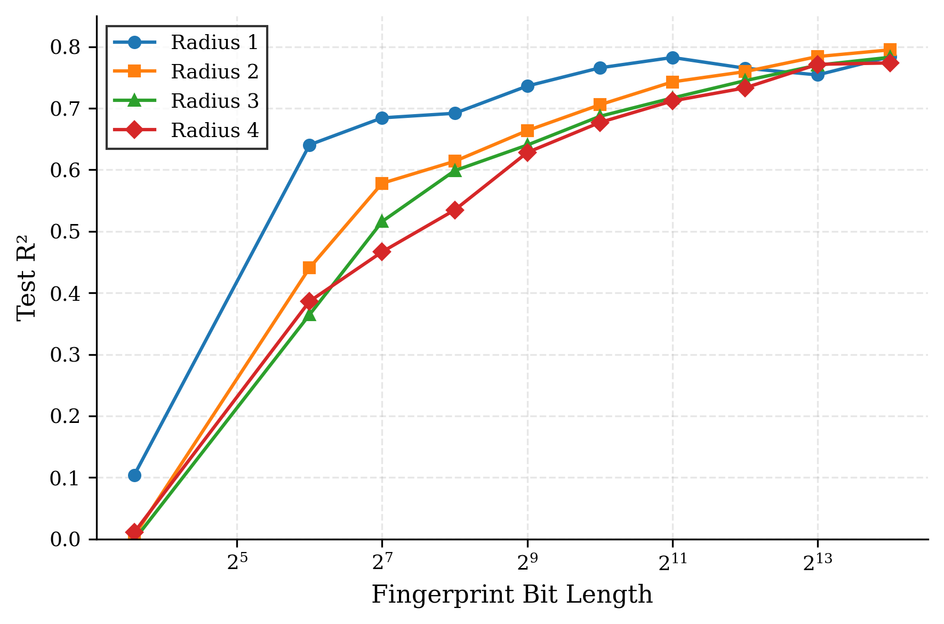
Figure 1. Effect of Morgan fingerprint bit length on test R² for radii 1–4. Performance increases with bit length and plateaus beyond 2,048 bits, with radius 2 achieving the highest accuracy.
Figure 7 presents a heatmap of test R² values across the full radius–bit length grid. A clear pattern emerged: radii 1 and 2 generally outperformed radii 3 and 4 at equivalent bit lengths. This is attributable to the fact that larger radii encode increasingly specific substructural environments, which may introduce noise and reduce generalizability when the training set does not contain sufficient structural diversity. At the same time, very small bit lengths (12–64 bits) were consistently inadequate regardless of radius, confirming that fingerprint dimensionality is a critical design parameter.
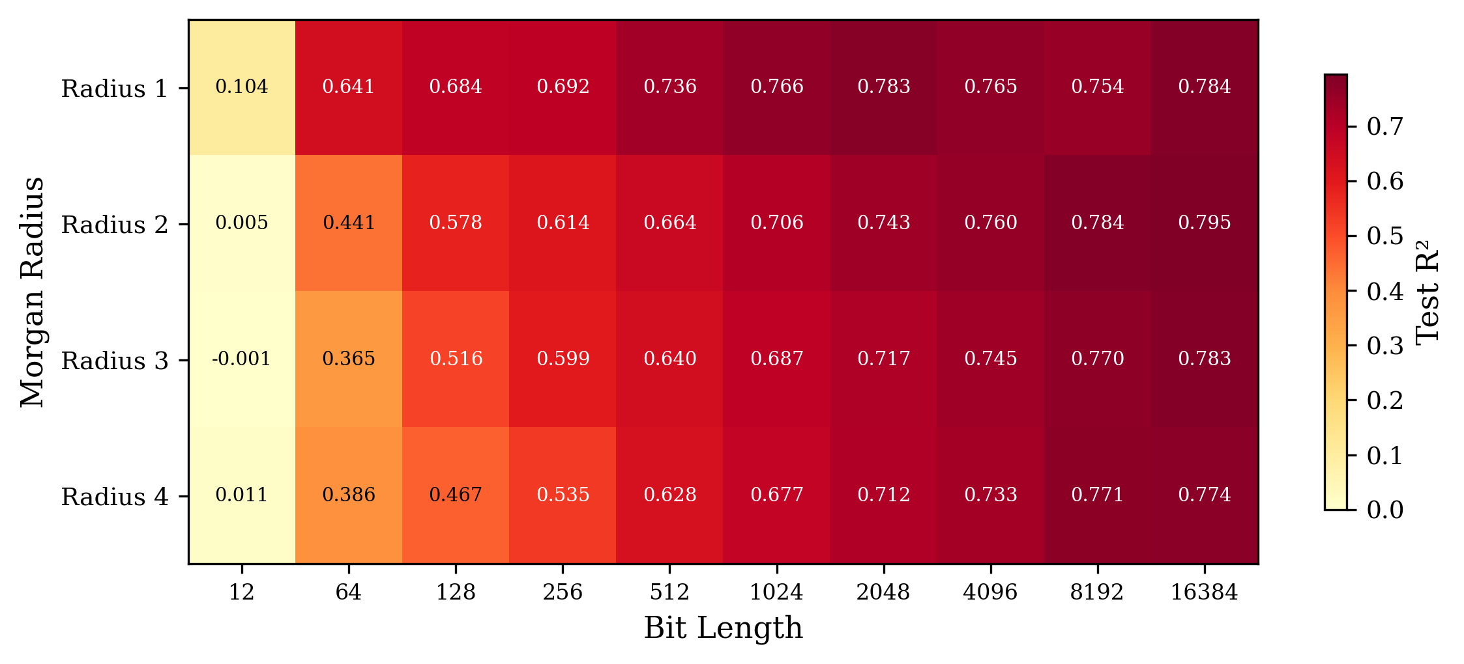
Figure 7. Heatmap of Morgan fingerprint test R² across all radius and bit-length combinations. Higher performance (darker shading) is concentrated at radius 1–2 with bit lengths ≥ 1,024.

Comparison Across Descriptor Types
Table 1 summarizes the best-performing model within each descriptor category. The five continuous physicochemical descriptors alone yielded a test R² of only 0.159 (RMSE = 3.117), indicating that this minimal feature set is wholly insufficient for pKa prediction across a structurally diverse compound library. This result underscores the importance of substructural information for capturing the electronic and steric factors that govern acid–base equilibria. MACCS keys (166 bits) produced a markedly better test R² of 0.780 (RMSE = 1.596), demonstrating the utility of predefined structural keys despite their modest dimensionality. The best Morgan fingerprint configuration (radius 2, 16,384 bits) slightly outperformed MACCS with a test R² of 0.795, attributable to its data-driven encoding of circular substructures rather than a fixed key set. ^{8,9}
Table 1. Performance comparison of XGBoost models across descriptor categories.
Descriptor Type | Features | Train R² | Test R² | MAE | RMSE
Continuous descriptors | 5 | 0.850 | 0.159 | 2.385 | 3.117
MACCS keys | 166 | 0.977 | 0.780 | 1.056 | 1.596
Morgan FP (best) | 16384 | 0.961 | 0.795 | 1.040 | 1.539
Combined (best) | 2219 | 0.995 | 0.817 | 0.913 | 1.454
Full descriptors | 1,135 | 0.9998 | 0.829 | 0.887 | 1.404
The combined descriptor vectors consistently outperformed their individual components. The best combined configuration (Morgan radius 1, 2,048 bits + MACCS + continuous) achieved test R² = 0.817 (RMSE = 1.454), representing a 2.8% improvement over the best individual Morgan fingerprint. This result corroborates previous findings that heterogeneous descriptor fusion captures complementary structural information. ^{5,7} Figure 2 provides a visual comparison of training and test R² across all five model categories.
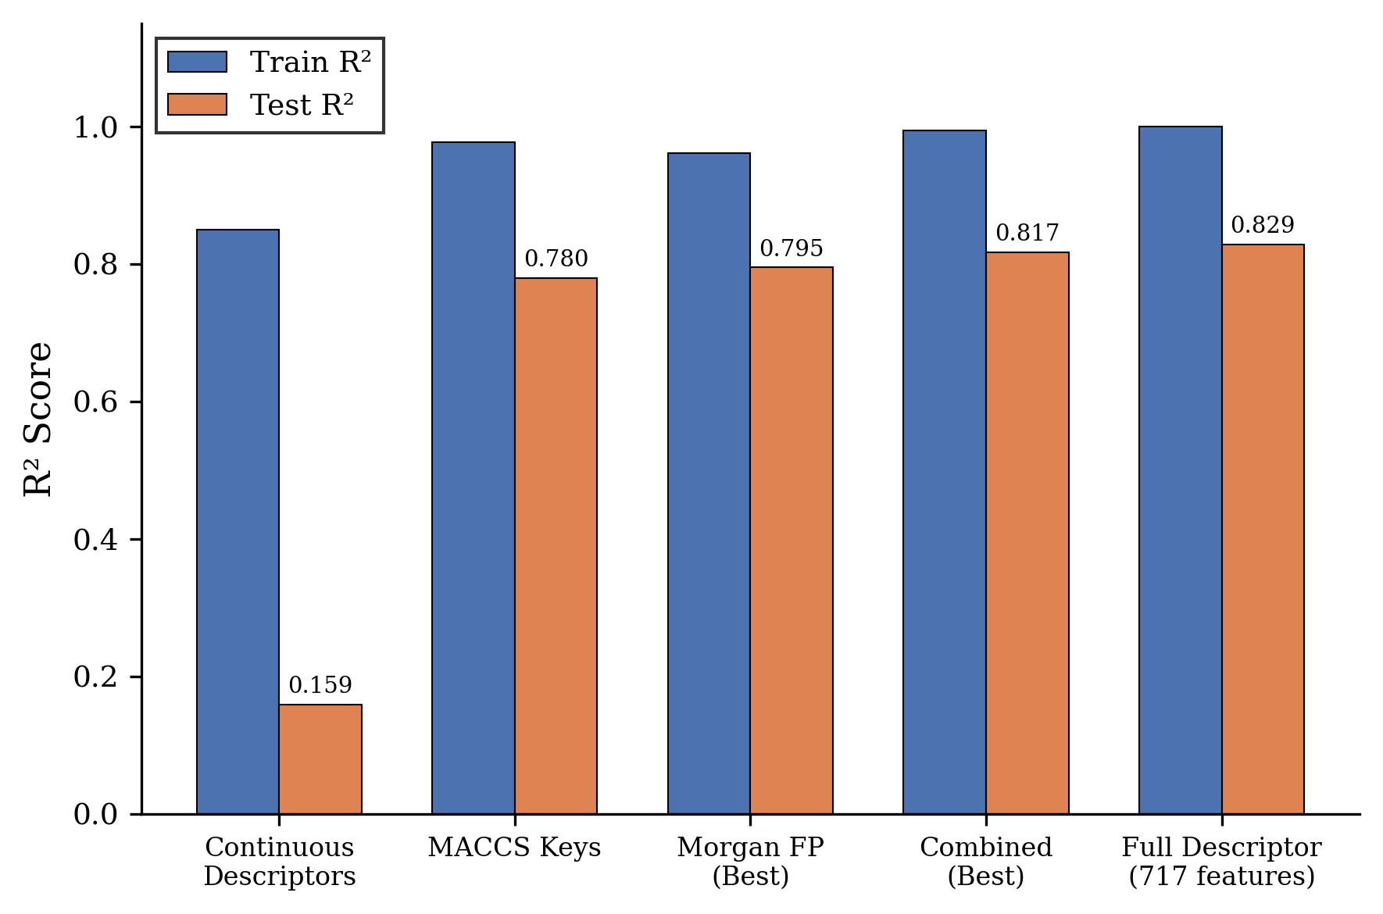
Figure 2. Comparison of train and test R² across descriptor categories. Combined and full-descriptor models achieve the highest test performance.

Predicted Versus Experimental pKa
Figure 3 presents scatter plots of predicted versus experimental pKa values for the full-descriptor XGBoost model on both training and test sets. The training set (n = 2293) exhibited near-perfect fit (R² = 0.9998, RMSE = 0.047), while the test set (n = 765) showed good generalization (R² = 0.829, RMSE = 1.404). The scatter around the diagonal identity line was relatively uniform across the pKa range of −3 to 14, suggesting that the model does not exhibit systematic bias toward any particular pKa region.
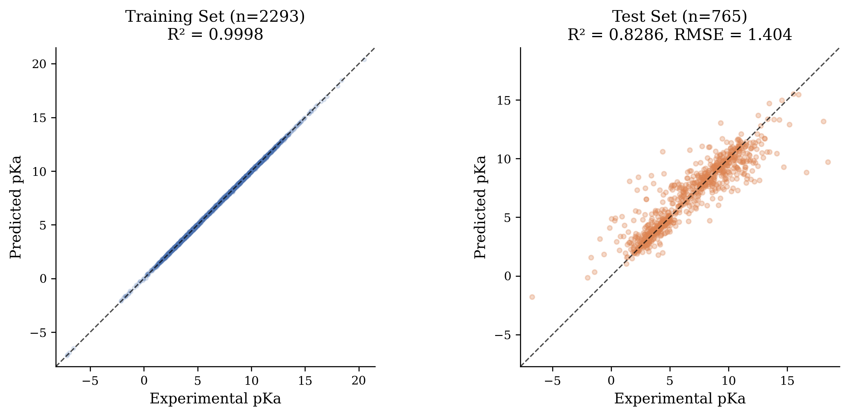
Figure 3. Predicted versus experimental pKa for the full-descriptor XGBoost model. (a) Training set (n = 2293). (b) Test set (n = 765). The dashed line represents perfect prediction.

Overfitting Analysis
The gap between training and test R² was examined as an indicator of overfitting. Figure 5 plots this gap for Morgan fingerprint models across all radii and bit lengths. Models with max_depth = 6 exhibited larger train–test gaps (up to 0.20 R² units) compared to max_depth = 3, consistent with the known tendency of deeper trees to memorize training data. ⁶ Nevertheless, the regularization provided by XGBoost (L2 penalty via reg_lambda) prevented catastrophic overfitting even at high dimensionalities. The full-descriptor model showed the largest absolute train–test gap (train R² = 0.9998 vs. test R² = 0.829), suggesting that with 1,135 features and 2,293 training samples, some degree of overfitting is inevitable. Future work should explore additional regularization strategies (e.g., feature selection or ensemble averaging) to narrow this gap.
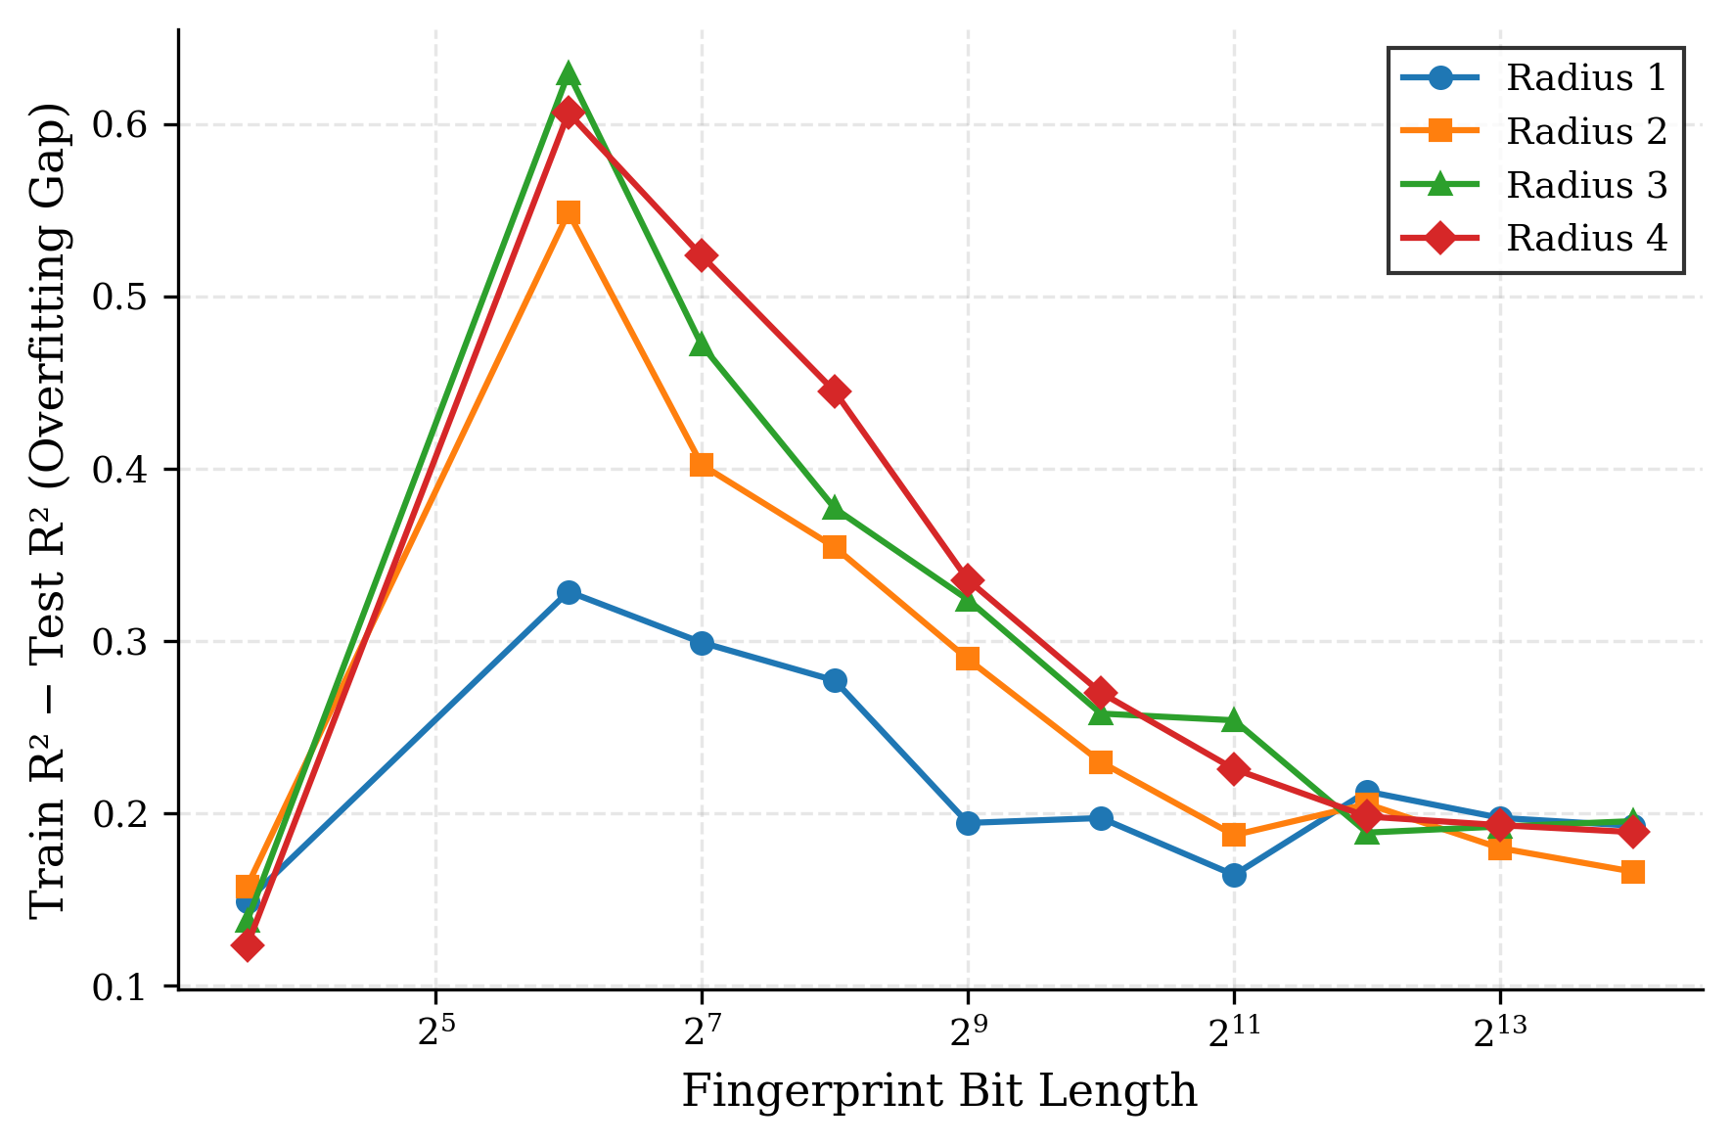
Figure 5. Overfitting gap (train R² − test R²) for Morgan fingerprint models as a function of bit length and radius.

Feature Importance Analysis
Feature importances extracted from the full-descriptor XGBoost model provide chemical insight into the structural drivers of pKa variation (Figure 4). The most important feature was nAcid (importance = 0.176), a Mordred descriptor counting the number of acidic functional groups in the molecule. This is chemically intuitive: the presence and number of acidic groups directly determine the pKa landscape. The second-ranked feature, SpAbs_Dzpe (importance = 0.049), is a spectral descriptor related to Barysz-weighted electronegativity, capturing electronic distribution patterns. The third most important feature, fr_Ar_NH (importance = 0.029), counts aromatic amine groups, which are well-known weak acids.
Other highly ranked features included nHBAcc (hydrogen-bond acceptor count, importance = 0.022), phenolic hydroxyl groups (fr_phenol, 0.019), and MaxPartialCharge (0.015). This feature importance profile is consistent with chemical theory: molecular acidity is primarily governed by the presence of ionizable functional groups, the electronic environment around those groups (partial charges, electronegativity), and intramolecular hydrogen bonding. ² Table 2 lists the top ten features.
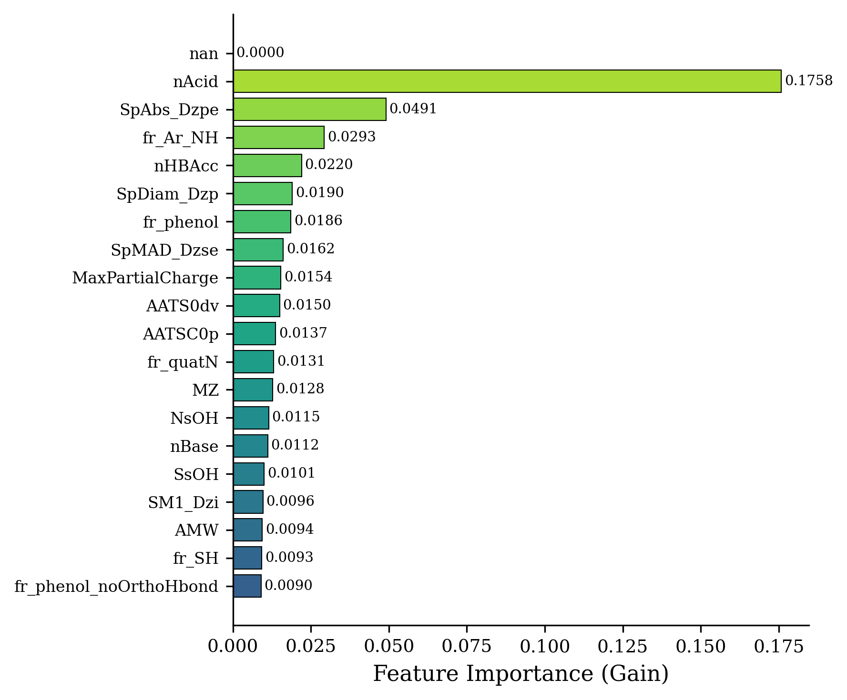
Figure 4. Top 20 feature importances (gain metric) from the full-descriptor XGBoost model. Acidic group count (nAcid) dominates, followed by spectral and functional-group descriptors.
Table 2. Top ten molecular descriptors ranked by XGBoost feature importance (gain metric).
Rank | Descriptor | Importance | Description
1 | nAcid | 0.176 | Number of acidic groups
2 | SpAbs_Dzpe | 0.049 | Spectral Barysz electronegativity
3 | fr_Ar_NH | 0.029 | Aromatic amine count
4 | nHBAcc | 0.022 | H-bond acceptor count
5 | SpDiam_Dzp | 0.019 | Spectral Barysz polarizability
6 | fr_phenol | 0.019 | Phenol group count
7 | SpMAD_Dzse | 0.016 | Spectral distance descriptor
8 | MaxPartialCharge | 0.015 | Maximum partial charge
9 | AATS0dv | 0.015 | Moreau–Broto autocorrelation
10 | AATSC0p | 0.014 | Centred Moreau–Broto polarizability

Residual Analysis
Figure 6 presents the residual distribution and residuals-versus-predicted plot for the full-descriptor model on the test set. The residual histogram is approximately symmetric around zero, with a slight positive skew. The majority of predictions (>80%) fall within ±2 pKa units of the experimental value. The residuals-versus-predicted plot shows no strong systematic pattern, although larger absolute residuals are observed at extreme pKa values (below −1 and above 12), where training data density is lower. These observations suggest that the model’s prediction errors are largely random rather than systematic, and that performance could be improved by augmenting the training set in the extreme pKa ranges.
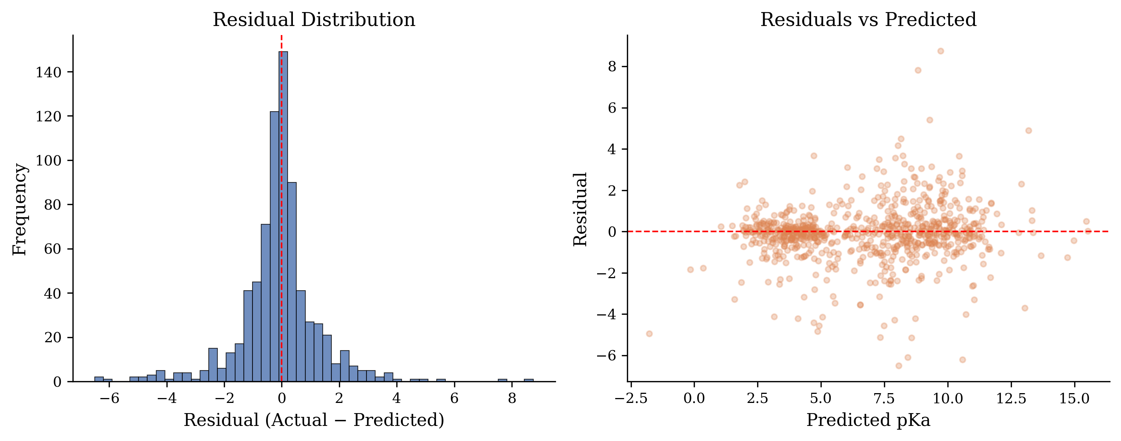
Figure 6. Residual analysis for the full-descriptor XGBoost model on the test set. (a) Histogram of residuals. (b) Residuals plotted against predicted pKa values.

Comparison with Literature
The results of this study are consistent with the findings of Mansouri et al., ¹ who reported RMSE values around 1.5 pKa units for XGBoost models trained on the same DataWarrior dataset. The present combined-fingerprint model (RMSE = 1.454) and full-descriptor model (RMSE = 1.404) both fall within this range. Yang et al. ¹² achieved a lower MAE of 0.87 pKa units using solvent-specific SPOC descriptors, but their study was restricted to a smaller, more homogeneous dataset. Sanchez et al. ⁴ achieved high accuracy by combining DFT-computed features with molecular fragmentation descriptors, albeit at substantially higher computational cost than the purely descriptor-based approach presented here. The results demonstrate that purely 2D descriptor-based XGBoost models provide a favorable balance of accuracy, interpretability, and computational efficiency for large-scale pKa prediction.

Conclusions
This study systematically evaluated the performance of four molecular descriptor categories for pKa prediction using XGBoost regression on a curated dataset of 7,912 compounds. The following conclusions were drawn:
Morgan circular fingerprints at radius 2 with 16,384 bits achieved the best standalone fingerprint performance (test R² = 0.795, RMSE = 1.539), while bit lengths below 128 proved insufficient for accurate prediction regardless of radius. MACCS structural keys (166 bits) provided competitive performance (test R² = 0.780) relative to their low dimensionality. Continuous physicochemical descriptors alone were inadequate (test R² = 0.159), confirming the necessity of substructural information. The combination of Morgan fingerprints, MACCS keys, and physicochemical descriptors consistently outperformed individual representations, with the best combined model achieving test R² = 0.817 (RMSE = 1.454). An extended analysis with 1,135 Mordred and RDKit descriptors further improved prediction accuracy to test R² = 0.829 (RMSE = 1.404). Feature importance analysis revealed that acidic group count, spectral electronegativity descriptors, and aromatic amine fragments were the most influential predictors, aligning with established chemical theory of acid–base equilibria.
These findings demonstrate that descriptor fusion is a simple yet effective strategy for improving pKa prediction accuracy, and that XGBoost offers a computationally efficient and interpretable framework suitable for large-scale virtual screening. Future work should explore the application of these models to external validation sets, the integration of three-dimensional molecular descriptors, and the comparison with graph neural network approaches to further advance the field.

Acknowledgements
The authors acknowledge the support provided by King Fahd University of Petroleum and Minerals, Dhahran, Saudi Arabia. The authors also acknowledge the developers of the open-source software packages used in this work, including RDKit, Mordred, XGBoost, scikit-learn, and DataWarrior.

References
1. Mansouri, K. et al. Open-source QSAR models for pKa prediction using multiple machine learning approaches. J. Cheminform. 11, 60 (2019).
2. Göller, A. H. The art of atom descriptor design. Drug Discov. Today Technol. 32–33, 37–43 (2020).
3. Lawler, R. et al. DFT–Machine learning approach for accurate prediction of pKa. J. Phys. Chem. A 125, 8712–8722 (2021).
4. Sanchez, A. J., Maier, S. & Raghavachari, K. Leveraging DFT and molecular fragmentation for chemically accurate pKa prediction using machine learning. J. Chem. Inf. Model. 64, 712–723 (2024).
5. Tropsha, A. Best practices for QSAR model development, validation, and exploitation. Mol. Inform. 29, 476–488 (2010).
6. Chen, T. & Guestrin, C. XGBoost: A scalable tree boosting system. Proc. 22nd ACM SIGKDD Int. Conf. Knowl. Discov. Data Min. 785–794 (2016).
7. Boldini, D. et al. Practical guidelines for the use of gradient boosting for molecular property prediction. J. Cheminform. 15, 73 (2023).
8. Rogers, D. & Hahn, M. Extended-connectivity fingerprints. J. Chem. Inf. Model. 50, 742–754 (2010).
9. Durant, J. L., Leland, B. A., Henry, D. R. & Nourse, J. G. Reoptimization of MDL keys for use in drug discovery. J. Chem. Inf. Comput. Sci. 42, 1273–1280 (2002).
10. Moriwaki, H., Tian, Y.-S., Kawashita, N. & Takagi, T. Mordred: a molecular descriptor calculator. J. Cheminform. 10, 4 (2018).
11. Sander, T., Freyss, J., von Korff, M. & Rufener, C. DataWarrior: an open-source program for chemistry aware data visualization and analysis. J. Chem. Inf. Model. 55, 460–473 (2015).
12. Yang, Q. et al. Holistic prediction of the pKa in diverse solvents based on a machine-learning approach. Angew. Chem. Int. Ed. 59, 19282–19291 (2020).
13. Pan, S. et al. MolGpKa: a web server for molecular pKa prediction using a graph-convolutional neural network. J. Chem. Inf. Model. 61, 3159–3165 (2021).
14. Landrum, G. RDKit: Open-source cheminformatics. https://www.rdkit.org (2024).
15. Pedregosa, F. et al. Scikit-learn: machine learning in Python. J. Mach. Learn. Res. 12, 2825–2830 (2011).

Undergraduate Author, Department of Chemical Engineering, King Fahd University of Petroleum & Minerals, Dhahran 31261, Saudi Arabia. (*Corresponding Author; Email: s202283300@kfupm.edu.sa; ORCID 0009-0003-7015-9092).
Research Mentor, Professor, Department of Information & Computer Science, King Fahd University of Petroleum & Minerals, Dhahran 31261, Saudi Arabia. (Email: moayad@kfupm.edu.sa; ORCID 0000-0001-6792-5348).
Research Mentor, Professor, Department of Chemical Engineering, King Fahd University of Petroleum & Minerals, Dhahran 31261, Saudi Arabia. (*Corresponding Author; Email: mfkhater@kfupm.edu.sa; ORCID 0000-0003-0926-4056).
Research Mentor, Researcher, Interdisciplinary Research Center for Refining & Advanced Chemicals, King Fahd University of Petroleum & Minerals, 31261 Dhahran, Saudi Arabia (*Corresponding Author; Email: mfkhater@kfupm.edu.sa; ORCID 0000-0003-0926-4056)

