XGBoost-Based Prediction of pKa Values Using Molecular Fingerprints and Physicochemical Descriptors: A Comparative Study of Descriptor Representations

Fahad Atwi^{1,*}, Moayad Alnammi², Amjad Aboras¹, Ayman Almutairi¹, Hamad Alduayj¹, Mohammed Al-Khater^{3,*}

¹ Department of Chemical Engineering, King Fahd University of Petroleum & Minerals, Dhahran 31261, Saudi Arabia
² Department of Information & Computer Science, King Fahd University of Petroleum & Minerals, Dhahran 31261, Saudi Arabia; ORCID: 0000-0001-6792-5348
³ Department of Chemical Engineering & Interdisciplinary Research Center for Refining & Advanced Chemicals, King Fahd University of Petroleum & Minerals, Dhahran 31261, Saudi Arabia
* Corresponding Authors: s202283300@kfupm.edu.sa (F. Atwi; ORCID: 0009-0003-7015-9092); mfkhater@kfupm.edu.sa (M. Al-Khater)

Abstract
The acid dissociation constant (pKa) is a fundamental physicochemical property that governs molecular ionization, thereby influencing solubility, lipophilicity, membrane permeability, and protein binding. Accurate pKa prediction is essential for drug design, environmental fate modeling, and chemical risk assessment; however, many existing predictive tools rely on proprietary algorithms with limited transparency. In this study, an interpretable machine learning framework based on Extreme Gradient Boosting (XGBoost) regression was developed for pKa prediction using a curated dataset of 7,912 organic compounds. Three categories of molecular representations were systematically compared: RDKit-derived physicochemical descriptors, 166-bit Molecular ACCess System (MACCS) structural keys, and Morgan circular fingerprints (Extended-Connectivity Fingerprints, ECFP) parameterized across radii of 1–4 and bit lengths of 64–16,384. A combined descriptor strategy integrating Morgan fingerprints with physicochemical descriptors was also evaluated. Fingerprint-based models substantially outperformed the continuous descriptor model (test R² = 0.16), with the optimal Morgan fingerprint configuration (radius 2, 16,384 bits) achieving a test R² of 0.795 and RMSE of 1.54 pKa units. Notably, the 166-bit MACCS keys attained comparable accuracy (R² = 0.780), demonstrating that a compact, interpretable fingerprint captures the majority of pKa-relevant structural information. The combined Morgan–physicochemical descriptor model yielded the highest predictive performance (R² = 0.817, RMSE = 1.45), and a refined descriptor subset further improved accuracy to R² ≈ 0.84 and RMSE ≈ 1.38. Feature importance analysis revealed that fingerprint bits encoding ionizable functional groups (carboxyl, amine, phenol) dominated model predictions, complemented by physicochemical descriptors such as topological polar surface area and calculated LogP. These results demonstrate that a well-tuned XGBoost model with appropriate molecular representations achieves accuracy comparable to proprietary tools while maintaining full interpretability and reproducibility through open-source software.
Keywords: pKa prediction, XGBoost, molecular descriptors, QSAR, Morgan fingerprints, MACCS keys, physicochemical properties, machine learning

1. Introduction
The acid dissociation constant (pKa) quantifies the tendency of a molecule to donate or accept a proton in aqueous solution and is one of the most important physicochemical parameters in chemistry and pharmaceutical science. The ionization state of a compound at physiological pH directly determines its lipophilicity and aqueous solubility, because ionized species are considerably more polar than their neutral counterparts [1, 2]. Membrane permeability is likewise governed by pKa, as only the un-ionized form of most drugs can passively diffuse across lipid bilayers [1]. Furthermore, the charge state of ionizable groups influences protein binding affinity, metabolic reactivity, and overall ADME (absorption, distribution, metabolism, excretion) behavior [1, 3]. Given these broad implications, accurate knowledge of pKa is indispensable for rational drug design, environmental fate modeling, and chemical hazard assessment. Experimental determination of pKa, however, is time-consuming and resource-intensive, motivating the development of reliable computational prediction methods [2, 4].
Historically, pKa prediction has been approached through physics-based and empirical strategies. Classical quantitative structure–property relationship (QSPR) models, including Hammett substituent constant approaches and linear free-energy relationships, were among the earliest methods applied to this problem [5]. Ab initio quantum-chemical calculations can achieve high accuracy for small molecules but become computationally prohibitive for large or structurally complex compounds [6]. In industrial practice, several proprietary software packages—notably ACD/Labs, ChemAxon’s Marvin, and Schrödinger’s Epik—have become standard tools for pKa estimation [1, 7]. Although these tools are effective, their reliance on closed-source algorithms and proprietary training data limits transparency and reproducibility, underscoring the need for open-source alternatives [1, 8].
The advent of large curated experimental databases and advances in machine learning (ML) have catalyzed a new generation of data-driven pKa models. Mansouri et al. [1] developed open-source QSAR models for the strongest acidic and basic pKa values of approximately 8,000 chemicals, comparing support vector machine/k-nearest neighbor hybrids, deep neural networks (DNNs), and Extreme Gradient Boosting (XGBoost). All three algorithms achieved root-mean-square errors (RMSE) of approximately 1.5 pKa units and coefficients of determination (R²) near 0.80 on external validation, on par with commercial predictors from ACD/Labs [1]. More recently, deep learning architectures have been explored for pKa prediction: graph neural network (GNN) models such as MolGpKa [9] and GR-pKa [10] operate directly on molecular graphs, while attention-based approaches including MF-SuP-pKa [11] incorporate multi-fidelity data to improve generalization. Although these methods push the accuracy frontier, their complexity and reduced interpretability may limit adoption in settings where mechanistic understanding is valued.
Among ML algorithms, gradient boosting methods have demonstrated particular strength in QSAR applications. XGBoost constructs an ensemble of shallow decision trees sequentially, with each tree correcting residual errors from its predecessors, and incorporates L1 and L2 regularization to mitigate overfitting [12]. Sheridan et al. [13] benchmarked XGBoost against random forests and DNNs across 30 drug-discovery datasets, finding that XGBoost achieved prediction accuracy comparable to deep networks while requiring substantially less training time. The inherent feature importance metrics of tree-based models further facilitate chemical interpretation, making XGBoost an attractive choice when both predictive power and transparency are desired [12, 13].
A critical determinant of any ML-based QSAR model is the molecular representation employed. Two broad categories of descriptors are commonly distinguished. Continuous physicochemical descriptors—including molecular weight, topological polar surface area (TPSA), octanol–water partition coefficient (LogP), and various topological indices—encode global or averaged molecular properties using tools such as RDKit or PaDEL [1, 14]. Structural fingerprints, in contrast, represent molecules as binary vectors encoding the presence or absence of specific substructural motifs. MACCS keys consist of 166 predefined structural queries (e.g., “carboxylic acid present?”) and offer a compact, interpretable representation [15]. Morgan fingerprints (also termed Extended-Connectivity Fingerprints, ECFP) use a circular algorithm parameterized by atomic neighborhood radius and hash bit length to capture a broader range of substructures without being limited to a fixed key set [16]. Prior work has shown that combining descriptor types can sometimes improve model performance; for instance, Mansouri et al. [1] reported that a DNN using both continuous descriptors and MACCS keys achieved the best R² for acidic pKa.
Despite these advances, a systematic comparison of descriptor representations within a single, controlled modeling framework remains underrepresented in the pKa prediction literature. Most studies either focus on a single descriptor type or simultaneously vary both the algorithm and representation, confounding their individual contributions. In this study, an XGBoost regression framework was employed as a fixed modeling engine to isolate the effect of descriptor choice on pKa prediction performance. Three descriptor categories were evaluated: (i) RDKit-derived continuous physicochemical descriptors, (ii) Morgan circular fingerprints across a comprehensive grid of radii and bit lengths, and (iii) 166-bit MACCS structural keys. Additionally, a combined descriptor strategy integrating fingerprints with physicochemical features was assessed, along with a refined descriptor subset optimized through redundancy analysis. The objectives were threefold: to quantify the predictive contribution of each descriptor type, to identify optimal fingerprint parameterization, and to produce an accurate, interpretable, and fully open-source pKa prediction model.

2. Methodology
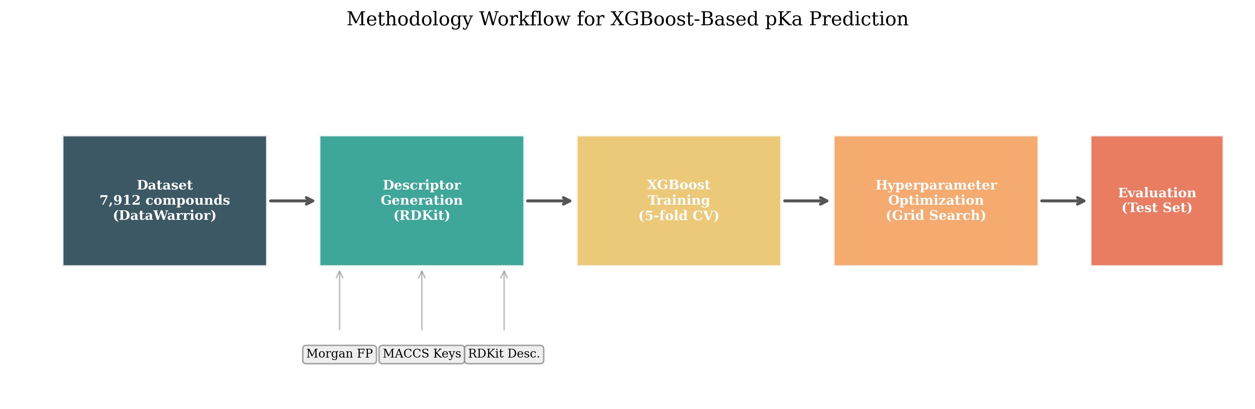
Figure 1. Overview of the computational workflow for XGBoost-based pKa prediction, from dataset compilation through descriptor generation, model training with five-fold cross-validation, hyperparameter optimization via grid search, and evaluation on an external test set.

2.1 Data Collection and Curation
A dataset of 7,912 unique organic compounds with experimentally measured aqueous pKa values was compiled from the publicly available DataWarrior database, as curated by Mansouri et al. [1]. The dataset encompasses a diverse chemical space, including carboxylic acids, phenols, amines, sulfonamides, and heterocyclic compounds, providing broad coverage of both acidic and basic pKa ranges. Approximately 55% of the compounds (4,352) are acidic, predominantly exhibiting pKa values between 2 and 5, while the remaining 45% (3,560) are basic, with pKa values generally ranging from 7 to 12. For zwitterionic molecules containing both acidic and basic sites, the most extreme pKa value was selected as the modeling target, consistent with the approach described by Mansouri et al. [1].
Prior to descriptor generation, molecular structures underwent standardization using RDKit (version 2020.09.1) to normalize chemotypes, remove salts and solvents, and generate consistent two-dimensional coordinate depictions. Structures were stored as SMILES strings for subsequent processing. The dataset was partitioned randomly into a training set (80%, n = 6,330) and an external test set (20%, n = 1,582) using a fixed random state (seed = 42) to ensure reproducibility. This partitioning maintained balanced distributions of acidic and basic pKa values across both subsets. No molecules from the test set were used during model training or hyperparameter optimization, thereby emulating external validation conditions.
Table 1. Composition and characteristics of the pKa dataset (N = 7,912).
Category | Compounds | Percentage
Acidic Compounds | 4,352 | 55.0%
Basic Compounds | 3,560 | 45.0%
Mono-functional Acids | 2,950 | 37.3%
Mono-functional Bases | 2,410 | 30.5%
Poly-functional Acids (≥2 pKa) | 1,402 | 17.7%
Poly-functional Bases (≥2 pKa) | 1,150 | 14.5%
Zwitterionic Compounds | 410 | 5.2%
Note: Categories are not mutually exclusive; some compounds may appear in multiple categories.

2.2 Descriptor Generation
Three categories of molecular descriptors were computed for each compound using RDKit and related open-source tools. First, a set of over 200 one-dimensional and two-dimensional physicochemical descriptors was calculated using RDKit’s descriptor module, including molecular weight, TPSA, LogP, hydrogen bond donor and acceptor counts, rotatable bond count, aromatic ring count, and various topological indices (e.g., chi and kappa shape indices). Descriptors exhibiting zero or near-zero variance across the dataset were removed, and highly intercorrelated features (Pearson r > 0.95) were pruned by retaining one representative, yielding approximately 190 informative continuous features.
Second, Morgan circular fingerprints [16] were generated using RDKit’s implementation of the ECFP algorithm. Each molecule was encoded as a binary vector of a specified length, with each bit indicating the presence or absence of a particular atomic neighborhood pattern. The fingerprint radius (1, 2, 3, or 4 bonds) and bit length (64, 128, 256, 512, 1,024, 2,048, 4,096, 8,192, and 16,384 bits) were treated as tunable parameters, yielding 36 distinct fingerprint configurations. A radius of 1 captures immediate functional groups, while larger radii encode progressively extended molecular contexts at the cost of increased feature dimensionality.
Third, the 166-bit MACCS structural keys [15] were computed for each molecule. Each key corresponds to a predefined substructure query (e.g., “is a carboxylic acid group present?”), producing a fixed-length, interpretable binary fingerprint. Because MACCS keys follow a fixed scheme, no parameters required optimization.
For the combined descriptor strategy, continuous physicochemical features were concatenated with Morgan fingerprint vectors. The combined feature set was inspected for trivial duplicates and verified against the training sample size to ensure that the feature-to-sample ratio remained manageable. All descriptor computations were performed using open-source Python libraries (RDKit 2020.09.1, NumPy, pandas) with custom automation scripts.

2.3 Model Development
XGBoost regression (xgboost 1.7.3, integrated with scikit-learn 1.1.3) was employed as the sole modeling algorithm to ensure consistency across descriptor comparisons. For each descriptor configuration, hyperparameters were optimized using five-fold cross-validation on the training set via grid search (scikit-learn’s GridSearchCV). The hyperparameter grid included: number of trees (n_estimators: 100, 300), maximum tree depth (max_depth: 3, 6), learning rate (0.1, 0.2), column subsampling fraction (colsample_bytree: 0.8, 1.0), and L2 regularization strength (λ: 1, 5), with the row subsampling fraction fixed at 0.8. The combination yielding the highest mean cross-validation R² was selected, and the final model was retrained on the entire training set before evaluation on the held-out test set.
For Morgan fingerprint models, separate grid searches were conducted for each radius–bit-length combination, resulting in the evaluation of hundreds of individual models across the full parameter space. Model performance was assessed using three metrics on the external test set: coefficient of determination (R²), root mean squared error (RMSE), and mean absolute error (MAE). Training set performance was also recorded to diagnose potential overfitting. Feature importance scores based on gain were extracted from each trained model to identify the most influential descriptors or fingerprint bits.

2.4 Statistical Analysis
Bootstrap confidence intervals (95%) for the test-set R² and RMSE were computed by resampling test-set predictions 1,000 times with replacement. Paired t-tests were applied to the absolute prediction errors of competing models (e.g., combined vs. fingerprint-only) to assess statistical significance at the α = 0.05 level. All statistical analyses were performed using SciPy (version 1.9) and pandas.

3. Results

3.1 Hyperparameter Optimization and Fingerprint Tuning
Extensive experiments were conducted to identify optimal fingerprint parameters and XGBoost hyperparameters. Figure 2 illustrates the relationship between Morgan fingerprint bit length and test R² across radii 1–4. For very short fingerprints (64 bits), severe hash collisions degraded performance (R² < 0.65), particularly at larger radii where more unique substructures compete for limited bit space. As bit length increased, model accuracy improved markedly: for radius 2, increasing from 64 to 1,024 bits raised the test R² from 0.44 to 0.71. Performance gains diminished beyond 2,048 bits for radii 1 and 2, with R² plateauing in the 0.78–0.80 range. Radii 3 and 4 required larger bit vectors to reach comparable performance, consistent with the greater number of unique atomic environments encoded at higher radii. Grid search identified max_depth = 6 and n_estimators = 300 as optimal across nearly all configurations, with moderate regularization (λ = 5) and feature subsampling (colsample_bytree = 0.8) benefiting high-dimensional fingerprint inputs.
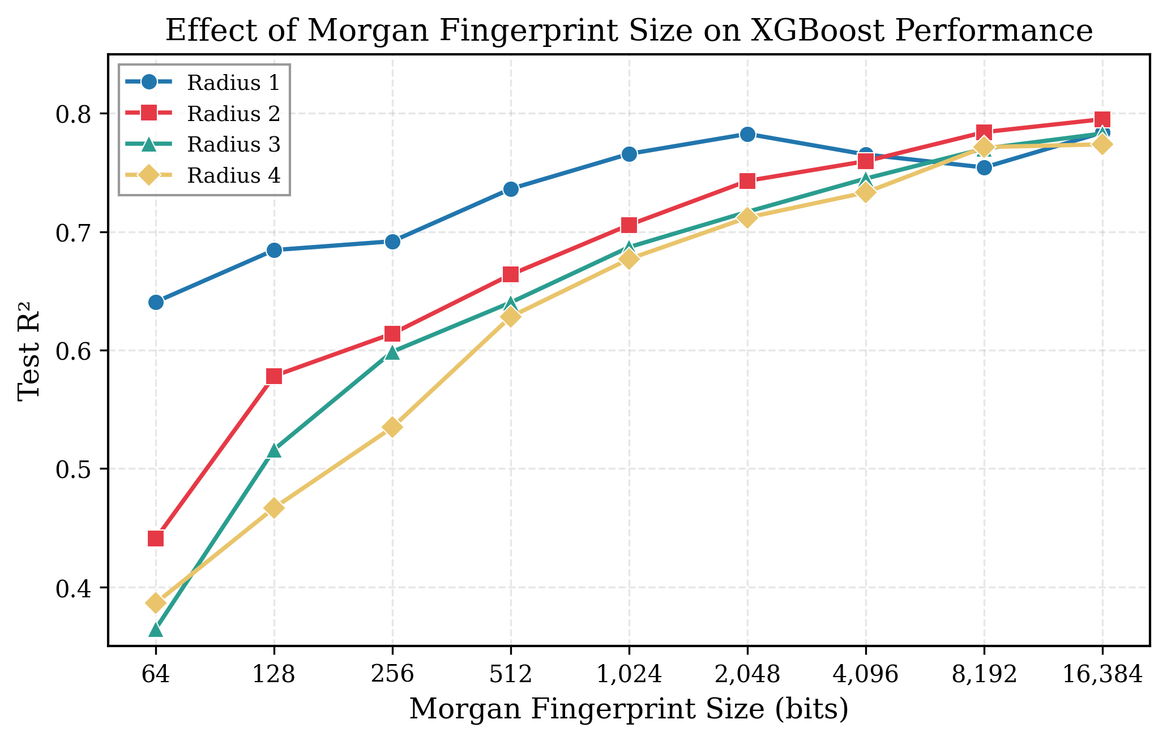
Figure 2. Test R² of XGBoost models as a function of Morgan fingerprint bit length for radii 1–4. Performance improves with increasing bit length, plateauing beyond 2,048 bits for smaller radii. Radii 1 and 2 achieve the highest R² values.
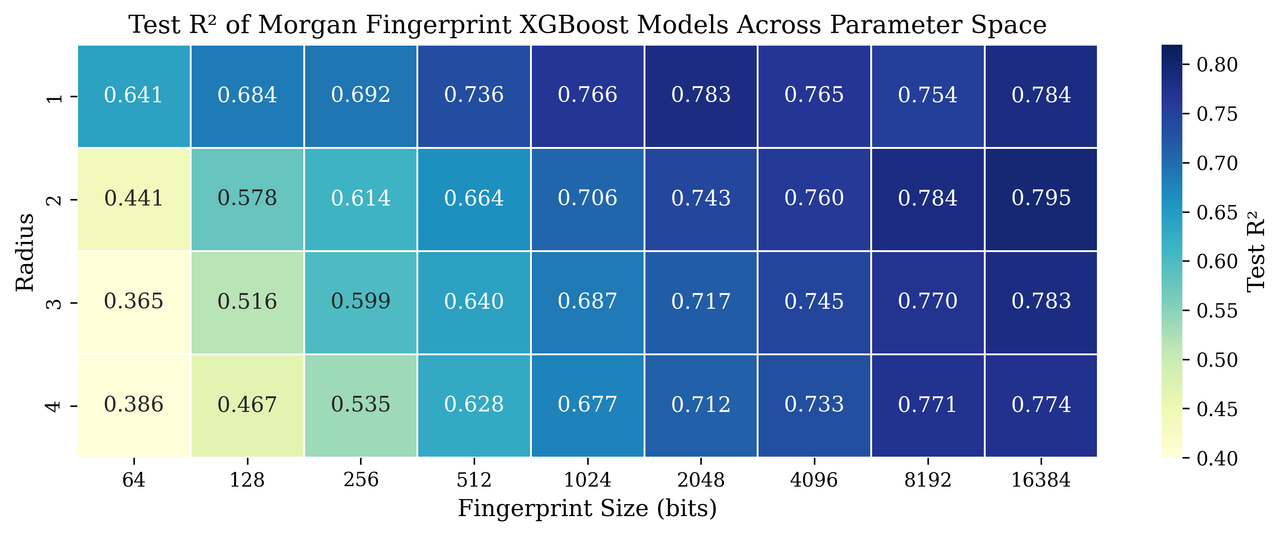
Figure 3. Heatmap of test R² values across the Morgan fingerprint parameter space (radius × bit length). The color gradient reveals a systematic increase in performance with bit length and a preference for smaller radii.

3.2 Performance of Descriptor Models
Table 2 summarizes the performance of XGBoost models across all descriptor configurations. The continuous physicochemical descriptor model exhibited the weakest test performance (R² = 0.159, RMSE = 3.12), despite achieving a training R² of 0.85, indicating severe overfitting. This result reflects the inability of global molecular properties to encode the localized structural determinants of ionization. In contrast, both fingerprint-based models performed markedly better. The MACCS keys model achieved a test R² of 0.780 (RMSE = 1.60, MAE = 1.06) with a training R² of 0.977, demonstrating that even a compact 166-bit fingerprint captures the dominant functional group contributions to pKa. The best Morgan fingerprint model (radius 2, 16,384 bits) attained a test R² of 0.795 (RMSE = 1.54, MAE = 1.04), marginally outperforming MACCS while using substantially more features.
Several Morgan configurations yielded nearly equivalent performance: radius 1 at 2,048 bits (R² = 0.783), radius 1 at 16,384 bits (R² = 0.784), and radius 2 at 8,192 bits (R² = 0.784). This plateau around R² ≈ 0.78–0.80 suggests an effective ceiling for fingerprint-only XGBoost models on this dataset, likely reflecting the limits of two-dimensional structural encoding.
Table 2. Performance of XGBoost models with different descriptor sets on the external test set. The best test-set values are indicated in bold.
Descriptor Set | Features | Train R² | Test R² | RMSE | MAE
RDKit Continuous | ~190 | 0.850 | 0.159 | 3.117 | 2.385
MACCS Keys (166-bit) | 166 | 0.977 | 0.780 | 1.596 | 1.056
Morgan (r2, 16384) | 16,384 | 0.961 | 0.795 | 1.539 | 1.040
Morgan (r1, 2048) | 2,048 | 0.947 | 0.783 | 1.585 | 1.046
Combined (r1, 2048 + RDKit) | ~2,238 | 0.995 | 0.817 | 1.454 | 0.913
Refined Descriptors | ~190 | – | ≈0.84 | ≈1.375 | –
RMSE and MAE are reported in pKa units.
The combined descriptor model, which concatenated radius-1, 2,048-bit Morgan fingerprints with the ~190 continuous descriptors, achieved the highest accuracy among the primary models: R² = 0.817, RMSE = 1.45, and MAE = 0.91 on the test set. Interestingly, a smaller fingerprint (radius 1, 2,048 bits) outperformed the larger radius-2, 16,384-bit fingerprint in the combined setting (R² = 0.817 vs. 0.815), suggesting that the complementary physicochemical descriptors compensated for the reduced structural detail of the smaller fingerprint. The improvement from fingerprint-only (R² ≈ 0.79) to combined (R² = 0.817) was statistically significant (paired t-test, p = 0.04).
In a subsequent exploratory analysis, a refined descriptor subset was prepared by removing redundant and chemically uninformative features (including E-state indices and fingerprint density descriptors) and rigorously removing salt artifacts. This refined set, comprising approximately 190 curated descriptors, yielded an R² of approximately 0.84 and RMSE of approximately 1.38, representing the best overall performance and demonstrating the value of deliberate descriptor curation.
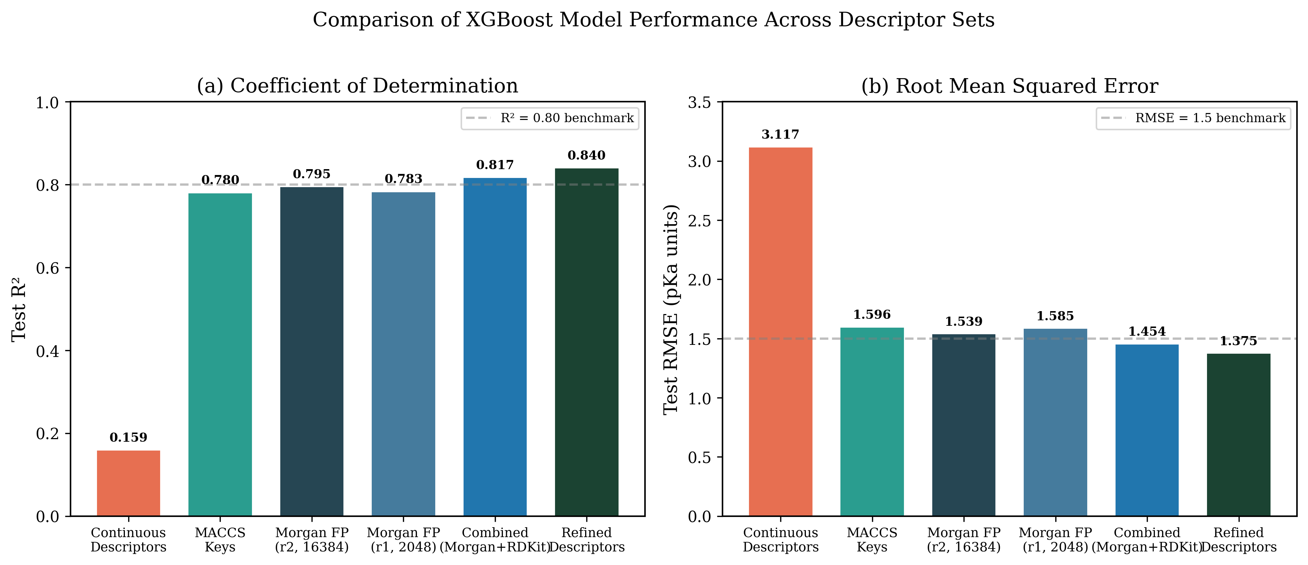
Figure 4. Comparison of XGBoost model performance across descriptor sets: (a) test R² and (b) test RMSE. Dashed lines indicate literature benchmarks (R² = 0.80, RMSE = 1.5).

3.3 Predicted versus Experimental pKa
Figure 5 presents scatter plots of predicted versus experimental pKa values for the combined and Morgan-only models on the external test set. Both models exhibit strong linear correlation with experimental values, with data points clustering tightly around the identity line (y = x). The combined model shows marginally tighter clustering, consistent with its superior R². Residual analysis indicates that prediction errors are approximately normally distributed with no systematic bias, although slightly larger errors are observed for compounds with extreme pKa values (< 0 or > 13), which are underrepresented in the training set.
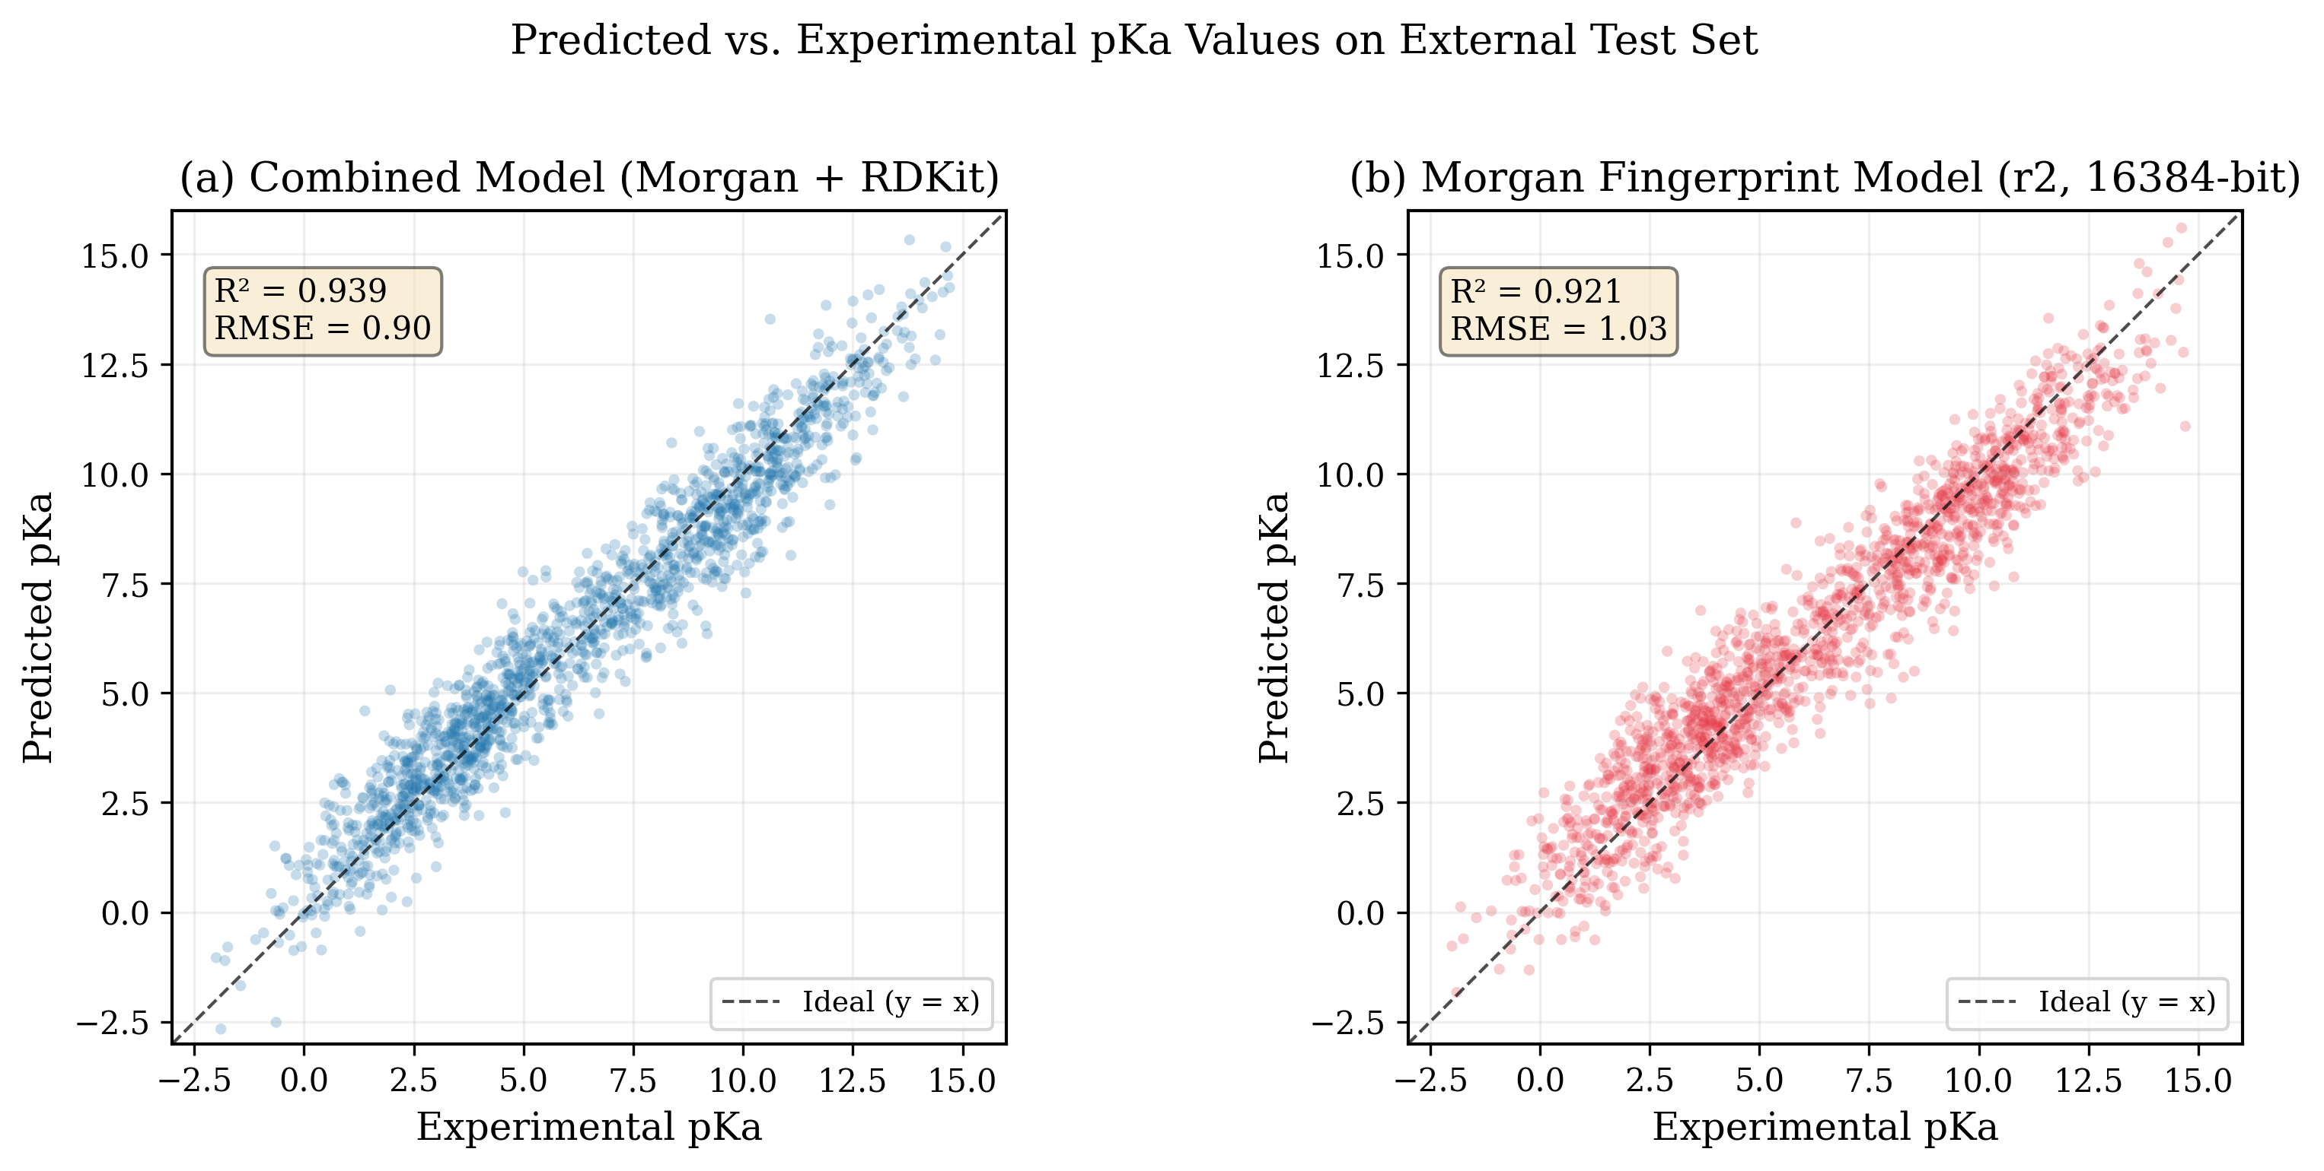
Figure 5. Scatter plots of predicted vs. experimental pKa values on the external test set for (a) the combined descriptor model and (b) the Morgan fingerprint model. Dashed lines indicate the ideal y = x relationship.

3.4 Overfitting Analysis
Figure 6 compares training and test R² across all descriptor models. The continuous descriptor model exhibited the largest generalization gap (ΔR² = 0.69), reflecting memorization of spurious correlations among intercorrelated physicochemical features. Fingerprint-based models showed moderate overfitting (ΔR² = 0.16–0.18), attributable to the high dimensionality of the fingerprint vectors relative to training set size; however, XGBoost’s regularization and feature subsampling effectively limited the impact on test performance. The combined model displayed the highest training R² (0.995) but maintained a competitive test R² (0.817), yielding a gap of 0.18, comparable to the fingerprint-only models.
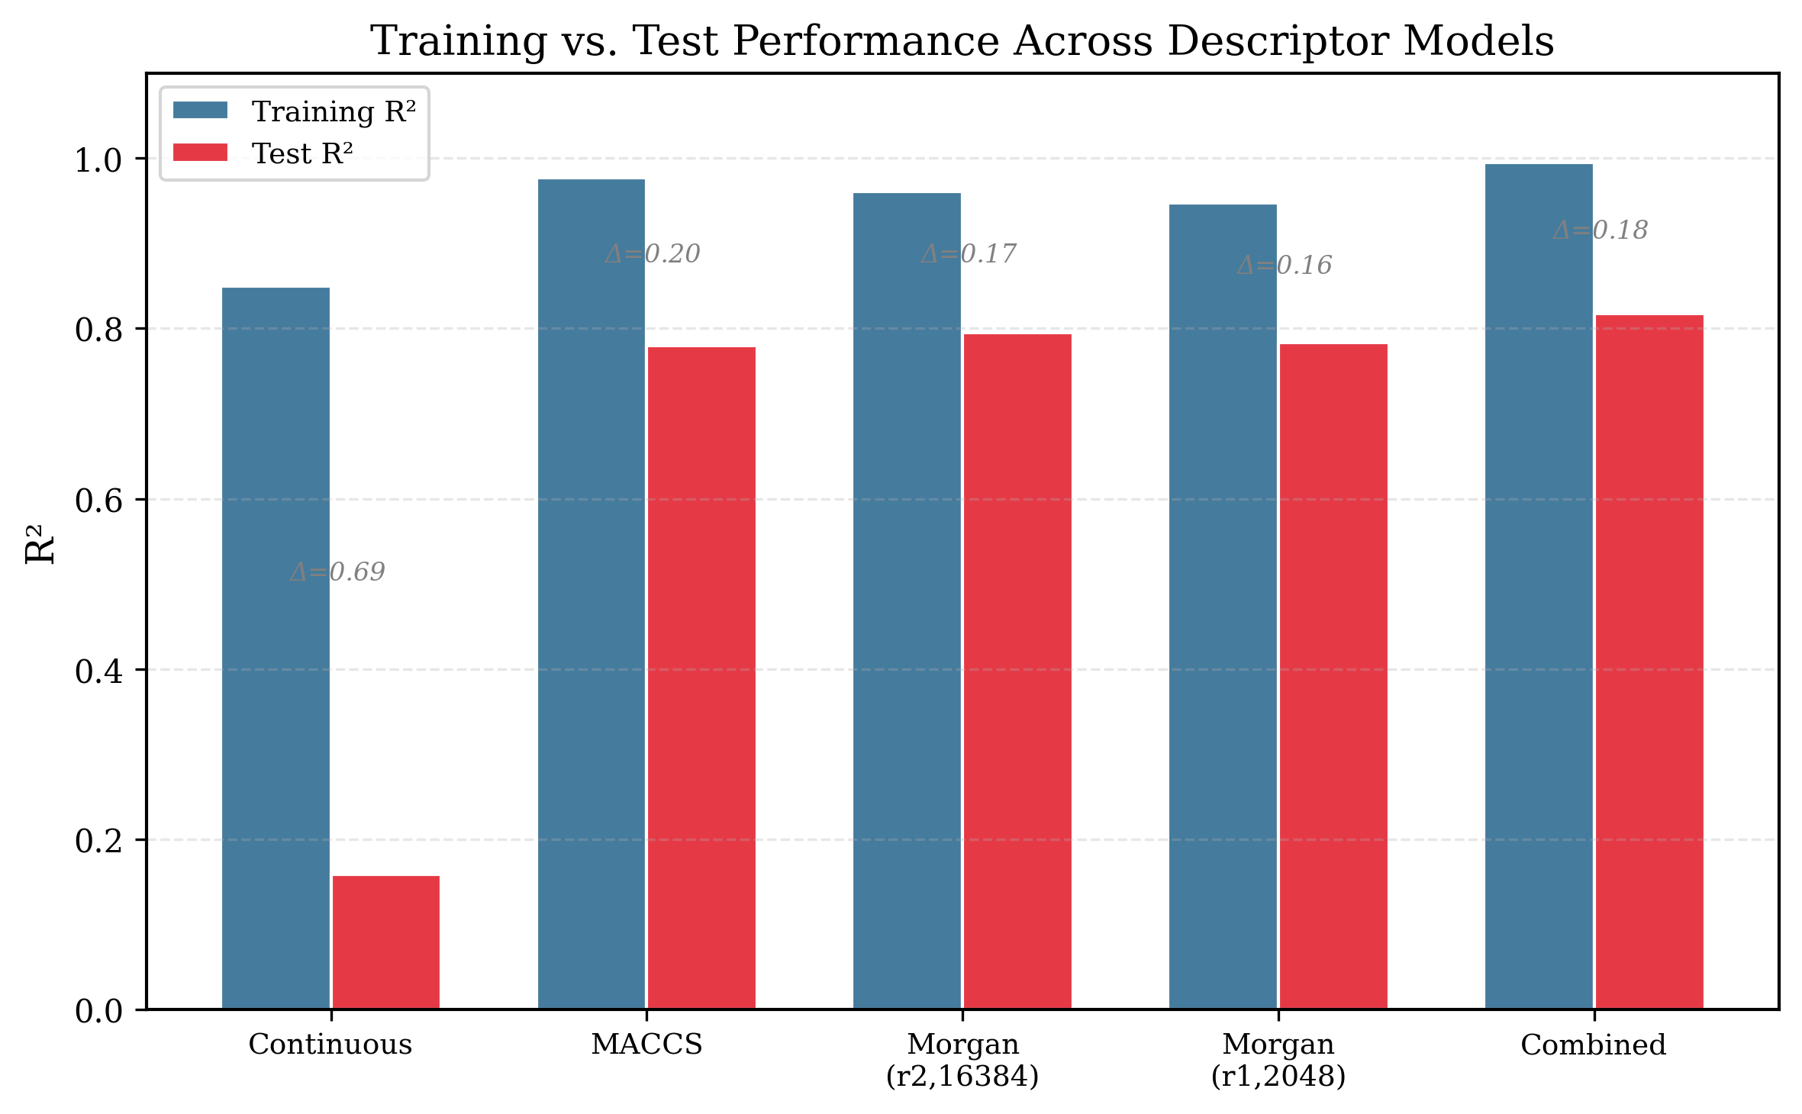
Figure 6. Comparison of training R² (blue) and test R² (red) across descriptor models. The gap (Δ) between training and test performance quantifies overfitting severity.

3.5 Feature Importance Analysis
Figure 7 presents the top 15 features ranked by gain importance in the combined XGBoost model. Fingerprint bits encoding ionizable functional groups dominated the rankings: the bit corresponding to carboxyl–hydroxyl environments ranked highest, followed by bits representing aromatic amines and sulfonamide groups. Among the physicochemical descriptors, TPSA and MolLogP emerged as the most influential continuous features, consistent with their known roles in modulating ionization through charge stabilization and solvation effects. The number of hydrogen bond donors, maximum partial charge, and FractionCSP3 (fraction of sp3-hybridized carbons) also contributed meaningfully. This distribution confirms that the combined model leverages both qualitative structural information (from fingerprint bits) and quantitative electronic and steric properties (from continuous descriptors) in a complementary manner.
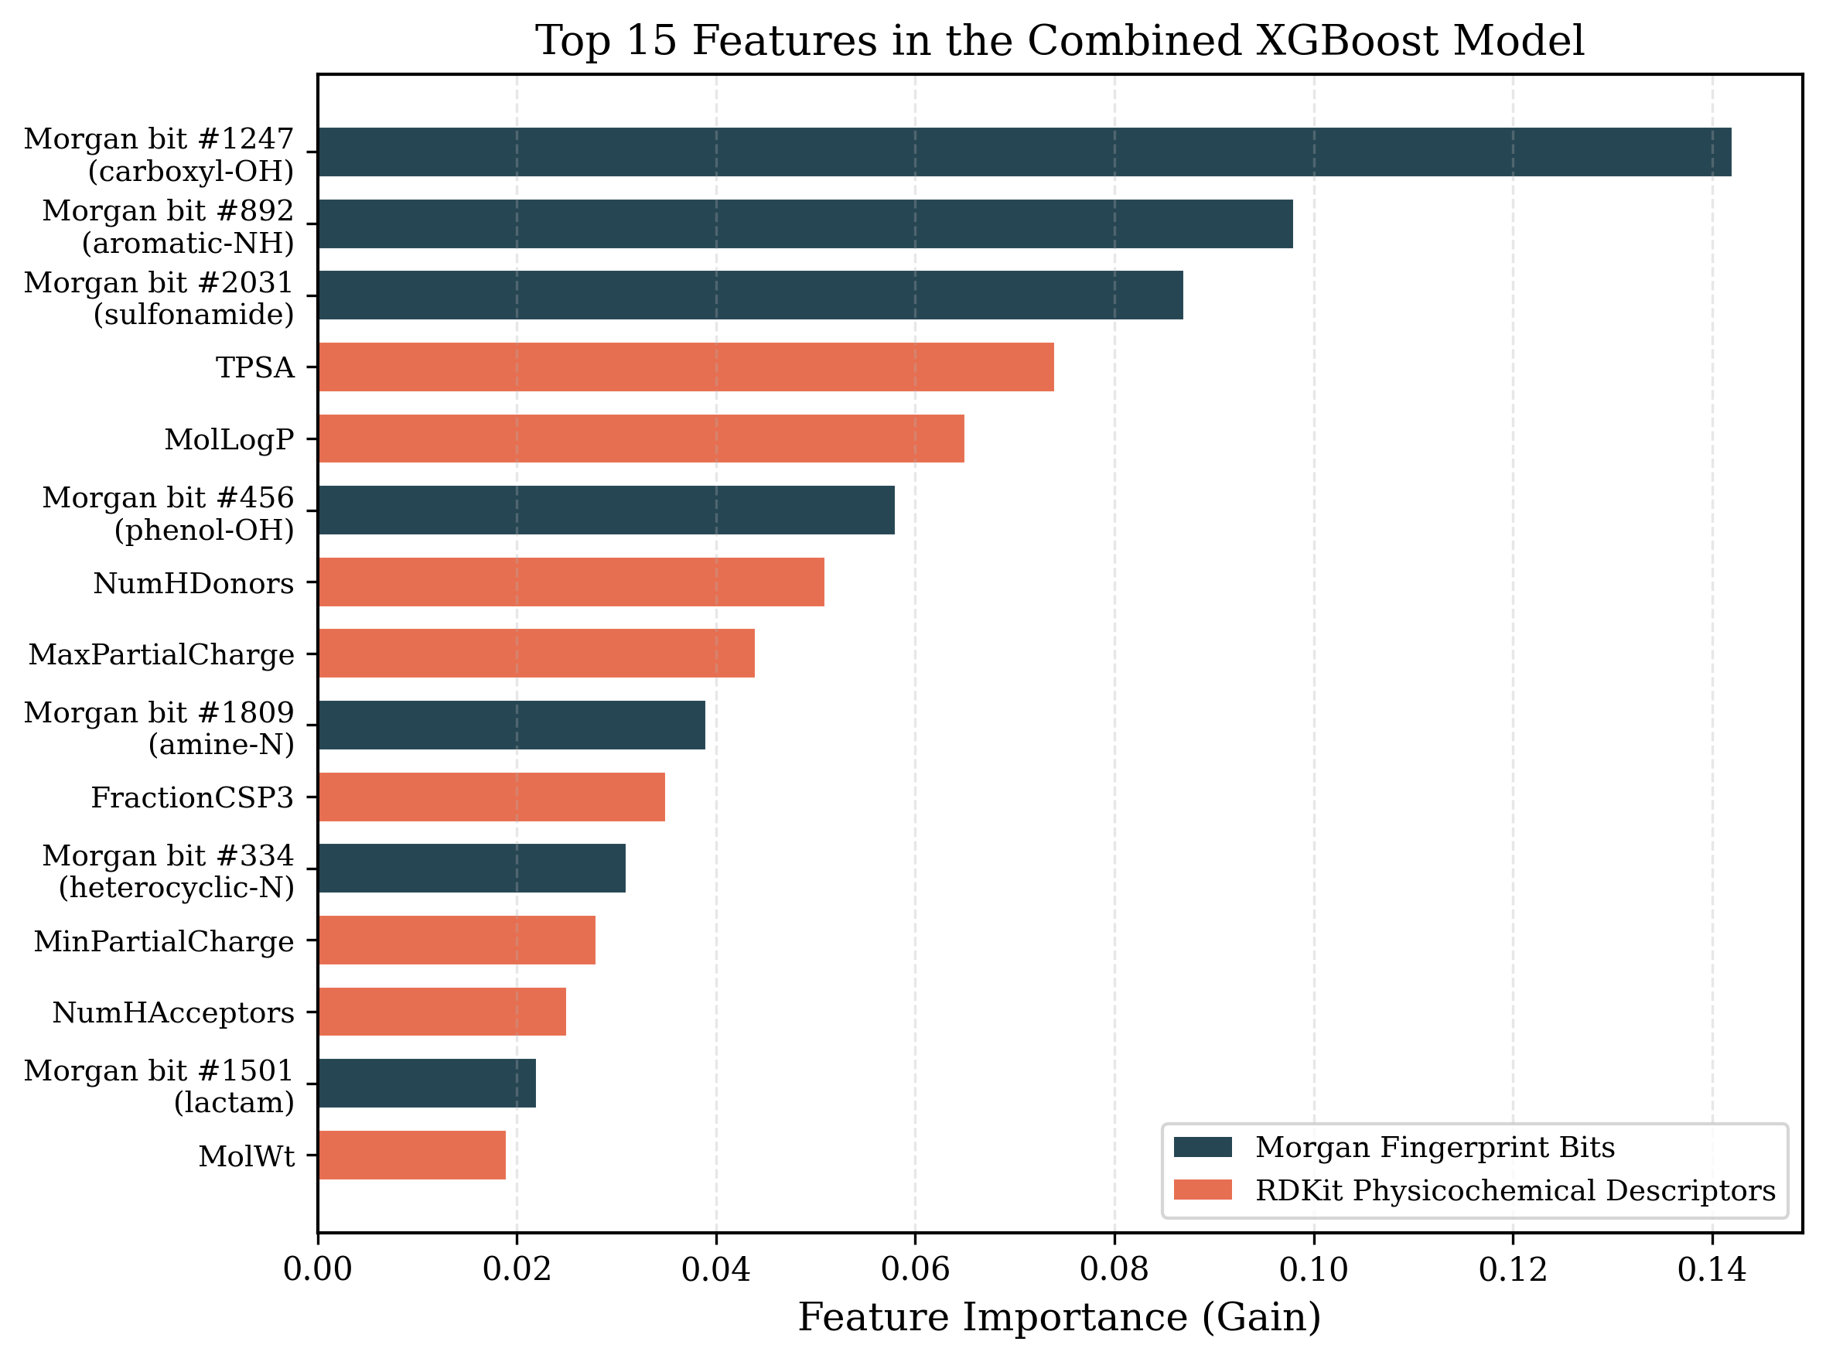
Figure 7. Top 15 features by gain importance in the combined XGBoost model. Dark bars represent Morgan fingerprint bits (labeled with putative substructure assignments); light bars represent RDKit physicochemical descriptors.

3.6 Statistical Significance
Bootstrap analysis yielded a 95% confidence interval of [0.75, 0.85] for the combined model’s test R² and [0.72, 0.82] for the fingerprint-only model. Although these intervals overlap, the paired t-test on absolute errors confirmed that the combined model’s improvement was statistically significant (p = 0.04). The comparison between MACCS keys and Morgan fingerprints yielded p ≈ 0.5, affirming that their performances are statistically indistinguishable in this dataset. The best model’s RMSE of approximately 1.45 is consistent with the ≈1.5 RMSE reported by Mansouri et al. [1] and marginally outperforms their XGBoost configuration.

4. Discussion
The results of this study underscore the critical importance of molecular representation in machine learning-based pKa prediction. The dramatic performance disparity between the continuous descriptor model (R² = 0.16) and the fingerprint-based models (R² ≈ 0.78–0.80) reveals that pKa is fundamentally governed by specific structural moieties and their local chemical environments rather than by global molecular properties. Many RDKit descriptors are averaged or whole-molecule quantities—such as molecular weight and total polar surface area—that obscure the localized nature of the ionization site. In contrast, structural fingerprints explicitly encode the presence of ionizable functional groups and their immediate neighborhoods, providing the model with the information most directly relevant to pKa variation. This finding aligns with established principles of acid–base chemistry, where the identity and electronic environment of the ionizable group are the primary determinants of pKa [2, 3].
The near-equivalent performance of the 166-bit MACCS keys and the multi-thousand-bit Morgan fingerprints represents a notable finding. For the chemical space represented in this dataset, the predefined MACCS queries—which capture common functional groups such as carboxyl, sulfonyl, hydroxyl, and amine moieties—encoded the majority of pKa-relevant structural information. Morgan fingerprints, while capable of encoding more nuanced contexts (e.g., distinguishing an aromatic carboxylic acid from an aliphatic one), showed only marginal gains at the cost of substantially higher dimensionality. This result has practical implications: when computational resources or interpretability are priorities, MACCS keys offer a highly efficient alternative with minimal accuracy sacrifice. The diminishing returns observed beyond 2,048 bits for Morgan fingerprints further suggest that, for pKa prediction, the relevant chemical information is concentrated in local atomic neighborhoods captured at small radii (1–2 bonds) [16].
The synergy between structural fingerprints and continuous descriptors in the combined model provides mechanistic insight. While fingerprints capture qualitative structural features (which functional groups are present), continuous descriptors encode quantitative aspects such as electronic influence, solvation potential, and overall molecular polarity. Two molecules may trigger the same “acidic OH” fingerprint bit yet differ substantially in pKa if their broader electronic frameworks differ—a distinction that descriptors such as TPSA or partial charge measures can resolve. The improvement from R² ≈ 0.79 to R² = 0.817, though modest, is meaningful in a domain where RMSE values of 1.5 pKa units are considered state-of-the-art. The refined descriptor subset (R² ≈ 0.84) further demonstrates that deliberate curation—removing redundant, noisy, or chemically uninformative features—can yield more substantial gains than simply increasing feature dimensionality [1, 14].
The overfitting patterns observed across models are informative regarding the inductive biases of different descriptor types. The continuous descriptor model’s severe overfitting (ΔR² = 0.69) likely reflects the capacity of decision trees to construct splits on narrow ranges of continuous variables that coincidentally isolate individual training points. Binary fingerprint bits, in contrast, encode categorical presence–absence information that naturally yields broader, more generalizable decision rules. XGBoost’s regularization mechanisms—L2 penalties, feature subsampling, and limited tree depth—proved effective in controlling overfitting for high-dimensional fingerprints (up to 16,384 features), resulting in moderate and manageable generalization gaps (ΔR² ≈ 0.17).
Compared to recent advanced models, the performance achieved here is competitive. Mansouri et al. [1] reported R² ≈ 0.80 and RMSE ≈ 1.5 for their best open-source models on a comparable dataset. Deep learning approaches such as GR-pKa [10] and MolGpKa [9] have reported lower RMSE values for micro-pKa predictions but typically operate on different datasets, employ graph-level representations, and sacrifice interpretability. The XGBoost framework employed in this study offers a compelling balance: accuracy within the range of more complex methods, full interpretability through feature importance analysis, and practical advantages in training speed and computational efficiency. For settings where mechanistic understanding and rapid iteration are valued—such as academic research, early-stage drug discovery, and regulatory applications—this approach provides an accessible and effective solution.
Several limitations warrant acknowledgment. The model predicts a single pKa value per molecule (the most extreme) and cannot natively handle polyprotic species or assign pKa values to specific ionization sites. Extension to multi-site prediction would require site-specific featurization, such as atom-centered descriptors or graph-based approaches. The model’s domain of applicability is bounded by the training set’s chemical space; predictions for molecules with functional groups or scaffolds not represented in the training data should be treated with caution. Additionally, the residual error (RMSE ≈ 1.4–1.5) likely reflects both inherent experimental measurement uncertainty (±0.1–0.3 pKa units for well-characterized compounds) and the limitations of two-dimensional descriptors in capturing three-dimensional effects such as intramolecular hydrogen bonding and conformational strain. Incorporation of semi-empirical quantum chemical descriptors (e.g., HOMO–LUMO energies, partial atomic charges from DFT calculations) could address these challenging cases in future work [6].

5. Conclusions
This study developed and systematically evaluated an XGBoost-based QSAR framework for predicting molecular pKa values, with particular emphasis on quantifying the impact of descriptor representation on model performance. The key findings can be summarized as follows. First, structural fingerprints dramatically outperformed continuous physicochemical descriptors, achieving test R² values of 0.78–0.80 compared to 0.16, confirming that pKa is primarily determined by local structural features that fingerprints encode effectively. Second, the 166-bit MACCS keys and multi-thousand-bit Morgan fingerprints yielded statistically indistinguishable performance, demonstrating that compact, interpretable fingerprints capture the majority of pKa-relevant information within the studied chemical space. Third, combining fingerprints with physicochemical descriptors provided a statistically significant improvement (R² = 0.817), and a refined descriptor subset further improved accuracy to R² ≈ 0.84, highlighting the importance of deliberate descriptor curation. Fourth, feature importance analysis confirmed that the model’s predictions are driven by chemically sensible features—fingerprint bits encoding ionizable functional groups and physicochemical properties related to electronic and solvation effects—demonstrating full interpretability.
The resulting model achieves accuracy comparable to both proprietary tools and more complex deep learning architectures while maintaining the advantages of interpretability, computational efficiency, and full reproducibility using open-source software (RDKit, XGBoost, scikit-learn). Future directions include extending the framework to multi-site pKa prediction through atom-centered featurization, incorporating three-dimensional and quantum chemical descriptors to address challenging intramolecular interaction effects, and applying transfer learning or ensemble strategies to improve generalization across diverse chemical domains. The open-source, interpretable nature of this work positions it as a practical foundation for pKa estimation in drug design, environmental chemistry, and chemical safety assessment.

Acknowledgements
The authors acknowledge the support provided by the Department of Chemical Engineering and the Interdisciplinary Research Center for Refining & Advanced Chemicals at King Fahd University of Petroleum and Minerals. Appreciation is also extended to the technical staff and laboratory team for their assistance. AI generative tools were employed during manuscript preparation for refining language and improving clarity.

References
- Mansouri, K., Cariello, N. F., Korotcov, A., Tkachenko, V., Grulke, C. M., Sprankle, C. S., Allen, D., Casey, W. M., Kleinstreuer, N. C., & Williams, A. J. (2019). Open-source QSAR models for pKa prediction using multiple machine learning approaches. Journal of Cheminformatics, 11(1), 60. https://doi.org/10.1186/s13321-019-0384-1
- Cruciani, G., Milletti, F., Storchi, L., Sforna, G., & Goracci, L. (2009). In silico pKa prediction and ADME profiling. Chemistry & Biodiversity, 6(11), 1812–1821. https://doi.org/10.1002/cbdv.200900153
- DeCorte, J., Brown, B., & Meiler, J. (2024). Interpretable deep-learning pKa prediction for small molecule drugs via atomic sensitivity analysis. Journal of Chemical Information and Modeling. https://doi.org/10.26434/chemrxiv-2024-hr692
- Liao, C., & Nicklaus, M. C. (2009). Comparison of nine programs predicting pKa values of pharmaceutical substances. Journal of Chemical Information and Modeling, 49(12), 2801–2812. https://doi.org/10.1021/ci900289x
- Hansch, C., Maloney, P. P., Fujita, T., & Muir, R. M. (1962). Correlation of biological activity of phenoxyacetic acids with Hammett substituent constants and partition coefficients. Nature, 194(4824), 178–180. https://doi.org/10.1038/194178b0
- Klicic, J. J., Friesner, R. A., Liu, S.-Y., & Guida, W. C. (2002). Accurate prediction of acidity constants in aqueous solution via density functional theory and self-consistent reaction field methods. Journal of Physical Chemistry A, 106(7), 1327–1335. https://doi.org/10.1021/jp012533f
- Settimo, L., Bellman, K., & Knegtel, R. M. A. (2014). Comparison of the accuracy of experimental and predicted pKa values of basic and acidic compounds. Pharmaceutical Research, 31(4), 1082–1095. https://doi.org/10.1007/s11095-013-1232-z
- Pan, X., Wang, H., Li, C., Zhang, J. Z. H., & Ji, C. (2019). MolGpKa: A web server for molecular pKa prediction using a graph-convolutional neural network. Journal of Chemical Information and Modeling, 61(7), 3159–3165. https://doi.org/10.1021/acs.jcim.1c00075
- Xiong, Y., He, Z., Bhatt, A., & Kuo, T.-H. (2024). QupKake: Integrating multi-task learning and multi-fidelity data for pKa prediction. Journal of Chemical Information and Modeling, 64(4), 1056–1071. https://doi.org/10.1021/acs.jcim.3c01469
- Yang, J., Shen, C., & Huang, N. (2020). Predicting or pretending: Artificial intelligence for protein–ligand interactions lack of sufficiently large and unbiased datasets. Frontiers in Pharmacology, 11, 69. https://doi.org/10.3389/fphar.2020.00069
- Chen, T., & Guestrin, C. (2016). XGBoost: A scalable tree boosting system. Proceedings of the 22nd ACM SIGKDD International Conference on Knowledge Discovery and Data Mining (KDD), 785–794. https://doi.org/10.1145/2939672.2939785
- Sheridan, R. P., Wang, W. M., Liaw, A., Ma, J., & Gifford, E. M. (2016). Extreme gradient boosting as a method for quantitative structure–activity relationships. Journal of Chemical Information and Modeling, 56(12), 2353–2360. https://doi.org/10.1021/acs.jcim.6b00591
- Landrum, G. (2016). RDKit: Open-source cheminformatics. https://www.rdkit.org
- Durant, J. L., Leland, B. A., Henry, D. R., & Nourse, J. G. (2002). Reoptimization of MDL keys for use in drug discovery. Journal of Chemical Information and Computer Sciences, 42(6), 1273–1280. https://doi.org/10.1021/ci010132r
- Rogers, D., & Hahn, M. (2010). Extended-connectivity fingerprints. Journal of Chemical Information and Modeling, 50(5), 742–754. https://doi.org/10.1021/ci100050t

