
UNIT 4 – SCRIPTING TECHNIQUES

HANDS ON ACTIVITY 5 IT 207

Name: Date:
Course & Section: Result:

Activity Title: Building a Simple BMI Calculator
Objective:
Learn how to use HTML, CSS, and JavaScript to create a web-based application that calculates and displays BMI based on user input.
Instructions:
Create three separate files:
o index.html (for the structure of the webpage)
o style.css (for styling the webpage)
o script.js (for the BMI calculation logic)
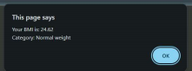

The output/computation should be displayed as an alert
Ex:



