SET2
Roll number:cb.en.u4cse22527
Q1)
isTriangular ::[[Int]]->String
isTriangular []="None"
isTriangular mat
|isUpper mat ="UPPER"++show(len mat)
|isLower mat ="Lower"++show(len mat)
|otherwise ="None"

len ::[[Int]]->Int
len []=0
len (x:xs)=1+len xs

isUpper :: [[Int]] -> Bool
isUpper mat = all (== 0) [mat !! i !! j | i <- [1..n-1], j <- [0..i-1]]
where n = len mat

isLower :: [[Int]] -> Bool
isLower mat = all (== 0) [mat !! i !! j | i <- [0..n-2], j <- [i+1..n-1]]
where n = len mat
main = do
print (isTriangular [])
print (isTriangular [[1,2,3], [0,4,5], [0,0,6]])
print (isTriangular [[1,0,0], [1,4,0], [1,4,6]])
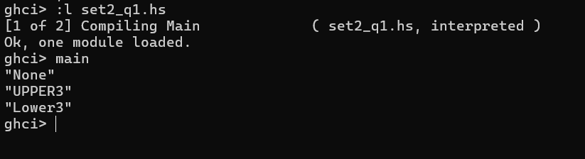
Q2)
splitAtElem :: Eq a => a -> [a] -> ([a], [a])
splitAtElem _ [] = ([], [])
splitAtElem x (y:ys)
| x == y = ([], y:ys)
| otherwise = let (before, after) = splitAtElem x ys
in (y:before, after)

main :: IO ()
main = do
print $ splitAtElem 3 [1,2,3,4,5]
print $ splitAtElem 7 [5,6,8,9]
print $ splitAtElem 's' "haskell"
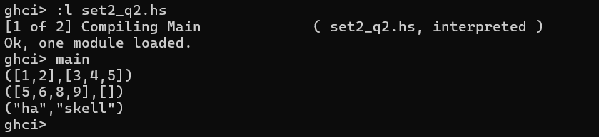
Q4)
sumGreaterThanN :: Int -> [Int] -> Int
sumGreaterThanN _ [] = 0
sumGreaterThanN n (x:xs)
| x > n = x + sumGreaterThanN n xs
| otherwise = sumGreaterThanN n xs

sumGreaterThanNHO :: Int -> [Int] -> Int
sumGreaterThanNHO n lst = sum (filter (> n) lst)

main :: IO ()
main = do
let lst = [3,5,1,6,8,4]
let n = 5
print $ "Recursive Sum: " ++ show (sumGreaterThanN n lst)
print $ "Higher-Order Sum: " ++ show (sumGreaterThanNHO n lst)
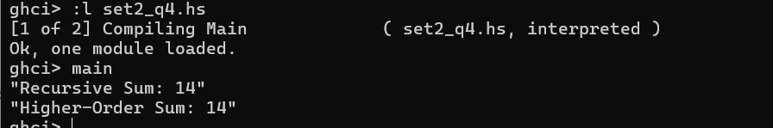
Q5)
temperatureDiff :: Double -> Double -> Double
temperatureDiff t1 t2 = abs (t1 - t2)

cumulativeTempDiff :: [Double] -> Double
cumulativeTempDiff temps = foldl1 (\acc t -> acc + abs t) (zipWith (-) temps (tail temps))

cumulativeTempDiffFoldr :: [Double] -> Double
cumulativeTempDiffFoldr temps = foldr (\t acc -> abs t + acc) 0 (zipWith (-) temps (tail temps))

main :: IO ()
main = do
print $ temperatureDiff 32.6 44.3
print $ cumulativeTempDiff [32, 44, 38, 11.7]
print $ cumulativeTempDiffFoldr [32, 44, 38, 11.7]
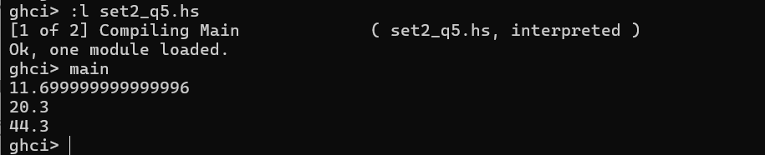
Q6)
myFilterFunction :: (Int -> Bool) -> (Int -> Int) -> [Int] -> [Int]
myFilterFunction predicate func lst = [if predicate x then func x else x | x <- lst]

-- Test Cases
main :: IO ()
main = do
print $ myFilterFunction (>0) (*5) [-5..5]
print $ myFilterFunction (>=0) (*5) [-5..5]
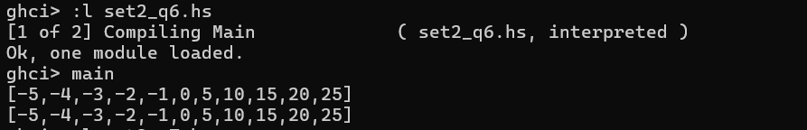
Q7)
import Data.Char (isDigit)

retainDigits :: [String] -> [String]
retainDigits lst = [filter isDigit str | str <- lst]

main :: IO ()
main = do
print $ retainDigits ["Hello12", "B3Y4E5", "000"]
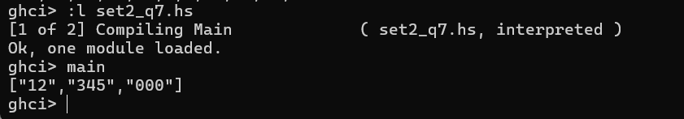
Q8)
sortedmerge :: (Ord a, Eq a) => [a] -> [a] -> [a]
sortedmerge xs [] = xs
sortedmerge [] ys = ys
sortedmerge (x:xs) (y:ys)
| x < y = x : sortedmerge xs (y:ys)
| x == y = x : sortedmerge xs ys
| x > y = y : sortedmerge (x:xs) ys

-- Test Cases
main :: IO ()
main = do
print $ sortedmerge [1, 3, 5] [2, 3, 6]
print $ sortedmerge [1, 2, 2, 4] [2, 3, 4, 5]
print $ sortedmerge "abc" "bdf"
