SET1
Roll number:cb.en.u4cse22527

Q1)
isVal :: [[a]] -> Bool
isVal [] = True
isVal matrix = isValid && checkDimensions matrix (head matrix)
where
isValid = all (\row -> length row == length (head matrix)) matrix
checkDimensions m firstRow =
case (length m, length firstRow) of
(3, 3) -> True -- Triple matrix
(4, 4) -> True -- Quad matrix
_ -> True

main :: IO ()
main = do
print $ isVal [[1,2], [3,4], [5,6]]
print $ isVal [[1,2,3], [4,5,6], [7,8,9]]
print $ isVal [[1,2,3,4], [5,6,7,8], [9,10,11,12], [13,14,15,16]]
print $ isVal [[1,2,3], [4,5], [6,7,8]]
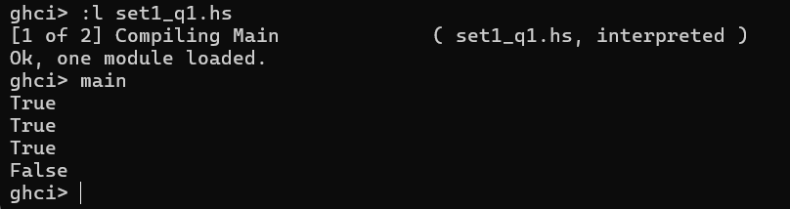
Q2)
partitionList :: (a -> Bool) -> [a] -> ([a], [a])
partitionList p lst = foldr (\x (yes, no) -> if p x then (x:yes, no) else (yes, x:no)) ([], []) lst

main :: IO ()
main = do
print $ partitionList even [1, 2, 3, 4, 5, 6]
print $ partitionList (> 10) [5, 10, 15, 20]
print $ partitionList (`elem` "aeiou") "haskell"
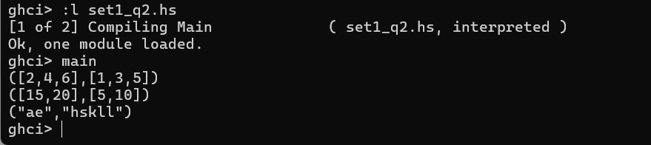
4. lst ::(Eq a, Num a) => [a] -> a -> a -> [a]
lst [] _ _= []
lst (x:xs) a n
| (a == 0) = n : lst xs a (n-1)
| otherwise = x : lst xs (a-1) n

Non-recursive: 4 – i and 5 – i+1
(take 4 [3,5,1,6,8,14]) ++ [15] ++ (drop 5 [3,5,1,6,8,14])
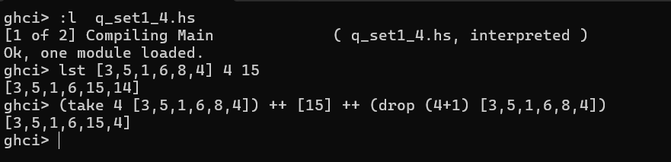
5. addFive :: Int -> Int
addFive x = x + 5

square_it :: Int -> Int
square_it x = x^2

main :: IO()
main = do
print( (\x -> square_it . addFive $ x) 3)
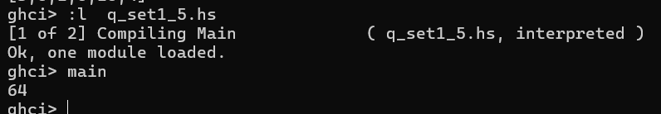
6. myfilter ::(Int->Bool) -> (Int->Bool) -> [Int] -> [Int]
myfilter p1 p2 [] = []
myfilter p1 p2 (x:xs)
| even x = if p2 x then x : myfilter p1 p2 xs else myfilter p1 p2 xs
| otherwise = if p1 x then x : myfilter p1 p2 xs else myfilter p1 p2 xs
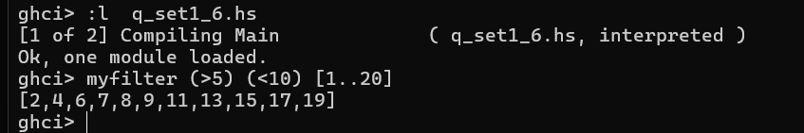
7. rem_vo :: [String] -> [String]
rem_vo [] = []
rem_vo (xs:xxs) = helper xs : rem_vo xxs

helper :: String -> String
helper [] = []
helper (x:xs)
| x elem "aeiouAEIOU" = helper xs
| otherwise = x : helper xs
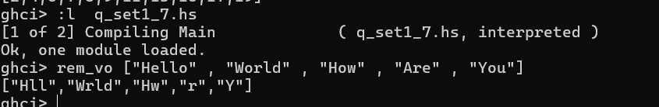
8. rotate :: [a] -> Int -> [a]
rotate xs n
| n >= 0 = (drop n xs) ++ (take n xs)
| n < 0 = (drop len xs) ++ (take len xs)
where len = n + length xs
