Academic Year 2024-25 Even
19CSE313 – Principles of Programming Language
B.Tech CSE 2022-26 F Section
Practice Set 5 - Higher Order Function
- multThree :: (Num a) => a -> a -> a -> a
multThree x y z = x * y * z
ghci> let multTwoWithNine = multThree 9
ghci> multTwoWithNine 2 3
ghci> let multWithEighteen = multTwoWithNine 2
ghci> multWithEighteen 10
ghci> multThree 3 4
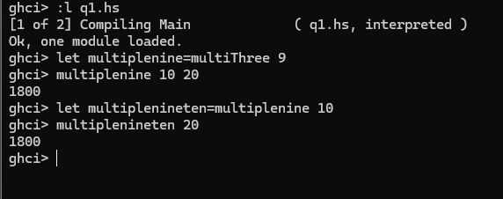

- compareWithHundred :: (Num a, Ord a) => a -> Ordering
compareWithHundred x = compare 100 x
ghci> compareWithHundred 99
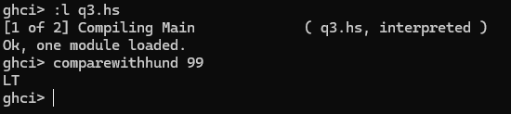
- compareWithHundred :: (Num a, Ord a) => a -> Ordering
compareWithHundred = compare 100
ghci> compareWithHundred 99
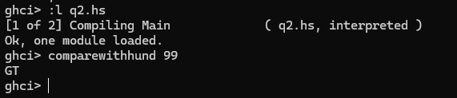
The difference between 2 and 3 question is in q2 the argument is passed into function while in q3 the compare withhund is a defined function and inferred automatically.
- divideByTen :: (Floating a) => a -> a
divideByTen = (/10)
ghci> divideByTen 200
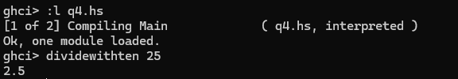
- isUpperAlphabetic :: Char -> Bool
isUpperAlphabetic = (`elem` ['A'..'Z'])
ghci> isUpperAlphabetic 'A'
ghci> isUpperAlphabetic 'd'
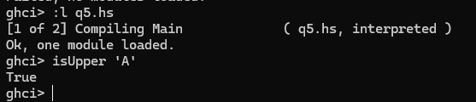
- subtract4 :: (Num a) => a -> a
subtract4 = (subtract 4)
ghci> subtract4 16
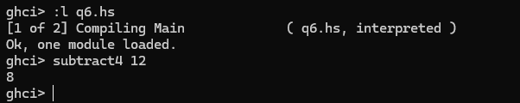
it called as arg-4,
- subtract4 :: (Num a) => a -> a
subtract4 = ((-) 4)
ghci> subtract4 16
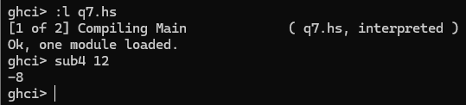
it call as 4-arg .since (-) is taken as inflix not as -4
- applyTwice :: (a -> a) -> a -> a
applyTwice f x = f (f x)
ghci> applyTwice (+3) 10
ghci> applyTwice (++ " HAHA") "HEY"
ghci>applyTwice ("HAHA " ++) "HEY"

ghci>applyTwice (3:) [1]
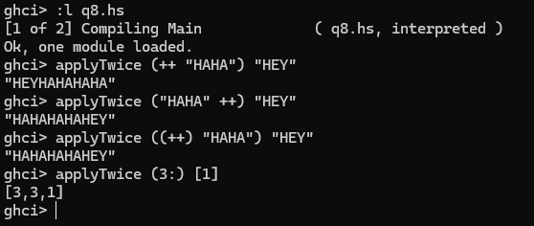
here in case 1 and 2 it is just like concaztenation while in case 3 it takes as influx and for case 4 (3: ) is the function that is going to call twice of list
- zipWith' :: (a -> b -> c) -> [a] -> [b] -> [c]
zipWith' _ [] _ = []
zipWith' _ _ [] = []
zipWith' f (x:xs) (y:ys) = f x y : zipWith' f xs ys
ghci> zipWith' (+) [4,2,5,6] [2,6,2,3]
ghci> zipWith' max [6,3,2,1] [7,3,1,5]
ghci> zipWith' (++) ["foo ", "bar ", "baz "] ["fighters", "hoppers", "aldrin"]
ghci>zipWith' (*) (replicate 5 2) [1..]
ghci> zipWith' (zipWith' (*)) [[1,2,3],[3,5,6],[2,3,4]] [[3,2,2],[3,4,5],[5,4,3]]
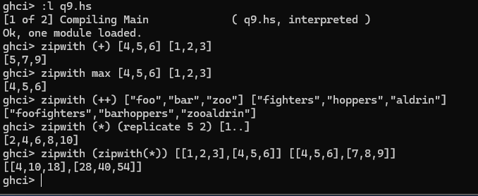
in case 1 and 2,3:it doing addition and max,concatenation operation for element in each l;ist with corresponding element while in case 4 we are creating a list by replicating 2 5 times and doping * operation ,in case 5 we aree calling f(f(x)),

- flip' :: (a -> b -> c) -> (b -> a -> c)
flip' f = g
where g x y = f y x
ghci> flip' zip [1,2,3,4,5] "hello"
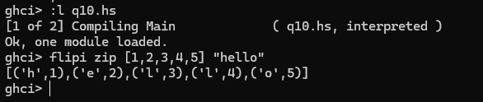
in this we are doing g(f(x)) for f(g(x))
- flip2' :: (a -> b -> c) -> b -> a -> c
flip2' f y x = f x y
ghci> flip2' zip [1,2,3,4,5] "hello"
ghci> zipWith (flip2' div) [2,2..] [10,8,6,4,2]
ghci> zipWith flip2' div [2,2..] [10,8,6,4,2]
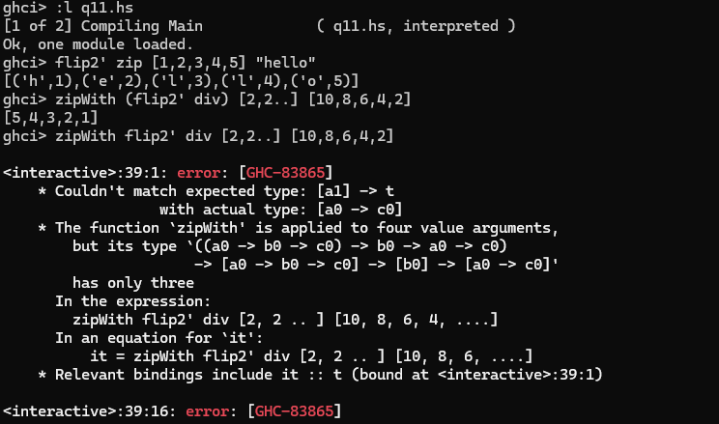
in this zipwith flip2’ div will be the function and eaxch element in 2 list will be passed every time and evaluated,while if there is no () for flip2’ div it is not calculayed as a single function
- map :: (a -> b) -> [a] -> [b]
map _ [] = []
map f (x:xs) = f x : map f xs
ghci> map (+3) [1,5,3,1,6]
ghci> map (++ "!") ["BIFF", "BANG", "POW"]
ghci> map (replicate 3) [3..6]
ghci> map (map (^2)) [[1,2],[3,4,5,6],[7,8]]
ghci> map fst [(1,2),(3,5),(6,3),(2,6),(2,5)]
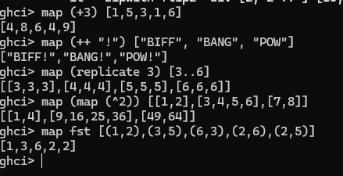
- filter :: (a -> Bool) -> [a] -> [a]
filter _ [] = []
filter p (x:xs)
| p x = x : filter p xs
| otherwise = filter p xs
ghci> filter (>3) [1,5,3,2,1,6,4,3,2,1]
ghci> filter (==3) [1,2,3,4,5]
ghci> filter even [1..10]
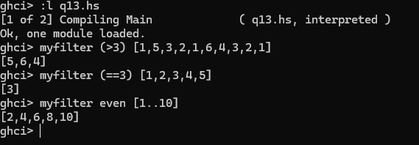
- quicksort :: (Ord a) => [a] -> [a]
quicksort [] = []
quicksort (x:xs) =
let smallerSorted = quicksort (filter (<=x) xs)
biggerSorted = quicksort (filter (>x) xs)
in smallerSorted ++ [x] ++ biggerSorted
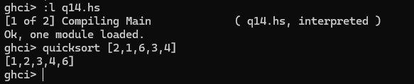
- largestDivisible :: (Integral a) => a
largestDivisible = head (filter p [100000,99999..])
where p x = x `mod` 3829 == 0
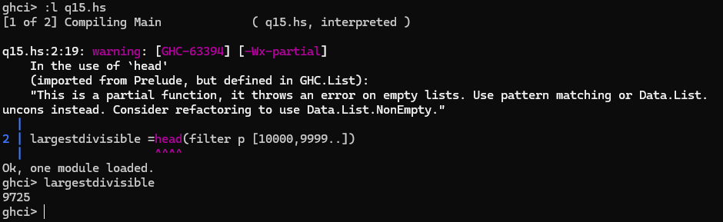
- ghci> takeWhile (/=' ') "elephants know how to party"
- ghci> sum (takeWhile (<10000) (filter odd (map (^2) [1..])))
- ghci> sum (takeWhile (<10000) [n^2 | n <- [1..], odd (n^2)])
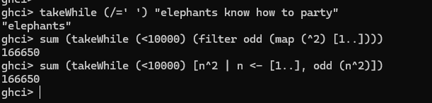
- chain :: (Integral a) => a -> [a]
chain 1 = [1]
chain n
| even n = n:chain (n `div` 2)
| odd n = n:chain (n*3 + 1)
ghci> chain 10
ghci> chain 1
ghci> chain 30
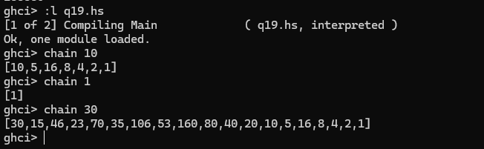
- numLongChains :: Int
numLongChains = length (filter isLong (map chain [1..100]))
where isLong xs = length xs > 15
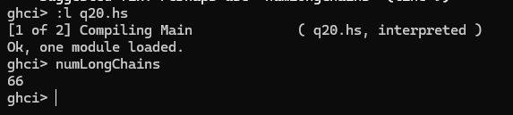

Lambda Functions
- ghci> let listOfFuns = map (*) [0..]
ghci> (listOfFuns !! 4) 5
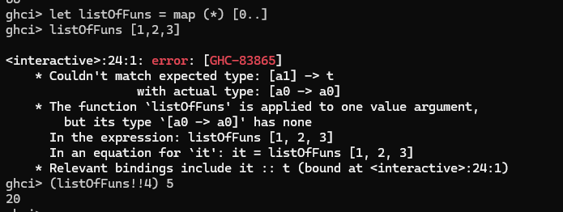
- numLongChains :: Int
numLongChains = length (filter (\xs -> length xs > 15) (map chain [1..100]))
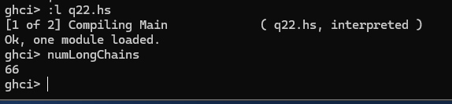
- ghci> map (+3) [1,6,3,2]
ghci> map (\x -> x + 3)[1,6,3,2]
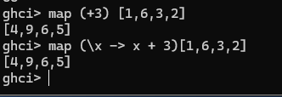
- ghci> zipWith (\a b -> (a * 30 + 3) / b) [5,4,3,2,1] [1,2,3,4,5]
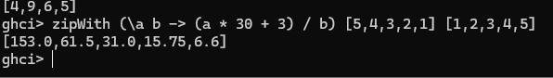
- ghci> map (\(a,b) -> a + b) [(1,2),(3,5),(6,3),(2,6),(2,5)]
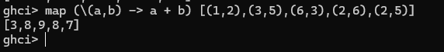
FOLDL/FOLDR
- mysum :: (Num a) => [a] -> a
mysum [] = 0
mysum (x:xs) = x + sum xs
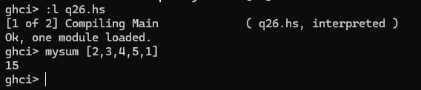
- sum' :: (Num a) => [a] -> a
sum' xs = foldl (\acc x -> acc + x) 0 xs
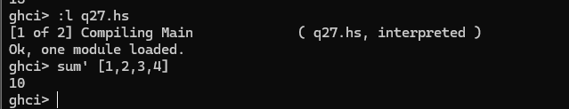
- map' :: (a -> b) -> [a] -> [b]
map' f xs = foldr (\x acc -> f x : acc) [] xs
ghci> map' (+3) [1,2,3]
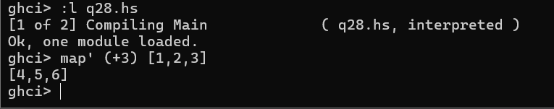
- Write your observations on the following function implementations using FOLDL and FOLDR
- ($) :: (a -> b) -> a -> b
f $ x = f x
ghci> sqrt 3 + 4 + 9
ghci> sqrt $ 3+4+9
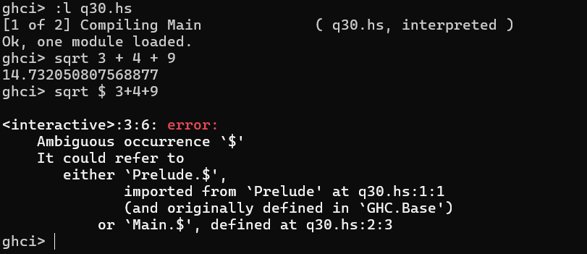
- ghci> sum (filter (> 10) (map (*2) [2..10]))
sum filter (>10) map (*2) [2..10]
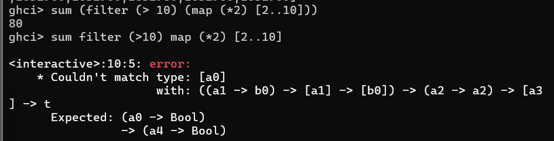
ghci> sum $ filter (>10) $ map (*2) [2..10]
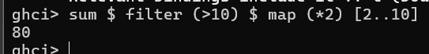
Composition
- ghci>map (\x -> negate (abs x)) [5,-3,-6,7,-3,2,-19,24]
ghci>map (negate . abs) [5,-3,-6,7,-3,2,-19,24]
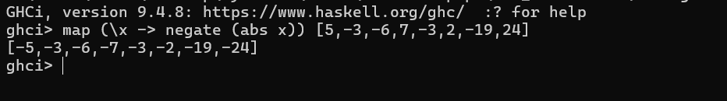
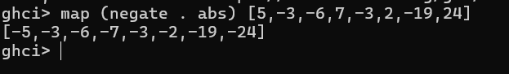
- ghci> map (\xs -> negate (sum (tail xs))) [[1..5],[3..6],[1..7]]
ghci> map (negate . sum . tail) [[1..5],[3..6],[1..7]]
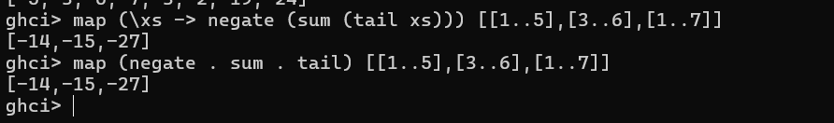
- ghci> sum (replicate 5 (max 6.7 8.9))
ghci> (sum . replicate 5 . max 6.7) 8.9
ghci> sum . replicate 5 . max 6.7 $ 8.9
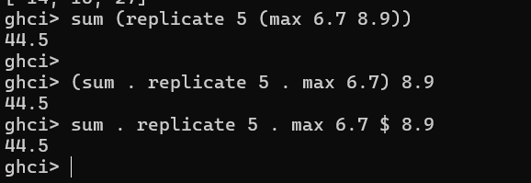
- -- Define two functions
addOne :: Int -> Int
addOne x = x + 1
multiplyByTwo :: Int -> Int
multiplyByTwo x = x * 2

-- Compose the functions
addOneThenMultiplyByTwo :: Int -> Int
addOneThenMultiplyByTwo = multiplyByTwo . addOne

-- Usage
main :: IO ()
main = print (addOneThenMultiplyByTwo 3) -- Output will be 8
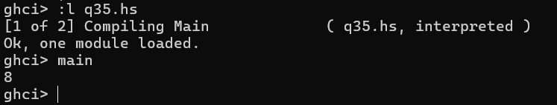
- ghci>replicate 100 (product (map (*3) (zipWith max [1,2,3,4,5] [4,5,6,7,8])))
ghci>replicate 100 . product . map (*3) . zipWith max [1,2,3,4,5] $ [4,5,6,7,8]
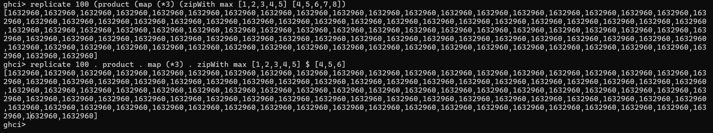
- oddSquareSum :: Integer
oddSquareSum = sum (takeWhile (<10000) (filter odd (map (^2) [1..])))
ghci> oddSquareSum
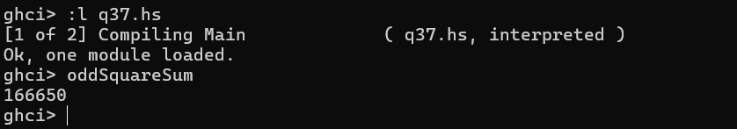
- oddSquareSum :: Integer
oddSquareSum = sum . takeWhile (<10000) . filter odd . map (^2) $ [1..]
ghci> oddSquareSum
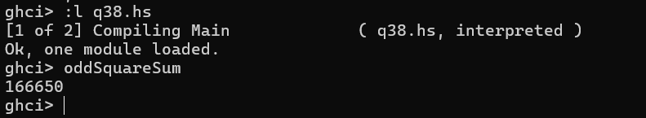
- oddSquareSum :: Integer
oddSquareSum =
let oddSquares = filter odd $ map (^2) [1..]
belowLimit = takeWhile (<10000) oddSquares
in sum belowLimit
ghci> oddSquareSum
