Academic Year 2024-25 Even
19CSE313 – Principles of Programming Language
B.Tech CSE 2022-26 F Section
Practice Set 4 - Pattern Matching and Recursion
- sayMe :: (Integral a) => a -> String
sayMe 1 = "One!"
sayMe 2 = "Two!"
sayMe 3 = "Three!"
sayMe 4 = "Four!"
sayMe 5 = "Five!"
sayMe x = "Not between 1 and 5“
ghci> :l sayMe.hs
ghci> sayMe 1
ghci> sayMe 5
ghci> sayMe 7
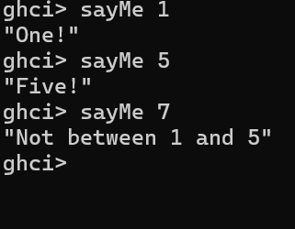
- fact :: Int -> Int
fact 0 = 1
fact n = n * fact ( n - 1 )
main = do
putStrLn "The factorial of 5 is:"
print (fact 5)
ghci> main
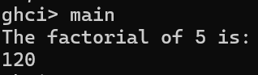
- factorialp :: (Integral a) => a -> a
factorialp 0 = 1
factorialp n = n * factorialp (n - 1)
ghci> :l factorialp.hs
ghci> factorialp 0
ghci> factorialp 5
ghci> factorialp -5
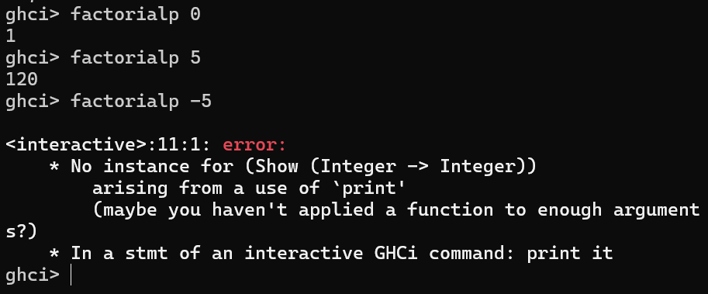
- --charName.hs
charName :: Char -> String
charName 'a' = "Albert"
charName 'b' = "Broseph"
charName 'c' = "Cecil“
ghci>:l charName.hs
ghci> charName 'a'
ghci> charName 'c'
ghci> charName ‘h'
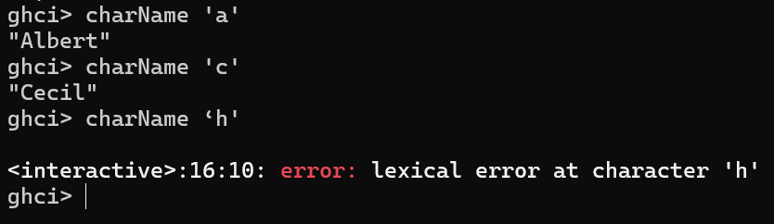
- Add charName1 x = "String not defined” to the definition of charName and try again
- addVectors :: (Num a) => (a, a) -> (a, a) -> (a, a)
addVectors a b = (fst a + fst b, snd a + snd b)
ghci> :l addVectors.hs
ghci> addVectors (1,2) (3,4)
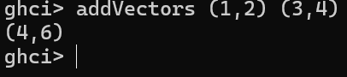
- --addVectors1.hs - with pattern matching
addVectors1 :: (Num a) => (a, a) -> (a, a) -> (a, a)
addVectors1 (x1, y1) (x2, y2) = (x1 + x2, y1 + y2)
ghci> :l addVectors1.hs
ghci> addVectors1 (1,2) (3,4)
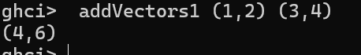
- - - tripletFunctions.hs
first :: (a, b, c) -> a
first (x, _, _) = x
second :: (a, b, c) -> b
second (_, y, _) = y
third :: (a, b, c) -> c
third (_, _, z) = z
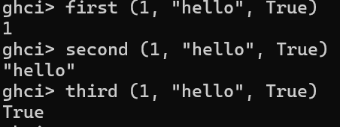
- let xs = [(1,3), (4,3), (2,4), (5,3), (5,6), (3,1)]
[a+b | (a,b) <- xs]
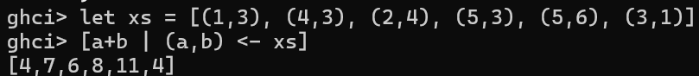
- --myhead.hs
myhead :: [a] -> a
myhead [] = error "Can't call head on an empty list, dummy!"
myhead (x:_) = x
ghci> :l myhead.hs
ghci> myhead [4,5,6]
ghci> myhead "Hello"
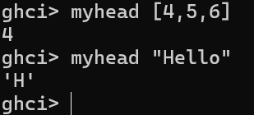

- --tell.hs
tell :: (Show a) => [a] -> String
tell [] = "The list is empty"
tell (x:[]) = "The list has one element: " ++ show x
tell (x:y:[]) = "The list has two elements: " ++ show x ++ " and " ++ show y
tell (x:y:_) = "This list is long. The first two elements are: " ++ show x ++ " and " ++ show y
ghci> :l tell.hs
ghci> tell []
ghci> tell [1]
ghci> tell [1,2]
ghci> tell [1,2,3]
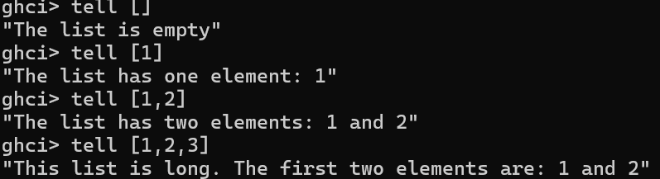
- --mylength.hs
mylength :: (Num b) => [a] -> b
mylength [] = 0 -- length of empty list
mylength (_:xs) = 1 + mylength xs -- recursive call to mylength
ghci> :l mylength.hs
ghci> mylength []
ghci> mylength [1,2,3,4,5]
ghci> mylength “Hello CSE F”
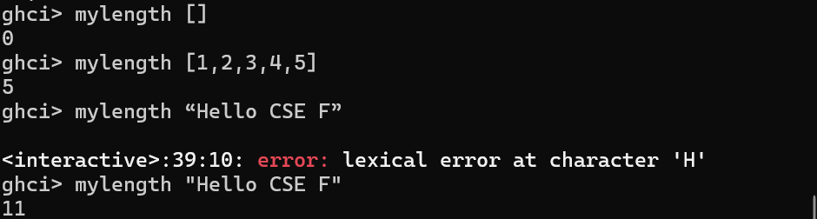
- --mysum.hs
mysum :: (Num a) => [a] -> a
mysum [] = 0
mysum (x:xs) = x + mysum xs
ghci> :l mysum.hs
ghci> mysum [1,2,3,4,5]
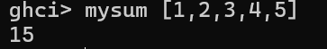
- --bmiTell.hs
bmiTell :: (RealFloat a) => a -> String
bmiTell bmi
| bmi <= 18.5 = "You're underweight"
| bmi <= 25.0 = "You're supposedly normal.”
| bmi <= 30.0 = "You’re overweight”
| otherwise = "You’re obese”
ghci> :l bmiTell.hs
ghci> bmiTell 24.3
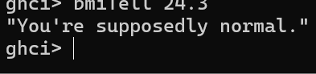
- --bmiTell1.hs
bmiTell1 :: (RealFloat a) => a -> a -> String
bmiTell1 weight height
| weight / height ^ 2 <= 18.5 = "You're underweight"
| weight / height ^ 2 <= 25.0 = "You're supposedly normal. "
| weight / height ^ 2 <= 30.0 = "You’re overweight!"
| otherwise = "You’re obese!”
ghci> :l bmiTell.hs
ghci> bmiTell1 85 1.90
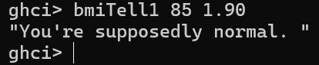
- --mymax.hs
mymax :: (Ord a) => a -> a -> a
mymax a b
| a > b = a
| otherwise = b
ghci> :l mymax.hs
ghci> mymax 3 2
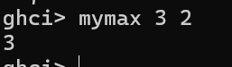
- myCompare :: (Ord a) => a -> a -> Ordering
a `myCompare` b
| a > b = GT
| a == b = EQ
| otherwise = LT
ghci> :l mymax.hs
ghci> myCompare 3 2
ghci> 3 `myCompare` 2
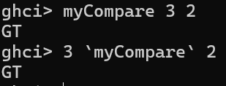
- roots :: (Float, Float, Float) -> (Float, Float)
roots (a,b,c) = (x1, x2) where
x1 = e + sqrt d / (2 * a)
x2 = e - sqrt d / (2 * a)
d = b * b - 4 * a * c
e = - b / (2 * a)
main = do
putStrLn "The roots of our Polynomial equation are:"
print (roots(1,-8,6))
ghci> :l whereroots.hs
ghci> main
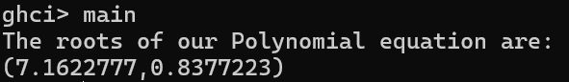
- Modify bmiTell1.hs using ‘where’ clause
bmiTell :: (RealFloat a) => a -> a -> String
bmiTell weight height
| bmi <= 18.5 = "You're underweight"
| bmi <= 25.0 = "You're supposedly normal."
| bmi <= 30.0 = "You’re overweight"
| otherwise = "You’re obese"
where
bmi = weight / height^2

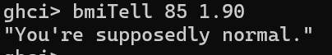
- bmiTell :: (RealFloat a) => a -> a -> String
bmiTell weight height
| bmi <= skinny = "You're underweight!"
| bmi <= normal = "You're supposedly normal."
| bmi <= fat = "You're overweight"
| otherwise = "You're obese"
where bmi = weight / height ^ 2
skinny = 18.5
normal = 25.0
fat = 30.0
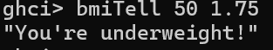
- bmiTell :: (RealFloat a) => a -> a -> String
bmiTell weight height
| bmi <= skinny = "You're underweight!"
| bmi <= normal = "You're supposedly normal."
| bmi <= fat = "You're overweight"
| otherwise = "You're obese"
where bmi = weight / height ^ 2
(skinny, normal, fat) = (18.5, 25.0, 30.0)
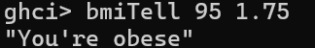

- –createInitials.hs
initials :: String -> String -> String
initials firstname lastname = [f] ++ ". " ++ [l] ++ "."
where (f:_) = firstname
(l:_) = lastname
ghci>:l createInitials.hs
ghci>initials "Abraham" "Lincoln"

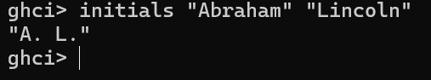
- - - surfarea.hs
cylinder :: (RealFloat a) => a -> a -> a
cylinder r h =
let sideArea = 2 * pi * r * h
topArea = pi * r ^2
in sideArea + 2 * topArea
ghci>:l surfarea.hs
ghci>cylinder 20 30
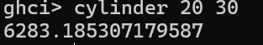
- ghci> 4 * (if 10 > 5 then 10 else 0) + 2
- ghci> 4 * (let a = 9 in a + 1) + 2
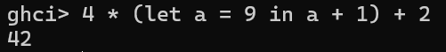
- [let square x = x * x in (square 5, square 3, square 2)]
- (let a = 100; b = 200; c = 300 in a*b*c, let foo="Hey "; bar = "there!" in foo ++ bar)
- (let (a,b,c) = (1,2,3) in a+b+c) * 100
- ghci> let zoot x y z = x * y + z
ghci> zoot 3 9 2
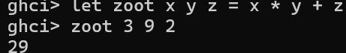
- ghci> let boot x y z = x * y + z in boot 3 4 2
ghci> boot
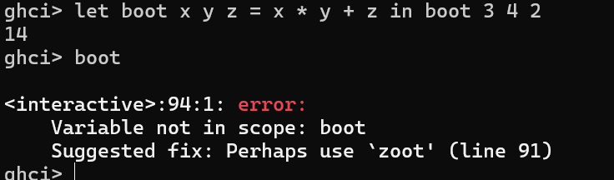
- calcBmis :: (RealFloat a) => [(a, a)] -> [a]
calcBmis xs = [bmi | (w, h) <- xs, let bmi = w / h ^ 2]
ghci>:l bmi.hs
ghci> calcBmis [(85,1.9)]
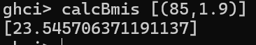
- describeList :: [a] -> String
describeList xs = "The list is " ++ case xs of [] -> "empty."
[x] -> "a singleton list."
xs -> "a longer list."
- describeList :: [a] -> String
describeList xs = "The list is " ++ what xs where
what [] = "empty."
what [x] = "a singleton list."
what xs = "a longer list."
ghci>:l listDescription.hs
ghci> describeList []
ghci> describeList [1]
ghci>describeList [1,2,3]
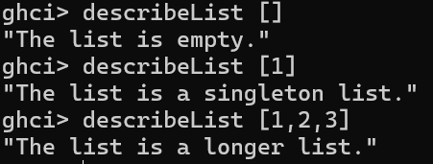

Recursion
--maxrec.hs
maxrec :: (Ord a) => [a] -> a
maxrec [] = error "maximum of empty list"
maxrec [x] = x
maxrec (x:xs)
| x > maxTail = x
| otherwise = maxTail
where maxTail = maxrec xs
ghci> maxrec "Hello World"
ghci> maxrec [5,2,3,1,4]
ghci> maxrec [454,678,989,12,1]
ghci> maxrec []
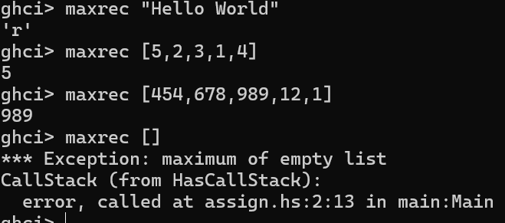
----------------------------------------------------------------------------------------------------------------
--maxrec1.hs
maxrec1 :: (Ord a) => [a] -> a
maxrec1 [] = error "maximum of empty list"
maxrec1 [x] = x
maxrec1 (x:xs) = max x (maxrec1 xs)
ghci> maxrec1 [2,5,1]
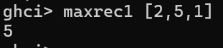
---------------------------------------------------------------------------------------------------------------
--myreplicate.hs
myreplicate :: (Num i, Ord i) => i -> a -> [a]
myreplicate n x
| n <= 0 = []
| otherwise = x:myreplicate (n-1) x
ghci> myreplicate 3 5
ghci> myreplicate 0 5
ghci> myreplicate 5 'A'
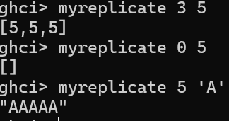
------------------------------------------------------------------------------------------------------------
--mytake.hs
mytake :: (Num i, Ord i) => i -> [a] -> [a]
mytake n _
| n <= 0 = []
mytake _ [] = []
mytake n (x:xs) = x : mytake (n-1) xs
ghci> mytake 3 [5,4,3,2,1]
ghci> mytake 0 [5,4,3,2,1]
ghci> mytake 1 []
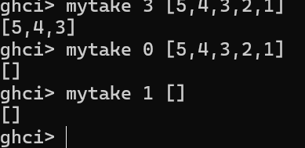
--------------------------------------------------------------------------------------------------
--myreverse.hs
myreverse :: [a] -> [a]
myreverse [] = []
myreverse (x:xs) = myreverse xs ++ [x]
ghci> myreverse [1,2,3,4,5]
ghci>myreverse “Hello”
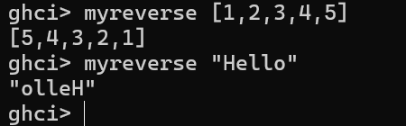
----------------------------------------------------------------------------------------------
--elem1.hs
elem1 :: (Eq a) => a -> [a] -> Bool
elem1 a [] = False
elem1 a (x:xs)
| a == x = True
| otherwise = a `elem1` xs
ghci> elem1 2 [1,2,3,4,5]
ghci> elem1 2 []
ghci> elem1 'h' "Hello"
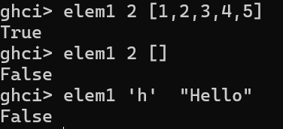
---------------------------------------------------------------------------------------------

quicksort :: (Ord a) => [a] -> [a]
quicksort [] = []
quicksort (x:xs) =
let smallerSorted = quicksort [a | a <- xs, a <= x]
biggerSorted = quicksort [a | a <- xs, a > x]
in smallerSorted ++ [x] ++ biggerSorted
ghci> quicksort [10,2,5,3,1,6,7,4,2,3,4,8,9]
ghci> quicksort "the quick brown fox jumps over the lazy dog"



