IR Temperature Sensing Project

6/25/19 - 6/26/19

Project Objective

Project Key Results/Deliverables

Project Timeline

Rationale

Data Collection Protocol

Example Scenario Data

Noise in IR Temperature Sensing

#1 while standing

Sitting Only

#1 while sitting (male)

#2 Only

#2, then #1

Preliminary Conclusions

Detection of “use”

Characterization of #1 vs. #2

Next Steps

# 

# Project Objective

* Demonstrate ability automatically classify toilet-use-case-scenarios for passive user experience.

# Project Key Results/Deliverables

* Initial assessment of data, sensors, and feasibility of signal processing route.
* Correctly classify if user has used a toilet with probability score > 90%.
* Correctly classify new incoming data as #1 or #2 with probability score > 80%.
* Written report of methodology and results, alongside assessment of future feasibility to reach future probably score of > 99%.

# Project Timeline

* Approximately 80 hours, ending September 30, 2019.

# Rationale

* Contact-less IR sensor can detect temperature from a distance
  + Attaches easily to toilet-bowl clip and pointed slightly towards inside
  + Everything exiting a human will be at body temperature and thus detectable
* Contact-less IR/photodiode sensor can detect IR RGB color wavelength intensity
  + Water vs #1 vs #2 have distinct color differences that may be identifiable

# Data Collection Protocol

* **Note: Brian can assist in the collection of more example/training data using the setup below.**
* **Note: Brian can provide existing raw data.**
* Arduino sketch loops through IR temperature reading to Serial out every 250 microseconds.
  + Run, plot in Google Sheets
* Taped IR sensor to a clip so I could easily adjust angle for testing
  + Most tests carried out at “angle 1” (left)

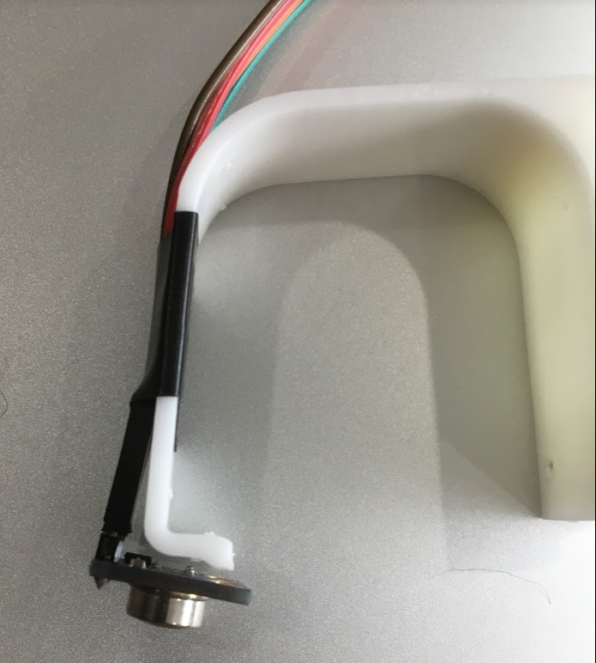 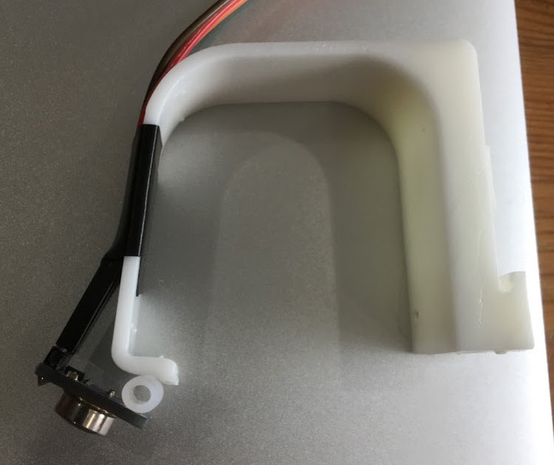

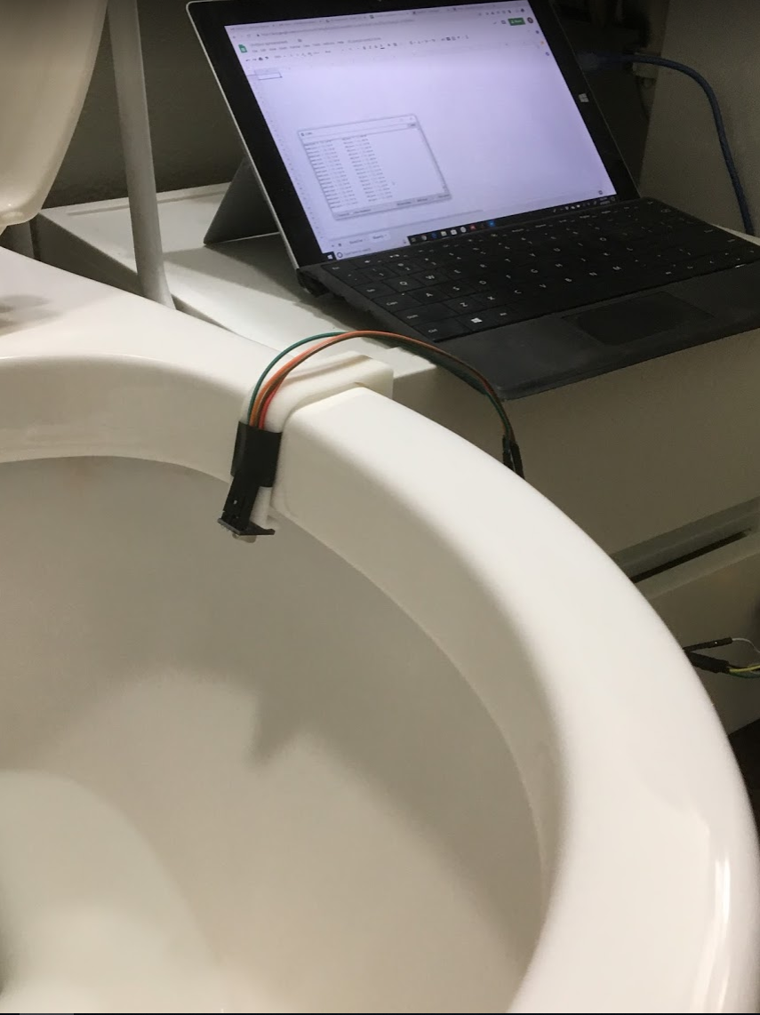

# Example Scenario Data

## Noise in IR Temperature Sensing

* Baseline readings in position with no use.

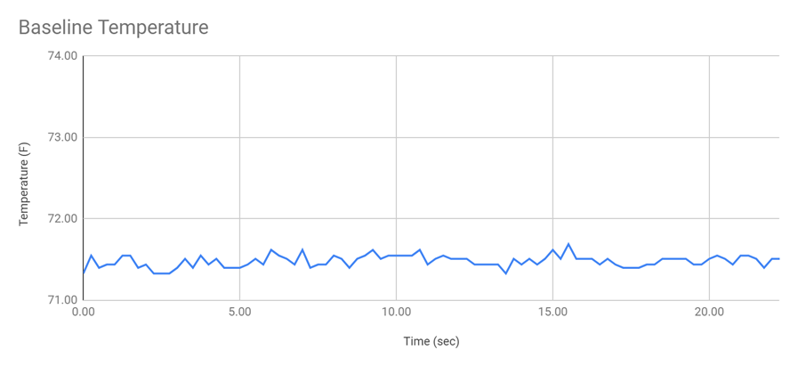

## #1 while standing

* Gradual rise in temperature from baseline
* Stays elevated, but gradually goes down
* Flushing quickly brings temperature down. Returns *almost* to baseline, not quite.

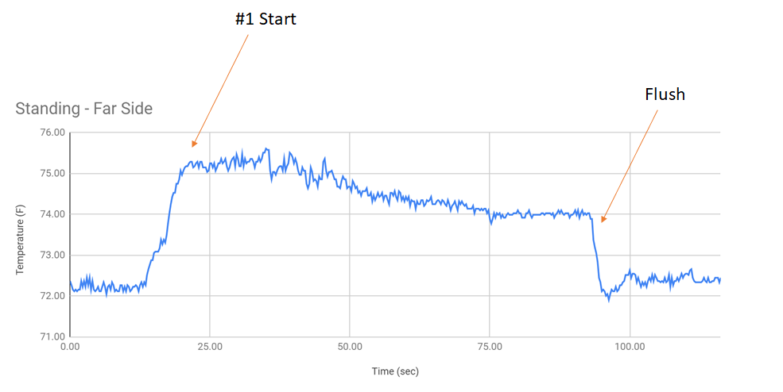

## Sitting Only

* Sitting down increases temperature slightly

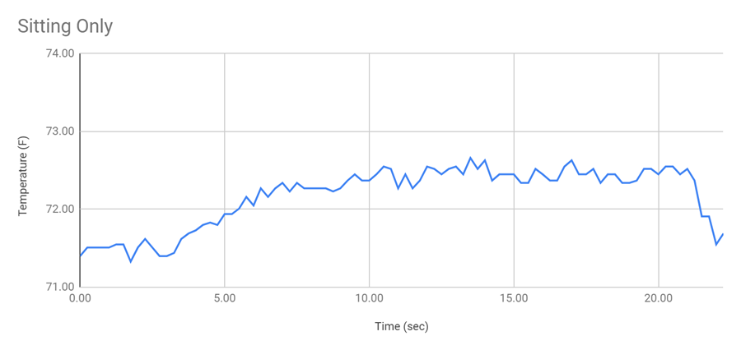

## #1 while sitting (male)

* Same gradual rise in temperature above “sitting” baseline.

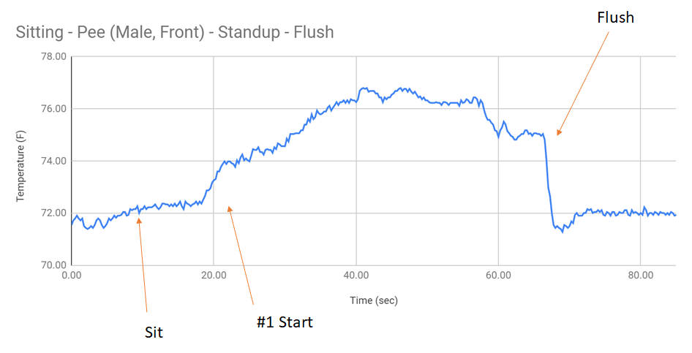

## #2 Only

* Not the same kind of gradual rise or general temperature behavior as #1.
* Often see “signature” spikes (depends on “solidity” of #2?)

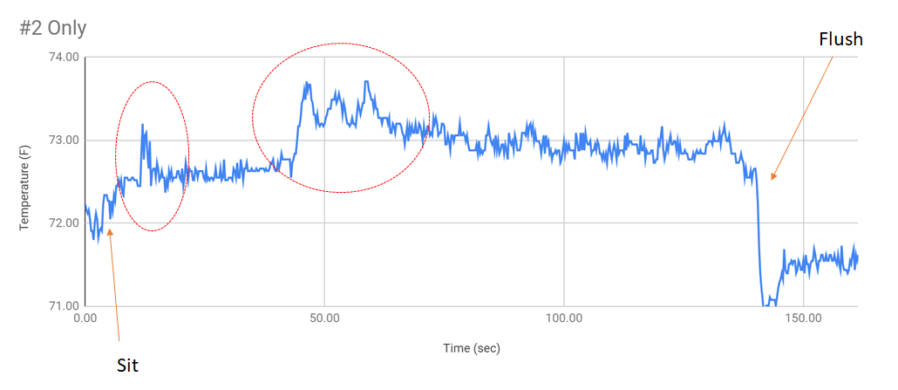

## #2, then #1

* See separate “phases,” with resembling characteristics of #2, and #1 in different parts of the plot.

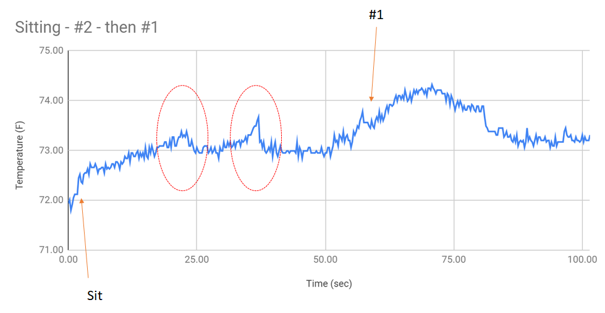

# Preliminary Conclusions

## Detection of “use”

* Appears to easily identify if someone uses the toilet
  + Very clear delineation between baseline noise and use
  + Clear delineation between sitting (only) and sitting and use

## Characterization of #1 vs. #2

* There are temperature “signatures” that appear to be able to differentiate between #1 and #2.

## Next Steps for IR Temp

* More data collection will help
  + More “use cases”
    - Female
    - Various “kinds” of #2’s
  + Test in really hot environment
    - Room temperature close to body temperature
      * Still see detection?

## RGB Sensor

* Data enclosed in Excel file.
* RBG sensor on right in image below (IR Temp on left)

