Proposal

**Group 11/Project 2**

*Vincent Adams, Tia Anderson-Ortega, Krishna Pulipaka, Sylvester Vredenburg*

**Chosen Topic and rationale**:

How is travel influencing Covid-19 rates?

**Link to data set**:

<https://data.bts.gov/Research-and-Statistics/Trips-by-Distance-Harris-County-TX/9rn3-w4e2>

<https://data.cdc.gov/Case-Surveillance/COVID-19-Case-Surveillance-Public-Use-Data/vbim-akqf>

**Three screenshots of relevant visualizations**:

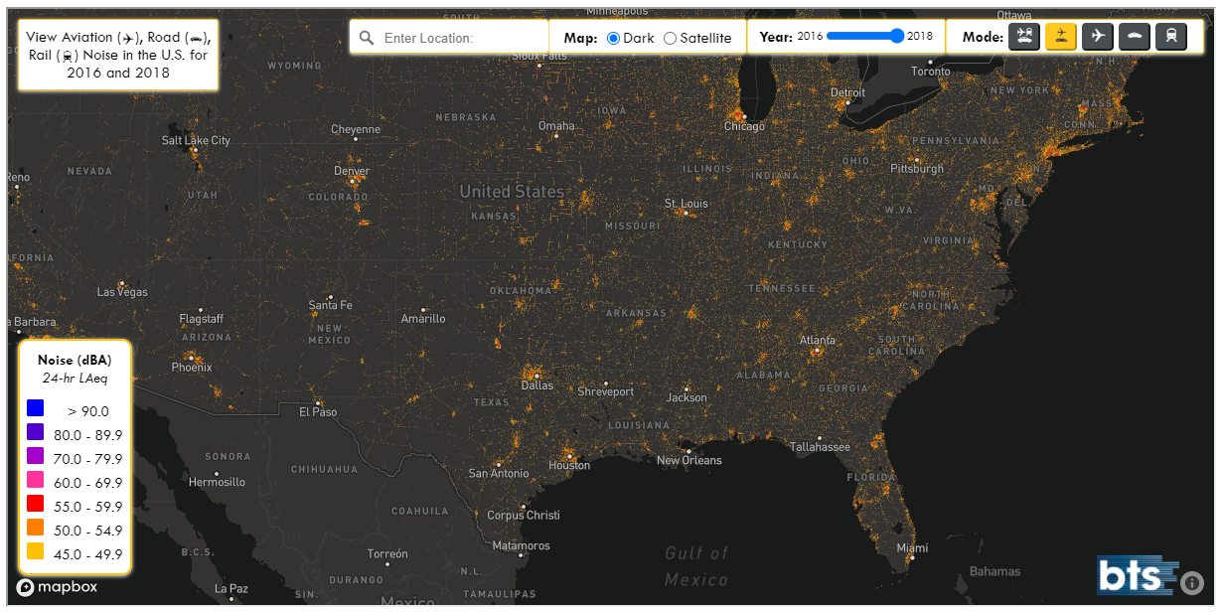

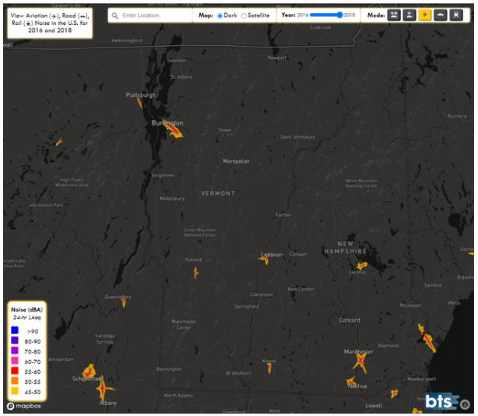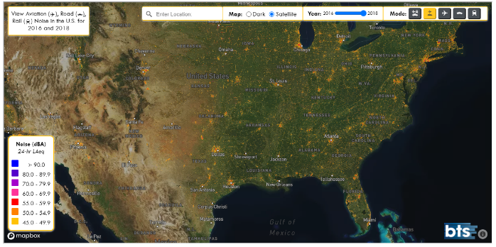

**Sketch of final design**: 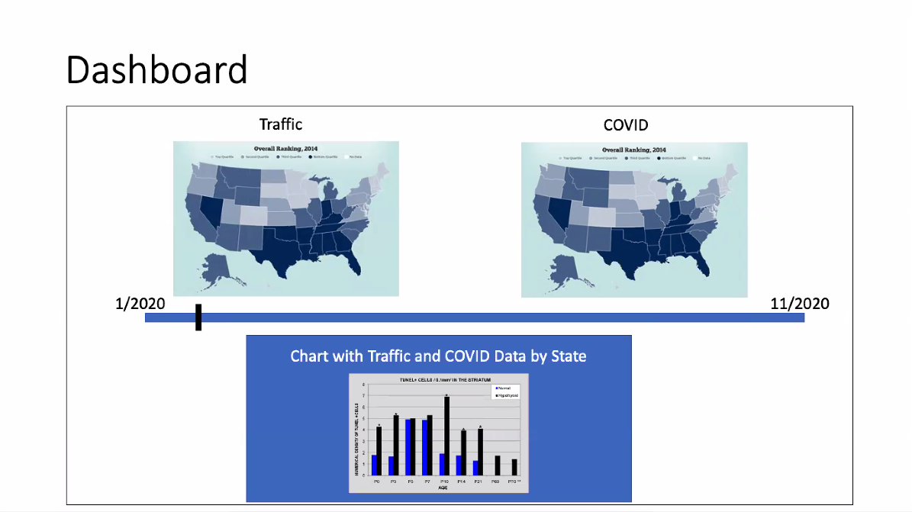

**Link to GitHub repository**: svredenburg98/Traveling-And-COVID19-Cases