**CSE 5345 Lab # 1 – OPNET**

**Fall 2018**

Swetha Vijaya Raghavan

1001551229

**Lab Exercises**

**Question 1:** Analyze the graphs that compare the Delay and Throughput of the four scenarios. What are the effects of utilizing PCF and fragmentation on these two statistics?

1. The following graph is the resultant of graphs that compare the Delay and Throughput for the four scenarios.

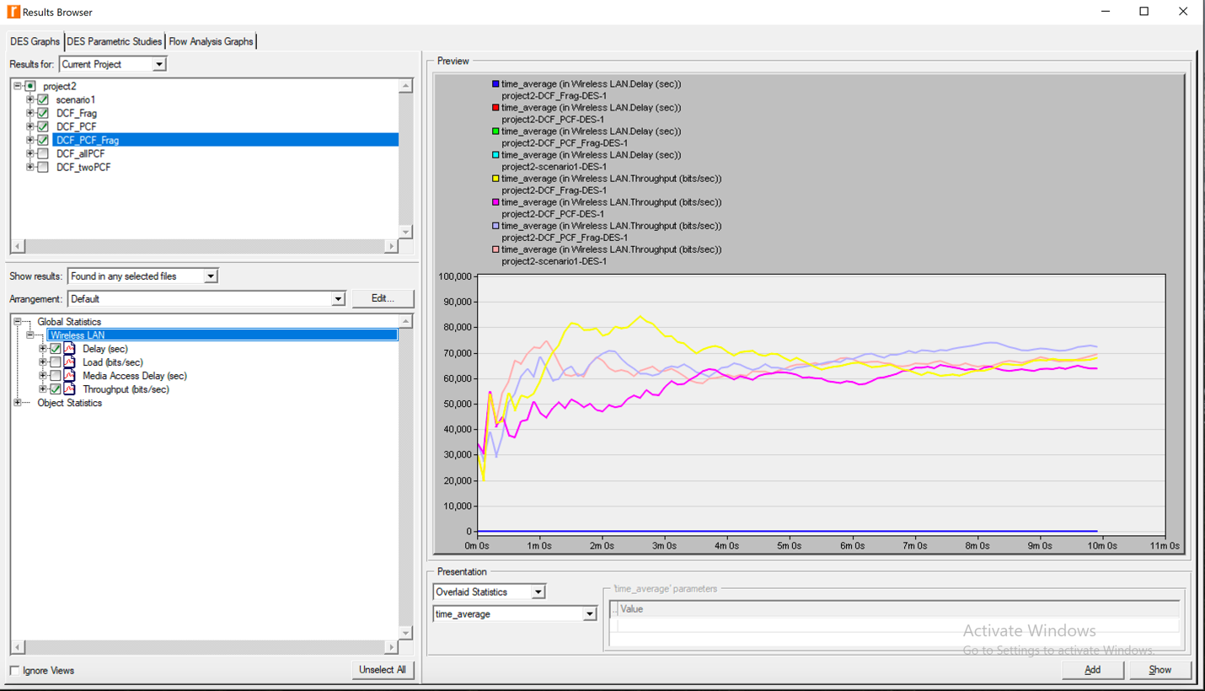

Fig1. Delay(sec) & Throughput(bits/sec) for Four Scenarios

From the graphs, we can see that utilizing PCF can reduce the delay. With PCF enabled, it generates contention free periods (CFP), and there is less contention in the network. Since the medium in DCF will be idle, if the contention gets reduced, and the serving process will be efficient, the delay will get reduced. The graphs also indicate that PCF can enhance the throughput. It is because with PCF enabled, there is less delay, the station can deal with data transmission for a longer time, in this way, the throughput gets increased. To the effect of utilizing fragmentation, it can be found that the delay gets increased. As every fragment is sent and acknowledged respectively, fragmentation raises the collision in the network, and so the delay increases. We can also see that fragmentation decreases the throughput, because delay increases, the station has less time for transmission.

So, the effects of utilizing PCF and fragmentation on the end to end delay are that without PCF or fragmentation of data, the delay is increased significantly. While if only fragmentation is enabled, the delay is even greater.

As PCF and fragmentation are enabled, throughput increases, but if fragmentation of data is enabled alone, functionality of the network drops substantially.

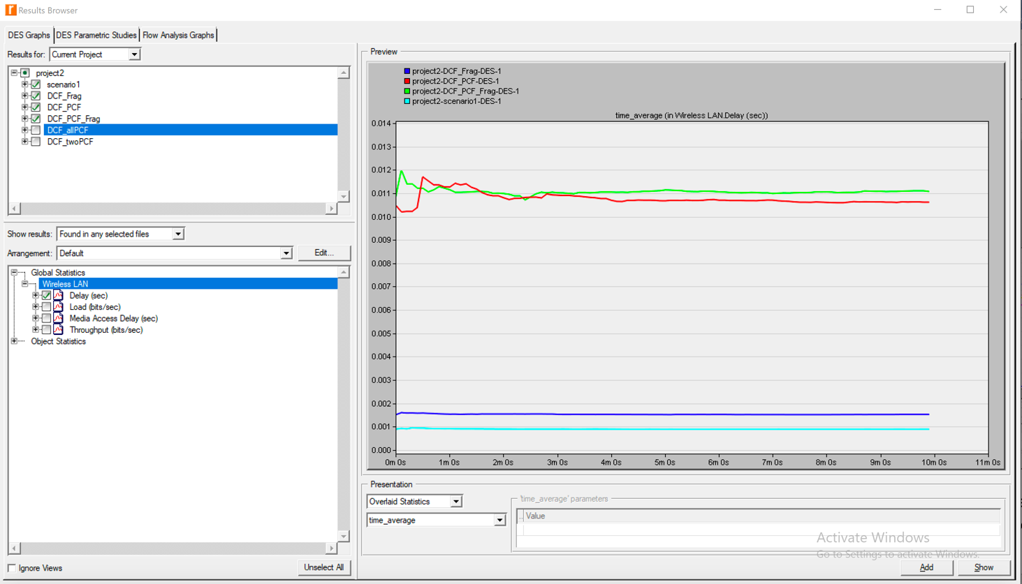

Fig2. Delay(sec) for Four Scenarios

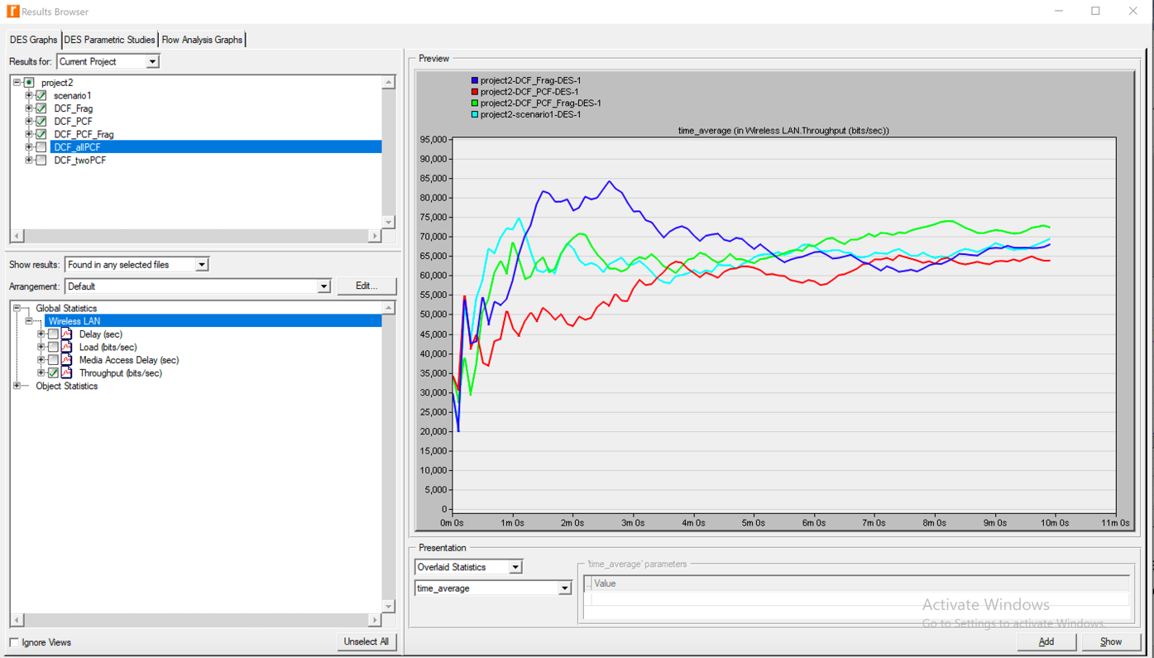

Fig3. Throughput(bits/sec) for Four Scenarios

**Question 2:** From the last four graphs, explain how the performance of a node without PCF is affected by having PCF enabled in other nodes in the network.

Consider the graphs, node 5 has PCF enabled and node 4 does not. We can see the effect PCF has on both LAN Delay and Retransmission Attempts in the PCF_DCF scenario. Since PCF is enabled in node 5, it experiences fewer delays and retransmissions as PCF knows which station can transmit next allowing for fewer collisions and fewer delays. Since a part of network working with PCF will decrease the load of the whole network, which in turn can make the other node work better. In the figures below, before running PCF, the retransmission attempts are very high, but after some node takes the PCF, the retransmission attempts for the node which does not run the PCF will also reduce.

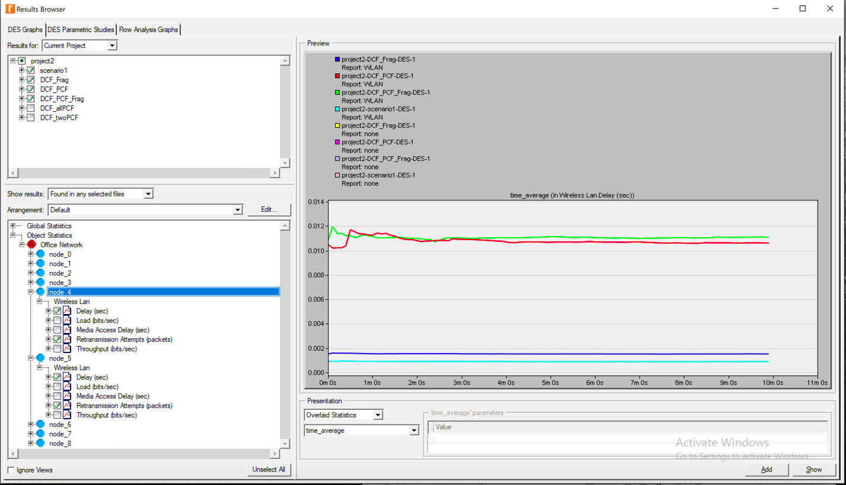

Fig4. Delay(sec) & Retransmission Attempts(packets) for Four Scenarios (PCF Enabled – Node 5, PCF disabled – Node 4)

Fig4. 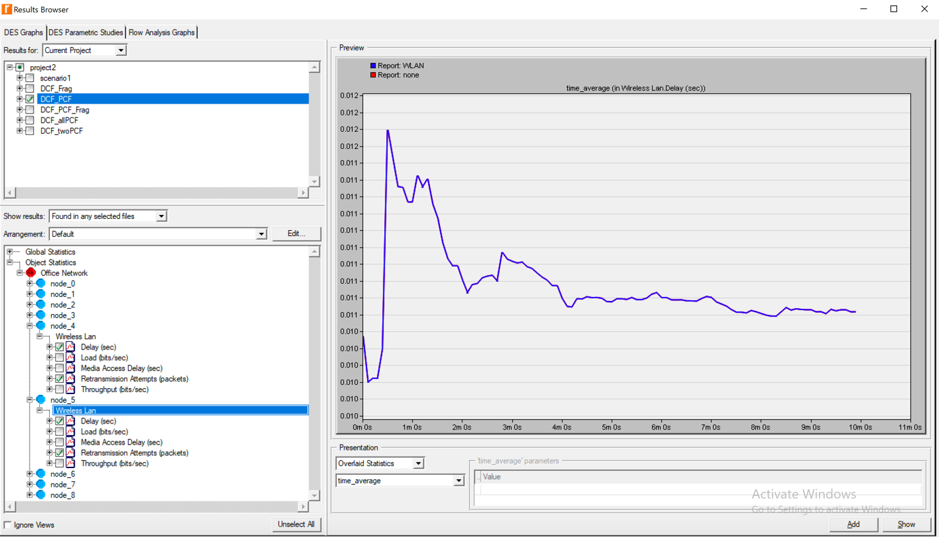

Fig5. Object Statistics hierarchy: PCF enabled in the **DCF_PCF** scenario (node 5), PCF disabled (node 4) Delay(sec) & Retransmission Attempts(packets) as statistics.

**Question 3:** Create two new scenarios as duplicates of the **DCF_PCF** scenario. Name the first new scenario **DCF_allPCF** and the second new scenario **DCF_twoPCF**. In **DCF_allPCF**, enable the PCF attribute in all eight nodes: node_1 through node_8. (Note: Do not include node_0 in any of your attribute editing.) In **DCF_twoPCF**, disable the PCF attribute in node_3 and node_5 (this will leave only node_1 and node_7 with PCF enabled). Generate the graphs for the **Delay, Load**, and **Throughput** statistics, and explain how the number of PCF nodes might affect the performance of the wireless network.

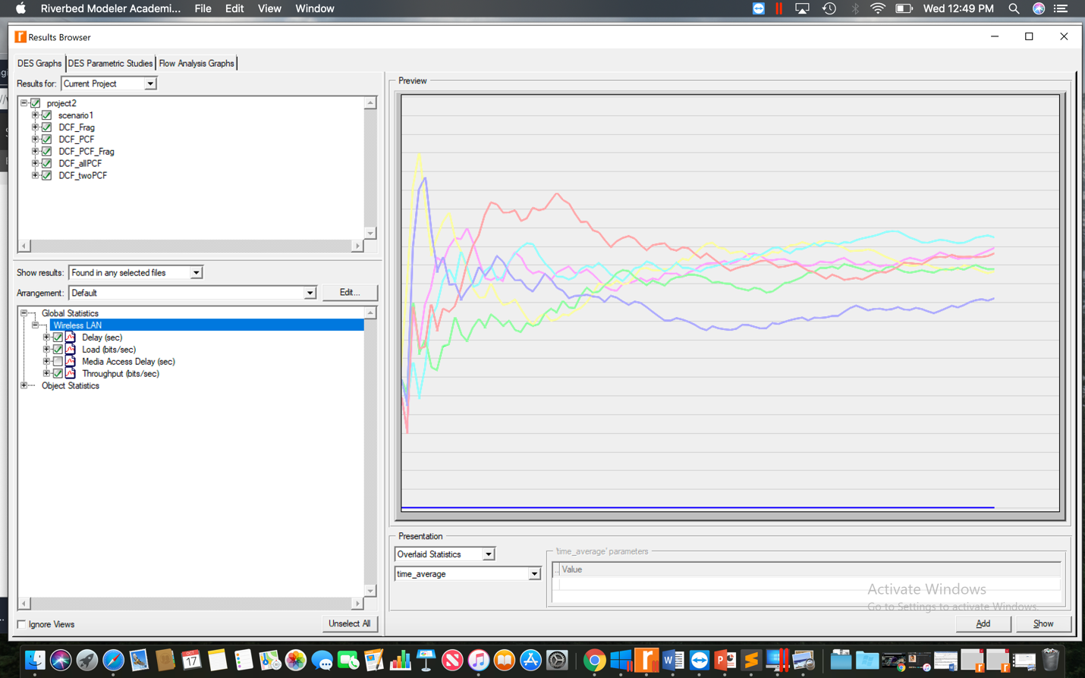

Fig6. Delay(sec), Load(bits/sec) & Throughput(bits/sec) for Six Scenarios

Individual Graphs:

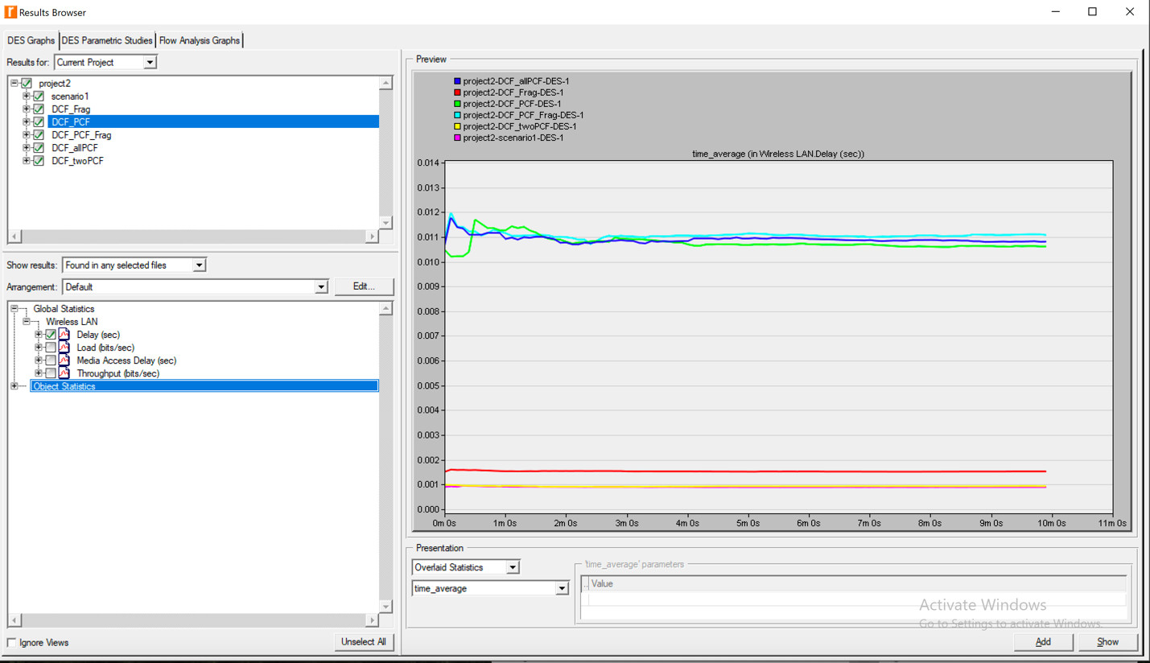

Fig7. Delay(sec) for Six Scenarios

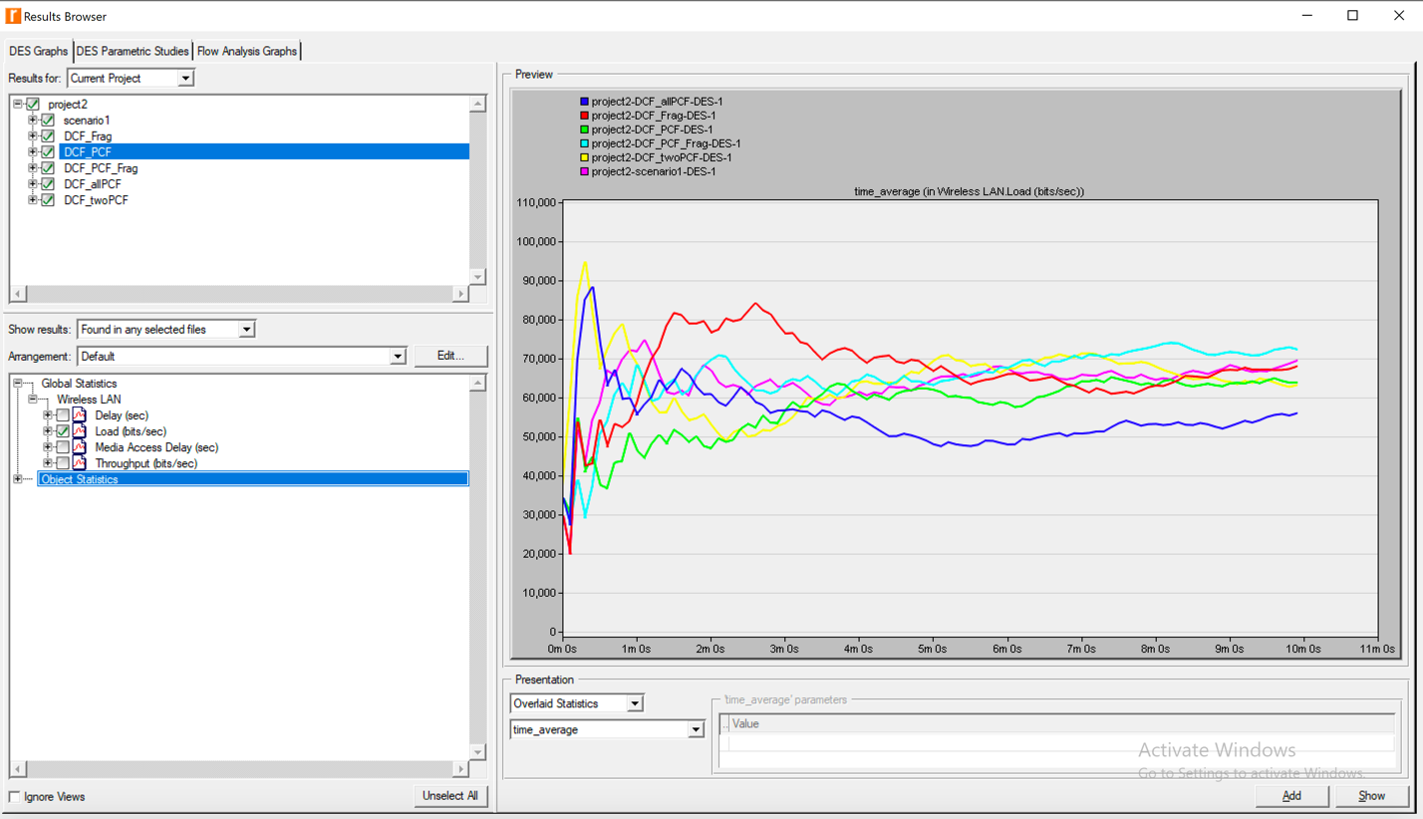

Fig8. Load(bits/sec) for Six Scenarios

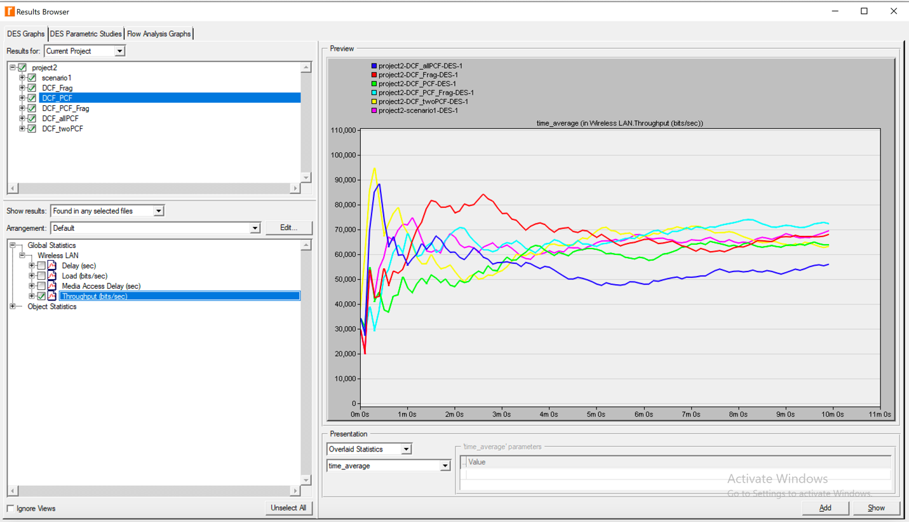

Fig9. Throughput(bits/sec) for Six Scenarios

If we consider just DCF_PCF scenario when comparing to these new scenarios we have just created, there is a lot more fluctuations in delay times. As we add more PCF enabled wireless LAN Stations these delays begin to stabilize. It is a bit hard to read **Fig8** which shows the load of these stations as the amount of bits/sec transmitted are all over the place. We can clearly see that if we add more stations that have PCF enabled, on an average the performance is lowered. In the figure **Fig9** which shows the throughput, it is evident that as the number of PCF stations increases, the throughput also increases. This is due to the concept that these stations already have information as to which station to transmit to next saving time spend configuring routes.

**Question 4:** For all scenarios, select the Media Access Delay statistic from the Global Statistics· Wireless LAN hierarchy. Rerun the simulation for all scenarios. Generate the graph that compares the Media Access Delay statistic of all scenarios. Analyze the graph, explaining the effect of PCF, fragmentation, and number of PCF nodes on media access delay.

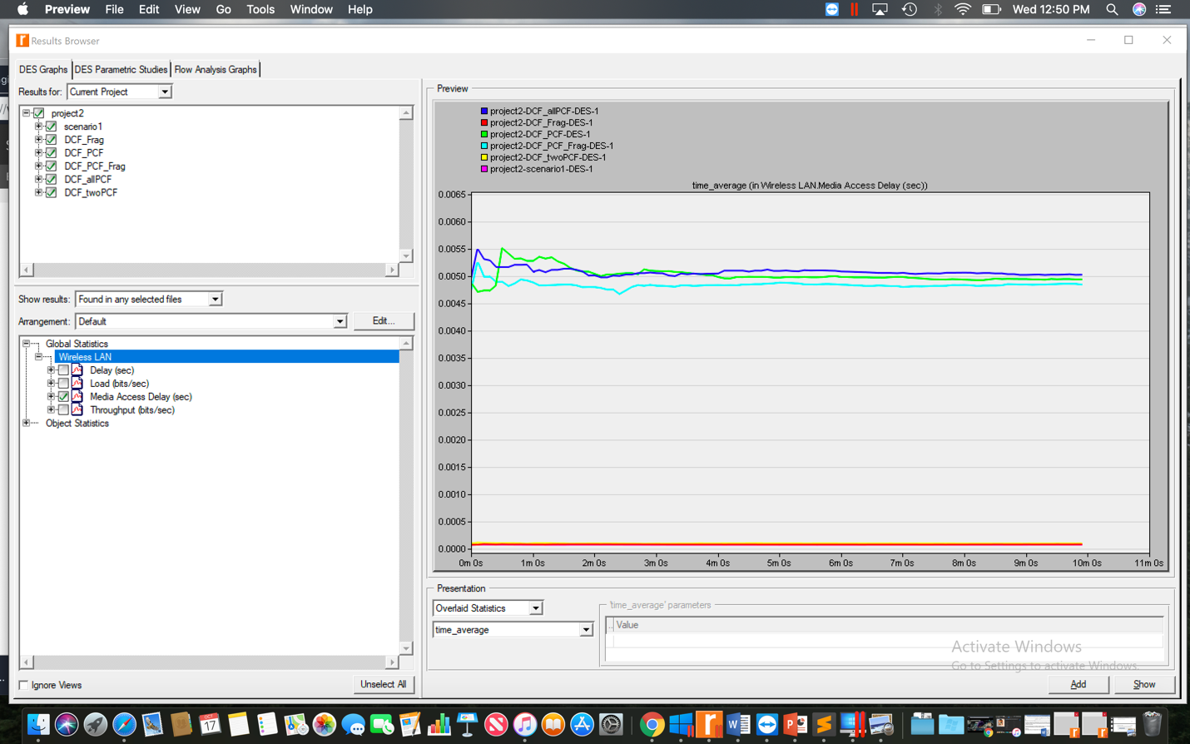

Fig10. Media Access Delay(sec) for Six Scenarios

Usually the DCF with packet fragmentation graph has the highest delay rate. I think this is the slowest because the data has to be separated and then reassembled which will consume the most time and effort. When adding stations with PCF enabled on them, we see that the delay decreases, but as we convert all stations to having PCF, we see that delay rate drops substantially.

References: <https://www.it.iitb.ac.in/~sri/papers/dot11-iccc02.pdf> , Wikipedia, Wireless Communictions & Networks (2nd Edition) By William Stallings