CSE 5345 Lab 2 Swetha Vijaya Raghavan

1001551229

AODV Versus DSR (MANET Communications)

Steps performed to obtain the resultant graph for MANET and simulated the performance of DSR and AODV

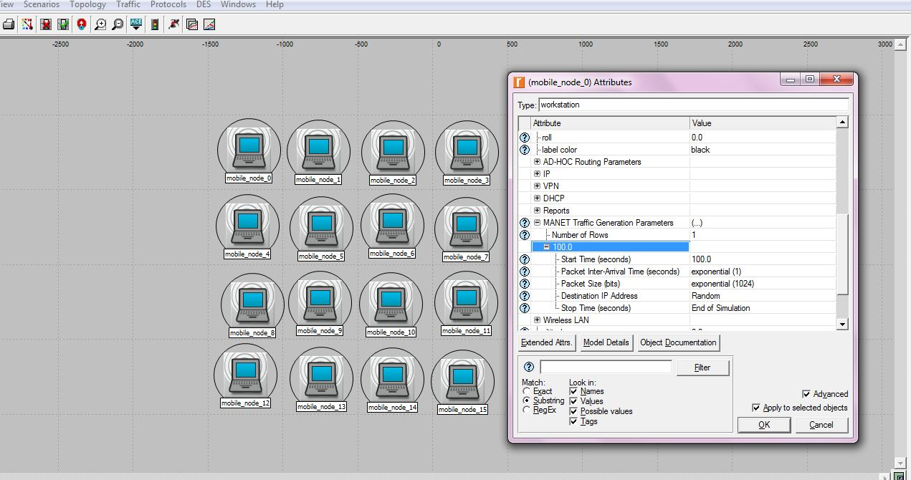

Fig 1: Manet Simulation Layout Along With traffic generation parameters

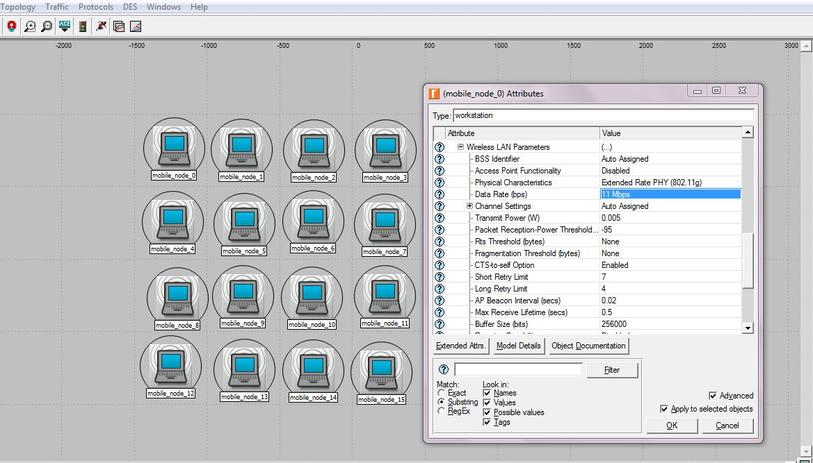

Fig 2: Manet Simulation Layout Along With Wireless LAN parameters

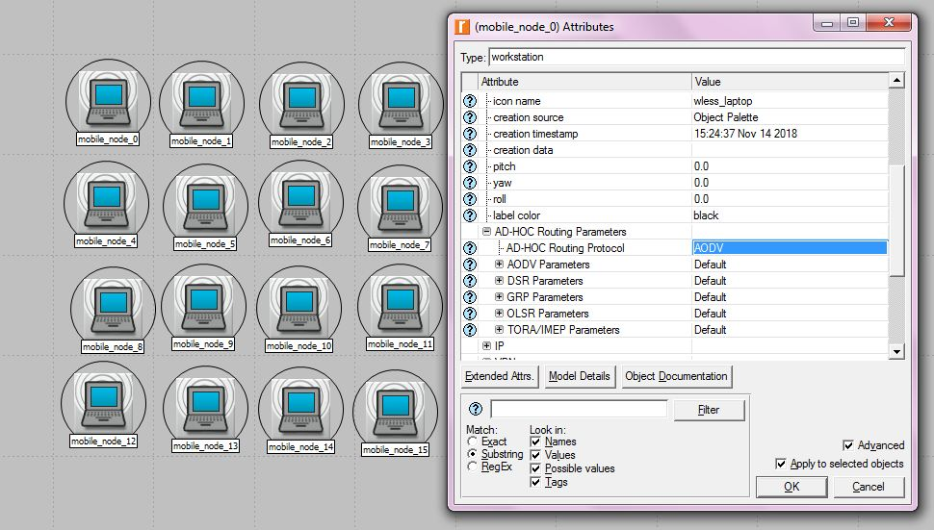

Fig3: Manet Simulation Layout Along With AD-HOC Routing parameters for AODV

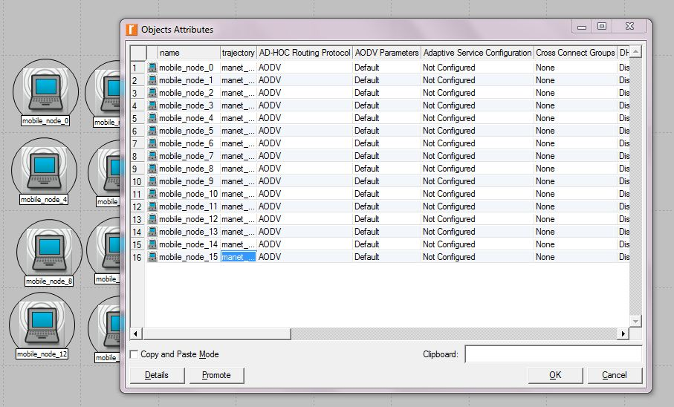

Fig 4: Manet Simulation Layout Along With Object Attributes

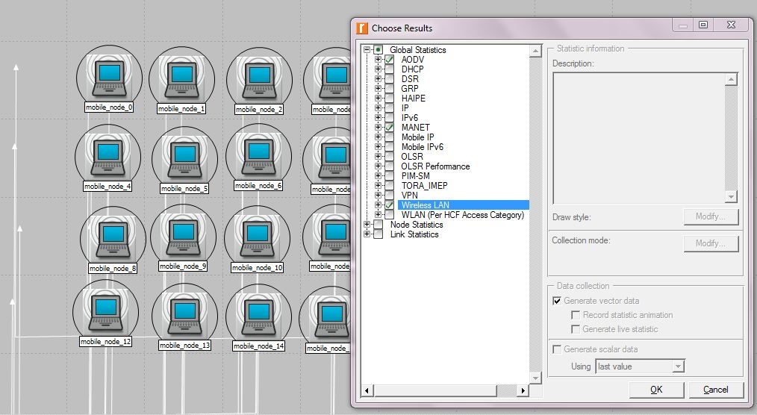

Fig 5: Manet Simulation Layout Along With Configuring Statistics for AODV

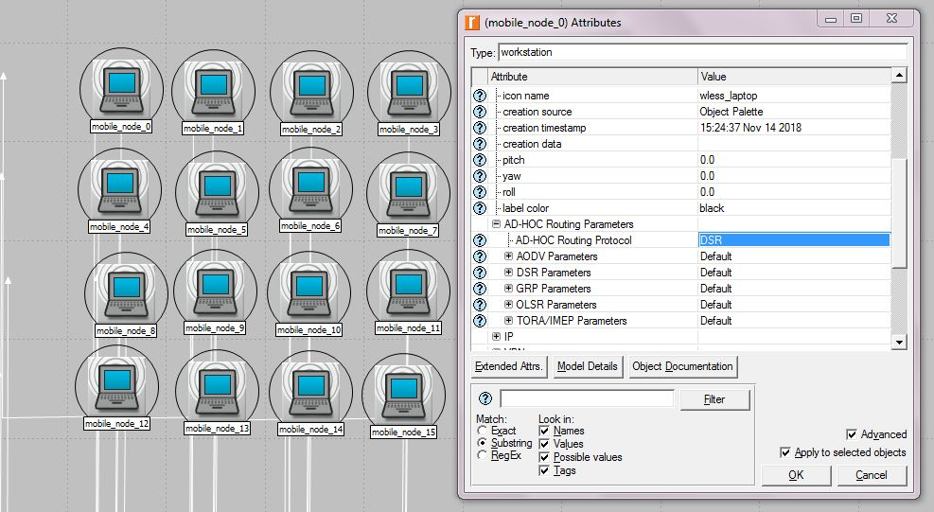

Fig 6: Manet Simulation Layout Along With AD-HOC Routing parameters for DSR

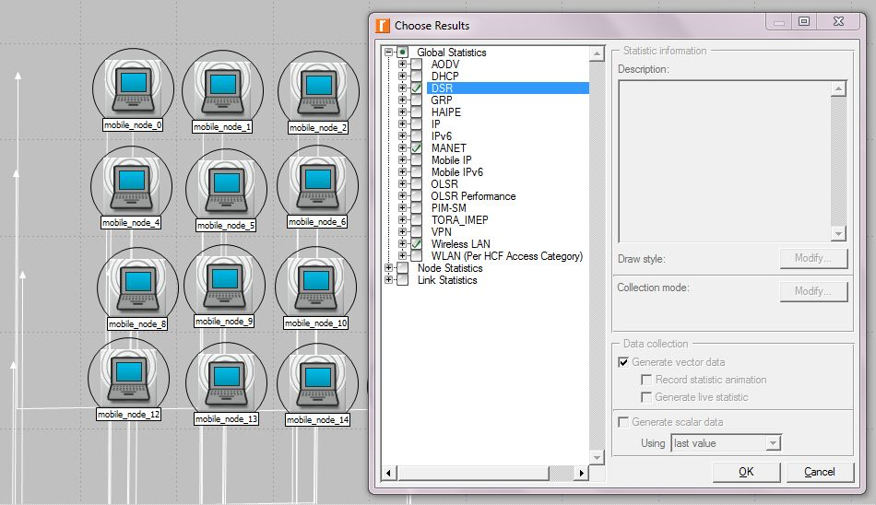

Fig7: Manet Simulation Layout Along With Configuring Statistics for DSR

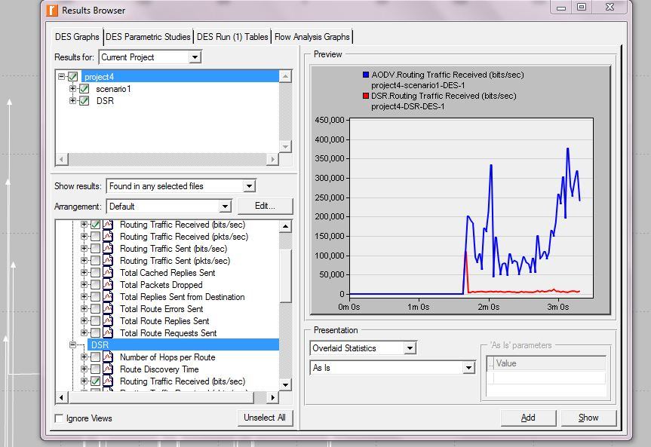

Fig 8: AODV and DSR Results

Question1: Study the AODV and DSR MANET routing protocols. Provide main differences and similarities.

* Dynamic Source Routing (DSR) is based on source routing for multi hop where as Ad Hoc On-Demand Distance Vector Routing(AODV) is based on combination of both Destination sequenced Distance Vector Routing(DSDV) and Dynamic Source Routing(DSR). AODV uses On demand mechanism of DSR and hop by hop routing, sequence numbers as well as periodic beacons from DSDV.
* DSR does not use periodic advertisements in other words it is a reactive protocol. DSR is similar to AODV in a case where it forms a route on demand when transmitting node request one. But in intermediate device, instead of using routing table, DSR uses source routing.
* AODV also a reactive protocol and is a routing protocol for mobile ad hoc networks (MANETS) and other wireless ad hoc networks where as DSR is for wireless mesh networks. AODV is used in ZigBee which is a low power, low data rate wireless ad hoc network.
* DSR computes the routes and maintains them. AODV uses destination sequence numbers to ensure loop freedom every time which avoids Bellman Ford count to infinity problem.

For the entire project, my scenario 1 - AODV

Question2: Display and compare Global Statistics like Number of Hops per Route, Route Discovery Time, and Routing Traffic Received for the AODV and DSR scenarios. Based on your study in 1, can you explain two differences?

scenario 1 - AODV

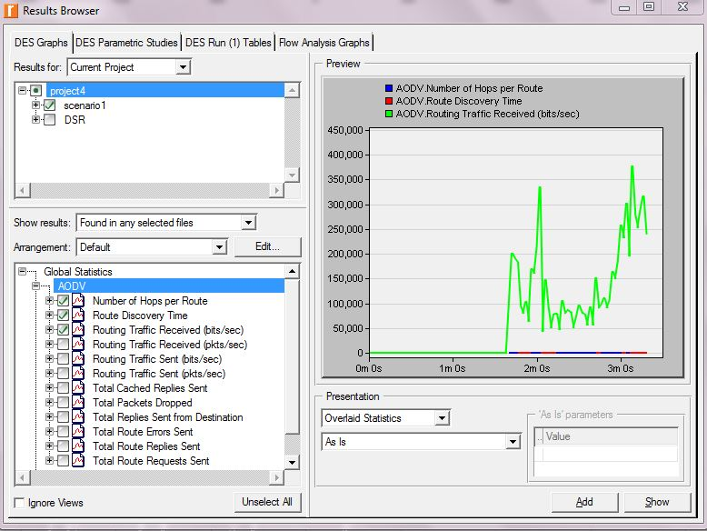

AODV

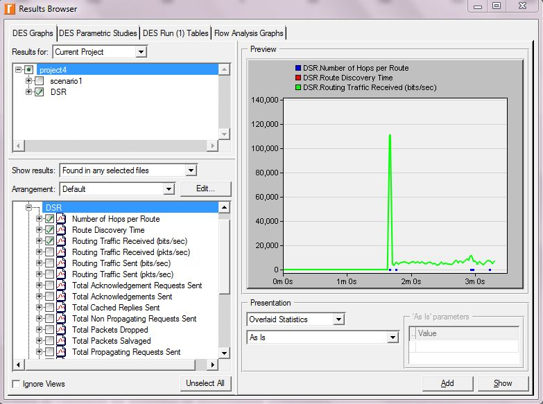

DSR

Differences:

* In AODV, number of hops per route, Route Discovery Time is null whereas in DSR number of hops per route is null and cannot depict Route Discovery Time in DSR.
* In AODV, Routing Traffic is more fluctuating (many peaks) than DSR, the highest peak is between 350,000 – 400,000 bits whereas in DSR the only one peak is between 100,000 - 120,000 bits.
* In DSR, few of the hops at 2m 0s are at the peak starting and ending.
* In AODV, the traffic null till 1m 75s close to 2m0s, after that more fluctuations are there whereas in DSR the traffic is null till 1m 85s very close to 2m0s.

Question 3: Display and compare Global Statistics for MANET, like, Delay, Traffic Received, and Traffic Sent. Can you explain two differences?

scenario 1 - AODV

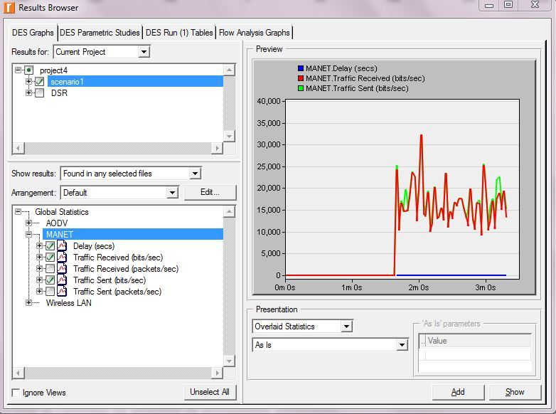

AODV : Global Statistics for MANET

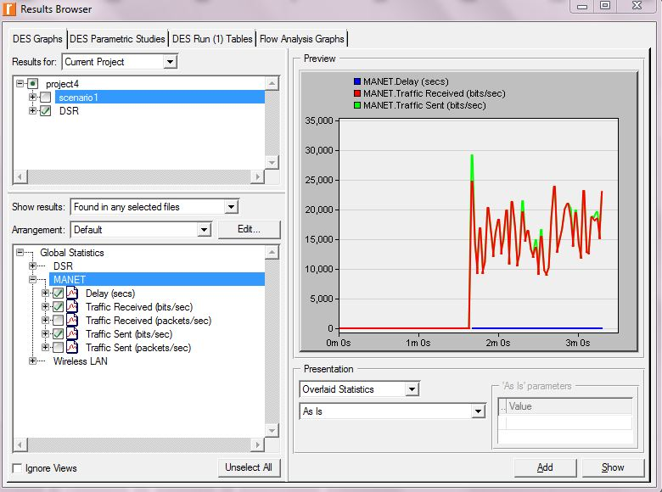

DSR : Global Statistics for MANET

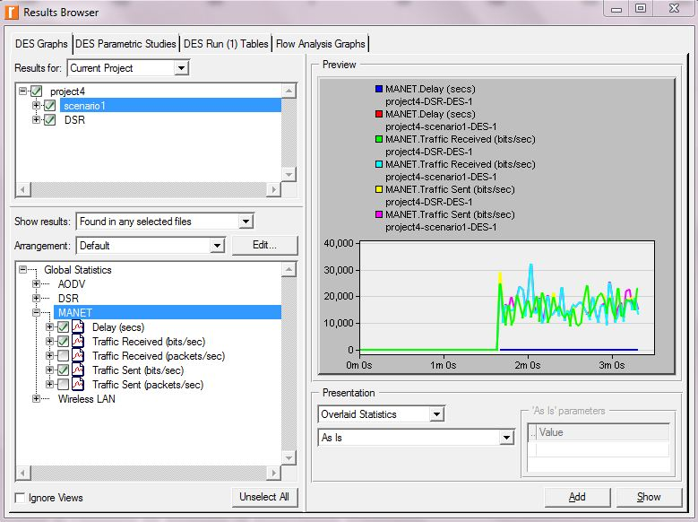

AODV & DSR : Global Statistics for MANET

Differences:

* In AODV : Global Statistics for MANET, Traffic Received(bits/sec) is attaining the highest peak than Traffic Sent(bits/sec) whereas In DSR: Global Statistics for MANET, it’s the reverse. i.e, the highest peak is for Traffic Sent(bits/sec) than Traffic Received(bits/sec).
* The highest peak at the Traffic Received in AODV is between 30,000 – 35,000 bits whereas in DSR, the highest peak at the Traffic Sent is between 25,000 - 30,000.
* Well in Combined AODV & DSR: Global Statistics for MANET, the Traffic Received(bits/sec) of AODV has the highest peak at approximately 33,000 bits and the next highest peak of DSR is for Traffic Sent(bits/sec) is at 30,000 bits.
* More zig zag pattern in DSR than AODV in terms of peaks of the graph. Other parameter like Delay(secs) is null in both the scenarios. Also the traffic received (bits/sec) is null till 1m 80s close to 2m 0s.

Question 4: Display and compare Global Statistics for Wireless LAN, like, Data Dropped (Retry Threshold Exceeded), Delay, Load and Retransmission Attempts? Can you explain two differences?

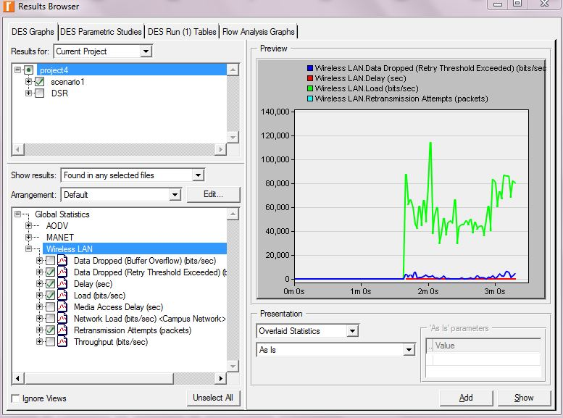

AODV: Global Statistics for Wireless LAN, like, Data Dropped (Retry Threshold Exceeded), Delay, Load and Retransmission Attempts

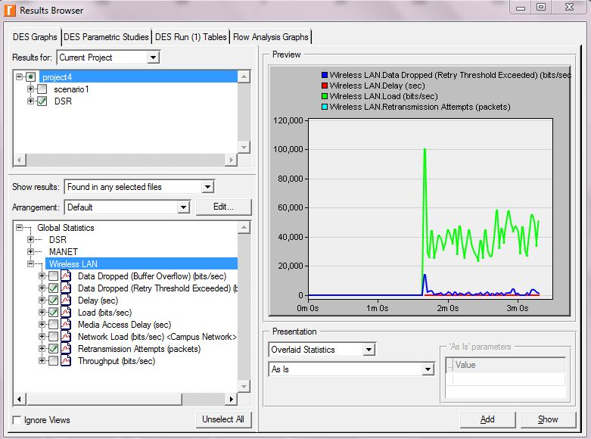

DSR: Global Statistics for Wireless LAN, like, Data Dropped (Retry Threshold Exceeded), Delay, Load and Retransmission Attempts

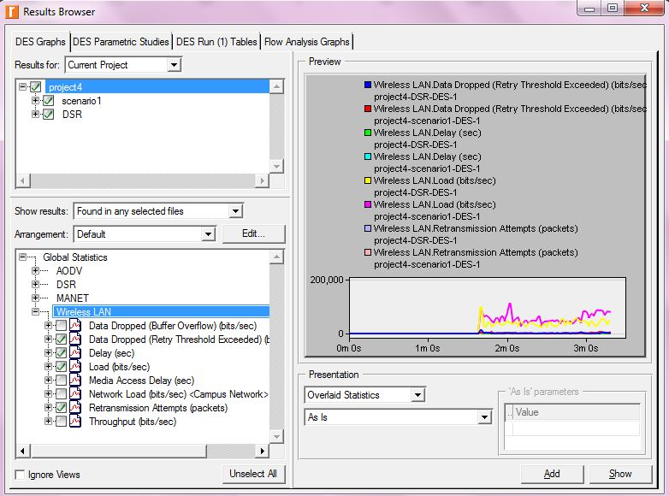

AODV & DSR: Global Statistics for Wireless LAN, like, Data Dropped (Retry Threshold Exceeded), Delay, Load and Retransmission Attempts.

Differences:

* The highest peak of Wireless LAN Load(bits/sec) of AODV is more than DSR and is at 119,000 whereas for DSR it is exactly at 100,000(bits/sec).
* At 1m80s close to 2m0s, I can see that in DSR there is a small peak of LAN Data Dropped (Retry Threshold Exceeded) bits/sec attaining close to 20,000 bits whereas that is not happening in AODV.
* Well in combined graph, LAN Load bits (bits/sec) of AODV has the highest peak at 100,000 bits whereas the next highest peak of LAN Load bits (bits/sec) of DSR is less than 100,000 bits.
* Wireless LAN Delay(sec) is null in both AODV and DSR from 2m0s. Wireless Retransmission Attempts(packets) are not visible in both the AODV and DSR graphs.
* Wireless Data Dropped (Retry Threshold Exceeded) of AODV & DSR is null till 1m80s close to 2m0s and then there are few fluctuations.

References:

<https://en.wikipedia.org/wiki/Ad_hoc_On-Demand_Distance_Vector_Routing>

<https://en.wikipedia.org/wiki/Dynamic_Source_Routing> <https://www.researchgate.net/publication/228787796_Important_Characteristic_of_Differences_between_DSR_and_AODV_Routing_Protocol>