Deciphering endophytic bacteria-mediated salinity tolerance in rice (Oryza sativa L. cv. IR-64) through physiological and biochemical responses of single isolates and dual-strain consortia
[Author Name]^{1,*}, [Co-author / Research Guide Name]¹
¹[Department], [Institution], [City, PIN], India
*Corresponding author: [e-mail address]
Abstract
Salinity limits rice yields on roughly one billion hectares of salt-affected land, and the seedling stage is where the crop is most exposed. This study tested whether six rice endophytes (IS-01 to IS-06) and five dual-strain consortia assembled from these isolates (C1-3, C1-5, C2-3, C2-5, C4-5) keep seedlings of the salt-susceptible cultivar IR-64 growing and metabolically stable under 0, 50, 100 and 150 mM NaCl. At 150 mM, salinity cut seedling vigour index (SVI) by 57.7%, chlorophyll a by 82.8%, soluble protein by 60.3% and soluble sugars by 67.5%. Inoculation did not change germination significantly (likelihood-ratio χ² = 11.61, df = 6, p = 0.071), but the inoculant × NaCl interaction was significant (p < 0.001) for every continuous growth and biochemical trait except consortium shoot length. At 150 mM, IS-06 raised chlorophyll a by 240%, soluble sugars by 169% and SVI by 142% over the salinity-matched control. Consortium C4-5 (IS-04 + IS-05) kept 80.8% of its unstressed protein, against 39.7% in uninoculated plants, and exceeded both parent strains for protein, chlorophyll a and SVI. A single growth–metabolite axis carried 51.7% of the variance in principal component analysis, and a composite membership index ranked IS-06 (0.647) and C4-5 (0.617) first under severe stress. Three pairings (C1-3, C1-5, C2-3) ranked below both parent strains, so the value of a consortium depended on which strains were combined. IS-06 and C4-5 are the strongest candidates for field evaluation.
Keywords: bacterial endophytes; microbial consortium; seed bacterization; salinity tolerance; osmolytes; photosynthetic pigments; rice
Highlights
• Six rice endophytes and five dual-strain consortia were screened under 0 to 150 mM NaCl.
• Salinity reduced seedling vigour by 57.7% and leaf soluble sugars by 67.5% at 150 mM.
• Inoculation did not alter germination significantly but protected growth and leaf metabolites.
• Isolate IS-06 and consortium C4-5 ranked highest on a composite resilience index.
• Consortium benefit depended on the partner pair; three of five pairings underperformed.
1. Introduction
Rice feeds more than half of the world's population, yet it is one of the more salt-sensitive cereals, and its sensitivity peaks during seedling establishment and again at flowering (Singh et al., 2021). The problem is large. About one billion hectares of land carry some form of salinity or sodicity (Basak et al., 2022), and irrigated rice systems in South and Southeast Asia sit squarely inside that footprint (Saleem et al., 2025). Breeding has produced tolerant cultivars, but progress is slow because tolerance is controlled by many genes acting at different growth stages (Ismail & Horie, 2017). Interventions that can be deployed within a single cropping season are therefore needed on marginal saline land.
Salt damages plants in two overlapping phases. The first is osmotic: a saline root zone lowers the water potential of the soil solution, so roots struggle to take up water and cell expansion slows within hours. The second is ionic. Sodium and chloride accumulate in older leaves, displace potassium, disturb enzyme function and speed up leaf senescence (Munns & Tester, 2008). Riding on both phases is oxidative stress. When CO₂ fixation slows, electrons pile up in the chloroplast and reactive oxygen species (ROS) form faster than the antioxidant system can remove them, damaging membranes, pigments and proteins (Gill & Tuteja, 2010). Plants respond by adjusting ion transport and metabolism and by accumulating compatible solutes such as soluble sugars, proline and glycine betaine (van Zelm et al., 2020). Because the size of these adjustments differs between genotypes and treatments, physiological markers like chlorophyll, soluble protein and sugars are widely used to score salt responses (Negrão et al., 2017).
Endophytic bacteria offer a different route to tolerance. They live inside plant tissues for at least part of their life cycle without causing disease (Hardoim et al., 2015). Rice roots, stems, leaves and seeds carry a diverse endophytic community, with Bacillus, Pseudomonas, Enterobacter and Pantoea among the genera most often isolated (Santoyo et al., 2016). Because endophytes already occupy host tissues, they are thought to face less competition from the soil microflora than rhizosphere inoculants do. Seed-borne endophytes are particularly interesting. They travel with the seed, colonize the seedling early and can be passed on vertically (Walitang et al., 2017). Their composition in rice shifts with host genotype and with salt stress itself (Walitang et al., 2018), which hints that some of these bacteria have been selected for life in a saline host.
How do these bacteria help? The best-studied mechanism is the enzyme 1-aminocyclopropane-1-carboxylate (ACC) deaminase. It breaks down ACC, the immediate precursor of ethylene, and so blunts the burst of stress ethylene that otherwise inhibits root elongation (Glick, 2014). Growth-promoting bacteria also produce indole-3-acetic acid, solubilize phosphate and other nutrients, release siderophores and, in some cases, fix nitrogen. Under salinity, a further set of traits becomes relevant. Inoculated rice plants have shown lower shoot Na⁺, better K⁺ uptake, higher antioxidant enzyme activity and altered hormone profiles (M. A. Khan et al., 2021; Asif et al., 2023), and inoculated seedlings often accumulate more soluble sugars and other osmolytes. Halotolerant strains carrying ACC deaminase have promoted rice seedling growth under salt, and salt-tolerant bacteria have improved both growth and grain yield of rice in saline soil. Microbe-mediated salt tolerance is therefore best seen as a set of complementary mechanisms rather than a single trait (Ilangumaran & Smith, 2017; Etesami & Glick, 2020).
That view leads naturally to consortia. If no single strain carries every useful trait, combining two or more compatible strains might cover more of the stress response. A meta-analysis of 51 live-soil studies found that consortium inoculation raised plant growth by 48% on average, compared with 29% for single-strain inoculation (Liu et al., 2023). Consortia have also improved wheat growth and yield under saline conditions (M. Y. Khan et al., 2022), and a ten-member synthetic community colonized rice roots together as a stable group (Moronta-Barrios et al., 2018). The case is not closed, though. Strains can compete for the same niche, and poorly matched partners may cancel each other out. Most rice studies still test either a single strain or a single mixture (Ganie et al., 2021; Wang et al., 2025). Comparisons that line up individual isolates next to consortia built from those same isolates, across germination, seedling growth and leaf biochemistry, are scarce.
A second gap is methodological. Screening papers often report dozens of traits one at a time, each with its own significance test, and rank inoculants by whichever trait looks best. That makes it hard to see whether an inoculant helps the plant as a whole or only moves one number. Standardizing traits and combining them, through indices and multivariate ordination, gives a fairer picture (Jolliffe & Cadima, 2016).
This study was built around those two gaps. The objectives were to (i) assemble dual-strain consortia from six rice endophytes and check their in vitro compatibility; (ii) compare isolates and consortia for effects on germination and seedling vigour in a laboratory assay; (iii) test the same inoculants in a polyhouse pot trial under 0, 50, 100 and 150 mM NaCl, measuring growth, photosynthetic pigments, phenolics, soluble protein, soluble sugars and DPPH radical scavenging; and (iv) rank the inoculants with salinity-induced reduction and mitigation indices, a composite membership index and principal component analysis. It was hypothesized that at least one consortium to outperform both of its parent strains under severe salinity, and that the benefit of mixing would depend on which strains were paired.
2. Materials and methods
2.1 Experimental overview
The work ran in five linked stages (Fig. 1): inoculum and consortium preparation, seed bacterization, a laboratory germination assay without salt, a polyhouse pot trial across a graded NaCl series, and leaf biochemistry on the pot-grown plants, followed by univariate, index-based and multivariate analysis.
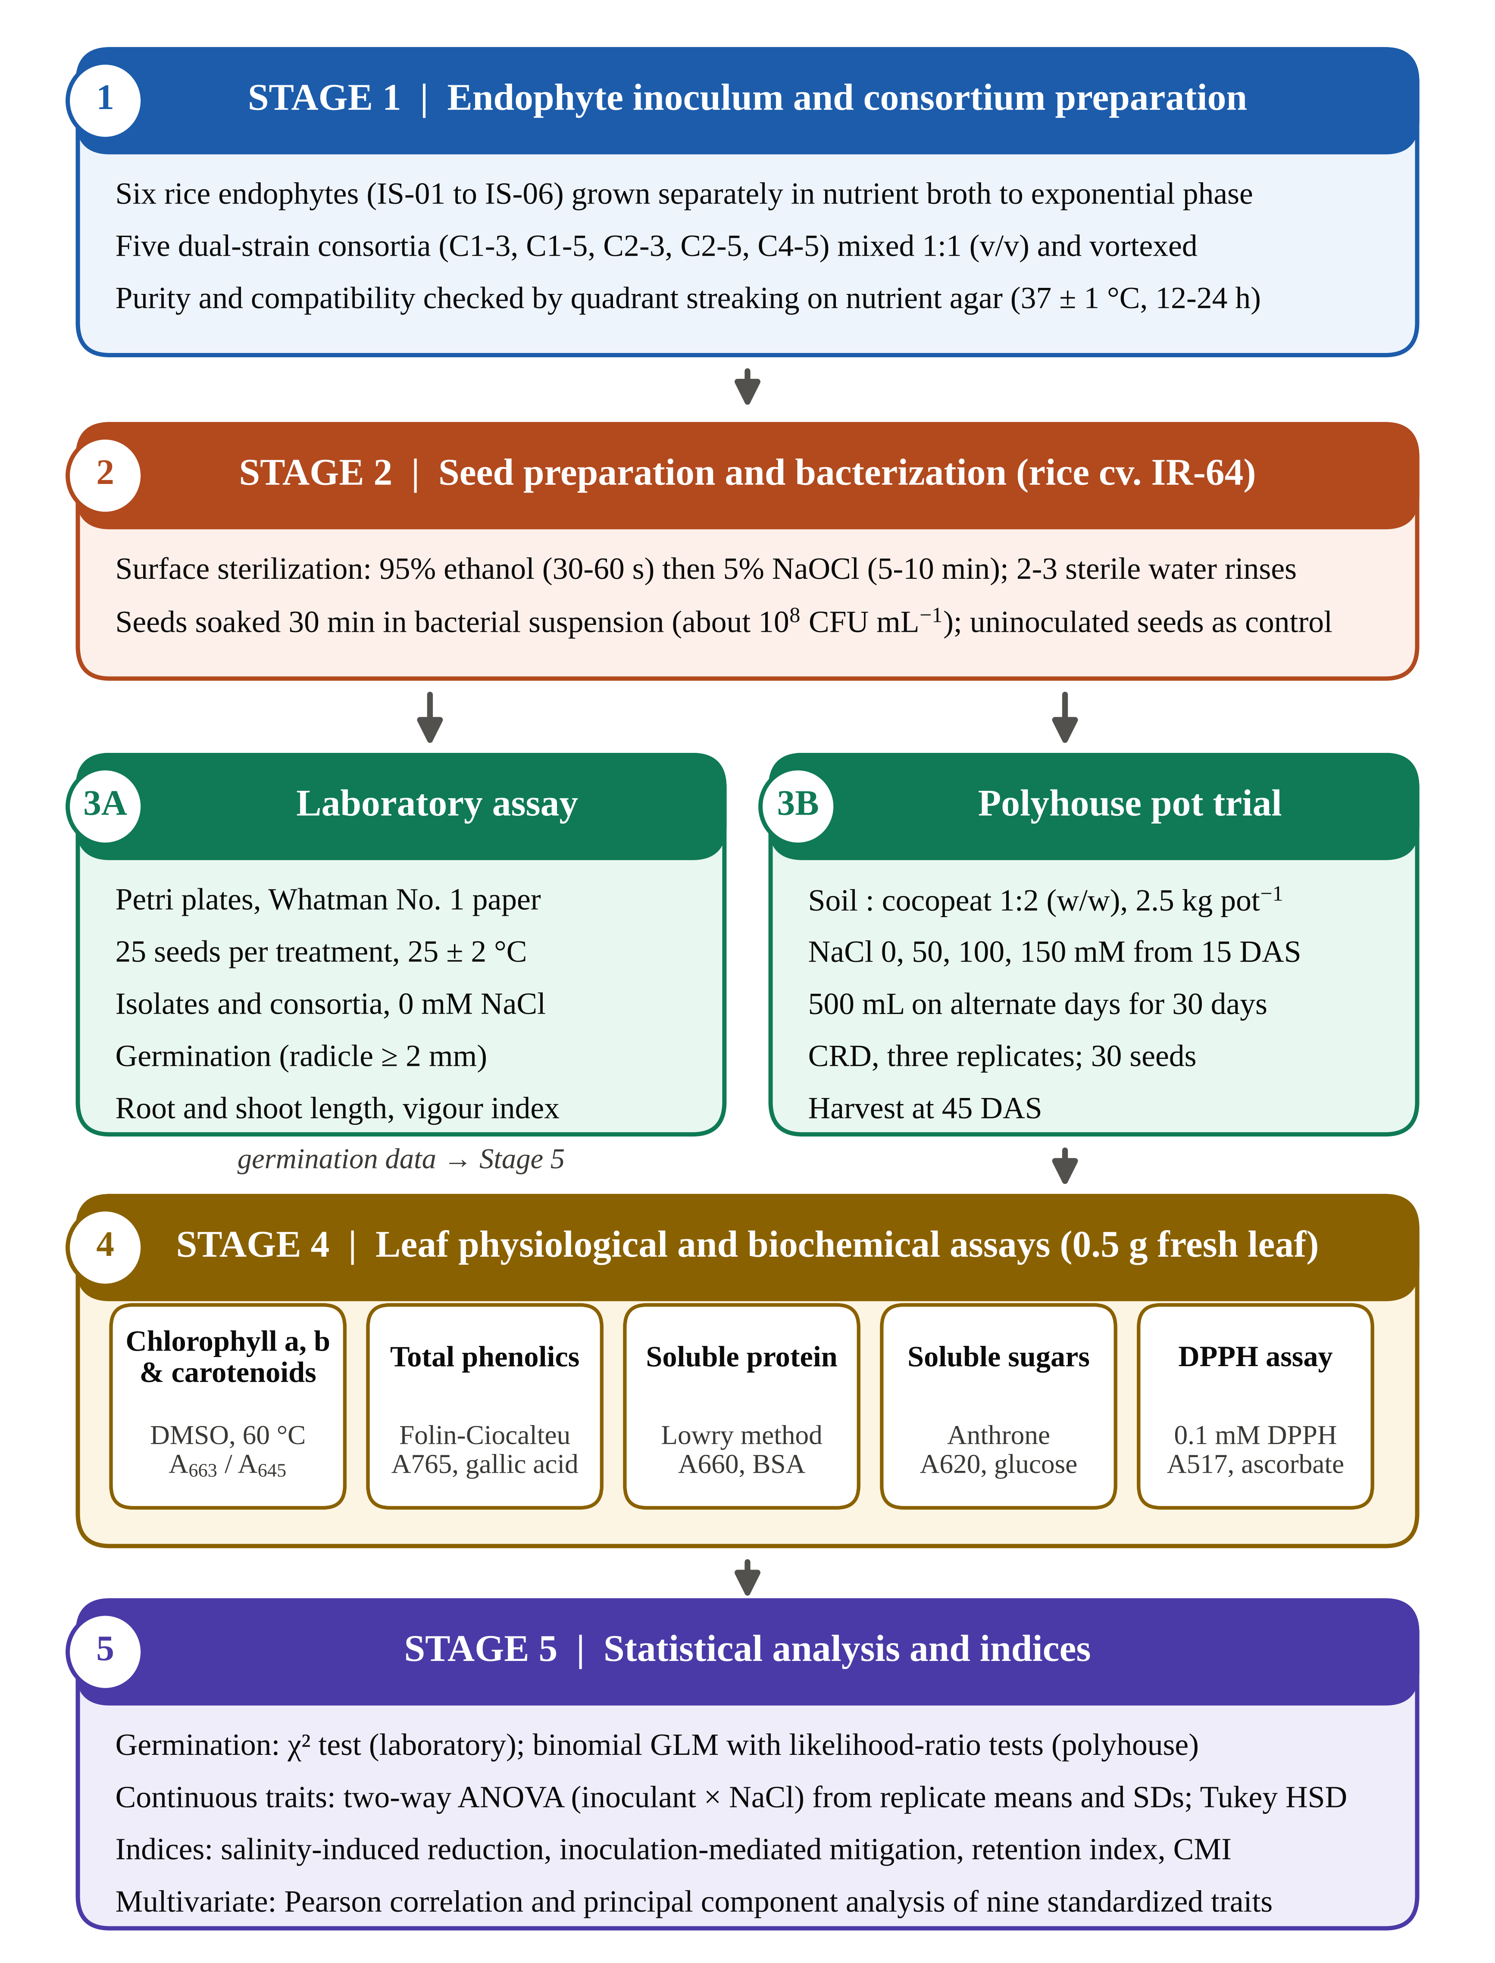
Fig. 1. Infographic flowchart of the experimental workflow. Stage 1, preparation of single-isolate inocula and dual-strain consortia with purity checks; Stage 2, surface sterilization and bacterization of rice cv. IR-64 seeds; Stage 3A, laboratory germination assay; Stage 3B, polyhouse pot trial under 0–150 mM NaCl; Stage 4, leaf biochemical assays on polyhouse plants; Stage 5, statistical analysis, derived indices and multivariate analysis. DAS, days after sowing; CRD, completely randomized design; CMI, composite membership index.
2.2 Endophytic isolates and consortium preparation
Six endophytic bacterial isolates previously recovered from surface-sterilized tissues of rice plants (IS-01 to IS-06) were grown separately in nutrient broth at 37 ± 1 °C to exponential phase. Five two-member consortia were assembled by mixing equal volumes (1:1, v/v) of the partner cultures: C1-3 (IS-01 + IS-03), C1-5 (IS-01 + IS-05), C2-3 (IS-02 + IS-03), C2-5 (IS-02 + IS-05) and C4-5 (IS-04 + IS-05). Compatibility and purity were checked by quadrant streaking on nutrient agar (37 ± 1 °C, 12–24 h), recording colony morphology, density and any inhibition zone between colony types (Walitang et al., 2017).
2.3 Seed sterilization, bacterization and NaCl solutions
Seeds of IR-64, a widely grown but salt-susceptible indica cultivar, were surface-sterilized in 95% (v/v) ethanol for 30–60 s and 5% (v/v) sodium hypochlorite for 5–10 min, rinsed two to three times in sterile distilled water and soaked for 30 min in the appropriate bacterial suspension (about 10⁸ CFU mL⁻¹); control seeds were not bacterized. NaCl solutions of 50, 100 and 150 mM (2.922, 5.844 and 8.766 g L⁻¹) were prepared in sterile distilled water, which served as the 0 mM treatment.
2.4 Laboratory germination assay
Bacterized seeds (25 per treatment) were placed on moist Whatman No. 1 filter paper in Petri dishes at 25 ± 2 °C and kept moist throughout. A seed was scored as germinated when the radicle reached 2 mm, and root and shoot lengths were measured at the end of the assay. Isolates and consortia were run as separate batches, each with its own control. The seedling vigour index was calculated as SVI = germination (%) × (root + shoot length, cm) (Abdul-Baki & Anderson, 1973).
2.5 Polyhouse pot experiment
Pots (15 cm × 18 cm) held 2.5 kg of sterilized soil and cocopeat (1:2, w/w) and were arranged in a completely randomized design with three replicate pots per treatment. The isolate experiment had seven inoculation levels (control, IS-01 to IS-06) and the consortium experiment six (control and the five consortia), each crossed with four NaCl levels (0, 50, 100 and 150 mM); 30 seeds were sown per treatment. Germination was scored as the percentage of sown seeds that produced a seedling, and seedlings were then thinned to three per pot. Salt stress was applied from the two- to three-leaf stage (15 days after sowing, DAS) with 500 mL of the relevant solution on alternate days for 30 days. Plants were harvested at 45 DAS for root and shoot length and leaf biochemistry.
2.6 Leaf biochemical assays
All assays used 0.5 g of fresh, fully expanded leaf tissue. Pigments were extracted in 5 mL of dimethyl sulfoxide at 60 °C for 30 min (Hiscox & Israelstam, 1979) and read at 663, 645 and 490 nm. Chlorophyll a and b were calculated with Arnon's (1949) equations (Chl a = 12.7 A₆₆₃ − 2.69 A₆₄₅; Chl b = 22.9 A₆₄₅ − 4.68 A₆₆₃) and are reported, like carotenoids (Lichtenthaler, 1987), as mg L⁻¹ of extract; total chlorophyll is the sum of a and b. Total phenolics were measured with Folin–Ciocalteu reagent at 765 nm against gallic acid (y = 0.009x + 0.005, R² = 0.9998) (Singleton & Rossi, 1965), soluble protein by the Lowry method at 660 nm against bovine serum albumin (Lowry et al., 1951), and soluble sugars with anthrone at 620 nm against glucose (Yemm & Willis, 1954). DPPH radical scavenging was measured at 517 nm after 30 min in the dark, with ascorbic acid as the reference, as [(A₀ − A₁) / A₀] × 100 (Brand-Williams et al., 1995; Gülçin, 2020). Because every extract was prepared from the same tissue mass in the same volume, all biochemical values are expressed per volume of extract and are directly comparable between treatments. Isolate and consortium extracts were assayed in separate batches.
2.7 Derived indices
Salinity-induced reduction in uninoculated plants was SIR = (X₀ − X_{S}) / X₀ × 100, where X₀ and X_{S} are values at 0 mM and salinity level S. Inoculation-mediated mitigation compared each inoculant with the control at the same salinity: IMM = (X_{i,S} − X_{c,S}) / X_{c,S} × 100. The retention index was RI = X_{i,150} / X_{i,0} × 100. Relative measures are preferred when treatments differ in their unstressed baseline (Negrão et al., 2017). A composite membership index (CMI) was computed by rescaling nine traits (germination, root length, shoot length, SVI, chlorophyll a, carotenoids, soluble protein, soluble sugars and DPPH scavenging) to 0–1 across all 48 treatment combinations as (X − X_{min}) / (X_{max} − X_{min}) and averaging them. Phenolics (incomplete for isolates) and chlorophyll b (batch-dependent; Section 3.3) were excluded.
2.8 Statistical analysis
Laboratory germination was compared within each batch by a χ² test of independence, with Fisher's exact test for the best inoculant against the control. Pot germination was fitted with a binomial generalized linear model (logit link; factors inoculant and NaCl), and effects were tested by likelihood-ratio (LR) χ² tests between nested models. Continuous traits were analysed by two-way ANOVA (inoculant × NaCl) computed from replicate means and SDs (n = 3) (Larson, 1992), with partial eta-squared (η_{p}²) as effect size and Tukey's HSD at α = 0.05 (Tukey, 1949); traits without recorded replicate SDs (consortium sugars and DPPH) were described only. Pearson correlations among the nine CMI traits were computed across the 48 treatment means (|r| ≥ 0.285 for p < 0.05), and principal component analysis (PCA) was run on the z-scored trait matrix (Jolliffe & Cadima, 2016). Analyses used SciPy (Virtanen et al., 2020) and statsmodels (Seabold & Perktold, 2010). Values are means ± SD of three replicates.
3. Results
3.1 Consortium compatibility and laboratory germination
All five pairings grew as uniform, stable cultures, with no inhibition zones or altered colony forms where partners met; consortium plates also looked denser than single-isolate plates. This shows that the partners can share a plate, not that the strains cooperate within the plant.
In the laboratory assay, germination ranged from 60% to 92% among isolates and 56% to 84% among consortia (Table 1), but the differences were not significant (isolates χ² = 9.40, df = 6, p = 0.152; consortia χ² = 7.02, df = 5, p = 0.219). Even IS-06 against its control (92% vs. 80%) gave p = 0.417. The clear effects were on seedling growth. IS-06 (SVI 1327.8) and IS-04 (1313.2) stood well above the control (920.2), whereas IS-02 and IS-03 fell below it; among the consortia, C4-5 produced the longest roots of the assay (90.66 ± 0.57 mm) and the highest SVI (1271.9).
Table 1. Germination and early seedling growth of rice cv. IR-64 bacterized with single endophytic isolates or dual-strain consortia in the laboratory assay (0 mM NaCl; 25 seeds per treatment).
Treatment | Germinated / total | Germination (%) | Root length (mm) | Shoot length (mm) | SVI
Single isolates (batch 1)
Control | 20 / 25 | 80 | 62.43 ± 1.19 | 52.60 ± 3.78 | 920.2
IS-01 | 19 / 25 | 76 | 55.66 ± 3.05 | 34.00 ± 4.58 | 681.4
IS-02 | 15 / 25 | 60 | 40.33 ± 0.47 | 50.66 ± 1.15 | 545.9
IS-03 | 17 / 25 | 68 | 32.33 ± 2.08 | 42.33 ± 1.52 | 507.7
IS-04 | 21 / 25 | 84 | 73.00 ± 4.35 | 83.33 ± 3.21 | 1313.2
IS-05 | 20 / 25 | 80 | 63.00 ± 1.00 | 72.33 ± 2.51 | 1082.6
IS-06 | 23 / 25 | 92 | 52.33 ± 2.51 | 92.00 ± 2.64 | 1327.8
Dual-strain consortia (batch 2)
Control | 17 / 25 | 68 | 43.50 ± 1.09 | 33.78 ± 2.30 | 525.5
C1-3 | 14 / 25 | 56 | 70.00 ± 0.00 | 44.00 ± 3.60 | 638.4
C1-5 | 15 / 25 | 60 | 63.66 ± 1.52 | 51.66 ± 2.88 | 691.9
C2-3 | 17 / 25 | 68 | 41.66 ± 2.08 | 33.33 ± 3.21 | 509.9
C2-5 | 21 / 25 | 84 | 83.66 ± 2.30 | 61.00 ± 1.73 | 1215.1
C4-5 | 20 / 25 | 80 | 90.66 ± 0.57 | 68.33 ± 2.08 | 1271.9
Root and shoot lengths are means ± SD. SVI = germination (%) × (root + shoot length, cm), recalculated from the recorded values (Abdul-Baki & Anderson, 1973). Germination did not differ among treatments within either batch (isolates: χ² = 9.40, df = 6, p = 0.152; consortia: χ² = 7.02, df = 5, p = 0.219).
3.2 Germination and seedling growth in the polyhouse
Germination declined with increasing NaCl in every treatment (Fig. 2). In uninoculated plants it fell from 83.3% at 0 mM to 60.0% at 150 mM, and the salinity effect was highly significant in both experiments (isolates LR χ² = 34.84, df = 3, p < 0.001; consortia LR χ² = 23.15, df = 3, p < 0.001). At 150 mM, IS-06 and IS-05 (70.0%) and C4-5 (76.7%) remained above the control, whereas IS-02 (56.7%), IS-03 (53.3%) and C2-3 (50.0%) fell below it. These differences lay within overlapping 95% confidence intervals, and neither the inoculant effect (isolates LR χ² = 11.61, df = 6, p = 0.071; consortia LR χ² = 10.40, df = 5, p = 0.065) nor the inoculant × NaCl interaction (p = 0.999 and 0.835) was significant. The near-parallel dose–response lines in Fig. 2 thus indicate that salt reduced germination to a similar extent irrespective of inoculation.
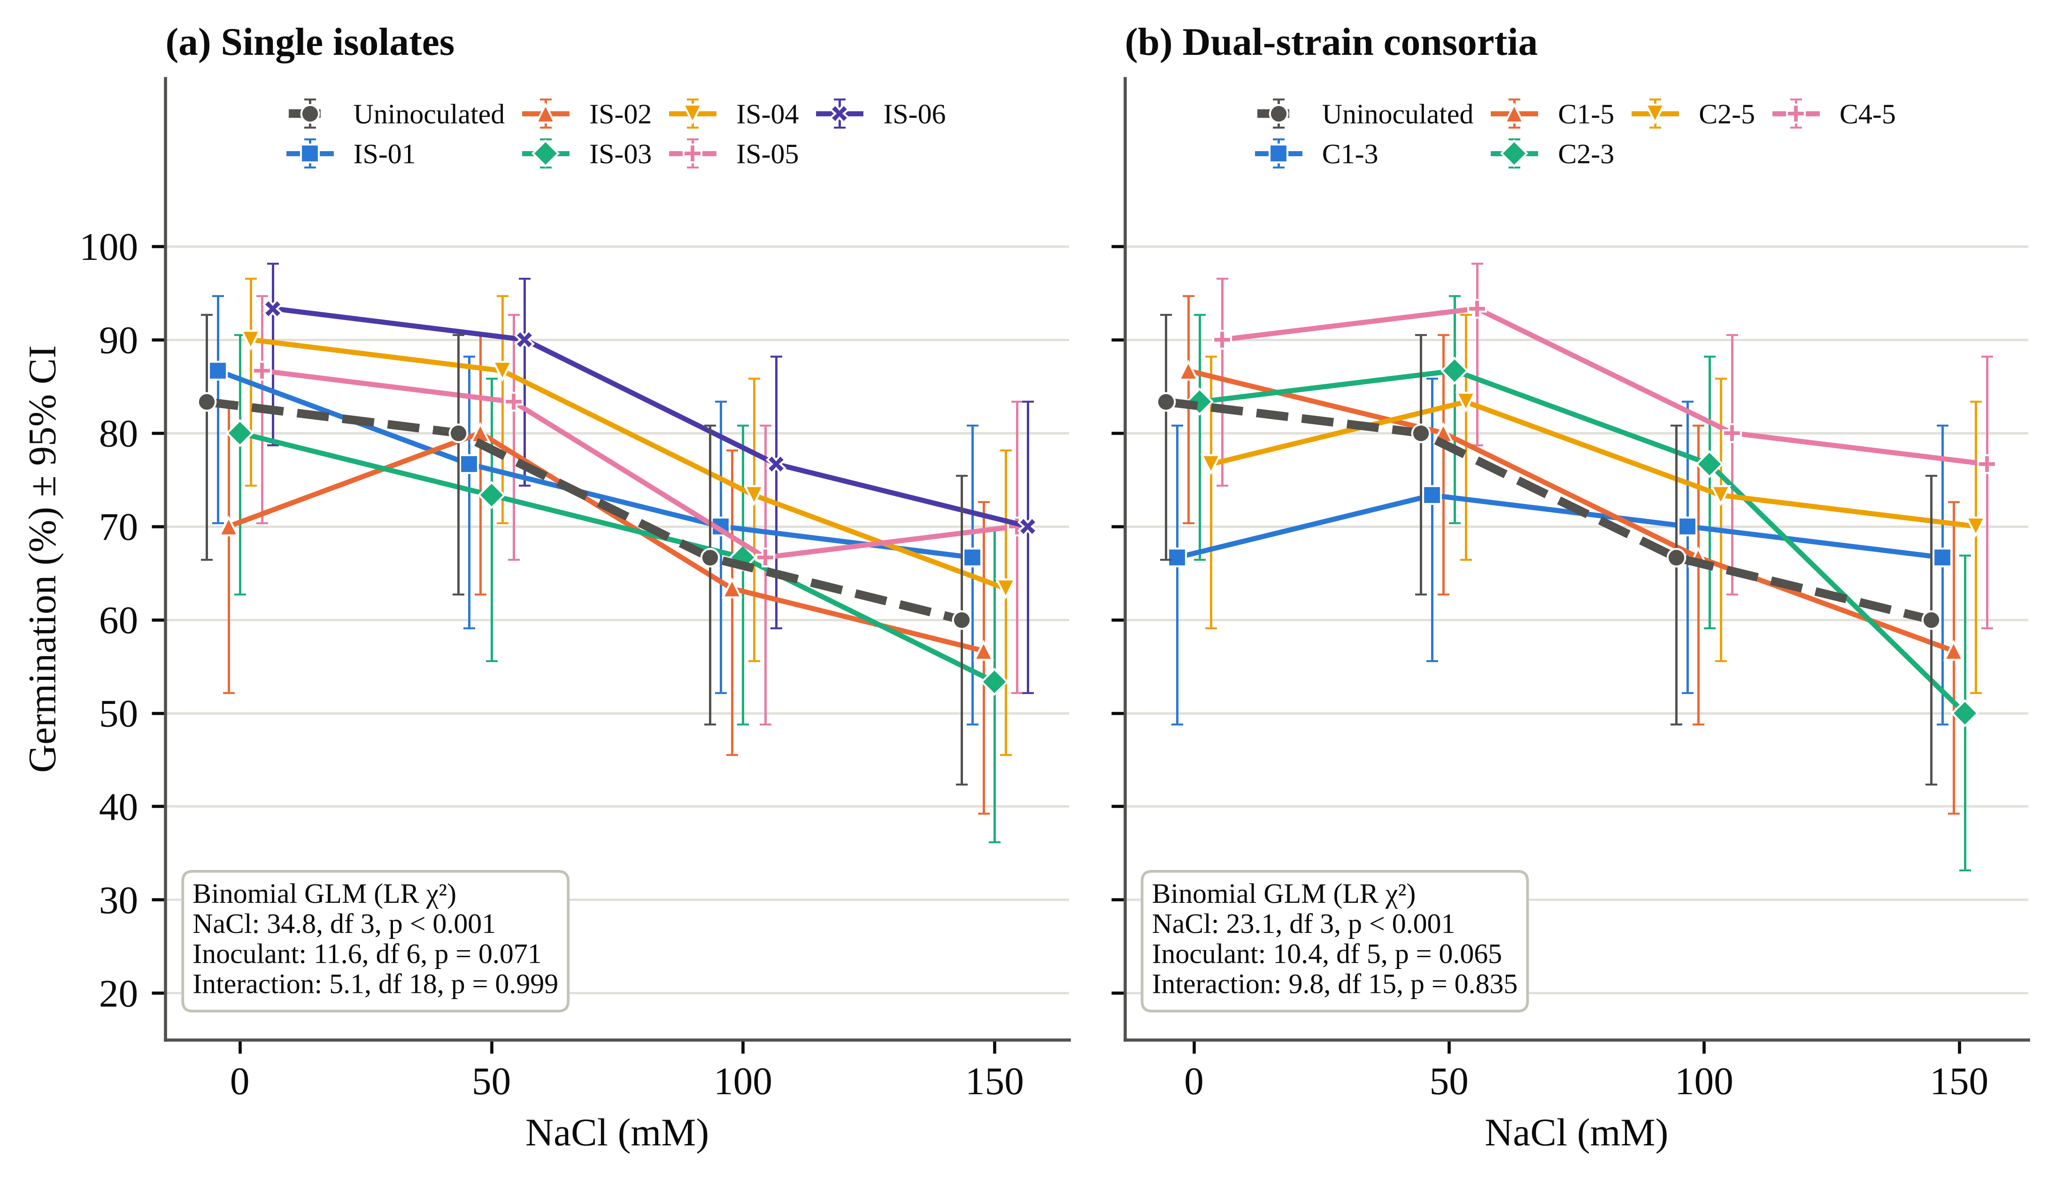
Fig. 2. Germination of rice cv. IR-64 across 0–150 mM NaCl in the polyhouse after bacterization with (a) single isolates and (b) dual-strain consortia. Points are percentages of 30 sown seeds with Wilson 95% confidence intervals; points are offset horizontally for clarity. Binomial GLM likelihood-ratio tests are given in each panel.
Seedling growth responded far more strongly. Uninoculated root and shoot length fell by 52.1% and 39.2% at 150 mM, and SVI by 57.7% (Table 2). In the isolate experiment, inoculant, salinity and their interaction all affected root length (interaction F_{18,56} = 706.4, p < 0.001; HSD 0.21 cm) and shoot length (F_{18,56} = 414.6, p < 0.001; Table 3). At 150 mM, IS-06 roots (5.02 ± 0.02 cm) and shoots (28.19 ± 0.26 cm) were 144% and 102% longer than the control. IS-05 matched IS-06 for root length, although its 100 mM root value (1.08 ± 0.08 cm) is an apparent outlier. Consortium effects on root length were also significant (F_{15,48} = 52.2, p < 0.001), led by C4-5. Consortium shoot length carried replicate SDs of 8–13 cm in several salt treatments and showed no significant effect (all p ≥ 0.39). Under salt, C4-5 kept SVI at 2235–2841, 135% above the control at 150 mM and close to IS-06 (142%; Table 2).

Table 2. Germination (%) and seedling vigour index (SVI) of rice cv. IR-64 bacterized with endophytic isolates or consortia and grown under graded NaCl in the polyhouse (30 seeds per treatment).
Treatment | Germination (%) |  |  |  | Seedling vigour index
Treatment | 0 mM | 50 mM | 100 mM | 150 mM | 0 mM | 50 mM | 100 mM | 150 mM
Uninoculated control | 83.3 | 80.0 | 66.7 | 60.0 | 2272 | 2008 | 1507 | 961
Single isolates
IS-01 | 86.7 | 76.7 | 70.0 | 66.7 | 2724 | 2233 | 1436 | 1405
IS-02 | 70.0 | 80.0 | 63.3 | 56.7 | 2023 | 2201 | 1273 | 1080
IS-03 | 80.0 | 73.3 | 66.7 | 53.3 | 1959 | 1963 | 1765 | 1412
IS-04 | 90.0 | 86.7 | 73.3 | 63.3 | 2543 | 2442 | 1713 | 1766
IS-05 | 86.7 | 83.3 | 66.7 | 70.0 | 2895 | 2682 | 1541 | 2010
IS-06 | 93.3 | 90.0 | 76.7 | 70.0 | 2941 | 2751 | 2111 | 2325
Dual-strain consortia
C1-3 | 66.7 | 73.3 | 70.0 | 66.7 | 1409 | 1871 | 1626 | 1555
C1-5 | 86.7 | 80.0 | 66.7 | 56.7 | 1629 | 2114 | 1671 | 1424
C2-3 | 83.3 | 86.7 | 76.7 | 50.0 | 1402 | 2169 | 1459 | 986
C2-5 | 76.7 | 83.3 | 73.3 | 70.0 | 1444 | 1925 | 1958 | 1753
C4-5 | 90.0 | 93.3 | 80.0 | 76.7 | 1947 | 2841 | 2235 | 2246
Germination = germinated seeds / 30 × 100. SVI = germination (%) × (root + shoot length, cm), recalculated from the recorded root and shoot lengths. Binomial GLM likelihood-ratio tests, isolate experiment: NaCl χ² = 34.84 (df 3, p < 0.001), inoculant χ² = 11.61 (df 6, p = 0.071), interaction χ² = 5.14 (df 18, p = 0.999); consortium experiment: NaCl χ² = 23.15 (df 3, p < 0.001), inoculant χ² = 10.40 (df 5, p = 0.065), interaction χ² = 9.75 (df 15, p = 0.835). The uninoculated control was shared by both experiments.

3.3 Photosynthetic pigments and phenolics
Chlorophyll a was the trait hit hardest: in uninoculated plants it fell by 68.8% at 50 mM and 82.8% at 150 mM (Fig. 3a). Inoculation held it up at every salt level (isolate interaction F_{18,56} = 792.0, p < 0.001). IS-06 was the most effective isolate, 188–240% above the matched control across 50–150 mM, with IS-05, IS-04 and IS-01 roughly doubling chlorophyll a at 150 mM. C4-5 (IMM 184%) and C2-5 (129%) protected chlorophyll a, whereas C1-3, C1-5 and C2-3 fell below the control at every salt level (Fig. 4). Carotenoids followed the same pattern; at 150 mM, IS-06 nearly doubled them and C4-5 raised them by 167%. Chlorophyll b of inoculated consortium treatments (0.01–3.99 mg L⁻¹) was an order of magnitude below the isolate batch even at 0 mM, which points to a batch difference in extraction or reading; it is therefore compared only within batches.
Salinity cut phenolics of uninoculated leaves by 70.1% at 150 mM. In the consortium experiment (interaction F_{15,48} = 430.1, p < 0.001), C4-5 gave the highest values at every salt level, 153–184% above the matched control, while C1-3 matched the control at 150 mM. Among the isolates, for which only part of the phenolic data were available, IS-06 kept 3.4 times the control level at 150 mM, whereas IS-01 dropped to 2.80 µg mL⁻¹, the lowest value recorded.
3.4 Soluble protein, soluble sugars and DPPH activity
Soluble protein fell from 215.15 to 85.39 µg mL⁻¹ as salt rose (Fig. 3b), and every inoculant slowed the decline. The isolate ranking was the same at every salinity level (IS-06 > IS-05 > IS-04 > IS-03 > IS-02 > IS-01), but the consortia did better: C4-5 held 181.51 µg mL⁻¹ at 150 mM (IMM 113%), the highest of any stressed treatment, and retained 80.8% of its unstressed protein, against 75.4% for C2-5, 69.6% for IS-06 and 39.7% for the control. Soluble sugars fell further (SIR 67.5%), and here the isolates were stronger (Fig. 3c): IS-06 retained 89.2% of its unstressed sugar (IMM 169% at 150 mM), while C4-5 led the consortia (IMM 120%). Protein and sugar moved together across treatments (r = 0.89).
DPPH scavenging was less consistent. Uninoculated activity was not monotonic with salt (90%, 65%, 82% and 70% across 0–150 mM), and the unstressed control differed between batches (90% vs. 70.6%). Under salt, IS-06 (88%) and C4-5 (84.6%) gave the highest activity at 150 mM (isolate interaction F_{18,56} = 76.7, p < 0.001). DPPH was unrelated to protein and sugars (|r| ≤ 0.04).
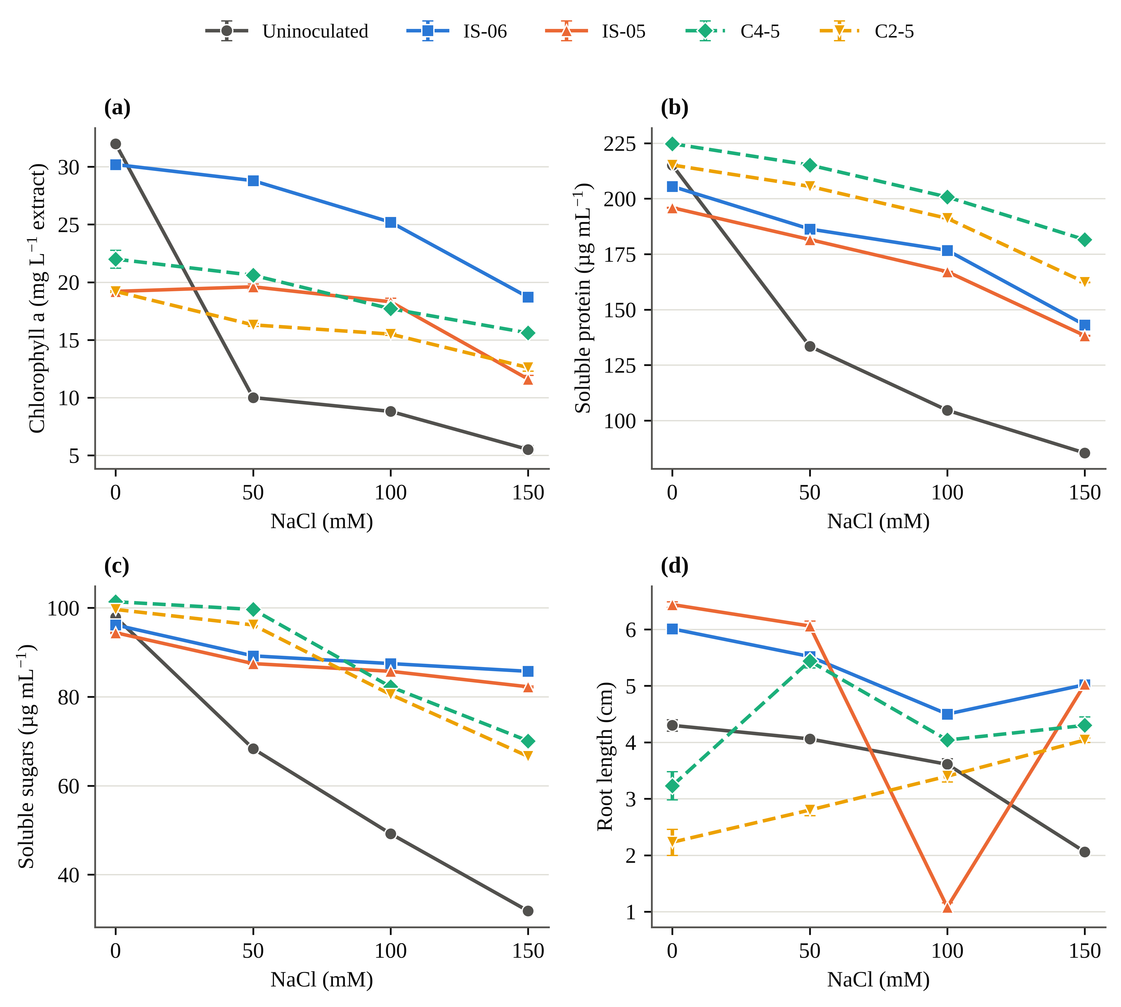
Fig. 3. Dose–response of (a) chlorophyll a, (b) soluble protein, (c) soluble sugars and (d) root length to NaCl in uninoculated rice and in plants inoculated with the two best single isolates (IS-06, IS-05; solid lines) and the two best consortia (C4-5, C2-5; dashed lines). Error bars are SD (n = 3); replicate SDs were not recorded for consortium sugars. The low IS-05 root value at 100 mM is shown as recorded.
3.5 Mitigation profile, composite ranking and multivariate structure
Across the mitigation heat map (Fig. 4), protein and sugars were raised by every inoculant at every salinity level, pigment protection split the consortia into protective (C4-5, C2-5) and harmful (C1-3, C1-5, C2-3) pairs, and benefits grew with stress (IS-06 chlorophyll a: IMM 188% at 50 mM to 240% at 150 mM). The CMI ranked IS-06 (0.647) and C4-5 (0.617) first at 150 mM, followed by IS-05 (0.534) and C2-5 (0.482); the control was last (0.139). Averaged across salinity levels, C2-3 (0.427) and C1-3 (0.384) fell below the control (0.439). The two leaders recovered the unstressed profile in different ways (Fig. 5): IS-06 on root and shoot length, chlorophyll a, sugars and DPPH, and C4-5 on germination, carotenoids and protein.
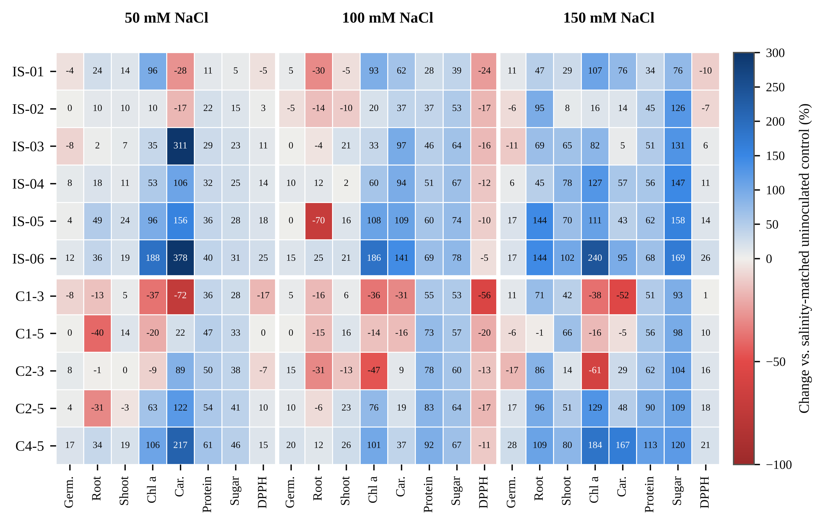
Fig. 4. Heat map of inoculation-mediated mitigation (IMM, %), i.e. the change in each trait relative to the uninoculated control at the same NaCl level, for six single isolates (upper block) and five consortia (lower block) at 50, 100 and 150 mM NaCl. Blue cells denote improvement and red cells impairment; the colour scale is truncated at −100% and +300%, and cell labels give exact values. Germ., germination; Car., carotenoids.
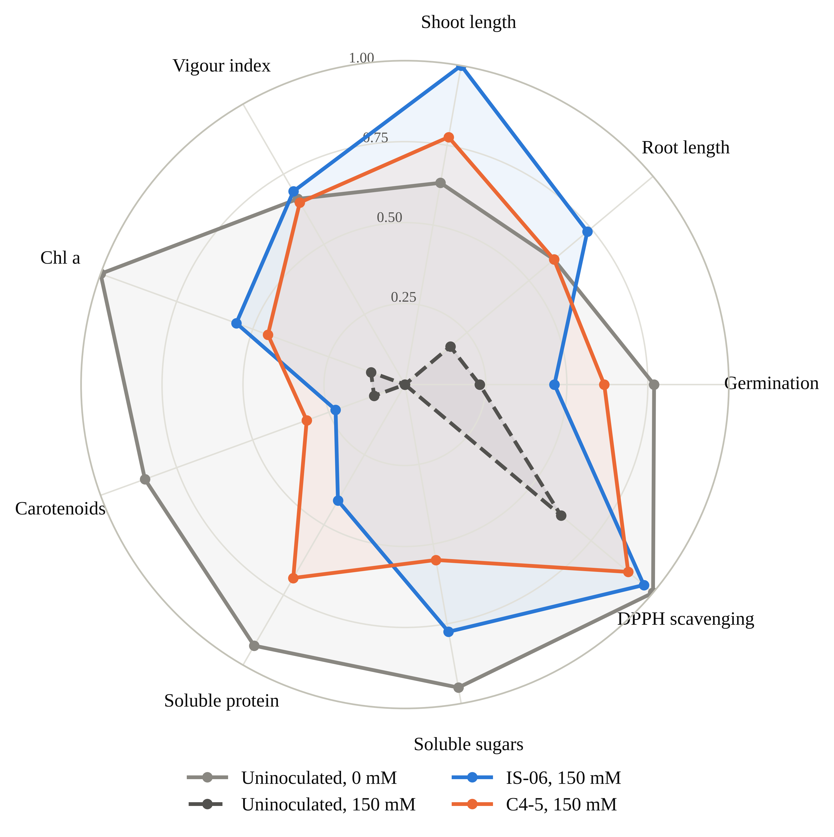
Fig. 5. Radar chart of nine traits rescaled to 0–1 across all 48 treatment combinations, comparing unstressed and 150 mM NaCl uninoculated plants with plants inoculated with IS-06 and C4-5 under 150 mM NaCl. A larger polygon indicates a trait profile closer to the best observed values.
The first two principal components explained 71.3% of the variance (Fig. 6). PC1 (51.7%) loaded positively on every trait, most strongly SVI (0.91), chlorophyll a (0.84) and germination (0.82), and represents general seedling health. PC2 (19.6%) separated protein and sugars from DPPH and root and shoot length. Uninoculated plants moved steadily to negative PC1 with salt, whereas IS-06 stayed on the positive side at every salinity level, and IS-06 at 150 mM scored higher than the control at 50 mM.
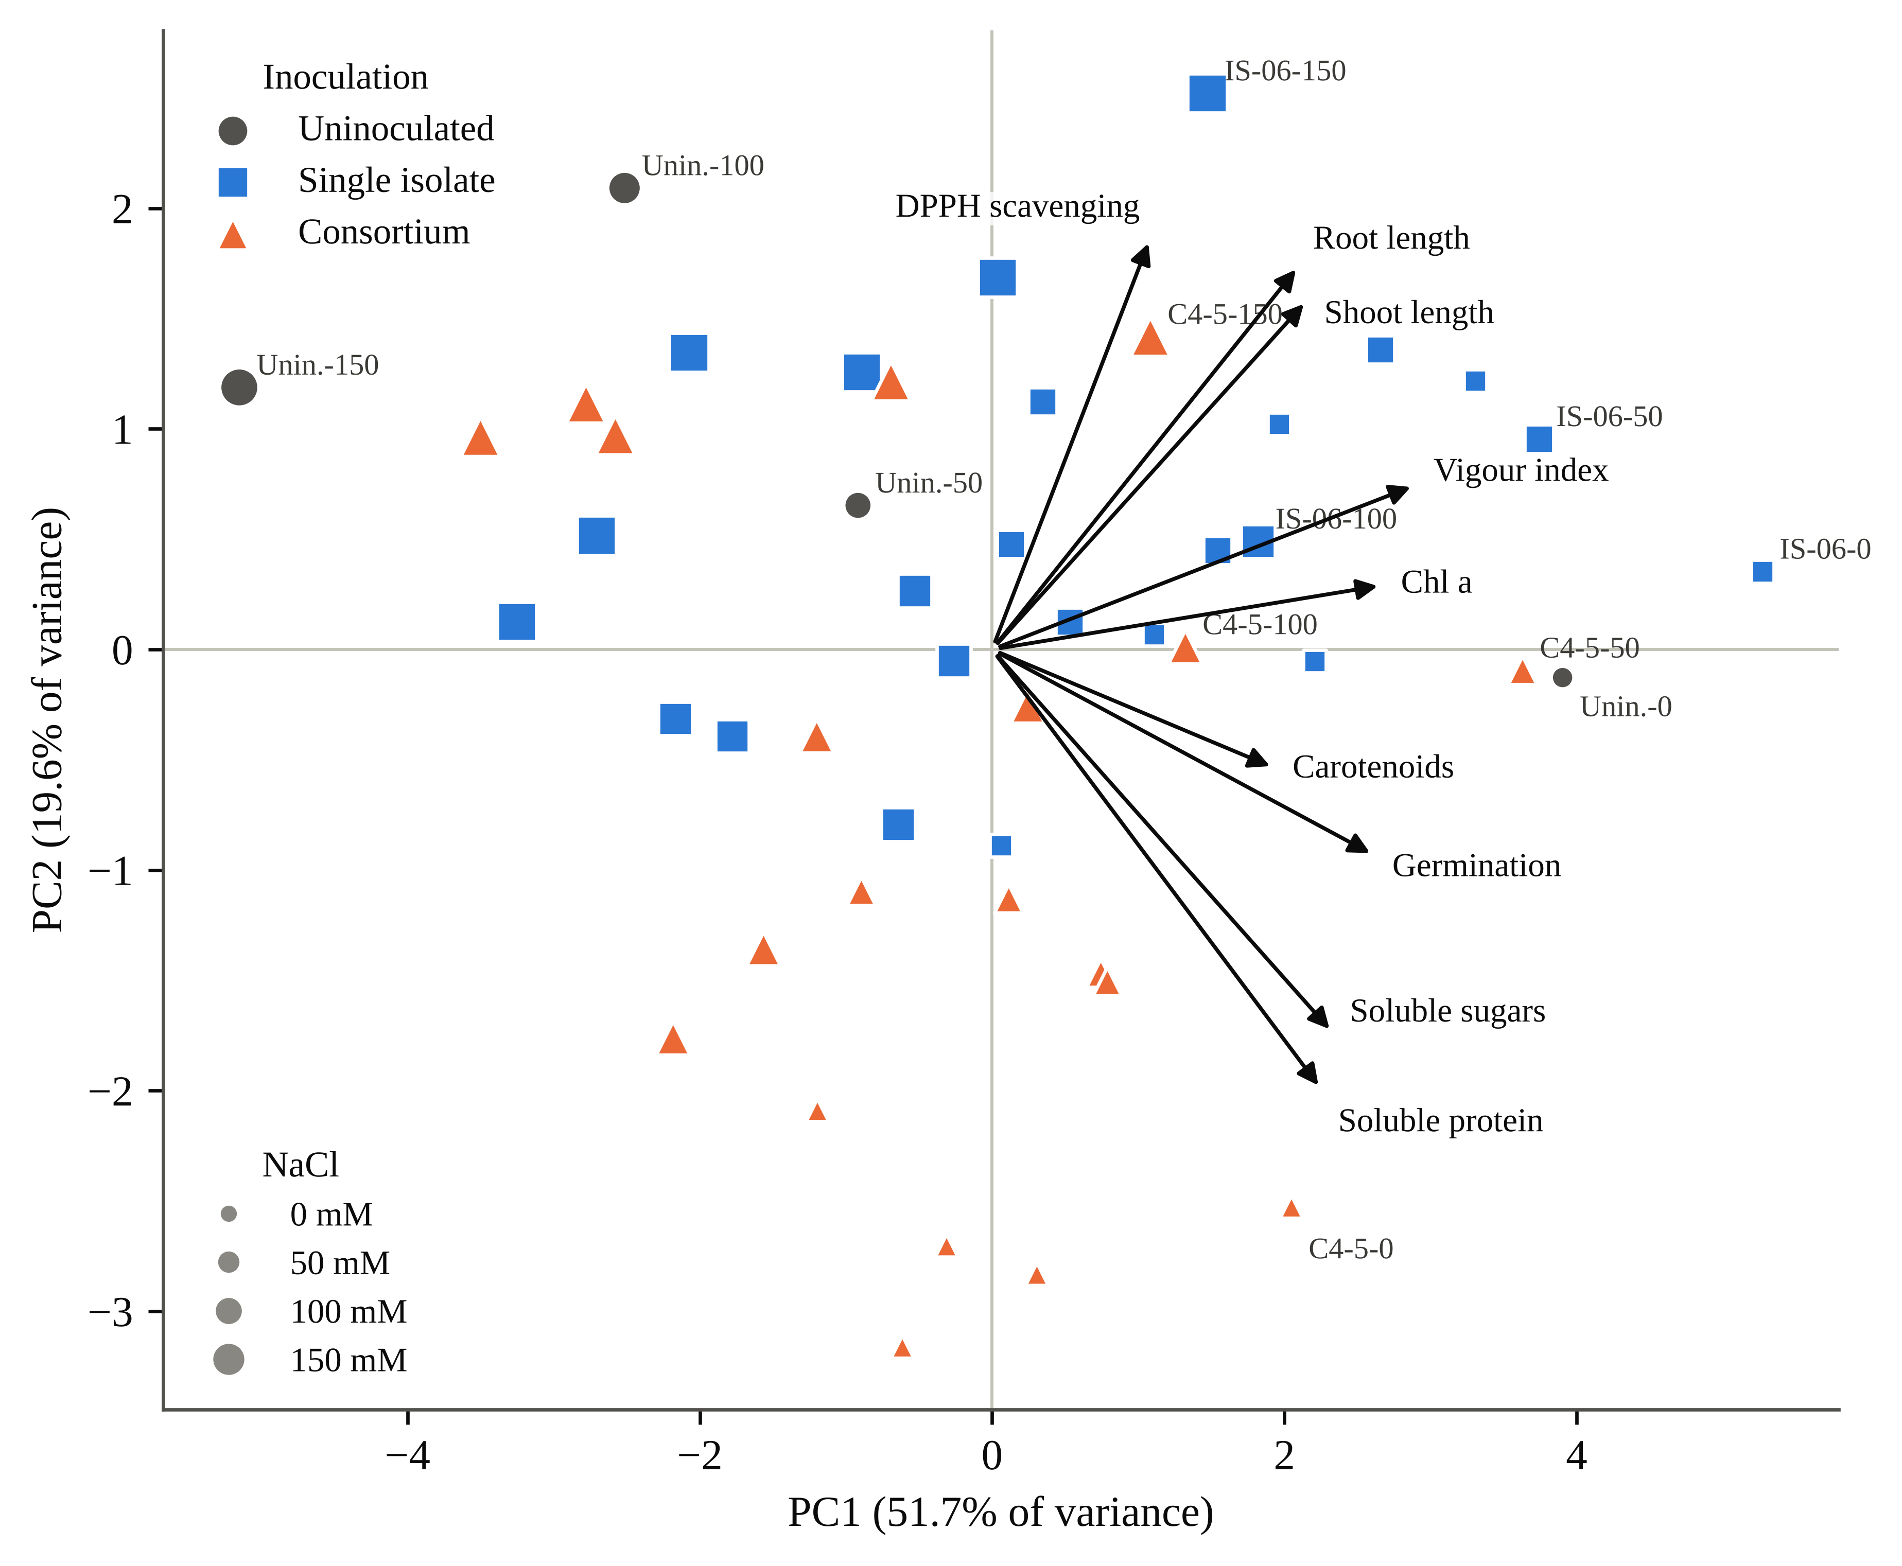
Fig. 6. Principal component analysis biplot of nine standardized traits across 48 treatment combinations. Symbol shape and colour indicate inoculation type and symbol size indicates NaCl level; selected treatments are labelled as inoculant–NaCl (mM). Arrows show trait loadings (scaled ×3.2). PC1 represents general seedling growth and metabolite status; PC2 separates protein and sugar content from root and shoot length and DPPH activity.

Table 3. Two-way ANOVA (inoculant × NaCl) for seedling growth and leaf biochemical traits of rice cv. IR-64, computed from replicate means and standard deviations (n = 3).
Trait | Inoculant F | NaCl F | Inoculant × NaCl F | η_{p}² (interaction) | Tukey HSD_{0.05}
Single-isolate experiment (7 inoculation levels × 4 NaCl levels)
Root length (cm) | 1156.4∗∗∗ | 3650.8∗∗∗ | 706.4∗∗∗ | 0.996 | 0.21
Shoot length (cm) | 1414.8∗∗∗ | 1884.3∗∗∗ | 414.6∗∗∗ | 0.993 | 0.68
Chlorophyll a (mg L⁻¹) | 4768.0∗∗∗ | 5411.7∗∗∗ | 792.0∗∗∗ | 0.996 | 0.81
Chlorophyll b (mg L⁻¹) | 4324.4∗∗∗ | 5914.4∗∗∗ | 1196.0∗∗∗ | 0.997 | 0.82
Soluble protein (µg mL⁻¹) | 1.36 × 10⁵∗∗∗ | 7.25 × 10⁵∗∗∗ | 2.75 × 10⁴∗∗∗ | 1.000 | 0.48
Soluble sugars (µg mL⁻¹) | 5.61 × 10⁴∗∗∗ | 8.28 × 10⁴∗∗∗ | 9767.6∗∗∗ | 1.000 | 0.48
DPPH scavenging (%) | 512.5∗∗∗ | 47.5∗∗∗ | 76.7∗∗∗ | 0.961 | 3.19
Consortium experiment (6 inoculation levels × 4 NaCl levels)
Root length (cm) | 123.0∗∗∗ | 86.1∗∗∗ | 52.2∗∗∗ | 0.942 | 0.59
Shoot length (cm) | 0.9 ns | 1.0 ns | 0.4 ns | 0.106 | 23.21
Chlorophyll a (mg L⁻¹) | 5916.3∗∗∗ | 4217.1∗∗∗ | 855.6∗∗∗ | 0.996 | 0.80
Chlorophyll b (mg L⁻¹) | 3815.2∗∗∗ | 1753.8∗∗∗ | 1294.0∗∗∗ | 0.998 | 0.90
Soluble protein (µg mL⁻¹) | 3.21 × 10⁵∗∗∗ | 7.72 × 10⁵∗∗∗ | 3.63 × 10⁴∗∗∗ | 1.000 | 0.47
Total phenolics (µg mL⁻¹) | 1.07 × 10⁴∗∗∗ | 1.10 × 10⁴∗∗∗ | 430.1∗∗∗ | 0.993 | 0.47
∗∗∗ p < 0.001; ns, not significant (p ≥ 0.05). η_{p}², partial eta-squared. HSD is the minimum significant difference between any two treatment means of the same experiment, in the units of the trait. Degrees of freedom: isolates F_{6,56} (inoculant), F_{3,56} (NaCl), F_{18,56} (interaction); consortia F_{5,48}, F_{3,48}, F_{15,48}. Isolate phenolics, consortium sugars and consortium DPPH are omitted because replicate SDs were not recorded. Several traits carried identical replicate SDs (±0.15) across treatments, which inflates F; effect sizes and treatment rankings are the more reliable guide.

4. Discussion
4.1 Salinity damage in IR-64 seedlings
The uninoculated plants behaved as expected for a salt-susceptible indica cultivar. Roots slowed first: at 150 mM, root length fell by about half and SVI by 57.7%, which fits the osmotic phase in which water uptake and cell expansion are restricted before ions reach toxic levels (Munns & Tester, 2008). The pigment data point beyond osmotic slowdown. Chlorophyll a lost more than two-thirds of its value at only 50 mM, while germination barely changed, and pigment loss that steep and that early usually signals oxidative injury in the chloroplast (Gill & Tuteja, 2010). The parallel fall in carotenoids, which quench excess excitation energy, would have left the chloroplast more exposed still.
Soluble sugars behaved less conventionally. Tolerant plants usually accumulate sugars as osmolytes (Parida & Das, 2005; Mahajan & Tuteja, 2005), yet in IR-64 sugars fell by 67.5%, together with protein and phenolics. This pattern is interpreted as a susceptible cultivar unable to keep carbon assimilation going well enough to fund an osmotic response, consistent with reviews that place photosynthetic capacity upstream of most salt-tolerance traits in rice (Sackey et al., 2025) and with the broader view of salt signalling as a reprogramming of metabolism (Zhu, 2016). The present data cannot establish the causal order, because gas exchange was not measured.
4.2 Germination was not where inoculation made its difference
The clearest negative result is that no inoculant changed germination detectably. Many bacterization studies report higher germination (Sagar et al., 2020; Ali et al., 2022), and the direction of effect for the best inoculants agrees, with IS-06 and C4-5 10–17 percentage points above the control at 150 mM (Fig. 2), although IS-02, IS-03 and C2-3 fell below it. But with 30 seeds per treatment, Fisher's exact test needs a difference of about 27 points to reach significance, so the design could not confirm effects of this size. Germination was also one of the least salt-sensitive traits (SIR 28%, against 52% for root length and 83% for chlorophyll a). Stand losses in saline paddies are therefore more likely to come from weak seedlings than from seeds that never sprout, which is where the inoculants worked and where rice is most vulnerable (Singh et al., 2021). Because salt was applied from 15 DAS, its effect on emergence suggests that saline irrigation reached the seed zone early or that the counts partly reflect seedling survival; future trials should record the two separately.
4.3 IS-06: a strong single strain for pigment and osmolyte protection
IS-06 was the most consistent performer, ranking first among the isolates for chlorophyll a, protein, sugars and DPPH under salt and first on the CMI at all four salinity levels. Its 240% gain in chlorophyll a at 150 mM is at the high end of reports for rice, where halotolerant Bacillus strains restored photosynthetic parameters alongside ion homeostasis and antioxidant defence (Siddika et al., 2024) and halotolerant endophytes adjusted hormones and ion-transporter expression (Asif et al., 2023).
The mechanism behind IS-06 is still open, and two routes seem most likely. ACC deaminase would lower stress ethylene, protecting root elongation and delaying ethylene-driven chlorophyll breakdown (Glick, 2014); ACC deaminase-positive Enterobacter strains protected salt-stressed rice seedlings in exactly this way (Sarkar et al., 2018; Sagar et al., 2020). Alternatively, IS-06 may limit sodium entry into the shoot, as reported for other rice endophytes (M. A. Khan et al., 2021), possibly helped by exopolysaccharides that bind Na⁺ around the roots (Sun et al., 2020). Most growth-promoting strains combine several such traits (Glick, 2012; Etesami & Maheshwari, 2018), and direct assays for ACC deaminase, indole-3-acetic acid, exopolysaccharide and shoot Na⁺/K⁺ would separate them. The sugar data add one point: IS-06 kept 89% of its unstressed sugar against 33% in the control, which probably reflects preserved chlorophyll feeding a steady carbon supply. Inoculation-driven accumulation of compatible solutes is well documented (Arora et al., 2020; Ramasamy & Mahawar, 2023), but the present data cannot show whether the extra sugar served osmotic adjustment or simply reflects higher assimilation.
4.4 Consortia: complementarity is real but depends on the pair
Meta-analysis predicts that consortia outperform single strains (Liu et al., 2023); the present results support a more guarded version. On the average CMI, only C4-5 beat both of its parents, C2-5 sat between its parents, and C1-3, C1-5 and C2-3 ranked below both. C4-5 combined the second- and third-ranked isolates and, at 150 mM, exceeded both parents for protein (181.51 vs. 133.45 and 138.26 µg mL⁻¹), chlorophyll a and SVI, though not for sugars. Improving some traits beyond either parent, but not all, is what complementarity looks like in practice, and consortia have likewise improved growth and yield of wheat under salinity (M. Y. Khan et al., 2022).
All five pairs passed the plate test, so the failures are not simple antagonism. Partners sharing a niche inside the root may compete for colonization sites (Compant et al., 2019; Kandasamy & Kathirvel, 2023), or the same trait may be duplicated without adding function. Each weak consortium contains at least one of the three isolates that protected chlorophyll least (IS-01, IS-02, IS-03), although C2-5 shows the pattern is not absolute. Mixing therefore adds risk as well as potential, which is why reviews of halotolerant bacteria stress trait-based partner selection (Numan et al., 2018; Zamanzadeh-Nasrabadi et al., 2023). Because isolates and consortia were run as separate batches with a shared control, consortium–parent comparisons are indirect and should be confirmed in a single experiment.
4.5 Protein, phenolics and antioxidant activity
Protein retention was the one trait where consortia clearly outperformed single strains (81% for C4-5 and 75% for C2-5, against 70% for IS-06 and 40% for the control). Salinity lowers soluble protein through poorer nitrogen assimilation and faster proteolysis (Parida & Das, 2005), and two partners could plausibly ease both. Phenolics, which scavenge radicals and stabilize membranes, were largely maintained by C4-5 and IS-06, in line with inoculation-induced antioxidant capacity in salt-stressed plants (Neshat et al., 2022); the collapse under IS-01 at 150 mM suggests that some endophytes suppress phenolic accumulation and should not be carried forward. DPPH was the least informative trait: it differed between batches, was not monotonic with salt and measures an extract's combined radical-quenching capacity rather than any one enzyme (Gülçin, 2020). Phenolic and antioxidant profiles of rice also shift under other abiotic stresses (Bhadwal et al., 2024), so DPPH is supporting evidence here and not a primary endpoint.
4.6 What the indices and PCA add
Ranking trait by trait gives different winners: IS-06 for sugars, C4-5 for protein, IS-05 for root length. The CMI and PCA, which weight traits differently, agreed on IS-06 and C4-5 at the top and on C2-3 and C1-3 at the bottom, supporting composite, relative measures for comparing salt responses (Negrão et al., 2017). PC1 showed that most of the difference between good and poor treatments lay on a single axis of seedling health, while PC2 separated the consortia's protein-retention route from IS-06's growth-and-pigment route.
4.7 Limitations and next steps
The isolates still need confirmed taxonomic identity and quantified growth-promoting traits before these isolates can be compared with published inoculants or registered (Afzal et al., 2019; Ganie et al., 2021). Biochemical values are expressed per volume of extract; the fixed tissue-to-solvent ratio makes treatments comparable, but not directly with per-gram data from other studies. Several assays recorded identical replicate SDs (±0.15), probably analytical rather than biological replication, which inflates F; effect sizes and rankings are the more reliable guide. Colonization was not verified by re-isolation or marker tracking (Walitang et al., 2017; Gupta et al., 2023), and ion contents, oxidative-damage markers and antioxidant enzymes were outside the scope of this trial. Finally, the trial ended at 45 DAS in pots, and seedling-stage tolerance in rice correlates only weakly with tolerance at flowering (Singh et al., 2021). Salt-tolerant rhizobacteria have improved rice yield in saline soil (Shultana et al., 2020), so yield-stage field testing of IS-06 and C4-5, ideally with a tolerant cultivar since host genotype shapes the endophytic community (Walitang et al., 2018; Wang et al., 2025), is the logical next step.
5. Conclusions
Salinity at 150 mM NaCl reduced seedling vigour of IR-64 rice by 58%, chlorophyll a by 83% and soluble sugars by 68%. Bacterization with rice endophytes did not change germination significantly, but it strongly protected seedling growth, photosynthetic pigments, soluble protein, sugars and phenolics under salt. IS-06 was the most consistent single strain, raising chlorophyll a by 240%, sugars by 169% and SVI by 142% at 150 mM. C4-5 retained 81% of its unstressed protein and exceeded both parent strains for protein, chlorophyll a and vigour, whereas three of the five consortia ranked below both parents. A composite index and PCA agreed on IS-06 and C4-5 as the leading candidates for strain identification, colonization tests and yield-stage evaluation in saline fields.

Declarations
Author contributions (CRediT). [Author Name]: Conceptualization, Investigation, Formal analysis, Data curation, Writing – original draft. [Co-author / Research Guide Name]: Supervision, Methodology, Resources, Writing – review and editing.
Funding. [Funding agency and grant number, or "This research received no specific grant."]
Declaration of competing interest. The authors declare no competing interests.
Data availability. Treatment-level data and analysis scripts are available from the corresponding author on reasonable request.
Declaration of generative AI use. An AI writing assistant was used to help structure the text, run statistical calculations from the recorded data and draw figures. The authors generated all data, reviewed all content and take full responsibility for the article.

References
Abdul-Baki, A. A., & Anderson, J. D. (1973). Vigor determination in soybean seed by multiple criteria. Crop Science, 13(6), 630–633. https:/​/​doi.​org/​10.​2135/​cropsci1973.​0011183X001300060013x
Afzal, I., Shinwari, Z. K., Sikandar, S., & Shahzad, S. (2019). Plant beneficial endophytic bacteria: Mechanisms, diversity, host range and genetic determinants. Microbiological Research, 221, 36–49. https:/​/​doi.​org/​10.​1016/​j.​micres.​2019.​02.​001
Ali, Q., Ayaz, M., Mu, G., Hussain, A., Yuanyuan, Q., Yu, C., Xu, Y., Manghwar, H., Gu, Q., Wu, H., & Gao, X. (2022). Revealing plant growth-promoting mechanisms of Bacillus strains in elevating rice growth and its interaction with salt stress. Frontiers in Plant Science, 13, Article 994902. https:/​/​doi.​org/​10.​3389/​fpls.​2022.​994902
Arnon, D. I. (1949). Copper enzymes in isolated chloroplasts. Polyphenoloxidase in Beta vulgaris. Plant Physiology, 24(1), 1–15. https:/​/​doi.​org/​10.​1104/​pp.​24.​1.​1
Arora, N. K., Fatima, T., Mishra, J., Mishra, I., Verma, S., Verma, R., Verma, M., Bhattacharya, A., Verma, P., Mishra, P., & Bharti, C. (2020). Halo-tolerant plant growth promoting rhizobacteria for improving productivity and remediation of saline soils. Journal of Advanced Research, 26, 69–82. https:/​/​doi.​org/​10.​1016/​j.​jare.​2020.​07.​003
Asif, S., Jan, R., Kim, N., Asaf, S., Lubna, Khan, M. A., Kim, E. G., Jang, Y. H., Bhatta, D., Lee, I. J., & Kim, K. M. (2023). Halotolerant endophytic bacteria alleviate salinity stress in rice (Oryza sativa L.) by modulating ion content, endogenous hormones, the antioxidant system and gene expression. BMC Plant Biology, 23(1), Article 494. https:/​/​doi.​org/​10.​1186/​s12870-​023-​04517-​z
Basak, N., Rai, A. K., Sundha, P., Meena, R. L., Bedwal, S., Yadav, R. K., & Sharma, P. C. (2022). Assessing soil quality for rehabilitation of salt-affected agroecosystem: A comprehensive review. Frontiers in Environmental Science, 10, Article 935785. https:/​/​doi.​org/​10.​3389/​fenvs.​2022.​935785
Bhadwal, S., Sharma, S., & Singh, D. (2024). Interactive effects of selenium and arsenic on phenolic constituents and antioxidant activity in rice (Oryza sativa L.). Chemosphere, 350, Article 141071. https:/​/​doi.​org/​10.​1016/​j.​chemosphere.​2023.​141071
Brand-Williams, W., Cuvelier, M. E., & Berset, C. (1995). Use of a free radical method to evaluate antioxidant activity. LWT – Food Science and Technology, 28(1), 25–30. https:/​/​doi.​org/​10.​1016/​S0023-​6438(95)80008-​5
Compant, S., Samad, A., Faist, H., & Sessitsch, A. (2019). A review on the plant microbiome: Ecology, functions, and emerging trends in microbial application. Journal of Advanced Research, 19, 29–37. https:/​/​doi.​org/​10.​1016/​j.​jare.​2019.​03.​004
Etesami, H., & Glick, B. R. (2020). Halotolerant plant growth–promoting bacteria: Prospects for alleviating salinity stress in plants. Environmental and Experimental Botany, 178, Article 104124. https:/​/​doi.​org/​10.​1016/​j.​envexpbot.​2020.​104124
Etesami, H., & Maheshwari, D. K. (2018). Use of plant growth promoting rhizobacteria (PGPRs) with multiple plant growth promoting traits in stress agriculture: Action mechanisms and future prospects. Ecotoxicology and Environmental Safety, 156, 225–246. https:/​/​doi.​org/​10.​1016/​j.​ecoenv.​2018.​03.​013
Ganie, S. A., Bhat, J. A., & Devoto, A. (2021). The influence of endophytes on rice fitness under environmental stresses. Plant Molecular Biology, 109(4–5), 447–467. https:/​/​doi.​org/​10.​1007/​s11103-​021-​01219-​8
Gill, S. S., & Tuteja, N. (2010). Reactive oxygen species and antioxidant machinery in abiotic stress tolerance in crop plants. Plant Physiology and Biochemistry, 48(12), 909–930. https:/​/​doi.​org/​10.​1016/​j.​plaphy.​2010.​08.​016
Glick, B. R. (2012). Plant growth-promoting bacteria: Mechanisms and applications. Scientifica, 2012, Article 963401. https:/​/​doi.​org/​10.​6064/​2012/​963401
Glick, B. R. (2014). Bacteria with ACC deaminase can promote plant growth and help to feed the world. Microbiological Research, 169(1), 30–39. https:/​/​doi.​org/​10.​1016/​j.​micres.​2013.​09.​009
Gülçin, İ. (2020). Antioxidants and antioxidant methods: An updated overview. Archives of Toxicology, 94(3), 651–715. https:/​/​doi.​org/​10.​1007/​s00204-​020-​02689-​3
Gupta, A., Tiwari, R. K., Shukla, R., Singh, A. N., & Sahu, P. K. (2023). Salinity alleviator bacteria in rice (Oryza sativa L.), their colonization efficacy, and synergism with melatonin. Frontiers in Plant Science, 13, Article 1060287. https:/​/​doi.​org/​10.​3389/​fpls.​2022.​1060287
Hardoim, P. R., van Overbeek, L. S., Berg, G., Pirttilä, A. M., Compant, S., Campisano, A., Döring, M., & Sessitsch, A. (2015). The hidden world within plants: Ecological and evolutionary considerations for defining functioning of microbial endophytes. Microbiology and Molecular Biology Reviews, 79(3), 293–320. https:/​/​doi.​org/​10.​1128/​MMBR.​00050-​14
Hiscox, J. D., & Israelstam, G. F. (1979). A method for the extraction of chlorophyll from leaf tissue without maceration. Canadian Journal of Botany, 57(12), 1332–1334. https:/​/​doi.​org/​10.​1139/​b79-​163
Ilangumaran, G., & Smith, D. L. (2017). Plant growth promoting rhizobacteria in amelioration of salinity stress: A systems biology perspective. Frontiers in Plant Science, 8, Article 1768. https:/​/​doi.​org/​10.​3389/​fpls.​2017.​01768
Ismail, A. M., & Horie, T. (2017). Genomics, physiology, and molecular breeding approaches for improving salt tolerance. Annual Review of Plant Biology, 68, 405–434. https:/​/​doi.​org/​10.​1146/​annurev-​arplant-​042916-​040936
Jolliffe, I. T., & Cadima, J. (2016). Principal component analysis: A review and recent developments. Philosophical Transactions of the Royal Society A: Mathematical, Physical and Engineering Sciences, 374(2065), Article 20150202. https:/​/​doi.​org/​10.​1098/​rsta.​2015.​0202
Kandasamy, G. D., & Kathirvel, P. (2023). Insights into bacterial endophytic diversity and isolation with a focus on their potential applications – A review. Microbiological Research, 266, Article 127256. https:/​/​doi.​org/​10.​1016/​j.​micres.​2022.​127256
Khan, M. A., Hamayun, M., Asaf, S., Khan, M., Yun, B. W., Kang, S. M., & Lee, I. J. (2021). Rhizospheric Bacillus spp. rescues plant growth under salinity stress via regulating gene expression, endogenous hormones, and antioxidant system of Oryza sativa L. Frontiers in Plant Science, 12, Article 665590. https:/​/​doi.​org/​10.​3389/​fpls.​2021.​665590
Khan, M. Y., Nadeem, S. M., Sohaib, M., Waqas, M. R., Alotaibi, F., Ali, L., Zahir, Z. A., & Al-Barakah, F. N. I. (2022). Potential of plant growth promoting bacterial consortium for improving the growth and yield of wheat under saline conditions. Frontiers in Microbiology, 13, Article 958522. https:/​/​doi.​org/​10.​3389/​fmicb.​2022.​958522
Larson, D. A. (1992). Analysis of variance with just summary statistics as input. The American Statistician, 46(2), 151–152. https:/​/​doi.​org/​10.​1080/​00031305.​1992.​10475872
Lichtenthaler, H. K. (1987). Chlorophylls and carotenoids: Pigments of photosynthetic biomembranes. Methods in Enzymology, 148, 350–382. https:/​/​doi.​org/​10.​1016/​0076-​6879(87)48036-​1
Liu, X., Mei, S., & Salles, J. F. (2023). Inoculated microbial consortia perform better than single strains in living soil: A meta-analysis. Applied Soil Ecology, 190, Article 105011. https:/​/​doi.​org/​10.​1016/​j.​apsoil.​2023.​105011
Lowry, O. H., Rosebrough, N. J., Farr, A. L., & Randall, R. J. (1951). Protein measurement with the Folin phenol reagent. Journal of Biological Chemistry, 193(1), 265–275. https:/​/​doi.​org/​10.​1016/​S0021-​9258(19)52451-​6
Mahajan, S., & Tuteja, N. (2005). Cold, salinity and drought stresses: An overview. Archives of Biochemistry and Biophysics, 444(2), 139–158. https:/​/​doi.​org/​10.​1016/​j.​abb.​2005.​10.​018
Moronta-Barrios, F., Gionechetti, F., Pallavicini, A., Marys, E., & Venturi, V. (2018). Bacterial microbiota of rice roots: 16S-based taxonomic profiling of endophytic and rhizospheric diversity, endophytes isolation and simplified endophytic community. Microorganisms, 6(1), Article 14. https:/​/​doi.​org/​10.​3390/​microorganisms6010014
Munns, R., & Tester, M. (2008). Mechanisms of salinity tolerance. Annual Review of Plant Biology, 59, 651–681. https:/​/​doi.​org/​10.​1146/​annurev.​arplant.​59.​032607.​092911
Negrão, S., Schmöckel, S. M., & Tester, M. (2017). Evaluating physiological responses of plants to salinity stress. Annals of Botany, 119(1), 1–11. https:/​/​doi.​org/​10.​1093/​aob/​mcw191
Neshat, M., Abbasi, A., Hosseinzadeh, A., Sarikhani, M. R., Dadashi Chavan, D., & Rasoulnia, A. (2022). Plant growth promoting bacteria (PGPR) induce antioxidant tolerance against salinity stress through biochemical and physiological mechanisms. Physiology and Molecular Biology of Plants, 28(2), 347–361. https:/​/​doi.​org/​10.​1007/​s12298-​022-​01128-​0
Numan, M., Bashir, S., Khan, Y., Mumtaz, R., Shinwari, Z. K., Khan, A. L., Khan, A., & Al-Harrasi, A. (2018). Plant growth promoting bacteria as an alternative strategy for salt tolerance in plants: A review. Microbiological Research, 209, 21–32. https:/​/​doi.​org/​10.​1016/​j.​micres.​2018.​02.​003
Parida, A. K., & Das, A. B. (2005). Salt tolerance and salinity effects on plants: A review. Ecotoxicology and Environmental Safety, 60(3), 324–349. https:/​/​doi.​org/​10.​1016/​j.​ecoenv.​2004.​06.​010
Ramasamy, K. P., & Mahawar, L. (2023). Coping with salt stress—interaction of halotolerant bacteria in crop plants: A mini review. Frontiers in Microbiology, 14, Article 1077561. https:/​/​doi.​org/​10.​3389/​fmicb.​2023.​1077561
Sackey, O. K., Feng, N., Mohammed, Y. Z., Dzou, C. F., Zheng, D., Zhao, L., & Shen, X. (2025). A comprehensive review on rice responses and tolerance to salt stress. Frontiers in Plant Science, 16, Article 1561280. https:/​/​doi.​org/​10.​3389/​fpls.​2025.​1561280
Sagar, A., Sayyed, R. Z., Ramteke, P. W., Sharma, S., Marraiki, N., Elgorban, A. M., & Syed, A. (2020). ACC deaminase and antioxidant enzymes producing halophilic Enterobacter sp. PR14 promotes the growth of rice and millets under salinity stress. Physiology and Molecular Biology of Plants, 26(9), 1847–1854. https:/​/​doi.​org/​10.​1007/​s12298-​020-​00852-​9
Saleem, M. A., Khan, A., Tu, J., Huang, W., Liu, Y., Feng, N., Zheng, D., & Xue, Y. (2025). Salinity stress in rice: Multilayered approaches for sustainable tolerance. International Journal of Molecular Sciences, 26(13), Article 6025. https:/​/​doi.​org/​10.​3390/​ijms26136025
Santoyo, G., Moreno-Hagelsieb, G., Orozco-Mosqueda, M. del C., & Glick, B. R. (2016). Plant growth-promoting bacterial endophytes. Microbiological Research, 183, 92–99. https:/​/​doi.​org/​10.​1016/​j.​micres.​2015.​11.​008
Sarkar, A., Ghosh, P. K., Pramanik, K., Mitra, S., Soren, T., Pandey, S., Mondal, M. H., & Maiti, T. K. (2018). A halotolerant Enterobacter sp. displaying ACC deaminase activity promotes rice seedling growth under salt stress. Research in Microbiology, 169(1), 20–32. https:/​/​doi.​org/​10.​1016/​j.​resmic.​2017.​08.​005
Seabold, S., & Perktold, J. (2010). Statsmodels: Econometric and statistical modeling with Python. Proceedings of the 9th Python in Science Conference, 92–96. https:/​/​doi.​org/​10.​25080/​Majora-​92bf1922-​011
Shultana, R., Kee Zuan, A. T., Yusop, M. R., & Saud, H. M. (2020). Characterization of salt-tolerant plant growth-promoting rhizobacteria and the effect on growth and yield of saline-affected rice. PLOS ONE, 15(9), Article e0238537. https:/​/​doi.​org/​10.​1371/​journal.​pone.​0238537
Siddika, A., Rashid, A. A., Khan, S. N., Khatun, A., Karim, M. M., Prasad, P. V. V., & Hasanuzzaman, M. (2024). Harnessing plant growth-promoting rhizobacteria, Bacillus subtilis and B. aryabhattai to combat salt stress in rice: A study on the regulation of antioxidant defense, ion homeostasis, and photosynthetic parameters. Frontiers in Plant Science, 15, Article 1419764. https:/​/​doi.​org/​10.​3389/​fpls.​2024.​1419764
Singh, R. K., Kota, S., & Flowers, T. J. (2021). Salt tolerance in rice: Seedling and reproductive stage QTL mapping come of age. Theoretical and Applied Genetics, 134(11), 3495–3533. https:/​/​doi.​org/​10.​1007/​s00122-​021-​03890-​3
Singleton, V. L., & Rossi, J. A. (1965). Colorimetry of total phenolics with phosphomolybdic-phosphotungstic acid reagents. American Journal of Enology and Viticulture, 16(3), 144–158. https:/​/​doi.​org/​10.​5344/​ajev.​1965.​16.​3.​144
Sun, L., Lei, P., Wang, Q., Ma, J., Zhan, Y., Jiang, K., Xu, Z., & Xu, H. (2020). The endophyte Pantoea alhagi NX-11 alleviates salt stress damage to rice seedlings by secreting exopolysaccharides. Frontiers in Microbiology, 10, Article 3112. https:/​/​doi.​org/​10.​3389/​fmicb.​2019.​03112
Tukey, J. W. (1949). Comparing individual means in the analysis of variance. Biometrics, 5(2), 99–114. https:/​/​doi.​org/​10.​2307/​3001913
van Zelm, E., Zhang, Y., & Testerink, C. (2020). Salt tolerance mechanisms of plants. Annual Review of Plant Biology, 71, 403–433. https:/​/​doi.​org/​10.​1146/​annurev-​arplant-​050718-​100005
Virtanen, P., Gommers, R., Oliphant, T. E., Haberland, M., Reddy, T., Cournapeau, D., Burovski, E., Peterson, P., Weckesser, W., Bright, J., van der Walt, S. J., Brett, M., Wilson, J., Millman, K. J., Mayorov, N., Nelson, A. R. J., Jones, E., Kern, R., Larson, E., . . . van Mulbregt, P. (2020). SciPy 1.0: Fundamental algorithms for scientific computing in Python. Nature Methods, 17(3), 261–272. https:/​/​doi.​org/​10.​1038/​s41592-​019-​0686-​2
Walitang, D. I., Kim, K., Madhaiyan, M., Kim, Y. K., Kang, Y., & Sa, T. (2017). Characterizing endophytic competence and plant growth promotion of bacterial endophytes inhabiting the seed endosphere of rice. BMC Microbiology, 17(1), Article 209. https:/​/​doi.​org/​10.​1186/​s12866-​017-​1117-​0
Walitang, D. I., Kim, C. G., Kim, K., Kang, Y., Kim, Y. K., & Sa, T. (2018). The influence of host genotype and salt stress on the seed endophytic community of salt-sensitive and salt-tolerant rice cultivars. BMC Plant Biology, 18(1), Article 51. https:/​/​doi.​org/​10.​1186/​s12870-​018-​1261-​1
Wang, J., Gao, X., Yang, M., Zhang, Y., & Chen, Y. (2025). Alleviative effects of plant growth-promoting rhizobacteria on salt-stressed rice seedlings: Mechanisms mediated by rhizosphere microbiota and root exudates. Frontiers in Plant Science, 16, Article 1661074. https:/​/​doi.​org/​10.​3389/​fpls.​2025.​1661074
Yemm, E. W., & Willis, A. J. (1954). The estimation of carbohydrates in plant extracts by anthrone. Biochemical Journal, 57(3), 508–514. https:/​/​doi.​org/​10.​1042/​bj0570508
Zamanzadeh-Nasrabadi, S. M., Mohammadiapanah, F., Hosseini-Mazinani, M., & Sarikhan, S. (2023). Salinity stress endurance of the plants with the aid of bacterial genes. Frontiers in Genetics, 14, Article 1049608. https:/​/​doi.​org/​10.​3389/​fgene.​2023.​1049608
Zhu, J.-K. (2016). Abiotic stress signaling and responses in plants. Cell, 167(2), 313–324. https:/​/​doi.​org/​10.​1016/​j.​cell.​2016.​08.​029

