Endophytic bacteria and dual-strain consortia alleviate salinity stress in rice (Oryza sativa L. cv. IR-64) seedlings through physiological and biochemical responses
Abstract
Soil salinity is a major abiotic stress that adversely affects rice growth, physiological processes, and productivity. The seedling stage is particularly sensitive to salt stress, making early-stage tolerance crucial for successful rice establishment and yield potential. This study tested whether six rice endophytes (IS-01 to IS-06) and five dual-strain consortia assembled from these isolates (C1-3, C1-5, C2-3, C2-5, C4-5) keep seedlings of the salt-susceptible cultivar IR-64 growing and metabolically stable under 0, 50, 100 and 150 mM NaCl. At 150 mM, salinity cut seedling vigour index (SVI) by 57.7%, chlorophyll a by 82.8%, soluble protein by 60.3% and soluble sugars by 67.5%. Inoculation did not change germination significantly (likelihood-ratio χ² = 11.61, df = 6, p = 0.071), but the inoculant × NaCl interaction was significant (p < 0.001) for every continuous growth and biochemical trait except consortium shoot length. At 150 mM, IS-06 raised chlorophyll a by 240%, soluble sugars by 169% and SVI by 142% over the salinity-matched control. Consortium C4-5 (IS-04 + IS-05) kept 80.8% of its unstressed protein, against 39.7% in uninoculated plants, and exceeded both parent strains for protein, chlorophyll a and SVI. A single growth–metabolite axis carried 51.7% of the variance in principal component analysis, and a composite membership index ranked IS-06 (0.647) and C4-5 (0.617) first under severe stress. Three pairings (C1-3, C1-5, C2-3) ranked below both parent strains, so the value of a consortium depended on which strains were combined. IS-06 and C4-5 are the strongest candidates for field evaluation.
Keywords: bacterial endophytes; microbial consortium; seed bacterization; salinity tolerance; osmolytes; photosynthetic pigments; rice
1. Introduction
Rice (Oryza sativa L.) is a staple food for more than half of the global population; however, its productivity is highly susceptible to soil salinity, particularly during seedling establishment and flowering (Singh et al., 2021). Approximately one billion hectares of land worldwide are affected by salinity or sodicity (Basak et al., 2022), posing a substantial challenge to rice production in salt-affected regions of South and Southeast Asia (Saleem et al., 2025). Although conventional breeding has developed salt-tolerant cultivars, progress remains challenging because salinity tolerance is a complex, polygenic trait that varies across developmental stages (Ismail and Horie, 2017). Consequently, rapid, cost-effective and biologically based strategies are needed to improve rice establishment and performance in saline soils within existing cropping systems.
Salinity stress affects plants through two interconnected mechanisms such as osmotic stress and ionic toxicity. Initially, elevated salt concentrations in the root zone reduce the water potential of the soil solution, restricting water uptake and inhibiting cell expansion and plant growth. Subsequently, excessive accumulation of Na⁺ and Cl⁻ in plant tissues disrupts ion homeostasis, particularly K⁺ acquisition and retention, impairs enzyme activity, and accelerates leaf senescence (Munns and Tester, 2008). Salinity-induced oxidative stress further aggravates cellular damage through the excessive production of reactive oxygen species (ROS), which can exceed the capacity of antioxidant defense systems and cause lipid peroxidation, pigment degradation, and protein oxidation (Gill & Tuteja, 2010). To mitigate these effects, plants regulate ion transport, modify metabolic processes, and accumulate compatible solutes, including soluble sugars, proline, and glycine betaine, which contribute to osmotic adjustment and cellular protection (van Zelm et al., 2020). Accordingly, physiological and biochemical parameters, including chlorophyll content, soluble protein, and soluble sugars, are widely used to evaluate plant responses to salinity stress and assess the effectiveness of stress-mitigation strategies (Negrão et al., 2017).
Plant-associated endophytic bacteria represent a promising biological approach for enhancing host tolerance to salinity. These microorganisms colonize internal plant tissues for at least part of their life cycle without causing disease under the conditions of association (Hardoim et al., 2015). Diverse endophytic bacterial communities have been reported in rice roots, stems, leaves, and seeds, with members of the genera Bacillus, Pseudomonas, Enterobacter, and Pantoea commonly reported among rice-associated isolates (Santoyo et al., 2016). Their internal association with the host may facilitate sustained interactions with plant tissues, although colonization and persistence depend on bacterial identity, host genotype, and environmental conditions. Seed-associated endophytes are of particular interest because they may be transmitted through seeds, establish during early seedling development, and, in some cases, contribute to vertical transmission across plant generations (Walitang et al., 2017). Previous studies have also reported that rice endophytic bacterial communities vary with host genotype and salinity conditions (Walitang et al., 2018), suggesting that these microbial communities may contain strains adapted to saline environments or capable of supporting host stress responses. Evaluating individual endophytes and compatible bacterial consortia may therefore help identify effective biological candidates for improving rice seedling performance under salinity stress.

Plant growth promoting bacteria (PGPB), including endophytic strains, can alleviate salinity-induced growth inhibition through multiple complementary mechanisms. One well-characterized mechanism involves 1-aminocyclopropane-1-carboxylate (ACC) deaminase, which degrades ACC, the immediate precursor of ethylene, thereby potentially limiting stress-induced ethylene accumulation and its inhibitory effects on root elongation (Glick, 2014). Other plant growth-promoting traits include the production of indole-3-acetic acid (IAA), phosphate solubilization, siderophore production, and biological nitrogen fixation in appropriate bacterial taxa. Under saline conditions, additional mechanisms may contribute to improved plant performance, including the regulation of Na⁺ and K⁺ homeostasis, enhancement of antioxidant defense, modulation of phytohormone signaling, and maintenance of osmotic balance. Previous studies have reported that bacterial inoculation can improve ion homeostasis, antioxidant activity, and physiological responses in rice exposed to salinity (Khan et al., 2021; Asif et al., 2023). Changes in soluble sugar and other compatible-solute concentrations may also contribute to osmotic adjustment and cellular protection. Furthermore, salt-tolerant bacterial isolates, including strains with ACC deaminase activity, have shown potential to improve plant growth under saline conditions. These findings indicate that bacterially mediated salinity tolerance involves multiple interacting mechanisms rather than a single growth-promoting trait (Ilangumaran and Smith, 2017; Etesami and Glick, 2020).
The multifunctional nature of plant growth-promoting bacteria provides a rationale for developing microbial consortia. Combining compatible strains with complementary traits may improve the range of beneficial functions available to the host compared with individual-strain inoculation. Microbial consortia have also demonstrated potential to improve wheat growth and yield under saline conditions (Khan et al., 2022), while synthetic bacterial communities have been investigated for their capacity to establish jointly in rice roots (Moronta-Barrios et al., 2018). Nevertheless, combining strains does not necessarily produce additive or synergistic effects. Competition for nutrients and colonization sites, differences in growth rates, and antagonistic interactions may reduce consortium performance. Consequently, the effectiveness of a consortium must be established experimentally rather than inferred from the individual performance of its constituent strains (Compant et al., 2019; Liu et al., 2023).
Despite increasing interest in microbial approaches to salinity management, systematic comparisons of individual bacterial isolates and consortia assembled from the same isolates remain important for identifying effective strain combinations (Ganie et al., 2021; Wang et al., 2025). In particular, evaluating germination, seedling growth, and biochemical responses across a salinity gradient can help distinguish the contributions of individual strains from those of their combinations. Such comparisons can also reveal whether consortium performance is consistently superior to that of individual isolates or depends on the specific combination of bacterial partners. Addressing this gap is essential for identifying promising bacterial endophytes and consortia for subsequent validation as biological approaches to improving rice performance under saline conditions.
A further methodological gap concerns the integration of multiple plant growth and biochemical responses when evaluating microbial inoculants. Studies often assess individual traits separately and rank inoculants according to selected responses, making it difficult to determine whether an inoculant provides an overall benefit or improves only specific traits. Standardization of measured variables, followed by the integration of complementary indices and multivariate approaches, can facilitate a more comprehensive comparison of inoculant performance across treatments (Jolliffe & Cadima, 2016).
Therefore, the present study aimed to (i) assess the compatibility of five dual-strain consortia developed from six rice endophytic bacteria and their effects on seed germination and seedling vigour; (ii) evaluate single isolates and consortia for seedling growth and leaf biochemical traits of IR-64 under 0–150 mM NaCl in a polyhouse; and (iii) rank inoculant performance using stress indices, a composite membership index and principal component analysis (PCA). It was hypothesized that at least one consortium would outperform both constituent strains under severe salinity.

2. Materials and methods
2.1 Endophytic isolates and consortium preparation
Six endophytic bacterial isolates (IS-01 to IS-06), previously isolated from surface-sterilized tissues of rice plants, were grown separately in nutrient broth at 37 °C to the exponential phase. Five dual-strain consortia were prepared by mixing equal volumes (1:1, v/v) of the partner cultures: C1-3 (IS-01 + IS-03), C1-5 (IS-01 + IS-05), C2-3 (IS-02 + IS-03), C2-5 (IS-02 + IS-05) and C4-5 (IS-04 + IS-05). Compatibility and purity were checked by cross-streaking the partner strains on nutrient agar, and colony morphology, growth density and the presence of any inhibition zone at the junction of the colonies were recorded (Walitang et al., 2017).
2.2 Seed sterilization, bacterization and preparation of NaCl solutions
Seeds of IR-64, a widely grown but salt-susceptible indica cultivar, were surface-sterilized with 95% (v/v) ethanol for 30–60 s and 5% (v/v) sodium hypochlorite for 5–10 min, rinsed three times in sterile distilled water and soaked in the bacterial suspension (10⁸ CFU mL⁻¹) for 30 min; control seeds were soaked in sterile nutrient broth without bacteria. NaCl solutions of 50, 100 and 150 mM were prepared in sterile distilled water, and distilled water alone served as the 0 mM treatment.
2.3 Seed germination assay under laboratory condition
Bacterized seeds (25 per treatment) were placed on moist Whatman No. 1 filter paper in Petri dishes, incubated at 25 ± 2 °C and kept moist throughout the assay. A seed was considered germinated when the radicle reached 2 mm in length, and root and shoot lengths were measured at the end of the assay. Isolates and consortia were tested as separate batches, each with its own uninoculated control. The seedling vigour index was calculated as SVI = germination (%) × (root length + shoot length, cm) (Abdul-Baki and Anderson, 1973).
2.4 Plant growth-promoting assay under polyhouse condition
Pots (15 cm × 18 cm) were filled with 2.5 kg of a sterilized soil–cocopeat mixture (1:2, w/w) and arranged in a completely randomized design with three replicate pots per treatment. The isolate experiment comprised seven inoculation treatments (uninoculated control and IS-01 to IS-06) and the consortium experiment six (uninoculated control and five consortia), each combined with four NaCl concentrations (0, 50, 100 and 150 mM). Thirty seeds were sown per treatment, germination was recorded as the percentage of sown seeds that produced a seedling, and seedlings were then thinned to three per pot. Salt stress was imposed from the two- to three-leaf stage (15 days after sowing, DAS) by applying 500 mL of the respective NaCl solution on alternate days for 30 days. At 45 DAS, plants were uprooted, and the root and shoot of each plant were used for length measurements, while fresh leaves were sampled for all biochemical assays (Section 2.5).
2.5 Biochemical analysis of leaf samples
For all biochemical assays, 0.5 g of fresh tissue was taken from the youngest fully expanded leaf of each plant. Pigments were extracted with 5 mL of dimethyl sulfoxide at 60 °C for 30 min (Hiscox and Israelstam, 1979), and absorbance was recorded at 663, 645 and 490 nm. Chlorophyll a and b were calculated with the equations of Arnon (1949) (Chl a = 12.7 A₆₆₃ − 2.69 A₆₄₅; Chl b = 22.9 A₆₄₅ − 4.68 A₆₆₃), and total chlorophyll as their sum. Carotenoids were calculated according to Lichtenthaler (1987). Total phenolics were determined with Folin–Ciocalteu reagent at 765 nm against a gallic acid standard curve (y = 0.009x + 0.005, R² = 0.9998) (Singleton and Rossi, 1965). Soluble protein was determined by the Lowry method at 660 nm against bovine serum albumin (Lowry et al., 1951), and soluble sugars with anthrone reagent at 620 nm against glucose (Yemm and Willis, 1954). Antioxidant activity was assayed as DPPH radical scavenging at 517 nm after 30 min of incubation in the dark, with ascorbic acid as the reference standard, and calculated as [(A₀ − A₁)/A₀] × 100, where A₀ and A₁ are the absorbances of the control and the sample (Brand-Williams et al., 1995; Gülçin, 2020). Because every extract was prepared from the same tissue mass in the same volume of solvent, all biochemical values are expressed per volume of extract (mg L⁻¹ or µg mL⁻¹) and are directly comparable between treatments. Isolate and consortium extracts were assayed in separate batches.
2.6 Determination of derived indices
The salinity-induced reduction in uninoculated plants was calculated as SIR (%) = (X₀ − X_S)/X₀ × 100, where X₀ and X_S are the values at 0 mM and at salinity level S, respectively. Inoculation-mediated mitigation was calculated relative to the uninoculated control at the same salinity level as IMM (%) = (X_i,S − X_c,S)/X_c,S × 100, where X_i,S and X_c,S are the values of inoculant i and the control at level S. The retention index was calculated as RI (%) = X_i,150/X_i,0 × 100. Relative indices were used because treatments differed in their unstressed values (Negrão et al., 2017). A composite membership index (CMI) was obtained by rescaling nine traits (germination, root length, shoot length, SVI, chlorophyll a, carotenoids, soluble protein, soluble sugars and DPPH scavenging) to a 0–1 scale across all 48 treatment combinations as (X − X_min)/(X_max − X_min) and averaging the rescaled values. Phenolics (incomplete for the isolates) and chlorophyll b (batch-dependent; Section 3.3) were excluded.
2.7 Statistical analysis
Laboratory germination was compared within each batch by a χ² test of independence, and the best-performing inoculant was compared with the control by Fisher’s exact test. Pot germination was analysed with a binomial generalized linear model (logit link; factors inoculant and NaCl), and effects were tested by likelihood-ratio (LR) χ² tests between nested models. Continuous traits were analysed by two-way ANOVA (inoculant × NaCl) computed from treatment means and SDs (n = 3) (Larson, 1992), with partial eta-squared (η_p²) as the effect size and Tukey’s HSD test at α = 0.05 (Tukey, 1949); traits without recorded replicate SDs (consortium sugars and DPPH activity) are presented descriptively. Pearson correlations among the nine CMI traits were computed across the 48 treatment means (|r| ≥ 0.285 for p < 0.05), and principal component analysis (PCA) was performed on the standardized (z-scored) trait matrix (Jolliffe and Cadima, 2016). Analyses were performed with SciPy (Virtanen et al., 2020) and statsmodels (Seabold and Perktold, 2010). Values are presented as means ± SD of three replicates.
3. Results
3.1 Consortium compatibility and germination assay under laboratory condition
All five consortia formed uniform and stable cultures, and no inhibition zones or changes in colony morphology were observed at the junctions between partner strains; colony growth on consortium plates also appeared denser than on single-isolate plates. These results indicate in vitro compatibility of the partner strains but do not demonstrate cooperative interaction within the host plant.
Under laboratory conditions, germination ranged from 60% to 92% for the isolates and from 56% to 84% for the consortia (Table 1), but the differences were not significant (isolates χ² = 9.40, df = 6, p = 0.152; consortia χ² = 7.02, df = 5, p = 0.219). Even the difference between IS-06 and its control (92% vs. 80%) was not significant (Fisher's exact test, p = 0.417). In contrast, bacterization markedly affected seedling growth. IS-06 (SVI 1327.8) and IS-04 (1313.2) recorded substantially higher SVI than the control (920.2), whereas IS-02 and IS-03 recorded lower values; among the consortia, C4-5 recorded the maximum root length (90.66 ± 0.57 mm) and the highest SVI (1271.9).
Table 1. Germination and early seedling growth of rice cv. IR-64 bacterized with single endophytic isolates or dual-strain consortia in the laboratory assay (0 mM NaCl; 25 seeds per treatment).
Treatment | Germinated / total | Germination (%) | Root length (mm) | Shoot length (mm) | SVI
Single isolates (batch 1)
Control | 20 / 25 | 80 | 62.43 ± 1.19 | 52.60 ± 3.78 | 920.2
IS-01 | 19 / 25 | 76 | 55.66 ± 3.05 | 34.00 ± 4.58 | 681.4
IS-02 | 15 / 25 | 60 | 40.33 ± 0.47 | 50.66 ± 1.15 | 545.9
IS-03 | 17 / 25 | 68 | 32.33 ± 2.08 | 42.33 ± 1.52 | 507.7
IS-04 | 21 / 25 | 84 | 73.00 ± 4.35 | 83.33 ± 3.21 | 1313.2
IS-05 | 20 / 25 | 80 | 63.00 ± 1.00 | 72.33 ± 2.51 | 1082.6
IS-06 | 23 / 25 | 92 | 52.33 ± 2.51 | 92.00 ± 2.64 | 1327.8
Dual-strain consortia (batch 2)
Control | 17 / 25 | 68 | 43.50 ± 1.09 | 33.78 ± 2.30 | 525.5
C1-3 | 14 / 25 | 56 | 70.00 ± 0.00 | 44.00 ± 3.60 | 638.4
C1-5 | 15 / 25 | 60 | 63.66 ± 1.52 | 51.66 ± 2.88 | 691.9
C2-3 | 17 / 25 | 68 | 41.66 ± 2.08 | 33.33 ± 3.21 | 509.9
C2-5 | 21 / 25 | 84 | 83.66 ± 2.30 | 61.00 ± 1.73 | 1215.1
C4-5 | 20 / 25 | 80 | 90.66 ± 0.57 | 68.33 ± 2.08 | 1271.9
Root and shoot lengths are means ± SD. SVI was calculated as described in Section 2.3. Germination did not differ among treatments within either batch (isolates: χ² = 9.40, df = 6, p = 0.152; consortia: χ² = 7.02, df = 5, p = 0.219).
3.2 Germination and seedling growth under polyhouse
Germination decreased progressively with increasing NaCl concentration in all treatments (Fig. 2). In uninoculated plants, germination decreased from 83.3% at 0 mM to 60.0% at 150 mM, and the salinity effect was highly significant in both experiments (isolates LR χ² = 34.84, df = 3, p < 0.001; consortia LR χ² = 23.15, df = 3, p < 0.001). At 150 mM, IS-06 and IS-05 (70.0%) and C4-5 (76.7%) recorded higher germination than the control, whereas IS-02 (56.7%), IS-03 (53.3%) and C2-3 (50.0%) recorded lower germination. However, these differences fell within overlapping 95% confidence intervals, and neither the inoculant effect (isolates LR χ² = 11.61, df = 6, p = 0.071; consortia LR χ² = 10.40, df = 5, p = 0.065) nor the inoculant × NaCl interaction (p = 0.999 and 0.835) was significant. The near-parallel dose–response lines in Fig. 2 thus indicate that salt reduced germination to a similar extent irrespective of inoculation.
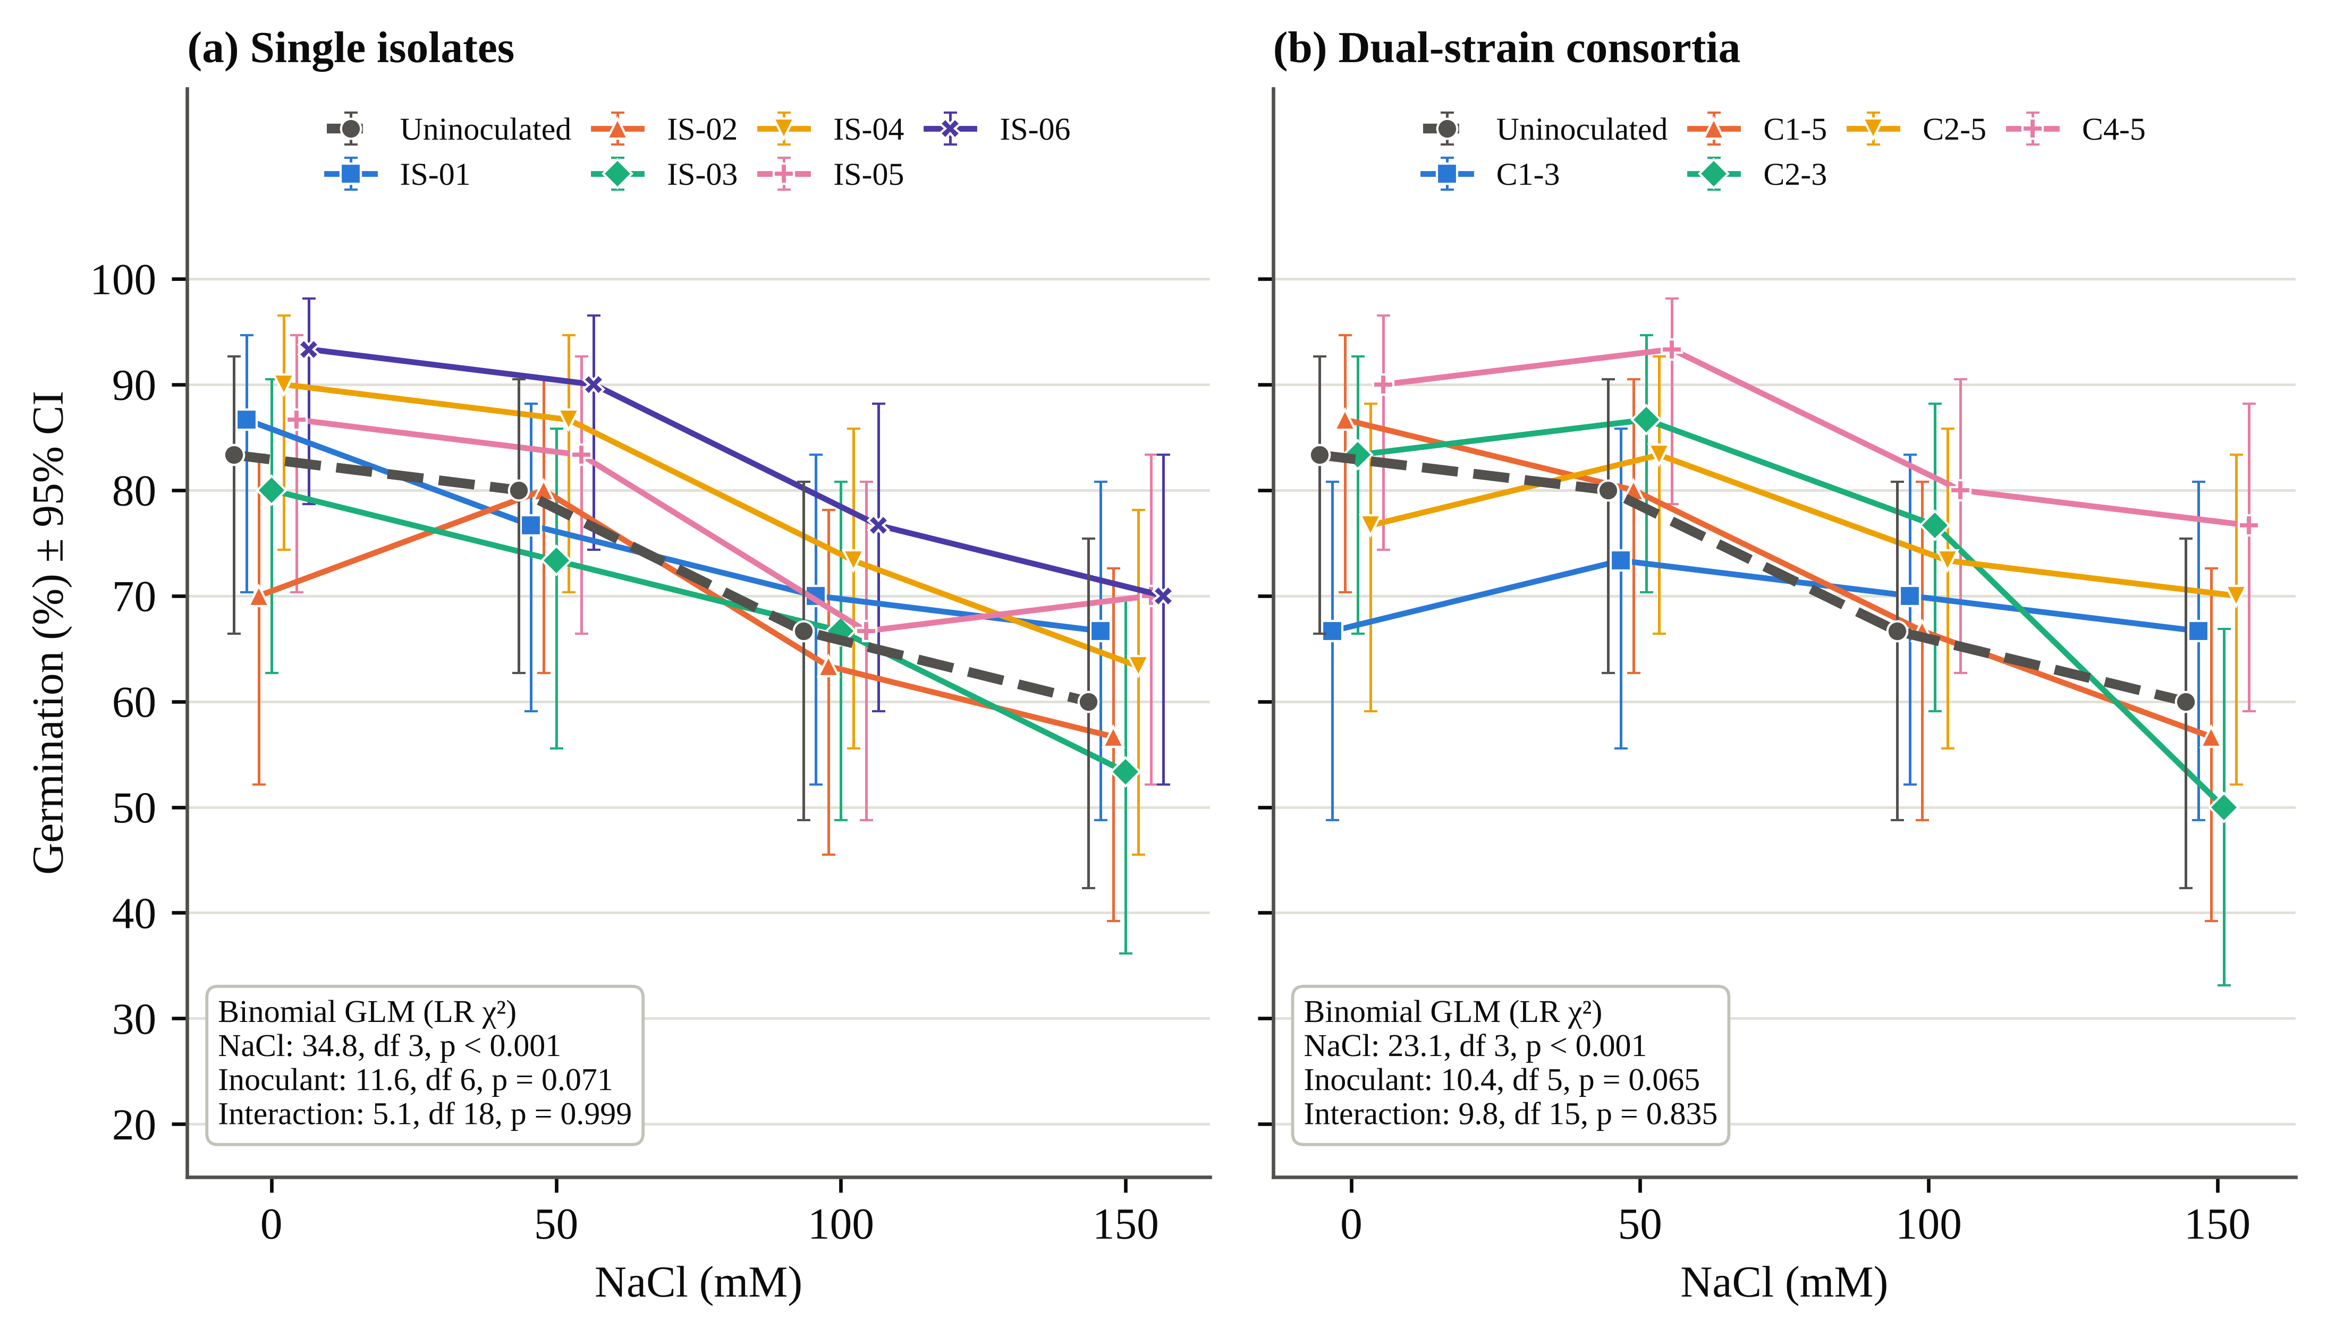
Fig. 2. Germination of rice cv. IR-64 across 0–150 mM NaCl in the polyhouse after bacterization with (a) single isolates and (b) dual-strain consortia. Points are percentages of 30 sown seeds with Wilson 95% confidence intervals; points are offset horizontally for clarity. Binomial GLM likelihood-ratio tests are given in each panel.
In contrast to germination, seedling growth was strongly affected by salinity. At 150 mM, root and shoot length of uninoculated plants decreased by 52.1% and 39.2%, respectively, and SVI by 57.7% (Table 2). In the isolate experiment, inoculant, salinity and their interaction significantly affected root length (interaction F_{18,56} = 706.4, p < 0.001; HSD 0.21 cm) and shoot length (F_{18,56} = 414.6, p < 0.001; Table 3). At 150 mM, IS-06 roots (5.02 ± 0.02 cm) and shoots (28.19 ± 0.26 cm) were 144% and 102% longer than the control. IS-05 was comparable to IS-06 in root length, although its 100 mM root value (1.08 ± 0.08 cm) is an apparent outlier. Consortium effects on root length were also significant (F_{15,48} = 52.2, p < 0.001), with the greatest root length recorded in C4-5. Consortium shoot length carried replicate SDs of 8–13 cm in several salt treatments and showed no significant effect (all p ≥ 0.39). Under salt stress, C4-5 maintained SVI at 2235–2841, 135% above the control at 150 mM and close to IS-06 (142%; Table 2). In the absence of salt, however, all five consortia recorded lower SVI (1402–1947) than the uninoculated control (2272) and each single isolate (1959–2941), and under 150 mM no consortium exceeded IS-06 (2325). The benefit of the consortia on seedling vigour was therefore expressed only under salinity and did not surpass that of the best single isolate.
Table 2. Germination (%) and seedling vigour index (SVI) of rice cv. IR-64 bacterized with single endophytic isolates or dual-strain consortia and grown under 0–150 mM NaCl in the polyhouse (30 seeds per treatment).

Treatment | Germination (%) |  |  |  | Seedling vigour index
Treatment | 0 mM | 50 mM | 100 mM | 150 mM | 0 mM | 50 mM | 100 mM | 150 mM
Uninoculated control | 83.3 | 80.0 | 66.7 | 60.0 | 2272 | 2008 | 1507 | 961
Single isolates
IS-01 | 86.7 | 76.7 | 70.0 | 66.7 | 2724 | 2233 | 1436 | 1405
IS-02 | 70.0 | 80.0 | 63.3 | 56.7 | 2023 | 2201 | 1273 | 1080
IS-03 | 80.0 | 73.3 | 66.7 | 53.3 | 1959 | 1963 | 1765 | 1412
IS-04 | 90.0 | 86.7 | 73.3 | 63.3 | 2543 | 2442 | 1713 | 1766
IS-05 | 86.7 | 83.3 | 66.7 | 70.0 | 2895 | 2682 | 1541 | 2010
IS-06 | 93.3 | 90.0 | 76.7 | 70.0 | 2941 | 2751 | 2111 | 2325
Dual-strain consortia
C1-3 | 66.7 | 73.3 | 70.0 | 66.7 | 1409 | 1871 | 1626 | 1555
C1-5 | 86.7 | 80.0 | 66.7 | 56.7 | 1629 | 2114 | 1671 | 1424
C2-3 | 83.3 | 86.7 | 76.7 | 50.0 | 1402 | 2169 | 1459 | 986
C2-5 | 76.7 | 83.3 | 73.3 | 70.0 | 1444 | 1925 | 1958 | 1753
C4-5 | 90.0 | 93.3 | 80.0 | 76.7 | 1947 | 2841 | 2235 | 2246
Germination = germinated seeds / 30 × 100. SVI = germination (%) × (root + shoot length, cm), recalculated from the recorded root and shoot lengths. Binomial GLM likelihood-ratio tests, isolate experiment: NaCl χ2 = 34.84 (df 3, p < 0.001), inoculant χ2 = 11.61 (df 6, p = 0.071), interaction χ2 = 5.14 (df 18, p = 0.999); consortium experiment: NaCl χ2 = 23.15 (df 3, p < 0.001), inoculant χ2 = 10.40 (df 5, p = 0.065), interaction χ2 = 9.75 (df 15, p = 0.835). The uninoculated control is shown from the isolate experiment; in the consortium experiment the control SVI was 2267, 2005, 1507 and 958 at 0, 50, 100 and 150 mM, respectively.

3.3 Determinations of photosynthetic pigments and phenolics
Chlorophyll a was the most salt-sensitive trait; in uninoculated plants, it decreased by 68.8% at 50 mM and 82.8% at 150 mM (Fig. 3a). Inoculation significantly alleviated the salinity-induced reduction in chlorophyll a at all salt levels (isolate interaction F_{18,56} = 792.0, p < 0.001). IS-06 was the most effective isolate, 188–240% above the matched control across 50–150 mM, while IS-05, IS-04 and IS-01 increased chlorophyll a approximately two-fold at 150 mM. C4-5 (IMM 184%) and C2-5 (129%) maintained higher chlorophyll a than the control, whereas C1-3, C1-5 and C2-3 recorded lower values than the control at all salt levels (Fig. 4). Carotenoid content showed a similar trend; at 150 mM, IS-06 increased carotenoids nearly two-fold and C4-5 increased them by 167%. Chlorophyll b of inoculated consortium treatments (0.01–3.99 mg L⁻¹) was approximately ten-fold lower than in the isolate batch even at 0 mM, which points to a batch difference in extraction or reading; it is therefore compared only within batches.
Salinity reduced the total phenolic content of uninoculated leaves by 70.1% at 150 mM. In the consortium experiment (interaction F_{15,48} = 430.1, p < 0.001), C4-5 recorded the highest phenolic content at all salt levels, 153–184% higher than the corresponding control, while C1-3 was comparable to the control at 150 mM. Among the isolates, for which only part of the phenolic data were available, IS-06 maintained a phenolic content 3.4-fold higher than the control at 150 mM, whereas IS-01 decreased to 2.80 µg mL⁻¹, the lowest value recorded.
3.4 Soluble protein, soluble sugars and DPPH activity
Soluble protein content decreased from 215.15 to 85.39 µg mL⁻¹ with increasing salinity (Fig. 3b), and all inoculants alleviated this reduction. The ranking of the isolates remained consistent across salinity levels (IS-06 > IS-05 > IS-04 > IS-03 > IS-02 > IS-01), whereas the consortia performed better: C4-5 maintained 181.51 µg mL⁻¹ at 150 mM (IMM 113%), the highest of any stressed treatment, and retained 80.8% of its unstressed protein, against 75.4% for C2-5, 69.6% for IS-06 and 39.7% for the control. Soluble sugars showed a greater reduction (SIR 67.5%), and in this case the isolates were more effective than the consortia (Fig. 3c): IS-06 retained 89.2% of its soluble sugar content under non-stress conditions (IMM 169% at 150 mM), while C4-5 led the consortia (IMM 120%). Soluble protein and soluble sugar contents were strongly and positively correlated across treatments (r = 0.89).
DPPH radical-scavenging activity showed a less consistent response. In uninoculated plants, activity did not change monotonically with salinity (90%, 65%, 82% and 70% across 0–150 mM), and the activity of the unstressed control varied between batches (90% vs. 70.6%). Under salt, IS-06 (88%) and C4-5 (84.6%) recorded the highest activity at 150 mM (isolate interaction F_{18,56} = 76.7, p < 0.001). DPPH activity was not correlated with soluble protein or sugars (|r| ≤ 0.04).
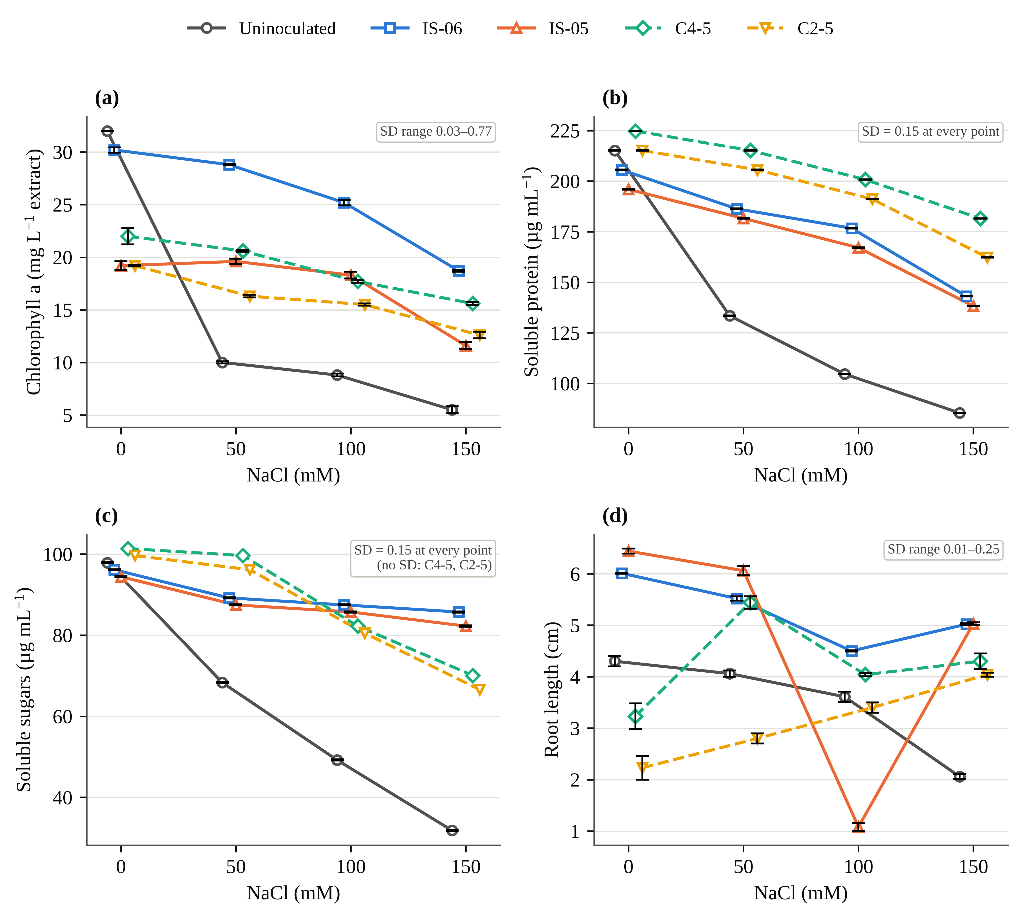
Fig. 3. Dose–response of (a) chlorophyll a, (b) soluble protein, (c) soluble sugars and (d) root length to NaCl in uninoculated rice and in plants inoculated with the single isolates IS-06 and IS-05 (solid lines) and the consortia C4-5 and C2-5 (dashed lines). Values are means of three replicates; error bars are SD (n = 3) and, where not visible, are smaller than the symbol. The SD range of each panel is shown in the upper right. Replicate SDs were not recorded for consortium soluble sugars, so these points have no error bars. Points are offset horizontally for clarity. The low IS-05 root value at 100 mM is shown as recorded.
3.5 Mitigation profile, composite ranking and multivariate structure
Across the mitigation heat map (Fig. 4), soluble protein and sugars were increased by all inoculants at all salinity levels; for pigments, the consortia were divided into protective (C4-5, C2-5) and detrimental (C1-3, C1-5, C2-3) combinations, and the mitigation effect increased with stress severity (IS-06 chlorophyll a: IMM 188% at 50 mM to 240% at 150 mM). The CMI ranked IS-06 (0.647) and C4-5 (0.617) first at 150 mM, followed by IS-05 (0.534) and C2-5 (0.482); the control was last (0.139). When averaged across salinity levels, C2-3 (0.427) and C1-3 (0.384) ranked below the control (0.439). The two top-ranked inoculants restored the unstressed trait profile through different traits (Fig. 5): IS-06 mainly through root and shoot length, chlorophyll a, sugars and DPPH, and C4-5 mainly through germination, carotenoids and protein.
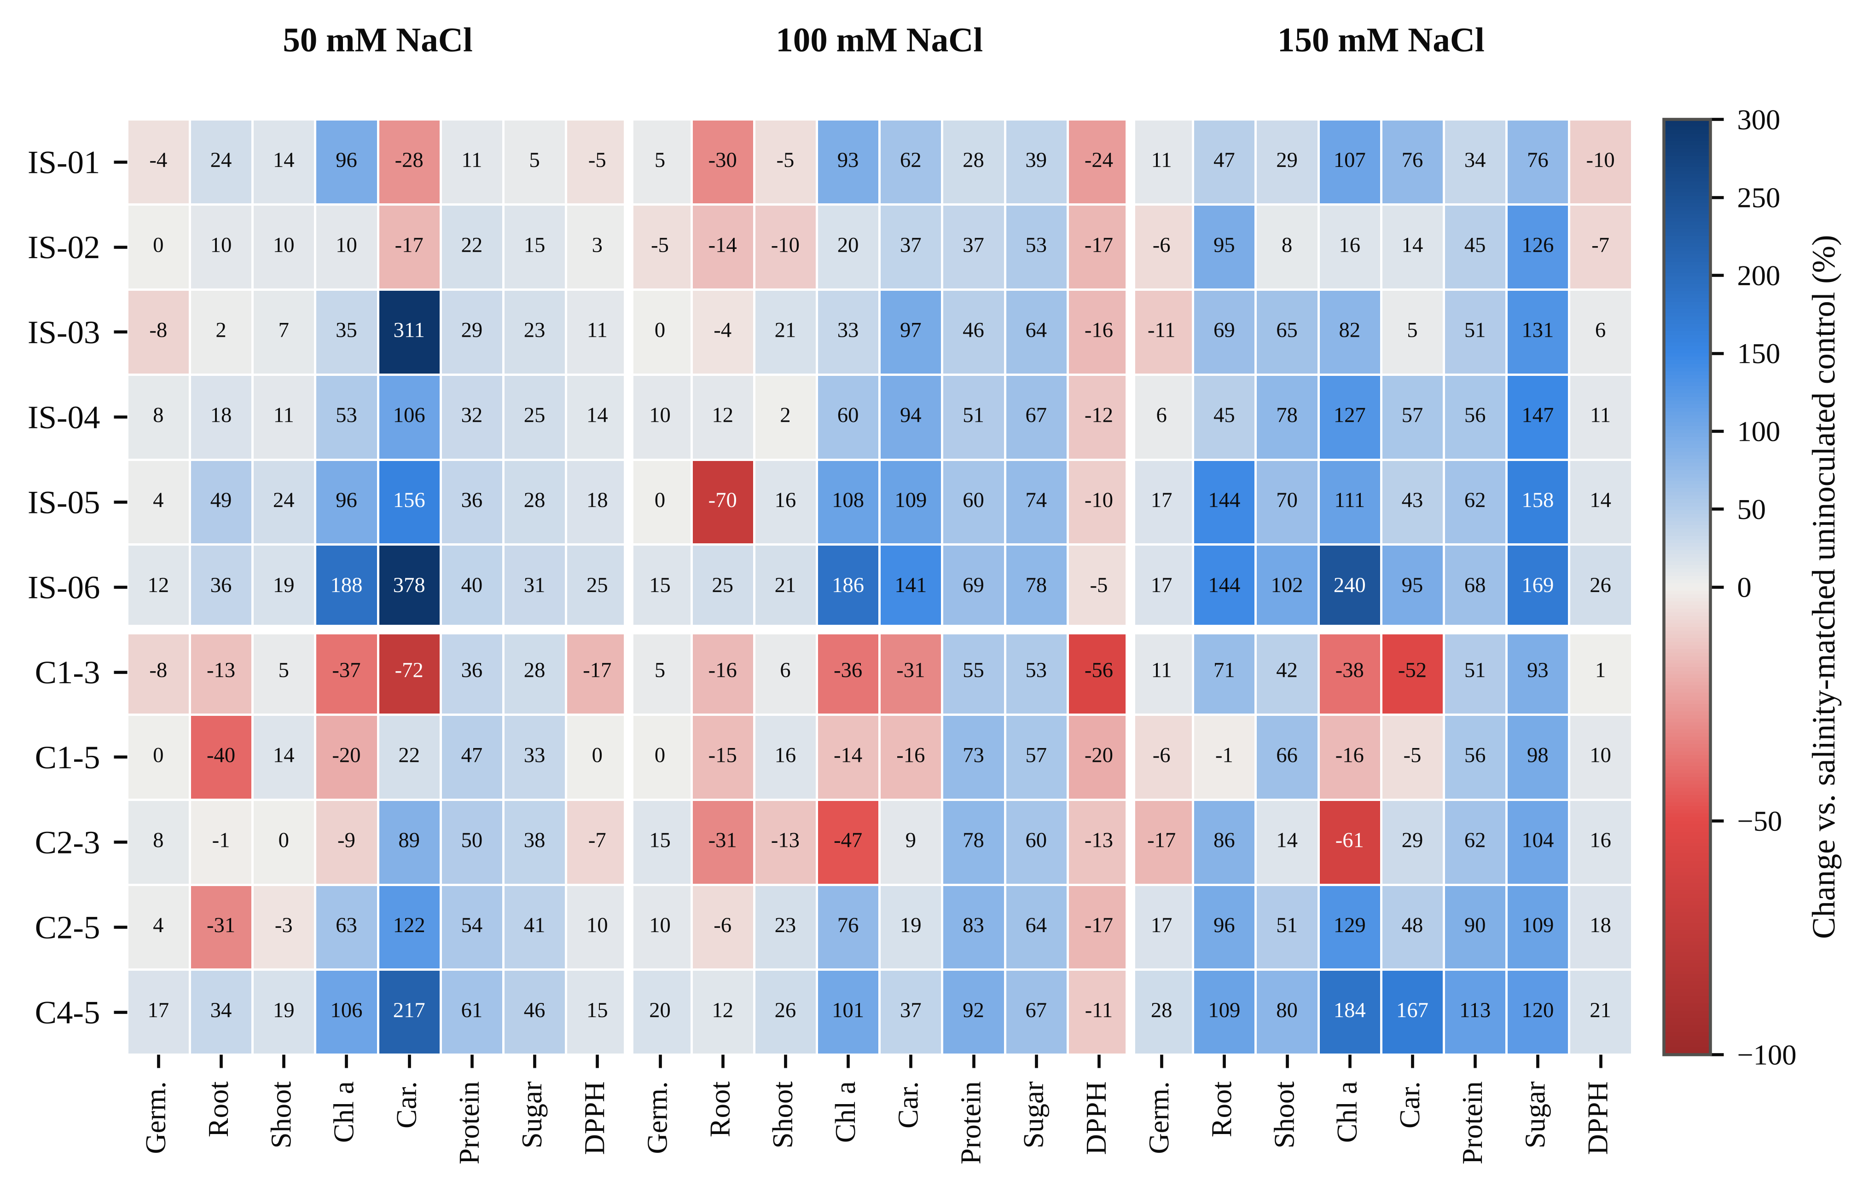
Fig. 4. Heat map of inoculation-mediated mitigation (IMM, %), i.e. the change in each trait relative to the uninoculated control at the same NaCl level, for six single isolates (upper block) and five consortia (lower block) at 50, 100 and 150 mM NaCl. Blue cells denote improvement and red cells impairment; the colour scale is truncated at −100% and +300%, and cell labels give exact values. Germ., germination; Car., carotenoids.
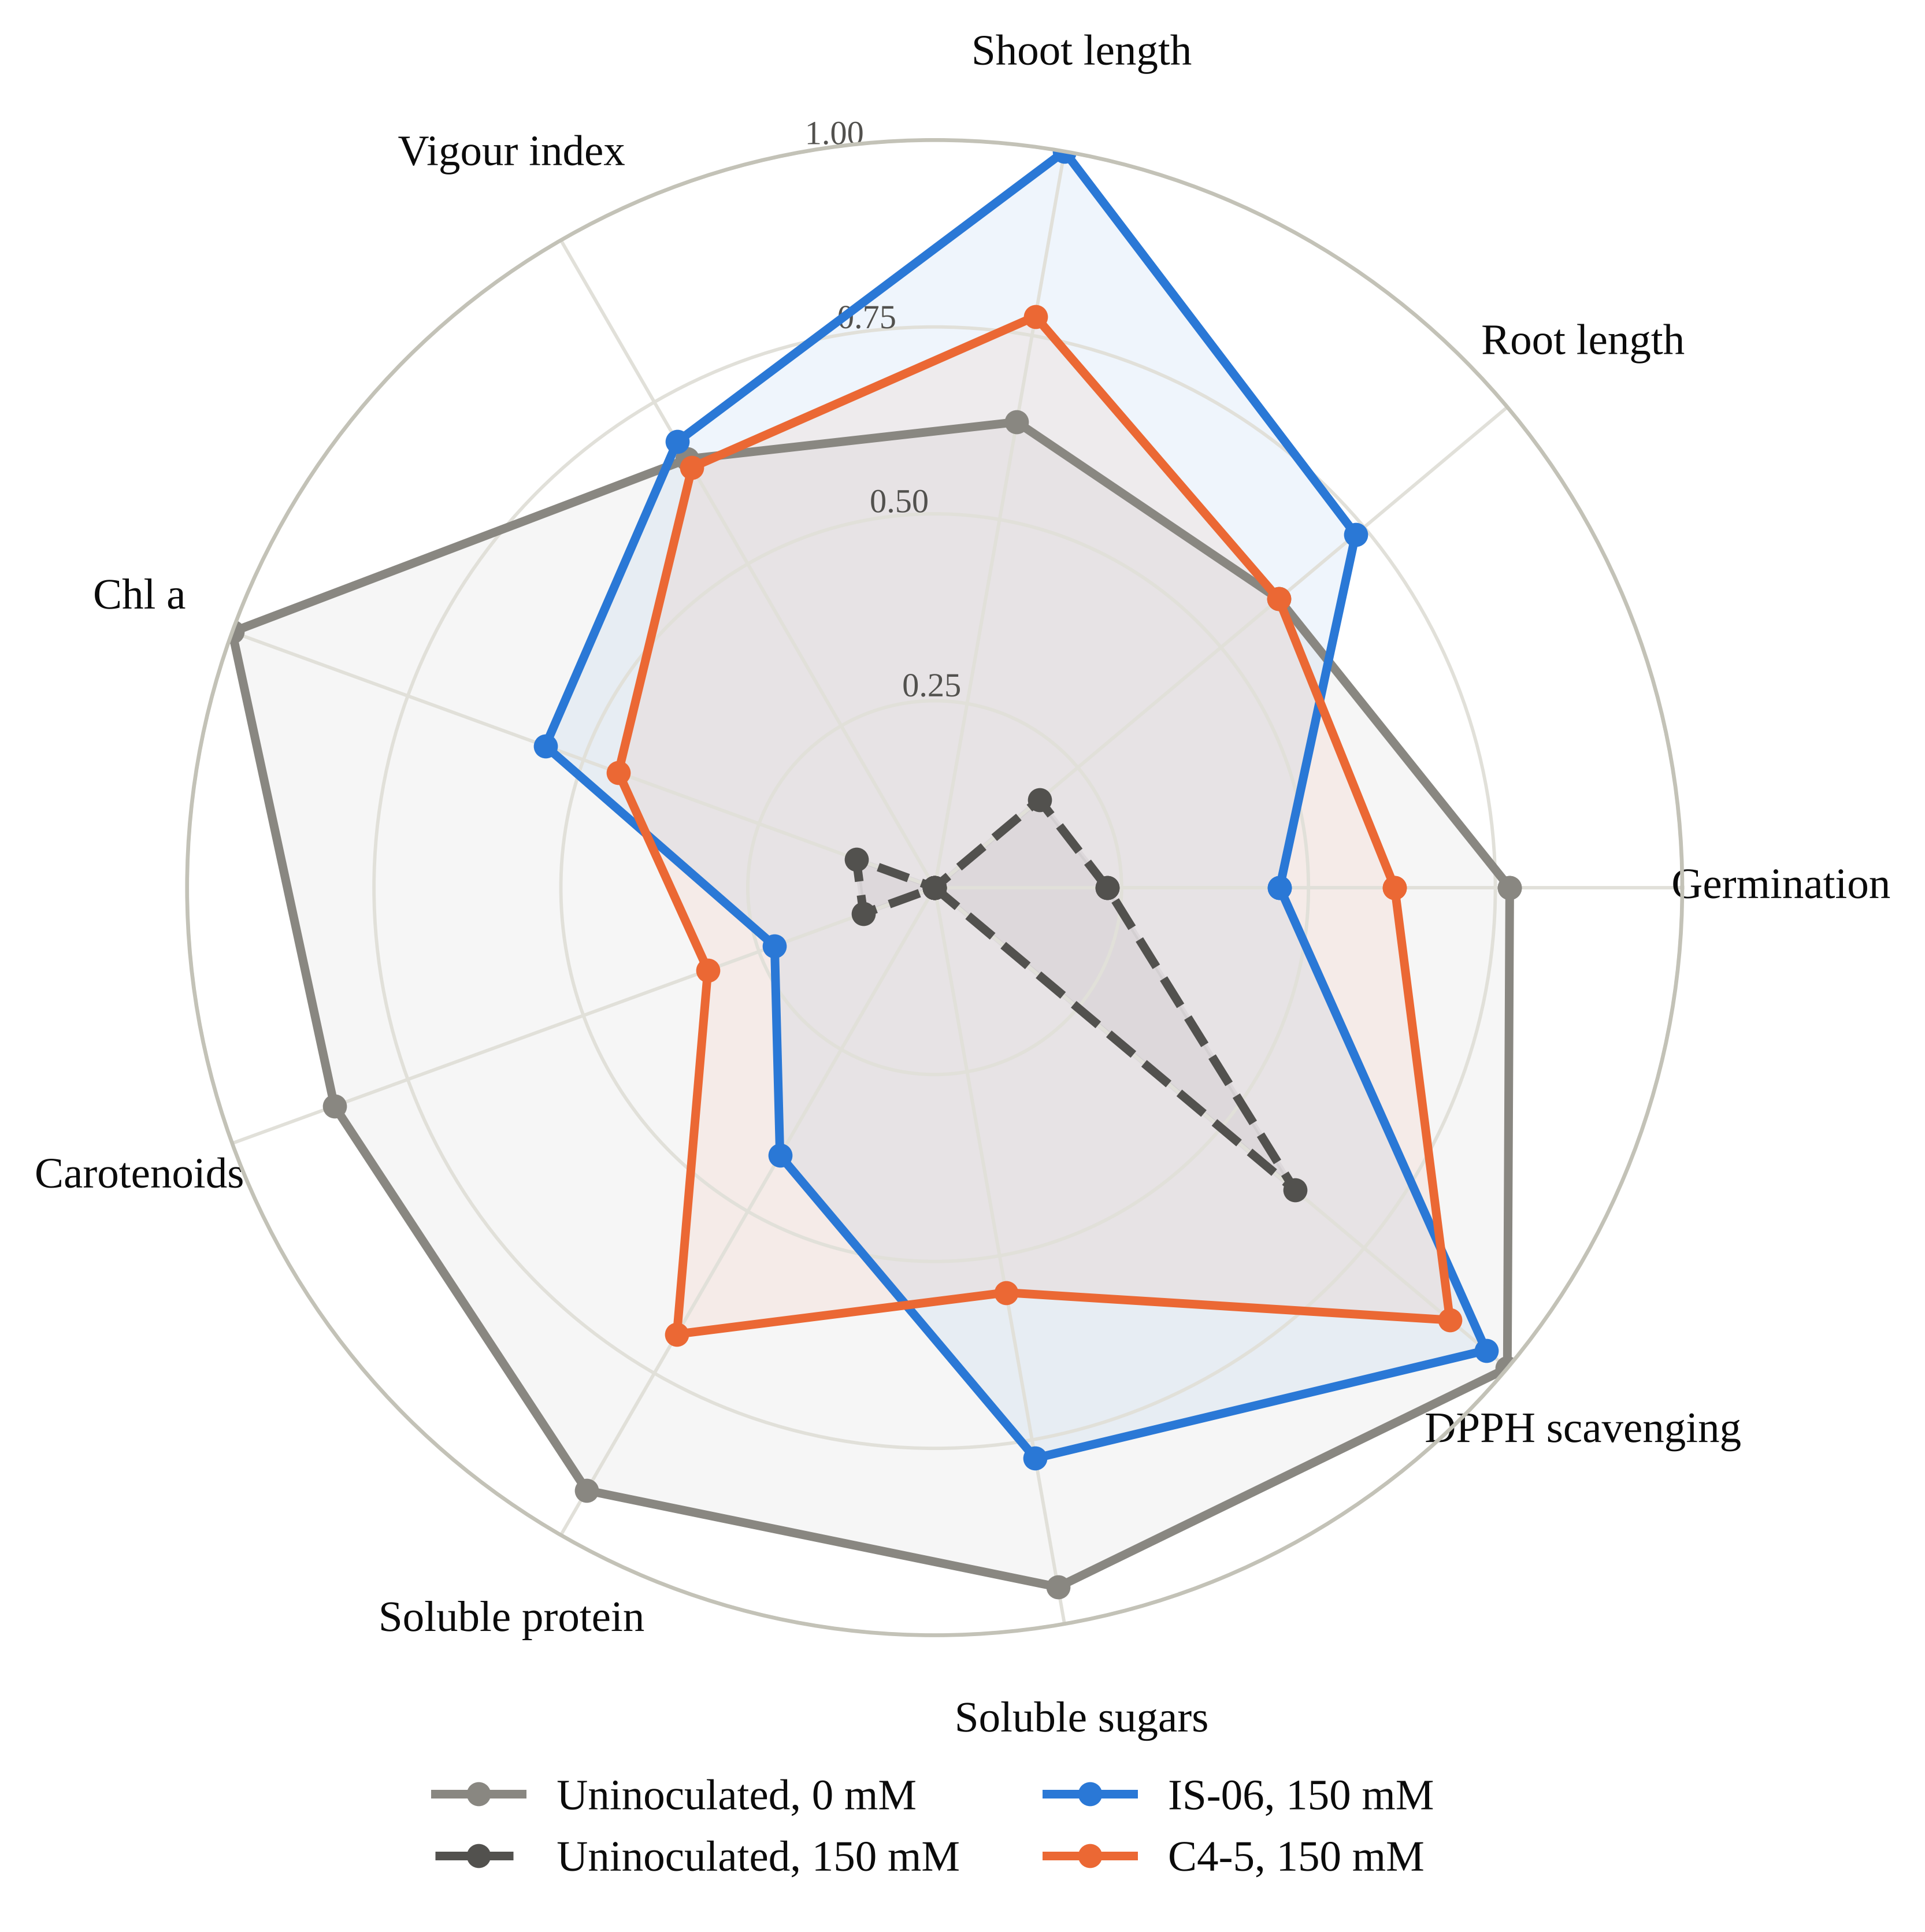
Fig. 5. Radar chart of nine traits rescaled to 0–1 across all 48 treatment combinations, comparing unstressed and 150 mM NaCl uninoculated plants with plants inoculated with IS-06 and C4-5 under 150 mM NaCl. A larger polygon indicates a trait profile closer to the best observed values.
The first two principal components (PCs) together explained 71.3% of the total variance (Fig. 6). PC1 (51.7%) showed positive loadings for all traits, most strongly SVI (0.91), chlorophyll a (0.84) and germination (0.82), and represents general seedling health. PC2 (19.6%) distinguished protein and sugars from DPPH and root and shoot length. Uninoculated plants shifted progressively toward negative PC1 scores with increasing salinity, whereas IS-06 stayed on the positive side at every salinity level, and IS-06 at 150 mM had a higher PC1 score than the control at 50 mM.
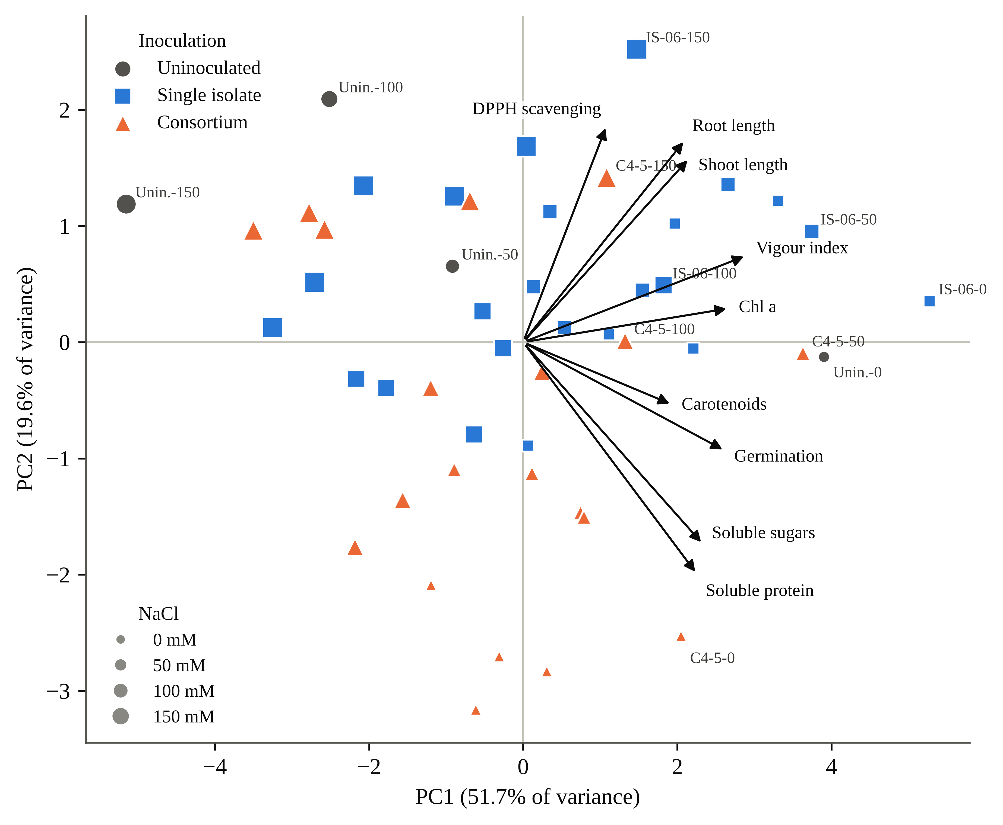
Fig. 6. Principal component analysis biplot of nine standardized traits across 48 treatment combinations. Symbol shape and colour indicate inoculation type and symbol size indicates NaCl level; selected treatments are labelled as inoculant–NaCl (mM). Arrows show trait loadings (scaled ×3.2). PC1 represents general seedling growth and metabolite status; PC2 separates protein and sugar content from root and shoot length and DPPH activity.

Table 3. Two-way ANOVA (inoculant × NaCl) for seedling growth and leaf biochemical traits of rice cv. IR-64, computed from replicate means and standard deviations (n = 3).
Trait | Inoculant F | NaCl F | Inoculant × NaCl F | η_{p}² (interaction) | Tukey HSD_{0.05}
Single-isolate experiment (7 inoculation levels × 4 NaCl levels)
Root length (cm) | 1156.4∗∗∗ | 3650.8∗∗∗ | 706.4∗∗∗ | 0.996 | 0.21
Shoot length (cm) | 1414.8∗∗∗ | 1884.3∗∗∗ | 414.6∗∗∗ | 0.993 | 0.68
Chlorophyll a (mg L⁻¹) | 4768.0∗∗∗ | 5411.7∗∗∗ | 792.0∗∗∗ | 0.996 | 0.81
Chlorophyll b (mg L⁻¹) | 4324.4∗∗∗ | 5914.4∗∗∗ | 1196.0∗∗∗ | 0.997 | 0.82
Soluble protein (µg mL⁻¹) | 1.36 × 10⁵∗∗∗ | 7.25 × 10⁵∗∗∗ | 2.75 × 10⁴∗∗∗ | 1.000 | 0.48
Soluble sugars (µg mL⁻¹) | 5.61 × 10⁴∗∗∗ | 8.28 × 10⁴∗∗∗ | 9767.6∗∗∗ | 1.000 | 0.48
DPPH scavenging (%) | 512.5∗∗∗ | 47.5∗∗∗ | 76.7∗∗∗ | 0.961 | 3.19
Consortium experiment (6 inoculation levels × 4 NaCl levels)
Root length (cm) | 123.0∗∗∗ | 86.1∗∗∗ | 52.2∗∗∗ | 0.942 | 0.59
Shoot length (cm) | 0.9 ns | 1.0 ns | 0.4 ns | 0.106 | 23.21
Chlorophyll a (mg L⁻¹) | 5916.3∗∗∗ | 4217.1∗∗∗ | 855.6∗∗∗ | 0.996 | 0.80
Chlorophyll b (mg L⁻¹) | 3815.2∗∗∗ | 1753.8∗∗∗ | 1294.0∗∗∗ | 0.998 | 0.90
Soluble protein (µg mL⁻¹) | 3.21 × 10⁵∗∗∗ | 7.72 × 10⁵∗∗∗ | 3.63 × 10⁴∗∗∗ | 1.000 | 0.47
Total phenolics (µg mL⁻¹) | 1.07 × 10⁴∗∗∗ | 1.10 × 10⁴∗∗∗ | 430.1∗∗∗ | 0.993 | 0.47
∗∗∗ p < 0.001; ns, not significant (p ≥ 0.05). η_{p}², partial eta-squared. HSD is the minimum significant difference between any two treatment means of the same experiment, in the units of the trait. Degrees of freedom: isolates F_{6,56} (inoculant), F_{3,56} (NaCl), F_{18,56} (interaction); consortia F_{5,48}, F_{3,48}, F_{15,48}. Isolate phenolics, consortium sugars and consortium DPPH are omitted because replicate SDs were not recorded. Several traits carried identical replicate SDs (±0.15) across treatments, which inflates F; effect sizes and treatment rankings are the more reliable guide.

4. Discussion
The uninoculated plants responded as expected for a salt-susceptible indica cultivar. Root growth was affected first: at 150 mM, root length decreased by approximately half and SVI by 57.7%, consistent with the osmotic phase in which water uptake and cell expansion are restricted before ions reach toxic levels (Munns and Tester, 2008). Similar to Siddika et al. (2024), who reported marked reductions in growth, chlorophyll content and photosynthetic parameters of salt-stressed rice without inoculation, chlorophyll a lost more than two-thirds of its value at only 50 mM, while germination barely changed. Pigment loss of this magnitude at a low salt level usually indicates oxidative injury in the chloroplast (Gill and Tuteja, 2010). A comparable decline in growth and pigments of uninoculated rice seedlings under NaCl was also reported by Asif et al. (2023) and Wang et al. (2025). The parallel fall in carotenoids, which quench excess excitation energy, would have further increased chloroplast vulnerability.
The response of soluble sugars differed from that commonly reported for salt-stressed plants. Tolerant plants usually accumulate sugars as osmolytes (Parida and Das, 2005; Mahajan and Tuteja, 2005), yet in IR-64 sugars fell by 67.5%, together with protein and phenolics. This pattern is interpreted as a susceptible cultivar unable to keep carbon assimilation going well enough to fund an osmotic response, consistent with reviews that place photosynthetic capacity upstream of most salt-tolerance traits in rice (Sackey et al., 2025) and with the broader view of salt signalling as a reprogramming of metabolism (Zhu, 2016). The present data cannot establish the causal order, because gas exchange was not measured.
The clearest negative result was that no inoculant changed germination significantly. In contrast to Sagar et al. (2020), who reported higher germination of rice and millets bacterized with the halophilic Enterobacter sp. PR14 under salt, and to Ali et al. (2022), who reported improved rice growth with salt-tolerant Bacillus strains, the present inoculants did not alter emergence detectably. The direction of effect for the best inoculants nevertheless agreed with these reports, with IS-06 and C4-5 10–17 percentage points above the control at 150 mM (Fig. 2), although IS-02, IS-03 and C2-3 fell below it. With 30 seeds per treatment, Fisher’s exact test requires a difference of about 27 percentage points to reach significance, so the design could not confirm effects of this size. Germination was also one of the least salt-sensitive traits (SIR 28%, against 52% for root length and 83% for chlorophyll a). Similar to Singh et al. (2021), who identified seedling establishment rather than seed germination as the critical salt-sensitive stage in rice, stand losses in saline paddies are therefore more likely to arise from weak seedlings than from seeds that fail to germinate, and this is where the inoculants were effective. Because salt was applied from 15 DAS, its effect on emergence suggests that saline irrigation reached the seed zone early or that the counts partly reflect seedling survival; future trials should record the two separately.
IS-06 was the most consistent performer, ranking first among the isolates for chlorophyll a, protein, sugars and DPPH activity under salt and first on the CMI at all four salinity levels. Its 240% increase in chlorophyll a at 150 mM is at the upper end of values reported for rice. Similar to Siddika et al. (2024), who reported that Bacillus subtilis and B. aryabhattai restored photosynthetic parameters of salt-stressed rice together with ion homeostasis and antioxidant defence, IS-06 maintained pigment levels close to those of unstressed plants. Asif et al. (2023) likewise reported that halotolerant endophytes improved rice growth under NaCl by regulating ion content, endogenous hormones and ion-transporter gene expression, and Sarkar et al. (2018) reported that an ACC deaminase-producing halotolerant Enterobacter sp. increased rice seedling growth and chlorophyll content under salt stress.
The mechanism behind IS-06 is still open, and two routes seem most likely. ACC deaminase would lower stress ethylene, protecting root elongation and delaying ethylene-driven chlorophyll breakdown (Glick, 2014); ACC deaminase-positive Enterobacter strains protected salt-stressed rice seedlings in exactly this way (Sarkar et al., 2018; Sagar et al., 2020). Alternatively, IS-06 may limit sodium entry into the shoot, as reported for other rice endophytes (Khan et al., 2021), possibly helped by exopolysaccharides that bind Na⁺ around the roots (Sun et al., 2020). Most growth-promoting strains combine several such traits (Glick, 2012; Etesami & Maheshwari, 2018), and direct assays for ACC deaminase, indole-3-acetic acid, exopolysaccharide and shoot Na⁺/K⁺ would separate them. The sugar data add one point: IS-06 kept 89% of its unstressed sugar against 33% in the control, which probably reflects preserved chlorophyll feeding a steady carbon supply. Inoculation-driven accumulation of compatible solutes is well documented (Arora et al., 2020; Ramasamy & Mahawar, 2023), but the present data cannot show whether the extra sugar served osmotic adjustment or simply reflects higher assimilation.
A meta-analysis of inoculation trials in living soil reported that consortia generally perform better than single strains (Liu et al., 2023); the present results support a more qualified conclusion. On the average CMI, only C4-5 outperformed both of its parent strains, C2-5 ranked between its parents, and C1-3, C1-5 and C2-3 ranked below both. At 150 mM, C4-5 exceeded both parents for protein (181.51 vs. 133.45 and 138.26 µg mL⁻¹), chlorophyll a and SVI, but not for sugars. Similar to M. Y. Khan et al. (2022), who reported that a compatible PGPB consortium improved the growth and yield of wheat under saline conditions, a well-matched pair (C4-5) improved several traits beyond either parent. In contrast to the consistent consortium advantage reported by Liu et al. (2023), however, three of the five pairs were inferior to their parents, and Moronta-Barrios et al. (2018) similarly showed that the members of a simplified rice endophytic community differ in colonization and persistence when inoculated together.
All five pairs passed the plate test, so the failures are not simple antagonism. Partners sharing a niche inside the root may compete for colonization sites (Compant et al., 2019; Kandasamy & Kathirvel, 2023), or the same trait may be duplicated without adding function. Each weak consortium contains at least one of the three isolates that protected chlorophyll least (IS-01, IS-02, IS-03), although C2-5 shows the pattern is not absolute. Combining strains can therefore be either beneficial or detrimental, and reviews of halotolerant bacteria accordingly emphasize trait-based selection of partner strains (Numan et al., 2018; Zamanzadeh-Nasrabadi et al., 2023). Because isolates and consortia were run as separate batches with a shared control, consortium–parent comparisons are indirect and should be confirmed in a single experiment.
Protein retention was the one trait in which the consortia clearly outperformed the single strains (81% for C4-5 and 75% for C2-5, against 70% for IS-06 and 40% for the control). Salinity lowers soluble protein through reduced nitrogen assimilation and accelerated proteolysis (Parida and Das, 2005), and two partners could plausibly alleviate both. Similar to Neshat et al. (2022), who reported that PGPR inoculation increased soluble protein and antioxidant capacity of salt-stressed plants, and to Gupta et al. (2023), who reported improved biochemical status of rice inoculated with salinity-alleviating bacteria, the consortia preserved leaf protein under 150 mM NaCl. Phenolics, which scavenge radicals and stabilize membranes, were largely maintained by C4-5 and IS-06, in line with inoculation-induced antioxidant capacity in salt-stressed plants (Neshat et al., 2022); the collapse under IS-01 at 150 mM suggests that some endophytes suppress phenolic accumulation and should not be carried forward. DPPH was the least informative trait: it differed between batches, was not monotonic with salt and measures an extract's combined radical-quenching capacity rather than any one enzyme (Gülçin, 2020). Phenolic and antioxidant profiles of rice also shift under other abiotic stresses (Bhadwal et al., 2024), so DPPH is supporting evidence here and not a primary endpoint.
Ranking trait by trait gives different winners: IS-06 for sugars, C4-5 for protein, IS-05 for root length. The CMI and PCA, which weight traits differently, agreed on IS-06 and C4-5 at the top and on C2-3 and C1-3 at the bottom, supporting composite, relative measures for comparing salt responses (Negrão et al., 2017). PC1 showed that most of the difference between good and poor treatments lay on a single axis of seedling health, while PC2 separated the consortia's protein-retention route from IS-06's growth-and-pigment route.
The isolates still require confirmed taxonomic identity and quantified plant growth-promoting traits before they can be compared with published inoculants or registered. Afzal et al. (2019) emphasized that identification and trait characterization are prerequisites for the safe application of endophytes, and Ganie et al. (2021) noted that the benefits of rice endophytes under stress depend strongly on strain identity. Following Sarkar et al. (2018) and Sagar et al. (2020), who linked salt tolerance of rice to quantified ACC deaminase and antioxidant-enzyme activity of identified Enterobacter strains, 16S rRNA gene sequencing and assays of ACC deaminase, IAA, phosphate solubilization and exopolysaccharide production are planned for IS-06, IS-04 and IS-05. Biochemical values are expressed per volume of extract; the fixed tissue-to-solvent ratio makes treatments comparable, but not directly with per-gram data from other studies. Several assays recorded identical replicate SDs (±0.15), probably analytical rather than biological replication, which inflates F; effect sizes and rankings are the more reliable guide. Colonization was not verified by re-isolation or marker tracking (Walitang et al., 2017; Gupta et al., 2023), and ion contents, oxidative-damage markers and antioxidant enzymes were outside the scope of this trial. Finally, the trial ended at 45 DAS in pots, and seedling-stage tolerance in rice correlates only weakly with tolerance at flowering (Singh et al., 2021). Salt-tolerant rhizobacteria have improved rice yield in saline soil (Shultana et al., 2020), so yield-stage field testing of IS-06 and C4-5, ideally with a tolerant cultivar since host genotype shapes the endophytic community (Walitang et al., 2018; Wang et al., 2025), is the logical next step.
5. Conclusions
Salinity at 150 mM NaCl reduced seedling vigour of IR-64 rice by 58%, chlorophyll a by 83% and soluble sugars by 68%. Bacterization with rice endophytes did not change germination significantly, but it strongly protected seedling growth, photosynthetic pigments, soluble protein, sugars and phenolics under salt. IS-06 was the most consistent single strain, raising chlorophyll a by 240%, sugars by 169% and SVI by 142% at 150 mM. C4-5 retained 81% of its unstressed protein and exceeded both parent strains for protein, chlorophyll a and vigour, whereas three of the five consortia ranked below both parents. A composite index and PCA agreed on IS-06 and C4-5 as the leading candidates for strain identification, colonization tests and yield-stage evaluation in saline fields.

Declarations
Author contributions (CRediT). [Author Name]: Conceptualization, Investigation, Formal analysis, Data curation, Writing – original draft. [Co-author / Research Guide Name]: Supervision, Methodology, Resources, Writing – review and editing.
References
Abdul-Baki, A. A., & Anderson, J. D. (1973). Vigor determination in soybean seed by multiple criteria. Crop Science, 13(6), 630–633. https:/​/​doi.​org/​10.​2135/​cropsci1973.​0011183X001300060013x
Afzal, I., Shinwari, Z. K., Sikandar, S., & Shahzad, S. (2019). Plant beneficial endophytic bacteria: Mechanisms, diversity, host range and genetic determinants. Microbiological Research, 221, 36–49. https:/​/​doi.​org/​10.​1016/​j.​micres.​2019.​02.​001
Ali, Q., Ayaz, M., Mu, G., Hussain, A., Yuanyuan, Q., Yu, C., Xu, Y., Manghwar, H., Gu, Q., Wu, H., & Gao, X. (2022). Revealing plant growth-promoting mechanisms of Bacillus strains in elevating rice growth and its interaction with salt stress. Frontiers in Plant Science, 13, Article 994902. https:/​/​doi.​org/​10.​3389/​fpls.​2022.​994902
Arnon, D. I. (1949). Copper enzymes in isolated chloroplasts. Polyphenoloxidase in Beta vulgaris. Plant Physiology, 24(1), 1–15. https:/​/​doi.​org/​10.​1104/​pp.​24.​1.​1
Arora, N. K., Fatima, T., Mishra, J., Mishra, I., Verma, S., Verma, R., Verma, M., Bhattacharya, A., Verma, P., Mishra, P., & Bharti, C. (2020). Halo-tolerant plant growth promoting rhizobacteria for improving productivity and remediation of saline soils. Journal of Advanced Research, 26, 69–82. https:/​/​doi.​org/​10.​1016/​j.​jare.​2020.​07.​003
Asif, S., Jan, R., Kim, N., Asaf, S., Lubna, Khan, M. A., Kim, E. G., Jang, Y. H., Bhatta, D., Lee, I. J., & Kim, K. M. (2023). Halotolerant endophytic bacteria alleviate salinity stress in rice (Oryza sativa L.) by modulating ion content, endogenous hormones, the antioxidant system and gene expression. BMC Plant Biology, 23(1), Article 494. https:/​/​doi.​org/​10.​1186/​s12870-​023-​04517-​z
Basak, N., Rai, A. K., Sundha, P., Meena, R. L., Bedwal, S., Yadav, R. K., & Sharma, P. C. (2022). Assessing soil quality for rehabilitation of salt-affected agroecosystem: A comprehensive review. Frontiers in Environmental Science, 10, Article 935785. https:/​/​doi.​org/​10.​3389/​fenvs.​2022.​935785
Bhadwal, S., Sharma, S., & Singh, D. (2024). Interactive effects of selenium and arsenic on phenolic constituents and antioxidant activity in rice (Oryza sativa L.). Chemosphere, 350, Article 141071. https:/​/​doi.​org/​10.​1016/​j.​chemosphere.​2023.​141071
Brand-Williams, W., Cuvelier, M. E., & Berset, C. (1995). Use of a free radical method to evaluate antioxidant activity. LWT – Food Science and Technology, 28(1), 25–30. https:/​/​doi.​org/​10.​1016/​S0023-​6438(95)80008-​5
Compant, S., Samad, A., Faist, H., & Sessitsch, A. (2019). A review on the plant microbiome: Ecology, functions, and emerging trends in microbial application. Journal of Advanced Research, 19, 29–37. https:/​/​doi.​org/​10.​1016/​j.​jare.​2019.​03.​004
Etesami, H., & Glick, B. R. (2020). Halotolerant plant growth–promoting bacteria: Prospects for alleviating salinity stress in plants. Environmental and Experimental Botany, 178, Article 104124. https:/​/​doi.​org/​10.​1016/​j.​envexpbot.​2020.​104124
Etesami, H., & Maheshwari, D. K. (2018). Use of plant growth promoting rhizobacteria (PGPRs) with multiple plant growth promoting traits in stress agriculture: Action mechanisms and future prospects. Ecotoxicology and Environmental Safety, 156, 225–246. https:/​/​doi.​org/​10.​1016/​j.​ecoenv.​2018.​03.​013
Ganie, S. A., Bhat, J. A., & Devoto, A. (2021). The influence of endophytes on rice fitness under environmental stresses. Plant Molecular Biology, 109(4–5), 447–467. https:/​/​doi.​org/​10.​1007/​s11103-​021-​01219-​8
Gill, S. S., & Tuteja, N. (2010). Reactive oxygen species and antioxidant machinery in abiotic stress tolerance in crop plants. Plant Physiology and Biochemistry, 48(12), 909–930. https:/​/​doi.​org/​10.​1016/​j.​plaphy.​2010.​08.​016
Glick, B. R. (2012). Plant growth-promoting bacteria: Mechanisms and applications. Scientifica, 2012, Article 963401. https:/​/​doi.​org/​10.​6064/​2012/​963401
Glick, B. R. (2014). Bacteria with ACC deaminase can promote plant growth and help to feed the world. Microbiological Research, 169(1), 30–39. https:/​/​doi.​org/​10.​1016/​j.​micres.​2013.​09.​009
Gülçin, İ. (2020). Antioxidants and antioxidant methods: An updated overview. Archives of Toxicology, 94(3), 651–715. https:/​/​doi.​org/​10.​1007/​s00204-​020-​02689-​3
Gupta, A., Tiwari, R. K., Shukla, R., Singh, A. N., & Sahu, P. K. (2023). Salinity alleviator bacteria in rice (Oryza sativa L.), their colonization efficacy, and synergism with melatonin. Frontiers in Plant Science, 13, Article 1060287. https:/​/​doi.​org/​10.​3389/​fpls.​2022.​1060287
Hardoim, P. R., van Overbeek, L. S., Berg, G., Pirttilä, A. M., Compant, S., Campisano, A., Döring, M., & Sessitsch, A. (2015). The hidden world within plants: Ecological and evolutionary considerations for defining functioning of microbial endophytes. Microbiology and Molecular Biology Reviews, 79(3), 293–320. https:/​/​doi.​org/​10.​1128/​MMBR.​00050-​14
Hiscox, J. D., & Israelstam, G. F. (1979). A method for the extraction of chlorophyll from leaf tissue without maceration. Canadian Journal of Botany, 57(12), 1332–1334. https:/​/​doi.​org/​10.​1139/​b79-​163
Ilangumaran, G., & Smith, D. L. (2017). Plant growth promoting rhizobacteria in amelioration of salinity stress: A systems biology perspective. Frontiers in Plant Science, 8, Article 1768. https:/​/​doi.​org/​10.​3389/​fpls.​2017.​01768
Ismail, A. M., & Horie, T. (2017). Genomics, physiology, and molecular breeding approaches for improving salt tolerance. Annual Review of Plant Biology, 68, 405–434. https:/​/​doi.​org/​10.​1146/​annurev-​arplant-​042916-​040936
Jolliffe, I. T., & Cadima, J. (2016). Principal component analysis: A review and recent developments. Philosophical Transactions of the Royal Society A: Mathematical, Physical and Engineering Sciences, 374(2065), Article 20150202. https:/​/​doi.​org/​10.​1098/​rsta.​2015.​0202
Kandasamy, G. D., & Kathirvel, P. (2023). Insights into bacterial endophytic diversity and isolation with a focus on their potential applications – A review. Microbiological Research, 266, Article 127256. https:/​/​doi.​org/​10.​1016/​j.​micres.​2022.​127256
Khan, M. A., Hamayun, M., Asaf, S., Khan, M., Yun, B. W., Kang, S. M., & Lee, I. J. (2021). Rhizospheric Bacillus spp. rescues plant growth under salinity stress via regulating gene expression, endogenous hormones, and antioxidant system of Oryza sativa L. Frontiers in Plant Science, 12, Article 665590. https:/​/​doi.​org/​10.​3389/​fpls.​2021.​665590
Khan, M. Y., Nadeem, S. M., Sohaib, M., Waqas, M. R., Alotaibi, F., Ali, L., Zahir, Z. A., & Al-Barakah, F. N. I. (2022). Potential of plant growth promoting bacterial consortium for improving the growth and yield of wheat under saline conditions. Frontiers in Microbiology, 13, Article 958522. https:/​/​doi.​org/​10.​3389/​fmicb.​2022.​958522
Larson, D. A. (1992). Analysis of variance with just summary statistics as input. The American Statistician, 46(2), 151–152. https:/​/​doi.​org/​10.​1080/​00031305.​1992.​10475872
Lichtenthaler, H. K. (1987). Chlorophylls and carotenoids: Pigments of photosynthetic biomembranes. Methods in Enzymology, 148, 350–382. https:/​/​doi.​org/​10.​1016/​0076-​6879(87)48036-​1
Liu, X., Mei, S., & Salles, J. F. (2023). Inoculated microbial consortia perform better than single strains in living soil: A meta-analysis. Applied Soil Ecology, 190, Article 105011. https:/​/​doi.​org/​10.​1016/​j.​apsoil.​2023.​105011
Lowry, O. H., Rosebrough, N. J., Farr, A. L., & Randall, R. J. (1951). Protein measurement with the Folin phenol reagent. Journal of Biological Chemistry, 193(1), 265–275. https:/​/​doi.​org/​10.​1016/​S0021-​9258(19)52451-​6
Mahajan, S., & Tuteja, N. (2005). Cold, salinity and drought stresses: An overview. Archives of Biochemistry and Biophysics, 444(2), 139–158. https:/​/​doi.​org/​10.​1016/​j.​abb.​2005.​10.​018
Moronta-Barrios, F., Gionechetti, F., Pallavicini, A., Marys, E., & Venturi, V. (2018). Bacterial microbiota of rice roots: 16S-based taxonomic profiling of endophytic and rhizospheric diversity, endophytes isolation and simplified endophytic community. Microorganisms, 6(1), Article 14. https:/​/​doi.​org/​10.​3390/​microorganisms6010014
Munns, R., & Tester, M. (2008). Mechanisms of salinity tolerance. Annual Review of Plant Biology, 59, 651–681. https:/​/​doi.​org/​10.​1146/​annurev.​arplant.​59.​032607.​092911
Negrão, S., Schmöckel, S. M., & Tester, M. (2017). Evaluating physiological responses of plants to salinity stress. Annals of Botany, 119(1), 1–11. https:/​/​doi.​org/​10.​1093/​aob/​mcw191
Neshat, M., Abbasi, A., Hosseinzadeh, A., Sarikhani, M. R., Dadashi Chavan, D., & Rasoulnia, A. (2022). Plant growth promoting bacteria (PGPR) induce antioxidant tolerance against salinity stress through biochemical and physiological mechanisms. Physiology and Molecular Biology of Plants, 28(2), 347–361. https:/​/​doi.​org/​10.​1007/​s12298-​022-​01128-​0
Numan, M., Bashir, S., Khan, Y., Mumtaz, R., Shinwari, Z. K., Khan, A. L., Khan, A., & Al-Harrasi, A. (2018). Plant growth promoting bacteria as an alternative strategy for salt tolerance in plants: A review. Microbiological Research, 209, 21–32. https:/​/​doi.​org/​10.​1016/​j.​micres.​2018.​02.​003
Parida, A. K., & Das, A. B. (2005). Salt tolerance and salinity effects on plants: A review. Ecotoxicology and Environmental Safety, 60(3), 324–349. https:/​/​doi.​org/​10.​1016/​j.​ecoenv.​2004.​06.​010
Ramasamy, K. P., & Mahawar, L. (2023). Coping with salt stress—interaction of halotolerant bacteria in crop plants: A mini review. Frontiers in Microbiology, 14, Article 1077561. https:/​/​doi.​org/​10.​3389/​fmicb.​2023.​1077561
Sackey, O. K., Feng, N., Mohammed, Y. Z., Dzou, C. F., Zheng, D., Zhao, L., & Shen, X. (2025). A comprehensive review on rice responses and tolerance to salt stress. Frontiers in Plant Science, 16, Article 1561280. https:/​/​doi.​org/​10.​3389/​fpls.​2025.​1561280
Sagar, A., Sayyed, R. Z., Ramteke, P. W., Sharma, S., Marraiki, N., Elgorban, A. M., & Syed, A. (2020). ACC deaminase and antioxidant enzymes producing halophilic Enterobacter sp. PR14 promotes the growth of rice and millets under salinity stress. Physiology and Molecular Biology of Plants, 26(9), 1847–1854. https:/​/​doi.​org/​10.​1007/​s12298-​020-​00852-​9
Saleem, M. A., Khan, A., Tu, J., Huang, W., Liu, Y., Feng, N., Zheng, D., & Xue, Y. (2025). Salinity stress in rice: Multilayered approaches for sustainable tolerance. International Journal of Molecular Sciences, 26(13), Article 6025. https:/​/​doi.​org/​10.​3390/​ijms26136025
Santoyo, G., Moreno-Hagelsieb, G., Orozco-Mosqueda, M. del C., & Glick, B. R. (2016). Plant growth-promoting bacterial endophytes. Microbiological Research, 183, 92–99. https:/​/​doi.​org/​10.​1016/​j.​micres.​2015.​11.​008
Sarkar, A., Ghosh, P. K., Pramanik, K., Mitra, S., Soren, T., Pandey, S., Mondal, M. H., & Maiti, T. K. (2018). A halotolerant Enterobacter sp. displaying ACC deaminase activity promotes rice seedling growth under salt stress. Research in Microbiology, 169(1), 20–32. https:/​/​doi.​org/​10.​1016/​j.​resmic.​2017.​08.​005
Seabold, S., & Perktold, J. (2010). Statsmodels: Econometric and statistical modeling with Python. Proceedings of the 9th Python in Science Conference, 92–96. https:/​/​doi.​org/​10.​25080/​Majora-​92bf1922-​011
Shultana, R., Kee Zuan, A. T., Yusop, M. R., & Saud, H. M. (2020). Characterization of salt-tolerant plant growth-promoting rhizobacteria and the effect on growth and yield of saline-affected rice. PLOS ONE, 15(9), Article e0238537. https:/​/​doi.​org/​10.​1371/​journal.​pone.​0238537
Siddika, A., Rashid, A. A., Khan, S. N., Khatun, A., Karim, M. M., Prasad, P. V. V., & Hasanuzzaman, M. (2024). Harnessing plant growth-promoting rhizobacteria, Bacillus subtilis and B. aryabhattai to combat salt stress in rice: A study on the regulation of antioxidant defense, ion homeostasis, and photosynthetic parameters. Frontiers in Plant Science, 15, Article 1419764. https:/​/​doi.​org/​10.​3389/​fpls.​2024.​1419764
Singh, R. K., Kota, S., & Flowers, T. J. (2021). Salt tolerance in rice: Seedling and reproductive stage QTL mapping come of age. Theoretical and Applied Genetics, 134(11), 3495–3533. https:/​/​doi.​org/​10.​1007/​s00122-​021-​03890-​3
Singleton, V. L., & Rossi, J. A. (1965). Colorimetry of total phenolics with phosphomolybdic-phosphotungstic acid reagents. American Journal of Enology and Viticulture, 16(3), 144–158. https:/​/​doi.​org/​10.​5344/​ajev.​1965.​16.​3.​144
Sun, L., Lei, P., Wang, Q., Ma, J., Zhan, Y., Jiang, K., Xu, Z., & Xu, H. (2020). The endophyte Pantoea alhagi NX-11 alleviates salt stress damage to rice seedlings by secreting exopolysaccharides. Frontiers in Microbiology, 10, Article 3112. https:/​/​doi.​org/​10.​3389/​fmicb.​2019.​03112
Tukey, J. W. (1949). Comparing individual means in the analysis of variance. Biometrics, 5(2), 99–114. https:/​/​doi.​org/​10.​2307/​3001913
van Zelm, E., Zhang, Y., & Testerink, C. (2020). Salt tolerance mechanisms of plants. Annual Review of Plant Biology, 71, 403–433. https:/​/​doi.​org/​10.​1146/​annurev-​arplant-​050718-​100005
Virtanen, P., Gommers, R., Oliphant, T. E., Haberland, M., Reddy, T., Cournapeau, D., Burovski, E., Peterson, P., Weckesser, W., Bright, J., van der Walt, S. J., Brett, M., Wilson, J., Millman, K. J., Mayorov, N., Nelson, A. R. J., Jones, E., Kern, R., Larson, E., . . . van Mulbregt, P. (2020). SciPy 1.0: Fundamental algorithms for scientific computing in Python. Nature Methods, 17(3), 261–272. https:/​/​doi.​org/​10.​1038/​s41592-​019-​0686-​2
Walitang, D. I., Kim, K., Madhaiyan, M., Kim, Y. K., Kang, Y., & Sa, T. (2017). Characterizing endophytic competence and plant growth promotion of bacterial endophytes inhabiting the seed endosphere of rice. BMC Microbiology, 17(1), Article 209. https:/​/​doi.​org/​10.​1186/​s12866-​017-​1117-​0
Walitang, D. I., Kim, C. G., Kim, K., Kang, Y., Kim, Y. K., & Sa, T. (2018). The influence of host genotype and salt stress on the seed endophytic community of salt-sensitive and salt-tolerant rice cultivars. BMC Plant Biology, 18(1), Article 51. https:/​/​doi.​org/​10.​1186/​s12870-​018-​1261-​1
Wang, J., Gao, X., Yang, M., Zhang, Y., & Chen, Y. (2025). Alleviative effects of plant growth-promoting rhizobacteria on salt-stressed rice seedlings: Mechanisms mediated by rhizosphere microbiota and root exudates. Frontiers in Plant Science, 16, Article 1661074. https:/​/​doi.​org/​10.​3389/​fpls.​2025.​1661074
Yemm, E. W., & Willis, A. J. (1954). The estimation of carbohydrates in plant extracts by anthrone. Biochemical Journal, 57(3), 508–514. https:/​/​doi.​org/​10.​1042/​bj0570508
Zamanzadeh-Nasrabadi, S. M., Mohammadiapanah, F., Hosseini-Mazinani, M., & Sarikhan, S. (2023). Salinity stress endurance of the plants with the aid of bacterial genes. Frontiers in Genetics, 14, Article 1049608. https:/​/​doi.​org/​10.​3389/​fgene.​2023.​1049608
Zhu, J.-K. (2016). Abiotic stress signaling and responses in plants. Cell, 167(2), 313–324. https:/​/​doi.​org/​10.​1016/​j.​cell.​2016.​08.​029

