Bioprospecting rice endophytic bacteria and their dual-strain consortia for plant growth promotion and leaf metabolite homeostasis in rice (Oryza sativa L. cv. IR-64) under graded salinity stress
[Author Name]^{1,*}, [Co-author / Research Guide Name]¹
¹[Department], [Institution], [City, PIN], India
*Corresponding author: [e-mail address]
Abstract
Salinity limits rice yields on roughly one billion hectares of salt-affected land, and the seedling stage is where the crop is most exposed. We asked whether six endophytic bacteria recovered from rice (IS-01 to IS-06), and five dual-strain consortia assembled from them (C1-3, C1-5, C2-3, C2-5 and C4-5), could keep salt-stressed seedlings of the salt-susceptible cultivar IR-64 growing and metabolically stable. Seeds were bacterized and tested first on moist filter paper and then in a polyhouse pot trial at 0, 50, 100 and 150 mM NaCl. We measured germination, root and shoot length, seedling vigour index (SVI), chlorophyll a and b, carotenoids, total phenolics, soluble protein, soluble sugars and DPPH radical scavenging. Salinity cut SVI by 57.7%, chlorophyll a by 82.8%, soluble protein by 60.3% and soluble sugars by 67.5% at 150 mM. Inoculation did not change germination significantly in either assay (likelihood-ratio χ² = 11.61, df = 6, p = 0.071 for isolates), but it strongly affected every continuous growth and biochemical trait (two-way ANOVA, inoculant × NaCl interaction p < 0.001 for all traits except consortium shoot length). At 150 mM NaCl, IS-06 raised chlorophyll a by 240%, soluble sugars by 169% and SVI by 142% relative to the salinity-matched uninoculated control. Consortium C4-5 (IS-04 + IS-05) kept 80.8% of its unstressed protein level, against 39.7% in uninoculated plants, and exceeded both parent strains for protein, chlorophyll a and SVI. Principal component analysis placed 51.7% of the variance on a single growth–metabolite axis, and a composite membership index ranked IS-06 (0.647) and C4-5 (0.617) first under severe stress. Not every pairing helped: C1-3, C1-5 and C2-3 ranked below both of their parent strains. We therefore recommend IS-06 and C4-5 for multi-location field testing, with strain identity and compatibility confirmed before formulation.
Keywords: bacterial endophytes; microbial consortium; seed bacterization; salinity tolerance; osmolytes; photosynthetic pigments; antioxidant activity; rice
Highlights
• Six rice endophytes and five dual-strain consortia were screened under 0 to 150 mM NaCl.
• Salinity reduced seedling vigour by 57.7% and leaf soluble sugars by 67.5% at 150 mM.
• Inoculation did not alter germination significantly but rescued growth and leaf metabolites.
• Isolate IS-06 and consortium C4-5 ranked highest on a composite resilience index.
• Consortium benefit depended on the partner pair; three of five pairings underperformed.
1. Introduction
Rice feeds more than half of the world's population, yet it is one of the more salt-sensitive cereals, and that sensitivity peaks during seedling establishment and again at flowering (Singh et al., 2021). The problem is not small. About one billion hectares of land worldwide carry some form of salinity or sodicity (Basak et al., 2022), and irrigated rice systems in South and Southeast Asia sit squarely inside that footprint (Saleem et al., 2025; Sackey et al., 2025). Breeding has produced tolerant cultivars, but progress is slow because tolerance is controlled by many genes acting at different stages (Ismail & Horie, 2017). Farmers on marginal saline land need something they can use this season.
Salt damages plants in two overlapping phases. The first is osmotic: a saline root zone lowers the water potential of the soil solution, so roots struggle to take up water and cell expansion slows within hours (Munns & Tester, 2008). The second phase is ionic. Sodium and chloride accumulate in older leaves, displace potassium, disturb enzyme function and speed up leaf senescence (Munns & Tester, 2008; van Zelm et al., 2020). Riding on both phases is oxidative stress. When CO₂ fixation slows, electrons pile up in the chloroplast and reactive oxygen species (ROS) form faster than the antioxidant system can remove them (Gill & Tuteja, 2010). Membranes, pigments and proteins are damaged in the process. Plants respond by adjusting signalling, ion transport and metabolism (Zhu, 2016), and by accumulating compatible solutes such as soluble sugars, proline and glycine betaine (Parida & Das, 2005; Mahajan & Tuteja, 2005). The size of these adjustments differs between genotypes, and for that reason physiological markers like chlorophyll, soluble protein and sugars are widely used to score salt responses (Negrão et al., 2017).
Endophytic bacteria offer a different route to tolerance. By definition they live inside plant tissues for at least part of their life cycle without causing disease (Hardoim et al., 2015). Rice roots, stems, leaves and seeds carry a diverse endophytic community, with Bacillus, Pseudomonas, Enterobacter and Pantoea among the genera most often isolated (Santoyo et al., 2016; Moronta-Barrios et al., 2018; Afzal et al., 2019). Because they already live inside the host, endophytes are thought to face less competition from the soil microflora than rhizosphere inoculants do (Compant et al., 2019). Seed-borne endophytes are particularly interesting. They travel with the seed, colonize the seedling early and can be passed on vertically (Walitang et al., 2017). Their composition in rice shifts with host genotype and with salt stress itself (Walitang et al., 2018), which hints that some of these bacteria have been selected for life in a saline host.
How do these bacteria help? The best-studied mechanism is the enzyme 1-aminocyclopropane-1-carboxylate (ACC) deaminase. It breaks down ACC, the immediate precursor of ethylene, and so blunts the burst of stress ethylene that otherwise inhibits root elongation (Glick, 2014). Growth-promoting bacteria also produce indole-3-acetic acid, solubilize phosphate and other nutrients, release siderophores and, in some cases, fix nitrogen (Glick, 2012; Etesami & Maheshwari, 2018). Under salinity, a further set of traits becomes relevant. Inoculated rice plants have shown lower shoot Na⁺, better K⁺ uptake, higher antioxidant enzyme activity and altered hormone profiles (M. A. Khan et al., 2021; Asif et al., 2023; Siddika et al., 2024). Exopolysaccharide-producing endophytes can bind sodium around the roots (Sun et al., 2020), and inoculated seedlings often accumulate more soluble sugars and other osmolytes (Arora et al., 2020; Ramasamy & Mahawar, 2023). Halotolerant Enterobacter strains carrying ACC deaminase have promoted rice seedling growth under salt (Sarkar et al., 2018; Sagar et al., 2020), and salt-tolerant rhizobacteria have improved both growth and grain yield of rice in saline soil (Shultana et al., 2020). Several reviews now treat microbe-mediated salt tolerance as a stack of complementary mechanisms rather than a single trait (Ilangumaran & Smith, 2017; Numan et al., 2018; Etesami & Glick, 2020; Zamanzadeh-Nasrabadi et al., 2023).
That view leads naturally to consortia. If no single strain carries every useful trait, combining two or more compatible strains might cover more of the stress response. A meta-analysis of 51 live-soil studies found that consortium inoculation raised plant growth by 48% on average, compared with 29% for single-strain inoculation (Liu et al., 2023). Consortia have also improved wheat growth and yield under saline conditions (M. Y. Khan et al., 2022), and a ten-member synthetic community colonized rice roots together as a stable group (Moronta-Barrios et al., 2018). The case is not closed, though. Strains can compete for the same niche, and poorly matched partners may cancel each other out. Most rice studies still test either a single strain or a single mixture (Ganie et al., 2021; Wang et al., 2025). Comparisons that line up individual isolates next to consortia built from those same isolates, across germination, seedling growth and leaf biochemistry, are scarce.
A second gap is methodological. Screening papers often report dozens of traits one at a time, each with its own significance test, and rank inoculants by whichever trait looks best. That approach makes it hard to see whether an inoculant helps the plant as a whole, or only moves one number. Standardizing traits and combining them, through indices and multivariate ordination, gives a fairer picture (Negrão et al., 2017; Jolliffe & Cadima, 2016).
This study was built around those two gaps. Our objectives were to (i) assemble dual-strain consortia from six rice endophytes and check their in vitro compatibility; (ii) compare isolates and consortia for their effects on germination and seedling vigour in a laboratory assay; (iii) test the same inoculants in a polyhouse pot trial under 0, 50, 100 and 150 mM NaCl, measuring growth, photosynthetic pigments, phenolics, soluble protein, soluble sugars and DPPH radical scavenging; and (iv) rank the inoculants with salinity-induced reduction and mitigation indices, a composite membership index and principal component analysis. We expected at least one consortium to outperform both of its parent strains under severe salinity. We also expected that the benefit of mixing would depend on which strains were paired.
2. Materials and methods
2.1 Experimental overview
The work ran in five linked stages, summarized in Fig. 1. Inocula and consortia were prepared first. Rice seeds were then surface-sterilized and bacterized. A laboratory germination assay screened all inoculants without salt, and a polyhouse pot trial tested them across a graded NaCl series. Leaf tissue from the pot trial supplied every biochemical measurement, and the combined data set was analysed with univariate, index-based and multivariate methods.
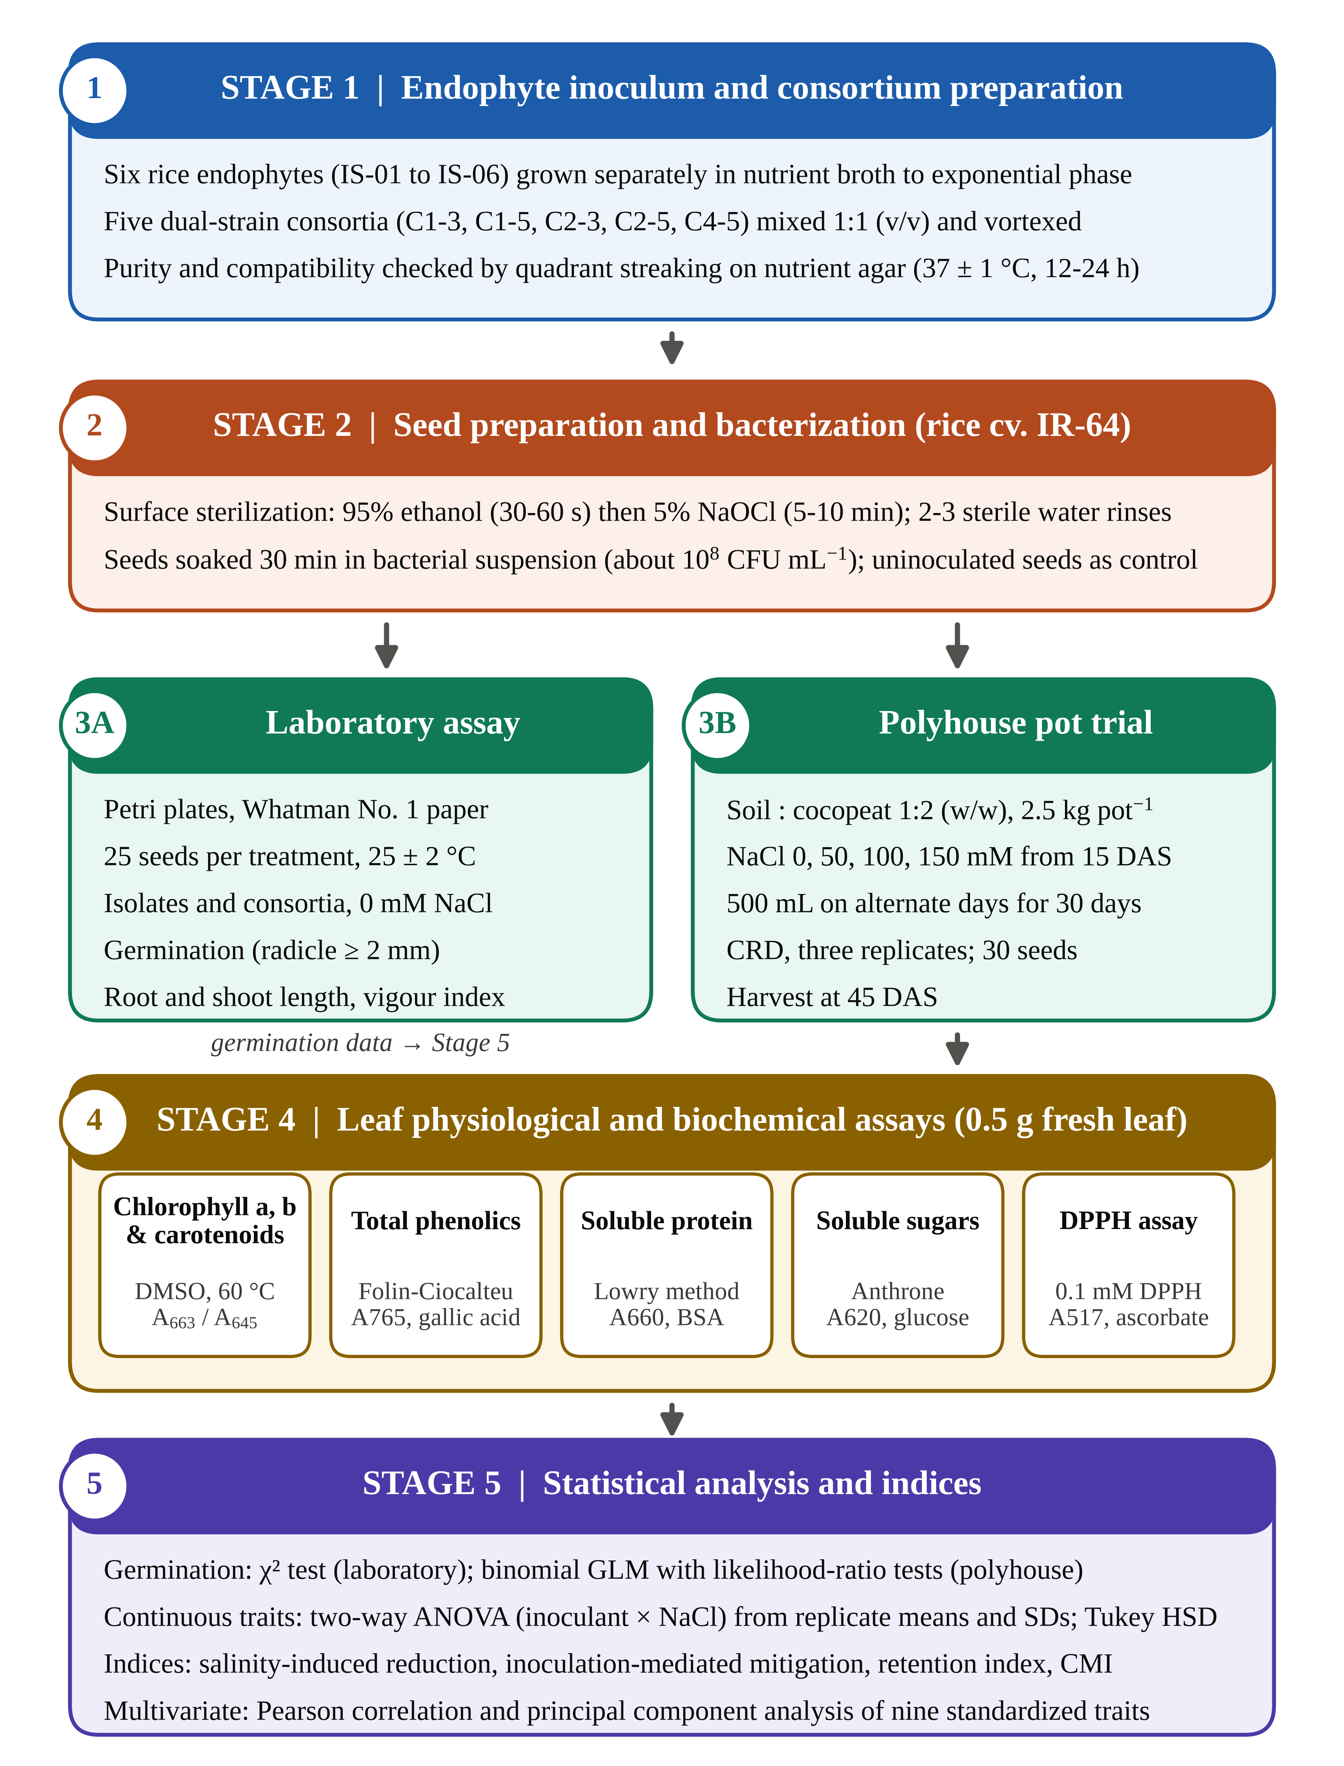
Fig. 1. Infographic flowchart of the experimental workflow. Stage 1, preparation of single-isolate inocula and dual-strain consortia with purity checks; Stage 2, surface sterilization and bacterization of rice cv. IR-64 seeds; Stage 3A, laboratory germination assay; Stage 3B, polyhouse pot trial under 0–150 mM NaCl; Stage 4, leaf biochemical assays on polyhouse plants; Stage 5, statistical analysis, derived indices and multivariate analysis. DAS, days after sowing; CRD, completely randomized design; CMI, composite membership index.
2.2 Endophytic isolates and consortium preparation
Six endophytic bacterial isolates previously recovered from surface-sterilized tissues of rice (Oryza sativa L.) plants, coded IS-01 to IS-06, were used. Each isolate was grown separately in nutrient broth at 37 ± 1 °C until the culture reached exponential phase. Five two-member consortia were assembled by mixing equal volumes (1:1, v/v) of the relevant cultures under aseptic conditions: C1-3 (IS-01 + IS-03), C1-5 (IS-01 + IS-05), C2-3 (IS-02 + IS-03), C2-5 (IS-02 + IS-05) and C4-5 (IS-04 + IS-05). Each mixture was vortexed gently so that both partners were evenly distributed. To check compatibility and purity, a loopful of every consortium was streaked by the quadrant method on nutrient agar and incubated at 37 ± 1 °C for 12–24 h. Colony morphology, density and any zone of inhibition between colony types were recorded, following the general approach used for rice seed endophytes by Walitang et al. (2017).
2.3 Plant material, seed sterilization and bacterization
Seeds of IR-64, a widely grown but salt-susceptible indica rice cultivar, were used throughout. Uniform, healthy seeds were immersed in 95% (v/v) ethanol for 30–60 s with gentle swirling, transferred to 5% (v/v) sodium hypochlorite for 5–10 min and rinsed two to three times in sterile distilled water. Sterilized seeds were used immediately. For bacterization, seeds were soaked for 30 min in the appropriate bacterial suspension (about 10⁸ CFU mL⁻¹); uninoculated control seeds were not bacterized.
2.4 Preparation of NaCl solutions
Sodium chloride (molar mass 58.44 g mol⁻¹) was dissolved in sterile distilled water to give 50 mM (2.922 g L⁻¹), 100 mM (5.844 g L⁻¹) and 150 mM (8.766 g L⁻¹) solutions. Sterile distilled water served as the 0 mM treatment.
2.5 Laboratory germination assay
Bacterized seeds were placed on sterile Whatman No. 1 filter paper in Petri dishes of uniform size, 25 seeds per treatment. Plates received equal volumes of sterile water so that moisture was comparable, and were kept at 25 ± 2 °C. Plates were checked regularly and topped up to prevent drying. A seed was counted as germinated when the radicle reached at least 2 mm. At the end of the observation period, root and shoot lengths were measured on the germinated seedlings. The isolate and consortium sets were run as separate batches, each with its own uninoculated control. Germination (G, %) was calculated as the number of germinated seeds divided by the number of seeds placed, multiplied by 100. The seedling vigour index was computed as SVI = G × (root length + shoot length, cm), following Abdul-Baki and Anderson (1973).
2.6 Polyhouse pot experiment
The pot trial used a completely randomized design with three replicate pots per treatment. Sterilized soil and cocopeat were mixed at 1:2 (w/w), and each pot (15 cm × 18 cm) held 2.5 kg of this medium. Soil was sterilized beforehand to limit interference from resident microorganisms. Bacterized seeds of each treatment were sown in their pots, 30 seeds per treatment in total, and the pots were irrigated regularly. The isolate experiment comprised seven inoculation levels (uninoculated, IS-01 to IS-06) and the consortium experiment six (uninoculated, C1-3, C1-5, C2-3, C2-5, C4-5), each crossed with four NaCl levels (0, 50, 100 and 150 mM). Salt stress was applied by irrigating each pot with 500 mL of the relevant solution on alternate days for 30 days, beginning at the two- to three-leaf stage (15 days after sowing, DAS). Germination in pots was scored as the percentage of the 30 sown seeds that produced a seedling. After establishment, seedlings were thinned to three uniform plants per pot. Plants were harvested at 45 DAS, when root and shoot lengths were measured and fully expanded leaves were sampled for biochemistry. SVI was calculated as in Section 2.5.
2.7 Photosynthetic pigments
Fresh leaf tissue (0.5 g) was placed in 5 mL of dimethyl sulfoxide (DMSO) and incubated at 60 °C for 30 min, a non-maceration extraction adapted from Hiscox and Israelstam (1979). Absorbance was read at 663 and 645 nm, and at 490 nm for carotenoids, against a DMSO blank on a UV–visible spectrophotometer. Chlorophyll a and b were calculated with Arnon's (1949) equations: Chl a (mg L⁻¹) = 12.7 A₆₆₃ − 2.69 A₆₄₅; Chl b (mg L⁻¹) = 22.9 A₆₄₅ − 4.68 A₆₆₃. Values were converted to a fresh-weight basis as C × V / W, where C is pigment concentration, V extract volume and W tissue fresh weight. Total chlorophyll was taken as the sum of chlorophyll a and b. Carotenoid determination followed the general principles set out by Lichtenthaler (1987).
2.8 Total phenolic content
Fresh leaf tissue (0.5 g) was homogenized in 80% (v/v) methanol and centrifuged, and the clear supernatant was used. Total phenolics were estimated with the Folin–Ciocalteu reagent as described by Singleton and Rossi (1965). An aliquot of extract (0.5 mL) was made up to 1.0 mL with distilled water, mixed with 0.5 mL of Folin–Ciocalteu reagent (diluted 1:1 with water) and then with 0.5 mL of 20% (w/v) sodium carbonate. After 30–60 min at room temperature, 7.0 mL of distilled water was added and absorbance was read at 765 nm. A gallic acid calibration (20–100 µg mL⁻¹) gave y = 0.009x + 0.005 (R² = 0.9998). Results are expressed as µg gallic acid equivalents per mL of extract. Because every sample was prepared from the same tissue mass in the same extraction volume, these values are directly comparable between treatments.
2.9 Soluble protein
Protein was extracted from 0.5 g of fresh leaf tissue and estimated by the method of Lowry et al. (1951), using bovine serum albumin as the standard (40–200 µg mL⁻¹). An aliquot of extract (0.5 mL) was made up to 1.0 mL, mixed with 5.0 mL of freshly prepared alkaline copper reagent (2% Na₂CO₃ in 0.1 N NaOH with 2% sodium potassium tartrate, plus 1% CuSO₄ at 50:1) and left for 10 min. Diluted Folin–Ciocalteu reagent (0.5 mL) was then added rapidly, and absorbance was read at 660 nm after a further 10 min. Protein is expressed as µg mL⁻¹ of extract.
2.10 Soluble sugars
Soluble sugars were extracted from 0.5 g of fresh leaf tissue in hot 80% (v/v) ethanol and estimated with anthrone (Yemm & Willis, 1954). One millilitre of extract was mixed with 5.0 mL of freshly prepared anthrone reagent (about 0.2%, w/v, in diluted H₂SO₄), heated in a boiling water bath for 10 min, cooled quickly and read at 620 nm. A glucose calibration (20–100 µg mL⁻¹) was used, and values are expressed as µg glucose equivalents per mL of extract.
2.11 DPPH radical scavenging activity
Methanolic leaf extracts (0.5 mL, made up to 1.0 mL with methanol) were mixed with 3.0 mL of 0.1 mM 2,2-diphenyl-1-picrylhydrazyl (DPPH) in methanol, wrapped in foil and incubated in the dark for 30 min at room temperature (Brand-Williams et al., 1995). Absorbance was read at 517 nm against a DPPH control without extract, and ascorbic acid (25–400 µg mL⁻¹) served as the reference antioxidant. Scavenging activity was calculated as [(A₀ − A₁) / A₀] × 100, where A₀ and A₁ are the absorbances of the control and the sample (Gülçin, 2020). The isolate and consortium extracts were assayed in separate batches.
2.12 Derived indices
Three simple indices were computed from treatment means. The salinity-induced reduction (SIR, %) described damage in uninoculated plants: SIR = (X₀ − X_{S}) / X₀ × 100, where X₀ and X_{S} are trait values at 0 mM and at salinity level S. The inoculation-mediated mitigation (IMM, %) compared each inoculant with the uninoculated control at the same salinity: IMM = (X_{i,S} − X_{c,S}) / X_{c,S} × 100. The retention index (RI, %) expressed how much of its own unstressed value an inoculant kept at 150 mM: RI = X_{i,150} / X_{i,0} × 100. Relative measures of this kind are preferred when genotypes or treatments differ in their unstressed baseline (Negrão et al., 2017).
To summarize performance across traits, we built a composite membership index (CMI). Each of nine traits (germination, root length, shoot length, SVI, chlorophyll a, carotenoids, soluble protein, soluble sugars and DPPH scavenging) was rescaled to 0–1 across all 48 treatment combinations as (X − X_{min}) / (X_{max} − X_{min}), and the nine rescaled values were averaged. A CMI near 1 means a treatment sat near the top of the observed range for most traits. Total phenolics and chlorophyll b were left out of the CMI: phenolic data were incomplete for the isolate set, and chlorophyll b values differed by an order of magnitude between the two experimental batches (Section 3.4).
2.13 Statistical analysis
Germination counts were analysed as binomial data. For the laboratory assay, a χ² test of independence compared germinated and non-germinated seeds across treatments within each batch, and Fisher's exact test compared the best inoculant with the control. For the pot trial, a binomial generalized linear model with a logit link was fitted to the germination proportions, with inoculant and NaCl level as factors. Salinity, inoculant and interaction effects were tested by likelihood-ratio (LR) χ² tests between nested models.
Continuous traits were analysed by two-way analysis of variance (ANOVA) with inoculant and NaCl level as fixed factors. Because the data were available as replicate means and standard deviations (n = 3), sums of squares were computed directly from these sufficient statistics (Larson, 1992). The error mean square was pooled from the within-treatment variances, and partial eta-squared (η_{p}²) was reported as the effect size. Tukey's honestly significant difference (HSD) at α = 0.05 was calculated for comparisons among the 28 (isolate) or 24 (consortium) treatment means (Tukey, 1949). Traits for which replicate SDs were not recorded (consortium soluble sugars and consortium DPPH activity) were described without inferential tests.
Pearson correlations were computed among the nine traits used in the CMI across the 48 treatment means; with 46 degrees of freedom, |r| ≥ 0.285 corresponds to p < 0.05 and |r| ≥ 0.465 to p < 0.001. Principal component analysis (PCA) was run on the standardized (z-scored) trait matrix (Jolliffe & Cadima, 2016). All analyses were carried out in Python with SciPy (Virtanen et al., 2020) and statsmodels (Seabold & Perktold, 2010). Unless stated otherwise, values are means ± SD of three replicates.
3. Results
3.1 Consortium compatibility
All five pairings grew as uniform, stable cultures on nutrient agar. We saw no inhibition zones, no pigment changes and no odd colony forms where partner strains met, so there was no visible sign of antagonism. Colony density on the consortium plates looked higher than on plates of the single isolates, and growth appeared faster. These are qualitative observations. They show that the partners can share a plate; they don't show that the partners cooperate inside the plant.
3.2 Laboratory germination and early seedling vigour
Germination on filter paper varied from 60% to 92% among the single isolates and from 56% to 84% among the consortia (Table 1). IS-06 gave the highest germination (92%) and the longest shoots (92.00 ± 2.64 mm). IS-04 gave the longest roots of the isolate set (73.00 ± 4.35 mm). Once root and shoot length were combined into SVI, IS-06 (1327.8) and IS-04 (1313.2) stood well above the uninoculated control (920.2). IS-02 and IS-03 fell below it (545.9 and 507.7). Among the consortia, C4-5 produced the longest roots of any treatment in the assay (90.66 ± 0.57 mm) and the highest consortium SVI (1271.9), with C2-5 close behind (1215.1). C1-3 and C1-5 germinated less well than their own batch control.
The germination differences themselves were not statistically significant. Proportions did not differ across the isolate treatments (χ² = 9.40, df = 6, p = 0.152) or across the consortium treatments (χ² = 7.02, df = 5, p = 0.219). Even the largest single contrasts, IS-06 against its control (92% vs. 80%) and C2-5 against its control (84% vs. 68%), were not significant by Fisher's exact test (p = 0.417 and p = 0.321). With 25 seeds per treatment, the assay could only have detected much larger differences. The strong effects in this screen were on seedling growth, not on whether seeds germinated.
Table 1. Germination and early seedling growth of rice cv. IR-64 bacterized with single endophytic isolates or dual-strain consortia in the laboratory assay (0 mM NaCl; 25 seeds per treatment).
Treatment | Germinated / total | Germination (%) | Root length (mm) | Shoot length (mm) | SVI
Single isolates (batch 1)
Control | 20 / 25 | 80 | 62.43 ± 1.19 | 52.60 ± 3.78 | 920.2
IS-01 | 19 / 25 | 76 | 55.66 ± 3.05 | 34.00 ± 4.58 | 681.4
IS-02 | 15 / 25 | 60 | 40.33 ± 0.47 | 50.66 ± 1.15 | 545.9
IS-03 | 17 / 25 | 68 | 32.33 ± 2.08 | 42.33 ± 1.52 | 507.7
IS-04 | 21 / 25 | 84 | 73.00 ± 4.35 | 83.33 ± 3.21 | 1313.2
IS-05 | 20 / 25 | 80 | 63.00 ± 1.00 | 72.33 ± 2.51 | 1082.6
IS-06 | 23 / 25 | 92 | 52.33 ± 2.51 | 92.00 ± 2.64 | 1327.8
Dual-strain consortia (batch 2)
Control | 17 / 25 | 68 | 43.50 ± 1.09 | 33.78 ± 2.30 | 525.5
C1-3 | 14 / 25 | 56 | 70.00 ± 0.00 | 44.00 ± 3.60 | 638.4
C1-5 | 15 / 25 | 60 | 63.66 ± 1.52 | 51.66 ± 2.88 | 691.9
C2-3 | 17 / 25 | 68 | 41.66 ± 2.08 | 33.33 ± 3.21 | 509.9
C2-5 | 21 / 25 | 84 | 83.66 ± 2.30 | 61.00 ± 1.73 | 1215.1
C4-5 | 20 / 25 | 80 | 90.66 ± 0.57 | 68.33 ± 2.08 | 1271.9
Root and shoot lengths are means ± SD. SVI = germination (%) × (root + shoot length, cm), recalculated from the recorded values (Abdul-Baki & Anderson, 1973). Germination did not differ among treatments within either batch (isolates: χ² = 9.40, df = 6, p = 0.152; consortia: χ² = 7.02, df = 5, p = 0.219).
3.3 Germination and seedling growth under salinity in the polyhouse
Salinity lowered germination in the pots in a clear, dose-dependent way (Fig. 2; Table 2). Uninoculated seeds fell from 83.3% at 0 mM to 60.0% at 150 mM, an SIR of 28.0%. The binomial model confirmed a strong salinity effect in both experiments (isolates: LR χ² = 34.84, df = 3, p < 0.001; consortia: LR χ² = 23.15, df = 3, p < 0.001). Inoculation shifted germination upward in most treatments. IS-06 germinated at 93.3%, 90.0%, 76.7% and 70.0% across the four salinity levels, and C4-5 at 90.0%, 93.3%, 80.0% and 76.7%. These shifts did not reach significance (isolates: LR χ² = 11.61, df = 6, p = 0.071; consortia: LR χ² = 10.40, df = 5, p = 0.065), and there was no evidence of an inoculant × salinity interaction on germination (p = 0.999 and p = 0.835).
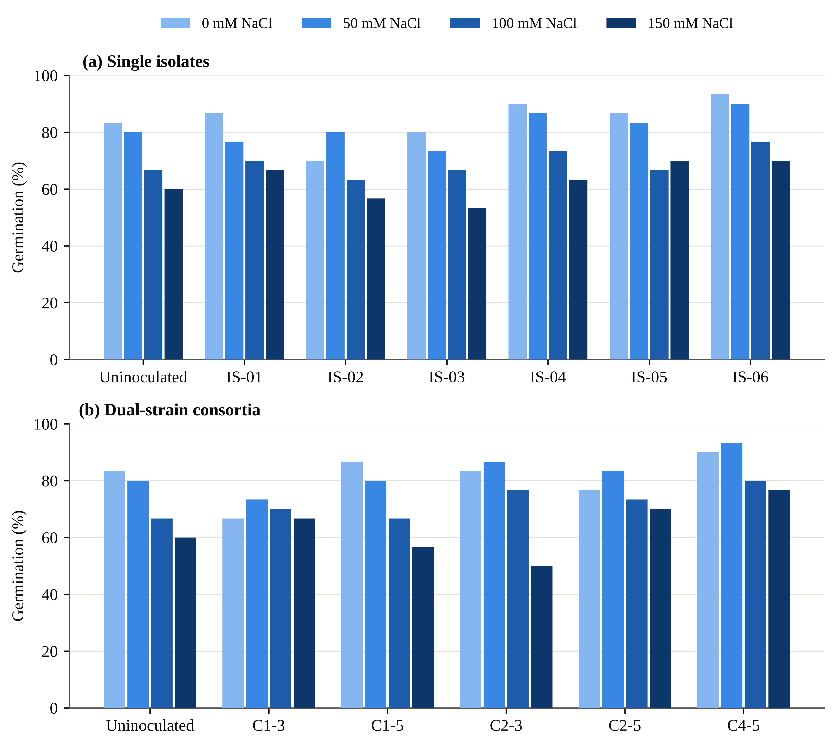
Fig. 2. Germination (%) of rice cv. IR-64 under 0, 50, 100 and 150 mM NaCl in the polyhouse after bacterization with (a) single endophytic isolates and (b) dual-strain consortia. Each bar is the percentage of 30 sown seeds. Salinity reduced germination (p < 0.001 in both experiments), whereas inoculant effects were not significant (p = 0.071 and 0.065; binomial GLM likelihood-ratio tests).
Seedling growth told a much stronger story. Root and shoot length of uninoculated plants dropped from 4.30 and 22.96 cm at 0 mM to 2.06 and 13.96 cm at 150 mM (SIR 52.1% and 39.2%). SVI, which combines germination with growth, fell by 57.7%. In the isolate experiment, the two-way ANOVA found large effects of inoculant, salinity and their interaction on root length (interaction F_{18,56} = 706.4, p < 0.001, η_{p}² = 0.996; HSD = 0.21 cm) and shoot length (interaction F_{18,56} = 414.6, p < 0.001; HSD = 0.68 cm) (Table 3). At 150 mM, IS-06 seedlings had roots of 5.02 ± 0.02 cm and shoots of 28.19 ± 0.26 cm, which is 144% and 102% longer than the matched control. IS-05 matched IS-06 for root length (5.03 ± 0.03 cm) but had shorter shoots (23.68 ± 0.59 cm). One value stands out in the IS-05 series: root length at 100 mM was only 1.08 ± 0.08 cm, far below both the 50 mM and the 150 mM values (Fig. 3d). We report it as recorded, but it looks like an outlier rather than a biological response.
Consortium effects on root length were also significant (interaction F_{15,48} = 52.2, p < 0.001; HSD = 0.59 cm). C4-5 gave the longest roots under stress, 5.44 ± 0.12 cm at 50 mM and 4.30 ± 0.15 cm at 150 mM. Shoot length in the consortium experiment was a different matter. Several salt treatments carried replicate SDs of 8 to 13 cm around means of 16 to 25 cm (for example, 25.0 ± 13.0 cm for C4-5 at 50 mM), and with that much spread the ANOVA detected no effect of inoculant, salinity or their interaction (all p ≥ 0.39). Unstressed consortium plants were also shorter than the uninoculated control, which lowered their SVI at 0 mM. Under salt, though, C4-5 kept SVI between 2235 and 2841 at every stress level. That is 135% above the control at 150 mM, close to the 142% achieved by IS-06 (Table 2).

Table 2. Germination (%) and seedling vigour index (SVI) of rice cv. IR-64 bacterized with endophytic isolates or consortia and grown under graded NaCl in the polyhouse (30 seeds per treatment).
Treatment | Germination (%) |  |  |  | Seedling vigour index
Treatment | 0 mM | 50 mM | 100 mM | 150 mM | 0 mM | 50 mM | 100 mM | 150 mM
Uninoculated control | 83.3 | 80.0 | 66.7 | 60.0 | 2272 | 2008 | 1507 | 961
Single isolates
IS-01 | 86.7 | 76.7 | 70.0 | 66.7 | 2724 | 2233 | 1436 | 1405
IS-02 | 70.0 | 80.0 | 63.3 | 56.7 | 2023 | 2201 | 1273 | 1080
IS-03 | 80.0 | 73.3 | 66.7 | 53.3 | 1959 | 1963 | 1765 | 1412
IS-04 | 90.0 | 86.7 | 73.3 | 63.3 | 2543 | 2442 | 1713 | 1766
IS-05 | 86.7 | 83.3 | 66.7 | 70.0 | 2895 | 2682 | 1541 | 2010
IS-06 | 93.3 | 90.0 | 76.7 | 70.0 | 2941 | 2751 | 2111 | 2325
Dual-strain consortia
C1-3 | 66.7 | 73.3 | 70.0 | 66.7 | 1409 | 1871 | 1626 | 1555
C1-5 | 86.7 | 80.0 | 66.7 | 56.7 | 1629 | 2114 | 1671 | 1424
C2-3 | 83.3 | 86.7 | 76.7 | 50.0 | 1402 | 2169 | 1459 | 986
C2-5 | 76.7 | 83.3 | 73.3 | 70.0 | 1444 | 1925 | 1958 | 1753
C4-5 | 90.0 | 93.3 | 80.0 | 76.7 | 1947 | 2841 | 2235 | 2246
Germination = germinated seeds / 30 × 100. SVI = germination (%) × (root + shoot length, cm), recalculated from the recorded root and shoot lengths. Binomial GLM likelihood-ratio tests, isolate experiment: NaCl χ² = 34.84 (df 3, p < 0.001), inoculant χ² = 11.61 (df 6, p = 0.071), interaction χ² = 5.14 (df 18, p = 0.999); consortium experiment: NaCl χ² = 23.15 (df 3, p < 0.001), inoculant χ² = 10.40 (df 5, p = 0.065), interaction χ² = 9.75 (df 15, p = 0.835). The uninoculated control was shared by both experiments.

3.4 Photosynthetic pigments
Chlorophyll was the trait hit hardest by salt. In uninoculated plants, chlorophyll a fell from 32.0 ± 0.03 to 10.0 ± 0.10 mg g⁻¹ FW at 50 mM, and to 5.5 ± 0.33 mg g⁻¹ FW at 150 mM (SIR 68.8% and 82.8%). Even the mildest salt level removed more than two-thirds of the pigment. Total chlorophyll (a + b) fell from 67.5 to 7.9 mg g⁻¹ FW. Most of the damage had already occurred at 50 mM; the curve flattened afterwards (Fig. 3a).
Inoculation held chlorophyll up at every salt level (isolate interaction F_{18,56} = 792.0, p < 0.001; HSD = 0.81 mg g⁻¹ FW). IS-06 was the most effective isolate by a wide margin. Its chlorophyll a values were 28.8, 25.2 and 18.7 mg g⁻¹ FW at 50, 100 and 150 mM, which is 188%, 186% and 240% above the matched control. IS-05, IS-04 and IS-01 followed, each roughly doubling chlorophyll a at 150 mM. Among the consortia, C4-5 (15.6 ± 0.14 mg g⁻¹ FW at 150 mM, IMM 184%) and C2-5 (12.6 ± 0.31, IMM 129%) protected chlorophyll a. C1-3, C1-5 and C2-3 did not; they fell below the salinity-matched control at every salt level (Fig. 4).
Carotenoids followed the same broad pattern. Uninoculated plants dropped from 0.140 to between 0.018 and 0.032 mg g⁻¹ FW under salt. IS-06 had the highest unstressed carotenoid content (0.163 mg g⁻¹ FW) and kept 0.041 mg g⁻¹ FW at 150 mM, nearly double the control. C4-5 did better still at 150 mM (0.056 mg g⁻¹ FW, IMM 167%).
A note of caution applies to chlorophyll b. In the isolate experiment, chlorophyll b ranged from 2.4 to 35.5 mg g⁻¹ FW. In the consortium experiment, every inoculated treatment fell between 0.01 and 3.99 mg g⁻¹ FW, even at 0 mM, while the shared uninoculated control stood at 35.5 mg g⁻¹ FW. A tenfold gap of this kind is more likely to come from extraction or reading differences between batches than from biology. For that reason, we compare chlorophyll b only within a batch and leave it out of the indices and the multivariate analysis. Within each batch, chlorophyll b responded to inoculant, salinity and their interaction (isolates: interaction F_{18,56} = 1196.0; consortia: F_{15,48} = 1294.0; both p < 0.001).
3.5 Total phenolic content
Phenolic content of uninoculated leaves fell with salt, from 20.56 to 9.50, 7.27 and 6.15 µg mL⁻¹ at 50, 100 and 150 mM (SIR 53.8%, 64.6% and 70.1%). The complete consortium data set shows that inoculation reversed much of this loss (interaction F_{15,48} = 430.1, p < 0.001; HSD = 0.47 µg mL⁻¹). C4-5 gave the highest values at every salinity level: 26.26, 24.03, 20.67 and 16.21 µg mL⁻¹, which is 153%, 184% and 164% above the matched control under salt. C2-5 ranked second. C1-3 barely helped, and at 150 mM its value was identical to the control (6.15 µg mL⁻¹).
For the single isolates, only part of the phenolic data set could be recovered, so these values are descriptive. IS-06 contained 25.26 µg mL⁻¹ without salt and kept 24.03, 24.03 and 20.67 µg mL⁻¹ at 50, 100 and 150 mM, which is 3.4 times the control at the highest salt level. IS-05 recorded 21.79, 16.21 and 15.09 µg mL⁻¹ under the same three salt levels. The lowest value in the whole study was IS-01 at 150 mM (2.80 µg mL⁻¹), less than half the uninoculated plants at that salinity. So not every endophyte supports phenolic synthesis under salt.
3.6 Soluble protein and soluble sugars
Soluble protein declined steadily as salt rose, from 215.15 µg mL⁻¹ in unstressed controls to 133.45, 104.62 and 85.39 µg mL⁻¹ (Fig. 3b). All inoculants slowed this decline. In the isolate experiment, the ranking was the same at every salinity level: IS-06 > IS-05 > IS-04 > IS-03 > IS-02 > IS-01. At 150 mM, IS-06 held 143.06 µg mL⁻¹ (IMM 68%). The consortia did better. C4-5 recorded 215.15, 200.74 and 181.51 µg mL⁻¹ at 50, 100 and 150 mM. At 150 mM this is 113% above the control, and it is the highest protein level of any stressed treatment in the study. Expressed as the retention index, C4-5 kept 80.8% of its unstressed protein at 150 mM, C2-5 75.4% and IS-06 69.6%; uninoculated plants kept 39.7%. Inoculant, salinity and their interaction were all significant, and the effects were very large (Table 3).
Soluble sugars fell even further than protein in uninoculated plants, down to 31.83 µg mL⁻¹ at 150 mM (SIR 67.5%). Here the single isolates were the stronger group (Fig. 3c). IS-06 barely lost sugar: 96.16, 89.21, 87.47 and 85.73 µg mL⁻¹ across the four levels, a retention index of 89.2%. At 150 mM, that is 169% above the control. IS-05 and IS-04 were close behind (82.25 and 78.77 µg mL⁻¹ at 150 mM). Among the consortia, C4-5 again ranked first (99.64, 82.25 and 70.08 µg mL⁻¹ at 50, 100 and 150 mM; IMM 120% at 150 mM), but consortium sugar levels dropped more steeply with salt than those of the best isolates. Protein and sugar moved together across treatments (r = 0.89, p < 0.001).
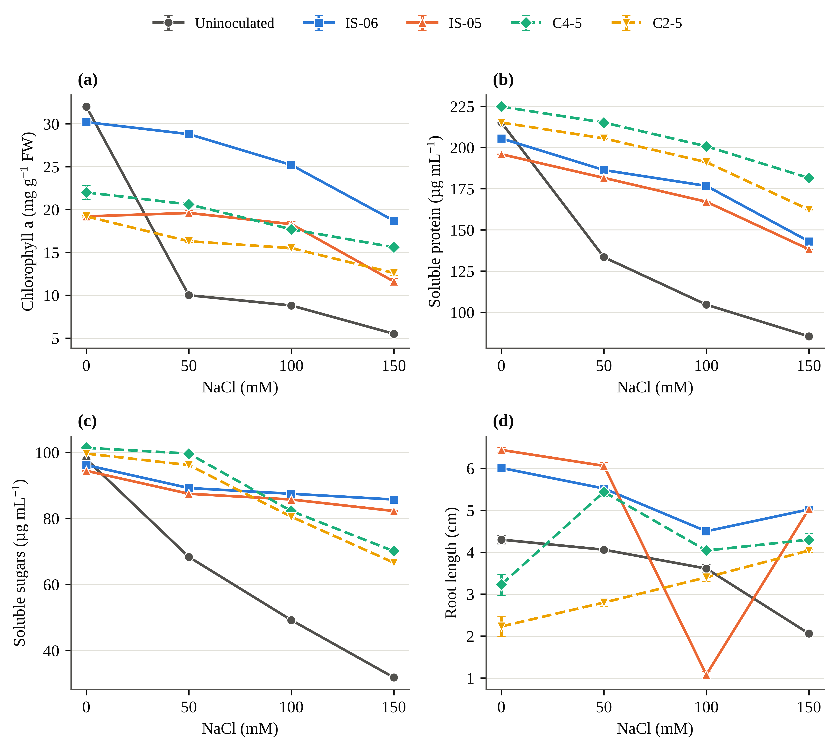
Fig. 3. Dose–response of (a) chlorophyll a, (b) soluble protein, (c) soluble sugars and (d) root length to NaCl in uninoculated rice and in plants inoculated with the two best single isolates (IS-06, IS-05; solid lines) and the two best consortia (C4-5, C2-5; dashed lines). Error bars are SD (n = 3); replicate SDs were not recorded for consortium sugars. The low IS-05 root value at 100 mM is shown as recorded.
3.7 DPPH radical scavenging activity
DPPH scavenging did not behave like the other traits. In the isolate batch, uninoculated leaves scavenged 90% of the radical at 0 mM, 65% at 50 mM, 82% at 100 mM and 70% at 150 mM. This is not monotonic, and the high value at 100 mM is hard to explain biologically. Without salt, every isolate gave lower activity than the control (64–80%). Under salt, the stronger isolates rose above it: IS-06 recorded 81%, 78% and 88% at 50, 100 and 150 mM, which is 26% above the control at 150 mM. IS-05 reached 80% at 150 mM. The interaction was significant (F_{18,56} = 76.7, p < 0.001; HSD = 3.19 percentage points).
In the consortium batch, the unstressed control scavenged only 70.6%, so the two batches can't be merged at 0 mM. Replicate SDs were not recorded for this batch. The pattern still matched the isolate results: C4-5 gave the highest activity at 50 mM (74.8%) and 150 mM (84.6%). C1-3 fell to 36.1% at 100 mM, the lowest value in the study. Across all 48 treatments, DPPH activity was essentially unrelated to protein (r = −0.04) and sugar (r = −0.02). It was only moderately linked to chlorophyll a (r = 0.42, p < 0.01).
3.8 Mitigation profile and composite ranking
Fig. 4 puts every inoculant, trait and salinity level on one heat map, expressed as IMM relative to the matched control. Three patterns stand out. First, protein and sugar were raised by every inoculant at every salinity level; not one of the 66 isolate or consortium cells for these two traits is negative. Second, pigment protection split the consortia into two groups. C4-5 and C2-5 raised chlorophyll a and carotenoids, while C1-3, C1-5 and C2-3 lowered them. Third, the benefits grew with stress. For IS-06, the IMM for chlorophyll a rose from 188% at 50 mM to 240% at 150 mM, and for soluble sugars from 31% to 169%.
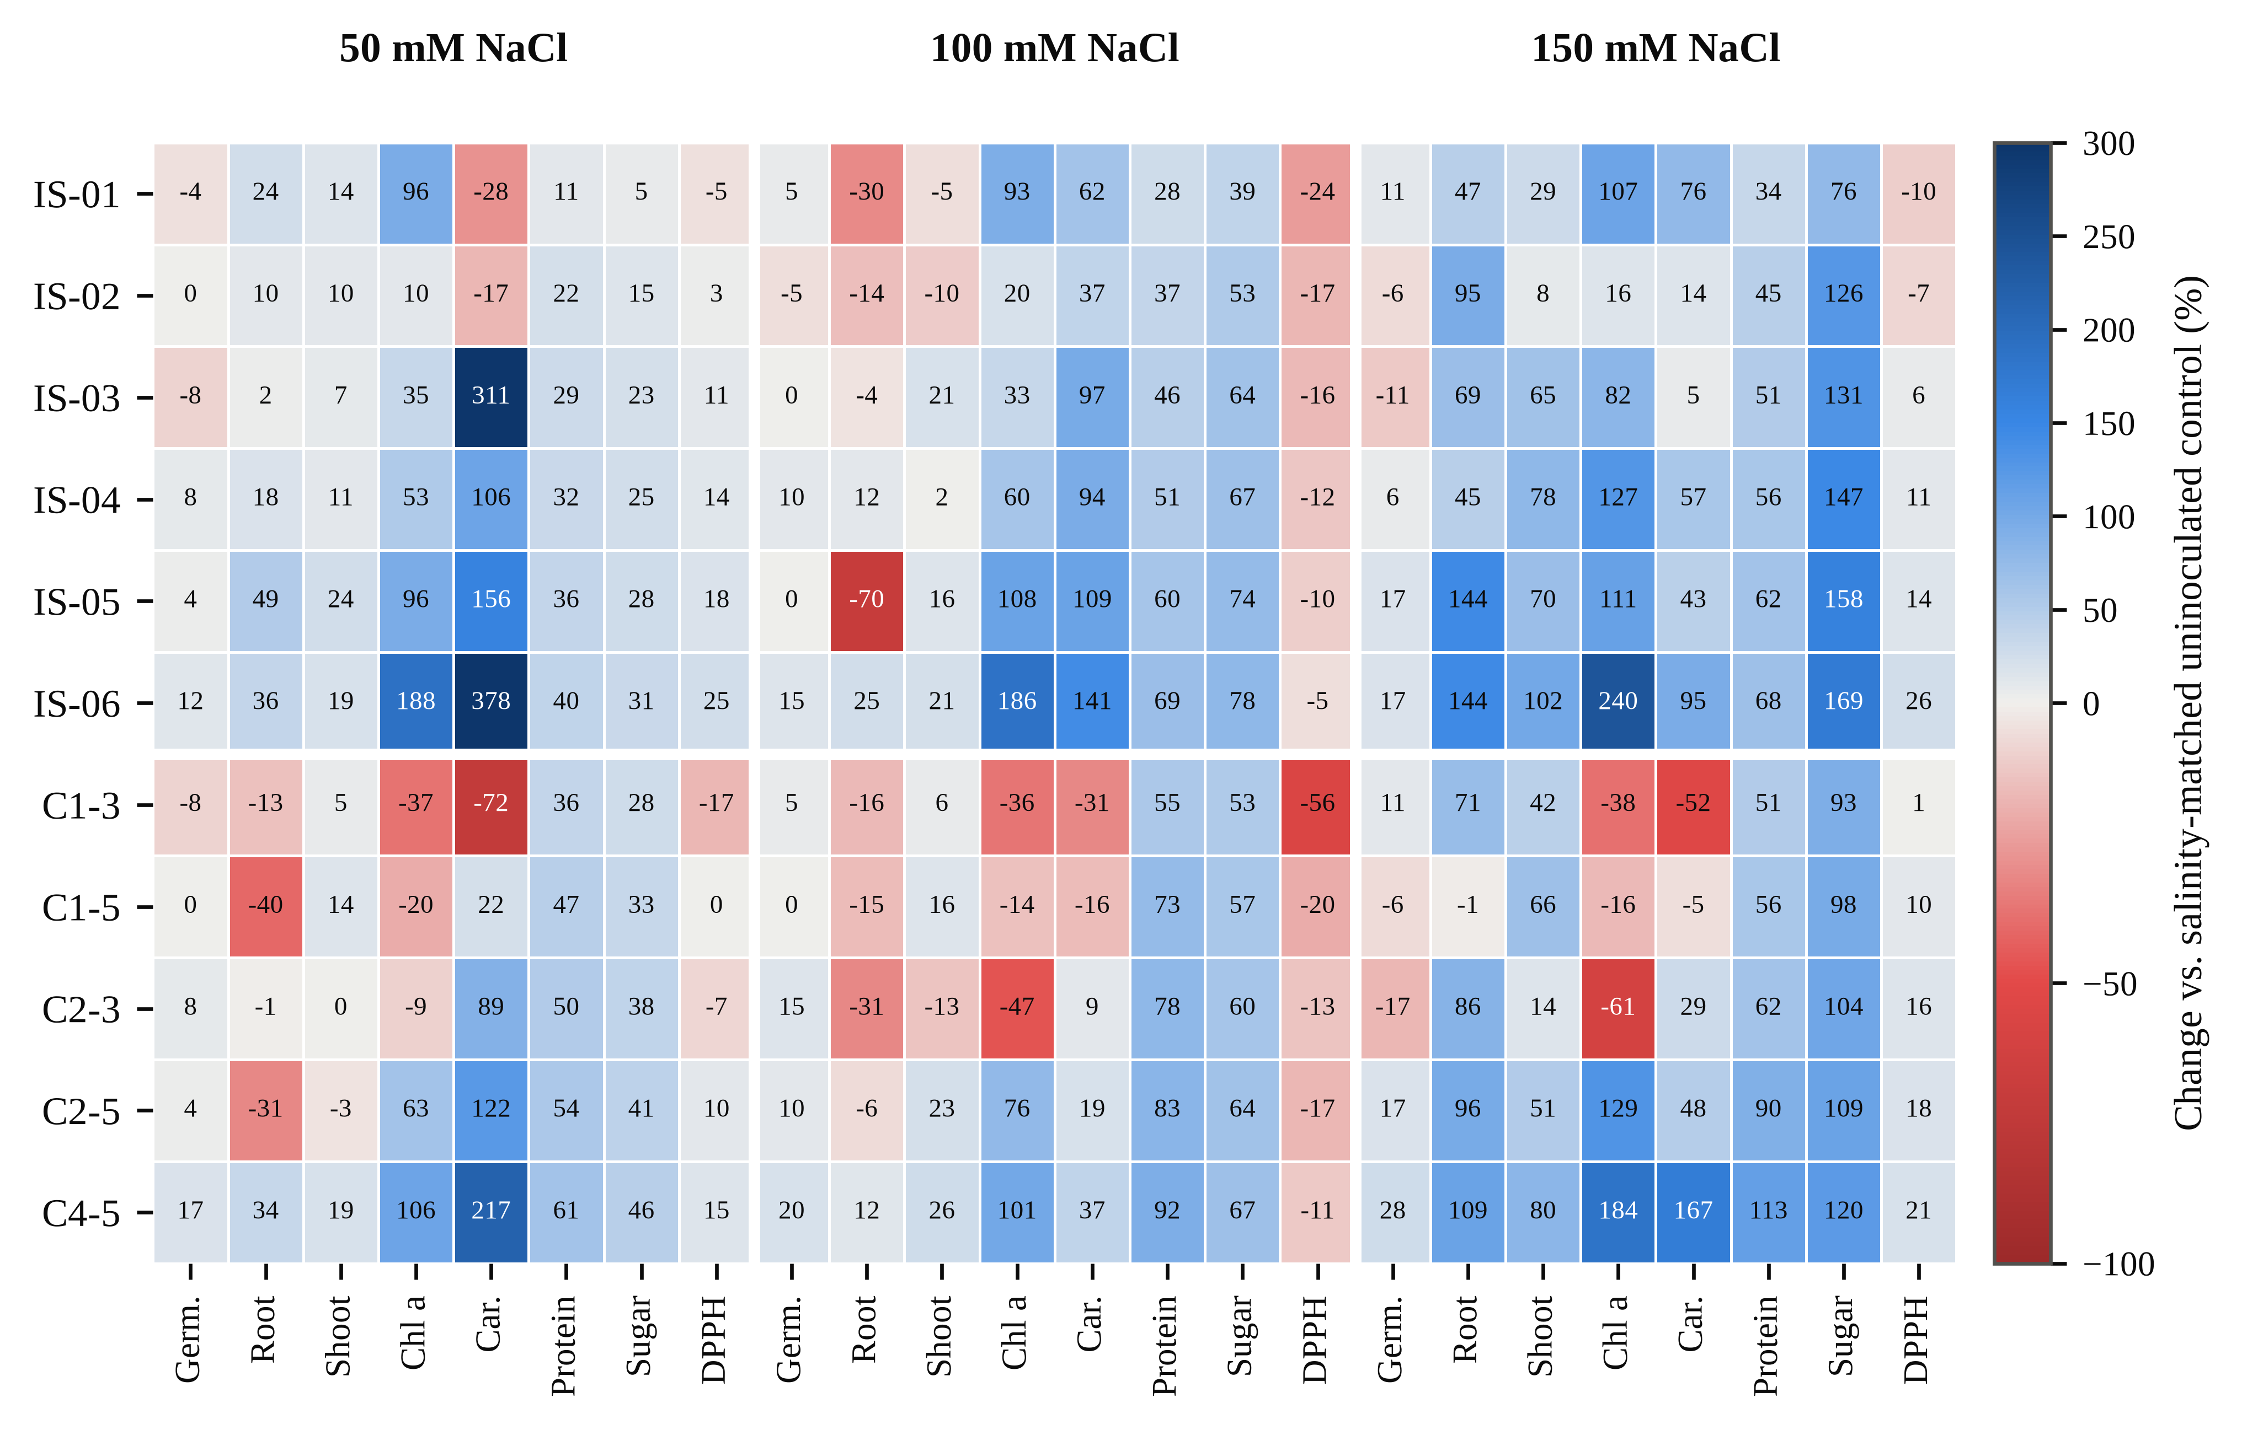
Fig. 4. Heat map of inoculation-mediated mitigation (IMM, %), i.e. the change in each trait relative to the uninoculated control at the same NaCl level, for six single isolates (upper block) and five consortia (lower block) at 50, 100 and 150 mM NaCl. Blue cells denote improvement and red cells impairment; the colour scale is truncated at −100% and +300%, and cell labels give exact values. Germ., germination; Car., carotenoids.
The CMI condenses these nine traits into one number per treatment. At 150 mM, the ranking was IS-06 (0.647), C4-5 (0.617), IS-05 (0.534), C2-5 (0.482), IS-04 (0.462) and IS-03 (0.375), followed by C1-3 (0.334), C1-5 (0.326), IS-01 (0.314), C2-3 (0.277) and IS-02 (0.276). The uninoculated control came last (0.139). Averaged over all four salinity levels, the first five positions stayed the same: IS-06 (0.757), C4-5 (0.672), IS-05 (0.625), IS-04 (0.571) and C2-5 (0.531). Two consortia, C2-3 (0.427) and C1-3 (0.384), ranked below the uninoculated control (0.439) on this average. The radar plot in Fig. 5 shows why IS-06 and C4-5 lead. Under 150 mM NaCl, both recover most of the trait profile of unstressed plants, although in different ways. IS-06 scores higher on root and shoot length, chlorophyll a, soluble sugars and DPPH activity, whereas C4-5 scores higher on germination, carotenoids and soluble protein.
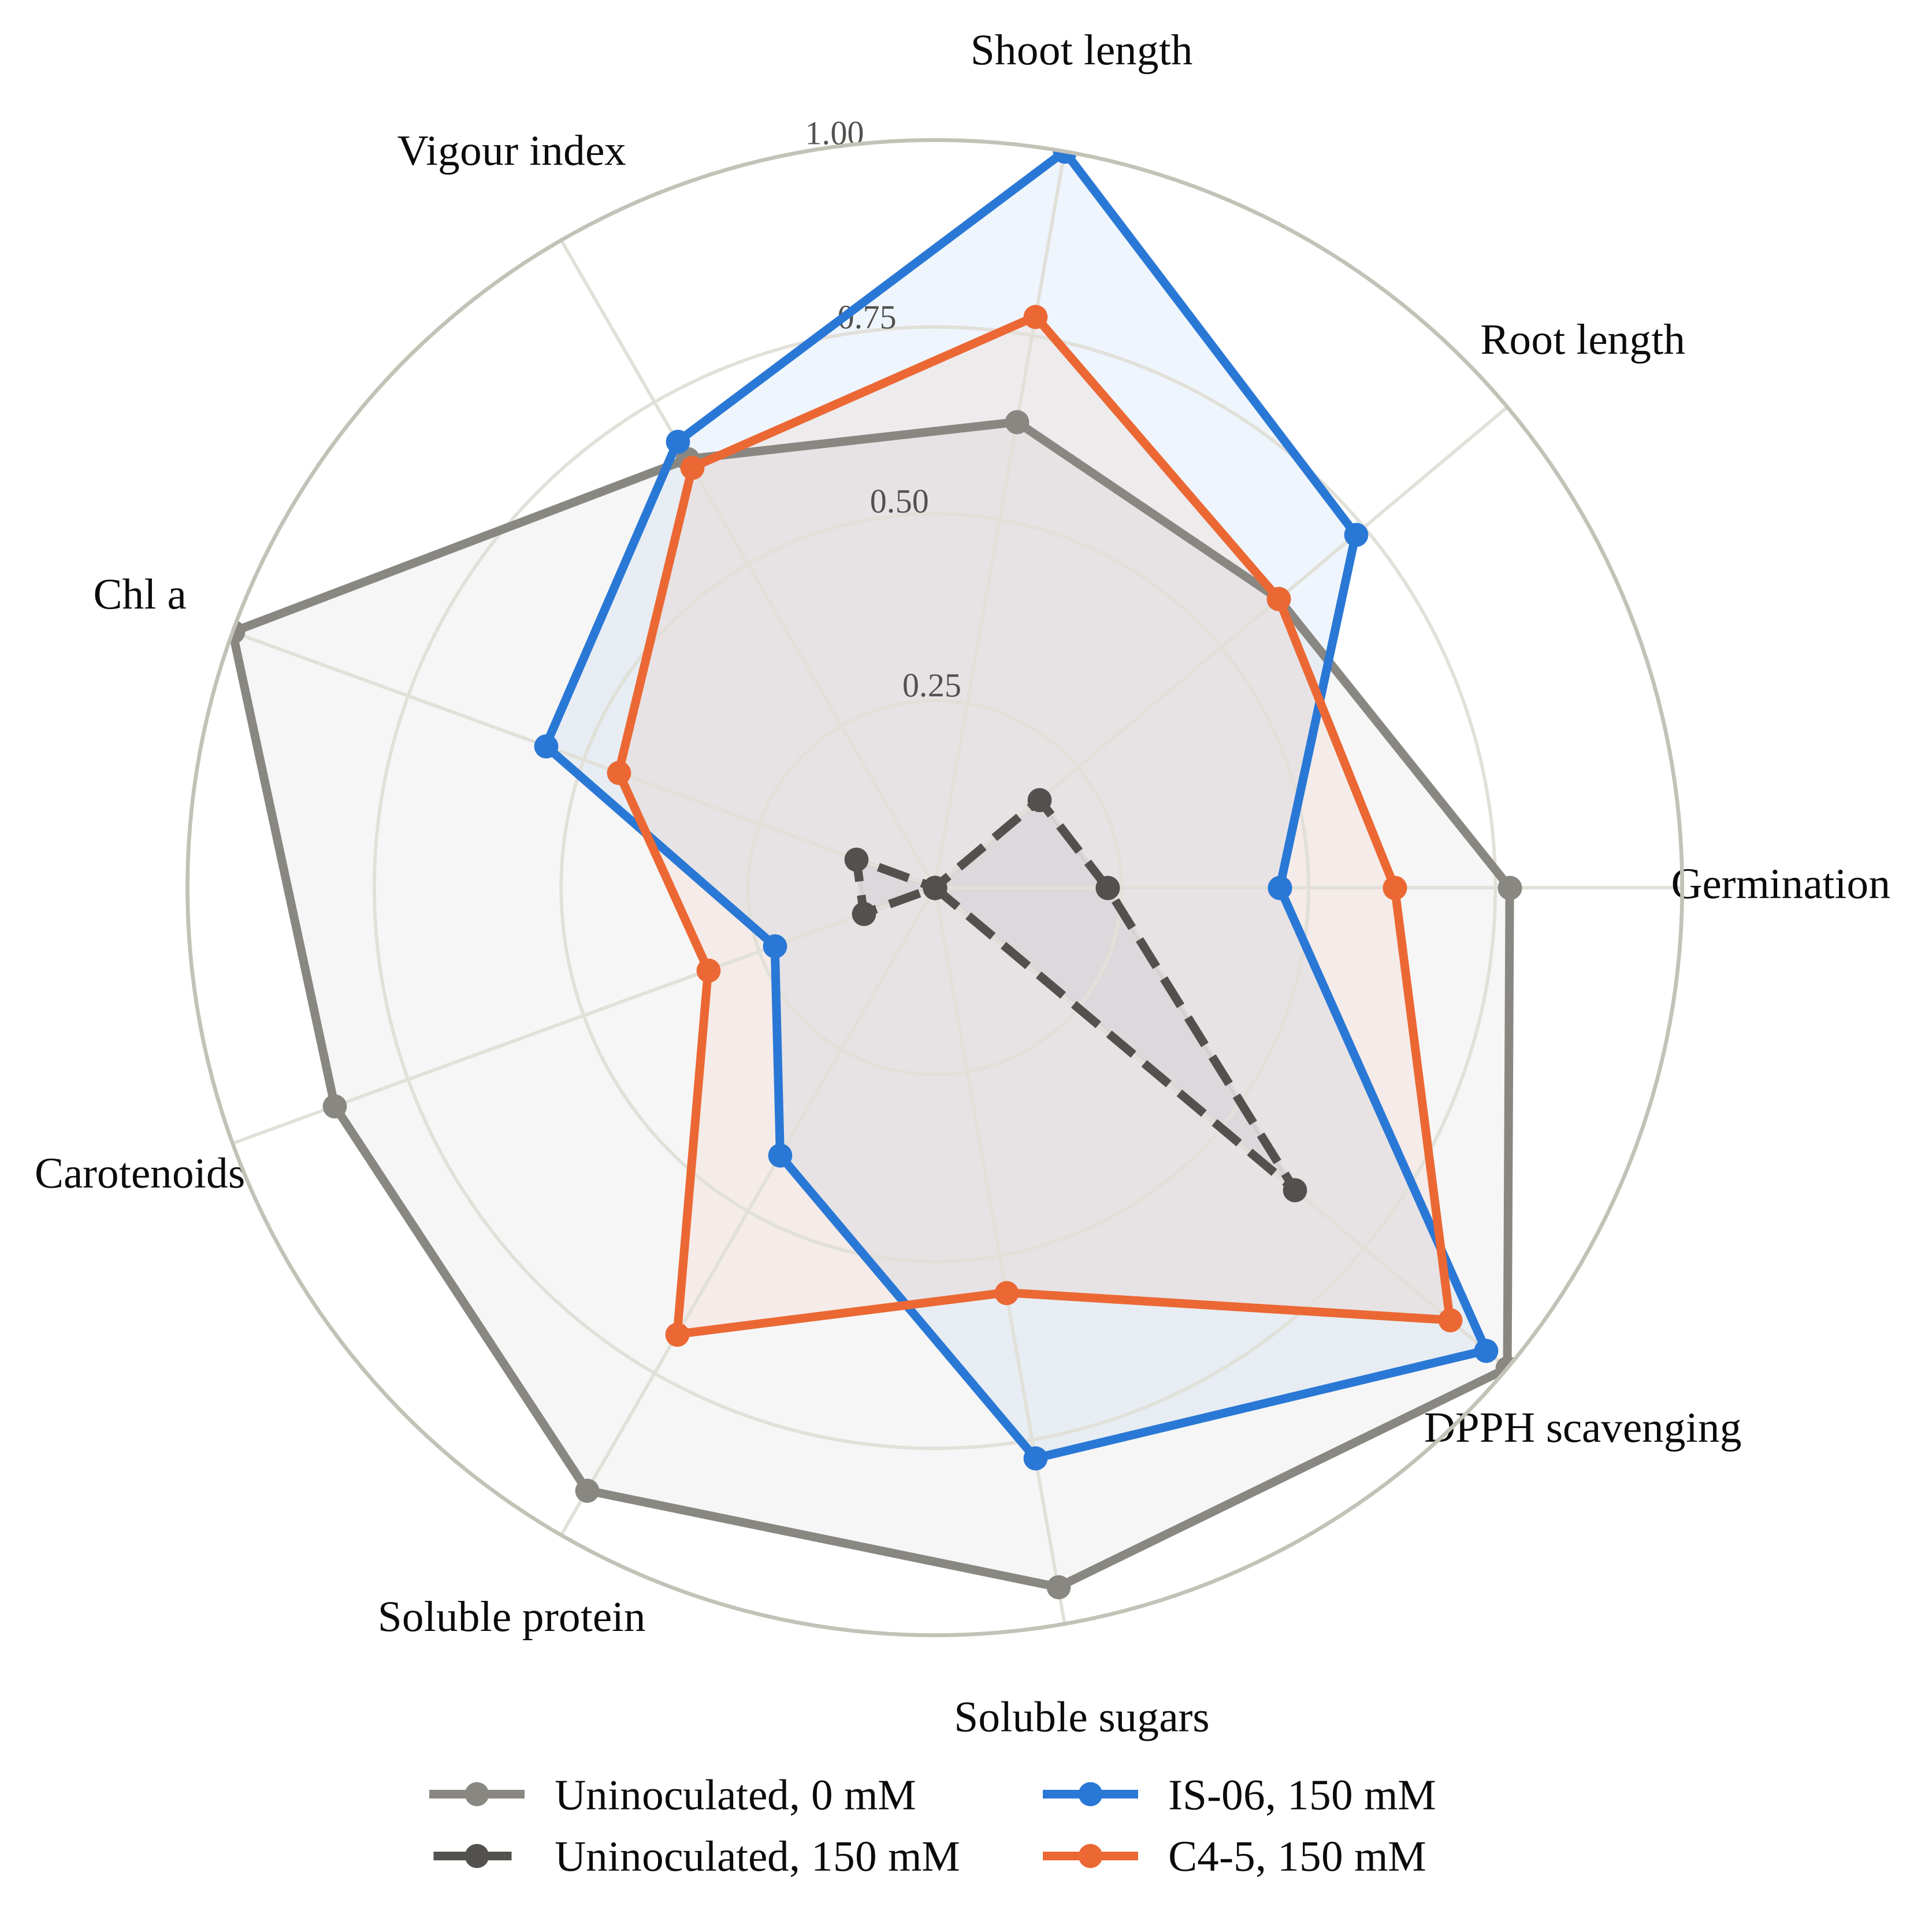
Fig. 5. Radar chart of nine traits rescaled to 0–1 across all 48 treatment combinations, comparing unstressed and 150 mM NaCl uninoculated plants with plants inoculated with IS-06 and C4-5 under 150 mM NaCl. A larger polygon indicates a trait profile closer to the best observed values.
3.9 Correlation and principal component analysis
The nine traits were largely positively correlated across treatments. SVI was tied most closely to germination (r = 0.79), shoot length (r = 0.82) and root length (r = 0.78). Chlorophyll a correlated with carotenoids (r = 0.69) and with SVI (r = 0.69). Germination tracked protein (r = 0.73) and sugar (r = 0.66) more closely than it tracked root length (r = 0.43).
The first two principal components explained 71.3% of the total variance (Fig. 6). PC1 (eigenvalue 4.65; 51.7%) carried positive loadings for every trait, highest for SVI (0.91), chlorophyll a (0.84) and germination (0.82). It is best read as a general growth-and-metabolite axis. PC2 (eigenvalue 1.77; 19.6%) separated the osmolyte traits, protein (−0.63) and sugars (−0.55), from DPPH activity (0.59) and root and shoot length (0.55 and 0.50). A third component (eigenvalue 1.13; 12.5%) also exceeded one but was not interpreted. On the biplot, uninoculated plants moved steadily towards negative PC1 as salinity rose, reaching the far left at 150 mM (PC1 = −5.1). IS-06 treatments stayed on the positive side of PC1 at every salinity level. Consortium treatments were spread widely along PC2, and the unstressed and 50 mM consortium treatments sat at its protein–sugar (negative) end, which fits their strength in protein retention. IS-06 at 150 mM sat higher on PC1 than the uninoculated control at 50 mM.
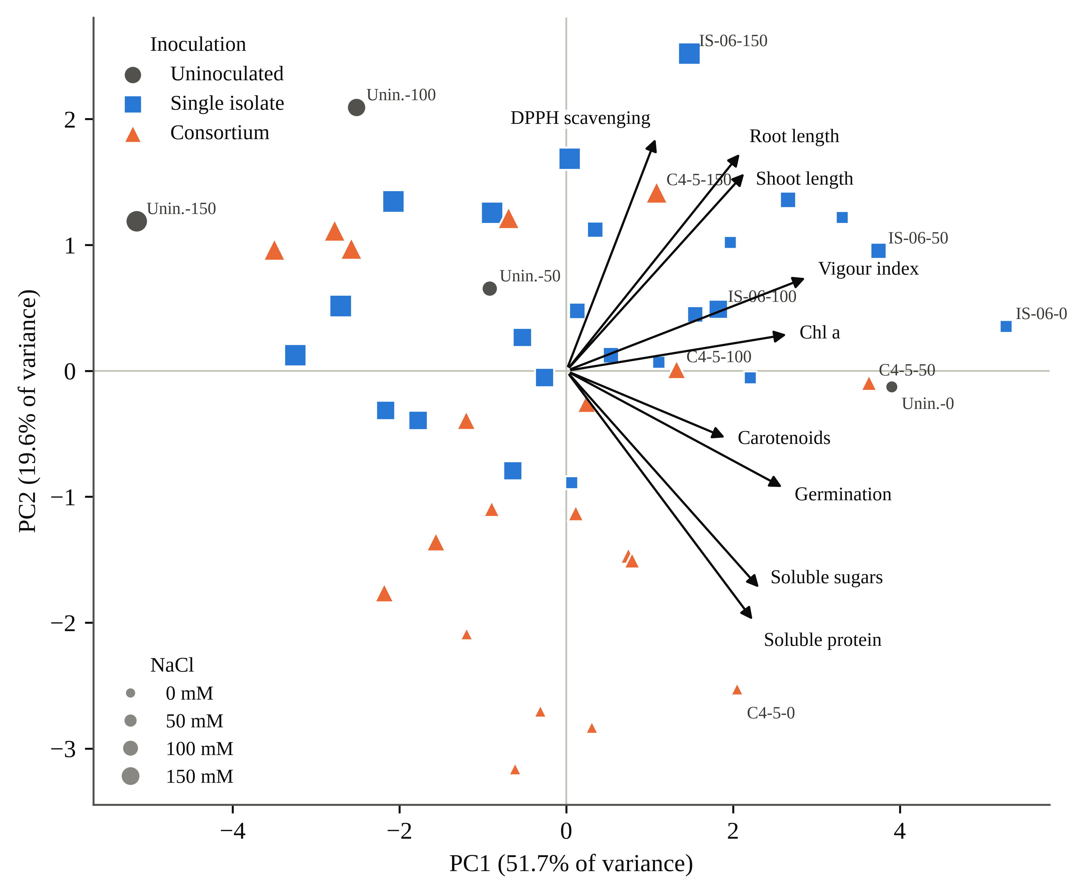
Fig. 6. Principal component analysis biplot of nine standardized traits across 48 treatment combinations. Symbol shape and colour indicate inoculation type and symbol size indicates NaCl level; selected treatments are labelled as inoculant–NaCl (mM). Arrows show trait loadings (scaled ×3.2). PC1 represents general seedling growth and metabolite status; PC2 separates protein and sugar content from root and shoot length and DPPH activity.

Table 3. Two-way ANOVA (inoculant × NaCl) for seedling growth and leaf biochemical traits of rice cv. IR-64, computed from replicate means and standard deviations (n = 3).
Trait | Inoculant F | NaCl F | Inoculant × NaCl F | η_{p}² (interaction) | Tukey HSD_{0.05}
Single-isolate experiment (7 inoculation levels × 4 NaCl levels)
Root length (cm) | 1156.4∗∗∗ | 3650.8∗∗∗ | 706.4∗∗∗ | 0.996 | 0.21
Shoot length (cm) | 1414.8∗∗∗ | 1884.3∗∗∗ | 414.6∗∗∗ | 0.993 | 0.68
Chlorophyll a (mg g⁻¹ FW) | 4768.0∗∗∗ | 5411.7∗∗∗ | 792.0∗∗∗ | 0.996 | 0.81
Chlorophyll b (mg g⁻¹ FW) | 4324.4∗∗∗ | 5914.4∗∗∗ | 1196.0∗∗∗ | 0.997 | 0.82
Soluble protein (µg mL⁻¹) | 1.36 × 10⁵∗∗∗ | 7.25 × 10⁵∗∗∗ | 2.75 × 10⁴∗∗∗ | 1.000 | 0.48
Soluble sugars (µg mL⁻¹) | 5.61 × 10⁴∗∗∗ | 8.28 × 10⁴∗∗∗ | 9767.6∗∗∗ | 1.000 | 0.48
DPPH scavenging (%) | 512.5∗∗∗ | 47.5∗∗∗ | 76.7∗∗∗ | 0.961 | 3.19
Consortium experiment (6 inoculation levels × 4 NaCl levels)
Root length (cm) | 123.0∗∗∗ | 86.1∗∗∗ | 52.2∗∗∗ | 0.942 | 0.59
Shoot length (cm) | 0.9 ns | 1.0 ns | 0.4 ns | 0.106 | 23.21
Chlorophyll a (mg g⁻¹ FW) | 5916.3∗∗∗ | 4217.1∗∗∗ | 855.6∗∗∗ | 0.996 | 0.80
Chlorophyll b (mg g⁻¹ FW) | 3815.2∗∗∗ | 1753.8∗∗∗ | 1294.0∗∗∗ | 0.998 | 0.90
Soluble protein (µg mL⁻¹) | 3.21 × 10⁵∗∗∗ | 7.72 × 10⁵∗∗∗ | 3.63 × 10⁴∗∗∗ | 1.000 | 0.47
Total phenolics (µg mL⁻¹) | 1.07 × 10⁴∗∗∗ | 1.10 × 10⁴∗∗∗ | 430.1∗∗∗ | 0.993 | 0.47
∗∗∗ p < 0.001; ns, not significant (p ≥ 0.05). η_{p}², partial eta-squared. HSD is the minimum significant difference between any two treatment means of the same experiment, in the units of the trait. Degrees of freedom: isolates F_{6,56} (inoculant), F_{3,56} (NaCl), F_{18,56} (interaction); consortia F_{5,48}, F_{3,48}, F_{15,48}. Isolate phenolics, consortium sugars and consortium DPPH are omitted because replicate SDs were not recorded. Several traits carried identical replicate SDs (±0.15) across treatments, which inflates F; effect sizes and treatment rankings are the more reliable guide.

4. Discussion
4.1 What salinity did to IR-64 seedlings
The uninoculated plants behaved much as the literature predicts for a salt-susceptible indica cultivar. Growth slowed first and most visibly in the roots. At 150 mM, root length fell by about half and SVI by 57.7%, which fits the osmotic phase described by Munns and Tester (2008): water uptake becomes harder, cell expansion slows, and growth drops long before ions reach toxic levels in the leaves. The pigment data point to damage beyond osmotic slowdown. Chlorophyll a lost more than two-thirds of its value at only 50 mM, whereas germination at that level barely changed (80.0% vs. 83.3%). Pigment loss that steep and that early usually signals oxidative injury in the chloroplast (Gill & Tuteja, 2010). The simultaneous fall in carotenoids, which normally quench excess excitation energy, would only have made the chloroplast more vulnerable.
The metabolite results are a little less conventional. Salt-tolerant plants typically accumulate soluble sugars as osmolytes under stress (Parida & Das, 2005; Mahajan & Tuteja, 2005). In IR-64, soluble sugars moved the other way, falling by 67.5% at 150 mM, and protein and phenolics fell with them. We read this as a sign that the susceptible cultivar could not keep carbon assimilation going well enough to fund an osmotic response. With chlorophyll a down by 83%, less assimilate was available for sugars, amino acids and phenylpropanoid products. This interpretation is consistent with reviews that place photosynthetic capacity upstream of most other salt-tolerance traits in rice (Saleem et al., 2025; Sackey et al., 2025), but our data cannot prove the causal order. Leaf Na⁺ and K⁺, gas exchange and proline were not measured, and each would help separate these explanations.
4.2 Germination was not where inoculation made its difference
One of the clearest outcomes of this study is a negative one. Across 25 seeds on filter paper and 30 seeds per pot, no inoculant changed germination by a statistically detectable amount. Many seed bacterization studies report higher germination after inoculation (Sagar et al., 2020; Ali et al., 2022), and our direction of effect agrees with them. IS-06 and C4-5 germinated 10 to 17 percentage points above the control at 150 mM. But with 30 seeds per treatment, Fisher's exact test needs a difference of about 27 percentage points (for example, 60% against 87%) to reach significance, so our design was never going to confirm effects of the size we saw. We'd rather say that plainly than lean on percentages that could easily shrink with more seeds.
The distinction matters for how bacterization is sold to farmers. Salt at 150 mM cut germination by 28%, root length by 52% and chlorophyll a by 83%. Germination was therefore one of the least salt-sensitive traits we measured, and the stand losses that matter in saline paddies are more likely to come from weak seedlings than from seeds that never sprout. That is where the inoculants worked. Singh et al. (2021) point out that rice is most vulnerable during seedling establishment, not at imbibition, and our data fit that pattern. There is also a caveat on timing. Salt was applied from the two- to three-leaf stage onwards, so salinity effects on emergence should have been small; the decline we recorded suggests that early saline irrigation reached the seed zone sooner than planned, or that the counts partly reflect seedling survival. Future trials should record emergence and survival separately.
4.3 IS-06: a strong single strain for pigment and osmolyte protection
IS-06 was the most consistent performer. Under salt, it ranked first among the isolates for chlorophyll a, soluble protein, soluble sugars and DPPH activity at every NaCl level, first or joint first for germination, and it topped the CMI at all four salinity levels. The size of its effect on chlorophyll a, a 240% gain over the control at 150 mM, is on the high side of what has been reported for rice. Halotolerant Bacillus strains, for instance, restored chlorophyll and photosynthetic parameters of salt-stressed rice alongside better ion homeostasis and antioxidant defence (Siddika et al., 2024). Halotolerant endophytes have done the same while adjusting hormone levels and the expression of ion transporter genes (Asif et al., 2023).
The mechanism behind IS-06 is still unknown, because the isolates were not characterized for growth-promoting traits here. Two routes seem most likely. The first is ACC deaminase. By lowering stress ethylene, it would protect root elongation and delay ethylene-driven leaf senescence and chlorophyll breakdown (Glick, 2014); rice seedlings inoculated with ACC deaminase-positive Enterobacter strains showed exactly this kind of growth protection (Sarkar et al., 2018; Sagar et al., 2020). The second route is better ionic control. If IS-06 reduced sodium entry into the shoot, as reported for other rice endophytes (M. A. Khan et al., 2021; Asif et al., 2023), the chloroplast would face less ionic stress and pigment synthesis could continue. The two routes aren't mutually exclusive, and tests for ACC deaminase activity, indole-3-acetic acid production, exopolysaccharide synthesis and shoot Na⁺/K⁺ ratios would tell them apart.
The soluble sugar data add something. IS-06 plants kept 89% of their unstressed sugar level at 150 mM, whereas uninoculated plants kept 33%. Soluble sugars are both products of photosynthesis and osmolytes in their own right, so this result probably reflects the preserved chlorophyll feeding a steady carbon supply. Inoculation-driven accumulation of compatible solutes has been shown directly in rice (Arora et al., 2020; Ramasamy & Mahawar, 2023). Our data fit that picture, but they can't show whether the extra sugar was used for osmotic adjustment or simply reflects higher assimilation.
4.4 Consortia: complementarity is real but depends on the pair
The meta-analytic expectation is that consortia outperform single strains (Liu et al., 2023). Our results support a more guarded version of that claim. On the CMI averaged across salinity levels, only one consortium, C4-5, beat both of its parents. C2-5 sat between its parents, and C1-3, C1-5 and C2-3 ranked below both of theirs. Two consortia even fell below the uninoculated control on the average CMI. Mixing strains, then, isn't automatically an improvement.
C4-5 deserves a closer look, because it combined IS-04 and IS-05, the third- and second-ranked single isolates. At 150 mM, C4-5 exceeded both parents for soluble protein (181.51 vs. 133.45 and 138.26 µg mL⁻¹), chlorophyll a (15.6 vs. 12.5 and 11.6 mg g⁻¹ FW) and SVI (2246 vs. 1766 and 2010). It fell below both for soluble sugars (70.08 vs. 78.77 and 82.25 µg mL⁻¹). A consortium that improves some traits beyond either parent, but not all, is what complementarity looks like in practice. Each partner probably contributes a different mechanism, and the combination covers more of the stress response than either strain alone. Consortium inoculation has likewise improved growth and yield of wheat under saline conditions (M. Y. Khan et al., 2022). Liu et al. (2023) linked the advantage of consortia partly to functional diversity among the members.
Why did the other pairs fail? The in vitro compatibility test was passed by all five, so the answer isn't simple antagonism on agar. Two explanations seem plausible. Strains that share a niche inside the root may compete for the same colonization sites, and the partner with weaker plant benefits may win (Compant et al., 2019; Kandasamy & Kathirvel, 2023). Alternatively, the same trait may be duplicated in both partners, adding cost to the plant without adding function. The pigment data offer a hint. Each of the three weak consortia contains at least one of the three isolates that protected chlorophyll least (IS-01, IS-02 and IS-03), two of them pair two such isolates, and all three lowered chlorophyll a below the uninoculated control. The pattern isn't absolute: C2-5 pairs IS-02 with IS-05 and still protected chlorophyll a. Even so, if a poor partner can dilute a good one, mixing adds risk as well as potential.
We should add a qualification. The consortium and isolate experiments were run as separate batches with a shared uninoculated control, and the chlorophyll b and DPPH data show that batch effects existed. Comparisons between consortia and their parent isolates are therefore indirect. A single experiment testing each consortium next to its own two parents would give a cleaner test of synergy, and we see that as the logical next step.
4.5 Protein, phenolics and antioxidant activity
Protein retention was the one trait where consortia clearly outperformed single strains. C4-5 and C2-5 retained 81% and 75% of their unstressed protein at 150 mM, against 70% for IS-06 and 40% for uninoculated plants. Soluble protein reflects both synthesis and breakdown. Under salinity, poorer nitrogen assimilation and faster proteolysis both push it down (Parida & Das, 2005). A consortium with two partners could plausibly ease both processes, for example if one partner improves nitrogen supply while the other limits oxidative damage to proteins. Our data don't settle which process dominated. The strong protein–sugar correlation (r = 0.89) suggests that the two traits share a common driver, most likely the overall carbon and nitrogen status of the leaf.
Phenolics behaved like a stress-protective trait that the susceptible cultivar could not sustain on its own. Uninoculated leaves lost 70% of their phenolic content at 150 mM, while C4-5 kept its phenolic level near the unstressed control at 50 mM, and IS-06 did the same up to 100 mM. Phenolic compounds scavenge radicals and stabilize membranes, and bacterial inoculation is known to raise antioxidant capacity in salt-stressed plants (Neshat et al., 2022). The sharp drop under IS-01 at 150 mM (2.80 µg mL⁻¹) is an unexpected outlier. It suggests that some endophytes can suppress phenolic accumulation, and that such strains shouldn't be carried forward into formulations.
DPPH activity was the least informative trait. The unstressed control differed between batches (90% vs. 70.6%), activity in uninoculated plants was not monotonic with salt, and the trait correlated only weakly with the other markers. DPPH measures the combined radical-quenching capacity of an extract, not the activity of any one enzyme (Gülçin, 2020). It can therefore move for reasons unrelated to stress protection. Phenolic constituents and antioxidant activity of rice also respond to other abiotic stresses (Bhadwal et al., 2024), which makes the assay a broad rather than a specific marker. The one pattern that did hold was that IS-06 and C4-5 gave the highest scavenging at 150 mM. We would treat DPPH as supporting evidence here and not as a primary endpoint. Measuring superoxide dismutase, catalase and ascorbate peroxidase activities directly would give a sharper picture of the antioxidant response.
4.6 What the indices and PCA add
Ranking inoculants trait by trait gives different winners depending on which trait is chosen: IS-06 for sugars, C4-5 for protein, IS-05 for root length. The CMI and the PCA resolve this by asking which treatments stay near the top across the whole profile. Both methods agreed on the first two places, IS-06 and C4-5, and on the bottom of the ranking. That agreement matters because the two methods weight traits differently. The CMI weights every trait equally, whereas PCA weights them by how much they vary together. Negrão et al. (2017) argue that composite, relative measures are the most defensible way to compare salt responses when baselines differ, and our experience supports that view.
PC1 captured half the variance and loaded positively on every trait. In other words, most of what distinguished good and poor treatments was a single, general axis of seedling health, rather than trade-offs between traits. PC2 then separated osmolyte-type traits (protein and sugars) from root and shoot length and DPPH activity. On this axis, the consortia and the best single isolates took different routes to the same outcome. The consortia leaned towards protein retention, while IS-06 leaned towards growth and pigment protection. Jolliffe and Cadima (2016) note that components with modest variance can still carry biologically meaningful structure, and PC2 seems to do so here.
4.7 Limitations and next steps
Several limitations need to be stated. First, the isolates were not identified to species, and their growth-promoting traits were not screened. Without 16S rRNA gene sequencing, the strains can't be compared with published inoculants or registered as bioinoculants. That work is essential before any field release (Afzal et al., 2019; Ganie et al., 2021). Second, biochemical values are expressed per millilitre of extract. The fixed tissue-to-solvent ratio makes treatments comparable, but it prevents direct comparison with studies that report per gram fresh weight. The absolute chlorophyll values should also be checked against a per-gram calculation before they are compared with other studies. Third, several assays recorded identical replicate SDs across all treatments (±0.15). This probably reflects analytical rather than biological replication, which would inflate the F values in Table 3; the effect sizes and ranking are more reliable than the exact p-values. Fourth, colonization was not verified. Re-isolating the inoculated strains from surface-sterilized roots and leaves, or tracking them with marker genes, would confirm that the effects came from endophytic populations (Walitang et al., 2017; Gupta et al., 2023). Finally, the trial ended at 45 DAS in pots. Salt tolerance at the seedling stage correlates only weakly with tolerance at flowering in rice (Singh et al., 2021), so yield-stage field trials remain the real test.
Despite these limits, the study offers a practical screening sequence: a compatibility check, a laboratory vigour assay, a graded-salinity pot trial and composite ranking. That sequence narrowed eleven candidate inoculants to two. For IS-06 and C4-5, we'd now prioritize strain identification, quantification of growth-promoting traits, a direct consortium-versus-parent comparison in one experiment, and multi-location field testing in salt-affected rice fields. Coupling inoculation with a tolerant cultivar is also worth testing, since host genotype shapes the endophytic community (Walitang et al., 2018; Wang et al., 2025).
5. Conclusions
Salinity at 150 mM NaCl reduced seedling vigour of IR-64 rice by 58%, chlorophyll a by 83% and soluble sugars by 68%. Bacterization with rice endophytes didn't change germination significantly, but it strongly protected seedling growth, photosynthetic pigments, soluble protein, sugars and phenolics under salt. Isolate IS-06 was the most consistent single strain. At 150 mM it raised chlorophyll a by 240%, soluble sugars by 169% and SVI by 142% over uninoculated plants. Consortium C4-5 retained 81% of its unstressed protein and exceeded both of its parent strains for protein, chlorophyll a and vigour. Three of the five consortia, however, ranked below both of their parent strains, so the benefit of combining strains depended on which strains were combined. A composite membership index and principal component analysis agreed on IS-06 and C4-5 as the leading candidates. The next steps are to identify these strains, confirm that they colonize the plant, and test them at the yield stage in saline fields.

Declarations
Author contributions (CRediT). [Author Name]: Conceptualization, Investigation, Formal analysis, Data curation, Writing – original draft. [Co-author / Research Guide Name]: Supervision, Methodology, Resources, Writing – review and editing. All authors read and approved the final manuscript.
Funding. [State the funding agency and grant number, or: "This research received no specific grant from any funding agency in the public, commercial or not-for-profit sectors."]
Declaration of competing interest. The authors declare that they have no known competing financial interests or personal relationships that could have appeared to influence the work reported in this paper.
Data availability. Treatment-level means, standard deviations and germination counts underlying all tables and figures, together with the analysis scripts, are available from the corresponding author on reasonable request and will be deposited in a public repository on acceptance.
Declaration of generative AI use. During the preparation of this manuscript, the authors used an AI writing assistant to help structure the text, run the statistical calculations from the recorded summary data, and draw the figures. All data were generated by the authors, and the authors reviewed and edited all content and take full responsibility for the published article.
Acknowledgements. [Acknowledge the institution, laboratory facilities and any technical assistance.]

References
Abdul-Baki, A. A., & Anderson, J. D. (1973). Vigor determination in soybean seed by multiple criteria. Crop Science, 13(6), 630–633. https:/​/​doi.​org/​10.​2135/​cropsci1973.​0011183X001300060013x
Afzal, I., Shinwari, Z. K., Sikandar, S., & Shahzad, S. (2019). Plant beneficial endophytic bacteria: Mechanisms, diversity, host range and genetic determinants. Microbiological Research, 221, 36–49. https:/​/​doi.​org/​10.​1016/​j.​micres.​2019.​02.​001
Ali, Q., Ayaz, M., Mu, G., Hussain, A., Yuanyuan, Q., Yu, C., Xu, Y., Manghwar, H., Gu, Q., Wu, H., & Gao, X. (2022). Revealing plant growth-promoting mechanisms of Bacillus strains in elevating rice growth and its interaction with salt stress. Frontiers in Plant Science, 13, Article 994902. https:/​/​doi.​org/​10.​3389/​fpls.​2022.​994902
Arnon, D. I. (1949). Copper enzymes in isolated chloroplasts. Polyphenoloxidase in Beta vulgaris. Plant Physiology, 24(1), 1–15. https:/​/​doi.​org/​10.​1104/​pp.​24.​1.​1
Arora, N. K., Fatima, T., Mishra, J., Mishra, I., Verma, S., Verma, R., Verma, M., Bhattacharya, A., Verma, P., Mishra, P., & Bharti, C. (2020). Halo-tolerant plant growth promoting rhizobacteria for improving productivity and remediation of saline soils. Journal of Advanced Research, 26, 69–82. https:/​/​doi.​org/​10.​1016/​j.​jare.​2020.​07.​003
Asif, S., Jan, R., Kim, N., Asaf, S., Lubna, Khan, M. A., Kim, E. G., Jang, Y. H., Bhatta, D., Lee, I. J., & Kim, K. M. (2023). Halotolerant endophytic bacteria alleviate salinity stress in rice (Oryza sativa L.) by modulating ion content, endogenous hormones, the antioxidant system and gene expression. BMC Plant Biology, 23(1), Article 494. https:/​/​doi.​org/​10.​1186/​s12870-​023-​04517-​z
Basak, N., Rai, A. K., Sundha, P., Meena, R. L., Bedwal, S., Yadav, R. K., & Sharma, P. C. (2022). Assessing soil quality for rehabilitation of salt-affected agroecosystem: A comprehensive review. Frontiers in Environmental Science, 10, Article 935785. https:/​/​doi.​org/​10.​3389/​fenvs.​2022.​935785
Bhadwal, S., Sharma, S., & Singh, D. (2024). Interactive effects of selenium and arsenic on phenolic constituents and antioxidant activity in rice (Oryza sativa L.). Chemosphere, 350, Article 141071. https:/​/​doi.​org/​10.​1016/​j.​chemosphere.​2023.​141071
Brand-Williams, W., Cuvelier, M. E., & Berset, C. (1995). Use of a free radical method to evaluate antioxidant activity. LWT – Food Science and Technology, 28(1), 25–30. https:/​/​doi.​org/​10.​1016/​S0023-​6438(95)80008-​5
Compant, S., Samad, A., Faist, H., & Sessitsch, A. (2019). A review on the plant microbiome: Ecology, functions, and emerging trends in microbial application. Journal of Advanced Research, 19, 29–37. https:/​/​doi.​org/​10.​1016/​j.​jare.​2019.​03.​004
Etesami, H., & Glick, B. R. (2020). Halotolerant plant growth–promoting bacteria: Prospects for alleviating salinity stress in plants. Environmental and Experimental Botany, 178, Article 104124. https:/​/​doi.​org/​10.​1016/​j.​envexpbot.​2020.​104124
Etesami, H., & Maheshwari, D. K. (2018). Use of plant growth promoting rhizobacteria (PGPRs) with multiple plant growth promoting traits in stress agriculture: Action mechanisms and future prospects. Ecotoxicology and Environmental Safety, 156, 225–246. https:/​/​doi.​org/​10.​1016/​j.​ecoenv.​2018.​03.​013
Ganie, S. A., Bhat, J. A., & Devoto, A. (2021). The influence of endophytes on rice fitness under environmental stresses. Plant Molecular Biology, 109(4–5), 447–467. https:/​/​doi.​org/​10.​1007/​s11103-​021-​01219-​8
Gill, S. S., & Tuteja, N. (2010). Reactive oxygen species and antioxidant machinery in abiotic stress tolerance in crop plants. Plant Physiology and Biochemistry, 48(12), 909–930. https:/​/​doi.​org/​10.​1016/​j.​plaphy.​2010.​08.​016
Glick, B. R. (2012). Plant growth-promoting bacteria: Mechanisms and applications. Scientifica, 2012, Article 963401. https:/​/​doi.​org/​10.​6064/​2012/​963401
Glick, B. R. (2014). Bacteria with ACC deaminase can promote plant growth and help to feed the world. Microbiological Research, 169(1), 30–39. https:/​/​doi.​org/​10.​1016/​j.​micres.​2013.​09.​009
Gülçin, İ. (2020). Antioxidants and antioxidant methods: An updated overview. Archives of Toxicology, 94(3), 651–715. https:/​/​doi.​org/​10.​1007/​s00204-​020-​02689-​3
Gupta, A., Tiwari, R. K., Shukla, R., Singh, A. N., & Sahu, P. K. (2023). Salinity alleviator bacteria in rice (Oryza sativa L.), their colonization efficacy, and synergism with melatonin. Frontiers in Plant Science, 13, Article 1060287. https:/​/​doi.​org/​10.​3389/​fpls.​2022.​1060287
Hardoim, P. R., van Overbeek, L. S., Berg, G., Pirttilä, A. M., Compant, S., Campisano, A., Döring, M., & Sessitsch, A. (2015). The hidden world within plants: Ecological and evolutionary considerations for defining functioning of microbial endophytes. Microbiology and Molecular Biology Reviews, 79(3), 293–320. https:/​/​doi.​org/​10.​1128/​MMBR.​00050-​14
Hiscox, J. D., & Israelstam, G. F. (1979). A method for the extraction of chlorophyll from leaf tissue without maceration. Canadian Journal of Botany, 57(12), 1332–1334. https:/​/​doi.​org/​10.​1139/​b79-​163
Ilangumaran, G., & Smith, D. L. (2017). Plant growth promoting rhizobacteria in amelioration of salinity stress: A systems biology perspective. Frontiers in Plant Science, 8, Article 1768. https:/​/​doi.​org/​10.​3389/​fpls.​2017.​01768
Ismail, A. M., & Horie, T. (2017). Genomics, physiology, and molecular breeding approaches for improving salt tolerance. Annual Review of Plant Biology, 68, 405–434. https:/​/​doi.​org/​10.​1146/​annurev-​arplant-​042916-​040936
Jolliffe, I. T., & Cadima, J. (2016). Principal component analysis: A review and recent developments. Philosophical Transactions of the Royal Society A: Mathematical, Physical and Engineering Sciences, 374(2065), Article 20150202. https:/​/​doi.​org/​10.​1098/​rsta.​2015.​0202
Kandasamy, G. D., & Kathirvel, P. (2023). Insights into bacterial endophytic diversity and isolation with a focus on their potential applications – A review. Microbiological Research, 266, Article 127256. https:/​/​doi.​org/​10.​1016/​j.​micres.​2022.​127256
Khan, M. A., Hamayun, M., Asaf, S., Khan, M., Yun, B. W., Kang, S. M., & Lee, I. J. (2021). Rhizospheric Bacillus spp. rescues plant growth under salinity stress via regulating gene expression, endogenous hormones, and antioxidant system of Oryza sativa L.. Frontiers in Plant Science, 12, Article 665590. https:/​/​doi.​org/​10.​3389/​fpls.​2021.​665590
Khan, M. Y., Nadeem, S. M., Sohaib, M., Waqas, M. R., Alotaibi, F., Ali, L., Zahir, Z. A., & Al-Barakah, F. N. I. (2022). Potential of plant growth promoting bacterial consortium for improving the growth and yield of wheat under saline conditions. Frontiers in Microbiology, 13, Article 958522. https:/​/​doi.​org/​10.​3389/​fmicb.​2022.​958522
Larson, D. A. (1992). Analysis of variance with just summary statistics as input. The American Statistician, 46(2), 151–152. https:/​/​doi.​org/​10.​1080/​00031305.​1992.​10475872
Lichtenthaler, H. K. (1987). Chlorophylls and carotenoids: Pigments of photosynthetic biomembranes. Methods in Enzymology, 148, 350–382. https:/​/​doi.​org/​10.​1016/​0076-​6879(87)48036-​1
Liu, X., Mei, S., & Salles, J. F. (2023). Inoculated microbial consortia perform better than single strains in living soil: A meta-analysis. Applied Soil Ecology, 190, Article 105011. https:/​/​doi.​org/​10.​1016/​j.​apsoil.​2023.​105011
Lowry, O. H., Rosebrough, N. J., Farr, A. L., & Randall, R. J. (1951). Protein measurement with the Folin phenol reagent. Journal of Biological Chemistry, 193(1), 265–275. https:/​/​doi.​org/​10.​1016/​S0021-​9258(19)52451-​6
Mahajan, S., & Tuteja, N. (2005). Cold, salinity and drought stresses: An overview. Archives of Biochemistry and Biophysics, 444(2), 139–158. https:/​/​doi.​org/​10.​1016/​j.​abb.​2005.​10.​018
Moronta-Barrios, F., Gionechetti, F., Pallavicini, A., Marys, E., & Venturi, V. (2018). Bacterial microbiota of rice roots: 16S-based taxonomic profiling of endophytic and rhizospheric diversity, endophytes isolation and simplified endophytic community. Microorganisms, 6(1), Article 14. https:/​/​doi.​org/​10.​3390/​microorganisms6010014
Munns, R., & Tester, M. (2008). Mechanisms of salinity tolerance. Annual Review of Plant Biology, 59, 651–681. https:/​/​doi.​org/​10.​1146/​annurev.​arplant.​59.​032607.​092911
Negrão, S., Schmöckel, S. M., & Tester, M. (2017). Evaluating physiological responses of plants to salinity stress. Annals of Botany, 119(1), 1–11. https:/​/​doi.​org/​10.​1093/​aob/​mcw191
Neshat, M., Abbasi, A., Hosseinzadeh, A., Sarikhani, M. R., Dadashi Chavan, D., & Rasoulnia, A. (2022). Plant growth promoting bacteria (PGPR) induce antioxidant tolerance against salinity stress through biochemical and physiological mechanisms. Physiology and Molecular Biology of Plants, 28(2), 347–361. https:/​/​doi.​org/​10.​1007/​s12298-​022-​01128-​0
Numan, M., Bashir, S., Khan, Y., Mumtaz, R., Shinwari, Z. K., Khan, A. L., Khan, A., & Al-Harrasi, A. (2018). Plant growth promoting bacteria as an alternative strategy for salt tolerance in plants: A review. Microbiological Research, 209, 21–32. https:/​/​doi.​org/​10.​1016/​j.​micres.​2018.​02.​003
Parida, A. K., & Das, A. B. (2005). Salt tolerance and salinity effects on plants: A review. Ecotoxicology and Environmental Safety, 60(3), 324–349. https:/​/​doi.​org/​10.​1016/​j.​ecoenv.​2004.​06.​010
Ramasamy, K. P., & Mahawar, L. (2023). Coping with salt stress—interaction of halotolerant bacteria in crop plants: A mini review. Frontiers in Microbiology, 14, Article 1077561. https:/​/​doi.​org/​10.​3389/​fmicb.​2023.​1077561
Sackey, O. K., Feng, N., Mohammed, Y. Z., Dzou, C. F., Zheng, D., Zhao, L., & Shen, X. (2025). A comprehensive review on rice responses and tolerance to salt stress. Frontiers in Plant Science, 16, Article 1561280. https:/​/​doi.​org/​10.​3389/​fpls.​2025.​1561280
Sagar, A., Sayyed, R. Z., Ramteke, P. W., Sharma, S., Marraiki, N., Elgorban, A. M., & Syed, A. (2020). ACC deaminase and antioxidant enzymes producing halophilic Enterobacter sp. PR14 promotes the growth of rice and millets under salinity stress. Physiology and Molecular Biology of Plants, 26(9), 1847–1854. https:/​/​doi.​org/​10.​1007/​s12298-​020-​00852-​9
Saleem, M. A., Khan, A., Tu, J., Huang, W., Liu, Y., Feng, N., Zheng, D., & Xue, Y. (2025). Salinity stress in rice: Multilayered approaches for sustainable tolerance. International Journal of Molecular Sciences, 26(13), Article 6025. https:/​/​doi.​org/​10.​3390/​ijms26136025
Santoyo, G., Moreno-Hagelsieb, G., Orozco-Mosqueda, M. del C., & Glick, B. R. (2016). Plant growth-promoting bacterial endophytes. Microbiological Research, 183, 92–99. https:/​/​doi.​org/​10.​1016/​j.​micres.​2015.​11.​008
Sarkar, A., Ghosh, P. K., Pramanik, K., Mitra, S., Soren, T., Pandey, S., Mondal, M. H., & Maiti, T. K. (2018). A halotolerant Enterobacter sp. displaying ACC deaminase activity promotes rice seedling growth under salt stress. Research in Microbiology, 169(1), 20–32. https:/​/​doi.​org/​10.​1016/​j.​resmic.​2017.​08.​005
Seabold, S., & Perktold, J. (2010). Statsmodels: Econometric and statistical modeling with Python. Proceedings of the 9th Python in Science Conference, 92–96. https:/​/​doi.​org/​10.​25080/​Majora-​92bf1922-​011
Shultana, R., Kee Zuan, A. T., Yusop, M. R., & Saud, H. M. (2020). Characterization of salt-tolerant plant growth-promoting rhizobacteria and the effect on growth and yield of saline-affected rice. PLOS ONE, 15(9), Article e0238537. https:/​/​doi.​org/​10.​1371/​journal.​pone.​0238537
Siddika, A., Rashid, A. A., Khan, S. N., Khatun, A., Karim, M. M., Prasad, P. V. V., & Hasanuzzaman, M. (2024). Harnessing plant growth-promoting rhizobacteria, Bacillus subtilis and B. aryabhattai to combat salt stress in rice: A study on the regulation of antioxidant defense, ion homeostasis, and photosynthetic parameters. Frontiers in Plant Science, 15, Article 1419764. https:/​/​doi.​org/​10.​3389/​fpls.​2024.​1419764
Singh, R. K., Kota, S., & Flowers, T. J. (2021). Salt tolerance in rice: Seedling and reproductive stage QTL mapping come of age. Theoretical and Applied Genetics, 134(11), 3495–3533. https:/​/​doi.​org/​10.​1007/​s00122-​021-​03890-​3
Singleton, V. L., & Rossi, J. A. (1965). Colorimetry of total phenolics with phosphomolybdic-phosphotungstic acid reagents. American Journal of Enology and Viticulture, 16(3), 144–158. https:/​/​doi.​org/​10.​5344/​ajev.​1965.​16.​3.​144
Sun, L., Lei, P., Wang, Q., Ma, J., Zhan, Y., Jiang, K., Xu, Z., & Xu, H. (2020). The endophyte Pantoea alhagi NX-11 alleviates salt stress damage to rice seedlings by secreting exopolysaccharides. Frontiers in Microbiology, 10, Article 3112. https:/​/​doi.​org/​10.​3389/​fmicb.​2019.​03112
Tukey, J. W. (1949). Comparing individual means in the analysis of variance. Biometrics, 5(2), 99–114. https:/​/​doi.​org/​10.​2307/​3001913
van Zelm, E., Zhang, Y., & Testerink, C. (2020). Salt tolerance mechanisms of plants. Annual Review of Plant Biology, 71, 403–433. https:/​/​doi.​org/​10.​1146/​annurev-​arplant-​050718-​100005
Virtanen, P., Gommers, R., Oliphant, T. E., Haberland, M., Reddy, T., Cournapeau, D., Burovski, E., Peterson, P., Weckesser, W., Bright, J., van der Walt, S. J., Brett, M., Wilson, J., Millman, K. J., Mayorov, N., Nelson, A. R. J., Jones, E., Kern, R., Larson, E., . . . van Mulbregt, P. (2020). SciPy 1.0: Fundamental algorithms for scientific computing in Python. Nature Methods, 17(3), 261–272. https:/​/​doi.​org/​10.​1038/​s41592-​019-​0686-​2
Walitang, D. I., Kim, K., Madhaiyan, M., Kim, Y. K., Kang, Y., & Sa, T. (2017). Characterizing endophytic competence and plant growth promotion of bacterial endophytes inhabiting the seed endosphere of rice. BMC Microbiology, 17(1), Article 209. https:/​/​doi.​org/​10.​1186/​s12866-​017-​1117-​0
Walitang, D. I., Kim, C. G., Kim, K., Kang, Y., Kim, Y. K., & Sa, T. (2018). The influence of host genotype and salt stress on the seed endophytic community of salt-sensitive and salt-tolerant rice cultivars. BMC Plant Biology, 18(1), Article 51. https:/​/​doi.​org/​10.​1186/​s12870-​018-​1261-​1
Wang, J., Gao, X., Yang, M., Zhang, Y., & Chen, Y. (2025). Alleviative effects of plant growth-promoting rhizobacteria on salt-stressed rice seedlings: Mechanisms mediated by rhizosphere microbiota and root exudates. Frontiers in Plant Science, 16, Article 1661074. https:/​/​doi.​org/​10.​3389/​fpls.​2025.​1661074
Yemm, E. W., & Willis, A. J. (1954). The estimation of carbohydrates in plant extracts by anthrone. Biochemical Journal, 57(3), 508–514. https:/​/​doi.​org/​10.​1042/​bj0570508
Zamanzadeh-Nasrabadi, S. M., Mohammadiapanah, F., Hosseini-Mazinani, M., & Sarikhan, S. (2023). Salinity stress endurance of the plants with the aid of bacterial genes. Frontiers in Genetics, 14, Article 1049608. https:/​/​doi.​org/​10.​3389/​fgene.​2023.​1049608
Zhu, J.-K. (2016). Abiotic stress signaling and responses in plants. Cell, 167(2), 313–324. https:/​/​doi.​org/​10.​1016/​j.​cell.​2016.​08.​029

