Valued but hard to reach and poorly managed: community perceptions of seven types of urban green space in Bengaluru, India
Vishnu H Vᵃ, N. Nandini*ᵃ
ᵃ Department of Environmental Science, Bangalore University, Jnana Bharathi Campus, Bengaluru 560 056, Karnataka, India
\ Corresponding author. [e-mail to be added]*

Highlights
- 300 Bengaluru residents rated one of seven mapped green-space classes on 29 items.
- A five-factor, second-order perception model fitted well (CFI = 0.988, HTMT ≤ 0.74).
- Environmental benefits scored highest (73.0/100); governance scored lowest (60.3/100).
- Ecological functions were endorsed 7.3 points below environmental benefits.
- Class shaped access; tenure shaped governance ratings; demographics barely mattered.

Abstract
Bengaluru has lost much of the green cover that earned it the name Garden City, yet little is known about how residents judge the different kinds of green space left. Most perception studies treat green space as one category. We surveyed 300 adult residents of Bengaluru Urban district with a 35-item questionnaire, given in English or Kannada through Google Forms and face-to-face interviews. Each respondent answered for the class of green space they visit most, chosen from a seven-class functional typology: urban forest, managed parks, institutional greens, lake-riparian systems, grassland/scrub, neighbourhood parks and avenue plantations. Twenty-nine five-point items measured usage and access, environmental perception, vegetation and climate awareness, soil and ecological function, and governance. A five-factor model fitted well (χ²(367) = 406.1, CFI = 0.988, RMSEA = 0.019). It outperformed merged four-factor alternatives (Δχ²(4) ≥ 130.2, p < 0.001), met the heterotrait–monotrait criterion (all HTMT ≤ 0.74), and supported a second-order composite, the Green Space Perception Index (GSPI = 67.1/100). Residents rated environmental benefits highest (73.0) and governance lowest (60.3). They endorsed ecological functions 7.3 points less than environmental benefits (95% CI 5.4–9.3; dz = 0.42), a gap that appeared in every class. Of 36 group comparisons, two survived Holm correction. Class shaped usage and access (ε² = 0.077), with urban forest and grassland/scrub the least reached. Longer residence went with higher governance ratings (ε² = 0.050). Age, gender and occupation showed no effect. The results point to visible management and better access, not persuasion, as the levers that would most change how residents experience the city's green space. The quota sample and cross-sectional design (2022–2024) limit generalisation.
Keywords: urban green space typology; public perception; Bengaluru; confirmatory factor analysis; governance; ecosystem services; Global South

1. Introduction
Between 2000 and 2007 Bangalore's core kept much of its vegetation but broke it into smaller pieces, while the periphery was cleared for building (Nagendra et al., 2012). Street trees are spread unevenly across the city (Nagendra and Gopal, 2010). In parks, large-canopied species are slowly being replaced by smaller ones that are easier to maintain but may not offer the same benefits (Nagendra and Gopal, 2011). Such losses matter because the city's green space still does measurable work. Street trees in Bangalore lower suspended particulate matter and sulphur dioxide (Vailshery et al., 2013). Across 262 green spaces, parks cooled their surroundings by 2.23 °C on average, with the effect reaching up to 347 m (Shah et al., 2021).
Physical benefits only reach people who use the space, value it and back its protection, and all three depend on perception. Restoration theories explain part of the appeal: natural settings help people recover from mental fatigue and stress (Kaplan, 1995; Ulrich et al., 1991). Later work groups the benefits into three pathways — reducing harm, restoring capacities and building new ones through activity and social contact (Markevych et al., 2017; Hartig et al., 2014). Dose matters too. Longer and more frequent visits go with better health (Shanahan et al., 2016), and about two hours a week in nature appears to be a threshold for reported well-being (White et al., 2019). Quality counts as well as quantity: psychological benefit rises with species richness (Fuller et al., 2007), and the quality, accessibility and perceived safety of a space shape whether people use it at all (Lee and Maheswaran, 2011).
Perception surveys have a long record in Asian cities. In Guangzhou, residents emphasised microclimate and scenery and gave little thought to wildlife habitat or species conservation (Jim and Chen, 2006). A later survey there found perceptions differed across most socioeconomic groups (Jim and Shan, 2013). In Hong Kong, the social character of a neighbourhood mattered more than park design in predicting visits (Lo and Jim, 2010). Bengaluru now has its own evidence. Residents along the rural–urban gradient report well-being linked to tree cover (Thapa et al., 2024), and they value lakes for regulating and cultural services, with only small differences between social groups (Plieninger et al., 2022).
Three gaps remain. First, "green space" is defined in incompatible ways across disciplines, sometimes as nature in general and sometimes as urban vegetation only (Taylor and Hochuli, 2017), so most surveys average over very different places. A resident thinking of Lalbagh and one thinking of a roadside avenue aren't describing the same thing. Second, reviews show that the field leans heavily on users' perceptions while rarely checking them against independent physical measures (Reyes-Riveros et al., 2021). Third, perception is often reduced to one satisfaction score, although recent work finds that perceived qualities have an internal structure (Zhou and Tan, 2024), and that visitors' judgements and spatial indicators of the same park can disagree (Kothencz and Blaschke, 2017).
We address these gaps with a survey in which every answer is tied to one class of a seven-class functional typology, mapped independently from satellite imagery in the wider study. We also tested the instrument's structure before comparing any groups. Four questions guide the analysis:
- RQ1. Do five related but distinct dimensions — usage and access, environmental perception, vegetation and climate awareness, soil and ecological function, and governance — describe residents' answers, and can they be combined into one index?
- RQ2. How do residents rate the five dimensions?
- RQ3. Which differences by green-space class and respondent characteristics survive correction for multiple testing?
- RQ4. Do residents endorse the ecological functions of green space less than its visible environmental benefits, and does that gap vary by class?
Following Jim and Chen (2006), we expected environmental appreciation to exceed ecological-function endorsement. We had no directional prediction for class, and we treated the demographic comparisons as exploratory.

2. Materials and methods

2.1 Study area and typology
Bengaluru Urban district (about 12.97° N, 77.59° E; 800–960 m above sea level) runs from a dense urban core through a peri-urban belt to an agricultural and scrub fringe. Its population passed nine million at the 2011 Census. A companion analysis classified the district's green space from Sentinel-2 imagery into seven functional classes:
- I, urban forest and reserved natural systems
- II, managed public parks and botanical gardens
- III, institutional green complexes
- IV, lake-riparian and blue-green systems
- V, grassland and scrubland
- VI, neighbourhood and community parks
- VII, avenue plantations and linear greens
These classes fit within the planning-oriented groupings of urban ecosystem services described by Gómez-Baggethun and Barton (2013). The questionnaire described each class in plain language with familiar examples — Turahalli for Class I, Lalbagh and Cubbon Park for Class II, Sankey Tank and Agara Lake for Class IV — so that people without technical training could place the space they use most.

2.2 Instrument
The questionnaire opened with a consent statement and had five parts.
- Part A recorded age, gender, education, occupation and length of residence in Bengaluru.
- Section 1 asked respondents to pick the one class they visit most often (Q6) and then to rate five usage and access statements (Q7–Q11).
- Sections 2 to 5 held six statements each: environmental perception (Q12–Q17), vegetation and climate awareness (Q18–Q23), soil and ecological function (Q24–Q29), and governance, management and threat perception (Q30–Q35).
Every statement used a five-point agreement scale from 1 (strongly disagree) to 5 (strongly agree), with "neutral/unsure" in the middle (Likert, 1932). Respondents answered for the class they had chosen. The questionnaire was given in English or Kannada. All items were positively worded. Supplementary Table S1 lists them in full.
Three governance items don't rate current management. Q31 (urban development threatens green spaces) taps perceived threat, and Q34–Q35 tap willingness to support conservation and better management. We kept them as designed and tested whether the results depend on them (Section 3.6).

2.3 Sampling and data collection
This was a cross-sectional survey of adult residents. Purposive quota sampling gave each comparison group enough people and stopped any one group dominating. The quotas were:
- five age bands of 60 respondents (18–25, 26–35, 36–45, 46–60, over 60)
- four education levels of 75 respondents
- five occupation groups of 60 respondents (student, private sector, public sector, self-employed, retired)
- 180 men and 120 women
Length of residence and class were not controlled; they reflect who took part and what they chose. Fieldwork ran from 2022 to 2024. The first author collected all 300 responses without enumerators: 210 (70%) through an online questionnaire on Google Forms and 90 (30%) in face-to-face field interviews, in which the author read out the items and recorded the answers. Respondents chose the mode and the language.
The quotas buy balanced comparisons at the price of representativeness. Older people, people with postgraduate or doctoral degrees, and retired people are over-represented relative to the city, and no weights were applied. We therefore read levels such as percentage agreement as descriptions of this sample only. Our emphasis falls on contrasts between dimensions and groups.

2.4 Ethics
Participation was voluntary and anonymous. The consent statement came first, and no names, contact details or other identifiers were recorded. The items covered opinions about green space and broad demographic categories, with no sensitive, health or personal-history questions. Formal approval from an institutional ethics committee was not sought, because the survey collected no identifying or sensitive information. [ETHICS: authors to add exemption or approval details.]

2.5 Measures
Each dimension index is the mean of its items. The Green Space Perception Index (GSPI) is the mean of the five dimension indexes. All indexes were rescaled to 0–100 as (mean − 1)/4 × 100. The data had no missing values, no respondent gave the same answer to all 29 items, and no response pattern was duplicated.

2.6 Statistical analysis
Structure and reliability. We checked factorability with the Kaiser–Meyer–Olkin measure (Kaiser, 1974) and Bartlett's test. Components were extracted from the correlation matrix and compared against Horn's (1965) parallel analysis (500 random datasets, 95th percentile), then rotated by varimax.
We then fitted five confirmatory factor analysis (CFA) models by maximum likelihood:
- the designed five-factor model
- a single-factor model
- two four-factor models that merged the most strongly related pairs
- a second-order model in which one general factor explains the five dimensions
Nested models were compared by χ² difference and all models by AIC and BIC. Fit was judged against the cut-offs of Hu and Bentler (1999).
Reliability was summarised by Cronbach's α (Cronbach, 1951) and McDonald's ω, which relaxes α's equal-loading assumption (Hayes and Coutts, 2020). Convergent validity was summarised by average variance extracted (AVE). Discriminant validity was checked two ways: with the Fornell–Larcker criterion (Fornell and Larcker, 1981), and with the heterotrait–monotrait ratio (HTMT), which detects a lack of discriminant validity more reliably (Henseler et al., 2015), using a 0.85 threshold and a 2,000-resample bootstrap interval. As a rough screen for common-method variance we report the variance carried by the first unrotated component (Podsakoff et al., 2003).
Group differences. Likert indexes are ordinal and some are skewed, so our main tests were Kruskal–Wallis tests with ε² as effect size (Tomczak and Tomczak, 2014). The test family was fixed before the results were seen: six grouping variables (class, residence, education, age, occupation, gender) crossed with the five indexes and the GSPI, 36 tests in all. Family-wise error was controlled by the Holm (1979) procedure, and both raw and adjusted p-values are reported. Effects that survived were followed by pairwise Mann–Whitney tests, Holm-corrected, with rank-biserial correlations. As a robustness check we regressed the GSPI on all six variables by ordinary least squares with HC3 standard errors, treating the index as approximately interval (Norman, 2010).
Salience gap. Environmental perception (Q12–Q17: cooling, air quality, noise, shade, seasonal moderation, overall quality) captures the benefits people feel directly. Soil and ecological function (Q24–Q29: soil condition, biodiversity, rainwater absorption, ground cover, benefits beyond recreation, protecting functions) captures endorsement of functions that are harder to see. We call the difference between the two indexes the salience gap. We tested it with a paired Wilcoxon signed-rank test and gave its mean with a 5,000-resample bootstrap 95% interval, overall and by class. A Kruskal–Wallis test asked whether the gap differs among classes. The two dimensions use different items, so the gap compares how strongly people endorse each set. It isn't a test of ecological knowledge, which the instrument doesn't measure.
All analyses ran in Python 3.11 (NumPy, SciPy, statsmodels). The CFA models were fitted by direct minimisation of the maximum-likelihood discrepancy function. The scripts reproduce every reported number from the response file.

3. Results

3.1 Sample
Table 1 shows the sample. Age, education and occupation groups were balanced by design. Just over half the respondents (53.0%) had lived in Bengaluru for more than ten years, and 5.0% for less than one. Managed parks (28.0%) and neighbourhood parks (26.0%) were named most often as the space people use most. Grassland/scrub (6.0%), institutional greens (8.0%) and avenues (8.0%) were named least. Those class sizes came from respondents' own choices, which limits what can be said about the smaller classes.
Table 1. Sample profile (N = 300).
Variable | Category | n | %
Age (years) | 18–25 / 26–35 / 36–45 / 46–60 / over 60 | 60 each | 20.0 each
Gender | Male / Female | 180 / 120 | 60.0 / 40.0
Education | Secondary or below / Undergraduate / Postgraduate / Doctoral | 75 each | 25.0 each
Occupation | Student / Private / Public / Self-employed / Retired | 60 each | 20.0 each
Residence in Bengaluru | <1 yr / 1–5 yr / 6–10 yr / >10 yr | 15 / 42 / 84 / 159 | 5.0 / 14.0 / 28.0 / 53.0
Class most visited | I Urban forest | 30 | 10.0
 | II Managed parks | 84 | 28.0
 | III Institutional | 24 | 8.0
 | IV Lake-riparian | 42 | 14.0
 | V Grassland/scrub | 18 | 6.0
 | VI Neighbourhood | 78 | 26.0
 | VII Avenue | 24 | 8.0

3.2 Item responses
Across the 29 items, 58.3% of answers were "agree" or "strongly agree", 29.0% were neutral and 12.8% disagreed. Item means ran from 3.37 to 3.94, with standard deviations of 0.92–1.09 (Supplementary Table S2). The top three items were all environmental — seasonal moderation (Q16, M = 3.94), overall environmental quality (Q17, M = 3.93) and shade (Q15, M = 3.92), each with 68–70% agreement. The bottom three were all governance items: support for conservation initiatives (Q34, M = 3.37; 43.7% agreement), the threat from urban development (Q31, M = 3.39) and the view that better management would help (Q35, M = 3.40). Skewness stayed between −0.67 and 0.02, so ceiling effects aren't a concern.
The Q34 result surprised us. Fewer than half the respondents agreed they would support conservation initiatives, even while most praised what the same spaces do for them.

3.3 Structure and reliability (RQ1)
The data suited factor analysis (KMO = 0.928; Bartlett's χ²(406) = 3525.9, p < 0.001). The first five eigenvalues were 9.37, 2.47, 1.67, 1.63 and 1.21. The Kaiser rule pointed to five components. Parallel analysis, a stricter benchmark, pointed to four: the fifth eigenvalue (1.21) fell short of its random-data counterpart (1.40). Even so, a five-component varimax solution explained 56.4% of the variance and recovered the designed structure item for item. Every item loaded highest on its own component (smallest primary loading 0.51), and none loaded 0.40 or more on a second (Supplementary Table S3).
Confirmatory models settled the question (Table 2). The designed five-factor model fitted well (χ²(367) = 406.1, χ²/df = 1.11, CFI = 0.988, TLI = 0.987, RMSEA = 0.019, SRMR = 0.040). Merging vegetation/climate awareness with soil/ecological function — the pair most likely to collapse — cut CFI to 0.949 and worsened fit sharply (Δχ²(4) = 130.2, p < 0.001). Merging environmental perception with vegetation awareness did worse still (Δχ²(4) = 155.6, p < 0.001). A single factor fitted poorly (CFI = 0.712, RMSEA = 0.091). So five factors describe the data better than four, despite the parallel-analysis result. That test is known to be conservative, which is why we read it as a lower bound here.
The second-order model fitted almost as well as the first-order one (χ²(372) = 417.8, CFI = 0.986, RMSEA = 0.020) and had the lowest BIC of all models (777.1 against 794.0). Loadings of the five dimensions on the general factor were 0.59 (usage), 0.76 (environment), 0.90 (vegetation), 0.80 (soil) and 0.71 (governance). This gives the GSPI a measurement basis: it summarises a real common factor, not just an average of unrelated scores.
Table 2. Comparison of measurement models (N = 300).
Model | χ² | df | CFI | RMSEA | AIC | BIC
Five correlated factors (designed) | 406.1 | 367 | 0.988 | 0.019 | 542.1 | 794.0
Second-order (five factors + general) | 417.8 | 372 | 0.986 | 0.020 | 543.8 | 777.1
Four factors (VEG + SOIL merged) | 536.3 | 371 | 0.949 | 0.039 | 664.3 | 901.4
Four factors (ENV + VEG merged) | 561.7 | 371 | 0.941 | 0.041 | 689.7 | 926.7
One factor | 1312.8 | 377 | 0.712 | 0.091 | — | —

The first unrotated component carried 32.3% of the variance, well short of the 50% that would signal a dominant method factor. This screen is blunt, though, and can't rule method variance out.
All five dimensions were reliable (Table 3). Cronbach's α ran from 0.80 to 0.86, ω matched α closely, and α for all 29 items was 0.92. Standardised loadings ranged from 0.58 to 0.77. AVE sat near the 0.50 benchmark (0.40–0.52), which is adequate rather than strong for scales with moderate loadings.
On discriminant validity the two criteria disagreed. Latent correlations ran from 0.31 to 0.72, and the Fornell–Larcker test failed for the closest pair, vegetation/climate awareness and soil/ecological function. The HTMT criterion, which performs better in simulation (Henseler et al., 2015), was met for every pair: values ran from 0.31 to 0.74, and the bootstrap upper bound for the closest pair was 0.81, below 0.85. Combined with the nested-model tests, we take the five dimensions to be distinct but related, as the second-order model implies.
Table 3. Reliability and validity of the five dimensions.
Dimension | Items | α | ω | AVE | Loadings | Highest HTMT
Usage and access | 5 | 0.843 | 0.843 | 0.518 | 0.69–0.75 | 0.56 (VEG)
Environmental perception | 6 | 0.798 | 0.798 | 0.397 | 0.58–0.69 | 0.65 (VEG)
Vegetation and climate awareness | 6 | 0.840 | 0.840 | 0.468 | 0.66–0.75 | 0.74 (SOIL)
Soil and ecological function | 6 | 0.824 | 0.825 | 0.441 | 0.59–0.70 | 0.74 (VEG)
Governance and management | 6 | 0.858 | 0.859 | 0.504 | 0.67–0.77 | 0.66 (VEG)

3.4 Overall profile (RQ2)
Environmental perception scored highest (73.0, 95% CI 71.2–74.9). Vegetation and climate awareness came next (68.9, 66.8–71.0), then usage and access (67.4, 65.2–69.7) and soil and ecological function (65.7, 63.6–67.8). Governance came last (60.3, 58.1–62.6). The GSPI was 67.1 (65.5–68.7) (Fig. 1). The paired contrasts agreed: environmental perception beat governance by 12.7 points, and soil/ecological function beat it by 5.3 points (both Wilcoxon p < 0.001).
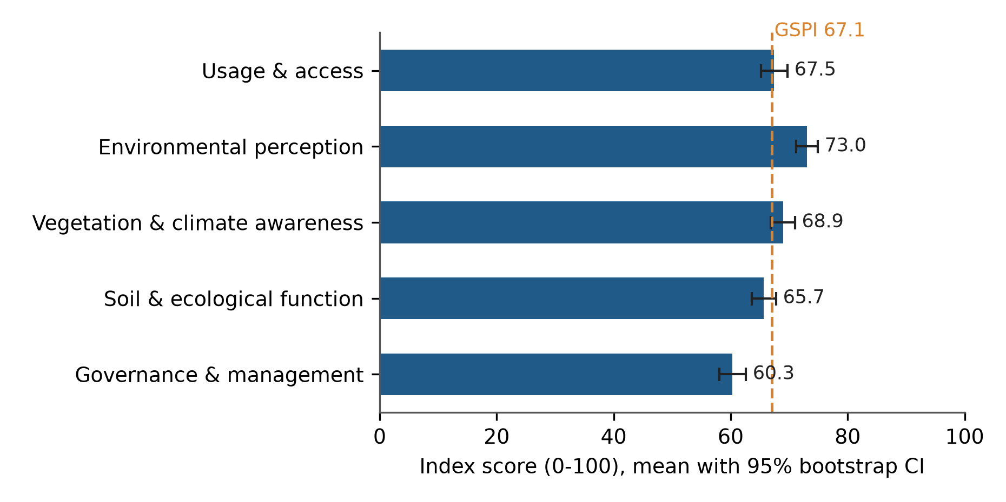
Fig. 1. Mean perception indexes (0–100) with 95% bootstrap confidence intervals. The dashed line marks the overall GSPI.

3.5 Differences by class and respondent (RQ3)
Seven of the 36 tests reached p < 0.05. Two survived Holm correction (Fig. 4; Supplementary Table S4).
Class and access. Class had a clear effect on usage and access (H(6) = 28.6, p = 0.0001, Holm p = 0.003, ε² = 0.077). Urban forest scored lowest (53.2), with grassland/scrub close behind (55.8). Managed parks scored 70.2, avenues 71.5 and neighbourhood parks 72.6 (Fig. 2). Pairwise tests, corrected, placed urban forest below managed parks, lake-riparian systems, neighbourhood parks and avenues (rank-biserial r from −0.43 to −0.54), and grassland/scrub below neighbourhood parks (r = −0.48). Class also seemed to affect environmental perception (H(6) = 15.9, p = 0.014), but that effect didn't survive correction (Holm p = 0.46).
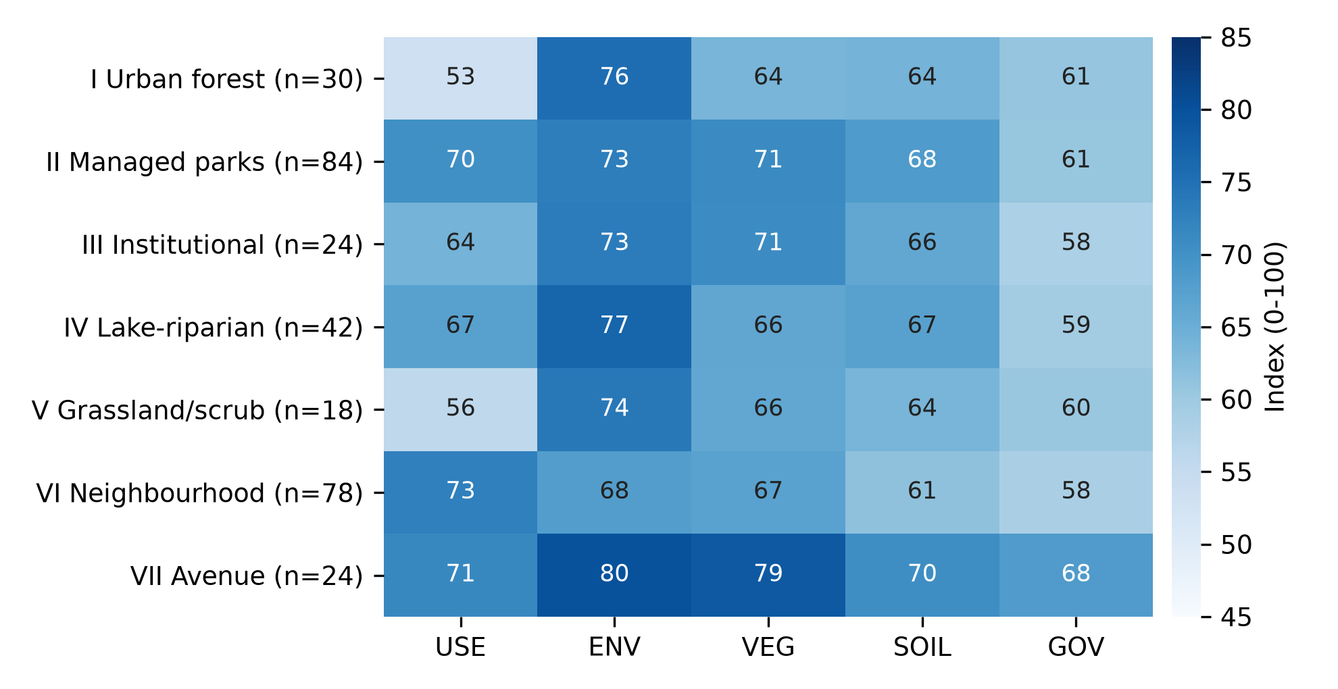
Fig. 2. Mean index (0–100) for each dimension by green-space class. USE, usage and access; ENV, environmental perception; VEG, vegetation and climate awareness; SOIL, soil and ecological function; GOV, governance and management.
Residence and governance. Governance ratings rose with time spent in the city (H(3) = 17.8, p = 0.0005, Holm p = 0.017, ε² = 0.050; Fig. 3). People resident for over ten years gave governance 64.8. Those resident 1–5 years gave 52.3 (r = −0.34) and those resident 6–10 years gave 56.2 (r = −0.25), both differences significant after correction. Newcomers of under a year (n = 15, 58.1) were too few to separate from the rest. Residence also showed nominal effects on vegetation awareness, soil/ecological function and the GSPI, none of which survived.
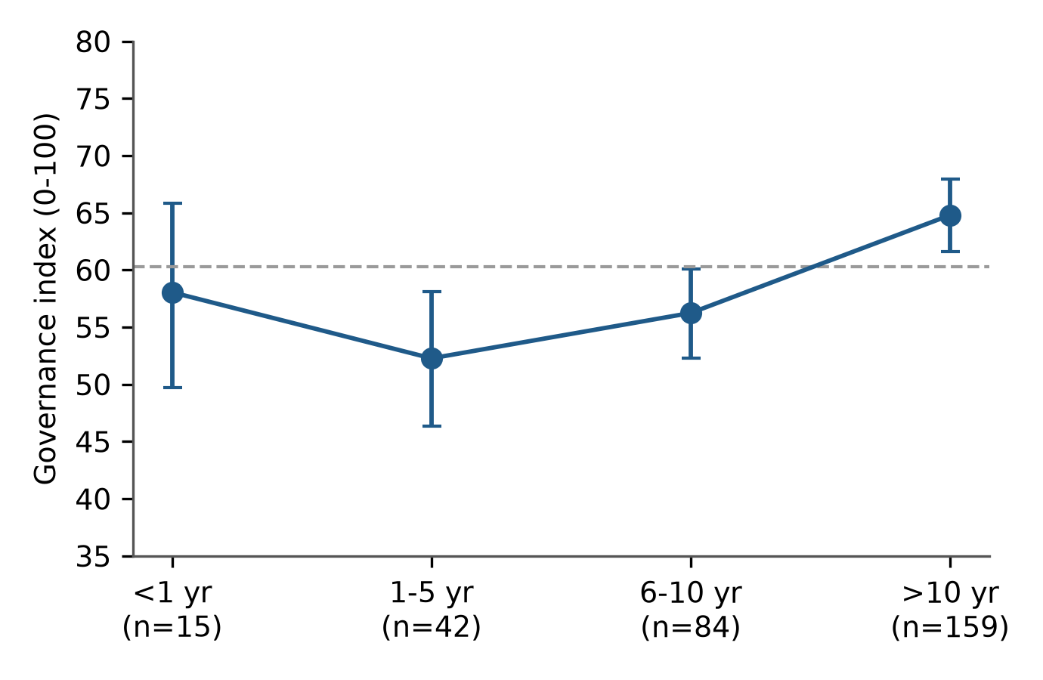
Fig. 3. Governance index by length of residence (mean with 95% bootstrap CI). The dashed line is the overall mean.
Other characteristics. Education produced one nominal effect, on vegetation awareness (H(3) = 10.2, p = 0.017; Holm p = 0.52). Age, gender and occupation produced none, even before correction. The GSPI regression explained little (R² = 0.101, adjusted R² = 0.034). Only one coefficient, for avenues, was nominally significant (β = 0.43, p = 0.008), and it didn't survive Holm correction.
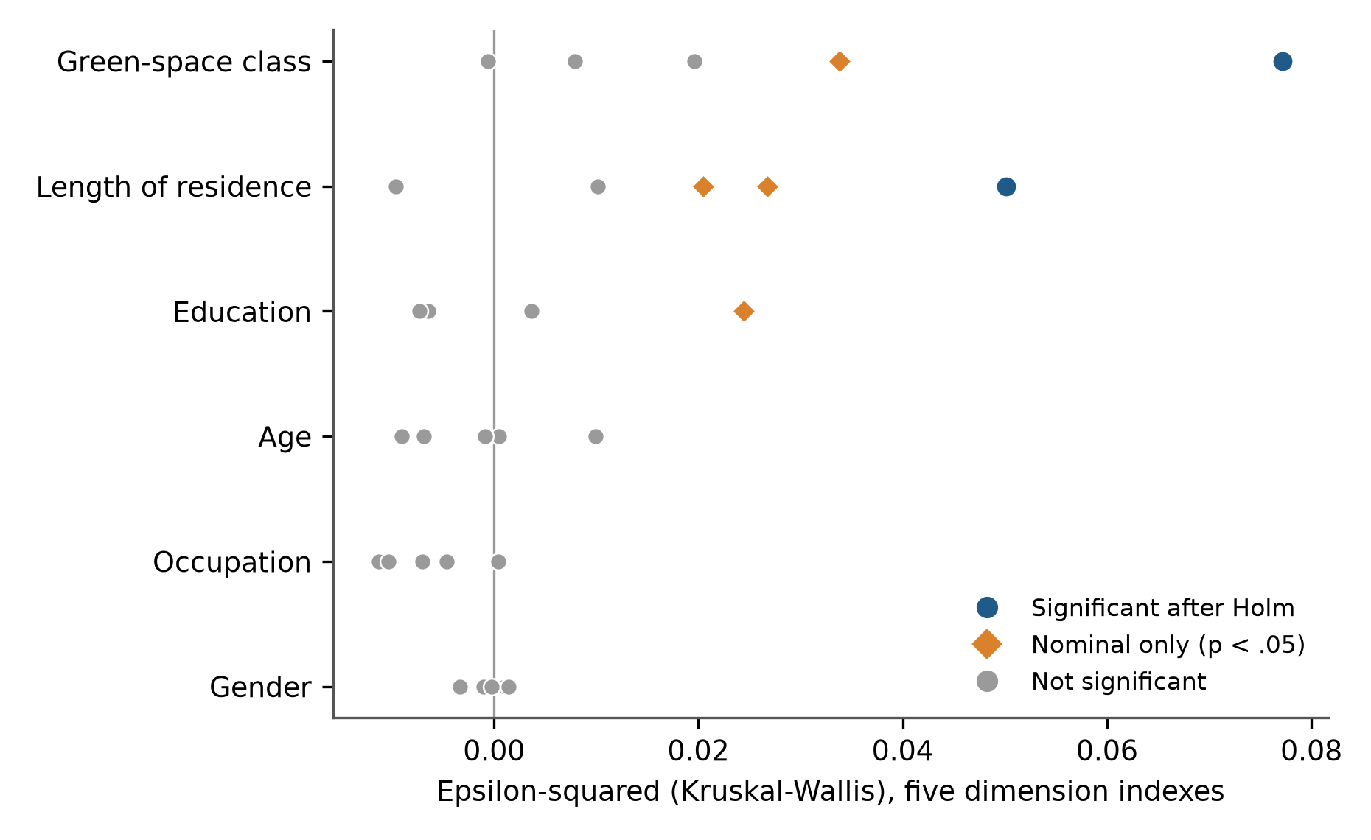
Fig. 4. Effect sizes (ε²) for the 30 tests on the five dimension indexes. Blue circles survived Holm correction across all 36 tests; orange diamonds were nominally significant only.

3.6 The salience gap (RQ4)
Residents rated the benefits they feel above the functions they can't easily see. The mean gap was 7.3 points (95% CI 5.4–9.3; Wilcoxon p < 0.001; dz = 0.42). For 62.7% of respondents environmental perception was the higher score, for 9.7% the two were equal, and for 27.6% it was lower.
The gap appeared in all seven classes (Fig. 5; Supplementary Table S5). It ranged from 4.5 points in managed parks to 11.5 in urban forest, and its interval excluded zero everywhere except institutional greens (n = 24; 7.1, CI −0.3 to 14.8). It did not, however, differ significantly between classes (H(6) = 6.20, p = 0.40). An exploratory comparison of the two least-reached classes against the rest — urban forest and grassland/scrub (n = 48, gap 11.0) versus the other five (n = 252, gap 6.6) — was also non-significant (p = 0.12). The larger gaps in forest, scrub and lake-riparian classes may be real, but this sample can't show it.
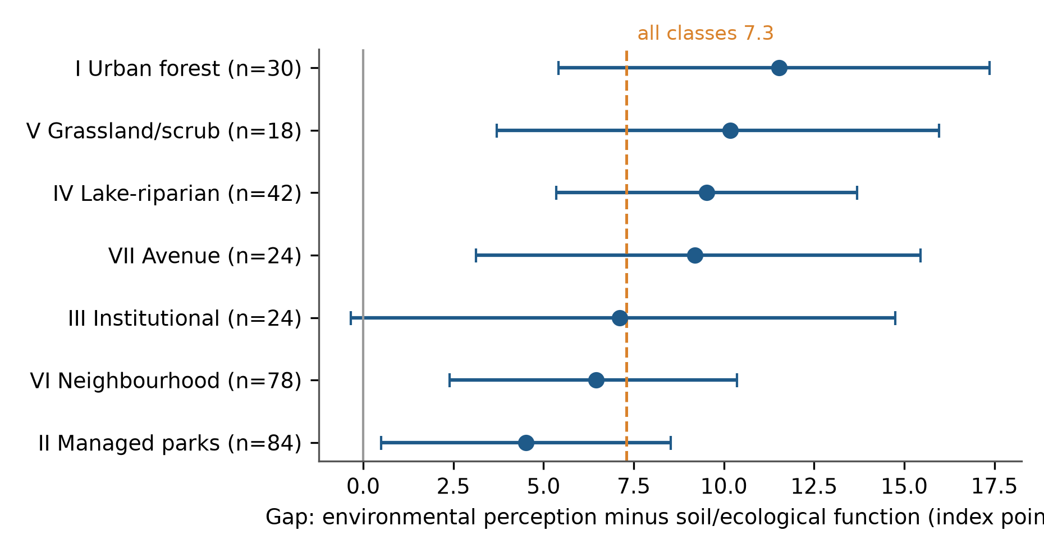
Fig. 5. Salience gap (environmental perception minus soil/ecological function, index points) by class, with 95% bootstrap CIs. Dashed line, overall mean; grey line, zero.
Sensitivity. We rebuilt the governance index from the three items that rate current management (Q30, Q32, Q33; α = 0.72). The residence effect stayed the same (H(3) = 17.6, p = 0.0005, ε² = 0.049), so it doesn't rest on the threat and support items.

4. Discussion

4.1 Felt benefits lead, management trails
Residents in this sample rated cooling, shade and cleaner air highest and management lowest. That ordering makes sense. Environmental benefits are felt on the skin and in the lungs, which is what restoration and stress-recovery accounts would lead us to expect (Kaplan, 1995; Ulrich et al., 1991). Management, by contrast, stays out of sight until something breaks. The ranking also matches Guangzhou, where residents stressed microclimate and environmental quality and paid little attention to habitat and species conservation (Jim and Chen, 2006). Bengaluru's own physical data back the residents up: the city's parks and street trees do cool the air and trap pollutants (Shah et al., 2021; Vailshery et al., 2013).
The salience gap fits our working expectation, but it needs a careful reading. Soil and ecological functions were still endorsed well above the scale midpoint (65.7). Respondents didn't reject them; they simply endorsed them less firmly than the benefits they feel. Since the instrument measures endorsement and not knowledge, the gap tells us what is salient to residents, not what they know. Calling it an "awareness deficit" would overstate the evidence. Fuller et al. (2007) found that park users perceived species richness accurately for some groups of organisms and poorly for others. That suggests salience depends on what is visible, which is consistent with what we found.
We had expected the gap to be widest in the classes that hold most carbon. The point estimates lean that way (urban forest 11.5, grassland/scrub 10.2, lake-riparian 9.5), but the between-class test was flat. With only 18 to 42 respondents in those classes, we treat the pattern as a hypothesis for a larger survey.

4.2 Access separates the classes
Only one class effect held up: access. Urban forest and grassland/scrub were reached least. Neighbourhood parks, managed parks and avenues were reached most. Yet environmental appreciation stayed high everywhere, including in the hard-to-reach classes. Low access, in other words, didn't mean low regard. Studies in Europe find the same link between distance and use (Schipperijn et al., 2010), and reviews show that access is distributed unevenly, often along income and ethnic lines (Rigolon, 2016; Kabisch and Haase, 2014). For Bengaluru's forest and scrub, the planning task looks like opening the door, not making the case.
The typology earned its place here. A single "green space" question would have averaged over a 19-point spread in access, from 53.2 to 72.6. Because the classes come from an independent land-cover map, the result also speaks to the call by Reyes-Riveros et al. (2021) to set perception against objective measures. The class differences in environmental perception (highest for avenues at 79.7, lowest for neighbourhood parks at 67.9) didn't survive correction, and we don't build on them.

4.3 Governance, maintenance and tenure
Governance was the weakest dimension in five of seven classes (in urban forest and grassland/scrub, access was lower still), and no class reached 70 on it. Among the five dimensions, governance is probably the easiest to change. Poorly kept vegetation is the park feature most often tied to fear of crime (Sreetheran and van den Bosch, 2014). Perceived quality, not just presence, predicts satisfaction and quality of life among park visitors (Kothencz et al., 2017). Visible maintenance can change within a budget cycle. Improvements still need care: greening that ignores who benefits can push out the residents it was meant to serve (Wolch et al., 2014).
Long-term residents rated governance higher than people who had arrived in the last decade. We didn't expect that. Several readings fit. Long-term residents may know whom to approach. They may have watched conditions improve, or feel attached to places they know well. Recent arrivals may be comparing Bengaluru with the cities they left. The design can't separate these, and the newest group is small (n = 15). The effect is moderate (ε² = 0.050), and residence effects on other dimensions vanished after correction. The finding chimes with evidence from Bengaluru that well-being differs across social groups (Thapa et al., 2024), but our evidence covers governance alone.

4.4 Little demographic variation
Age, gender and occupation made no detectable difference to any dimension. Education and residence produced only nominal effects on awareness. Plieninger et al. (2022) likewise found small socio-demographic differences in how Bengaluru residents value lakes, so the pattern may be local. Elsewhere, though, perceptions and use do split along social lines (Jim and Shan, 2013; Lo and Jim, 2010). Our quotas balanced groups but didn't record income, ward or distance, which is exactly where inequity tends to appear (Rigolon, 2016). The null result here is not evidence that Bengaluru's green space is equally shared.

4.5 What the instrument offers, and what it doesn't
The instrument holds five distinct dimensions that load on one general factor. The evidence for that comes from nested CFA, the HTMT criterion, the second-order model and reliabilities of 0.80–0.86, which goes further than most perception surveys report. Three cautions remain. Parallel analysis favoured four components, so the case for five rests on the confirmatory tests and on item content. AVE was modest. And the fit of the five-factor model was very close (RMSEA 0.019), which other samples should test before anyone treats the model as settled. We offer it as a structured, reliable profile tied to a mapped typology, ready for replication.

4.6 Implications for management
The findings support three actions, listed from the most to the least directly supported.
- Make management visible. Governance scored lowest, so clean and lit paths, posted maintenance schedules and a clearly named managing authority are the fastest way to improve how residents experience green space. Awareness of who manages a space (Q32) is itself part of the governance score.
- Open up forest and scrub. These classes were the least reached but still highly regarded. Better entry points, transport links and trail information would turn that regard into visits, with access managed to protect sensitive habitat.
- Show the hidden functions. Signs and short guides on soil, rainwater absorption and biodiversity in the most-used parks would address the salience gap where residents already go.

4.7 Limitations
Several limits apply.
- Sample. The sample is a purposive quota sample of 300, collected by one researcher, and isn't representative of Bengaluru. Levels such as percentage agreement can't be generalised.
- Class sizes. Class was self-selected. Sizes are uneven (6–28%), and the small classes (grassland/scrub, n = 18; institutional and avenue, n = 24 each) carry wide uncertainty. Class differences also mix the effect of the place with the profile of the people who use it.
- Design. Responses are self-reported and cross-sectional. Causal claims aren't possible, and acquiescence or social desirability may inflate agreement with virtuous statements.
- Measurement. The "awareness" dimensions measure endorsement, not knowledge, and the environmental and ecological scales use different items. Maximum-likelihood CFA treats five-point items as continuous; the near-symmetric distributions make this reasonable, but estimators for ordinal data would be a useful check. We could not test measurement invariance across groups because several cells were too small for multi-group models.
- Governance scale. Governance mixes ratings of current management with threat perception and support, though the residence finding held when those items were dropped.
- Missing variables. The instrument didn't record income, ward or travel distance, so questions of environmental justice remain open.

5. Conclusions
Residents in this sample prize what Bengaluru's green spaces do for the local environment (73.0/100) and think much less of how those spaces are run (60.3/100). They endorse the less visible ecological functions about seven points less firmly than the benefits they feel, and they do so in every class. Class separates the seven types mainly by access, with urban forest and grassland/scrub the hardest to reach. Long-term residents judge management more kindly than newcomers. Age, gender and occupation made no difference, and most other apparent effects vanished once 36 tests were corrected for. The policy message is short: maintain visibly, open up the least-reached classes, and explain the functions people can't see. A weighted citywide survey that records ward and income, and that links each class's perception score to measured carbon and soil data, is the obvious next step.

Declarations
Funding. No specific grant was received for this work.
Declaration of competing interest. The authors declare no competing interests.
Ethics statement. See Section 2.4.
Data availability. The anonymised responses and analysis scripts are available from the corresponding author on reasonable request.
CRediT authorship contribution statement. Vishnu H V: Conceptualization, Methodology, Investigation, Data curation, Formal analysis, Writing – original draft. N. Nandini: Supervision, Conceptualization, Writing – review & editing.
Declaration of generative AI and AI-assisted technologies in the writing process. During the preparation of this work the authors used Claude (Anthropic) to write and run analysis scripts and to draft and edit the text. After using this tool, the authors reviewed and edited the content as needed and take full responsibility for the content of the publication.
Acknowledgements. We thank the 300 residents who gave their time to the survey.

References
Cronbach, L.J., 1951. Coefficient alpha and the internal structure of tests. Psychometrika 16(3), 297–334. https://doi.org/10.1007/BF02310555
Fornell, C., Larcker, D.F., 1981. Evaluating structural equation models with unobservable variables and measurement error. Journal of Marketing Research 18(1), 39–50. https://doi.org/10.2307/3151312
Fuller, R.A., Irvine, K.N., Devine-Wright, P., Warren, P.H., Gaston, K.J., 2007. Psychological benefits of greenspace increase with biodiversity. Biology Letters 3(4), 390–394. https://doi.org/10.1098/rsbl.2007.0149
Gómez-Baggethun, E., Barton, D.N., 2013. Classifying and valuing ecosystem services for urban planning. Ecological Economics 86, 235–245. https://doi.org/10.1016/j.ecolecon.2012.08.019
Hartig, T., Mitchell, R., de Vries, S., Frumkin, H., 2014. Nature and health. Annual Review of Public Health 35, 207–228. https://doi.org/10.1146/annurev-publhealth-032013-182443
Hayes, A.F., Coutts, J.J., 2020. Use omega rather than Cronbach's alpha for estimating reliability. But…. Communication Methods and Measures 14(1), 1–24. https://doi.org/10.1080/19312458.2020.1718629
Henseler, J., Ringle, C.M., Sarstedt, M., 2015. A new criterion for assessing discriminant validity in variance-based structural equation modeling. Journal of the Academy of Marketing Science 43(1), 115–135. https://doi.org/10.1007/s11747-014-0403-8
Holm, S., 1979. A simple sequentially rejective multiple test procedure. Scandinavian Journal of Statistics 6(2), 65–70.
Horn, J.L., 1965. A rationale and test for the number of factors in factor analysis. Psychometrika 30(2), 179–185. https://doi.org/10.1007/BF02289447
Hu, L., Bentler, P.M., 1999. Cutoff criteria for fit indexes in covariance structure analysis: Conventional criteria versus new alternatives. Structural Equation Modeling 6(1), 1–55. https://doi.org/10.1080/10705519909540118
Jim, C.Y., Chen, W.Y., 2006. Perception and attitude of residents toward urban green spaces in Guangzhou (China). Environmental Management 38(3), 338–349. https://doi.org/10.1007/s00267-005-0166-6
Jim, C.Y., Shan, X., 2013. Socioeconomic effect on perception of urban green spaces in Guangzhou, China. Cities 31, 123–131. https://doi.org/10.1016/j.cities.2012.06.017
Kabisch, N., Haase, D., 2014. Green justice or just green? Provision of urban green spaces in Berlin, Germany. Landscape and Urban Planning 122, 129–139. https://doi.org/10.1016/j.landurbplan.2013.11.016
Kaiser, H.F., 1974. An index of factorial simplicity. Psychometrika 39(1), 31–36. https://doi.org/10.1007/BF02291575
Kaplan, S., 1995. The restorative benefits of nature: Toward an integrative framework. Journal of Environmental Psychology 15(3), 169–182. https://doi.org/10.1016/0272-4944(95)90001-2
Kothencz, G., Blaschke, T., 2017. Urban parks: Visitors' perceptions versus spatial indicators. Land Use Policy 64, 233–244. https://doi.org/10.1016/j.landusepol.2017.02.012
Kothencz, G., Kolcsár, R., Cabrera-Barona, P., Szilassi, P., 2017. Urban green space perception and its contribution to well-being. International Journal of Environmental Research and Public Health 14(7), 766. https://doi.org/10.3390/ijerph14070766
Lee, A.C.K., Maheswaran, R., 2011. The health benefits of urban green spaces: A review of the evidence. Journal of Public Health 33(2), 212–222.
Likert, R., 1932. A technique for the measurement of attitudes. Archives of Psychology 22(140), 1–55.
Lo, A.Y.H., Jim, C.Y., 2010. Differential community effects on perception and use of urban greenspaces. Cities 27(6), 430–442. https://doi.org/10.1016/j.cities.2010.07.001
Markevych, I., Schoierer, J., Hartig, T., Chudnovsky, A., Hystad, P., Dzhambov, A.M., et al., 2017. Exploring pathways linking greenspace to health: Theoretical and methodological guidance. Environmental Research 158, 301–317. https://doi.org/10.1016/j.envres.2017.06.028
Nagendra, H., Gopal, D., 2010. Street trees in Bangalore: Density, diversity, composition and distribution. Urban Forestry & Urban Greening 9(2), 129–137. https://doi.org/10.1016/j.ufug.2009.12.005
Nagendra, H., Gopal, D., 2011. Tree diversity, distribution, history and change in urban parks: Studies in Bangalore, India. Urban Ecosystems 14, 211–223. https://doi.org/10.1007/s11252-010-0148-1
Nagendra, H., Nagendran, S., Paul, S., Pareeth, S., 2012. Graying, greening and fragmentation in the rapidly expanding Indian city of Bangalore. Landscape and Urban Planning 105(4), 400–406. https://doi.org/10.1016/j.landurbplan.2012.01.014
Norman, G., 2010. Likert scales, levels of measurement and the "laws" of statistics. Advances in Health Sciences Education 15(5), 625–632. https://doi.org/10.1007/s10459-010-9222-y
Plieninger, T., Thapa, P., Bhaskar, D., Nagendra, H., Torralba, M., Zoderer, B.M., 2022. Disentangling ecosystem services perceptions from blue infrastructure around a rapidly expanding megacity. Landscape and Urban Planning 222, 104399. https://doi.org/10.1016/j.landurbplan.2022.104399
Podsakoff, P.M., MacKenzie, S.B., Lee, J.-Y., Podsakoff, N.P., 2003. Common method biases in behavioral research: A critical review of the literature and recommended remedies. Journal of Applied Psychology 88(5), 879–903. https://doi.org/10.1037/0021-9010.88.5.879
Reyes-Riveros, R., Altamirano, A., De La Barrera, F., Rozas-Vásquez, D., Vieli, L., Meli, P., 2021. Linking public urban green spaces and human well-being: A systematic review. Urban Forestry & Urban Greening 61, 127105.
Rigolon, A., 2016. A complex landscape of inequity in access to urban parks: A literature review. Landscape and Urban Planning 153, 160–169. https://doi.org/10.1016/j.landurbplan.2016.05.017
Schipperijn, J., Ekholm, O., Stigsdotter, U.K., Toftager, M., Bentsen, P., Kamper-Jørgensen, F., Randrup, T.B., 2010. Factors influencing the use of green space: Results from a Danish national representative survey. Landscape and Urban Planning 95(3), 130–137.
Shah, A., Garg, A., Mishra, V., 2021. Quantifying the local cooling effects of urban green spaces: Evidence from Bengaluru, India. Landscape and Urban Planning 209, 104043.
Shanahan, D.F., Bush, R., Gaston, K.J., Lin, B.B., Dean, J., Barber, E., Fuller, R.A., 2016. Health benefits from nature experiences depend on dose. Scientific Reports 6, 28551. https://doi.org/10.1038/srep28551
Sreetheran, M., van den Bosch, C.C.K., 2014. A socio-ecological exploration of fear of crime in urban green spaces – A systematic review. Urban Forestry & Urban Greening 13(1), 1–18.
Taylor, L., Hochuli, D.F., 2017. Defining greenspace: Multiple uses across multiple disciplines. Landscape and Urban Planning 158, 25–38. https://doi.org/10.1016/j.landurbplan.2016.09.024
Thapa, P., Torralba, M., Nölke, N., Chappell, M., Wangchuk, S., Kleinn, C., 2024. Disentangling associations of human wellbeing with green infrastructure, degree of urbanity, and social factors around an Asian megacity. Landscape Ecology 39, 68.
Tomczak, M., Tomczak, E., 2014. The need to report effect size estimates revisited. An overview of some recommended measures of effect size. Trends in Sport Sciences 21(1), 19–25.
Ulrich, R.S., Simons, R.F., Losito, B.D., Fiorito, E., Miles, M.A., Zelson, M., 1991. Stress recovery during exposure to natural and urban environments. Journal of Environmental Psychology 11(3), 201–230. https://doi.org/10.1016/S0272-4944(05)80184-7
Vailshery, L.S., Jaganmohan, M., Nagendra, H., 2013. Effect of street trees on microclimate and air pollution in a tropical city. Urban Forestry & Urban Greening 12, 408–415.
White, M.P., Alcock, I., Grellier, J., Wheeler, B.W., Hartig, T., Warber, S.L., et al., 2019. Spending at least 120 minutes a week in nature is associated with good health and wellbeing. Scientific Reports 9, 7730. https://doi.org/10.1038/s41598-019-44097-3
Wolch, J.R., Byrne, J., Newell, J.P., 2014. Urban green space, public health, and environmental justice: The challenge of making cities 'just green enough'. Landscape and Urban Planning 125, 234–244. https://doi.org/10.1016/j.landurbplan.2014.01.017
Zhou, K., Tan, R., 2024. Understanding the structure of public perceptions towards urban green spaces: A mixed-method investigation. Urban Forestry & Urban Greening 101, 128496. https://doi.org/10.1016/j.ufug.2024.128496

Supplementary material
- Table S1. Full questionnaire (English and Kannada).
- Table S2. Item descriptives: `t_items.csv`.
- Table S3. Rotated component loadings: `t_efa_loadings.csv`.
- Table S4. All 36 group tests with raw and Holm p-values: `t_group_tests.csv`.
- Table S5. Salience gap by class: `t_gap_by_class.csv`.
- Table S6. HTMT matrix and model comparisons: `validity_extra.json`.
- Fig. S1. Scree plot with parallel-analysis benchmark: `figs/figS1_scree.png`.
- Code. `analysis.py`, `validity_extra.py`.

