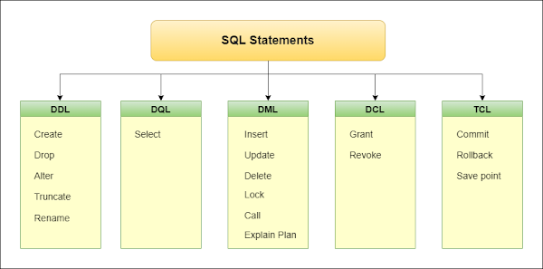

**Learnings**

SOLID - Design Principles

<https://www.dotnettricks.com/learn/designpatterns/solid-design-principles-explained-using-csharp>

Design Patterns

<https://www.geeksforgeeks.org/builder-design-pattern/>

<https://www.dotnettricks.com/learn/designpatterns/strategy-design-pattern-c-sharp>

Build in IOC .Net Core

<https://www.tutorialsteacher.com/core/internals-of-builtin-ioc-container-in-aspnet-core>

Windsor

<https://github.com/castleproject/Windsor/blob/master/docs/README.md>

C# Best Practices

0:00 - Intro

0:50 -  Name things well

7:51 - One class per file

10:18 - Use properties not variables

12:57 - Methods should do one thing

23:27 - Keep it simple

28:21 - Be consistent

32:22 - Use curly braces for if statements

37:45 - Concatenate strings using $""

45:37 - Avoid global variables

48:39 - Use public modifier only when necessary

50:54 -  Never trust the user (bonus)

52:24 -  Plan before you build

55:31 - Concluding remarks