# Structure

* MessengerService:

Interface defining shared behaviors between Server and Client

* MessengerServiceImpl:

Implement key-value storage with HashMap

* Client:

Get remote object MessengerService from Registry

* Server:

Creat Registry and bind remote object to Registry

# Compile

* javac *.java

# run

on Terminal 1:

* java Server <port>

on Terminal 2:

* java Client <port>

# Examples

Client 1:

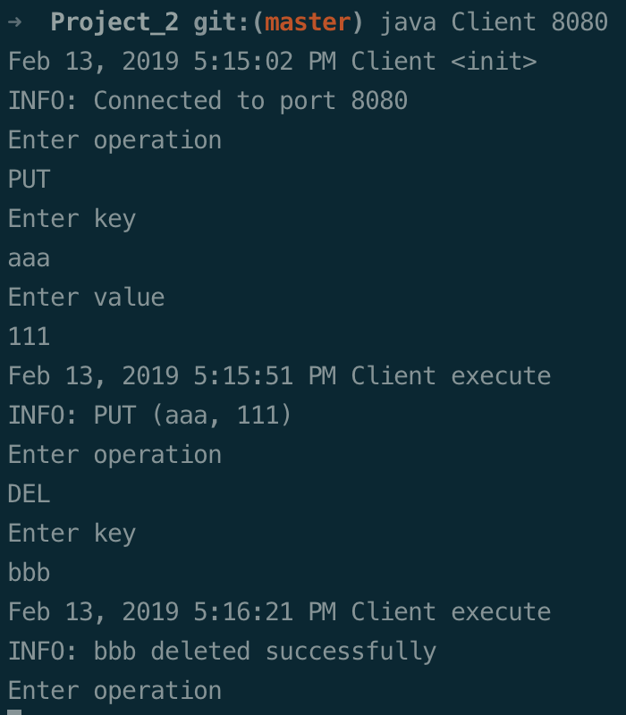

Client 2:

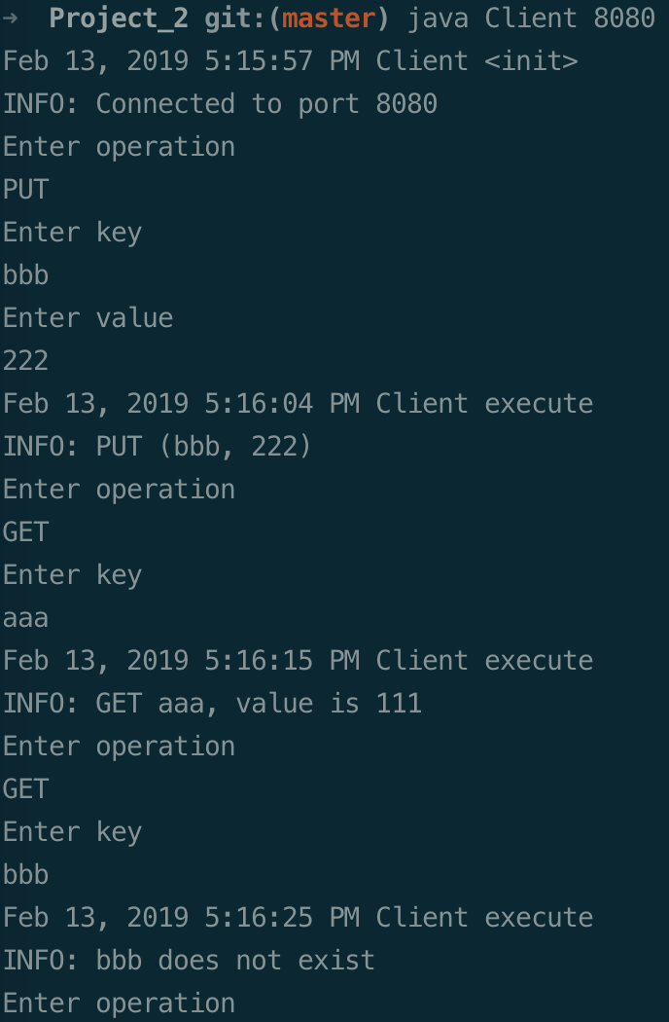

Server:

