# Project Structure

Server.java and Client.java are abstract class that define some common behavior shared by TCP and UDP implementations. TCPServer.java & TCPClient.java and UDPServer.java & UDPClient.java extend Server.java and Client.java.

# Behavior

The Server will keep running until being shut down by ctrl + C. The Client will keep trying to connect to Server until the Server is available. The Client will disconnect after 10 seconds if no input occurs. If there’re 2 or more than 2 Clients try to connect to Server, only 1 will connect successfully and the others will sleep until the Server is available again.

# Compilation

$ javac TCPServer.java TCPClient.java UDPServer.java UDPClient.java

# Run

**Server init**

$ java TCPServer

or

$ java UDPServer

**Client init**

$ java TCPClient

or

$ java UDPClient

**Operations**

The prompt shows

> Enter operation, GET, PUT, DELETE

Type

$ `GET` or `PUT` or `Delete`

The prompt shows

> Enter key

Type

$ <Any key>

If the prompt shows

> Enter value

Type

$ <Any Value>

# Examples

TCP:

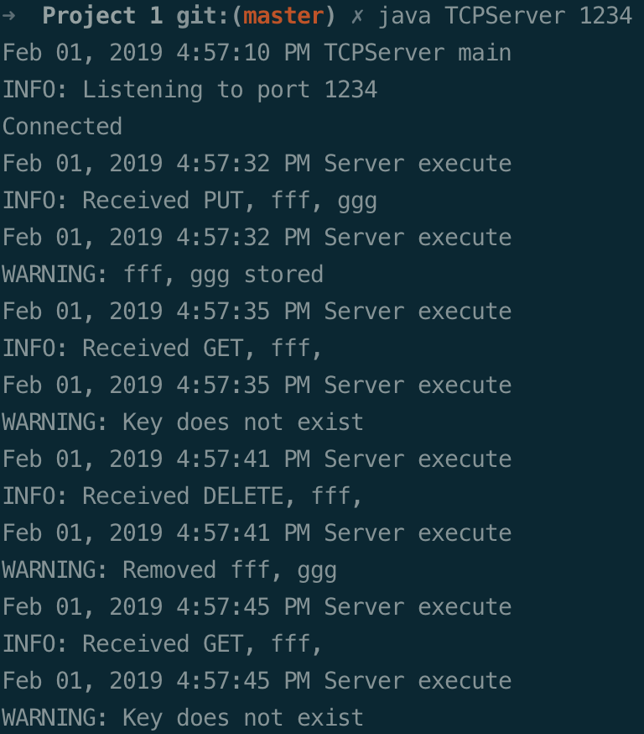

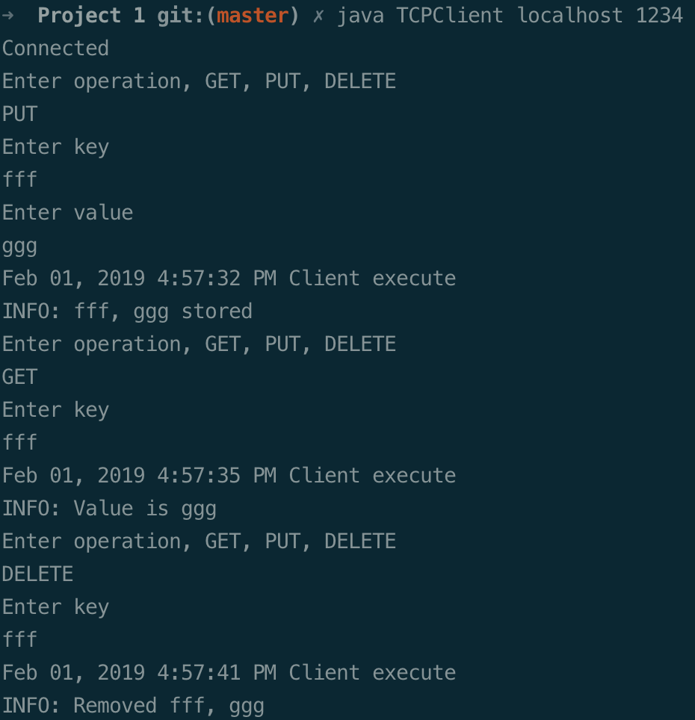

UDP:

