ORACLE 11204

RAC集群部署及数据迁移

**目录**

1. 前置工作 3

1.1 申请IP地址 3

1.2 系统优化 4

1.2.1 关闭防火墙 4

1.2.2 关闭NTP服务 4

1.2.3 设置CTSS服务 4

1.2.4 关闭内核防火墙 4

1.2.5 修改主机名 4

1.3 创建用户 5

1.4 配置环境变量 5

2. 搭建RAC集群 6

2.1 安装Grid软件 6

2.2 安装Oracle软件 16

2.3 创建Oracle数据库 21

3. 数据迁移 30

3.1 关闭、开启触发器 30

3.2 统计失效对象 31

3.3 按用户统计数据量 31

3.4 初始化表空间 31

3.5 导入用户 31

3.6 Expdp按用户导出数据 31

3.7 Impdp按用户导入数据 31

3.8 稽核数据量 31

3.9 重新编译失效对象 32

3.10 业务验证 32

1. 前置工作

1.1 申请IP地址

#Public IP

10.10.8.50 12cnod01

10.10.8.51 12cnod02

#Private IP

1.1.1.1 12cnod01-priv

1.1.1.2 12cnod02-priv

#Virtual IP

10.10.8.52 12cnod01-vip

10.10.8.53 12cnod02-vip

#scan-ip

10.10.8.54 racnode-cluster

分别在两台物理机上挂载好共享存储

此步骤需要存储厂商支持

1.2 系统优化

1.2.1 关闭防火墙

在rac1 和rac2 2个节点上分别执行如下语句：

[root@rac01 ~]# service iptables stop

[root@rac01 ~]# chkconfig iptables off

[root@rac01 ~]# chkconfig iptables --list

iptables 0:off 1:off 2:off 3:off 4:off 5:off 6:off

chkconfig iptables off ---永久

service iptables stop ---临时

/etc/init.d/iptables status ----会得到一系列信息，说明防火墙开着。

/etc/rc.d/init.d/iptables stop ----------关闭防火墙

1.2.2 关闭NTP服务

手动设置两个节点时间一致

[root@node2 ~]# service ntpd stop

Shutting down ntpd: [FAILED]

[root@node2 ~]# chkconfig ntpd off

[root@node2 ~]# mv /etc/ntp.conf /etc/ntp.conf.original

[root@node2 ~]# rm -rf /var/run/ntpd.pid

1.2.3 设置CTSS服务

#当集群中有NTP服务器时，ctss是以一个观察者（Observer mode）的身份来监控，不一致的时间会写入到alter中，但不会主动调整。

root@dzswjnfdb1:/u01/app/11.2.0.4/grid/bin# ./crsctl check ctss

CRS-4700: The Cluster Time Synchronization Service is in Observer mode.

#当关掉NTP时，CTSS就是主动模式（Active mode），来调整主节点的时间同步。

[root@rac2 ~]# crsctl check ctss

CRS-4701: The Cluster Time Synchronization Service is in Active mode

1.2.4 关闭内核防火墙

vi /etc/sysconfig/selinux

SELINUX=disabled

1.2.5 修改主机名

hostnamectl set-hostname racnode01

1.3 创建用户

--创建用户组及授权<认真看好目录的规划，否则会有权限的问题>

useradd -u 1100 -g oinstall -G asmadmin,asmdba,asmoper,oper,dba grid

useradd -u 1101 -g oinstall -G dba,asmdba,oper oracle

mkdir -p /u01/app/11.2.0/grid

mkdir -p /u01/app/grid

mkdir -p /u01/app/oracle

chown -R grid:oinstall /u01

chown -R oracle:oinstall /u01/app/oracle

chmod -R 775 /u01/

为oracle及grid设置密码

passwd oracle --oracle123

passwd grid --grid123

1.4 配置环境变量

grid配置文件

su - grid

vi .bash_profile

export TMP=/tmp

export TMPDIR=$TMP

export ORACLE_SID=+ASM1 # RAC1 --每个节点一条

export ORACLE_SID=+ASM2 # RAC2

export ORACLE_UNQNAME=crsdb

export ORACLE_BASE=/u01/app/grid

export ORACLE_HOME=/u01/app/11.2.0/grid

export TNS_ADMIN=/u01/app/oracle/product/11.2.0/db_1/network/admin

export PATH=/usr/sbin:/u01/app/11.2.0/grid/bin:$PATH

export PATH=$ORACLE_HOME/bin:$PATH

export LD_LIBRARY_PATH=$ORACLE_HOME/lib:/lib:/usr/lib

grid_home=/u01/app/grid/

source .bash_profile

oracle配置文件

su - oracle

vi .bash_profile

export TMP=/tmp

export TMPDIR=$TMP

export ORACLE_SID=crsdb1 # RAC1 ---每个节点一条

export ORACLE_SID=crsdb2 # RAC2

export ORACLE_UNQNAME=crsdb

export ORACLE_BASE=/u01/app/oracle

export ORACLE_HOME=$ORACLE_BASE/product/11.2.0/db_1

export TNS_ADMIN=$ORACLE_HOME/network/admin

export PATH=/usr/sbin:$PATH

export PATH=$ORACLE_HOME/bin:$PATH

export LD_LIBRARY_PATH=$ORACLE_HOME/lib:/lib:/usr/lib

1. 搭建RAC集群

2.1 安装Grid软件

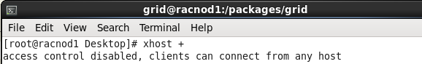

切换到grid用户

进入grid目录

Grid 安装包软件目录至少有oinstall的组权限

[root@racnode01 package]# pwd

/package

[root@racnode01 package]# ls

database grid

Cd /packages/grid

运行安装

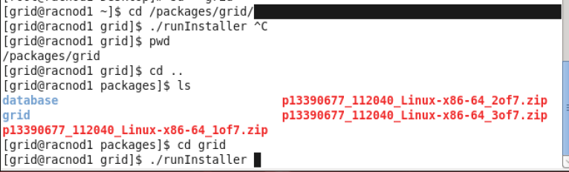

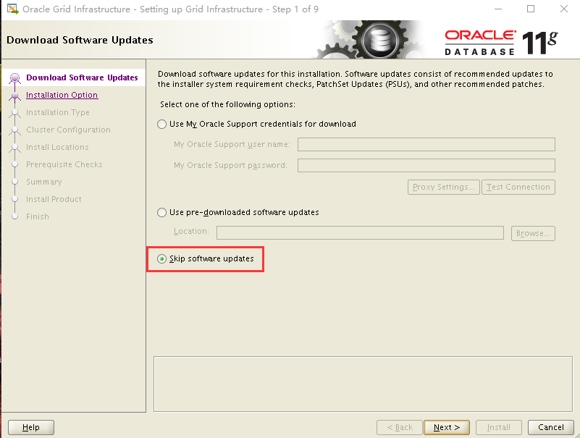

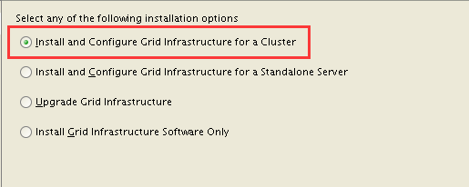

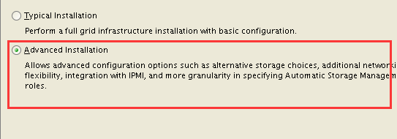

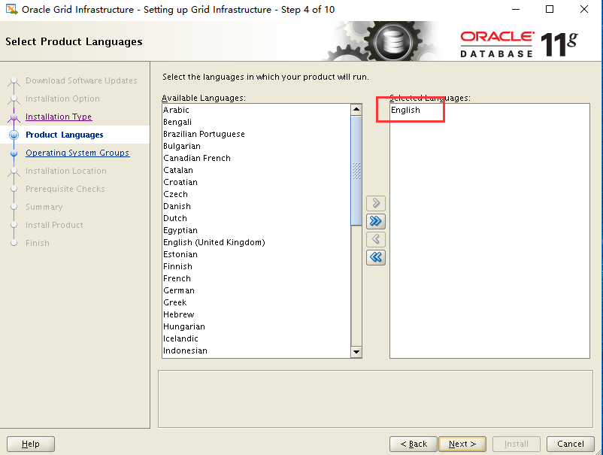

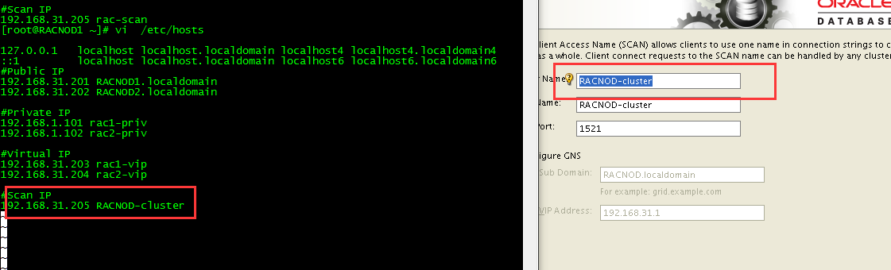

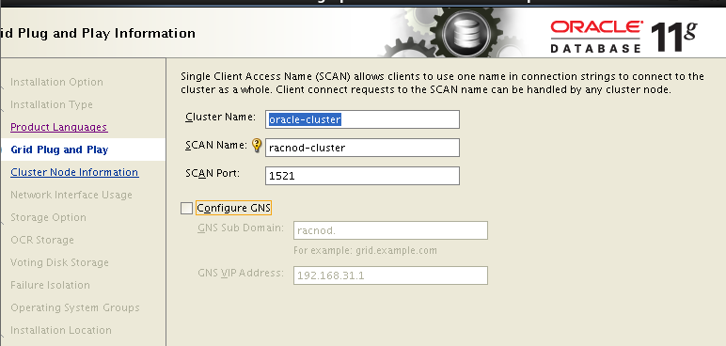

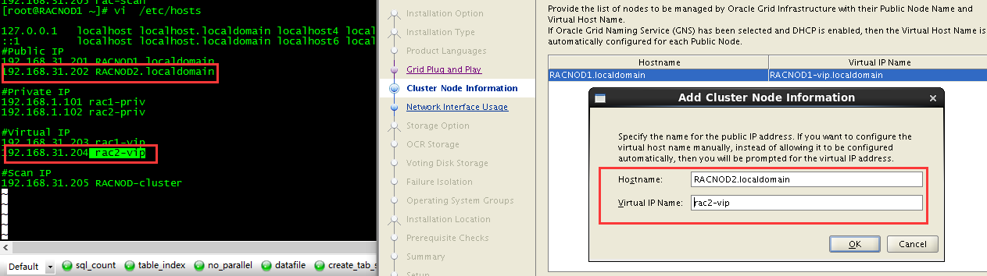

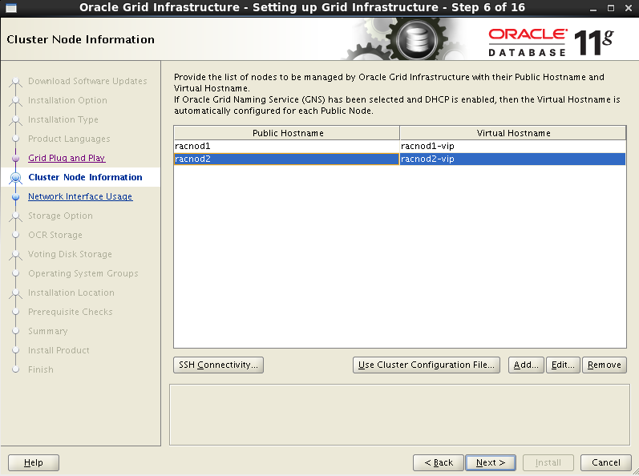

Grid SSH互信

两个节点的grid用户的密码要相同

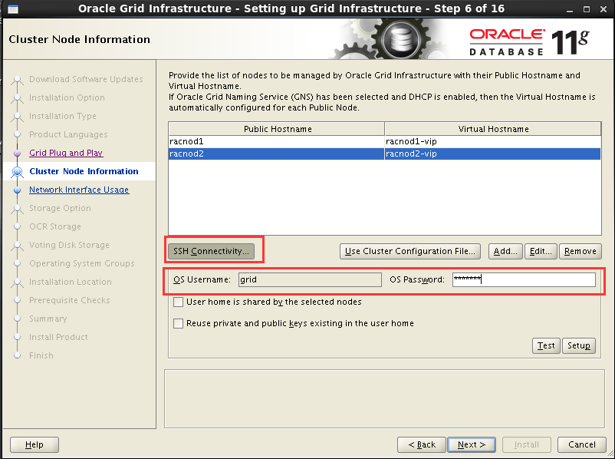

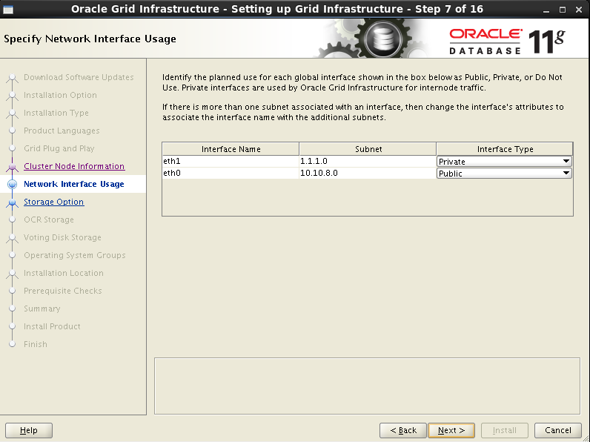

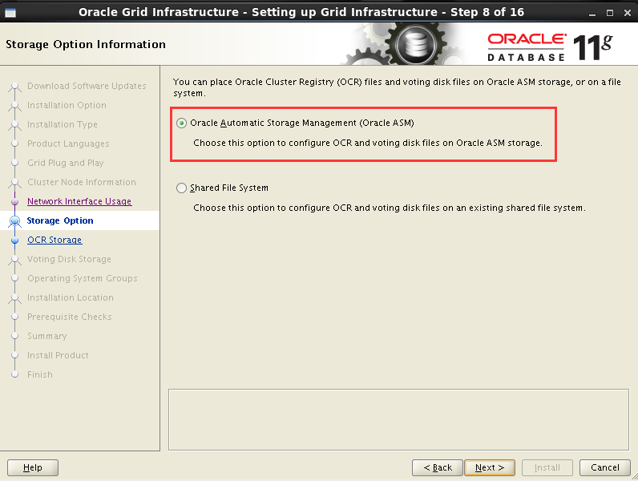

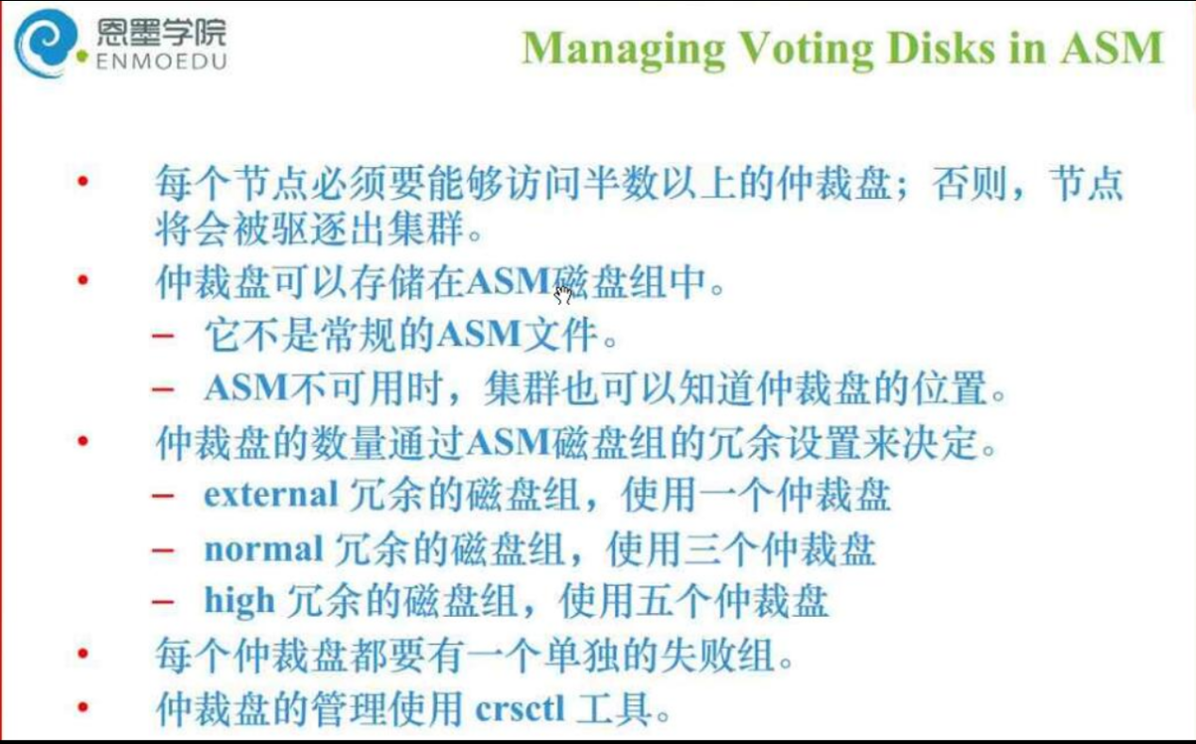

对于OCR和VF的盘，每个成员5G足够了。

--此处创建选择仲裁盘

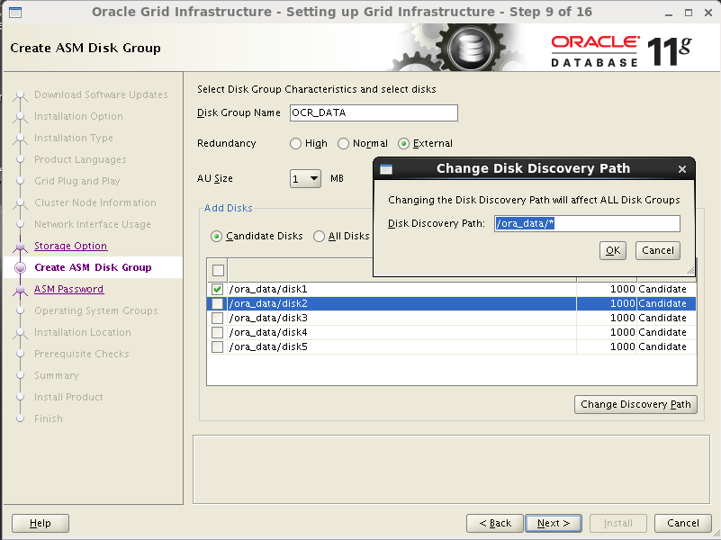

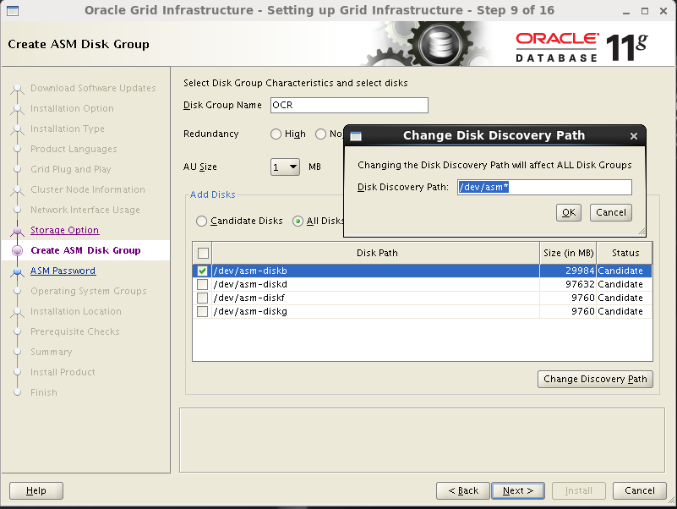

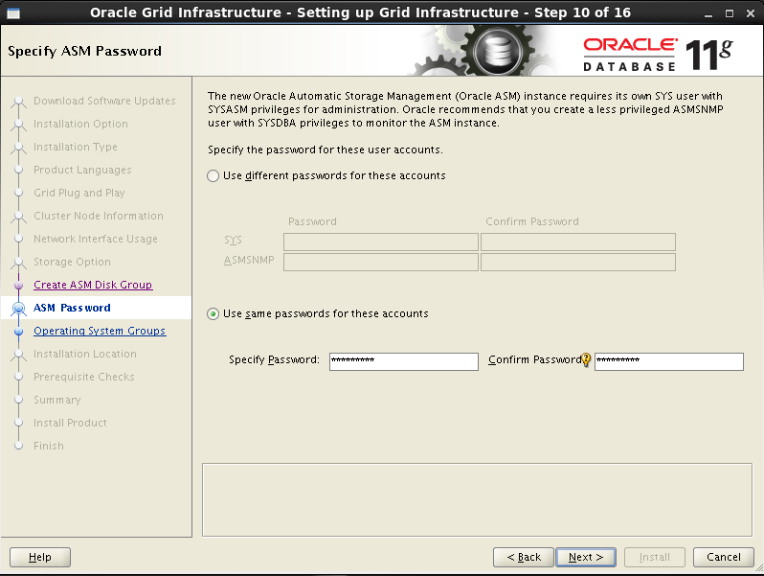

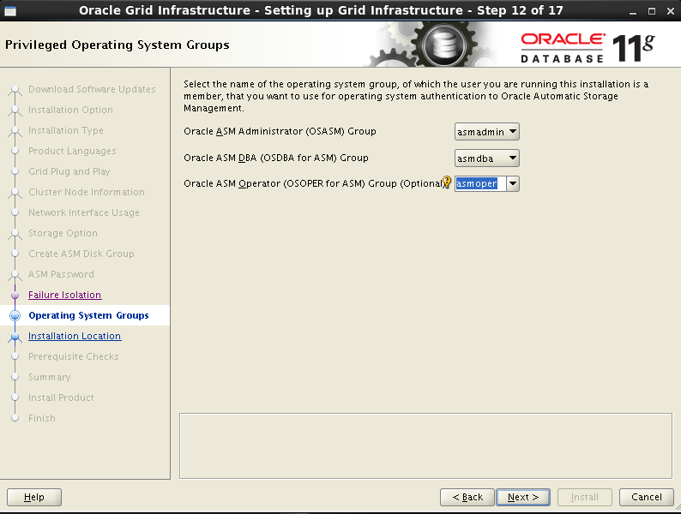

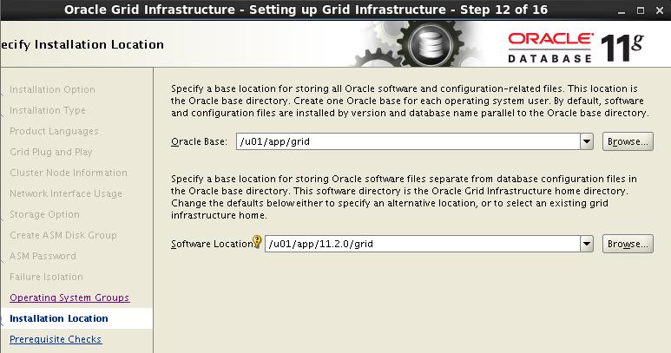

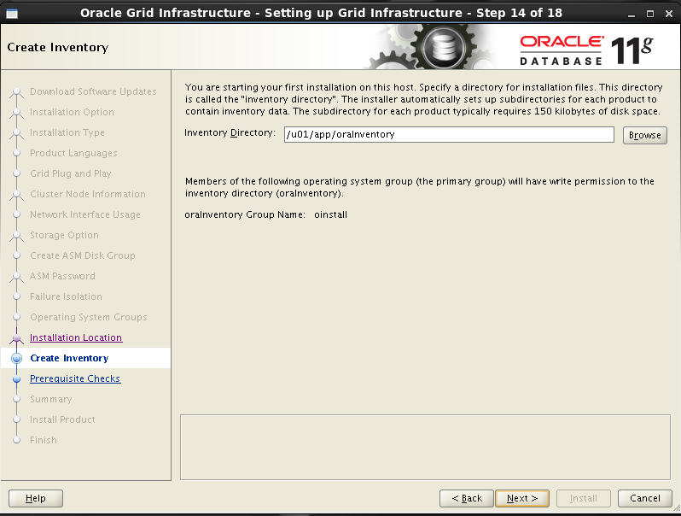

--根据提示进行检查修复

[root@racnod2 Packages]# cd /tmp/CVU_11.2.0.4.0_grid/

[root@racnod2 CVU_11.2.0.4.0_grid]# ./runfixup.sh

Response file being used is :./fixup.response

Enable file being used is :./fixup.enable

Log file location: ./orarun.log

uid=1100(grid) gid=1000(oinstall) groups=1000(oinstall),1020(asmadmin),1021(asmdba),1022(asmoper),1031(dba),1032(oper)

Installing Package /tmp/CVU_11.2.0.4.0_grid//cvuqdisk-1.0.9-1.rpm

Preparing... ########################################### [100%]

1:cvuqdisk ########################################### [100%]

--执行max processes的修复

[root@racnod1 CVU_11.2.0.4.0_grid]# cd /tmp/CVU_11.2.0.4.0_grid

[root@racnod1 CVU_11.2.0.4.0_grid]# ./runfixup.sh

Response file being used is :./fixup.response

Enable file being used is :./fixup.enable

Log file location: ./orarun.log

uid=1100(grid) gid=1000(oinstall) groups=1000(oinstall),1020(asmadmin),1021(asmdba),1022(asmoper),1031(dba),1032(oper)

grid soft nproc 2047

Value of MAX PROCESSES SOFTLIMIT in response file is not greater than value in /etc/security/limits.conf. Hence not changing it.

按顺序，先把1在两个节点执行完，再执行2

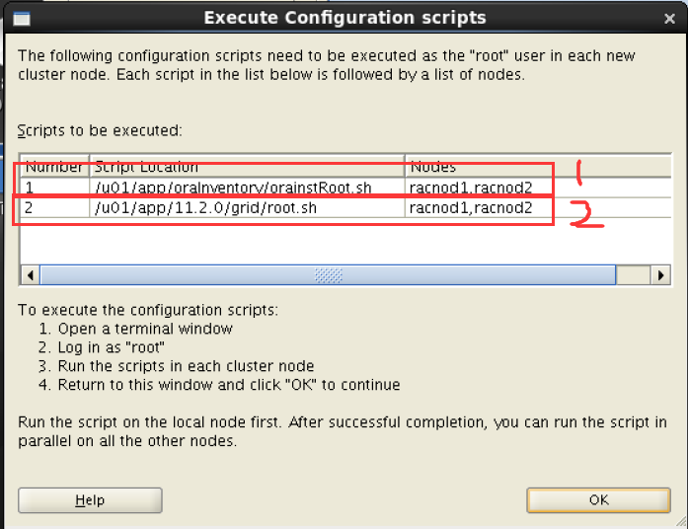

Racnod1

CRS-4266: Voting file(s) successfully replaced

## STATE File Universal Id File Name Disk group

-- ----- ----------------- --------- ---------

1. ONLINE 1bb9750df90c4f79bf04859857a0231d (/ora_data/disk1) [OCR_DATA]

Located 1 voting disk(s).

CRS-2672: Attempting to start 'ora.asm' on 'racnod1'

CRS-2676: Start of 'ora.asm' on 'racnod1' succeeded

CRS-2672: Attempting to start 'ora.OCR_DATA.dg' on 'racnod1'

CRS-2676: Start of 'ora.OCR_DATA.dg' on 'racnod1' succeeded

Configure Oracle Grid Infrastructure for a Cluster ... succeeded

Racnod2：

Using configuration parameter file: /u01/app/11.2.0/grid/crs/install/crsconfig_params

Creating trace directory

User ignored Prerequisites during installation

Installing Trace File Analyzer

OLR initialization - successful

Adding Clusterware entries to upstart

CRS-4402: The CSS daemon was started in exclusive mode but found an active CSS daemon on node racnod1, number 1, and is terminating

An active cluster was found during exclusive startup, restarting to join the cluster

Configure Oracle Grid Infrastructure for a Cluster ... succeeded

2.2 安装Oracle软件

切换到oracle 用户

[oracle@racnod1 packages]$ cd database/

[oracle@racnod1 database]$ ./runInstaller

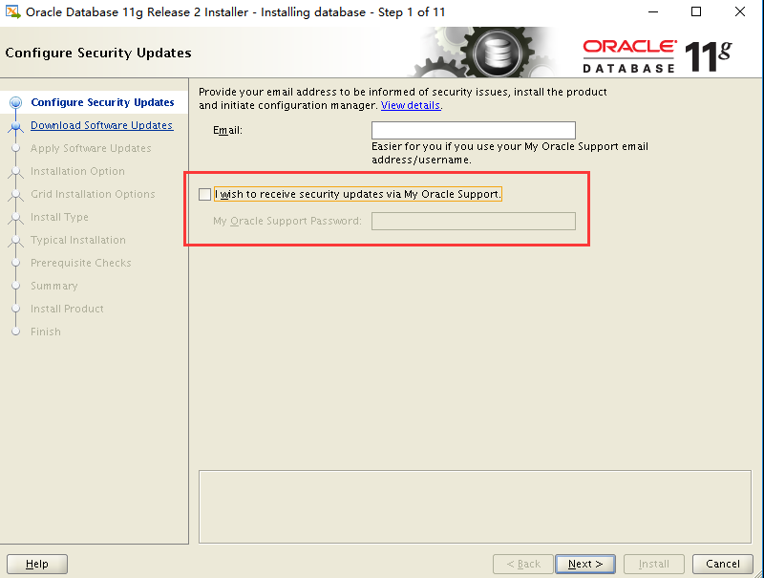

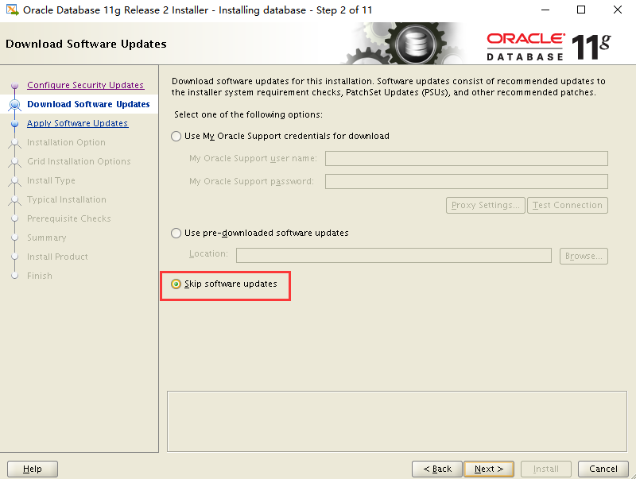

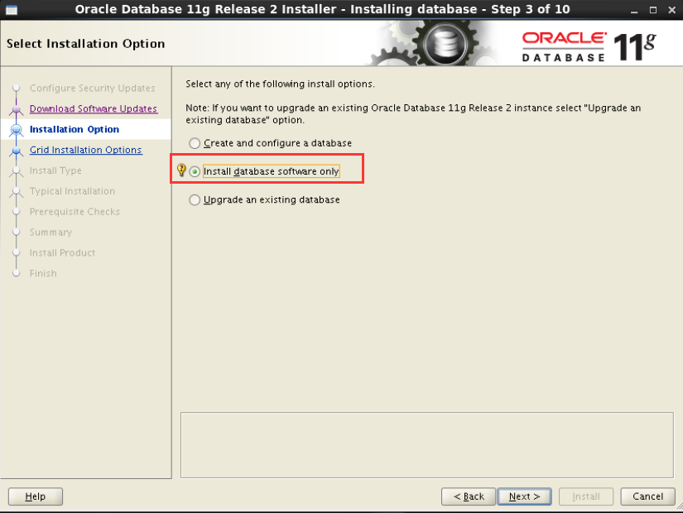

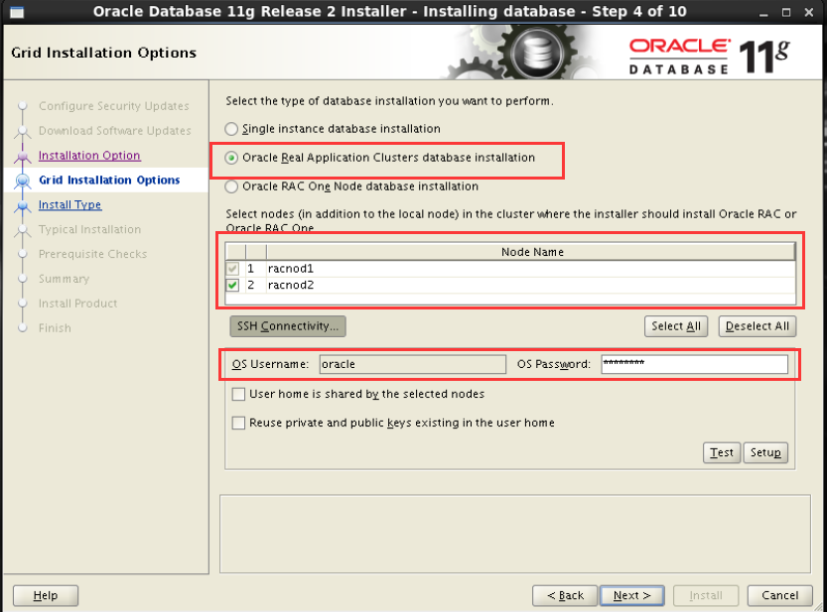

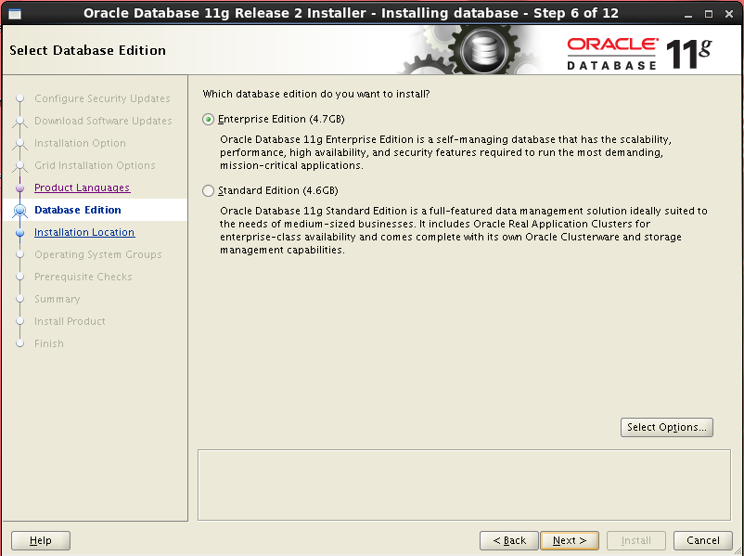

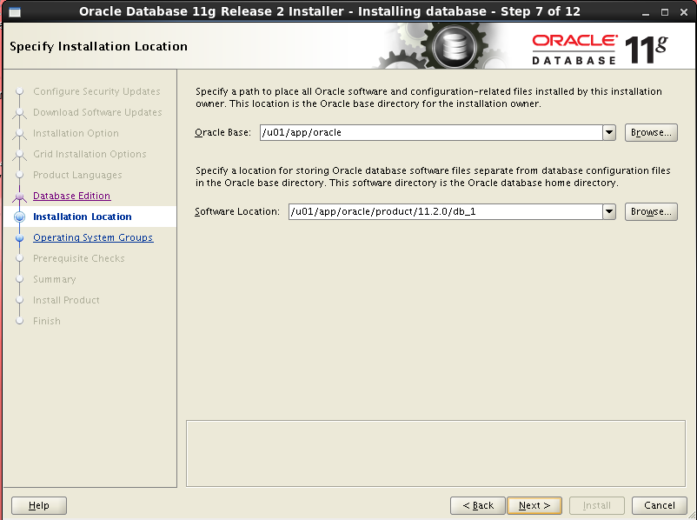

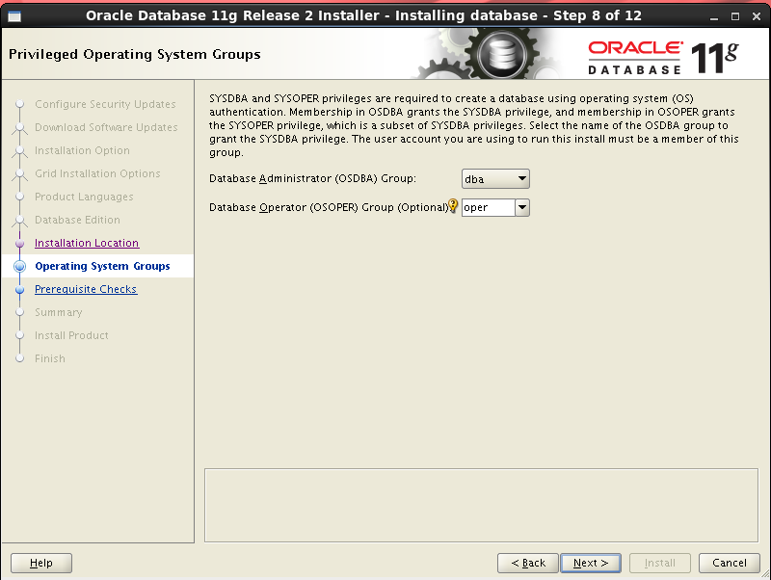

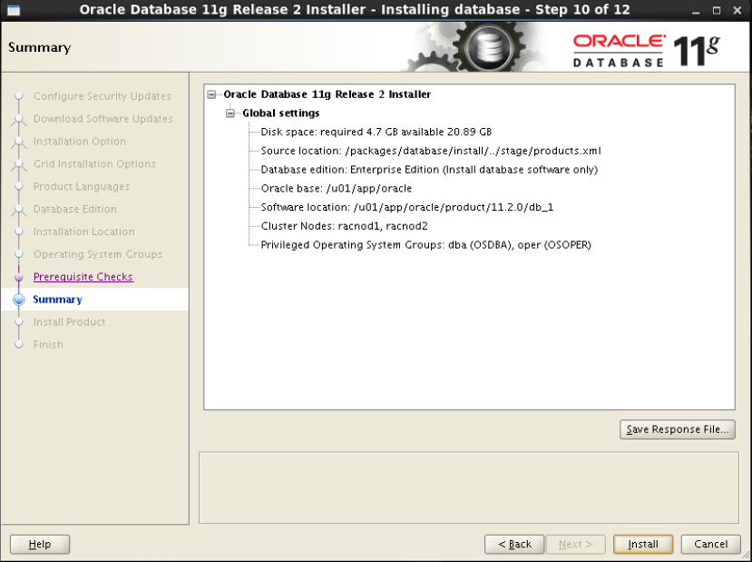

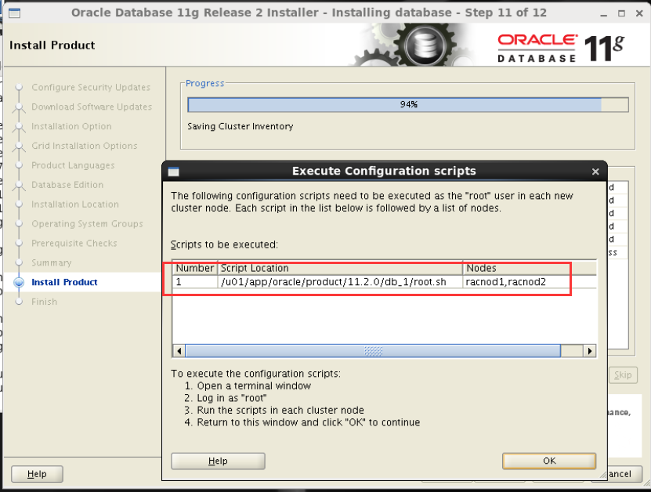

2.3 创建Oracle数据库

--oracle用户执行

[oracle@racnod1 database]$ dbca

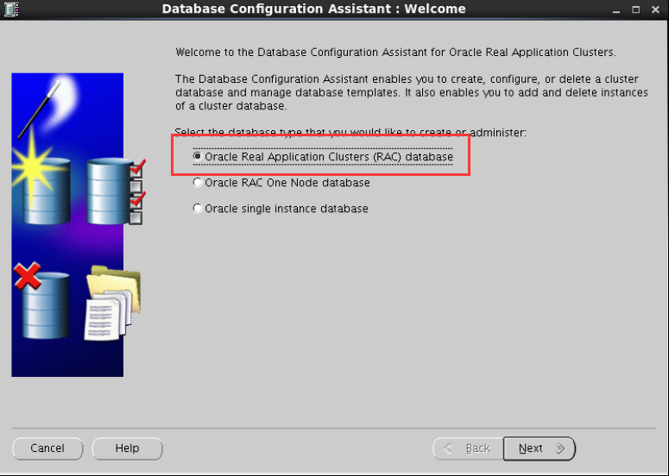

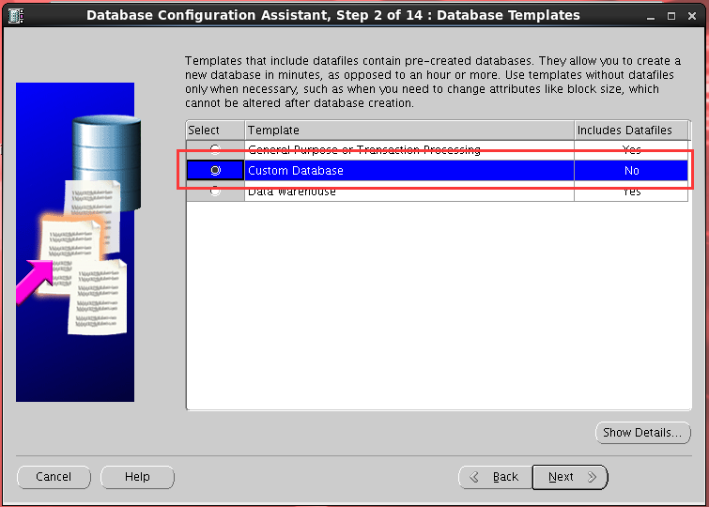

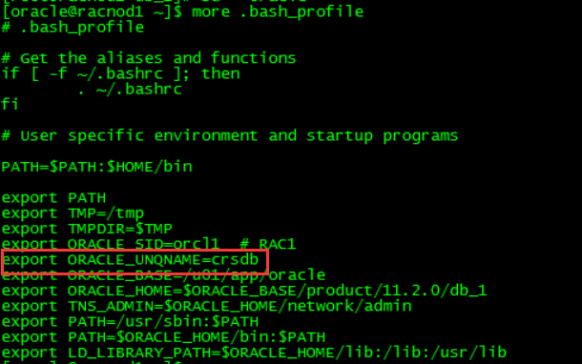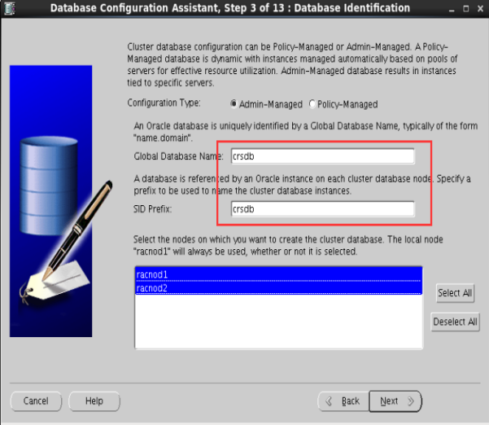

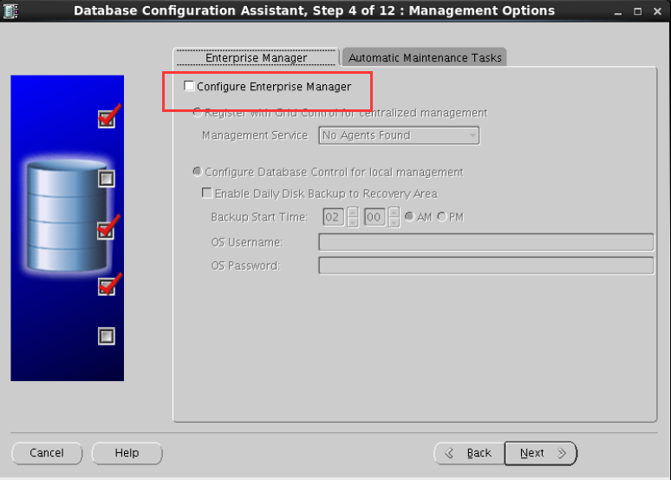

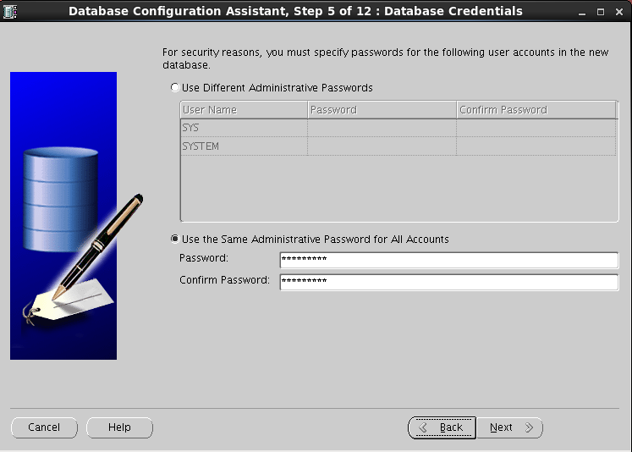

--在执行下面的操作之前需要创建磁盘组

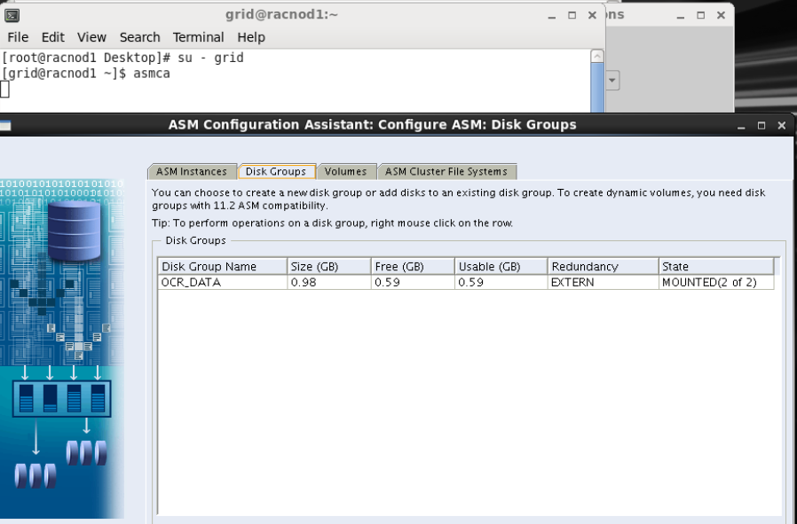

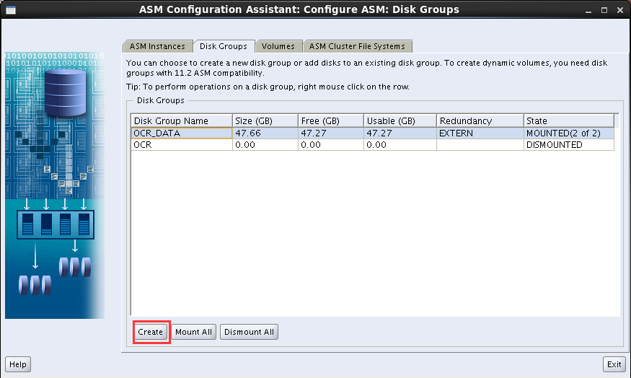

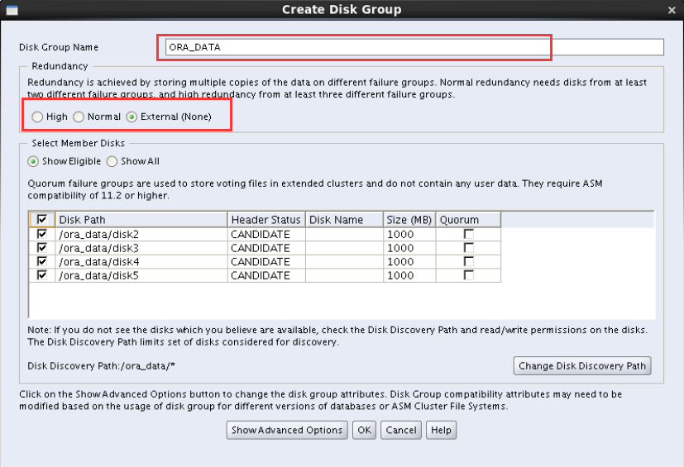

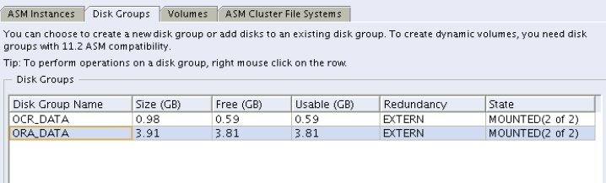

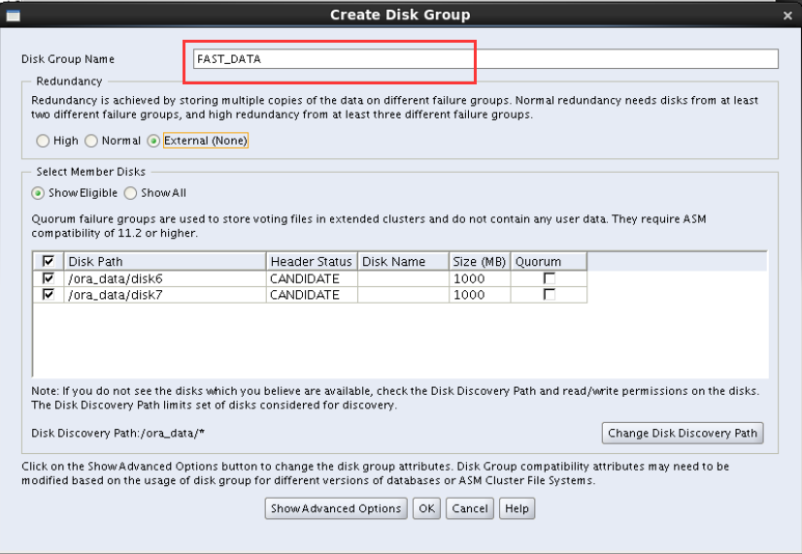

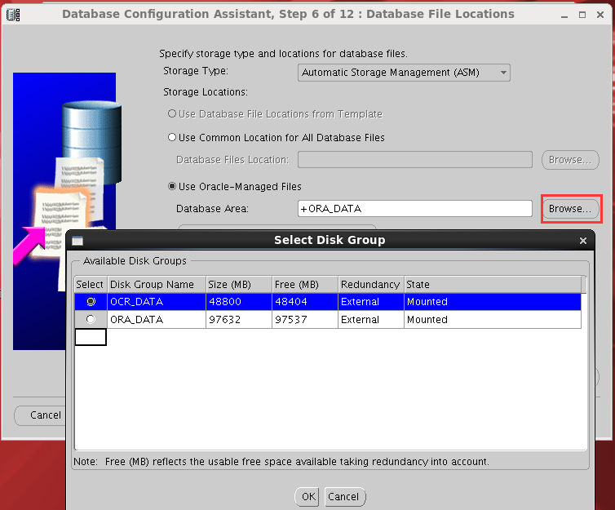

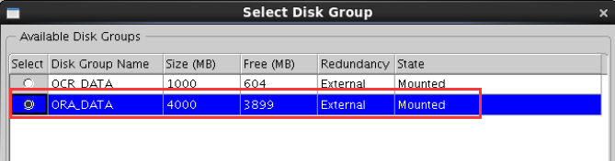

--指定快速恢复区

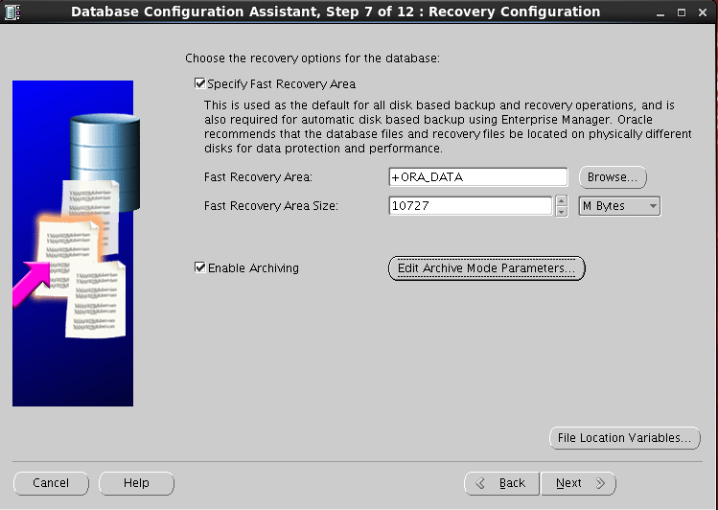

--oracle建议保留

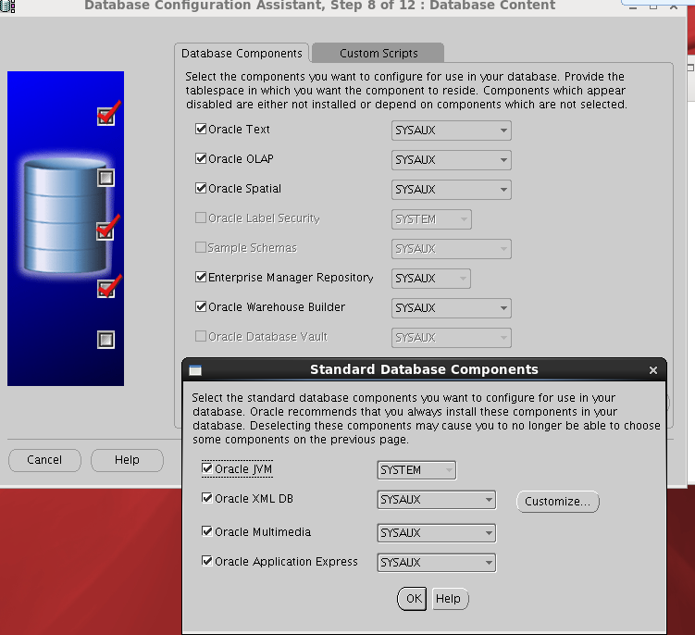

--先保持默认安装，安装好后再调整

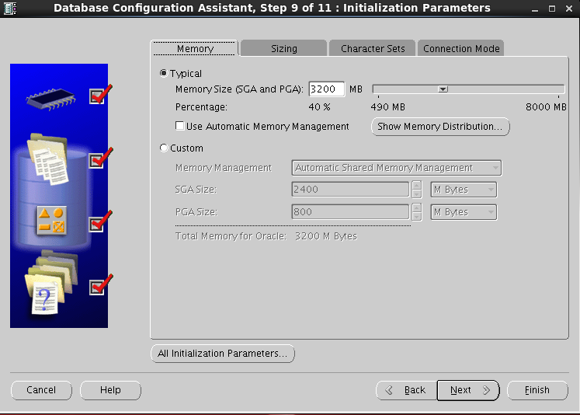

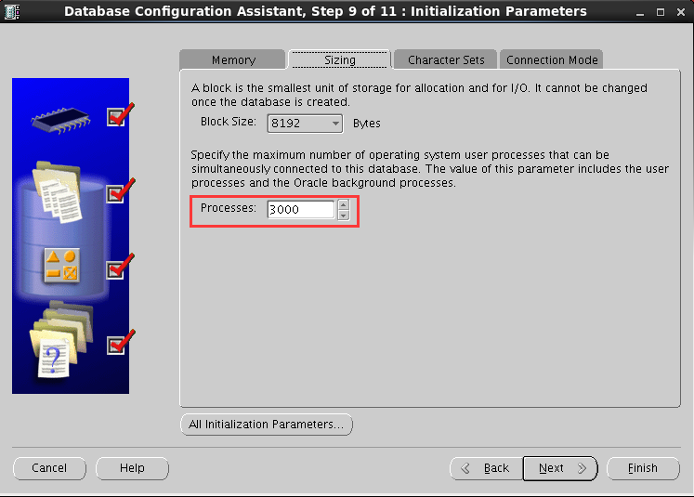

--根据其他库的字符集确定

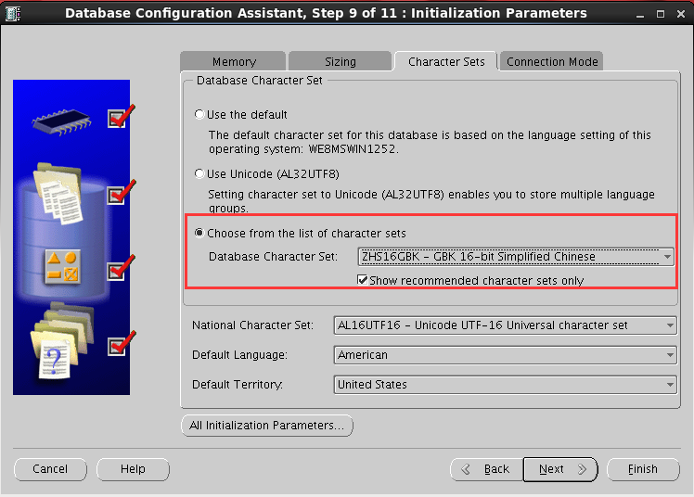

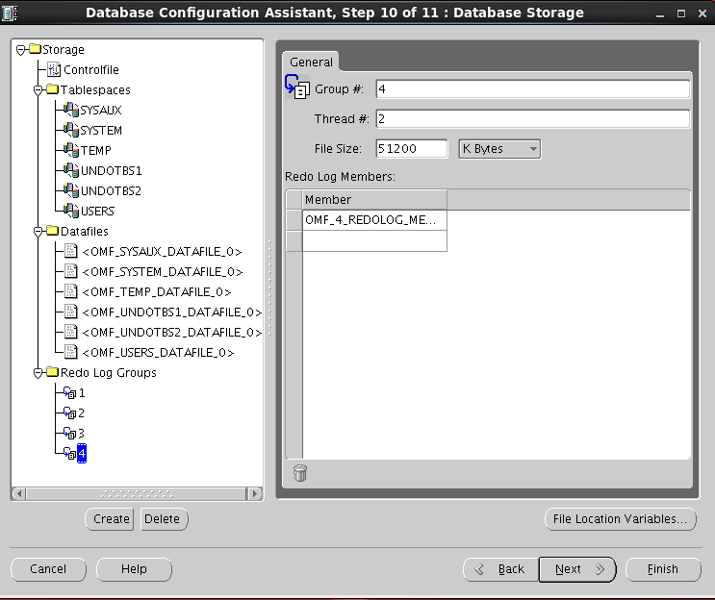

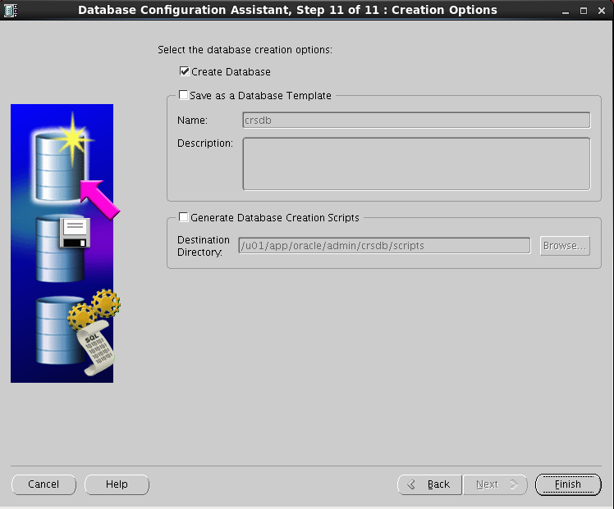

--给root用户添加crsctl命令

[root@racnod1 crsdb]# cd ~

[root@racnod1 ~]# vim .bash_profile

# .bash_profile

# Get the aliases and functions

if [ -f ~/.bashrc ]; then

. ~/.bashrc

fi

# User specific environment and startup programs

grid_bin=/u01/app/11.2.0/grid/bin

PATH=$grid_bin:$PATH:$HOME/bin

export PATH

Source ~/.bash_profile

1. 数据迁移
   1. 关闭、开启触发器

SELECT 'alter trigger ' ||t.owner||'.'||t.trigger_name||' disable;' FROM Dba_Triggers t WHERE t.table_owner='DB_TY';

SELECT 'alter trigger ' ||t.owner||'.'||t.trigger_name||' enable;' FROM Dba_Triggers t WHERE t.table_owner='DB_TY';

* 1. 统计失效对象

SELECT * FROM dba_invalid_objects;

* 1. 按用户统计数据量

SELECT T.OWNER, SUM(T.BYTES) / 1024 / 1024 / 1024 SUM_SIZE_G

FROM DBA_SEGMENTS T

WHERE T.OWNER NOT IN

(SELECT * FROM DBA_USERS_WITH_DEFPWD)

GROUP BY T.OWNER /*HAVING SUM(T.BYTES) / 1024 / 1024 / 1024<0.6*/

ORDER BY 2 DESC;

* 1. 初始化表空间

SELECT 'create tablespace '||t.TABLESPACE_NAME||';' FROM dba_tablespaces t WHERE t.TABLESPACE_NAME not in ('SYSTEM','SYSAUX','UNDOTBS1','TEMP','USERS','UNDOTBS2');

* 1. 导入用户

SELECT 'create user ' || t.username || ' identified by values ''' ||

b.password || ''' default tablespace ' || t.default_tablespace ||

' quota unlimited on ' || t.default_tablespace || ';'

FROM dba_users t, sys.user$ b

WHERE t.username = b.name

and t.username not in (SELECT * FROM DBA_USERS_WITH_DEFPWD)

/* and t.account_status = 'OPEN'*/

order by t.default_tablespace;

SELECT 'grant dba to '||t.username||';' FROM dba_users t WHERE t.username not in (SELECT * FROM DBA_USERS_WITH_DEFPWD) and t.username not in ('SYS','SYSTEM','SYSMAN');

* 1. Expdp按用户导出数据

nohup expdp ruanshuqin/\"RSQ@\!foresee2017\" directory=dmp DUMPFILE=HX_FP%u.dmp logfile=HX_PZ.log SCHEMAS=HX_PZ parallel=5 compression=all >HX_PZ.out 2>&1 &

* 1. Impdp按用户导入数据

nohup impdp cz/cz_123456 directory=dpump_dir DUMPFILE=HX_FP%u.dmp logfile=HX_FP.log table_exists_action=replace SCHEMAS=HX_FP parallel=5 >HX_FP.out 2>&1 &

* 1. 稽核数据量

SELECT t.owner, t.tablespace_name, sum(t.BYTES) / 1024 / 1024 / 1024

FROM dba_segments t

WHERE t.owner in (SELECT distinct t.TABLE_OWNER

FROM dba_synonyms t

WHERE t.owner = 'SJYY')

group by t.owner, t.tablespace_name

order by 1;

* 1. 重新编译失效对象

/home/oracle/app/oracle/product/11.2.0/dbhome_1/rdbms/admin

@utlrp.sql

* 1. 业务验证