Oracle19C部署

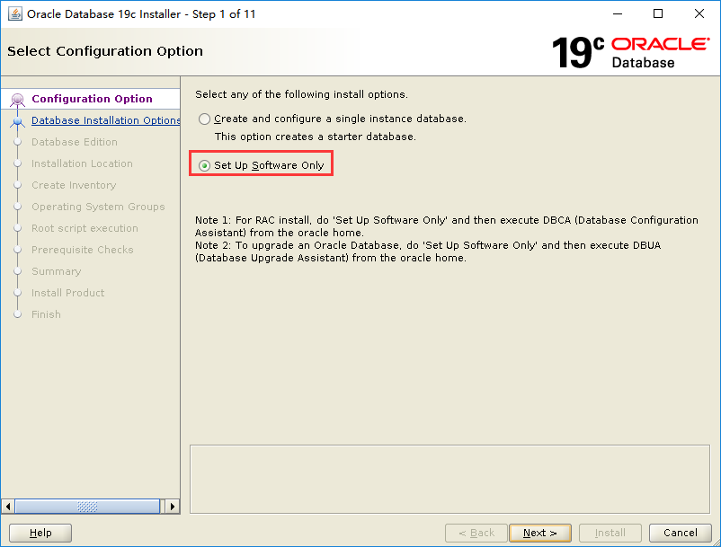

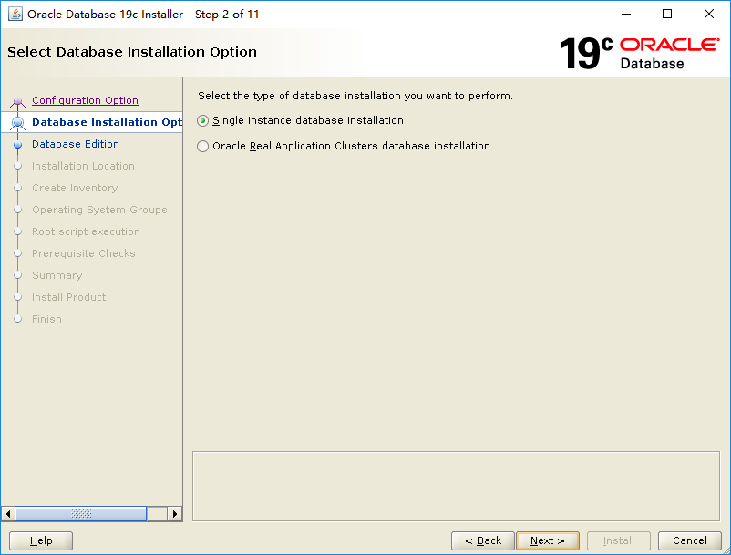

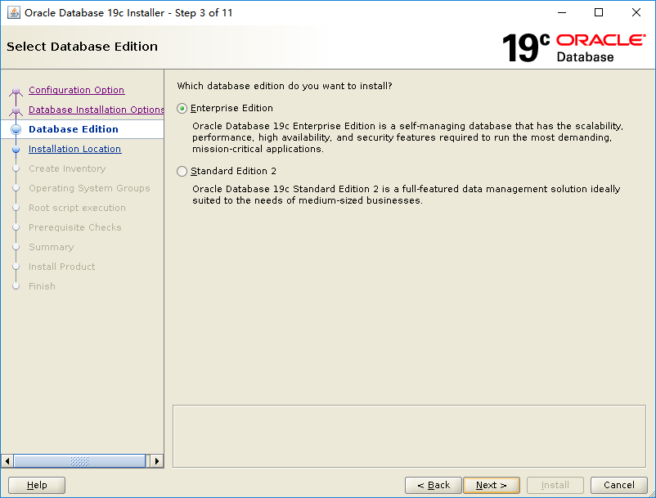

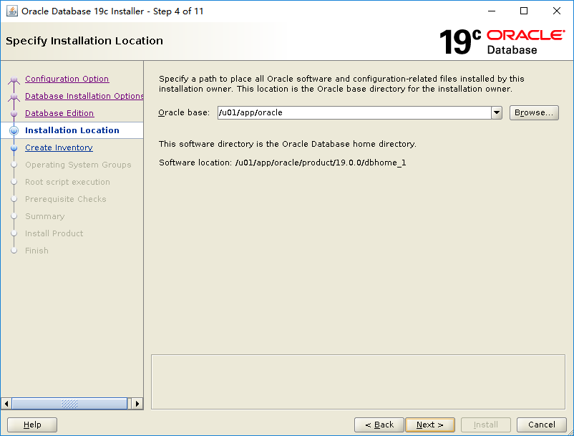

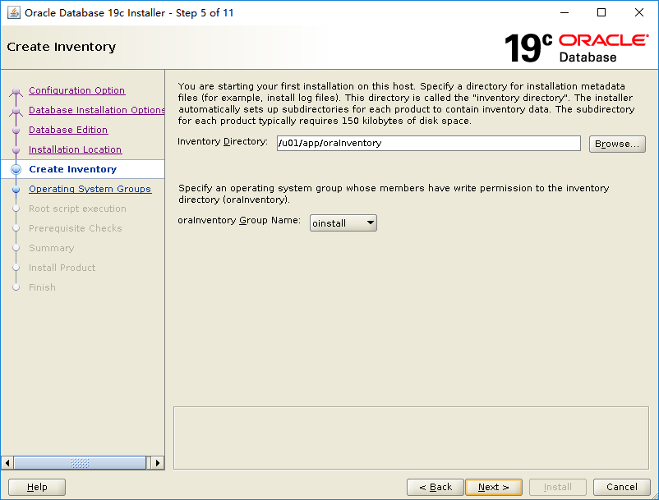

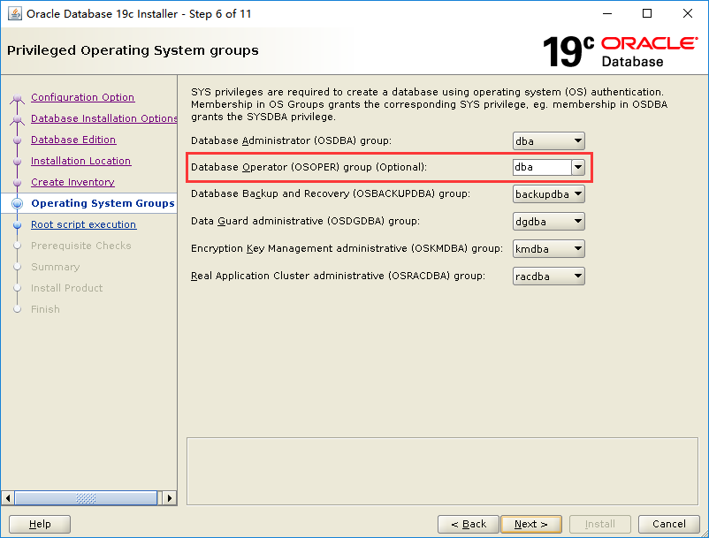

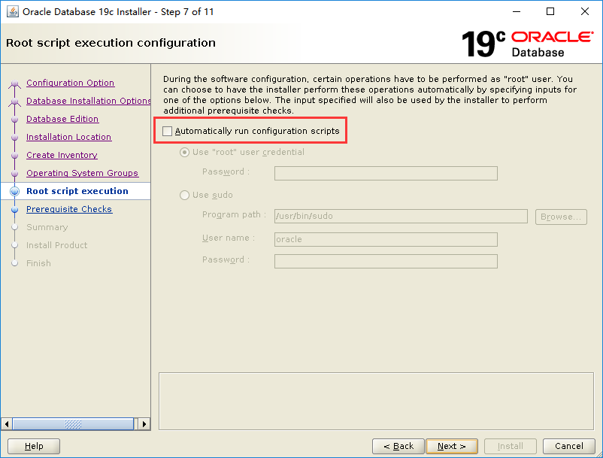

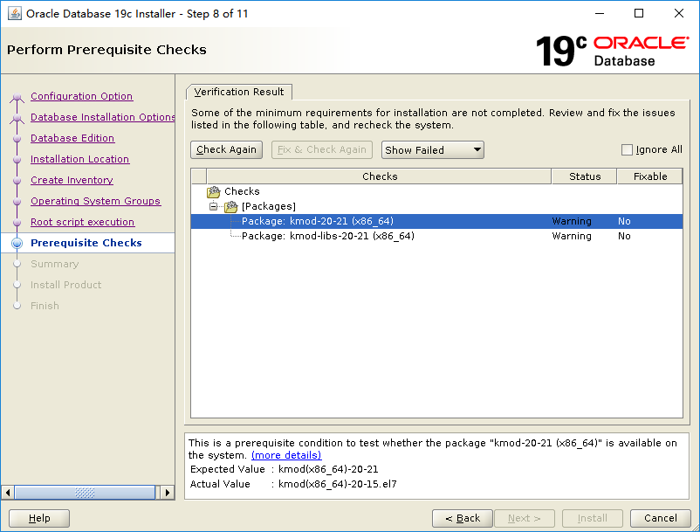

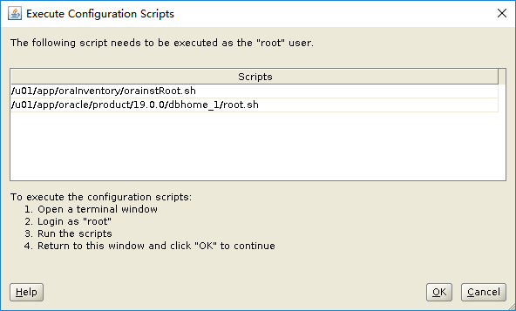

DBCA建库

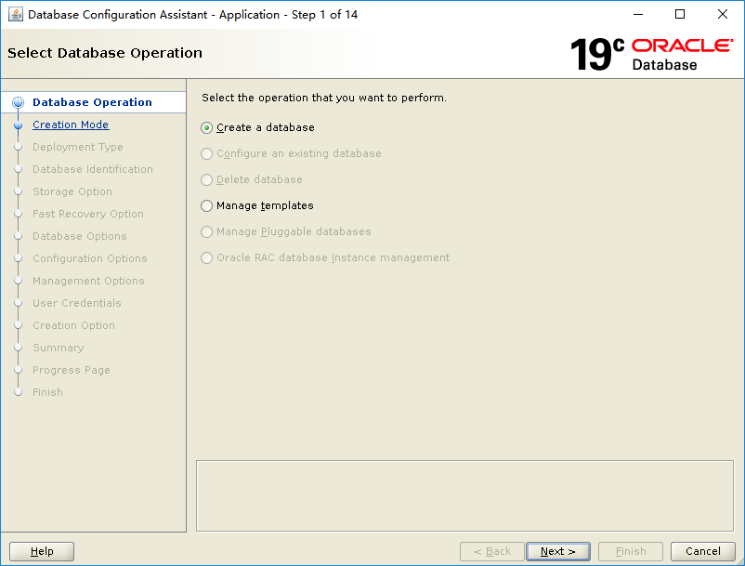

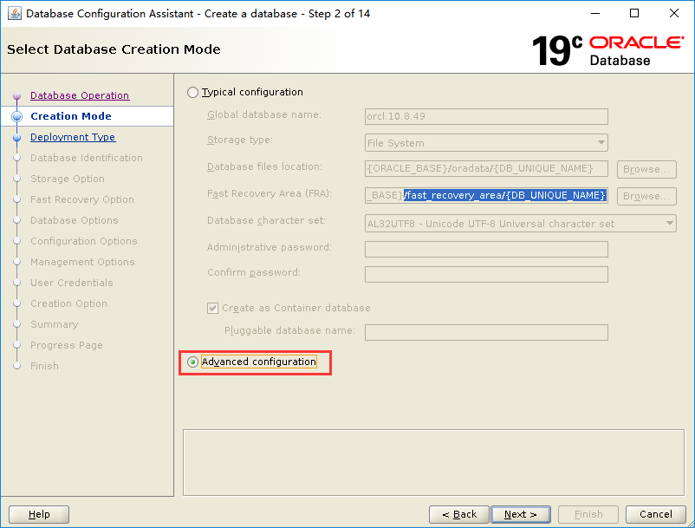

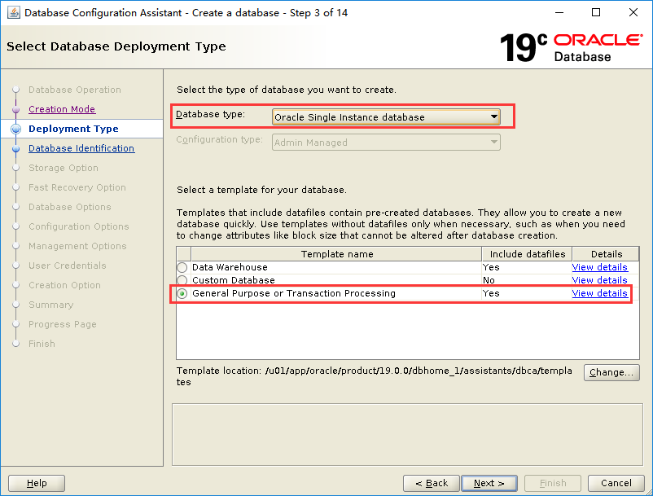

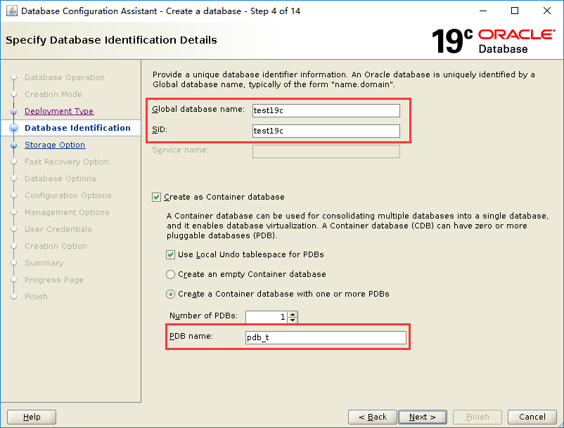

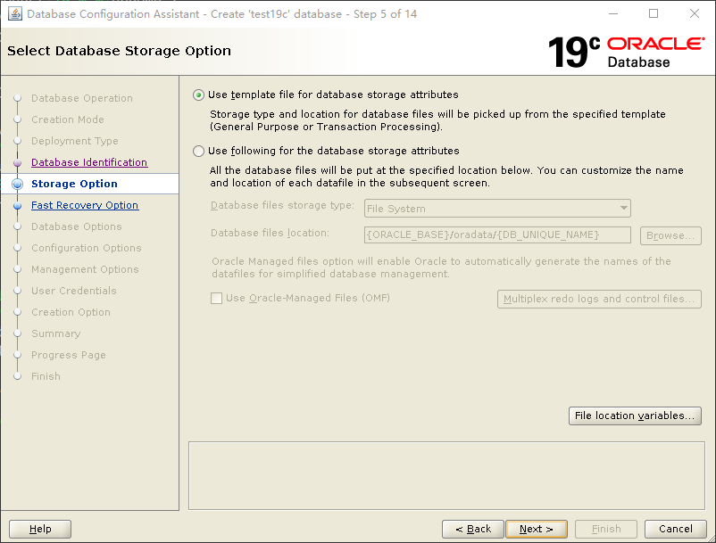

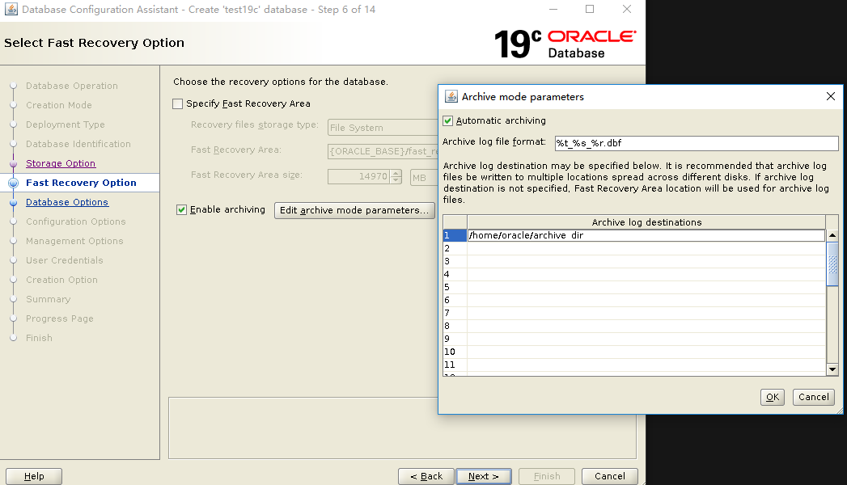

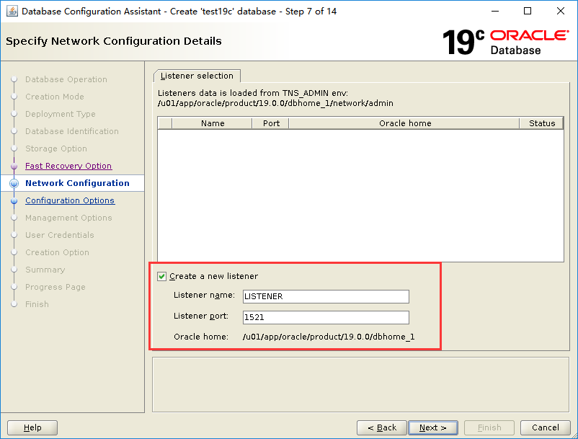

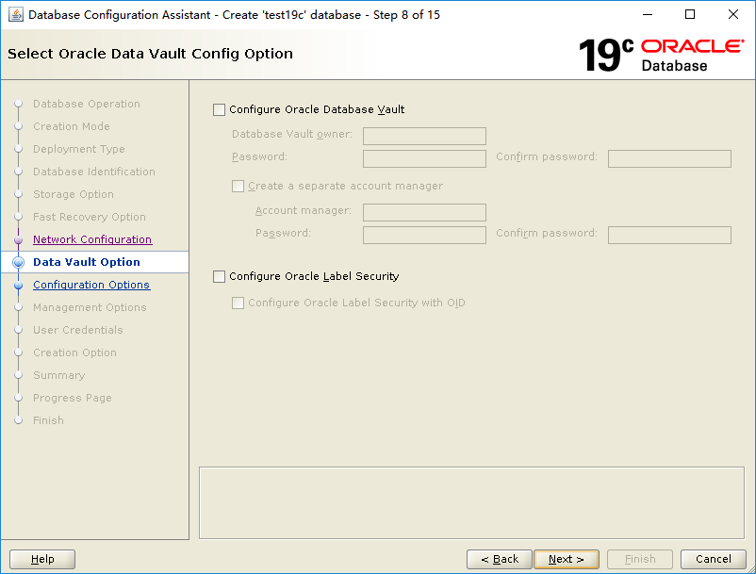

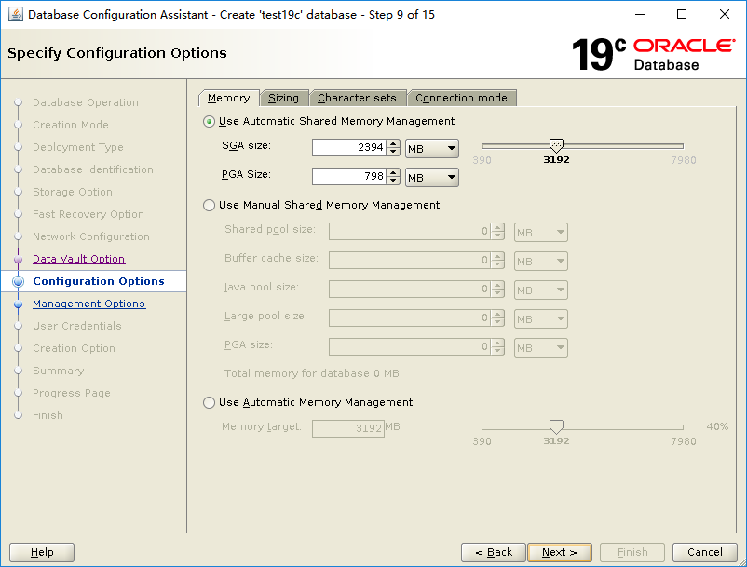

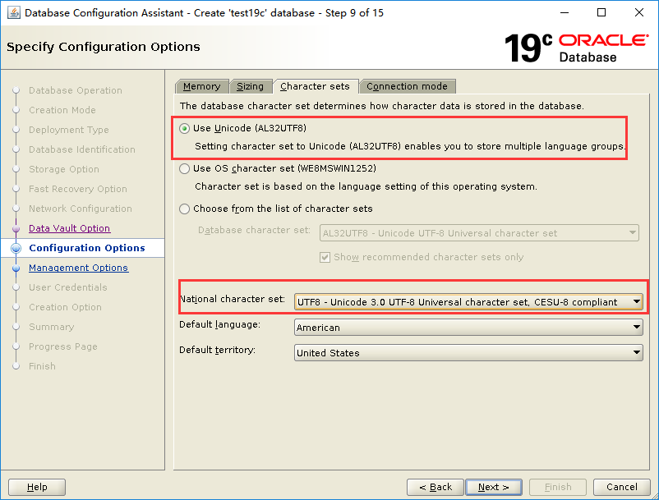

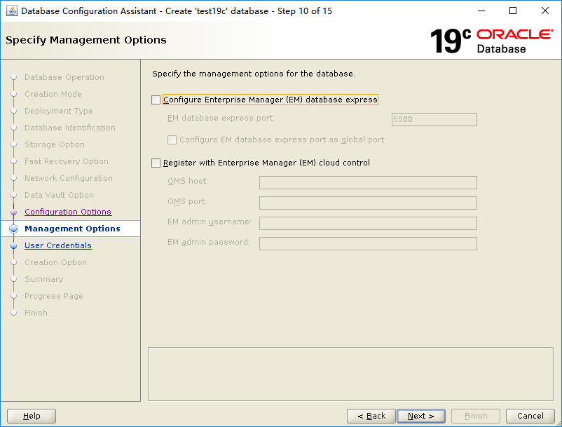

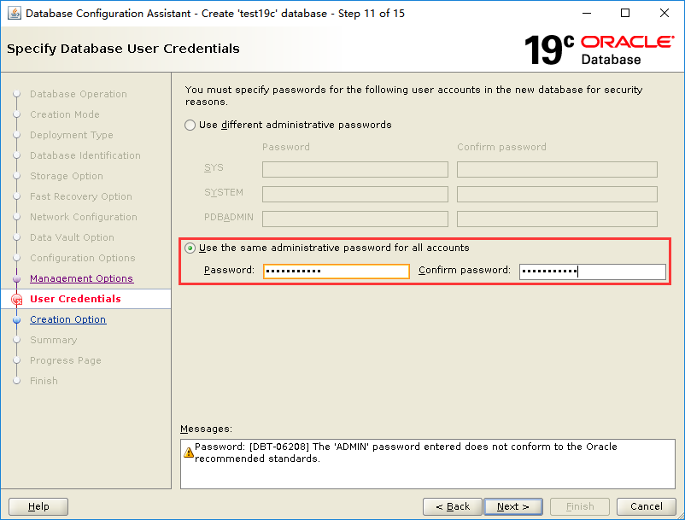

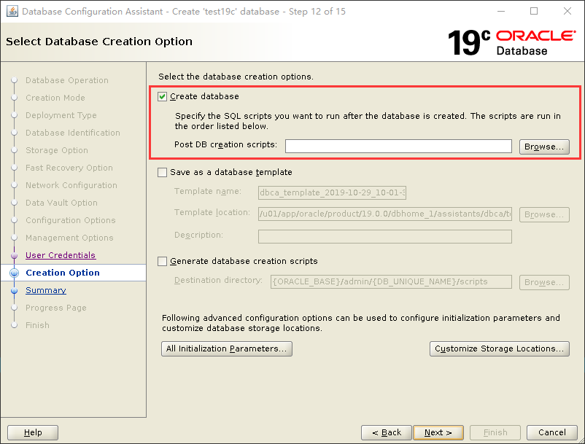

<https://10.10.8.49:5500/em/login>

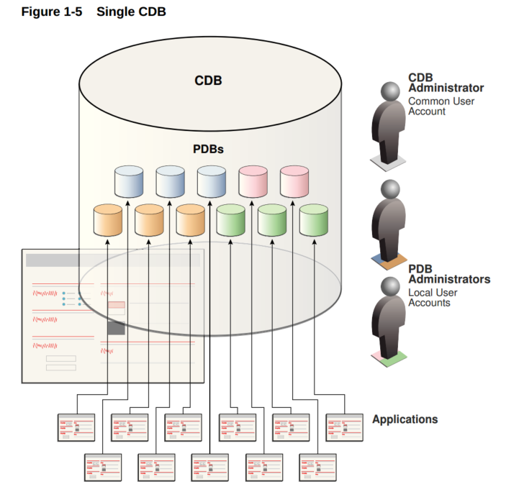

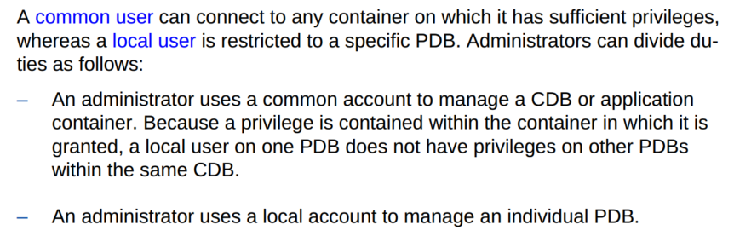

连接PDB：connect sys/foresee_abc@10.10.8.49:1521/pdb_t1 as sysdba

查看当前容器：select Sys_Context('Userenv', 'Con_Name') "current container" from dual;

SHOW con_name

启用PDB并通过plsqldev连接

SQL> show pdbs;

CON_ID CON_NAME OPEN MODE RESTRICTED

---------- ------------------------------ ---------- ----------

2 PDB$SEED READ ONLY NO

3 PDB_T1 READ WRITE NO

4 PDB_T2 READ WRITE NO

5 MY_PDB READ WRITE NO

SQL> alter session set container=PDB_T1;

Session altered.

Elapsed: 00:00:00.12

SQL> alter pluggable database PDB_T1 open;

SQL> create user cz identified by cz;

User created.

Elapsed: 00:00:00.12

SQL> grant dba to cz;

Grant succeeded.

PDB_T1_8.49 =

(DESCRIPTION =

(ADDRESS_LIST =

(ADDRESS = (PROTOCOL = TCP)(HOST = 10.10.8.49 )(PORT = 1521))

)

(CONNECT_DATA =

(SERVICE_NAME = PDB_T1)

)

)

