|  |
| --- |
| EASYCALCULATION  Live Project |
| **Project Functional Requirement Specification Version 1** |
| **Prepared by : V S S Narasimha Rao S(844834)**    **Reviewed by : Raghavendra BN** |

**Contents**

1. Purpose of the document 3
2. Project Overview 3
   1. Audience: 3
   2. Hardware and Software Components 3
3. Information Architecture 3
   1. Registration 3
   2. Login 4
4. Calculators. 5
   1. Age Calculators 5
      1. Age Calculator. 5
      2. Next Birthday. 6
      3. My Birthday Days 7
      4. My DOB. 8
   2. Love Calculator 8
5. Currency Conversions 12
   1. Conversion Home Page 13
      1. Length unit conversion 13
      2. Example 14
6. Currency Convertors 15
7. Logout 17

# Purpose of the document:

This is **not** a project plan. It is a guide for system architecture and development, not for phasing, timelines or deliverables.

This document is divided into three sections:

* Project Overview
* Information Architecture
* Site Design

# Project Overview:

* 1. **Audience:**

This document provides the information about mathematical calculations and conversions, currency conversions

Mathematics made easy through **EasyCalculation.com**. Calculate things online with just mouse moves. The site online math calculators, converters and tutorials. Use these simple math tools to solve complex calculations, conversions, logical and arithmetic problems.

Free mathematical calculation tools in this site include mathematics Calculator and Converters, Basic/ Scientific Calculator, Math Calculator, Matrix Calculations, Hex, Decimal, Binary Conversions, HEX Colour Converter, Date and Day Calculator, Mortgage Calculator, Unit Conversions and Bandwidth Calculator.

* 1. **Hardware and Software Components:**

The hardware requirements for the EasyCalculation are computer/laptop with good internet connection. EasyCalculation servers will be hosted at X company’s site.

EasyCalculation will be hosted on two servers: One to host the actual website and (language) code, and the other to host the (database name) database.

# Information Architecture

In order to access the easycalculation.com site the new users have to create their own account. For the account creation they need registration process.

* 1. **Registration**

Easycalculation.com application is part of HIOX Network and uses HIOX login. Enter URL https:[//www.easycalculation.com/,](http://www.easycalculation.com/) here the user can create his/her account by clicking on sign in option available at the top right corner of current window. After clicking sign in option, it will redirect to registration page as shown in fig: 1.0

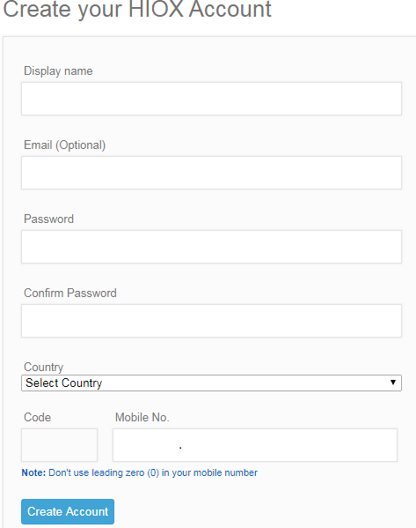

Fig: 1.0

After filling the particulars shown in above, by clicking on create account the new user can get his/her account registered.

* 1. **Log in**

Now the user can log in by his/her credentials such as

E-mail/mobile number provided during the registration and password as shown in the fig: 1.1

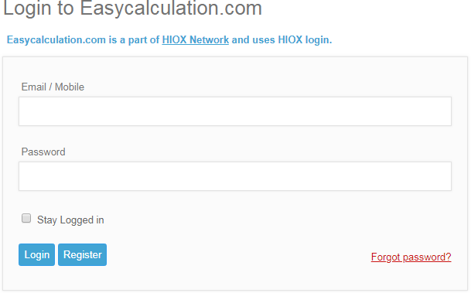

Fig: 1.1

After entering the credentials, by clicking on login the user can login into his/her account.If user forgotten his/her password, it is easy to reset the password by clicking on “Forgot password” which is visible in log-in window.

# Calculators:

* 1. **Age Calculators**

An electronic calculator is typically a portable [electronic](https://en.wikipedia.org/wiki/Electronics) device used to perform calculations, ranging from basic [arithmetic](https://en.wikipedia.org/wiki/Arithmetic) to complex [mathematics.](https://en.wikipedia.org/wiki/Mathematics) By EasyCalculation.com application, we can calculate things online with just mouse moves. This free online math web site will help us to learn mathematics in an easier way. EasyCalculation will also help us to solve difficult problems too.

* + 1. **Age Calculator**

Age Calculator is used to find the age of a person or any living things in years, months, days, hours, and minutes. By entering our Date of Birth we can compute the age interval between your birth date and current date.

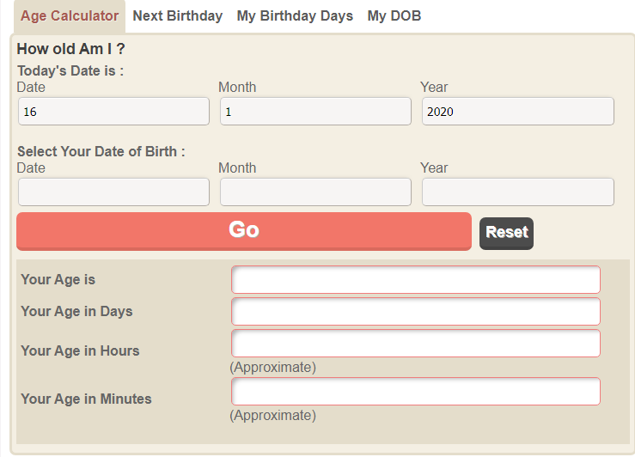

Fig: 1.2

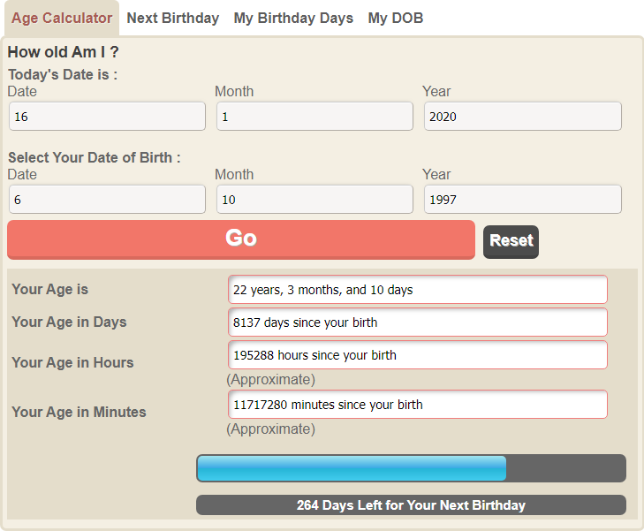

Fig: 1.3

* + 1. **Birthday Calculator by DOB**

A simple online birthday calculator by date of birth (DOB) is used to find our current age and the number of days left for our next birthday. By using this calculator we can also identify the day of our next birthday and which stage of life we are in your life now (Eg: Some stages are Justice, Soldier, Teenage Boy, School Boy etc.)

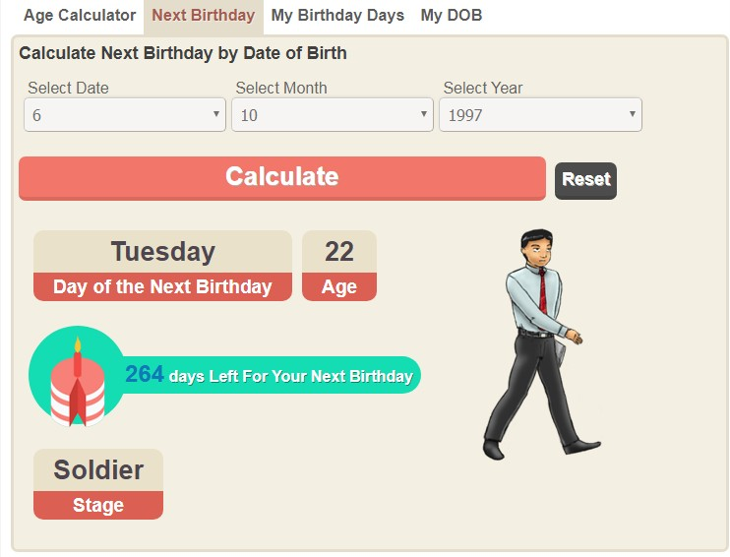

* + 1. **My Birthday Days Calculator**

This online fun calculator counts the number of birthdays we have celebrated since our birth in each day of the week. In this calculator we have to enter our DOB by selecting the date, month and year we were born. By using this calculator we can find out how many birthdays we have celebrated until now from our birth and the number of birthdays celebrated on Sunday, Monday, Tuesday, Wednesday, Thursday, Friday, and Saturday.

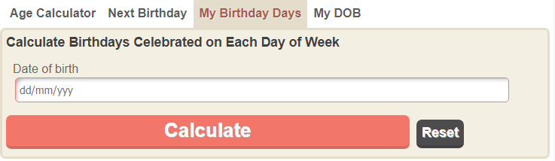

Fig: 1.5

After entering the date of birth the user have to click on the calculate then it calculates and gives the result as follows:

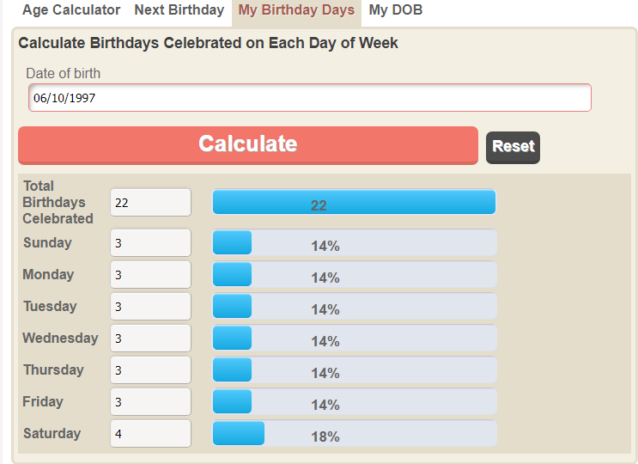

* + 1. **DOB Calculator**

This date of birth calculator allows us to find our birthday date by inserting the number of years, number of months and number of days since we born. The birthday date from age calculator will display our date of birth in year-month-date format (yyyy-mm-dd). For example, if we are 30 years 3 months and 16 days old as of April 7, 2018 then your DOB would be 1987-12-24.

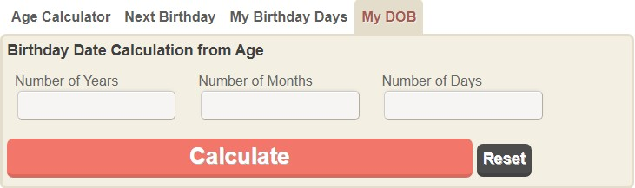

Fig: 1.7

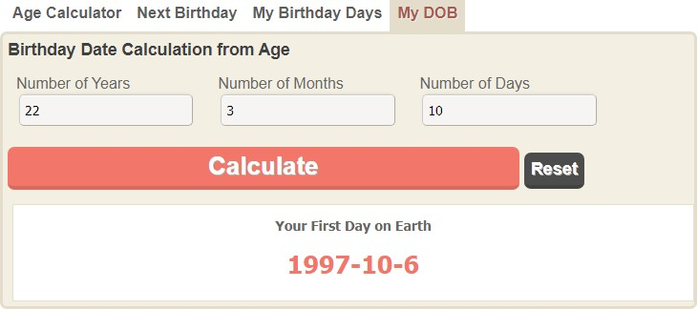

Fig: 1.8

* 1. **Love Calculators**

A Love calculator online to test your relationship strength and compatibility. It is a fun filled love calculator to test the status of your love relationship between him/her based on the FLAMES game.

**FLAMES** stands for -**F**riends, **L**over, **A**ffection, **M**arriage, **E**nemy, **S**ister. If you are in love with someone, and if you would like to test the love compatibility between him/her then take this Love Flames Game online test.

The following figure shows the text boxes which are empty. The users have to fill these boxes.

The user may fill one reference name and one or more partner name at a time in order to get a result by clicking on **FLAMES** Option.

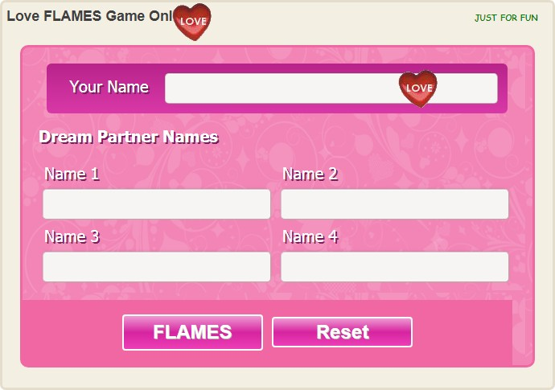

Fig: 1.9

After entering the data from user the text boxes are shown in fig

**Case 1:** One Reference Name and One Partner Name:

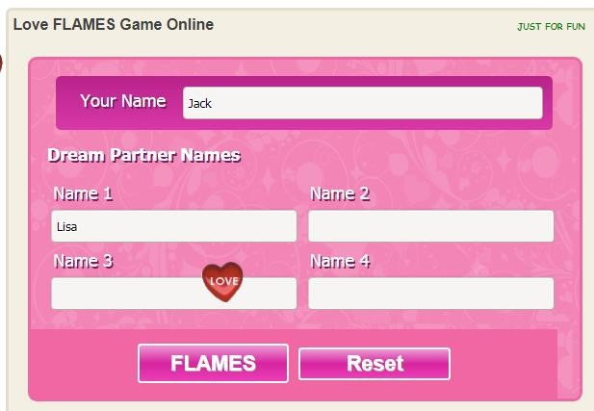

Fig: 2.0

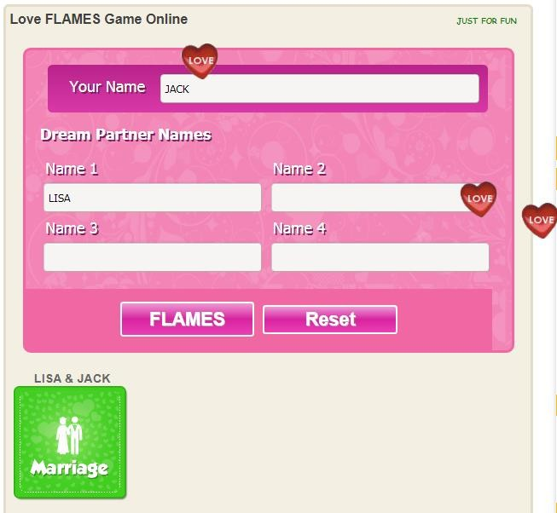

Fig: 2.1

**Case 2:** One reference name and more than one partner names:

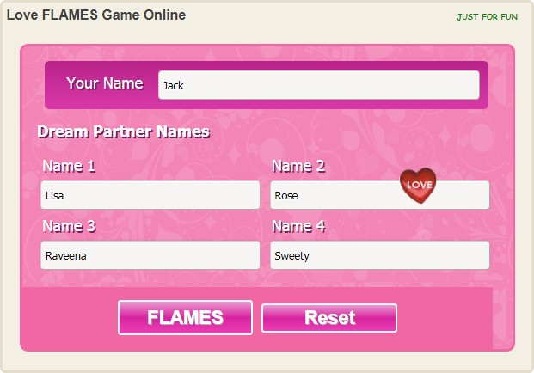

Fig: 2.2

By clicking on FLAMES option we will get the result as follows:

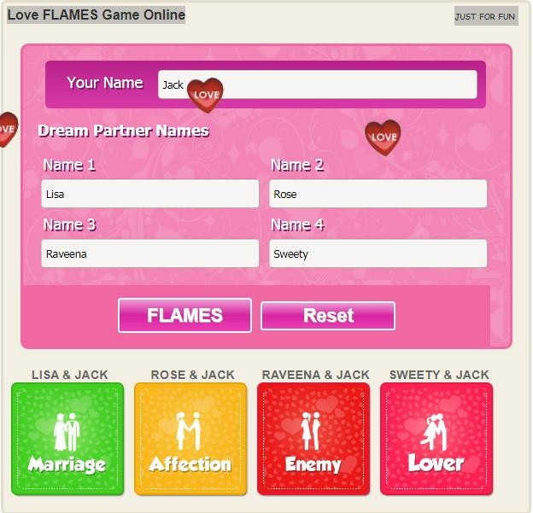

Fig: 2.3

# Currency Conversions

A standard measure of any physical quantity is called as a unit. For example, Volume is a physical quantity and unit to measure it is litres or millilitres. Similarly, weight is measured using kilograms or pounds. Some units have originated naturally and some have been standardized. Here is a list of large number of unit converters that are being used in many fields like Engineering, chemistry and many more.

* 1. **Conversions Homepage**

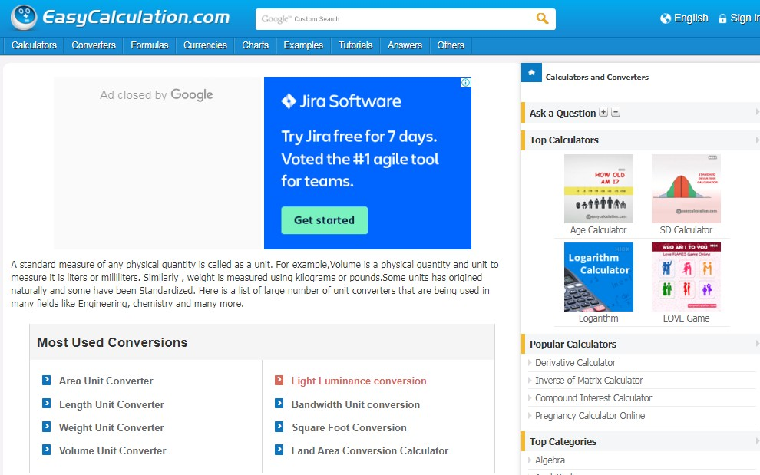

Fig: 2.4

There are so many types of conversions based on their physical quantity like Area Conversions, Length Conversions, Weight Conversions, Volume Conversions, Light Luminance Conversions, Bandwidth Conversions and Square Foot Conversions etc.

Based on the requirement we can select any one of the conversions. Suppose if we want Length based conversions we can select length unit converter.

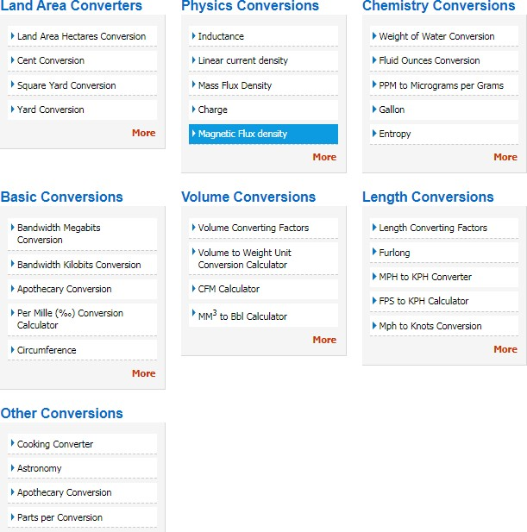

Fig: 2.5

* + 1. **Length Unit Conversions**

Length is a standard measure of distance expressed in millimetres, centimetres, steps, kilometres and other various units. It can also be termed as distance unit conversions. Here is a list of large number of length unit converters that are being used in many fields like mathematics, civil, engineering, chemistry, geometric calculations and many more. Click on the converter for which you want to convert and enter the values to convert length units.

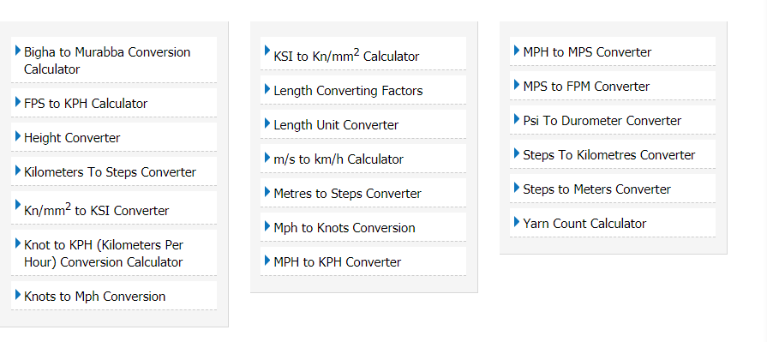

In the above figure it shows so many one to one conversions like FPS to KPH Calculator, Height Converter, and Meters to Steps Converter, and MPH to MPS Converter etc.

Based on the requirement we can select one of the converters. Suppose if we want Conversion between MPS to KPH we can select the required MPS to KPH Converter.

* + 1. **Example**

## MPS to KPH Converter

Meter per second is the derived SI unit of speed, which is used to measure distance. It is both scalar and vector quantity. 1 meter per second is exactly equal to 3.6km per hour. A kilometre is 1000 times greater than a meter. It is a metric unit used in the transportation. Use this conversion calculator to convert meters per second to kilometres per hour.

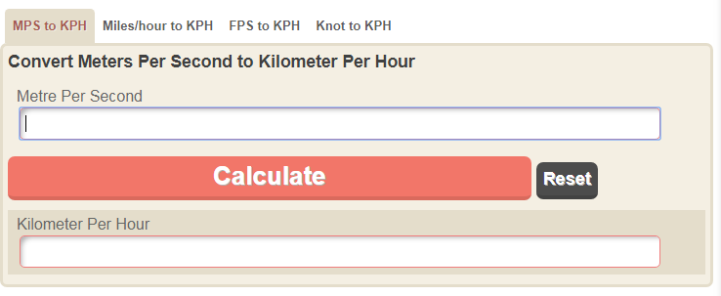

Fig: 2.7

In the below figure as it is shown MPS to KPH Converter gives the real time results, there is no need of using calculate button that is one of the advantage of this calculator.

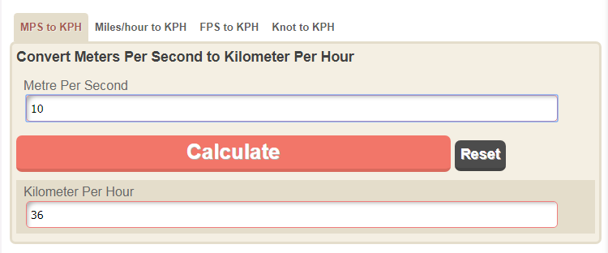

Calculate option is used for calculating results and Reset option is used for clearing the results as shown in the figure below.

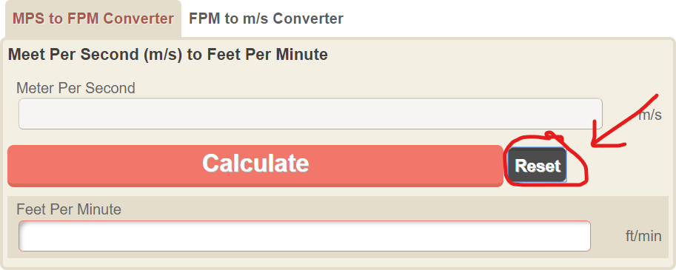

Fig: 2.9

# Currency Convertors:

Basically the currency rates in different countries are having different value. So, there is a need to convert the one currency rate into other currency rate, which is required.

The easycalculation.com site provides this feature also as shown in below fig:

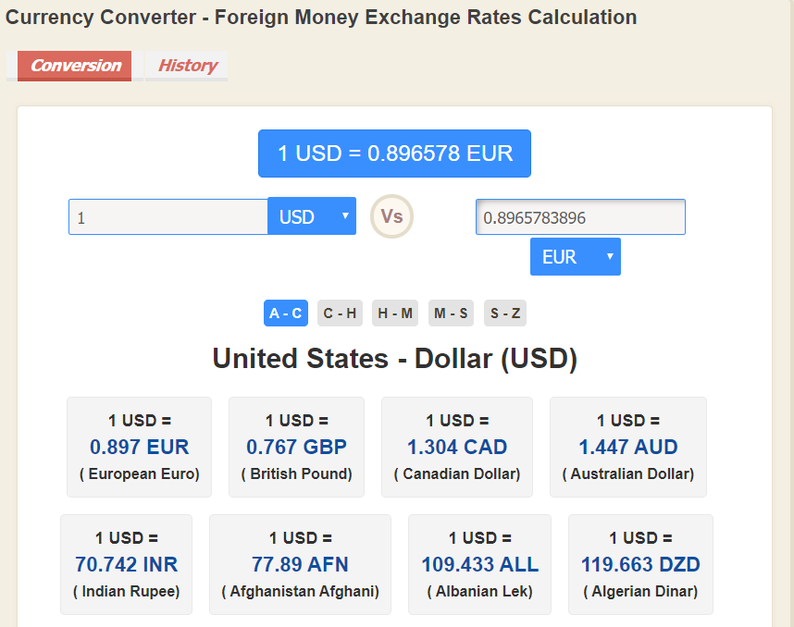

### Example- Conversion of United states dollar currency to Indian rupee conversion rate

The currency conversion can be made by selecting required currency options as shown in fig:

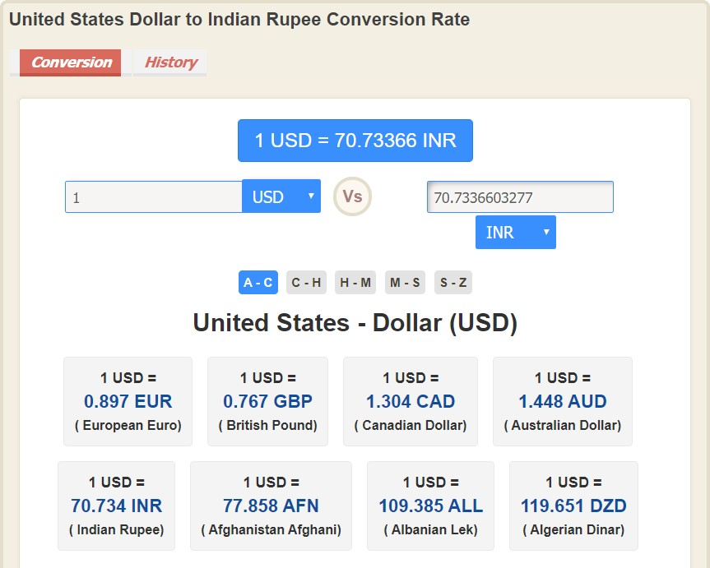

Fig: 3.1

The above fig shows the USD currency to Indian rupee currency rate i.e., 1USD =70.73 INR.

By using this conversion category site we can easily get the required currency rate from any available form of currency rate.

# Log out:

This section provides the information to user about logout from the Easycalculation.com application.

Here the users have to click on LOGOUT option that is available at the top right corner of the application

.i.e., as shown in below figure.



After logout from the application, the current page is redirected to its homepage i.e. as shown in below figure3.2

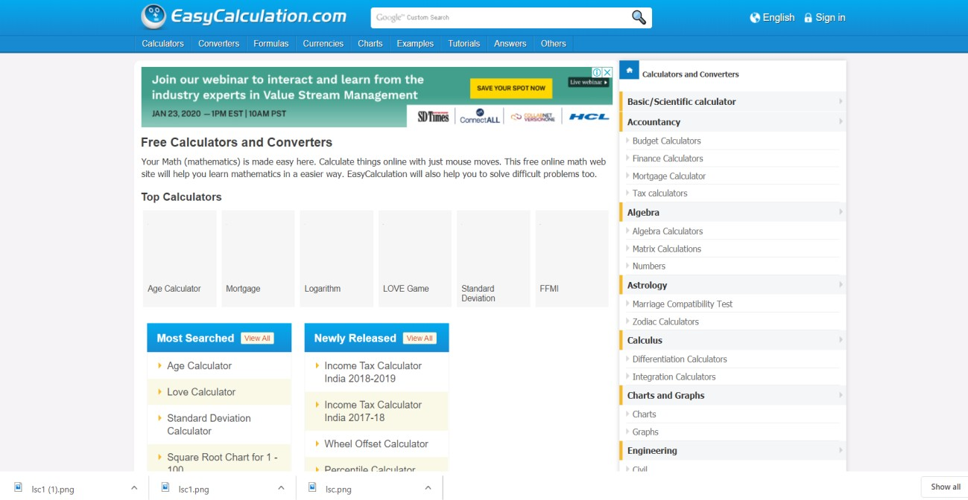

Fig: 3.2