**APPLICATIONS OF TRIGONOMETRY**

**Key concepts:**

* The concept of trigonometry is useful to study heights and distance in our daily life.
* The astronomers have used this concept to calculate the distance from Earth to the planets and stars.
* Trigonometry is also used in geography and in navigation.
* The knowledge of trigonometry is used to construct maps, determine the position of an island in relation to the longitudes and latitudes.
* To measure angles, the surveyors have used an instrument named ‘Theodolite’.
* Theodolite is a surveying instrument, which is based on the Principals of trigonometry, is used for measuring angles with a rotating telescope.

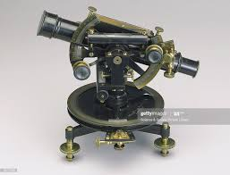

* By using this Theodolite, in 1852, the highest mountain Everest was discovered by Sir George Everest.

**Definition of some words used in this chapter:**

* When a boy is watching the top of a tree then

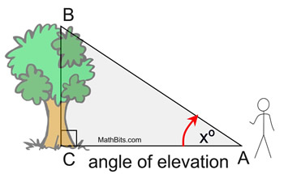 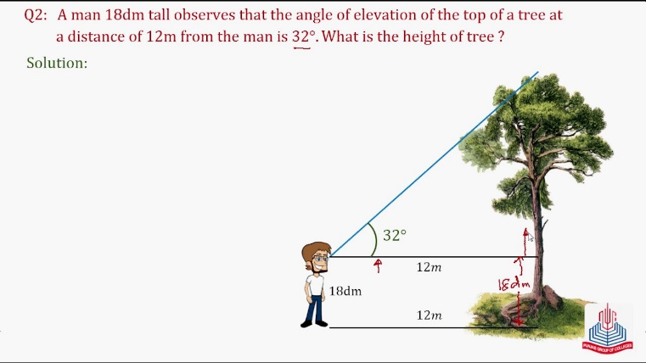

1. The imaginary line drawn from eye of the boy to the peak of the tree is called ‘***Line of sight***’ .
2. Line of sight is always drawn from the eyes of the observer. If the height of the observer is not mentioned in the given problem, then we will take the observer as a point.
3. The angle between the horizontal line and line of sight when the point viewed is above the horizontal level is called “Angle of elevation”.

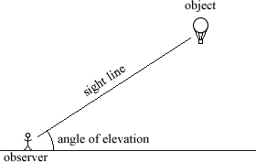

1. The angle between the horizontal line and line of sight when the point viewed is below the horizontal level is called “Angle of depression”.

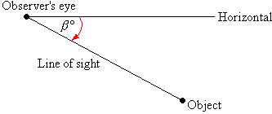

1. The angle of elevation is equal to the angle of depression because they are alternative interior angles.

