**Self-Assignment - 1**

**Topic: Tangents and secants to a circle**

**Class: 10th Max. Marks: 25**

**Answer all questions. Each question carries ½ mark 10 × ½ = 5M**

1. What is the difference between tangent and secant of a circle?
2. Find the area of the quadrant of circle whose radius is 7cm?
3. How can you mark the centre of the circle given without centre?
4. How many tangents can be drawn to a circle from a point on the same circle?
5. Find length of the arc of a sector whose angle is 900 and radius is 14cm??
6. If tangents PA and PB from the point P to circle with centre ‘O’ are inclined to each other at angle of 800, then find ∠POA?
7. The length of the tangent from external point ‘P’ to a circle with centre ‘O’ is always less than ‘OP’. Is the statement true? Give reason?
8. The length of the tangent to a circle from a point 17cm from its centre is 18 cm. Find the radius of the circle?
9. Define a tangent of circle?
10. Sireesha said, “Tangent of a circle from external point is a ray. So we can’t measure its length”. Do you agree with Sireesha? Justify your answer?

**Answer all questions. Each question carries 1 mark. 4 × 1 = 4M**

1. Two circles of radii 5cm and 3cm are concentric. Calculate the length of a chord of the circle which touches the inner circle?

1. In the given figure find the value of the angle MLP?

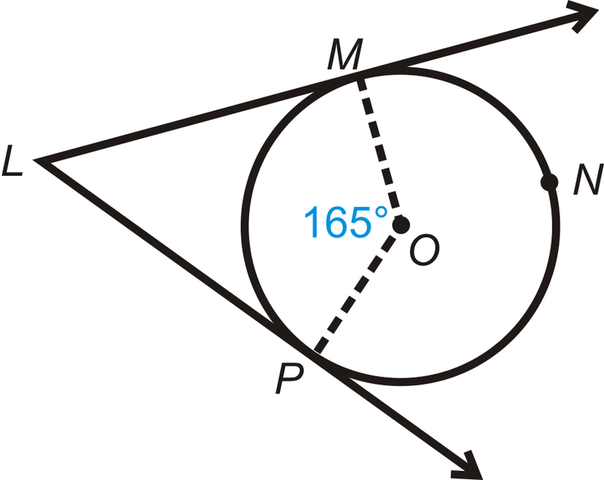

1. In the given figure, a circle touches all the four sides of a quadrilateral ABCD, whose sides are AB = 6cm, BC = 8cm, CD = 9cm. Find the length of the side AD?

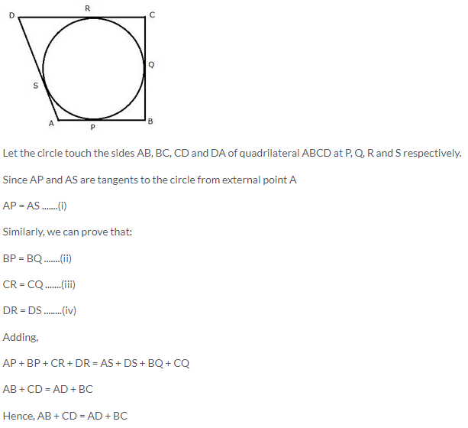

1. Jai says, “All similar triangles are congruent triangles”. Do you agree to him? Justify.

**Answer all questions. Each question carries 2 marks. 4 × 2 = 8M**

1. Prove that the tangents to a circle at the end point of a diameter are parallel?
2. Draw a circle and two lines parallel to given line such that one is a tangent and the other is a secant to the circle?
3. Prove that the lengths of tangents drawn from an external point to a circle are equal?
4. Draw a circle of radius 6cm. From a point 10cm away from the centre, construct the pair of tangents to the circle? (no need to write steps of construction)

**Answer all questions. Each question carries 4 marks. 2 × 4 = 8M**

1. A chord of a circle of radius 10cm, subtends a right angle at the centre. Find the area of the corresponding (Use π = 3.14)
2. Minor segment (ii) Major segment

Or

In the given figure, ∆ABC is an equilateral triangle inscribed in a circle of radius 4cm. Find the area of the shaded place?

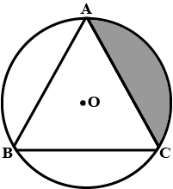

1. Prove that the parallelogram circumscribing a circle is a rhombus?

Or

In the given figure, circle are drawn by taking vertices A, B, C of an equilateral triangle of side 20cm, to intersect the sides BC, CA and AB at their respective mid-points D, E and F. Find the area of the shaded region? (Use π = 3.14)

