**Tangents and secants of a circle**

**Basic concepts:**

* The set of infinite points which are at equidistant from a fixed point is called ‘Circle’.



* The fixed point is called ‘Centre of the circle’.
* The distance between Centre of the circle and any point on the circle is called ‘Radius of the circle’. It is denoted by ‘r ‘.

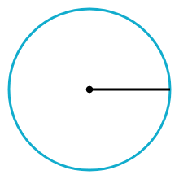

* A circle has infinite radii.
* All radii are equal.
* A circle divides the plane into there parts. They are

1. Interior of the circle
2. Exterior of the circle
3. On the boundary.

* ‘O’ is Centre of the circle, and ‘r’ is radius of the circle and ‘A’ a point in the plane.

If OA > r then ‘A’ lies in the exterior

If OA < r then ‘A’ lies in the interior

If OA = r then ‘A’ lies on the boundary of circle.

* The line segment joining any two points on the circle is called ‘Chord of the circle’.

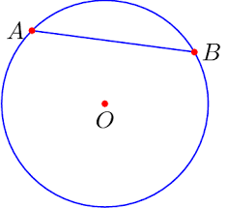

* A circle has infinite chords.
* All chords are not equal.
* The chords which are at equidistant from the Centre are equal,

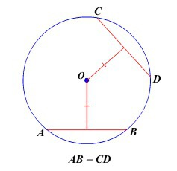

* Equal chords subtend equal angles at centre.

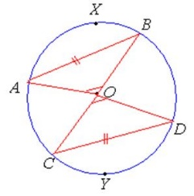

* The longest chord of a circle is called ‘Diameter’ of the circle.
* Diameter passes through the centre.
* Diameter is twice to the radius
* A circle has infinite diameters.
* All diameters are equal.

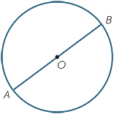

* The part of the circle is called ‘Arc of the circle’.
* The arc which is half of the circle is called ‘semi arc’.
* The arc which is less than half of the circle is called ‘Minor arc’.
* The arc which is greater than half of the circle is called ‘Major arc’.

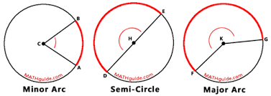

* Minor arc subtends an angle which is less than 1800 at the centre.
* Major arc subtends an angle which is greater than 1800 at the centre.
* Semi arc subtends 1800 at the centre.

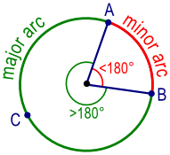

* The region enclosed between a chord and an arc is called ‘Segment of the circle’.
* The segment having minor arc is called ‘Minor segment’.
* The segment having major arc is called ‘Major segment’.
* The segment having semi arc is called ‘Semi circle’.

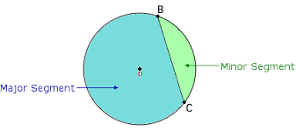

* Angle in a major segment is acute angle.
* Angle in a minor segment is obtuse angle.

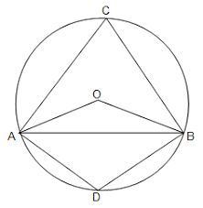

* Angle in a semi-circle is right angle.

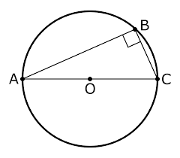

* The angles in a same segment are equal.

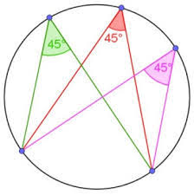

* The angle subtended by an arc at centre is twice to the angle subtended by same arc on its alternate arc.

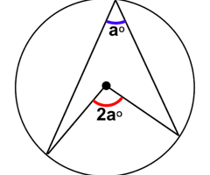

**A circle and a line in a plane:**

* We can draw a circle and a line in three ways in a plane.

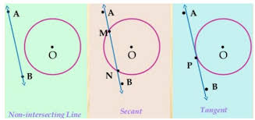

1) not intersecting

2) intersecting at two points

3) touching at only one point.

**Secant of a circle:**

* A line which intersects a circle in two distinct points is called ‘Secant of the circle’.

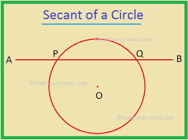

**Tangent of a circle:**

* A line which touches a circle at only one point is called ‘Tangent of the circle’. And the point is called ‘point of contact’.

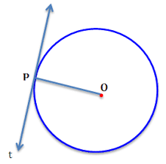

* The word ‘Tangent’ is originated from the Latin word ‘**TANGERE**’ which means ‘to touch’.
* The word ‘Tangent’ was introduced by Danish mathematician ‘Thomas Fineke’.
* A circle has infinitely many tangents.

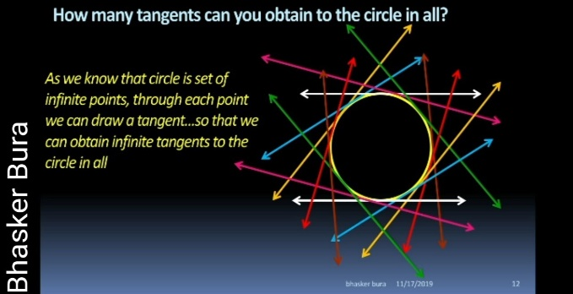

* A tangent to a circle is perpendicular to the radius through the point of contact.

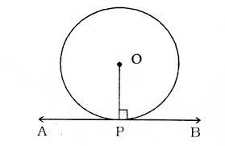

* A line drawn through the end point of a radius and perpendicular to it is tangent to the circle.

**Tangents of a circle through a point:**

* Through a point lying inside of the circle, no tangent can be drawn.
* Through a point on the circle, we can draw only one tangent.

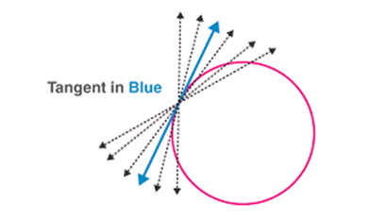

* Through a point lying outside of the circle, we can draw two tangents.

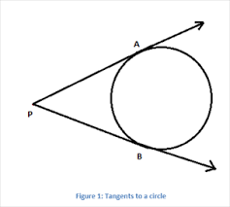

* The length of the segment of the tangent between the external point and the given point of contact with the circle is called ‘*length of the tangent***’**.
* The lengths of two tangents drawn from an external point to a circle are equal.

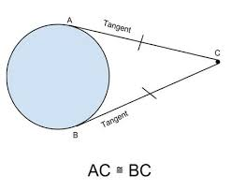

* If two tangents drawn to a circle from an external point, then

1. They subtend equal angles at the Centre,
2. They are equally inclined to the segment, joining the Centre to that point.

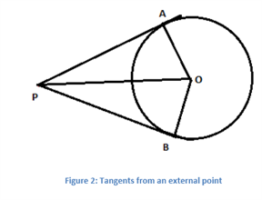

∠POA = ∠POB

∠OPA = ∠OPB

* Tangent lines at the end point of diameter are parallel.

