**Half mark and one-mark questions**

1. How many tangents can be drawn to a circle from a point on the same circle? Justify your answer with a rough diagram?
2. Find the length of the tangent from a point, which is 9.1 cm away from the centre of the circle, whose radius is 8.4 cm?
3. The length of the tangent from external point ‘P’ to a circle with centre ‘O’ is always less than ‘OP’. Is the statement true? Give reason?
4. The length of the minute hand of a clock is 3.5 cm. Find the area swept by minute hand in 30 minutes?
5. The length of the tangent to a circle from a point 17cm from its centre is 18 cm. Find the radius of the circle?
6. ‘O’ is centre of a circle. AB is a chord and AT is the tangent at A. If ∠AOB = 1000 then calculate ∠BAT?

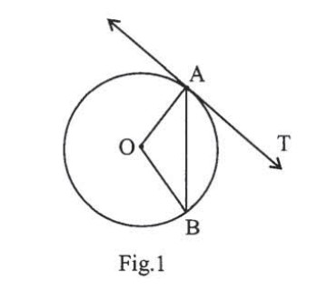

1. In the given figure, calculate ∠AOB?

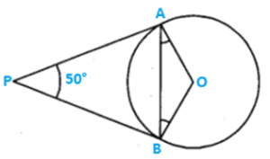

1. In the given figure, a circle touches all the four sides of a quadrilateral ABCD, whose sides are AB = 6cm, BC = 8cm, CD = 9cm. Find the length of the side AD?

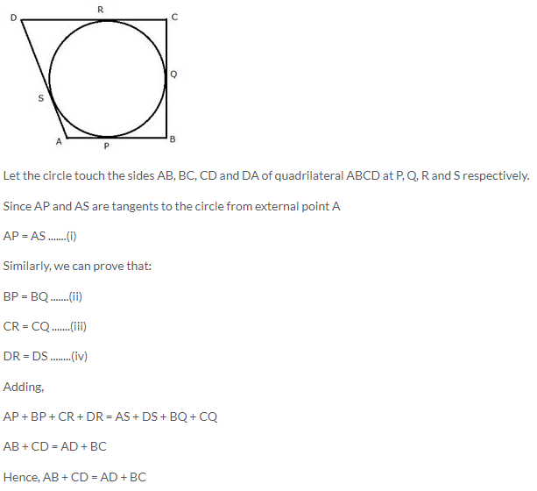

1. Define a tangent of circle?
2. Sireesha said, “Tangent of a circle from external point is a ray. So we can’t measure its length”. Do you agree with Sireesha? Justify your answer.

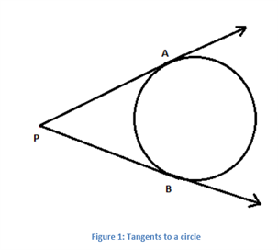

**Two marks questions**

1. Prove that the tangents to a circle at the end points of diameter are parallel?
2. Draw a circle and two lines parallel to a given line such that one is tangent and the other is a secant to the circle?
3. Prove that “in two concentric circles, such that a chord of the bigger circle, that touches the smaller circle is bisected at the point of contact with the smaller circle?
4. Find the area of the shaded region in the figure, if ABCD is a square of side 7cm and BPC and APD are semicircles?

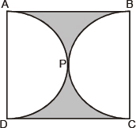

1. Calculate the area of the designed region, common between the two quadrants of the circles of radius 8cm each?

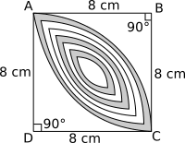

**Four marks questions**

1. Prove that the tangents drawn from external point to a circle are equal?
2. Draw a circle with radius 3cm and construct a pair of tangents from a point 8cm away from the centre?
3. Two concentric circles of radii 10cm and 6cm are drawn. Find the length of the chord of the larger circle which touches the smaller circle?
4. Ten identical mementos is made by my school to awarding 10 students first prize winners in game. If each memento is made as shown in the figure (shaded portion), its base PBCR is silver plated from the front side at the rate of Rs. 20/- per cm². Find the total cost of the silver plating of 10 mementos?

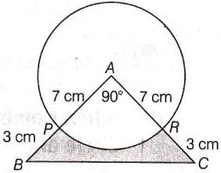

1. If two tangents PR and PQ are drawn to a circle with centre ‘O’ from an external point P, then prove that ∠RPQ = 2∠ORQ = 2∠OQR?

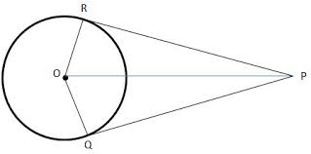

1. Prove that the parallelogram circumscribing a circle is a rhombus?
2. A triangle ABC is drawn to circumscribe a circle of radius 4cm such that the segments BD and DC are of lengths 8cm and 6cm respectively. Find the length of sides AB and AC when area of ∆ABC is 84cm²?

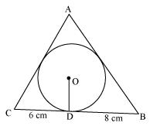

1. Find the area of the shaded region in the given figure where a circular arc of radius 7cm has been drawn with vertex A of an equilateral triangle ABC of side 14cm as centre? (Use $\sqrt{3}$ = 1.73).

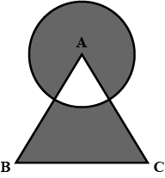

1. A quadrilateral ABCD is drawn to circumscribe a circle. Then prove that AB + CD = AD + BC?

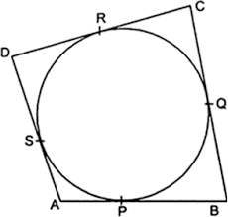

1. A chord of circle or radius 10cm subtends a right angle at the centre. Find the area of the corresponding

(i) Minor segment (ii) major segment? (Use π = 3.14)

1. Find the area of the shaded region in the given figure, if PQ = 24cm, PR = 7cm and ‘O’ is centre of the circle?

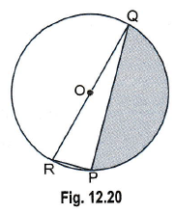

1. From each corner of a square of side 4cm a quadrant of a circle of radius 1cm is cut and also a circle of diameter 2cm is cut as shown in figure. Find the area of the remaining portion of the square?

