**Self-Assignment -1**

**Topic: Co-ordinate Geometry**

**Class: 9th Max. Marks: 25**

**Answer all questions. Each question carries 1/2 marks. 10 × 1/2 = 5M**

1. Write the general form of a point on Y-axis?
2. Find the distance of the point (-4, -3) from X-axis?
3. Where does the point lie if abscissa is -7 and ordinate is 2?
4. Who is the father of Co-ordinate geometry?
5. How many references we need to locate the exact position of a point?
6. If x < 0 and y > 0, then where does the point (x, -y) locate?
7. If (3x + y, 3) = (1, -y), then what are the values of x and y?
8. Statement A: (3, -4), (-5, -4) and (1/4, -4) are collinear points.

Statement B: The point (0, 0) lies on both axes.

Which statement(s) is/are true?

1. Where does the points lie if their abscissa is positive?
2. What is equation of X-axis?

**Answer all questions. Each question carries 1 mark. 4 × 1 = 4M**

1. If A = (-3, 7) and B = (8, 2), then what is the sum of ordinate of A and abscissa of B?
2. Eswar said, “If a < 0, then (a, -a) lies in Q3”. Can you agree with him? Justify.
3. What is the point which lies on X-axis at a distance of 4 units from origin in the negative direction?
4. Write the coordinates of origin?

**Answer all questions. Each question carries 2 marks. 4 × 2 = 8M**

1. Find the coordinates of the point whose abscissa is the solution of the first equation and ordinate is the solution of second equation.

3 = 2x = 7 and 2y + 1 = 10 – 2 $\frac{1}{2}$ y.

1. If we draw the perpendiculars AM and AN from the point A(6, -8) to X-axis and Y-axis respectively. Then write the co-ordinates of the points M and N?
2. By plotting the points on graph sheet, verify whether (2, 2), (6, 2), (8, 5) and (4, 5) form a square or not?
3. Use the graph given alongside, to find the coordinates of the point(s) satisfying the given condition:
4. The abscissa is 4 C) The ordinate is 0
5. The distance from X-axis is 5 units D) At equal distance from origin

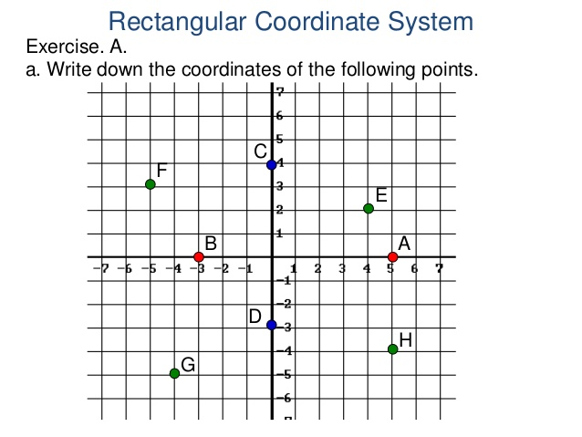

**Answer all questions. Each question carries 4 marks. 2 × 4 = 8M**

1. Plot the following points on graph sheet?
2. P is at 4 units distance form X- axis and 5 units distance from Y-axis.
3. The point Q who abscissa is -5 and ordinate is 3
4. The point which is on Y-axis at 5 units distance from origin in negative direction.

Or

In a square ABCD, A = (3, 4), B = (-2, 4), C = (-2, -1). By plotting these point on a graph sheet, find the coordinates of vertex D. And also find the area of the square?

1. In a rectangle OABC, point O is origin. OA = 10 units along X-axis and AB = 8 units. Find the coordinates of vertices A, B and C using graph sheet?

Or

A (-2, 4), C(4, 10) and D(-2, 10) are the vertices of a square ABCD. Use the graphical method to find the co-ordinates of fourth vertex B. Also find

1. The co-ordinates of the mid-point of BC
2. The co-ordinates of the mid-point of CD and
3. The co-ordinates of the point of intersection of the diagonals of the square ABCD.