**CO-ORDINATE GEOMETRY**

**INTRODUCTION:**

* Rene Descartes, a French mathematician and philosopher has developed the study of Co-ordinate Geometry.
* He found an association between algebraic equations and geometric curves.
* We need two references to describe for fixing the exact position of a point in a plane.
* The representation of a point on a plane with idea of two references led to develop of a new branch of Mathematics known as ‘Co-ordinate Geometry’.
* In honour of Descartes, this is also called as ‘Cartesian Geometry’ and also called as ‘Analytical Geometry’.

**Ordered pair:**

* A pair of numbers a and b listed in a specific order with a at the first place and b at the second place is called ‘Ordered pair’. It is denoted by (a, b).
* (a, b) ≠ (b, a)
* If a = b, then only (a, b) = (b, a).

**Co-ordinate system:**

* The system used for describing the position of a point in a plane by an ordered pair is known as ‘Co-ordinate System’.
* The position of a point in a plane is determined with reference to two fixed mutually perpendicular lines, called ‘Co-ordinate axes’.
* For the sake of convenience we take one line horizontally and another line vertically.
* The horizontal line XOX’ is known as X – axis.
* The vertical line YOY’ is known as Y – axis.
* The intersecting point of both axes is known as ‘Origin’ and denoted by ‘O’.
* The both axes are number lines only.
* Since the positive numbers lie on the direction OX, is called the positive X – axis. Similarly OY is positive Y – axis.
* In the same way OX’ is negative X – axis and OY’ is negative Y – axis.

Positive Y - axis

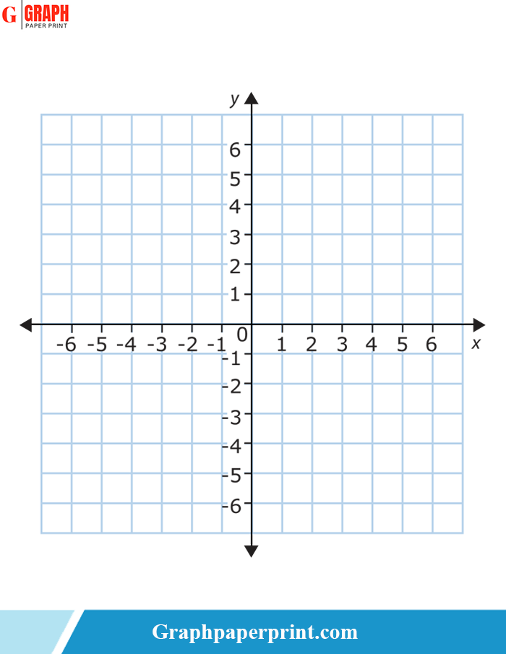

Negative Y - axis

Negative X - axis

Positive X - axis

**Coordinates of a point in a plane:**

* A position of point in the plane is represented by an ordered pair.
* If the point is at distance of ‘a’ units from Y – axis and ‘b’ units from X – axis, then we say that the coordinates of the point are (a, b).
* The first element of the ordered pair is called X – coordinate or Abscissa of the point.
* The second element of the ordered pair is called Y- coordinate or Ordinate of the point.
* Abscissa of a point represents the distance from Y – axis to the point.
* Ordinate of a point represents the distance from X – axis to the point.
* If abscissa or ordinate of a point have negative signs, it represents the distance from the axes in left or down directions respectively.
* Coordinates of origin are (0, 0).

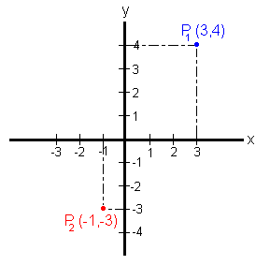

**Quadrants:**

* The co-ordinate axes divides the plane into four equal parts.
* Each part is called ‘Quadrant’. And denoted by Q1, Q2, Q3 and Q4.
* The region XOY is called first quadrant (Q1­).
* The region YOX’ is called second quadrant (Q2).
* The region X’OY’ is called third quadrant (Q3).
* The region YÓX is called fourth quadrant (Q4).
* We will take the quadrants in anti-clockwise direction.

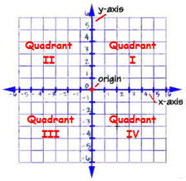

* Using the convention of signs, we have the signs of the coordinates in various quadrants as given below.

|  |  |  |  |
| --- | --- | --- | --- |
| Region | Quadrant | Nature of x and y | Signs of coordinates |
| XOY | Q1 | x > 0 and y > 0 | (+, +) |
| YOX’ | Q2 | x < 0 and y > 0 | (-, +) |
| X’OY’ | Q3 | x < 0 and y < 0 | (-, -) |
| Y’OX | Q4 | x > 0 and y < 0 | (+, -) |
| On X - axis | - | x ≠ 0 and y = 0 | (±, 0) |
| On Y - axis | - | x = 0 and y ≠ o | (0, ±) |

**Some more important concepts:**

* The general form of a point is (x, y).
* If the abscissa of a point is 0, then the point lie on Y – axis.
* If the ordinate of a point is 0, then the point lie on X – axis.
* The general form of a point on X – axis is (x, 0).
* The general form of a point on Y – axis is (0, y)
* Equation of X – axis is y = 0.
* Equation of Y – axis is x = 0.
* If the abscissa of points are constant, then they are collinear and represents a line parallel to Y – axis.
* If the ordinates of points are constant, then they are collinear and represents a line parallel to X – axis.
* Equation of the line parallel to X – axis is y = k (constant).
* Equation of the line parallel to Y – axis is x = k (constant).