**Half mark and one-mark questions**

1. If a point is at a distance of 2 units from X – axis and 3 units from Y – axis then find the coordinates of the point?
2. Write the coordinates of the point which is above X – axis lying on Y – axis at a distance 4 units?
3. Which of the following point do not lie in any quadrant?
4. (3, 4) B) (-4, 0) C) (4, -4) D) (-2, 3)
5. Which point lie on both coordinate axes?
6. In which quadrant the point (3, -8) lie?
7. If the point (x, y) lies in fourth quadrant then in which quadrant the point (-x, y) lie?
8. Statement A: on Y-axis, the abscissa is zero.

Statement B: The coordinates of any point on Y-axis is (0,y).

Which of the above statement(s) is correct?

1. Find the value of x and y if (3x + 1, 2y - 7) = (9, -9)?
2. What is the equation of X- axis?
3. Which of the following statement is not false?
4. The ordinate of a point is its X – coordinate.
5. The origin is in the first quadrant.
6. The Y-axis is the vertical number line
7. Every point is located in one of the four quadrants.
8. If a < 0, then the point (a, -a) lie in _______.
9. Find the sum of abscissa of (-4, 3) and ordinate of (3, -4)?
10. Are the positions of the points (x, y) and (y, x) same? Justify?
11. What can you say about the position of the points (1, 0), (-2, 0)?
12. Write three points having sum of its coordinates equal to 6?
13. Who is father of co-ordinate geometry?
14. Write the following based on the graph?
15. The co-ordinates
16. of point A, B and C
17. The point denoted by (3, -5).

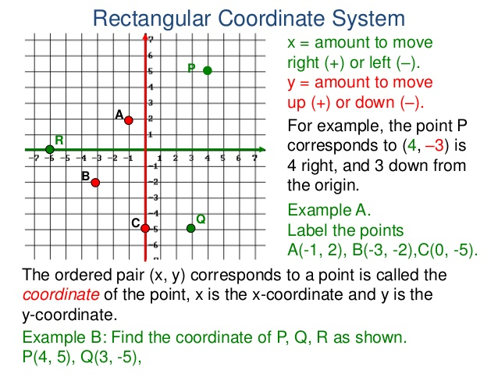

1. Ravi said, “If the point (-x, y) lies in Q1 then the point (x, y) lies Q2”. Can you agree with him? Justify?
2. Ashok said, “A point on Y-axis belongs to both Q1 and Q2”. Can you agree with him? Justify?
3. What is the distance from Y-axis to the point (-3, -5)?
4. Find the point which lies on Y-axis at a distance of 5 units in the negative direction of Y-axis?
5. A point P lies on X-axis. What can you say about coordinates of point P?

**Two marks questions**

1. Find the coordinates of the point whose abscissa is the solution of the first equation and the ordinate is the solution of the second equation

0.5x – 3 = -0.25x and 8 – 0.2(y + 3) = 3y + 1

1. Use the graph given alongside, to find the coordinates of the point(s) satisfying the given condition:
2. The abscissa is 4 C) The ordinate is 0
3. The distance from X-axis is 5 units D) At equal distance from origin

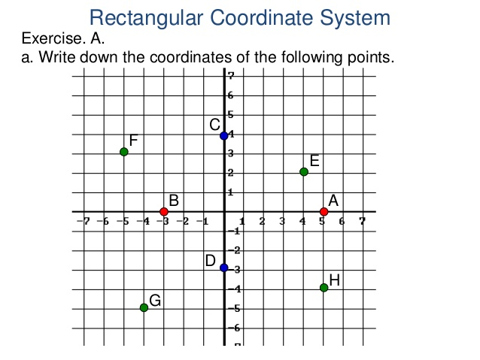

1. The coordinates of the three vertices of a rectangle ABCD are A(4, 2), B(-2, 2) and D(4, -2). By plotting the given points on a graph sheet find the coordinates of the vertex C?
2. Check whether the points (-2, -1), (-1, -4) and (-4, 1) are collinear or not by plotting the points on graph sheet?
3. In a rectangle OABC, point O is origin. OA = 10 units along X-axis and AB = 8 units. Find the coordinates of vertices A, B and C using graph sheet?
4. What can you say about the position of the points (3, -2), (3, 0), (3, 5) and (3, 2)? Verify by plotting the points on graph sheet?
5. By plotting the points on graph sheet, verify whether (2, 2), (6, 2), (8, 5) and (4, 5) form a square or not?
6. Plot the points (-4, 5) and (5, -4) on graph sheet. Are the two points locate same point?
7. Plot the points A(5, 5), B(-5, 5) and join OA, OB and AB. What figure is obtained? (O is origin)
8. Plot the following points on graph sheet?
9. P is at 4 units distance form X- axis and 5 units distance from Y-axis.
10. The point Q who abscissa is -5 and ordinate is 3
11. Plot the point A(5, -7). From A, draw AM perpendicular to X-axis, and AN perpendicular to Y-axis. Write the coordinates of points M and N?
12. If the perpendicular distance of a point P from the X-axis is 5 units and the foot of the perpendicular lies on the negative direction of X-axis, what will be the ordinate of the point P?
13. Sita said, “If the coordinates of a point have different signs it lie in Q2”. Can you agree with her? Justify.

**Four marks questions**

1. In a square ABCD, A = (3, 4), B = (-2, 4), C = (-2, -1). By plotting these point on a graph sheet, find the coordinates of vertex D. And also find the area of the square?
2. A (-2, 4), C(4, 10) and D(-2, 10) are the vertices of a square ABCD. Use the graphical method to find the co-ordinates of fourth vertex B. Also find
3. The co-ordinates of the mid-point of BC
4. The co-ordinates of the mid-point of CD and
5. The co-ordinates of the point of intersection of the diagonals of the square ABCD.
6. Plot any six points in a graph sheet each having the sum of its coordinates equal to 7? What can you notice? Explain?
7. Plot the points (2, 2), (7, 2) and (5, 7) on a graph sheet. And join them to form a triangle. Find the area of the triangle?
8. Write the coordinates of the vertices o a rectangle whose length and breadth are 5 and 3 units, one vertex on origin, the longer side lies on the X-axis and one of the vertices lies in the third quadrant?