**Coordinate geometry**

**Basic concepts:**

* A French mathematician ‘*Rene Des Cart*’ introduced Coordinate Geometry.
* This is a method of studying Geometry using Coordinate system.
* This is also called ‘*Analytical Geometry*’ or ‘*Cartesian Geometry*’.
* In a coordinate plane, the horizontal reference line is called X – axis. And the vertical reference line is called Y – axis. These both are called ‘Coordinate axes’.
* The intersecting point of the coordinate axes is called ‘*Origin*’.
* Any point of the coordinate plane is represented by an ‘Order pair’
* In the order pair, the first coordinate is called ‘Abscissa’ and the second coordinate is called ‘Ordinate’.
* The coordinates of Origin are (0, 0).
* The coordinate axes divide the plane into 4equal parts.
* Each part is called as ‘Quadrant’ and represented by Q1, Q2, Q3 and Q4.

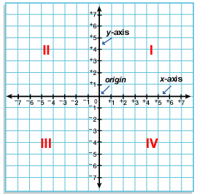

|  |  |  |
| --- | --- | --- |
| **Quadrants/axes** | **Sign of the coordinates** | **Remarks** |
| Q1 | (+, +) | x > 0, y > 0 |
| Q2 | (-, +) | x < 0, y > 0 |
| Q3 | (-, -) | x < 0, y < 0 |
| Q4 | (+, -) | x > 0, y < 0 |
| On X – axis | (±, 0) | x ≠ 0, y = 0 |
| On Y - axis | (0, ±) | x = 0, y ≠ 0 |

* On X – axis, the ordinate of any point is zero. And on Y – axis, the abscissa of any point is zero.
* General form of a point on X – axis is (x, 0).
* General form of a point on Y – axis is (0, y).
* Equation of X – axis is y = 0
* Equation of Y – axis is x = 0
* Equation of the line parallel to X – axis is y = k (constant)
* Equation of the line parallel to Y – axis is x = k (constant).

**Distance formula:**

* The **abscissa** of a point represents the perpendicular distance of the point from Y – axis.
* The **ordinate** of a point represents the perpendicular distance of the point from X – axis.

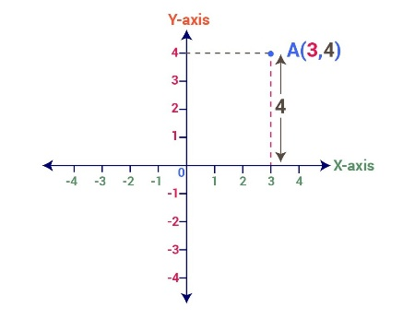

* The distance between two points having same abscissa (means lie on the line parallel to Y – axis) is equal to difference of the y coordinates of the two points.

The distance between the points (x, y1) and (x, y2) is |y2 – y1| or |y1 – y2|.

* The distance between two points having same ordinate (means lie on the line parallel to X – axis) is equal to the difference of the x coordinates of the two points.

The distance between the points (x1, y) and (x2, y) is |x2 – x1| or |x1 – x2|.

* The distance between the two points A(x1, y1) and B(x2, y2) is

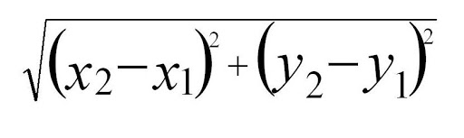

* The distance from origin (0, 0) to the point (x, y) is $\sqrt{x^{2}+y²}$
* In ΔABC, if

1. AB = BC = CA then it is ‘Equilateral Triangle’
2. Any two sides are equal then it is ‘Isosceles Triangle’
3. Any two sides are not equal then it is ‘Scalene Triangle’
4. If the sides satisfy Pythagoras theorem then it is a ‘Right angled triangle’

* In quadrilateral ABCD, if

1. AB = CD and BC = DA then it is a ‘Parallelogram’
2. AB = CD, BC = DA and AC = BD then it is a ‘Rectangle’
3. AB = BC = CD = DA then it is a ‘Rhombus’
4. AB = BC = CD = DA and AC = BD then it is a ‘Square’.

**Section formula:**

* If the point P (x, y) divides the line segment joining the points A (x1, y1) and B (x2, y2) in the ratio m:n, then

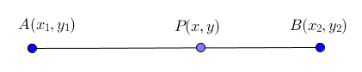

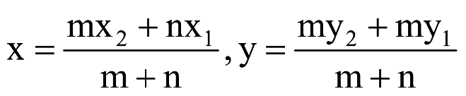

* If the point P (x, y) divides the line segment joining the points A (x1, y1) and B (x2, y2) in the ratio m:n, then

$\frac{m}{n}$ = $\frac{x1-x}{x-x2}$ = $\frac{y1-y}{y-y2}$

* The X – axis divides the line segment joining the points (x1, y1) and (x2, y2) in the ratio -y1 : y2
* The Y – axis divides the line segment joining the points (x1, y1) and (x2, y2) in the ratio – x1 : x2
* The midpoint of the line segment joining the points (x1, y1) and (x2, y2) is

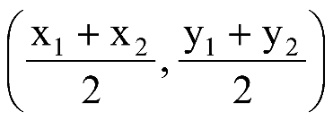

* The point which divides the given line segment in the ratio 2:1 or 1:2 is called ‘***Point of trisection’***.
* The point of concurrent of medians of a triangle is called ‘***Centroid***’ and represented by ‘G’.
* Centroid divides the median in the ratio 2:1.
* The coordinates of the Centroid of a triangle whose vertices are (x1, y1), (x2, y2) and (x3, y3) is

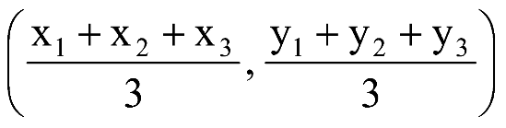

**Area of a triangle:**

* If the sides of a triangle are ‘a’, ‘b’, ‘c’ then area of the triangle is

Δ = $\sqrt{s(s-a)(s-b)(s-c)}$ where s = $\frac{a+b+c}{2}$

This is called ‘Heron’s Formula’

* The area of a triangle whose vertices are (x1, y1), (x2, y2) and (x3, y3) is

Δ = |x1(y2 – y3) + x2(y3 – y1) + x3(y1 – y2)|

* Area of the triangle formed by (0, 0), (x, 0) and (0, y) is $\frac{1}{2}|xy|$
* Area of the triangle formed by (0, 0),(x1, y1) and (x2, yis

x1y2 – x2y1|.

* If three or more points lie on a same line, they are called ‘Collinear points’ .
* The area of the triangle formed by three collinear points is zero. Its converse is also true.
* If A, B and C are collinear points then

1. ar(ΔABC) = 0
2. AB + BC = AC.

**Slope of a line:**

* The angle made by a straight line with the X – axis in positive direction (anti clockwise direction) is called ‘Angle of Inclination’.

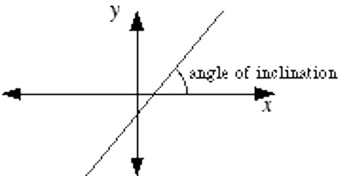

* If the angle of inclination of a line is ‘θ’ then the value of ‘tan θ’ is called slope of the line. It is denoted by ‘m’.

Slope (m) = tan θ

* If (x1, y1) and (x2, y2) are two points on the line then slope of the line is

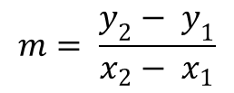

* The slope of X – axis is ‘zero’
* The slope of Y – axis is ‘not define’
* The slope of a line which is parallel to X – axis is ‘zero’
* The slope of a line which is parallel to Y – axis is ‘not define’.

**Some additional points:**

* If the midpoints of the sides AB, BC and CA of triangle ABC are D(x1, y1), E(x2, y2) and F(x3, y3) then

A = (x1 + x3 – x2, y1 + y3 – y2)

B = (x1 + x2 – x3, y1 + y2 - y3)

C = (x2 + x3 - x1, y2 + y3 – y1)

* If A(x1, y1), B(x2, y2) and C(x3, y3) are the vertices of the parallelogram ABCD, then the fourth vertex

D = (x1 + x3 – x2, y1 + y3 – y2)

* If A(x1, y1), B(x2, y2), C(x3, y3) and D(x4, y4) are the vertices of a parallelogram or rectangle or rhombus or square then

x1+ x3 = x2 + x4

y1 + y3 = y2 + y4

* If (a, b), (c, d), (e, f) are collinear points, then

a c e a

b d f b

⇒ (ad + cf + eb) – (bc + de + af) = 0

* If slope of two lines are equal, then they are parallel to each other.
* If the product of slopes of two lines is equal to -1, then they are perpendicular to each other.