**THE ELEMENTS OF GEOMETRY**

**History of Geometry:**

* The domine of Mathematics which study the shapes and sizes of structure is ‘Geometry’.
* The word ‘Geometry’ is derived from the Greek words “Geo” and “Metrein”.
* ‘Geo’ means ‘**Earth**’. ‘Metrein’ means ‘**Measure**’.
* The obtuse angled triangles are discovered by the early people in the ancient Indus valley and Babylonians.
* The “**Bakshali Manuscript**” employs a handful of geometric problems including problems about volumes of irregular solids.
* The “**Sulba Sutras**” in Vedic Sanskrit lists the rules and geometric principles involved in the construction of ritual fire altars.
* In fire altars, the constructions occupy same area although differ their shapes.
* Boudhayana composed the “Boudhayana Sulba Sutra”, the best known ‘Sulba Sutra’ which contain simple examples of simple Pythagorean triples such as (3, 4, 5), (5, 12, 13), (8, 15, 17).
* Boudhayana said Pythagoras theorem before ‘Pythagoras’.
* The Greek mathematician EUCLID of Alexandria in Egypt wrote 13 books called “**THE ELEMENTS**”.
* The father of Geometry is “**EUCLID**”.

**Terms used in Geometry:**

* The three building blocks of geometry are ‘Points, Line and Planes.
* Point has no dimensions.
* Line has one dimension.
* Plane has two dimensions.
* A solid has three dimensions.
* A point, a line and a plane (surface) are said to be as ‘Undefined Terms’.
* We can explain the undefined terms with the help of ‘Physical modals’.

**Definitions of some terms from the first book of “THE ELEMENTS”**

* A point is which has no part.
* A line is breathless length.
* The ends of a line are points.
* A straight line is a line which lies evenly with the point on itself.
* A surface is that which has length and breadth only.
* The edges of surface are lines.
* A plane surface is a surface which lies evenly with the straight lines on itself.

**Axioms and Postulates:**

* Axioms are statements which are self-evident and does not required any proofs.
* Axioms are always true statements.
* Axioms are the foundation stones of geometry.
* Postulates are universal truth which are specific to geometry.

**Euclid’s axioms:**

* Things which are equal to same things are equal to one another.

Ex: a + b + c = 90

P + q = 90 then **a + b + c = p + q**

* If equals are added to equals then the wholes are equal.

Ex: if a = b then a + c = b + c

* If equals are subtracted from equals then the remainders are equal.

Ex: if a = b then a – c = b – c

* Things which are double of same things are equal to one another.

Ex: if a = b then 2a = 2b.

* Things which are halves of same things are equal to one another.

Ex: if a = b then $\frac{a}{c}= \frac{b}{c}$ (c ≠ 0)

* Things which coincide with one another are equal to one another.
* The whole is greater than the part.

Ex: if x + y = z then z > x and z > y.

**Euclid’s Postulates:**

1. There is a unique line that passes through the given two distinct points.

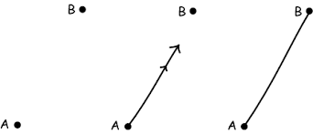

1. A line segment can be extended on either side to form a straight line.

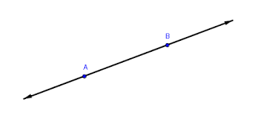

1. We can describe a circle with any centre and radius.

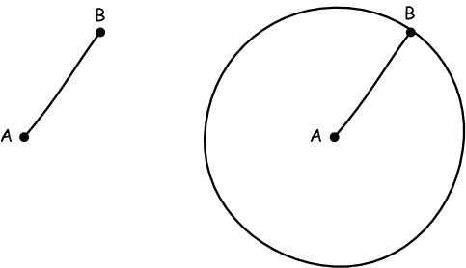

1. All right angles are equal to one another.

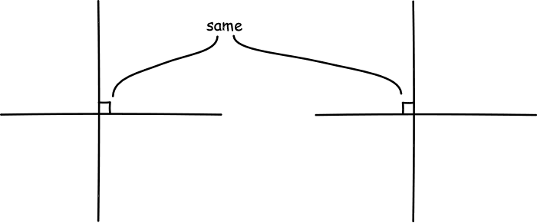

1. If a straight line falling on two straight lines makes the interior angles on the same side of it taken together is less than two right angles, then the two straight lines, if produced infinitely, meet on that side on which the sum of the angles is less than two right angles.

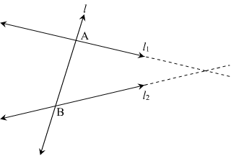

**Some other postulates:**

* Through a point not on a given line, exactly one parallel line may be drawn to the given line.(**John Play Fair**).

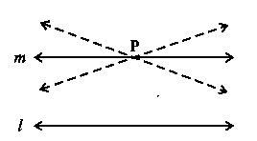

* The sum of angles of any triangle is a constant and is equal to two right angles. (**Legendre**)

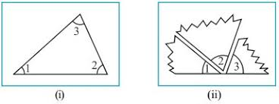

* There exists a pair of lines everywhere equidistant from one another (**Posidominus**)

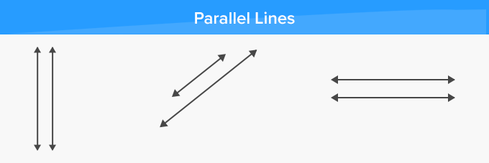

* If a straight line intersects any one of two parallel lines, then it will intersect the other also. (**Proclus**).

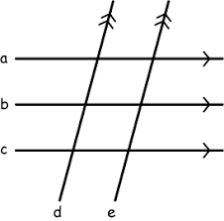

* Straight line parallel to the same straight line are parallel to one another. (**Proclus**).

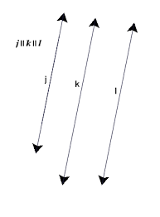

**Theorems (Propositions):**

* The true statements which need proof are called ‘Theorem’.

Ex: sum of three angles of a triangles is 1800.

* To prove a theorem, we will use deductive reasoning and the statements that were proved.
* In a theorem, there are 6 stages. They are

1. General Enunciation (Definition)
2. Diagram
3. Hypothesis (Given)
4. Conclusion (R.T.P)
5. Construction (depends on need)
6. Proof

* Deductive proof was introduced by “**Thales**”.

**Conjecture (Hypothesis):**

* The statements which are neither proved nor disproved are called ‘Conjecture’.
* Mathematics discoveries often start out as conjecture.

Ex: Every even number greater than 4 can be written as sum of two primes (**Gold Bach**)