**Half mark and one-mark questions**

1. Define conjecture?
2. What are the main pillars of Geometry?
3. From which words the word ‘Geometry’ is derived?
4. What are the boundaries of a solid figure?
5. According to the mathematician Euclid, what is the definition of ‘point’?
6. How many parts are there in the book ‘The Elements’?
7. Write any three undefined words that are used in Geometry?
8. What is axiom?
9. Write Play Fair’s axiom?
10. Which figure has no dimensions?
11. Rajesh said, “2 + 4 = 6 and 1 + 5 = 6. So 2 + 4 = 1 + 5”. Which axiom involved in the statement?
12. Who introduced ‘Deductive proof’?
13. What is a theorem?
14. What is the difference between axiom and theorem?
15. How many dimensions does a solid as?
16. Give an example to a conjecture?
17. Who wrote the 13 books called ‘The Element’?
18. How many points describes a line?
19. If two lines have a common point, what they are called?
20. Give three examples to axioms from daily life?
21. What are collinear points?
22. How many lines can pass through a given point?

**Two marks questions**

1. Find the sum of the angles as shown in the star shaped figure?

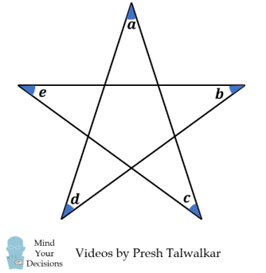

1. Which points are collinear points in the following figure? What is the condition that they become as collinear?

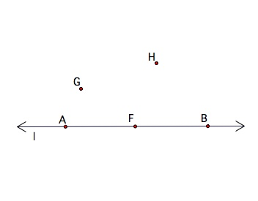

1. Write any four Euclid’s axioms?
2. Explain Euclid’s fifth postulate in your own words with a diagram?
3. Write any two equivalent postulates of Euclid’s fifth postulate?