**LINEAR EQUATIONS IN TWO VARIABLES**

**BASIC CONCEPTS:**

* The first degree equation is called as ‘linear equation’.
* A linear equation in one variable is called ‘**Simple equation’**.
* The general form of simple equation in the variable ‘x’ is ax + b = 0. (a,b are real numbers and a ≠ 0)
* The value of the variable which satisfies the given equation is called ‘Solution or Root’ of the equation.
* A linear equation in one variable has only one solution.
* General form of a two digit number is 10x + y.

**Linear equation in two variables:**

* The first degree equation in two variables is called ‘Linear equation in two variables’.
* The general form a linear equation in two variables is **ax + by + c = 0** if and only if |a| + |b| ≠ 0 or a² + b² ≠ 0 or a ≠ 0 and b ≠ o means a and b are simultaneously zero.
* The value of variables which makes L.H.S = R.H.S is called ‘Solution or Root’ of the equation.
* A linear equation in two variables have infinitely many solutions.
* The solutions of a linear equation in two variables are represented by ordered pairs.
* The solution of a linear equation satisfies the given equation.
* If (p, q) is a solution of the equation ax + by + c = 0, then px + qy + c = 0

**Graph of a linear equation:**

* The solution of a linear equation in two variables is represented by an ordered pair which can be expressed as a point in the graph sheet.
* The graphical representation of a linear equation is a **straight line.**

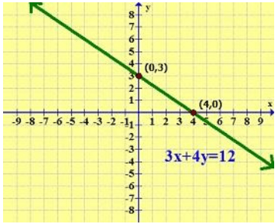

* Every solution of the linear equation represents a point on the straight line.
* Every point on the straight line is a solution of the linear equation.
* Any point that does not lie on the line is not a solution of the equation,

**Different types of linear equations – ther graphs:**

* If c = 0, then the graph of the equation ax + by + c = 0 represents a straight line which passes through origin.
* If a = 0, then the graph of the equation ax + by + c = 0 represents a straight line which is parallel to X-axis.
* If b = 0, then the graph of the equation ax + by + c = 0 represents a straight line which is parallel to Y-axis.
* The graph of the equation **y = mx** is a straight line which passes through origin. (m is constant and called as slope of the line)

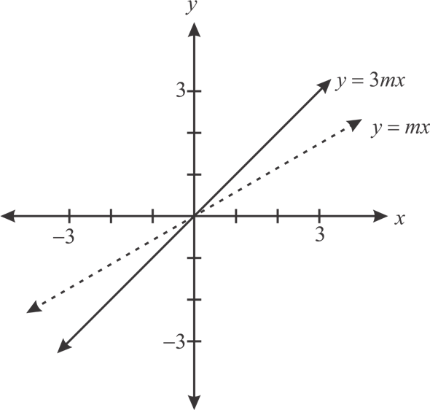

* The graph of the equation **y = mx + c** is a straight line which not passes through origin.
* The graph of the equation **y = mx + c** intersects the Y-axis at (0, C) and X- axis at $\left(-\frac{c}{m}, 0\right).$

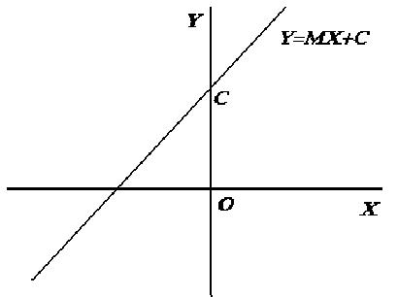

* The graph of the equation **ax + by + c = 0** intersects X-axis at $\left(-\frac{c}{a}, 0\right)$ and the Y-axis at $\left(0, -\frac{c}{b}\right)$.

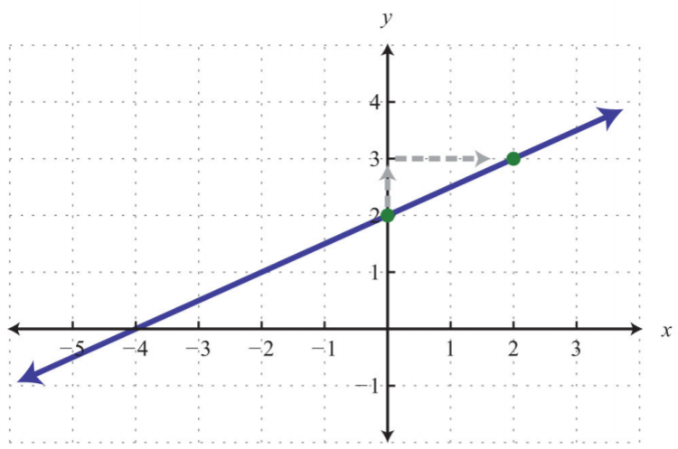

$$(0, -\frac{c}{b})$$

ax + by + c = 0

$$(-\frac{c}{a}, 0)$$

* The graph of the equation **x = k** is a line parallel to Y- axis at a distance of k units and passing through the point (k, 0).

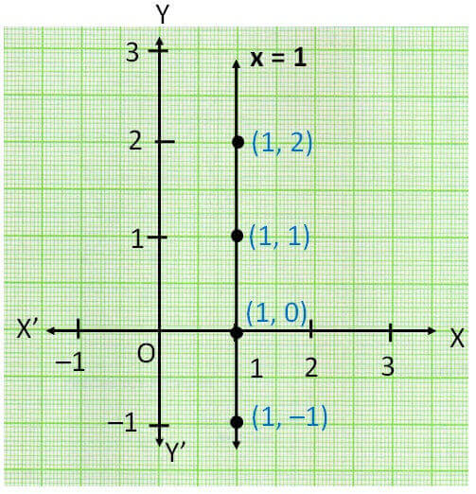

* The graph of the equation **y = k** is a line parallel to X- axis at a distance of k units and passing through the point (0, k).

