**Self-Assignment -1**

**Topic: Lines and angles**

**Class: 9th Max. Marks: 25**

**Answer all questions. Each question carries 1/2 marks. 10 × 1/2 = 5M**

1. Define ‘degree’?
2. Write the conjugate angle of right angle?
3. Which of the following is true?
4. If an angle is equal to its complementary angle, then each angle is equal to 900.
5. Linear pair angles are supplementary angles.
6. The angle whose measure is 900 is called ‘Right angle’.
7. Vertically opposite angles are always supplementary.
8. “There exits only one right angle in a triangle”. Justify?
9. How can you define the following angles?

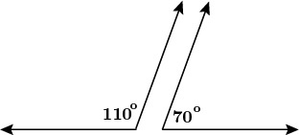

1. If one of the linear pair angles is 670, then what is the measure of second angle?
2. Statement A: Lines which are perpendicular to same line are parallel.

Statement B: Lines which are parallel to same line are parallel.

Which statement(s) is/are true?

1. What is the angle between angle bisectors of linear pair angles?
2. What is the measure of exterior angle of an equilateral triangle?
3. Write the ‘Linear pair axiom’?

**Answer all questions. Each question carries 1 mark. 4 × 1 = 4M**

1. If an angle is 600 more than twice of its supplementary angle, find the angle?
2. Nuoor said, “If the ratio of angles of a triangle is 1 : 2 : 6, then it is an obtuse angled triangle”. Do you agree with him? Justify your answer.
3. It is given that = 580 and AB is produced to the point X. A ray BY bisects $∠CBX$. Draw a figure to the given information?
4. Write the pair of alternate interior angles from the following diagram?

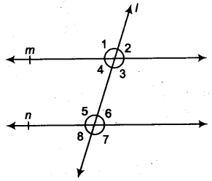

**Answer all questions. Each question carries 2 marks. 4 × 2 = 8M**

1. Find the value of ‘x’ in the following figure?

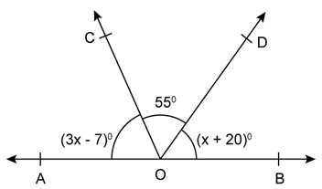

1. The exterior angle of a triangle is 1140 and one of the interior opposite angle is twice to another, then find the angles of the triangle?
2. In the given figure, sides QP and RQ of ∆PQR are produced to the points S and T respectively. If $∠SPR=135° and ∠PQT=110°$ then find $∠PRQ$?

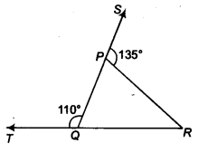

1. In the given figure, lines XY and MN intersect at ‘O’. if = 900 and a : b = 4: 5, then find ‘c’?

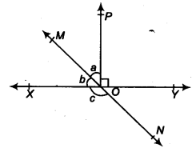

**Answer all questions. Each question carries 4 marks. 2 × 4 = 8M**

1. Using the information given in the following figure, find the measure of $∠AOC$?

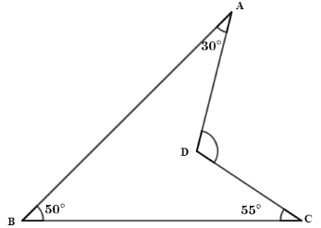

Or

In the given figure find ∠DCB, if AE ‖ CD?

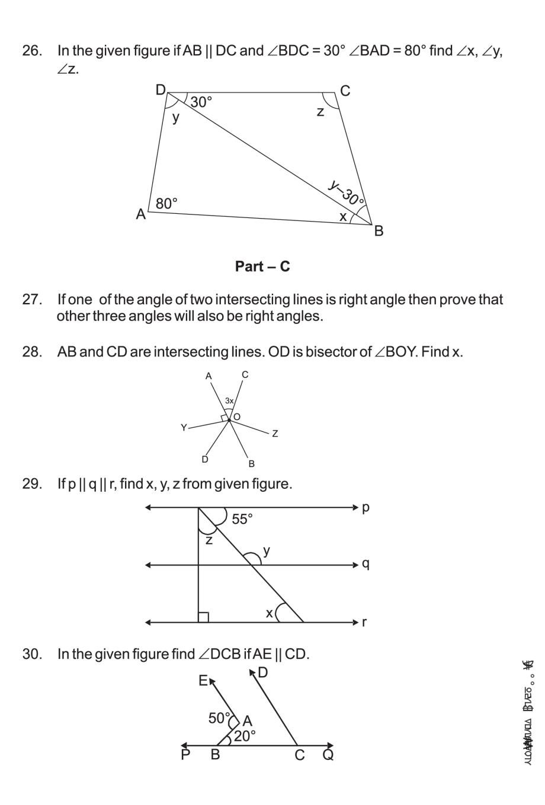

1. Prove that “The sum of exterior angles of a triangles is 3600?

Or

Prove that “If a transversal intersects two parallel lines, the co-exterior angles that formed are supplementary”?